“ONLINE MAHA-E-SEVA KENDRA”

**A Project Report Submitted in partial fulfillment of the**

**Requirement for the award of the Degree of**

#### **BACHELOR OF SCIENCE (INFORMATION TECHNOLOGY)**

**BY**

**MR. PALKAR SAURABH SUBHASH (TY BCS IT- 20)**

**Under the esteemed guidance of**

#### **Mr. BHUPINDER SINGH SIR**

**Designation**



**DEPARTMENT OF INFORMATION TECHNOLOGY**

#### **Navneet College Of Science, Commerce and Arts**

***(Affiliated to University of Mumbai)* MUMBAI-CENTRAL-400008 MAHARASHTRA**

**2023-2024**

# APPROVAL OF PROJECT PROPOSAL

#### **PNR No: 2022016401947103 Roll No: 2026885**

1. **Name of the Student**

**MR. PALKAR SAURABH SUBHASH**

1. **Title of the Project**

**ONLINE MAHA-E-SEVA KENDRA**

1. **Name of the Project Guide**

**Mr. Bhupinder Singh Sir**

1. **Teaching experience of the Project Guide - 15 Years**
2. **Is this your first submission?**

**Signature of the Student Signature of the Guide**

**Date: Date:**

**Signature of the Head of Dept. Signature of the Examiner**

**Date: Date:**

**Navneet College of Science, Commerce and Arts**

***(Affiliated to University of Mumbai)***

**MUMBAI-CENTRAL, MAHARASHTRA-400008**

**DEPARTMENT OF INFORMATION TECHNOLOGY**



#### **CERTIFICATE**

This is to certify that the project entitled **“ONLINE MAHA-E-SEVA KENDRA**” is authentic work of **MR. PALKAR SAURABH SUBHASH** bearing Seat No: **20** submitted in partial fulfilment of the requirements for the award of degree of BACHELOR OF SCIENCE in INFORMATION TECHNOLOGY from University of Mumbai.

**Internal Guide Coordinator**

**External Examiner**

**Date: College Seal**

**ABSTRACT**

In response to the challenges faced by citizens navigating the paper-based system for government services in Maharashtra, this project proposes the development of a digital platform inspired by **“ONLINE MAHA-E-SEVA KENDRA**” initiative. The aim is to create a user-friendly portal that streamlines access to a variety of government services and schemes. This comprehensive platform seeks to enhance citizen convenience, reduce inefficiencies associated with physical visits to government offices, and contribute to the overall improvement of government service delivery. Through a centralized and accessible digital ecosystem, the project endeavors to foster transparency, optimize resource utilization, and ultimately boost citizen satisfaction with governmental processes.

**ACKNOWLEDGEMENT**

We had a great pleasure for representing this project report for **“ONLINE MAHA-E-SEVA KENDRA”** and we grab this opportunity to convey our immense regards towards all the distinguished people who have their valuable contribution in the hour of need.We profoundly thank our principal **Mr. SATYENDRA PAL SIR** for giving us support throughout the course and made us capable of being worthy of recognition and extended query facility to us for making and computing this project smoothly.

We would like to express our sincere thanks to **Mr. BHUPINDER SINGH** (Head of SPM DEPARTMENT) for his constant encouragement, which made this project a success.

We are highly obliged to **Prof. BHUPINDER SINGH SIR** teaching staff member of the Information Technology department, who spread efforts in making the project a successful one with her guidance, appropriate advice and encouragement and of course the inspiration without which the project would be ineffective difficult task.

We sincerely thank and express my profound gratitude to our teachers for their timely and prestigious guidance. We also thank my family members for their continued support in completing this project work and last but not the least; we wish to thank all my friends and well-wishers who are directly or indirectly linked with the success of our project.

**DECLARATION**

I hereby declare that the project entitled, **“ONLINE MAHA-E-SEVA KENDRA”** done at **NAVNEET COLLEGE OF SCIENCE, COMMERCE AND ARTS** has not been in any case duplicated to submit to any other university for the award of any degree. To the best of my knowledge other than me, no one has submitted to any other university.

The project is done in partial fulfilment of the requirements for the award of degree of

**BACHELOR OF SCIENCE (INFORMATION TECHNOLOGY)** to be submitted as

final semester project as part of our curriculum.

#### **MR. MULLA SURAJ IKABAL**

**TABLE CONTENT**

# CHAPTER 1: INTRODUCTION

## 1.1 Background……………………………………………...…..08

## 1.2 Objectives……………………………………………………09

## 1.3 Purpose, Scope and Applicability…………………….…....09

### 1.3.1 Purpose………………………………………………..09

### 1.3.2 Scope………………………………………………….10

### 1.3.3 Applicability…………………………………………..10

## 1.4 Organization Report…………………………………………11

## CHAPTER 2: SURVEY OF TECHNOLOGY

## 2.1 ABOUT VISUAL STUDIO 2010………………………12

## 2.2 Front-end Technoloy……………………………………13

**2.2 Front-end Technology…………………………………..14**

## CHAPTER 3: REQUIREMENT & SPECIFICATION

## 3.1 Problem Definition…………………………………………15

## 3.2 Requirement Specification………………………………...15

## 3.3 Planning & Scheduling…………………………………….15

## 3.4 Software & Hardware Requirement……………………...16

3.4.1 Software Requirement **…………………………..……16**

3.4.2 Hardware Requirement**………………………………..16**

## 3.5 Preliminary Product Description………………………….16

## 3.5 Conceptual Model…………………………………………..17

3.6.1 Data Flow Diagram**……………………………………17**

### 3.6.2 ER Diagram……………………………………………19

3.6.3 Class Diagram**………………………………………….20**

### 3.6.4 Gantt Char………………………………………..21

### 3.6.5 Pert Chart…………………………………………22

# CHAPTER 4: SYSTEM DESIGN

## 4.1 Basic Module………………………………………….23

## 4.2 Data Design……………………………………………24

4.2.1 Schema Design**………………………………….24**

4.2.2 Data Integrity and Constraints**…………………..25**

## 4.3 Procedural Design…………………………………………..27

4.3.1 Logical Diagrams**…………………………………….27**

4.3.2 Data Structure**………………………………………..35**

4.3.2 Algorithm Design**……………………………………36**

## 4.4 User Interface Design………………………………………….37

## 4.5 Security Issue…………………………………………………..39

# 4.6Test Case Design……………………………………………….39

**CHAPTER 1**

**INTRODUCTION**

In the era of rapid technological advancement, governments globally are leveraging digital platforms to enhance citizen services and promote transparency. Maharashtra's Government, recognizing the need for streamlined public service delivery, introduced the **“ONLINE MAHA-E-SEVA KENDRA**”—an online platform translating to "Our Government" in Marathi. This initiative reflects the state's commitment to accessibility and efficiency.

The **“ONLINE MAHA-E-SEVA KENDRA**”portal serves as a virtual bridge, connecting millions of Maharashtra residents to government services and information. From vital document issuance to enrollment in schemes, citizens can easily access a range of services. This project aims to explore the success and impact of **“ONLINE MAHA-E-SEVA KENDRA**”, analyzing its implementation and contributions to citizen-centric governance. By understanding the challenges and solutions, we seek to contribute insights to the broader discourse on effective digital platforms in public service delivery.

## 1.1 BACKGROUND:-

In an era characterized by rapid technological advancement, governments worldwide are undergoing a digital transformation to enhance the efficiency and accessibility of citizen services. This paradigm shift is driven by the recognition that leveraging digital platforms is essential for fostering transparency and responsiveness in administrative processes.

In Maharashtra, a state in India, the Government has been at the forefront of embracing digital innovation to bridge the gap between administration and citizens. The introduction of the **“MAHA-E-SEVA**”marks a significant milestone in this journey. Translating to "Our Government" in Marathi, this online platform reflects the state's commitment to modernizing public service delivery.

Understanding the background of this transformative initiative sets the stage for a deeper exploration of its impact, challenges faced, and the overall evolution of public service delivery in Maharashtra. As we delve into this project, we seek to unravel the layers of the **“MAHA-E-SEVA**”success and contribute insights to the broader discourse on effective digital governance.

## 1.2 OBJECTIVES:-

The primary objective of this project is to design and implement a user-friendly digital platform inspired by the "MAHA-E-SEVA KENDRA" initiative in Maharashtra. Focused on streamlining the access to government services, the platform aims to provide citizens with a convenient and efficient means of interacting with various government departments. Key project objectives include developing an intuitive user interface for easy navigation, implementing robust user authentication and authorization mechanisms to safeguard sensitive information, integrating features for online application submission and tracking, establishing a feedback mechanism for citizens to submit suggestions and grievances, and ensuring compliance with relevant data protection and privacy regulations. By achieving these goals, the project seeks to enhance the overall citizen experience and facilitate a more seamless and secure interaction with government services in Maharashtra.

## 1.3 PURPOSE, SCOPE & APLICABILITY :-

### 1.3.1 PURPOSE:-

The purpose of this project is to create a user-friendly digital platform inspired by the successful "MAHA-E-SEVA KENDRA" initiative in Maharashtra. The platform aims to address the challenges associated with accessing government services by streamlining the process and enhancing citizen engagement. By developing an intuitive user interface, implementing robust security measures, and integrating features for online application management, tracking, and feedback, the project seeks to provide citizens with a more convenient and efficient means of interacting with various government departments. The ultimate purpose is to contribute to the improvement of public service delivery, ensuring accessibility, responsiveness, and compliance with data protection regulations in line with the evolving needs of the citizens in Maharashtra.

The goals of system are:

* Provide easy and convenient access to government services and schemes.
* Streamline processes through online application submission, tracking, and status updates.
* Foster active citizen participation through feedback, suggestions, and grievance registration.
* Ensure a seamless and intuitive user interface for a positive citizen experience.
* Adhere strictly to data protection and privacy regulations.

### 1.3.2 SCOPE:-

The scope of this project is comprehensive, aiming to design and implement a user-friendly digital platform inspired by the "MAHA-E-SEVA KENDRA" initiative in Maharashtra. This platform will encompass a diverse range of government services, ensuring inclusivity by addressing document issuance, enrollment in various schemes, and other essential services. Geographically, the platform's coverage extends to the entirety of Maharashtra, ensuring that citizens in both urban and rural areas have equitable access. With a user-centric approach, the platform's scope includes accommodation for individuals with varying levels of technological literacy, making it accessible to a broad demographic. Integration features, such as online application submission, tracking, and status updates, are incorporated to streamline service delivery efficiently. Security measures, including robust user authentication and authorization mechanisms, will be implemented to safeguard sensitive user information and ensure compliance with data protection regulations. The establishment of a feedback mechanism is within the project's scope, fostering transparent and responsive governance. Additionally, the project includes provisions for continuous improvement, scalability to accommodate future expansions, and user training and support to enhance digital literacy. Overall, the scope of this project is ambitious, seeking to create a dynamic and adaptable digital platform that enhances citizen accessibility to government services in Maharashtra.

### 1.3.3 APPLICABILITY:-

We offer progressive end-to-end solutions keeping in mind to maintain the specific data of contact us form, feedback form, upcoming event.

Services They Provide: -

* Maintaining the user’s information.
* Maintaining the documents information.
* To keep track applied documents status.
* To add/update/delete the user data.
* To add/update/delete the requested data.
* To add/update/delete the event data.
* Password reset mailing Feedback mail.

## 1.4 ORGANIZATION OF REPORT :-

The current chapter explains what the project is all about. Second chapter will explains the planning of the project and its development, its requirement its tasks and all the requirements, such as hardware and software requirements. The planning of resources and application to be used in the project will be decided. Once the project functionality will be explained with required flow diagrams, process diagrams etc. The data structure of the project and functionality will be explained. Algorithm designs with input data, output data and logic and design will also be explained.

**CHAPTER 2**

**SURVEY OF TECHNOLOGY**

## 2.1 ABOUT VISUAL STUDIO 2010:-

* Possesses a comprehensive understanding and hands-on experience in utilizing PHP as the primary server-side scripting language, MySQL as the relational database management system, and phpMyAdmin as the user interface for managing MySQL databases.
* Demonstrates skill in developing web applications that are not only dynamic and responsive but also user-friendly, ensuring a seamless and engaging experience for website visitors.
* Applies a diverse set of front-end technologies, including HTML for structuring content, CSS for styling, JavaScript and jQuery for interactive elements, Ajax for asynchronous data retrieval, and Bootstrap for responsive and consistent design.
* Demonstrates proficiency in handling MySQL databases seamlessly within the PHP framework, utilizing phpMyAdmin for efficient database management and administration tasks.
* Adopts contemporary web development practices to ensure the stability and security of applications, staying abreast of industry trends and best practices.
* Applies sophisticated error handling mechanisms within the PHP ecosystem to enhance code maintainability and streamline the debugging process, ensuring robust and error-free applications.
* Implements security measures that offer detailed control over component access within the PHP environment, ensuring a secure and controlled execution environment for web applications.
* Strives to create web applications that prioritize usability for end-users, incorporate robust security measures, and optimize resource management for efficient and effective performance.

## 2.2 Front-end Technologies:-

HTML (HyperText Markup Language):

As the foundational markup language, HTML is used to structure and present content on the web. It defines the elements and layout of web pages.

CSS (Cascading Style Sheets):

CSS is employed for styling HTML elements, enhancing the visual presentation of web pages. It dictates the layout, colors, and overall design aesthetics.

JavaScript:

JavaScript is a versatile scripting language that brings interactivity to web pages. It enables dynamic content updates, client-side data validation, and the creation of responsive user interfaces.

jQuery:

jQuery is a fast and lightweight JavaScript library that simplifies DOM manipulation, event handling, and AJAX interactions, streamlining the development of feature-rich and interactive web applications.

Ajax (Asynchronous JavaScript and XML):

Ajax is utilized to enable asynchronous data exchange between the browser and the server, enhancing user experience by allowing seamless updates without requiring a full page reload.

Bootstrap:

Bootstrap is a front-end framework that facilitates the development of responsive and mobile-friendly web applications. It provides a set of pre-designed components and styles for consistent and efficient UI development.

## 2.4 Back-end Technologies:-

PHP (Hypertext Preprocessor)

As a server-side scripting language, PHP is used to handle dynamic content generation, form processing, and database interactions. It forms the backbone of many web applications.

MySQL:

MySQL is a robust relational database management system (RDBMS) employed for efficient data storage, retrieval, and management within web applications.

phpMyAdmin:

phpMyAdmin serves as a web-based administration tool for MySQL databases, enabling developers to interactively manage databases, tables, and execute SQL queries.

**CHAPTER 3**

**REQUIREMENTS & ANALYSIS**

## 3.1 PROBLEM DEFINITION :-

* Inefficient Paper-Based Processes: Current government services rely on cumbersome paper-based systems.
* Physical Visits: Citizens face long queues and delays due to mandatory visits to government offices.
* Fragmented User Experience: Lack of a centralized digital platform complicates service navigation.
* Strained Resources: Inefficient processes strain government resources and prolong processing times.

## 3.2 REQUIREMENT SPECIFICATION :-

The envisioned digital platform places a strong emphasis on user-centric design and security, ensuring a seamless and secure interaction between citizens and government services. The user interface is meticulously crafted to be intuitive, responsive, and information-rich, promoting easy navigation and accessibility across various devices. Robust authentication and authorization mechanisms are implemented to safeguard user data, with secure login protocols and fine-grained controls based on user roles. The platform incorporates features for online application management, allowing users to submit applications seamlessly and track their status in real-time. The goals of the system are:

* Prioritizing an intuitive and responsive user interface for easy navigation
* Features for seamless application submission and real-time tracking.
* Robust authentication, authorization, and encryption protocols to safeguard sensitive user information.

## 3.3 PLANNING & SCHEDULING :-

* The purpose of project planning is to identify the scope of the project, estimate the work involved. Project planning begins with requirements that define the software to be developed. The project plan developed to the tasks that will lead to completion.
* Planning is the most important matter in any kind of work whether it is computerized or not. While for computerized system development, planning is very first and most important requirement.
* I have planned for my project as per follow:
  + Very first after deciding the topic for the project, I started to collect the related information for the project.
  + By collecting information, I decided about that and project is divided in specific time duration. So timing is also most necessary requirement for planning.
  + I also found different resources for gathering information about diamonds and all related tasks. And at last I start to work as per the planning and all tasks are completed one by one.

## 3.4 SOFTWARE and HARDWARE REUIREMENT :-

### 3.4.1 HARDWARE REQUIREMENT :

* + - RAM: 4GB
    - Processor: - i3 4th gen 3.50 GHz or better.
    - Graphics Card: - Any Graphic Card with at least 2GB Video Memory
    - Storage: - At least 128GB HDD or SSD

### 3.4.2 SOFTWARE REUIREMENT:

* Web Browser: Mozilla Firefox, Chrome, Opera
* Operating System: - Windows 7 or Higher
* Database:- MySQL

## 3.5 PRELIMINARY PRODUCT DESCRIPTION :-

Preliminary investigation helps in clarification, understanding and evaluation of the project request. Preliminary investigation basically refers to the collection of information that guides the management of an organisation to evaluate the merits and demerits of the adoption request and make informed judgement of about the feasibility of their project aim.

For this report, we conducted the preliminary investigation by using:

1. The document provided by the local common people.
2. The requirements of the user searching in the website.

## 3.6 CONCEPTUAL MODELS :-

To understand the problem domain and produce a model of the system, which describes operations that can be performed on the system, and the allowable sequences of those operations.

### 3.6.1 DATA FLOW DIAGRAMS :-

A data flow diagram (DFD) illustrates how data is processed by a system in terms of inputs and outputs. As its name indicates, its focus is on the flow of information, where data comes from, where it goes and how it gets stored.

# Level 0 Diagram :

* Shows all the processes that comprise the overall system.
* Shows how information moves from and to each process.
* Adds data stores.

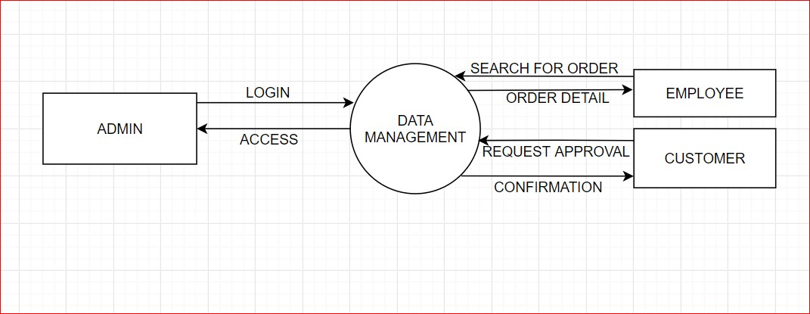

Documents

USER

# Level 1 Diagram :

* Shows all the processes that comprise a single process on the level 0 diagram.
* Shows how information moves from and to each of these processes.
* Shows in more detail the content of higher level process.
* Level 1 diagrams may not be needed for all level 0 processes.

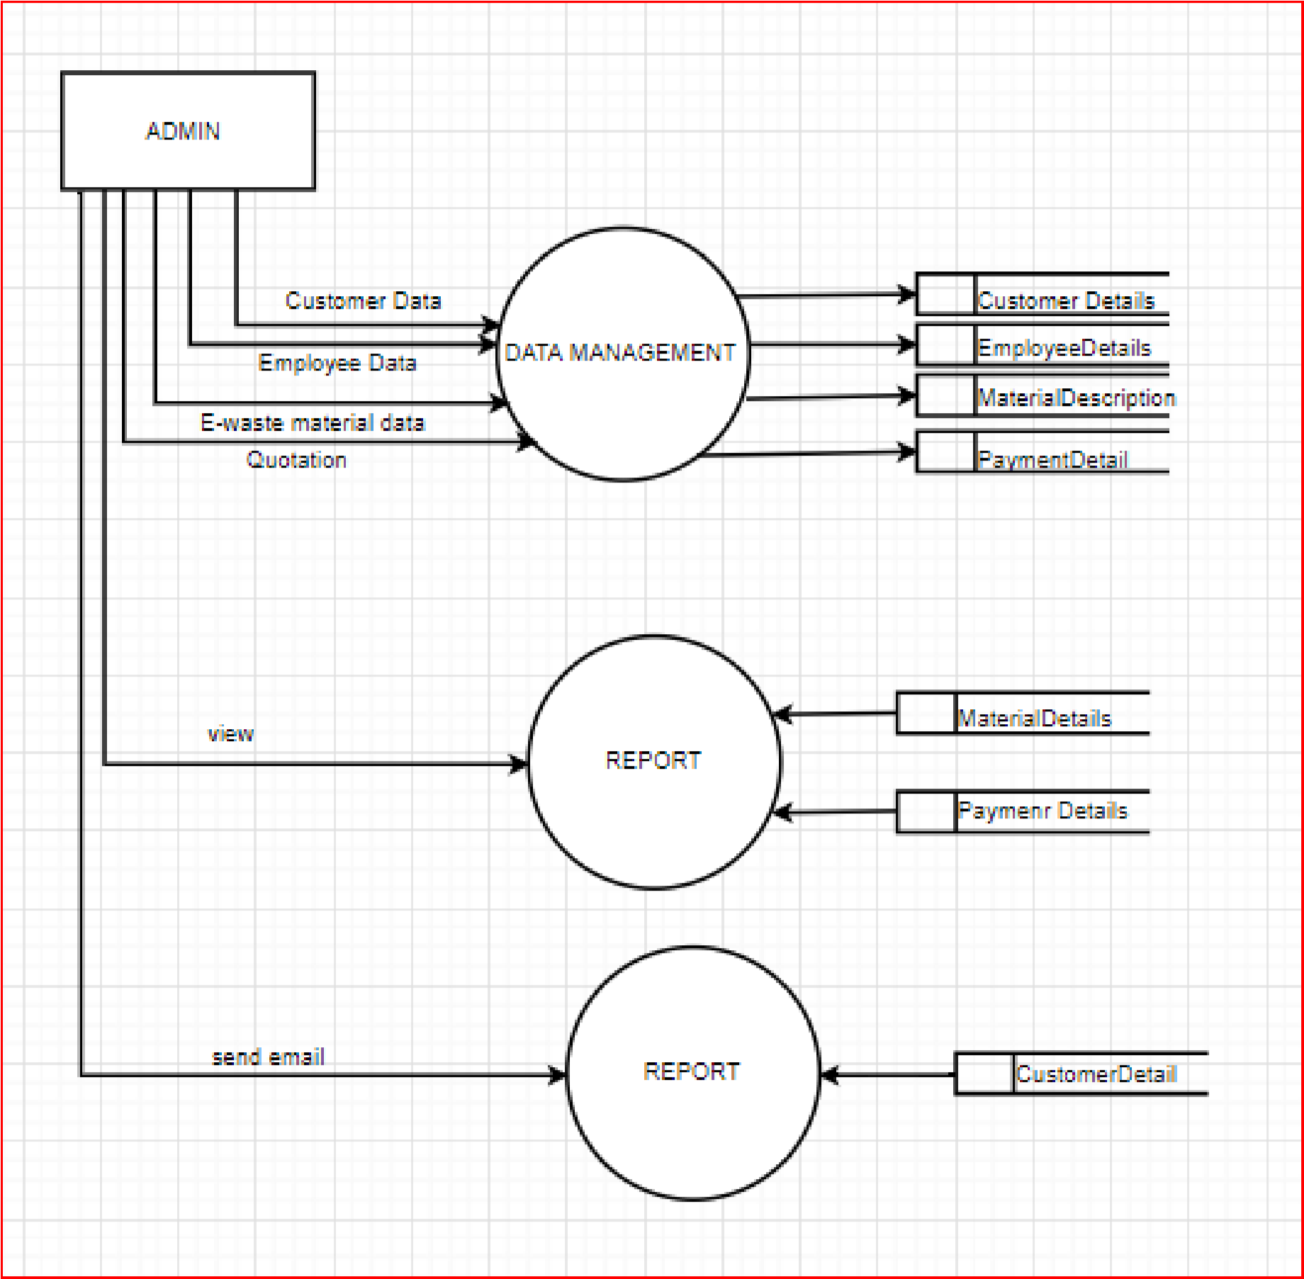

Documents data

dsdd

### 3.6.2 ER DIAGRAM :-

An Entity Relationship (ER) Diagram is a type of flowchart that illustrates how “entities” such as people, objects or concepts relate to each other within a system. ER Diagrams are most often used to design or debug relational databases in the fields of software engineering, business information systems, education and research. Also known as ERDs or ER Models, they use a defined set of symbols such as rectangles, diamonds, ovals and connecting lines to depict the interconnectedness of entities, relationships and their attributes. They mirror grammatical structure, with entities as nouns and relationships as verbs.

ER diagrams are related to data structure diagrams (DSDs), which focus on the relationships of elements within entities instead of relationships between entities themselves. ER diagrams also are often used in conjunction with data flow diagrams (DFDs), which map out the flow of information for processes or systems.

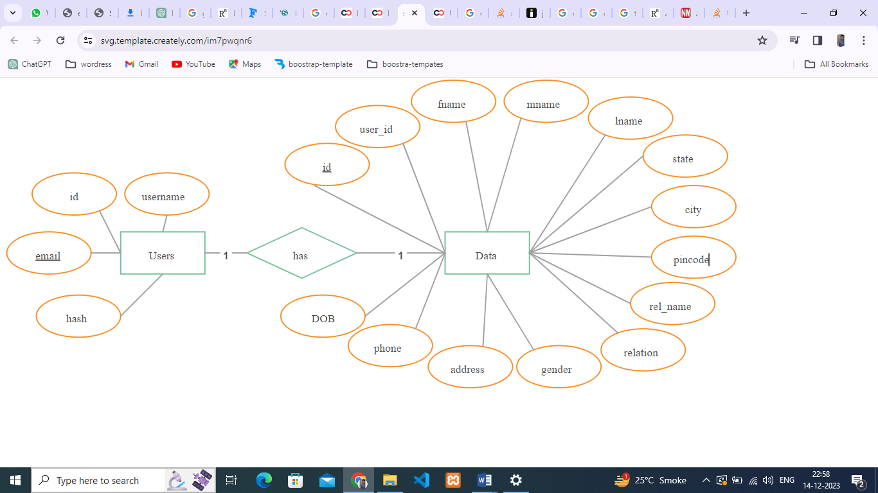

### 3.6.3 CLASS DIAGRAM :-

Class diagram is a static diagram. It represents the static view of an application. Class diagram is not only used for visualizing, describing, and documenting different aspects of a system but also for constructing executable code of the software application.

Class diagram describes the attributes and operations of a class and also the constraints imposed on the system. The purpose of class diagram is to model the static view of an application.

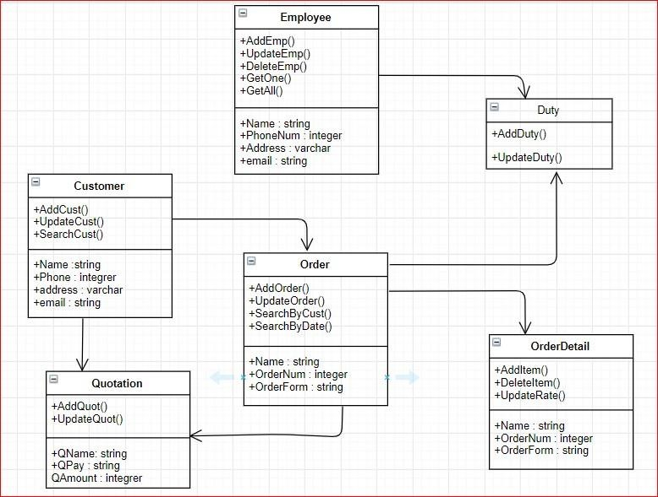

Documents Types

Documents

+AddDoc()

+UpdateDoc()

+DeleteEmp()

+GetOne()

### 3.6.4 GANTT CHART :-

Gantt charts illustrate the start and finish dates of the terminal elements and summary elements of a project. Terminal elements and summary elements comprise the work breakdown structure of the project. Modern Gantt charts also show the dependency (i.e., precedence network) relationships between activities.

* Gantt charts can be used to show current schedule status using percent- complete shadings and a vertical "TODAY" line.

* Although now regarded as a common charting technique, Gantt charts were considered revolutionary when first introduced. This chart is also used in information technology to represent data that have been collected.

* Gantt charts can be used for scheduling generic resources as well as for their use in project management. They can also be used for scheduling adoption processes and employee rostering.

15

/Jul

04

/Aug

24

/Aug

13

/Sep

03

/Oct

23

/Oct

12

/Nov

Documentation

requirment

gathering

Analysis

Design

start date

duration

### 3.6.5 PERT CHART :-

A PERT chart is a project management tool used to schedule, organize, and coordinate tasks within a project. PERT stands for *Program Evaluation Review Technique*, a methodology developed by the U.S. Navy in the 1950s to manage the Polaris submarine missile program. A similar methodology, the *Critical Path Method* (CPM) was developed for project management in the private sector at about the same time.

The PERT chart is sometimes preferred over the [Gantt chart,](https://searchsoftwarequality.techtarget.com/definition/Gantt-chart) another popular project management charting method, because it clearly illustrates task dependencies. On the other hand, the PERT chart can be much more difficult to interpret, especially on complex projects. Frequently, project managers use both techniques.

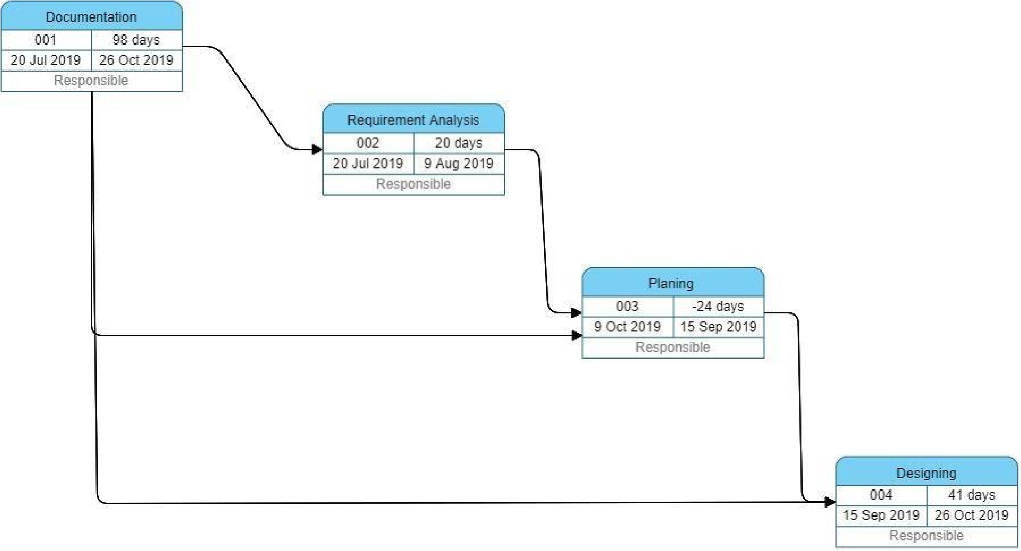

**CHAPTER 4**

**SYSTEM DESIGN**

## 4.1 BASIC MODULE:-

## LOGIN:

A login generally required the user to enter two pieces of information, first a user name and then a password. This information is enter into a login window on a GUI(Graphical User Interface) or on the command line in a console depending on the system.

A user name, also referred to as an account name, is string(i.e. sequence of characters) that uniquely identifies a user. User name can be same as or related to real names of user, or they can be completely arbitrary. A password is likewise a string, but it differs from a user in that it is intended to be kept a secret that is known only to its user and, perhaps to the system administrator.

# ADMIN LOGIN:

Admin page has following module like Change password, View Documents, view detail of new registered user, View order and Approve. Admin can view the order which are put up for collection. Admin can see total number of new users who has registered to his/her website. Admin can see all the order details. Admin can see total number of orders which are completed or pending. He can view all the detail of the user or customer.

# USER LOGIN:

A login, logging in or logging on is the entering of the identifier information into a system by a user in order to access that system ( computer or website).

# NEW USER:

This module is for the users who do not have their account. Here user is allowed to create an account to login. The account creation is done by filling the registration form with user details such as name, phone, email, address etc.

## 4.2 DATA DESIGN:-

Database design is the organization of data according to a database model. The designer determine what data must be stored and how the data elements interrelate. With this information they can being to fit the data to the database model. Database design involves classifying data and identifying interrelationship.

### 4.2.1 SCHEMA DESIGN :-

The **database schema** of a database system is its structure described in a [formal language s](https://en.wikipedia.org/wiki/Formal_language)upported by the [database management system (](https://en.wikipedia.org/wiki/Database_management_system)DBMS). The term "[schema"](https://en.wiktionary.org/wiki/schema) refers to the organization of data as a blueprint of how the database is constructed (divided into database tables in the case of [relational databases)](https://en.wikipedia.org/wiki/Relational_databases). The formal definition of a [database s](https://en.wikipedia.org/wiki/Database)chema is a set of formulas (sentences) called integrity constraints [i](https://en.wikipedia.org/wiki/Integrity_constraints)mposed on a database. These integrity constraints ensure compatibility between parts of the schema. All constraints are expressible in the same language. A database can be considered a structure in realization of the [database language.](https://en.wikipedia.org/wiki/Database_language) The states of a created [conceptual schema a](https://en.wikipedia.org/wiki/Conceptual_schema)re transformed into an [explicit mapping,](https://en.wikipedia.org/wiki/Explicit_and_implicit_methods) the database schema. This describes how real-world entities are modeled in the database.

"A database schema specifies, based on the database administrator['s](https://en.wikipedia.org/wiki/Database_administrator) knowledge of possible applications, the facts that can enter the database, or those of interest to the possible [end-users.](https://en.wikipedia.org/wiki/End-user)" The notion of a database schema plays the same role as the notion of theory in [predicate calculus.](https://en.wikipedia.org/wiki/Predicate_calculus) A model of this "theory" closely corresponds to a database, which can be seen at any instant of time as a [mathematical object.](https://en.wikipedia.org/wiki/Mathematical_object) Thus a schema can contain formulas representing [integrity constraints s](https://en.wikipedia.org/wiki/Data_integrity#Types_of_integrity_constraints)pecifically for an application and the constraints specifically for a type of database, all expressed in the same database language. In a [relational database,](https://en.wikipedia.org/wiki/Relational_database) the schema defines the [tables,](https://en.wikipedia.org/wiki/Table_(database)) [fields,](https://en.wikipedia.org/wiki/Field_(computer_science)) [relationships,](https://en.wikipedia.org/wiki/Relational_model) [views,](https://en.wikipedia.org/wiki/View_(database)) [indexes,](https://en.wikipedia.org/wiki/Index_(database)) [packages,](https://en.wikipedia.org/wiki/Software_package_(installation)) [procedures,](https://en.wikipedia.org/wiki/Stored_procedure) [functions,](https://en.wikipedia.org/wiki/Subroutine) [queues,](https://en.wikipedia.org/wiki/Queue_(data_structure)) [triggers,](https://en.wikipedia.org/wiki/Database_trigger) [types,](https://en.wikipedia.org/wiki/Data_type) [sequences,](https://en.wikipedia.org/wiki/Sequence) materialized view[s,](https://en.wikipedia.org/wiki/Materialized_view) [synonyms,](https://en.wikipedia.org/wiki/Synonym_(database)) database links, [directories,](https://en.wikipedia.org/wiki/Directory_(file_systems)) [XML schemas,](https://en.wikipedia.org/wiki/XML_schema) and other elements.

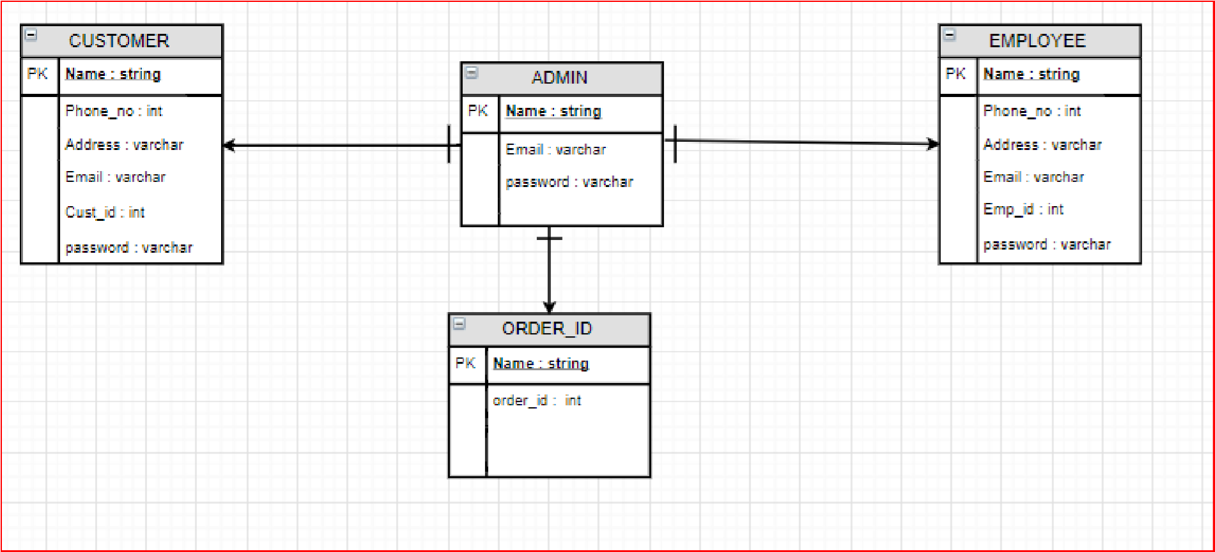

user

### 4.2.2 DATA INTEGRITY & CONSTRAINTS :

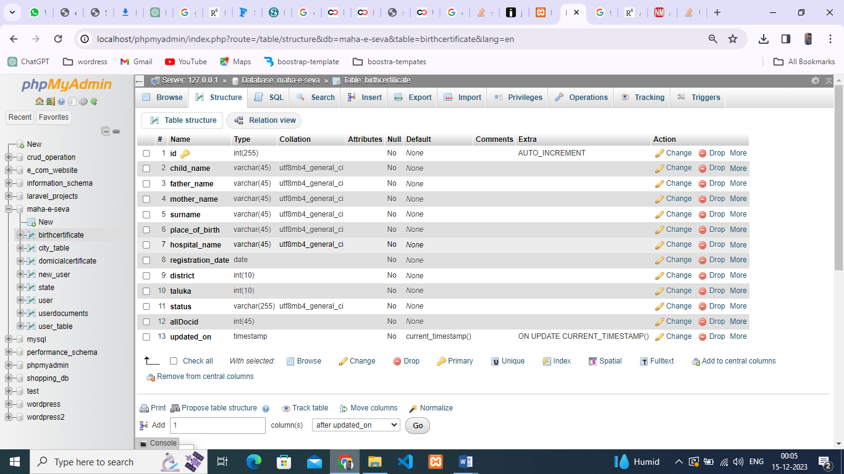

* User Table :

|  |  |  |
| --- | --- | --- |
| Column name | Data type | Constraints |
| User_id | Int | Unique, primary key |
| Name | Varchar | Not null |
| Contactc_no | Int | Not null |
| Address | Varchar | Not null |
| Email | Varchar | Not null |
| Username | Varchar | Not null |
| Password | Varchar | Not null |

* Admin Table:

|  |  |  |
| --- | --- | --- |
| Column name | Data type | Constraints |
| Admin_name | varchar | not null |
| admin_pass | string | not null |
| Contact_no | int | not null |

* Employee Table:

|  |  |  |
| --- | --- | --- |
| Column name | Data type | Constraints |
| email | string | not null |
| user_id | int | unique, Primary key |
| user_name | varchar(40) | not null |

* Request:

|  |  |  |
| --- | --- | --- |
| Column name | Data type | Constraints |
| req_id | Int | Unique, primary key |
| applied_date | Int | Not null |
| doc_type | Varchar | Not null |
| status | Varchar | Not null |

## 4.2 PROCEDURAL DESIGN :-

Component level design also called procedural design occurs after data, architectural and interface designs have been established.

Data, architectural and interface design must be translated into operational software. To accomplish this design must be represented at a level of abstraction that is close to code.

Component-level design establishes:-

* The algorithmic detail required to manipulate data structures.
* Effect communication between software components via their interfaces, and • Implement the processing algorithms allocated to each components.

### 4.2.1 LOGICAL DIAGRAMS :-

### CONTROL FLOW CHART:

A control-flow diagram can consist of a subdivision to show sequential steps, with if-then-else conditions, repetition, and/or case conditions. Suitably annotated geometrical figures are used to represent operations, data, or equipment, and arrows are used to indicate the sequential flow from one to another.

There are several types of control-flow diagrams, for example:

* Change-control-flow diagram, used in [project management](https://en.wikipedia.org/wiki/Project_management)
* Configuration-decision control-flow diagram, used in [configuration management](https://en.wikipedia.org/wiki/Configuration_management)
* [Process-control-](https://en.wikipedia.org/wiki/Process_control)flow diagram, used in [process management](https://en.wikipedia.org/wiki/Process_management) • Quality-control-flow diagram, used in [quality control.](https://en.wikipedia.org/wiki/Quality_control)

In software and systems development, control-flow diagrams can be used in [control-flow analysis,](https://en.wikipedia.org/wiki/Control-flow_analysis) [data-flow analysis,](https://en.wikipedia.org/wiki/Data-flow_analysis) [algorithm analysis,](https://en.wikipedia.org/wiki/Algorithm_analysis) and [simulation.](https://en.wikipedia.org/wiki/Simulation)

Control and data are most applicable for real time and data-driven systems. These flow analyses transform logic and data requirements text into graphic flows which are easier to analyze than the text. PERT, state transition, and transaction diagrams are examples of control-flow diagrams

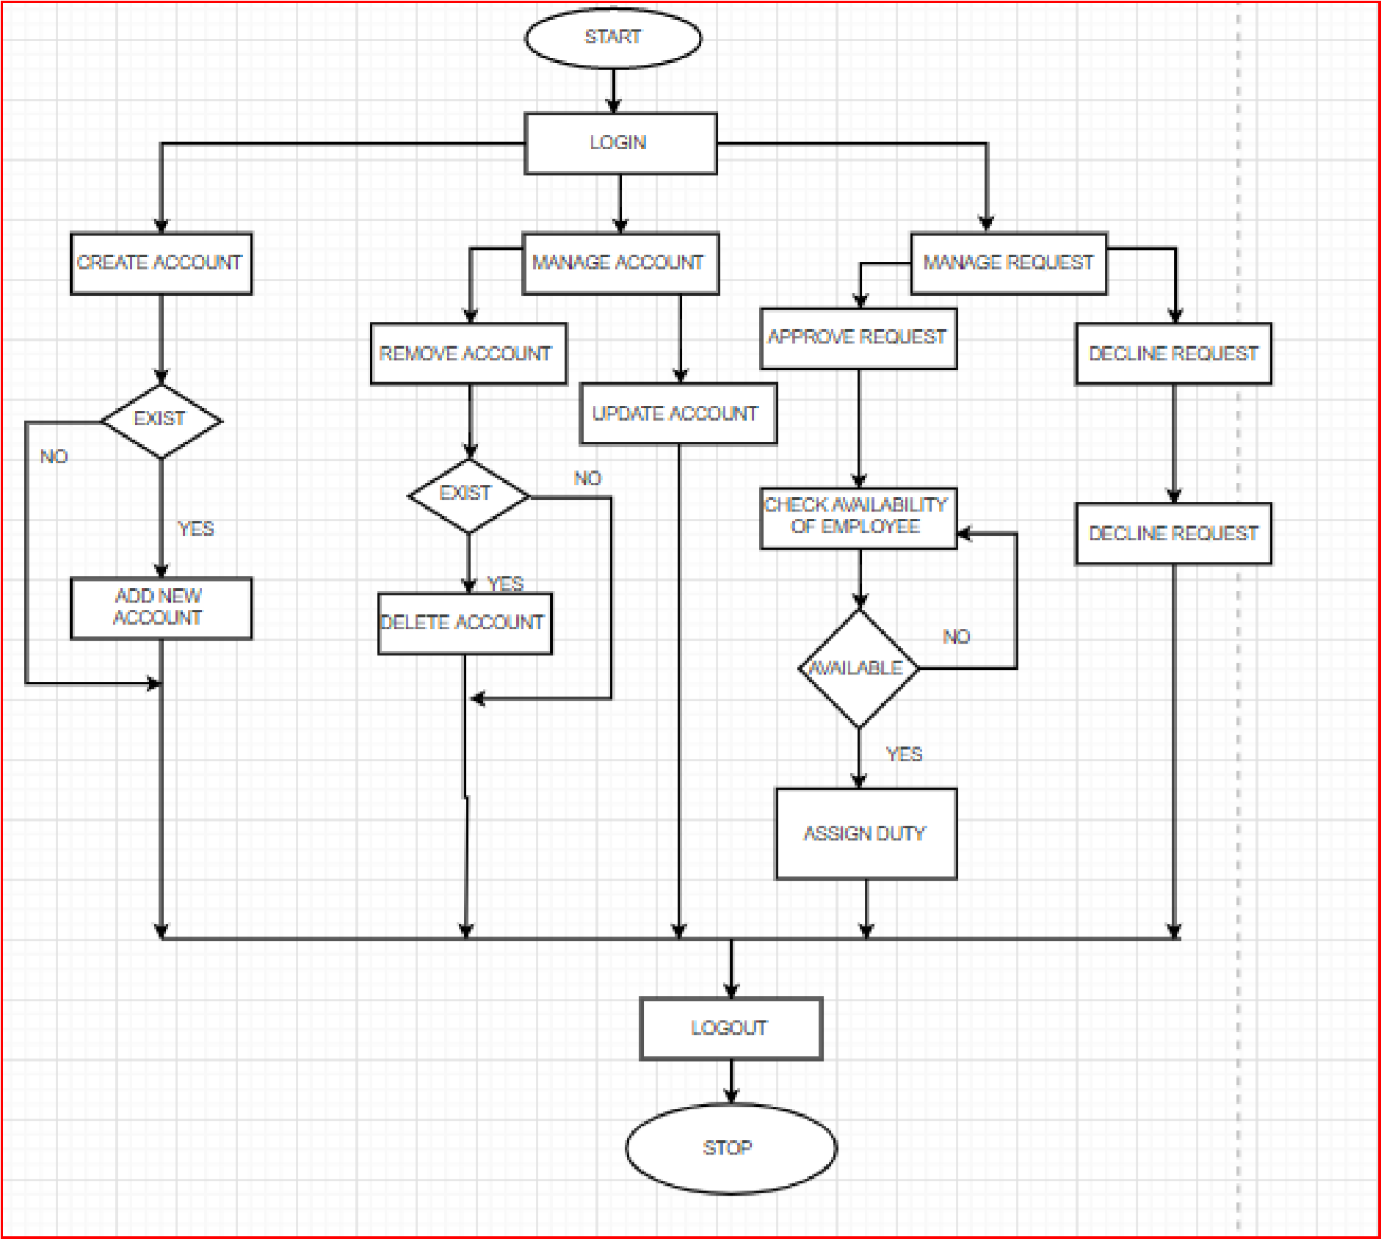

# ALGORITHM:

STEP 1 : Start.

STEP 2 : Login.

STEP 3 : If admin wants to create account click on Create Account.

STEP 4 : If account is existed press YES if not press NO and click on Add new account.

STEP 5 : If admin want to manage account click on Manage account. In manage account admin can update or delete account.

STEP 6 : If admin want to remove account press YES and click on delete account and if not press NO.

STEP 7 : If admin want to update press on update account.

STEP 8 : If admin want to manage quotation click on Manage Quotation.

STEP 9 : If quotation or payment is done admin can remove it press YES and if not press NO.

STEP 10 : Logout.

STEP 11 : Stop.

# ACTIVITY DIAGRAM:

Activity diagram is another important diagram in UML to describe the dynamic aspects of the system. Activity diagram is basically a flowchart to represent the flow from one activity to another activity. The activity can be described as an operation of the system. The control flow is drawn from one operation to another. This flow can be sequential, branched, or concurrent. Activity diagrams deal with all type of flow control by using different elements such as fork, join, etc. The basic purposes of activity diagrams is similar to other four diagrams. It captures the dynamic behavior of the system. Other four diagrams are used to show the message flow from one object to another but activity diagram is used to show message flow from one activity to another.

Activity is a particular operation of the system. Activity diagrams are not only used for visualizing the dynamic nature of a system, but they are also used to construct the executable system by using forward and reverse engineering techniques. The only missing thing in the activity diagram is the message part.

It does not show any message flow from one activity to another. Activity diagram is sometimes considered as the flowchart. Although the diagrams look like a flowchart, they are not. It shows different flows such as parallel, branched, concurrent, and single.

The purpose of an activity diagram can be described as − • Draw the activity flow of a system.

• Describe the sequence from one activity to another.

• Describe the parallel, branched and concurrent flow of the system.

# 1. MANAGE USERS:

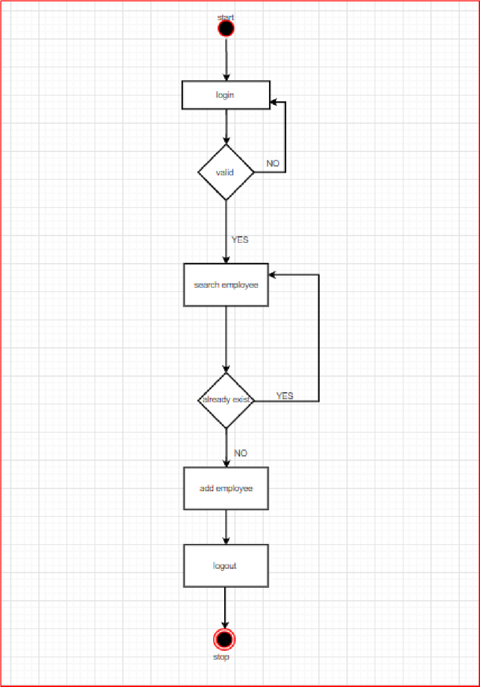

# SEQUENCE DIAGRAM:

A **sequence diagram** is defined by the **UML** Reference **Manual** as “a **diagram** that shows object interactions arranged in time **sequence**. In particular, it shows the objects participating in an interaction and the **sequence** of messages exchanged” . It represents objects as vertical lines and messages as arrows with labels.

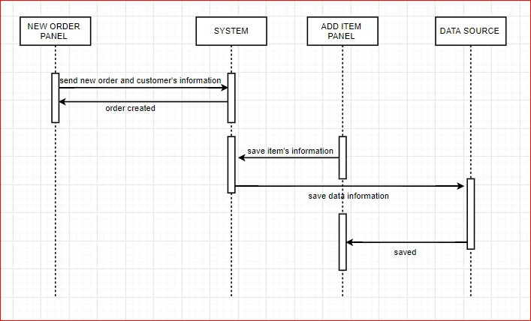

# USE CASE DIAGRAM:

A use case is a software and system engineering term that describes how a user uses a system to accomplish a particular goal. A use case acts as a software modelling technique that defines the features to be implemented and the resolution of any errors that may be encountered.

Three basic elements make up a use case:

* **Actors:** Actors are the type of users that interact with the system.

* **System:** Use cases capture functional requirements that specify the intended behaviour of the system.

* **Goals:** Use cases are typically initiated by a user to fulfil goals describing the activities and variants involved in attaining the goal.

The steps in designing use cases are:

* Identify the users of the system.
* For each category of users, create a user profile. This includes all roles played by the users relevant to the system.
* Identify significant goals associated with each role to support the system. The system’s value proposition identifies the significant role.
* Create use cases for every goal associated with a use case template and maintain the same abstraction level throughout the use case. Higher level use case steps are treated as goals for the lower level.
* Structure the use cases.
* Review and validate the users.

**1. ADMIN:**

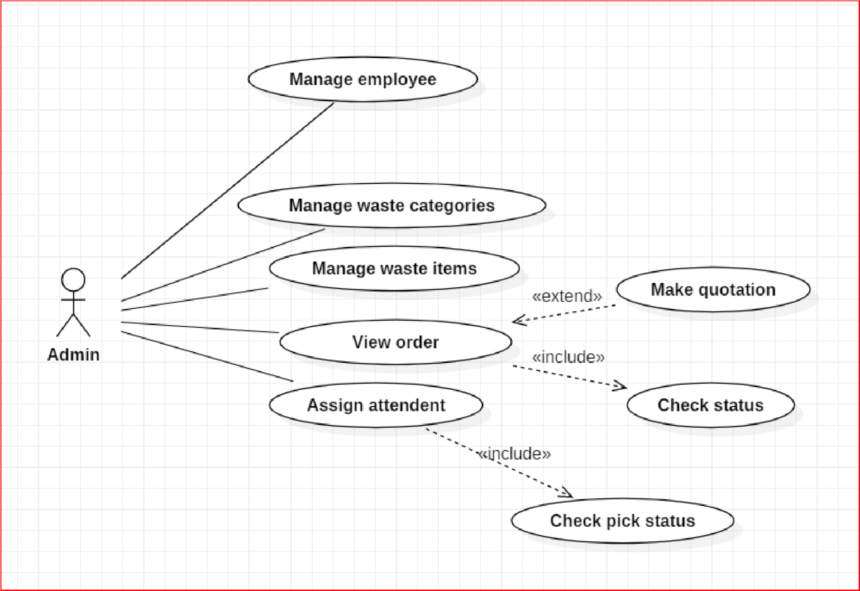

### 4.2.2 DATA STRUCTURES :- TREE DIAGRAM:

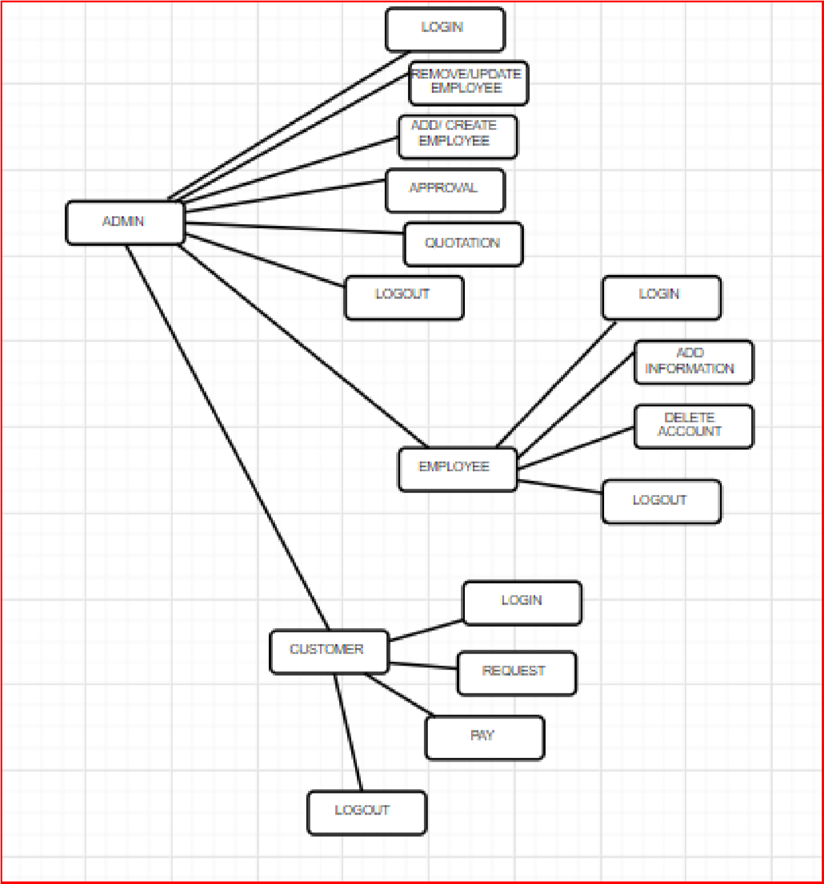

### 4.2.3 ALGORITHM DESIGN :-

# USER LOGIN:-

1. User visit the website.
2. User logins the website.
3. Enter username and password.
4. User clicks on login.

# NEW USER REGISTRATION:-

1. If user don’t have Login ID and Password then customer create a new account.
2. Enter the following details in Register form:-
   * Username
   * Password
   * Email ID
   * Address
   * Contact Number
3. After the filling details click on Register.
4. After registration user gets mail of registration.

# ADMIN LOGIN:-

1. Admin go to website of MAHA-E_SEVA KENDRA.
2. Go to login page.
3. Enter Username and Password.
4. Click on Login button.
5. After login admin going to the home page.

## 4.3 USER INTERFACE DESIGN :-

# ADMIN LOGIN:

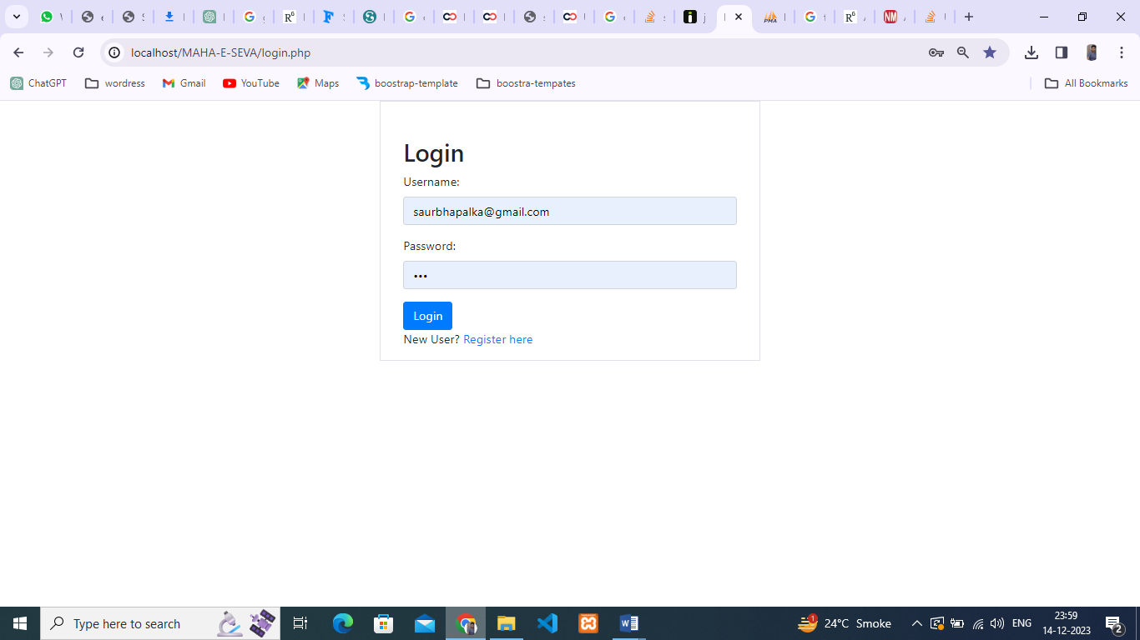

# USER LOGIN:



# NEW USER REGISTRATION:

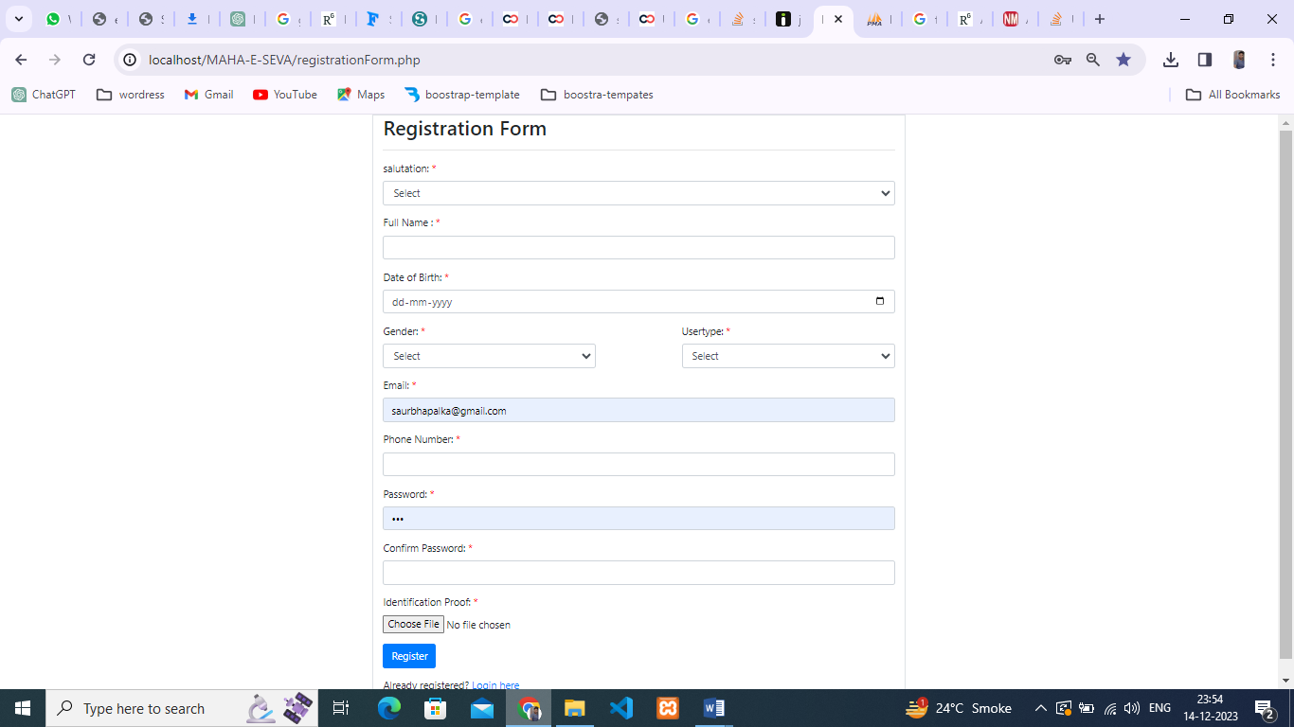

# DASHBOARD:

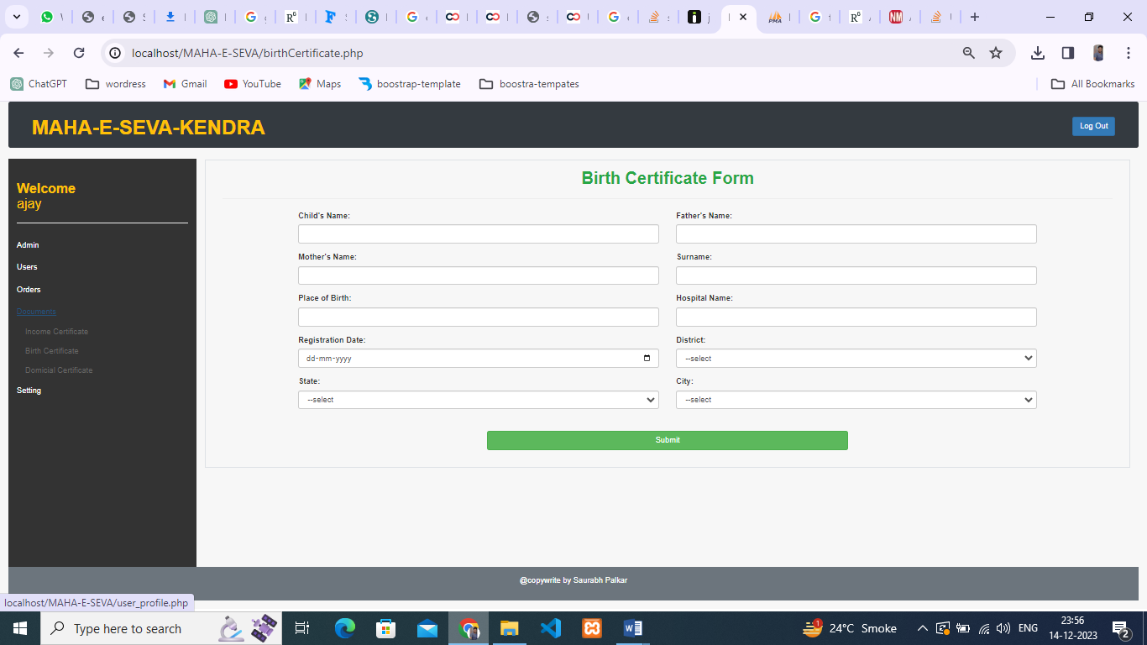

## 4.4 SECURITY ISSUES :-

## AUTHENTICATION :-

Authentication is the process of determining whether someone or something is in fact who or what it declares itself to be Authentication technology provides access control for systems by checking to see if users credentials match the credentials in a database of authorized users or in a data authentication server.

Users are usually identified with a user ID and authentication is accomplished when the user provides a credential for example a password that matches with that user ID. Most of the users are most familiar with using a password which ,as a piece of information that should be known only to the user is called a knowledge authentication factor.

The payment gateway is a valuable tool necessary to credit card processing for every online business. These gateways are designed to facilitate hundreds or thousands of transactions per day. If you notice an issue with your payment gateway contact your acquiring bank in a timely manner.

## 4.5 TEST CASES DESIGN :- LOGIN PAGE TEST CASE :

|  |  |  |
| --- | --- | --- |
| **Test case ID** | **Test case** | **Excepted results** |
| TC1 | Test if registered user is able to login successfully. | User must be logged in to the web page. |
| TC2 | Test if unregistered users is not able to login to the site. | Proper error must be displayed and prompt enter login again. |
| TC3 | Test with valid username and empty password such that login must get failed. | Proper error message must be displayed and prompt to enter login again. |
| TC4 | Test with empty username and empty password and check if login fails. | Proper error message must be displayed and prompt to enter login again. |

|  |  |  |
| --- | --- | --- |
| TC5 | Check of the password is masked on the screen i.e., password must be in bullets or asterisks. | The password field should display the characters in asterisks or bullets such that the password is not visible on the screen. |

# VALIDATION TEST CASE:

|  |  |  |
| --- | --- | --- |
| **Test case Id** | **Test case** | **Expected Result** |
| TC1 | Enter empty value for a e-waste textbox and click the add button | When the field is empty an appropriate validation  message will be displayed -” Please enter correct document details to add” |
| TC2 | Enter empty value for maha-e-seva kendr description or no photo uploaded and click the add button | When the field is empty an appropriate validation message will be displayed -” Please enter description details and an image of your  document to add” |
| TC3 | Click any delete/update button of a grid view. | A pop-up box should appear to show the message” deleted/updated a row from the grid view successfully. |