Saurabh Kumar

Blinkit Analysis

* See all the data imported

SELECT * FROM blinkit_data

After uploading the data check the uploaded data is correctly uploaded by running this quesry match the columns are numbers are same as the uploaded files

SELECT COUNT (*) FROM blinkit_data



* DATA CLEANING

Cleaning the Item_Fat_Content field ensures data consistency and accuracy in analysis. The presence of multiple variations of the same category (e.g., LF, low fat vs. Low Fat) can cause issues in reporting, aggregating and filtering. By standardizing these values we improve data quality making it easier to generate insights and maintain uniformity in our datasets.

UPDATE blinkit_data

SET Item_Fat_Content =

CASE

WHEN Item_Fat_Content IN ('LF', 'low fat') THEN 'Low Fat'

WHEN Item_Fat_Content = 'reg' THEN 'Regular'

ELSE Item_Fat_Content

END;

After executing this query check the data has been cleaned or not using below query

SELECT DISTINCT Item_Fat_Content FROM blinkit_data;



* COUNTING THE DATA

To particularly get the no of items each category has we can count query with conditions like if we need total number of items in Low fat or of rating 5 we can run query

SELECT COUNT(*) AS No_Of_Items_In_Low_Fat FROM blinkit_data

WHERE Item_Fat_Content = 'Low Fat'



SELECT COUNT(*) AS No_Of_Items_of_5_Rating FROM blinkit_data

WHERE Rating = 5



* TOTAL SALES

To calculate the total sales we run this query to get the data in millions

SELECT CONCAT(CAST(SUM(Sales)/1000000 AS DECIMAL(10,2)), ' Millions') AS Total_Sales_in_Millions

FROM blinkit_data



To get the data for Items_Fat_Content Category wise data we can run these query

SELECT CONCAT(CAST(SUM(Sales)/1000000 AS DECIMAL(10,2)), ' Millions') AS Total_Sales_in_Millions

FROM blinkit_data

WHERE Item_Fat_Content = 'Low Fat'



SELECT CONCAT(CAST(SUM(Sales)/1000000 AS DECIMAL(10,2)), ' Millions') AS Total_Sales_in_Millions

FROM blinkit_data

WHERE Item_Fat_Content = 'Regular'



Also if we need sales data for Oultlet_Establishment_Year we can run query

SELECT CONCAT(CAST(SUM(Sales)/1000000 AS DECIMAL(10,2)), ' Millions') AS Total_Sales_in_Millions

FROM blinkit_data

WHERE Outlet_Establishment_Year = 2017

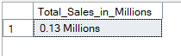

* Average Sales

Similarly for average sales

SELECT CAST(AVG(Sales) AS DECIMAL(10,1)) AS Average_Sales

FROM blinkit_data



If we need average sales for peerticular category or particular Establishment we can run similar query as sales by just changing the SUM to AVG also we need to remove the million’s part because average sales is a very small number that we can read easily

* Average Rating

SELECT CAST(AVG(Rating) AS DECIMAL(10,1)) AS Average_Rating

FROM blinkit_data

Instead of getting all these data separately we can run query at one places to get all data at one place for better insights and visualization

SELECT Item_Fat_Content,

CONCAT(CAST(SUM(Sales)/1000000 AS DECIMAL(10,2)), ' Millions') AS Total_sales,

CAST(AVG(Sales) AS DECIMAL(10,1)) AS Avg_Sales,

COUNT (*) AS No_Of_Items,

CAST(AVG(Rating) AS DECIMAL(10,2)) AS Avg_Rating

FROM blinkit_data

WHERE Outlet_Establishment_Year = 2020

GROUP BY Item_Fat_Content

ORDER BY Total_sales DESC

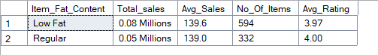

* Total Sales by Item types

SELECT Item_Type,

CONCAT(CAST(SUM(Sales) AS DECIMAL(10,2)), ' Millions') AS Total_sales,

CAST(AVG(Sales) AS DECIMAL(10,1)) AS Avg_Sales,

COUNT (*) AS No_Of_Items,

CAST(AVG(Rating) AS DECIMAL(10,2)) AS Avg_Rating

FROM blinkit_data

GROUP BY Item_Type

ORDER BY Total_sales DESC

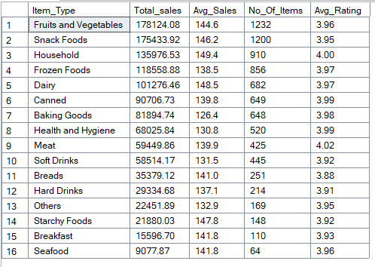

If we want data of best 5 Sold items we can run query

SELECT TOP 5 Item_Type,

CONCAT(CAST(SUM(Sales) AS DECIMAL(10,2)), ' Millions') AS Total_sales,

CAST(AVG(Sales) AS DECIMAL(10,1)) AS Avg_Sales,

COUNT (*) AS No_Of_Items,

CAST(AVG(Rating) AS DECIMAL(10,2)) AS Avg_Rating

FROM blinkit_data

GROUP BY Item_Type

ORDER BY Total_sales DESC

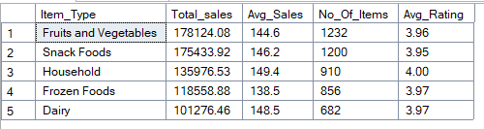

Similarly for bottom 5 we change DESC to ASC

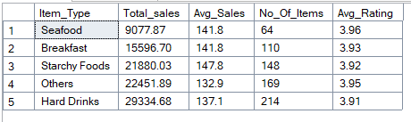

* Fat Content by Outlet for Total Sales

SELECT Outlet_Location_Type,

ISNULL([Low Fat], 0) AS Low_Fat,

ISNULL([Regular], 0) AS Regular

FROM

(

SELECT Outlet_Location_Type, Item_Fat_Content,

CAST(SUM(Sales) AS DECIMAL(10,2)) AS Total_Sales

FROM blinkit_data

GROUP BY Outlet_Location_Type, Item_Fat_Content

) AS SourceTable

PIVOT

(

SUM(Total_Sales)

FOR Item_Fat_Content IN ([Low Fat], [Regular])

) AS PivotTable

ORDER BY Outlet_Location_Type;

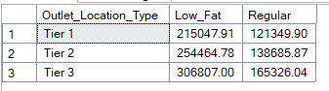

* Total Sales by Outlet Establishment Year

SELECT Outlet_Establishment_Year,

CAST(SUM(Sales) AS DECIMAL (10,2)) AS Total_sales

CAST(AVG(Sales) AS DECIMAL(10,1)) AS Avg_Sales,

COUNT(*) AS No_Of_Items,

CAST(AVG(Rating) AS DECIMAL(10,2)) AS Avg_Rating

FROM blinkit_data

GROUP BY Outlet_Establishment_Year

ORDER BY Outlet_Establishment_Year ASC

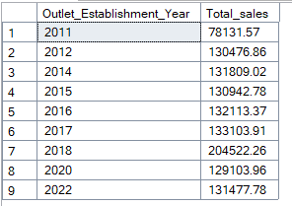

* Percentage of Sales by Outlet Size

SELECT Outlet_Size,

CAST(SUM(Sales) AS DECIMAL(10,2)) AS Total_Sales,

CAST((SUM(Sales)* 100.0 /SUM(SUM(Sales)) OVER ()) AS DECIMAL (10,2)) AS Sales_Percentage

FROM blinkit_data

GROUP BY Outlet_Size

ORDER BY Total_Sales DESC;

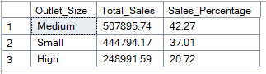

* Sales by Outlet Location :

SELECT Outlet_Location_Type,

CAST(SUM(Sales) AS DECIMAL (10,2)) AS Total_sales,

CAST((SUM(Sales)* 100.0 /SUM(SUM(Sales)) OVER ()) AS DECIMAL (10,2)) AS Sales_Percentage

CAST(AVG(Sales) AS DECIMAL(10,1)) AS Avg_Sales,

COUNT(*) AS No_Of_Items,

CAST(AVG(Rating) AS DECIMAL(10,2)) AS Avg_Rating

FROM blinkit_data

GROUP BY Outlet_Location_Type

ORDER BY Total_Sales DESC;

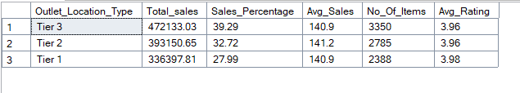

* ALL Metrics by Outlet Type:

SELECT Outlet_Type,

CAST(SUM(Sales) AS DECIMAL (10,2)) AS Total_sales,

CAST((SUM(Sales)* 100.0 /SUM(SUM(Sales)) OVER ()) AS DECIMAL (10,2)) AS Sales_Percentage

CAST(AVG(Sales) AS DECIMAL(10,1)) AS Avg_Sales,

COUNT(*) AS No_Of_Items,

CAST(AVG(Rating) AS DECIMAL(10,2)) AS Avg_Rating

FROM blinkit_data

GROUP BY Outlet_Type

ORDER BY Total_Sales DESC;

