Defect Report Analysis

Project Information
Project Name: Banking Automation Framework
Application Under Test: Guru99 Banking Application
Testing Type: Functional Testing
Automation Tool: Selenium WebDriver
Framework: TestNG, Maven, Page Object Model (POM)
Reporting Tool: Extent Reports
CI/CD Tool: Jenkins
Containerization: Docker
Tester: Saurabh Kumar
Test Environment:
- Browser: Google Chrome 149
- Operating System: Windows 11
- Java Version: 21
- Build Tool: Maven

Executive Summary
During the execution of functional and validation test scenarios on the Guru99 Banking Application, multiple defects were identified across customer registration, authentication, and transaction modules. The defects primarily relate to inadequate input validation, improper business rule enforcement, inconsistent transaction processing, and server-side exception handling.
A total of 6 defects were identified and documented. These defects vary in severity from Minor to Critical and affect both application reliability and data integrity.

Defect Statistics
Severity | Count
Critical | 1
Major | 4
Minor | 1
Total | 6

Priority | Count
High | 2
Medium | 4
Total | 6

Detailed Defect Analysis

BUG-001

Defect Title
Deposit page crashes after transaction submission and displays HTTP 500 Internal Server Error

Module
Deposit

Severity
Critical

Priority
High

Status
Open

Description
The Deposit functionality fails after submitting a valid deposit transaction. Instead of displaying a successful transaction confirmation page, the application crashes and redirects the user to an HTTP 500 Internal Server Error page.
This indicates an unhandled server-side exception occurring during deposit processing.

Preconditions
- User must be logged into the application.
- A valid customer account must exist.
- User must have access to the Deposit module.

Steps to Reproduce
- Login using valid credentials.
- Navigate to Deposit page.
- Enter a valid Account Number.
- Enter a valid Deposit Amount.
- Enter Transaction Description.
- Click Submit.

Expected Result
The deposit transaction should be completed successfully and a confirmation page should display transaction details.

Actual Result
Application crashes and displays HTTP 500 Internal Server Error.

Business Impact
- Core banking functionality becomes unusable.
- Customers cannot deposit funds.
- Potential loss of business transactions.
- Significant impact on customer trust.

Frequency
100% Reproducible

Recommendation
Investigate server logs and implement exception handling for deposit transactions.

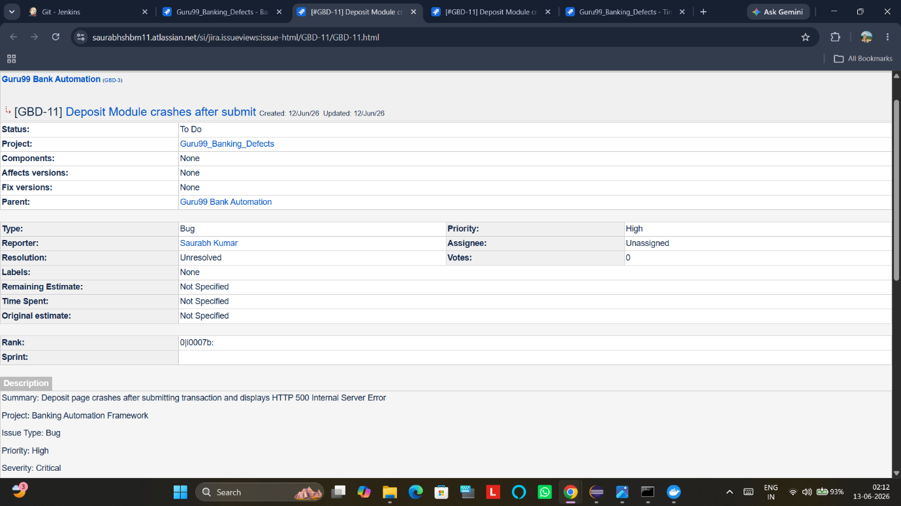



BUG-002

Defect Title
Password field accepts weak passwords below minimum length requirement

Module
Customer Registration

Severity
Major

Priority
Medium

Status
Open

Description
The Password field accepts passwords that do not meet the minimum required password length. Weak passwords such as "123" or "abc" are accepted and customer creation proceeds successfully.
The application lacks adequate password strength validation.

Preconditions
- User must navigate to Customer Registration page.

Steps to Reproduce
- Open Customer Registration page.
- Fill all mandatory fields.
- Enter password "123".
- Submit the form.

Expected Result
Application should reject passwords that fail minimum length requirements and display a validation message.

Actual Result
Weak password is accepted and customer record is created successfully.

Business Impact
- Security vulnerability.
- Increased risk of account compromise.
- Non-compliance with password security standards.

Frequency
100% Reproducible

Recommendation
Implement minimum password length and complexity validation.

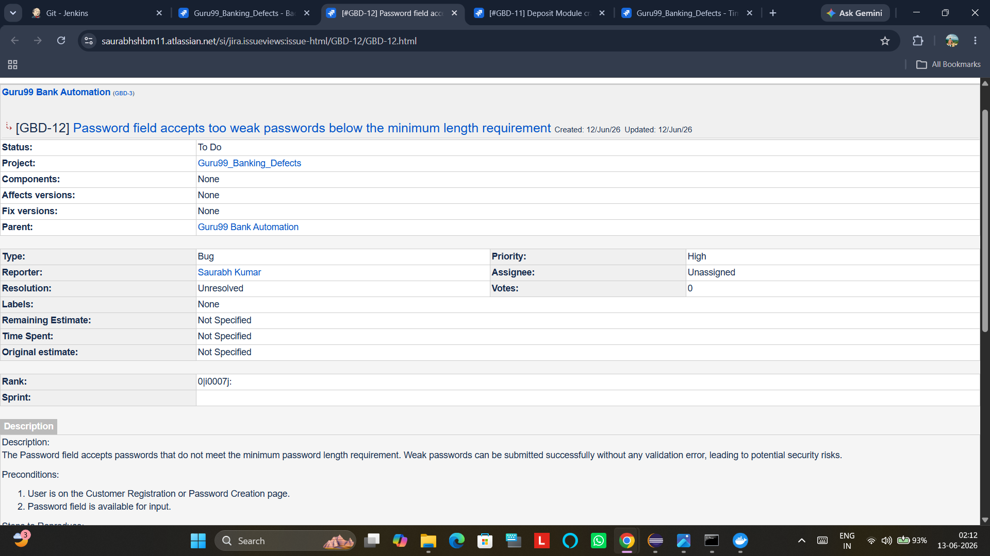

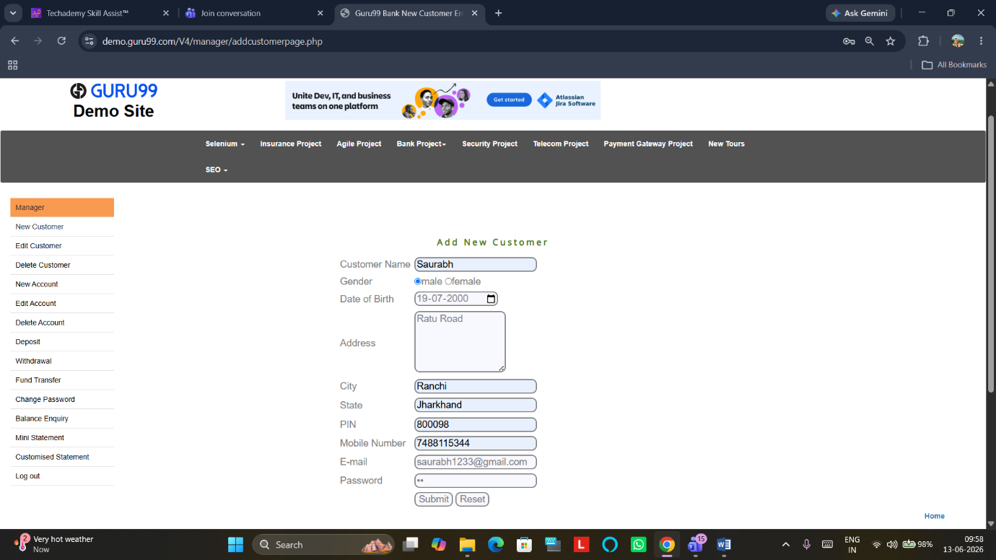

BUG-003

Defect Title
Customer Registration accepts invalid City and State combinations

Module
Customer Registration

Severity
Minor

Priority
Medium

Status
Open

Description
The application accepts any City and State combination without validation. Users can enter cities that do not belong to the specified state and customer creation proceeds successfully.

Preconditions
- User must be logged in.
- Customer Registration page must be accessible.

Steps to Reproduce
- Navigate to New Customer page.
- Enter City = Mumbai.
- Enter State = Bihar.
- Submit the form.

Expected Result
Application should validate City-State combinations and display an error message for invalid combinations.

Actual Result
Customer is created successfully despite invalid address information.

Business Impact
- Incorrect customer records.
- Reduced data quality.
- Reporting inaccuracies.

Frequency
100% Reproducible

Recommendation
Integrate geographical validation rules or reference datasets.

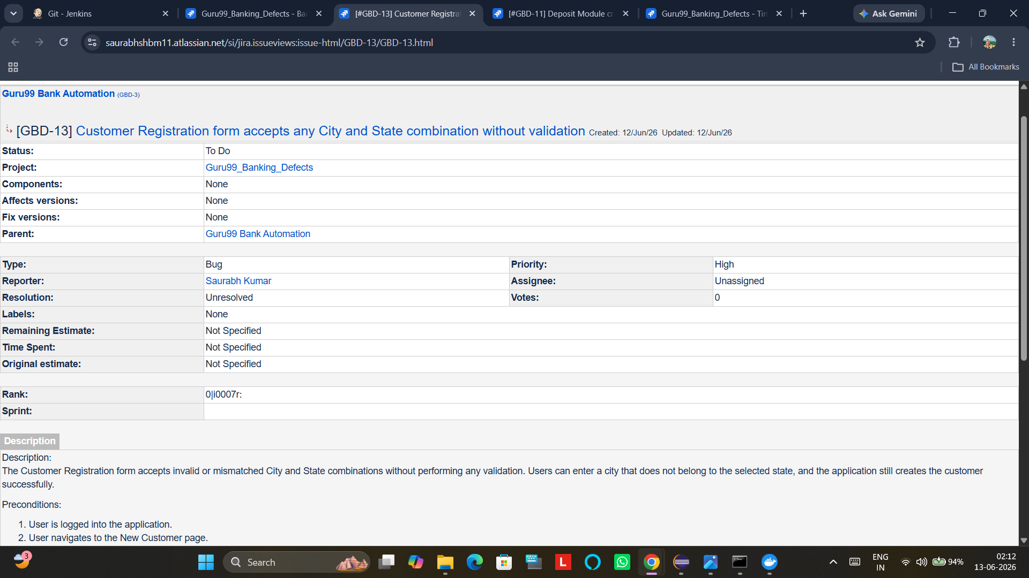
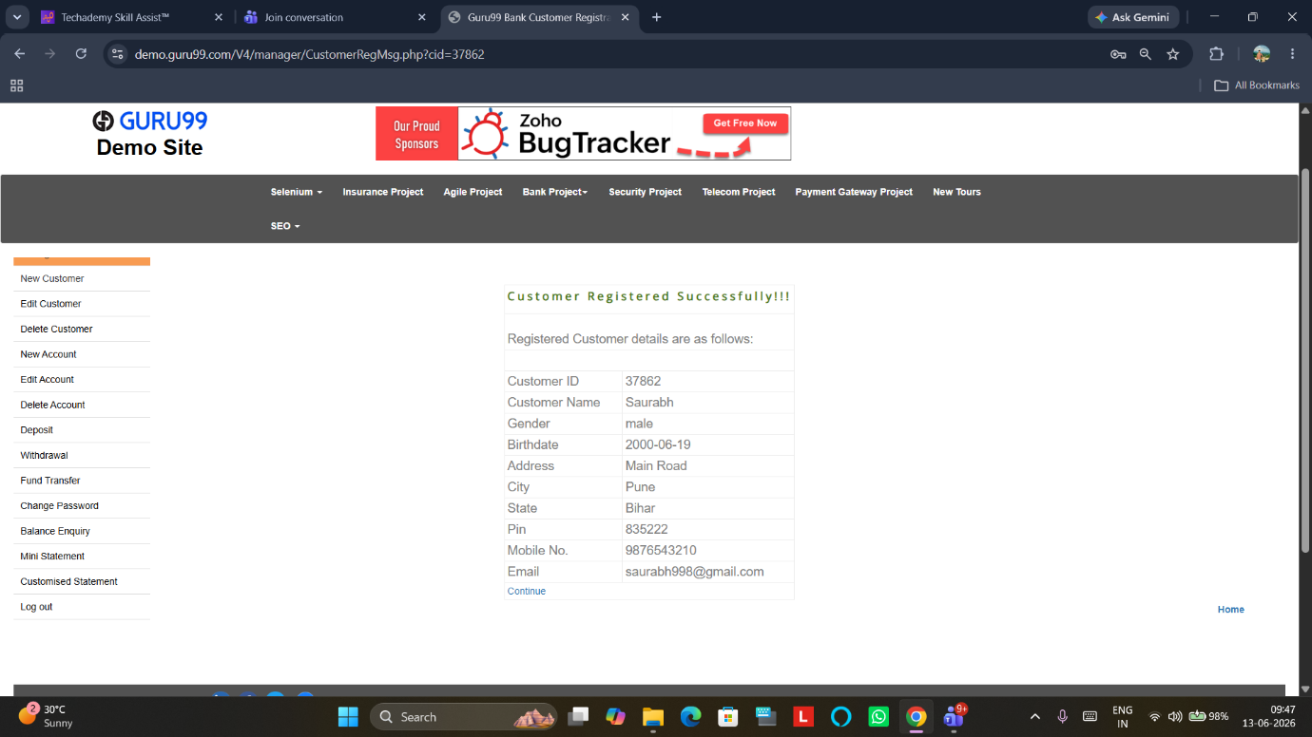

BUG-004

Defect Title
Date of Birth field accepts future dates

Module
Customer Registration

Severity
Major

Priority
Medium

Status
Open

Description
The Date of Birth field allows users to enter dates that occur in the future. The application successfully creates customer records using future dates, violating business logic.

Preconditions
- User must be logged in.
- Customer Registration page must be available.

Steps to Reproduce
- Navigate to New Customer page.
- Enter all mandatory fields.
- Enter DOB = 01/01/2035.
- Submit the form.

Expected Result
Application should reject future dates and display a validation message.

Actual Result
Customer is created successfully using future DOB.

Business Impact
- Invalid customer records.
- Failure of age-based validations.
- Poor data integrity.

Frequency
100% Reproducible

Recommendation
Validate DOB against current system date before form submission.
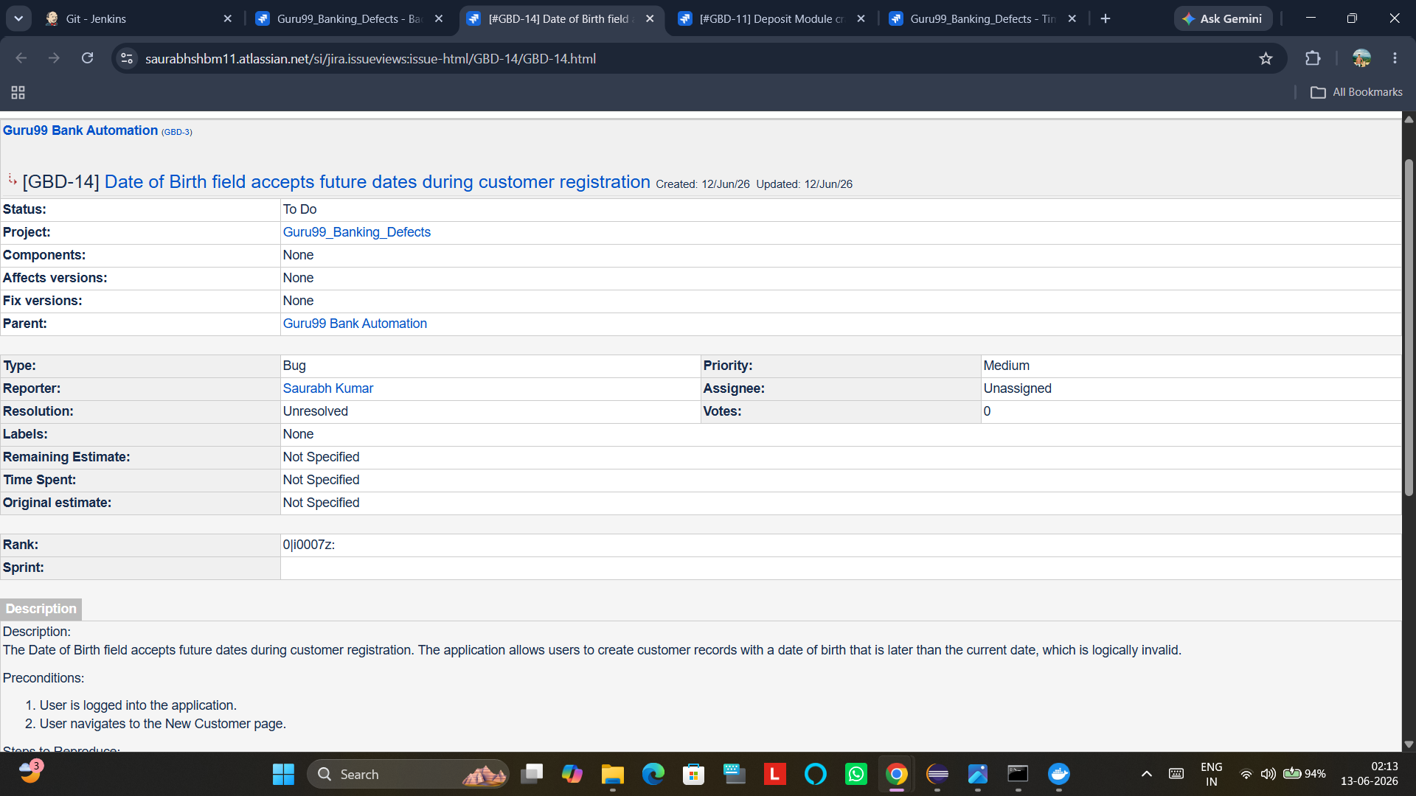

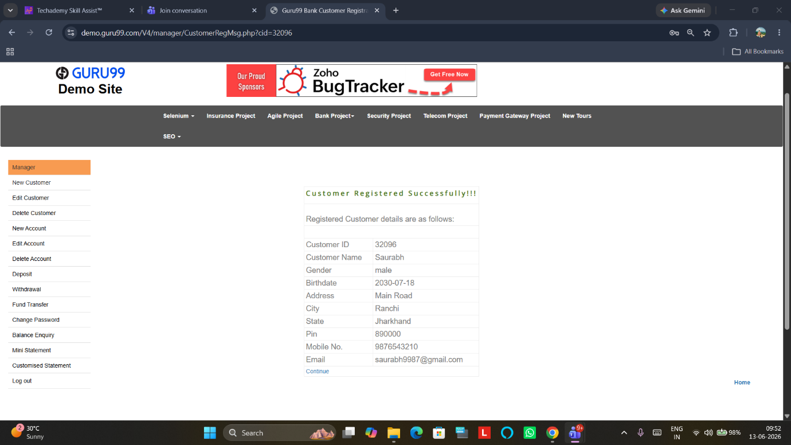

BUG-005

Defect Title
Deposit page intermittently displays "Please fill all fields" despite all fields being populated

Module
Deposit

Severity
Major

Priority
High

Status
Open

Description
The Deposit page occasionally displays the validation message "Please fill all fields" even when all mandatory fields contain valid values.
The issue occurs inconsistently and appears to be related to validation timing or synchronization problems.

Preconditions
- User must be logged in.
- Valid customer account must exist.

Steps to Reproduce
- Navigate to Deposit page.
- Enter valid Account Number.
- Enter valid Amount.
- Enter valid Description.
- Click Submit.
- Repeat multiple times.

Expected Result
Deposit transaction should be processed successfully.

Actual Result
Application displays "Please fill all fields" validation message.

Business Impact
- Transaction failures.
- User frustration.
- Reduced confidence in application reliability.

Frequency
Intermittent

Recommendation
Review client-side validation logic and synchronization handling.

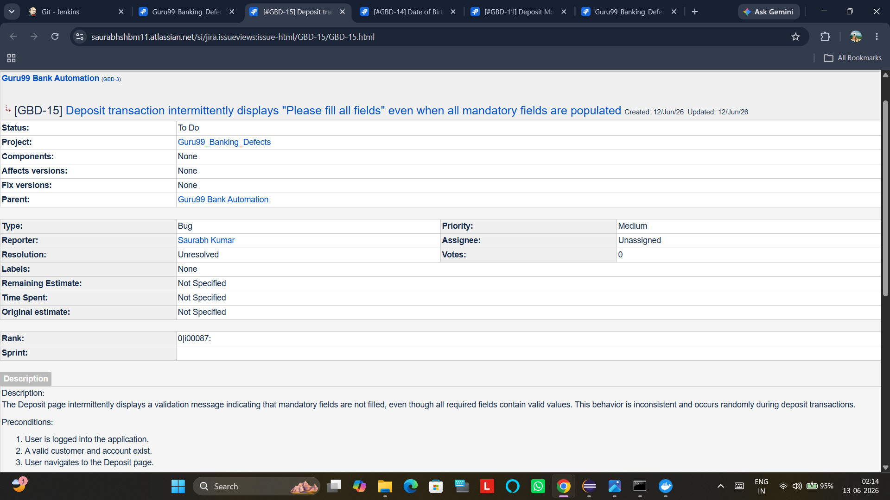

BUG-006

Defect Title
Customer Registration accepts invalid State names

Module
Customer Registration

Severity
Major

Priority
Medium

Status
Open

Description
The State field accepts random, non-existent, and invalid state names without performing any validation. Customer records are successfully created with invalid geographical information.

Preconditions
- User must be logged in.
- Customer Registration page must be available.

Steps to Reproduce
- Navigate to New Customer page.
- Enter valid customer details.
- Enter State = XYZState.
- Submit the form.

Expected Result
Application should validate state names and reject invalid values.

Actual Result
Customer record is created successfully with invalid state information.

Business Impact
- Incorrect customer data.
- Reduced data reliability.
- Reporting and communication issues.

Frequency
100% Reproducible

Recommendation
Implement validation using approved state lists or dropdown selection controls.
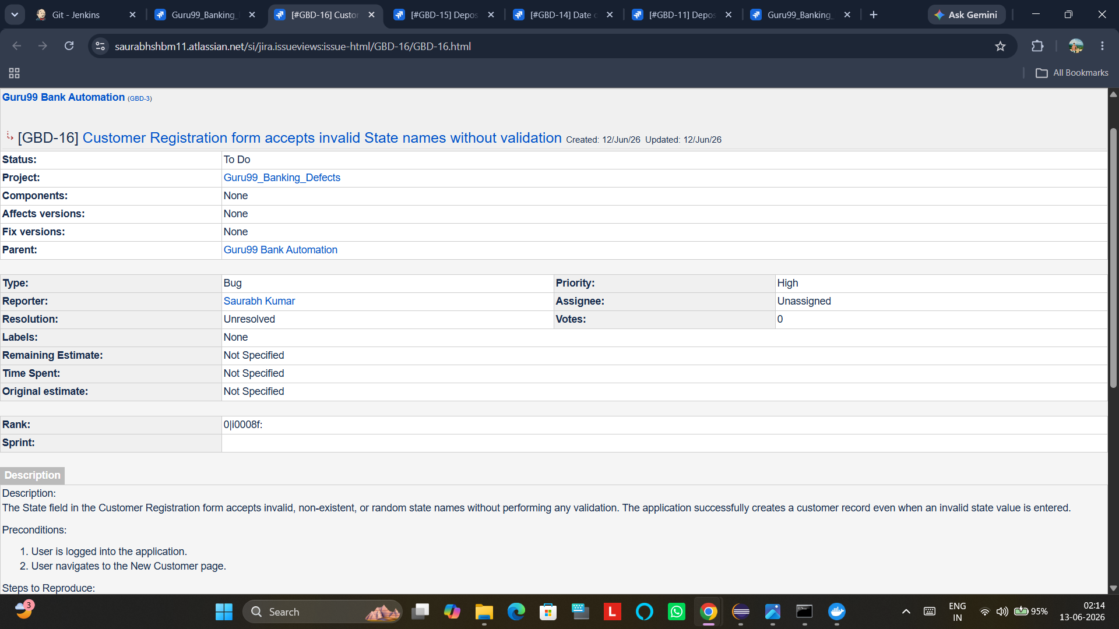

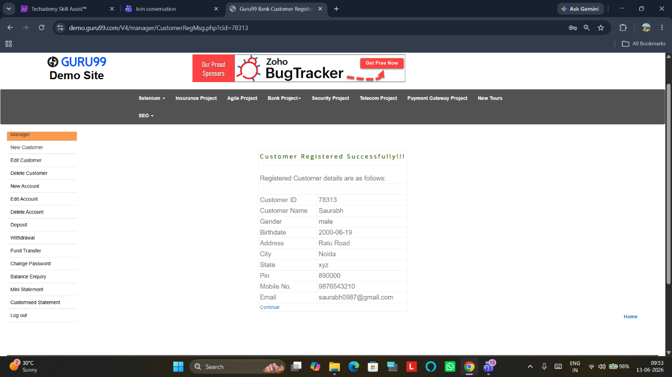

Root Cause Analysis
The identified defects indicate deficiencies in:
- Client-side validation
- Server-side validation
- Business rule enforcement
- Exception handling mechanisms
- Data integrity controls
The majority of defects are validation-related and could be prevented through stronger input validation and business logic verification.

Conclusion
The testing effort successfully identified multiple functional and validation defects across critical banking modules. The most severe issue is the Deposit transaction failure resulting in an HTTP 500 Internal Server Error, which directly impacts core banking operations. Other defects primarily affect data quality, security, and application reliability.
Resolving these defects will significantly improve system stability, user experience, data integrity, and compliance with standard banking application requirements.
Jira Structure-
