Banking Automation Framework - Source Code Documentation
Project: Banking Automation Framework
Technology: Selenium, Java, TestNG, Maven, Jenkins, Docker, Extent Reports

Project Overview
Framework developed using Page Object Model (POM) for Guru99 Banking Application automation.

Project Structure

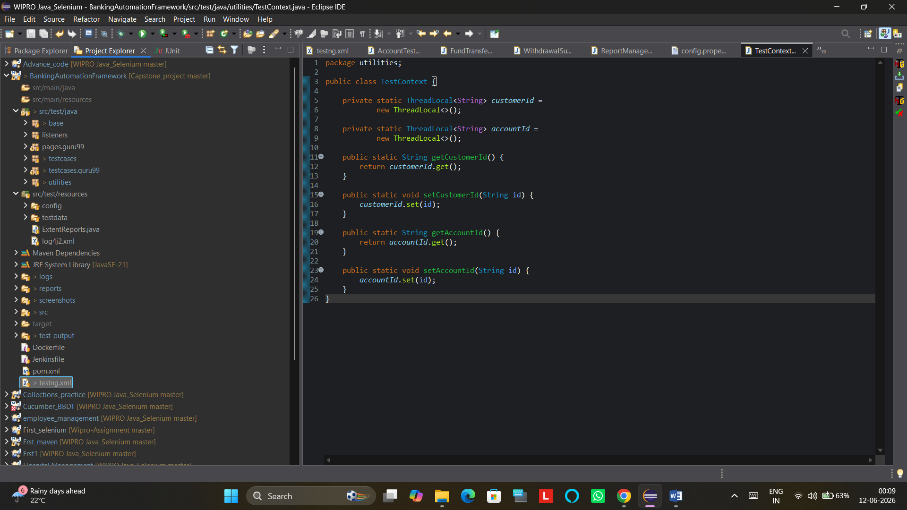
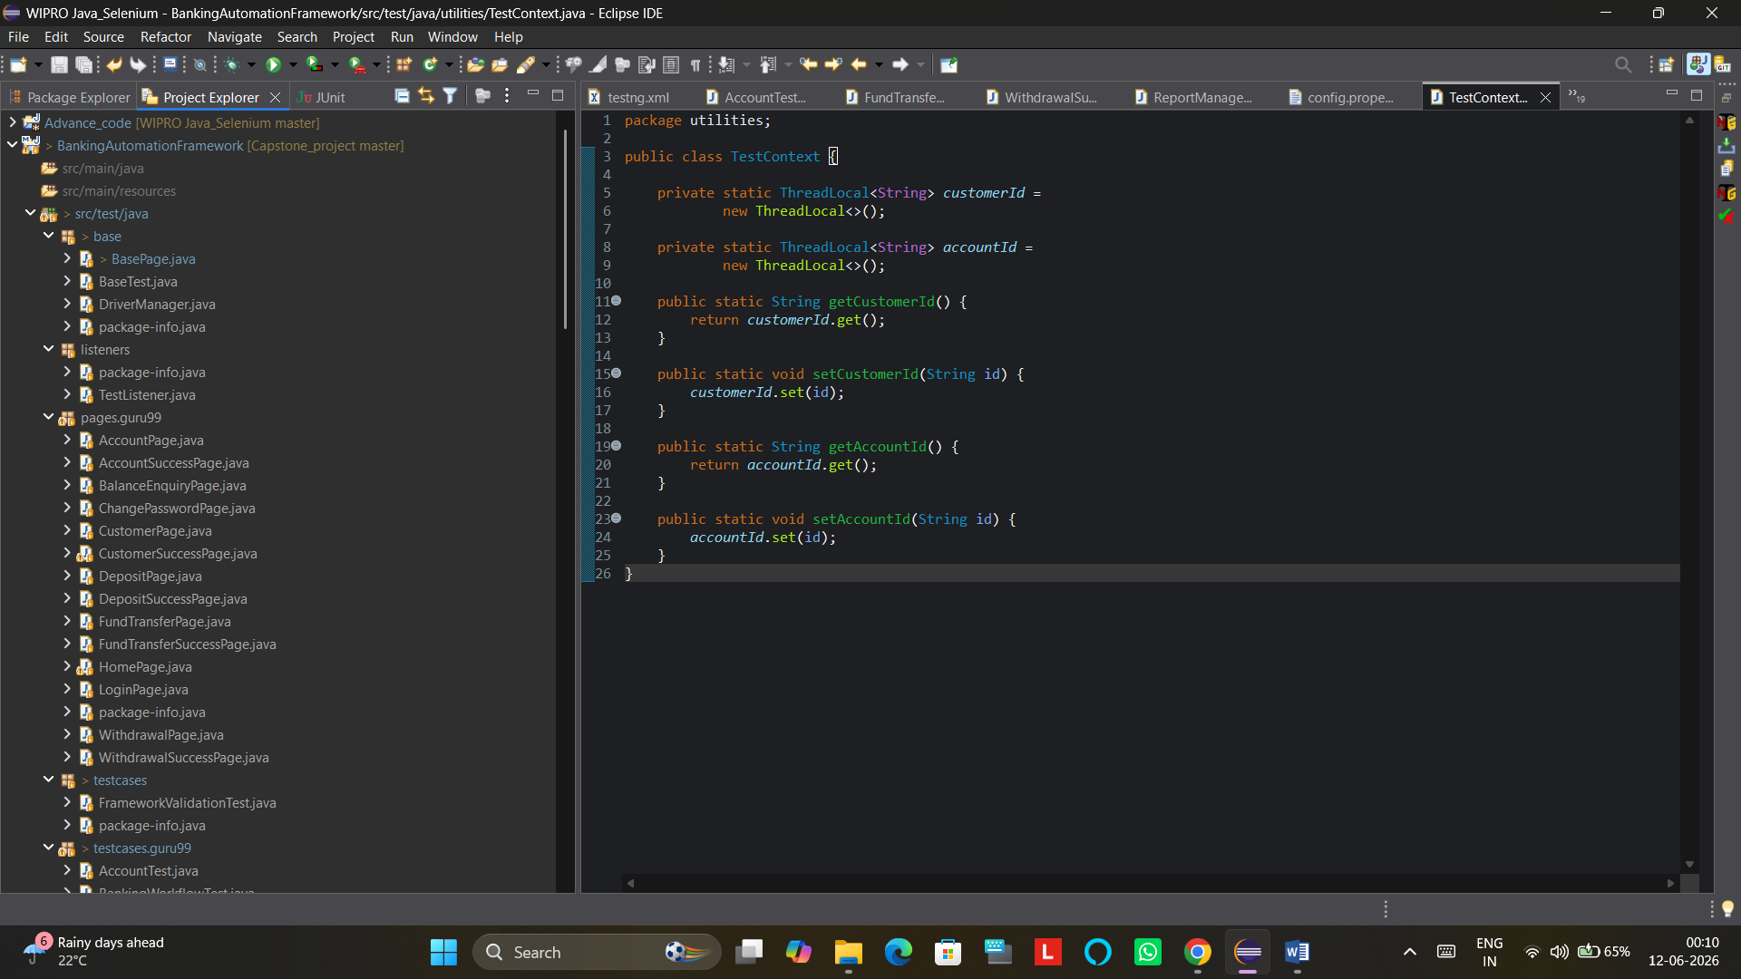

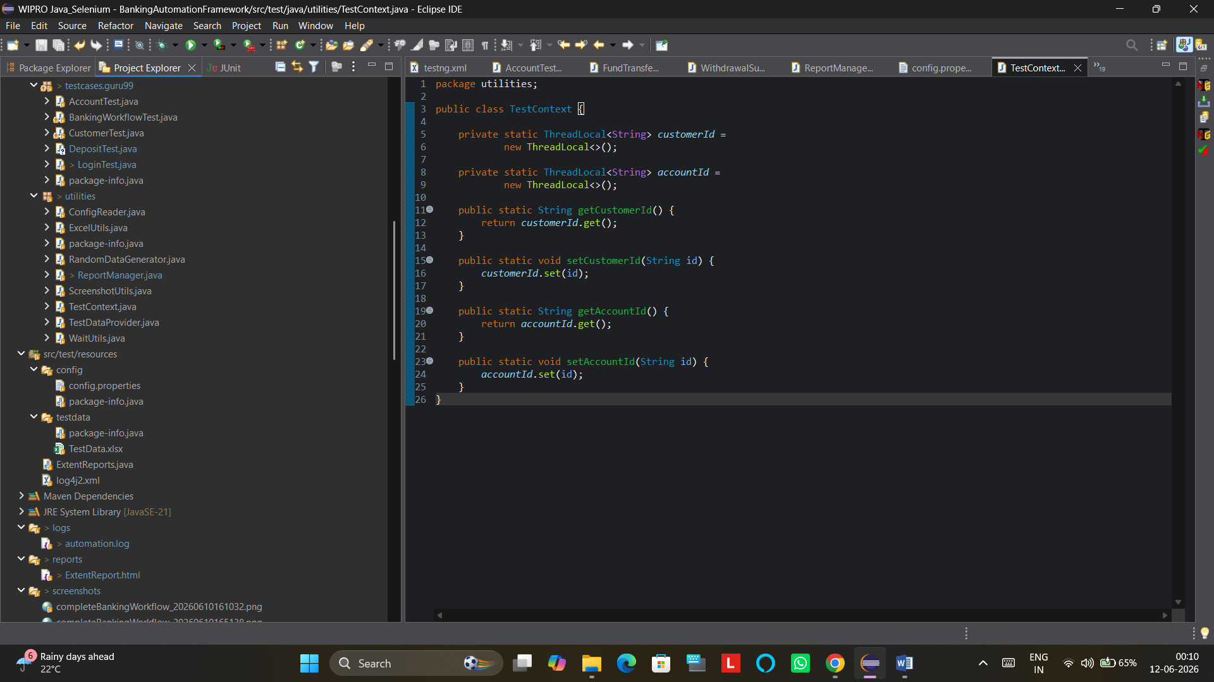
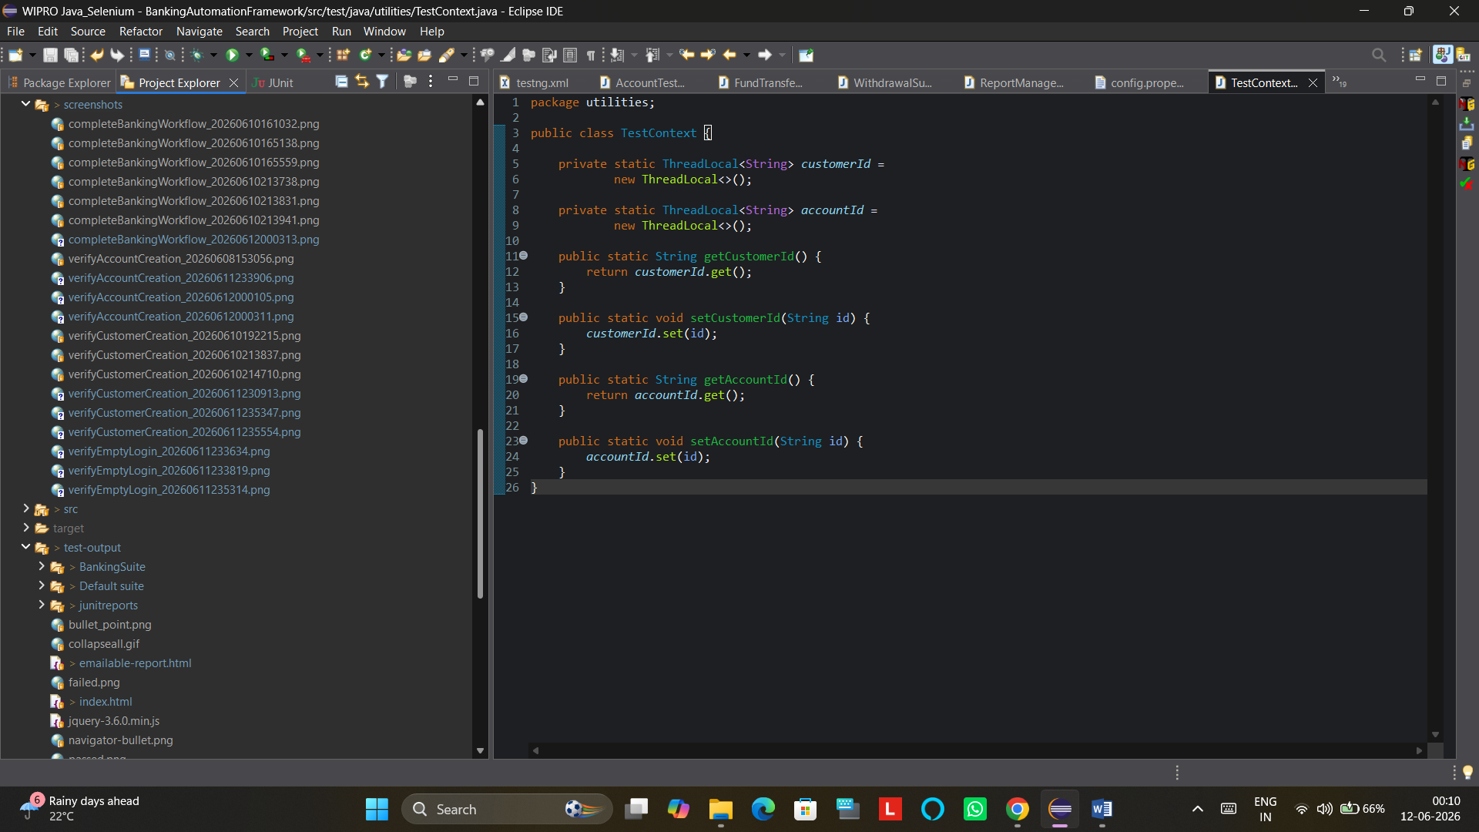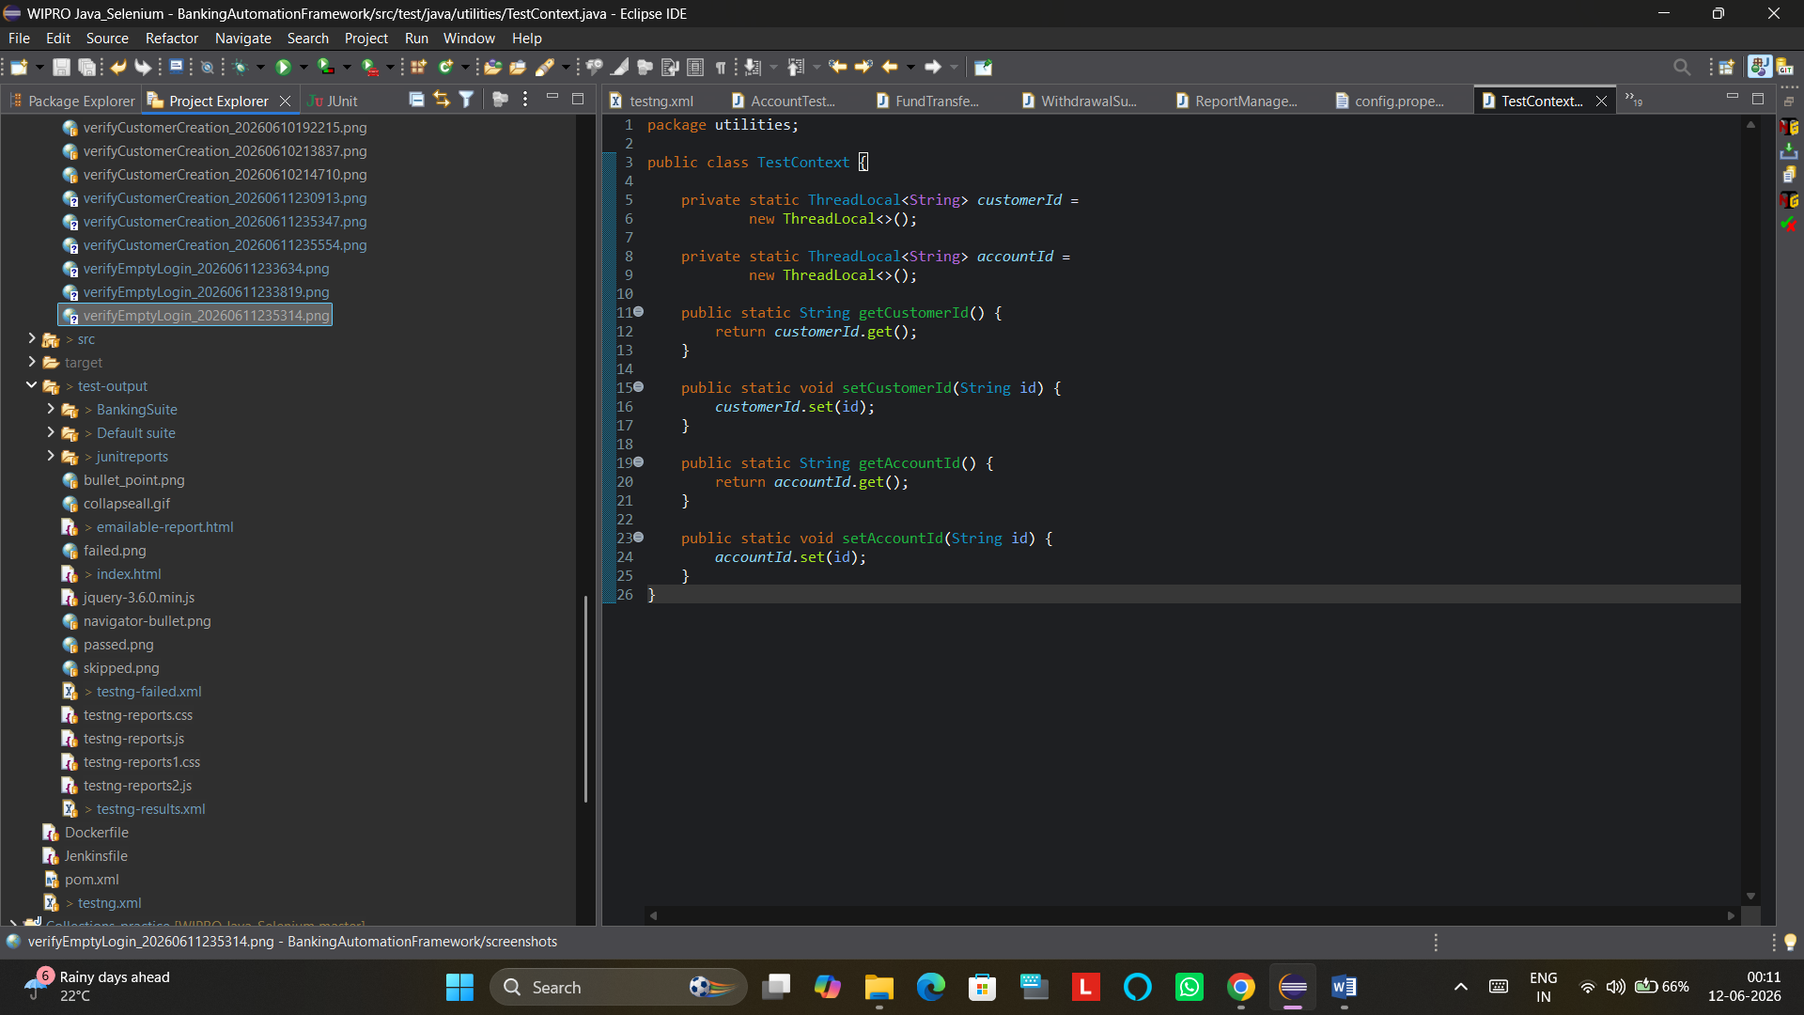

Base Package

BasePage:
package base;

import org.openqa.selenium.WebDriver;
import org.openqa.selenium.support.PageFactory;

public class BasePage {

protected WebDriver driver;

public BasePage(WebDriver driver) {

this.driver = driver;

PageFactory.initElements(driver,this);
}
}

BaseTest:
package base;

import org.testng.annotations.AfterMethod;
import org.testng.annotations.BeforeMethod;
import utilities.ConfigReader;
import utilities.TestContext;

public class BaseTest {

@BeforeMethod
public void setup() {

DriverManager.initializeDriver(
ConfigReader.getProperty("browser"));

DriverManager.getDriver().get(
ConfigReader.getProperty("url"));
}

@AfterMethod
public void tearDown() {

DriverManager.quitDriver();

TestContext.setCustomerId(null);
TestContext.setAccountId(null);
}
}

DriverManager:
package base;

import io.github.bonigarcia.wdm.WebDriverManager;
import org.openqa.selenium.WebDriver;
import org.openqa.selenium.chrome.ChromeDriver;
import org.openqa.selenium.edge.EdgeDriver;
import org.openqa.selenium.firefox.FirefoxDriver;
import org.openqa.selenium.chrome.ChromeOptions;
public class DriverManager {

private static final ThreadLocal<WebDriver> driver =
new ThreadLocal<>();

public static void initializeDriver(String browser) {

switch (browser.toLowerCase()) {

case "chrome":

ChromeOptions options =
new ChromeOptions();

if(System.getProperty("os.name")
.toLowerCase()
.contains("linux")) {

options.addArguments("--headless=new");
options.addArguments("--no-sandbox");
options.addArguments("--disable-dev-shm-usage");
options.addArguments("--disable-gpu");
options.addArguments("--window-size=1920,1080");
}

driver.set(new ChromeDriver(options));
break;

case "edge":
WebDriverManager.edgedriver().setup();
driver.set(new EdgeDriver());
break;

case "firefox":
WebDriverManager.firefoxdriver().setup();
driver.set(new FirefoxDriver());
break;

default:
throw new RuntimeException(
"Unsupported Browser");
}

getDriver().manage().window().maximize();
}

public static WebDriver getDriver() {

return driver.get();
}

public static void quitDriver() {

if(driver.get()!=null) {

driver.get().quit();

driver.remove();
}
}
}

listeners Package

TestListeners
package listeners;

import com.aventstack.extentreports.*;
import org.testng.*;
import utilities.ReportManager;
import utilities.ScreenshotUtils;

public class TestListener implements ITestListener {

private static ExtentReports extent =
ReportManager.getReportInstance();

private static ThreadLocal<ExtentTest> test =
new ThreadLocal<>();

@Override
public void onTestStart(ITestResult result) {

System.out.println("Listener Triggered");

test.set(
extent.createTest(
result.getMethod().getMethodName()));
}

@Override
public void onTestSuccess(
ITestResult result) {

test.get().pass("Test Passed");
}

@Override

public void onTestFailure(
ITestResult result) {

System.out.println(
"Failure Listener Triggered");

String screenshotPath =
ScreenshotUtils.capture(
result.getMethod().getMethodName());

System.out.println(
"Screenshot Path = "
+ screenshotPath);

test.get().fail(result.getThrowable());

test.get().addScreenCaptureFromPath(
screenshotPath);
}

@Override
public void onFinish(
ITestContext context) {

extent.flush();
}
}

Pages.guru99 Package (POM)

AccountPage
package pages.guru99;

import base.BasePage;
import org.apache.logging.log4j.LogManager;
import org.apache.logging.log4j.Logger;
import org.openqa.selenium.WebDriver;
import org.openqa.selenium.WebElement;
import org.openqa.selenium.support.FindBy;
import org.openqa.selenium.support.ui.Select;
import utilities.WaitUtils;

public class AccountPage extends BasePage {

private static final Logger logger =
LogManager.getLogger(AccountPage.class);

public AccountPage(WebDriver driver) {
super(driver);
}

@FindBy(name = "cusid")
private WebElement customerIdTxt;

@FindBy(name = "selaccount")
private WebElement accountTypeDropdown;

@FindBy(name = "inideposit")
private WebElement initialDepositTxt;

@FindBy(name = "button2")
private WebElement submitBtn;

public void createAccount(
String customerId,
String accountType,
String initialDeposit) {

logger.info("Creating New Account");

customerIdTxt.clear();
customerIdTxt.sendKeys(customerId);

Select select =
new Select(accountTypeDropdown);

select.selectByVisibleText(accountType);

initialDepositTxt.clear();
initialDepositTxt.sendKeys(initialDeposit);

System.out.println(
"Customer ID = "
+ customerIdTxt.getAttribute("value"));

System.out.println(
"Initial Deposit = "
+ initialDepositTxt.getAttribute("value"));

WaitUtils.waitForClickable(submitBtn);

submitBtn.click();
}
}

AccountSuccessPage:
package pages.guru99;

import base.BasePage;
import org.openqa.selenium.By;
import org.openqa.selenium.WebDriver;
import utilities.TestContext;

public class AccountSuccessPage extends BasePage {

public AccountSuccessPage(WebDriver driver) {
super(driver);
}

public String getAccountId() {

String accountId =
driver.findElement(
By.xpath(
"//td[text()='Account ID']/following-sibling::td"))
.getText();

TestContext.setAccountId(accountId);

return accountId;
}
}

BalanceEnquiryPage
package pages.guru99;

import base.BasePage;
import org.apache.logging.log4j.LogManager;
import org.apache.logging.log4j.Logger;
import org.openqa.selenium.WebDriver;
import org.openqa.selenium.WebElement;
import org.openqa.selenium.support.FindBy;
import utilities.WaitUtils;

public class BalanceEnquiryPage extends BasePage {

private static final Logger logger =
LogManager.getLogger(BalanceEnquiryPage.class);

public BalanceEnquiryPage(WebDriver driver) {
super(driver);
}

@FindBy(name = "accountno")
private WebElement accountNumberTxt;

@FindBy(name = "AccSubmit")
private WebElement submitBtn;

public void searchAccount(String accountNumber) {

logger.info("Performing Balance Enquiry");

accountNumberTxt.clear();
accountNumberTxt.sendKeys(accountNumber);

WaitUtils.waitForClickable(submitBtn);

submitBtn.click();
}
}

CustomerPage
package pages.guru99;

import base.BasePage;
import org.apache.logging.log4j.LogManager;
import org.apache.logging.log4j.Logger;
import org.openqa.selenium.WebDriver;
import org.openqa.selenium.WebElement;
import org.openqa.selenium.support.FindBy;
import utilities.WaitUtils;
import org.openqa.selenium.Keys;

public class CustomerPage extends BasePage {

private static final Logger logger =
LogManager.getLogger(CustomerPage.class);

public CustomerPage(WebDriver driver) {
super(driver);
}

@FindBy(name = "name")
private WebElement customerNameTxt;

@FindBy(xpath = "//input[@value='m']")
private WebElement maleRadioBtn;

@FindBy(id = "dob")
private WebElement dobTxt;

@FindBy(name = "addr")
private WebElement addressTxt;

@FindBy(name = "city")
private WebElement cityTxt;

@FindBy(name = "state")
private WebElement stateTxt;

@FindBy(name = "pinno")
private WebElement pinTxt;

@FindBy(name = "telephoneno")
private WebElement mobileTxt;

@FindBy(name = "emailid")
private WebElement emailTxt;

@FindBy(name = "password")
private WebElement passwordTxt;

@FindBy(name = "sub")
private WebElement submitBtn;

public void createCustomer(
String name,
String dob,
String address,
String city,
String state,
String pin,
String mobile,
String email,
String password) {

logger.info("Creating Customer");

WaitUtils.waitForVisibility(customerNameTxt);

customerNameTxt.sendKeys(name);
System.out.println("Name Entered");

maleRadioBtn.click();
System.out.println("Gender Selected");

dobTxt.sendKeys(Keys.CONTROL + "a");
dobTxt.sendKeys(Keys.DELETE);
dobTxt.sendKeys("01011998");
System.out.println("DOB Entered");

addressTxt.sendKeys(address);
System.out.println("Address Entered");

cityTxt.sendKeys(city);
System.out.println("City Entered");

stateTxt.sendKeys(state);
System.out.println("State Entered");

pinTxt.sendKeys(pin);
System.out.println("PIN Entered");

mobileTxt.sendKeys(mobile);
System.out.println("Mobile Entered");

emailTxt.sendKeys(email);
System.out.println("Email Entered");

passwordTxt.sendKeys(password);
System.out.println("Password Entered");

WaitUtils.waitForClickable(submitBtn);

System.out.println("Name = " + customerNameTxt.getAttribute("value"));
System.out.println("DOB = " + dobTxt.getAttribute("value"));
System.out.println("Address = " + addressTxt.getAttribute("value"));
System.out.println("City = " + cityTxt.getAttribute("value"));
System.out.println("State = " + stateTxt.getAttribute("value"));
System.out.println("PIN = " + pinTxt.getAttribute("value"));
System.out.println("Mobile = " + mobileTxt.getAttribute("value"));
System.out.println("Email = " + emailTxt.getAttribute("value"));
System.out.println("Password = " + passwordTxt.getAttribute("value"));

submitBtn.click();
}
}

CustomerSuccessPage
package pages.guru99;

import base.BasePage;
import org.openqa.selenium.By;
import org.openqa.selenium.WebDriver;
import utilities.TestContext;
import java.time.Duration;
import org.openqa.selenium.By;
import org.openqa.selenium.WebElement;
import org.openqa.selenium.support.ui.ExpectedConditions;
import org.openqa.selenium.support.ui.WebDriverWait;
public class CustomerSuccessPage extends BasePage {

public CustomerSuccessPage(WebDriver driver) {
super(driver);
}

public String getCustomerId() {

WebDriverWait wait =
new WebDriverWait(
driver,
Duration.ofSeconds(20));

WebElement customerElement =
wait.until(
ExpectedConditions
.visibilityOfElementLocated(
By.xpath(
"//td[text()='Customer ID']/following-sibling::td")));

String customerId = customerElement.getText();

System.out.println(
"Retrieved Customer ID = "
+ customerId);

TestContext.setCustomerId(customerId);

return customerId;
}
}

DepositPage
package pages.guru99;

import base.BasePage;
import org.apache.logging.log4j.LogManager;
import org.apache.logging.log4j.Logger;
import org.openqa.selenium.WebDriver;
import org.openqa.selenium.WebElement;
import org.openqa.selenium.support.FindBy;
import utilities.WaitUtils;

public class DepositPage extends BasePage {

private static final Logger logger =
LogManager.getLogger(DepositPage.class);

public DepositPage(WebDriver driver) {
super(driver);
}

@FindBy(name = "accountno")
private WebElement accountNumberTxt;

@FindBy(name = "ammount")
private WebElement amountTxt;

@FindBy(name = "desc")
private WebElement descriptionTxt;

@FindBy(name = "AccSubmit")
private WebElement submitBtn;

public void depositAmount(
String accountId,
String amount,
String description) {

logger.info("Performing Deposit");

accountNumberTxt.sendKeys(accountId);

amountTxt.sendKeys(amount);

descriptionTxt.sendKeys(description);

WaitUtils.waitForClickable(submitBtn);

submitBtn.click();
}
}

DepositSuccessPage
package pages.guru99;

import base.BasePage;
import org.openqa.selenium.By;
import org.openqa.selenium.WebDriver;

public class DepositSuccessPage extends BasePage {

public DepositSuccessPage(WebDriver driver) {
super(driver);
}

public boolean isDepositSuccessful() {

return driver.findElement(
By.xpath("//*[contains(text(),'Transaction details of Deposit')]"))
.isDisplayed();
}

public String getTransactionId() {

try {

return driver.findElement(
By.xpath("//td[text()='Transaction ID']/following-sibling::td"))
.getText();

} catch (Exception e) {

return "NOT AVAILABLE";
}
}

public void printDepositDetails() {

System.out.println(
"Deposit Successful");

System.out.println(
"Transaction ID : "
+ getTransactionId());
}
}

FundTransferPage
package pages.guru99;

import base.BasePage;
import org.apache.logging.log4j.LogManager;
import org.apache.logging.log4j.Logger;
import org.openqa.selenium.WebDriver;
import org.openqa.selenium.WebElement;
import org.openqa.selenium.support.FindBy;
import utilities.WaitUtils;

public class FundTransferPage extends BasePage {

private static final Logger logger =
LogManager.getLogger(FundTransferPage.class);

public FundTransferPage(WebDriver driver) {
super(driver);
}

@FindBy(name = "payersaccount")
private WebElement payerAccountTxt;

@FindBy(name = "payeeaccount")
private WebElement payeeAccountTxt;

@FindBy(name = "ammount")
private WebElement amountTxt;

@FindBy(name = "desc")
private WebElement descriptionTxt;

@FindBy(name = "AccSubmit")
private WebElement submitBtn;

public void transferFund(
String payerAccount,
String payeeAccount,
String amount,
String description) {

logger.info("Performing Fund Transfer");

payerAccountTxt.sendKeys(payerAccount);
payeeAccountTxt.sendKeys(payeeAccount);
amountTxt.sendKeys(amount);
descriptionTxt.sendKeys(description);

WaitUtils.waitForClickable(submitBtn);
submitBtn.click();
}
}

FundTransferSuccessPage
package pages.guru99;

import base.BasePage;
import org.openqa.selenium.By;
import org.openqa.selenium.WebDriver;

public class FundTransferSuccessPage extends BasePage {

public FundTransferSuccessPage(WebDriver driver) {
super(driver);
}

public boolean isFundTransferSuccessful() {

return driver.findElement(
By.xpath("//*[contains(text(),'Fund Transfer Details')]"))
.isDisplayed();
}

public void printFundTransferDetails() {

System.out.println(
"Fund Transfer Successful");
}
}

HomePage
package pages.guru99;

import base.BasePage;
import utilities.WaitUtils;

import java.time.Duration;

import org.apache.logging.log4j.LogManager;
import org.apache.logging.log4j.Logger;
import org.openqa.selenium.JavascriptExecutor;
import org.openqa.selenium.WebDriver;
import org.openqa.selenium.WebElement;
import org.openqa.selenium.support.FindBy;
import org.openqa.selenium.support.ui.ExpectedConditions;
import org.openqa.selenium.support.ui.WebDriverWait;

public class HomePage extends BasePage {

private static final Logger logger =
LogManager.getLogger(HomePage.class);

public HomePage(WebDriver driver) {
super(driver);
}

@FindBy(xpath =
"//td[contains(text(),'Manger Id') or contains(text(),'Manager Id')]")
private WebElement managerIdLabel;

@FindBy(linkText = "New Customer")
private WebElement newCustomerMenu;

@FindBy(linkText = "New Account")
private WebElement newAccountMenu;

@FindBy(linkText = "Deposit")
private WebElement depositMenu;

@FindBy(linkText = "Withdrawal")
private WebElement withdrawalMenu;

@FindBy(linkText = "Fund Transfer")
private WebElement fundTransferMenu;

@FindBy(linkText = "Change Password")
private WebElement changePasswordMenu;

@FindBy(linkText = "Balance Enquiry")
private WebElement balanceEnquiryMenu;

@FindBy(linkText = "Mini Statement")
private WebElement miniStatementMenu;

@FindBy(linkText = "Customised Statement")
private WebElement customisedStatementMenu;

@FindBy(linkText = "Log out")
private WebElement logoutMenu;

public boolean isManagerHomePageDisplayed() {

WaitUtils.waitForVisibility(managerIdLabel);

return managerIdLabel.isDisplayed();
}

public void clickNewCustomer() {
newCustomerMenu.click();
}

public void clickNewAccount() {

WebDriverWait wait =
new WebDriverWait(
driver,
Duration.ofSeconds(10));

wait.until(
ExpectedConditions.elementToBeClickable(
newAccountMenu));

JavascriptExecutor js =
(JavascriptExecutor) driver;

js.executeScript(
"arguments[0].click();",
newAccountMenu);
}

public void clickFundTransfer() {

WebDriverWait wait =
new WebDriverWait(
driver,
Duration.ofSeconds(10));

wait.until(
ExpectedConditions.visibilityOf(
fundTransferMenu));

JavascriptExecutor js =
(JavascriptExecutor) driver;

js.executeScript(
"arguments[0].scrollIntoView(true);",
fundTransferMenu);

js.executeScript(
"arguments[0].click();",
fundTransferMenu);
}

public void clickWithdrawal() {
withdrawalMenu.click();
}

public void clickDeposit() {
depositMenu.click();
}

public void logout() {
logoutMenu.click();
}
}

LoginPage
package pages.guru99;

import base.BasePage;
import org.apache.logging.log4j.LogManager;
import org.apache.logging.log4j.Logger;
import org.openqa.selenium.WebDriver;
import org.openqa.selenium.WebElement;
import org.openqa.selenium.support.FindBy;
import utilities.WaitUtils;

public class LoginPage extends BasePage {

private static final Logger logger =
LogManager.getLogger(LoginPage.class);

public LoginPage(WebDriver driver) {
super(driver);
}

@FindBy(name = "uid")
private WebElement userIdTxt;

@FindBy(name = "password")
private WebElement passwordTxt;

@FindBy(name = "btnLogin")
private WebElement loginBtn;

public boolean isLoginPageDisplayed() {

logger.info("Verifying Login Page");

return userIdTxt.isDisplayed();
}

public void enterUserId(String userId) {

logger.info("Entering User ID");

WaitUtils.waitForVisibility(userIdTxt);

userIdTxt.clear();

userIdTxt.sendKeys(userId);
}

public void enterPassword(String password) {

logger.info("Entering Password");

WaitUtils.waitForVisibility(passwordTxt);

passwordTxt.clear();

passwordTxt.sendKeys(password);
}

public void clickLogin() {

logger.info("Clicking Login Button");

WaitUtils.waitForClickable(loginBtn);

loginBtn.click();
}

public void login(
String userId,
String password) {

logger.info("Starting Login Process");

enterUserId(userId);

enterPassword(password);

clickLogin();

logger.info("Login Process Completed");
}
}

WithdrawalPage
package pages.guru99;

import base.BasePage;
import org.apache.logging.log4j.LogManager;
import org.apache.logging.log4j.Logger;
import org.openqa.selenium.WebDriver;
import org.openqa.selenium.WebElement;
import org.openqa.selenium.support.FindBy;
import utilities.WaitUtils;

public class WithdrawalPage extends BasePage {

private static final Logger logger =
LogManager.getLogger(WithdrawalPage.class);

public WithdrawalPage(WebDriver driver) {
super(driver);
}

@FindBy(name = "accountno")
private WebElement accountNumberTxt;

@FindBy(name = "ammount")
private WebElement amountTxt;

@FindBy(name = "desc")
private WebElement descriptionTxt;

@FindBy(name = "AccSubmit")
private WebElement submitBtn;

public void withdrawAmount(
String accountId,
String amount,
String description) {

logger.info("Performing Withdrawal");

accountNumberTxt.clear();
accountNumberTxt.sendKeys(accountId);

amountTxt.clear();
amountTxt.sendKeys(amount);

descriptionTxt.clear();
descriptionTxt.sendKeys(description);

WaitUtils.waitForClickable(submitBtn);

submitBtn.click();
}
}

WithdrawalSuccessPage
package pages.guru99;

import base.BasePage;
import org.openqa.selenium.By;
import org.openqa.selenium.WebDriver;

public class WithdrawalSuccessPage extends BasePage {

public WithdrawalSuccessPage(WebDriver driver) {
super(driver);
}

public boolean isWithdrawalSuccessful() {

return driver.findElement(
By.xpath("//p[contains(text(),'Transaction details of Withdrawal')]"))
.isDisplayed();
}

public String getTransactionId() {

try {

return driver.findElement(
By.xpath("//td[text()='Transaction ID']/following-sibling::td"))
.getText();

} catch (Exception e) {

return "NOT AVAILABLE";
}
}

public void printWithdrawalDetails() {

System.out.println(
"Withdrawal Successful");

System.out.println(
"Transaction ID : "
+ getTransactionId());
}
}

Testcases Package

FrameworkValidationTest
package testcases;

import base.BaseTest;
import base.DriverManager;
import org.testng.Assert;
import org.testng.annotations.Test;

public class FrameworkValidationTest
extends BaseTest {

@Test
public void verifyFrameworkSetup() {

String title =
DriverManager.getDriver()
.getTitle();

Assert.assertTrue(
title.contains("Guru99"));
}
}

Testcases.guru99 Package

BankingWorkflowTest
package testcases.guru99;

import base.BaseTest;
import base.DriverManager;
import org.testng.Assert;
import org.testng.annotations.Test;
import pages.guru99.*;
import utilities.ConfigReader;
import utilities.RandomDataGenerator;
import org.testng.annotations.Listeners;
import listeners.TestListener;

@Listeners(TestListener.class)

public class BankingWorkflowTest extends BaseTest {

@Test
public void completeBankingWorkflow() throws InterruptedException {

LoginPage loginPage =
new LoginPage(
DriverManager.getDriver());

loginPage.login(
ConfigReader.getProperty("username"),
ConfigReader.getProperty("password"));

HomePage homePage =
new HomePage(
DriverManager.getDriver());

Assert.assertTrue(
homePage.isManagerHomePageDisplayed());

// CUSTOMER CREATION

homePage.clickNewCustomer();

CustomerPage customerPage =
new CustomerPage(
DriverManager.getDriver());

customerPage.createCustomer(
"Saurabh Kumar",
"1998-01-01",
"Ranchi Main Road",
"Ranchi",
"Jharkhand",
"834001",
RandomDataGenerator.generateMobile(),
RandomDataGenerator.generateEmail(),
"Test@123");

CustomerSuccessPage customerSuccessPage =
new CustomerSuccessPage(
DriverManager.getDriver());

String customerId =
customerSuccessPage.getCustomerId();

System.out.println(
"Customer ID = "
+ customerId);

// ACCOUNT CREATION

homePage =
new HomePage(
DriverManager.getDriver());

homePage.clickNewAccount();

AccountPage accountPage =
new AccountPage(
DriverManager.getDriver());

accountPage.createAccount(
customerId,
"Savings",
"5000");

AccountSuccessPage accountSuccessPage =
new AccountSuccessPage(
DriverManager.getDriver());

String account1 =
accountSuccessPage.getAccountId();

System.out.println(
"Account 1 = "
+ account1);
homePage =
new HomePage(
DriverManager.getDriver());

homePage.clickNewAccount();

accountPage =
new AccountPage(
DriverManager.getDriver());

accountPage.createAccount(
customerId,
"Savings",
"3000");

accountSuccessPage =
new AccountSuccessPage(
DriverManager.getDriver());

String account2 =
accountSuccessPage.getAccountId();

System.out.println(
"Account 2 = " + account2);

homePage =
new HomePage(
DriverManager.getDriver());

homePage.clickNewAccount();

accountPage =
new AccountPage(
DriverManager.getDriver());

accountPage.createAccount(
customerId,
"Savings",
"3000");

accountSuccessPage =
new AccountSuccessPage(
DriverManager.getDriver());

String account2f =
accountSuccessPage.getAccountId();

System.out.println(
"Account 2 = " + account2);

homePage =
new HomePage(
DriverManager.getDriver());

homePage.clickFundTransfer();

FundTransferPage fundTransferPage =
new FundTransferPage(
DriverManager.getDriver());

fundTransferPage.transferFund(
account1,
account2,
"500",
"Transfer");
FundTransferSuccessPage fundTransferSuccessPage =
new FundTransferSuccessPage(
DriverManager.getDriver());

Assert.assertTrue(
fundTransferSuccessPage
.isFundTransferSuccessful());

fundTransferSuccessPage
.printFundTransferDetails();

System.out.println(
"Fund Transfer Completed");

homePage =
new HomePage(
DriverManager.getDriver());

homePage.clickWithdrawal();

WithdrawalPage withdrawalPage =
new WithdrawalPage(
DriverManager.getDriver());

withdrawalPage.withdrawAmount(
account1,
"100",
"ATM");
WithdrawalSuccessPage withdrawalSuccessPage =
new WithdrawalSuccessPage(
DriverManager.getDriver());

Assert.assertTrue(
withdrawalSuccessPage.isWithdrawalSuccessful());

withdrawalSuccessPage.printWithdrawalDetails();

try {

homePage.clickDeposit();

DepositPage depositPage =
new DepositPage(
DriverManager.getDriver());

depositPage.depositAmount(
account1,
"1000",
"Cash Deposit");

Thread.sleep(3000);

} catch (Exception e) {

System.out.println(
"Deposit Failed : "
+ e.getMessage());
}

System.out.println(
"Navigating back to Home Page");

DriverManager.getDriver().navigate().back();

Thread.sleep(2000);

DriverManager.getDriver().get(
"https://demo.guru99.com/V4/manager/Logout.php");

try {

DriverManager.getDriver()
.switchTo()
.alert()
.accept();

System.out.println(
"Logout Successful");

} catch (Exception e) {

System.out.println(
"Logout Alert Not Found");
}
}
}

LoginTest
package testcases.guru99;

import base.BaseTest;
import base.DriverManager;
import org.testng.Assert;
import org.testng.annotations.Test;
import pages.guru99.HomePage;
import pages.guru99.LoginPage;
import utilities.ConfigReader;
import java.time.Duration;
import org.openqa.selenium.Alert;
import org.openqa.selenium.support.ui.ExpectedConditions;
import org.openqa.selenium.support.ui.WebDriverWait;

public class LoginTest extends BaseTest {

@Test
public void verifyValidLogin() {

LoginPage loginPage =
new LoginPage(
DriverManager.getDriver());

loginPage.login(
ConfigReader.getProperty("username"),
ConfigReader.getProperty("password"));

HomePage homePage =
new HomePage(
DriverManager.getDriver());

Assert.assertTrue(
homePage.isManagerHomePageDisplayed(),
"Login Failed");
}

@Test
public void verifyInvalidLogin() {

LoginPage loginPage =
new LoginPage(
DriverManager.getDriver());

loginPage.login(
"invalidUser",
"invalidPassword");

WebDriverWait wait =
new WebDriverWait(
DriverManager.getDriver(),
Duration.ofSeconds(10));

Alert alert =
wait.until(
ExpectedConditions.alertIsPresent());

String alertText =
alert.getText();

System.out.println(
"Alert Message = "
+ alertText);

Assert.assertTrue(
alertText.contains("not valid"),
"Invalid login message not displayed");

alert.accept();
}

@Test
public void verifyEmptyLogin() {

LoginPage loginPage =
new LoginPage(
DriverManager.getDriver());

loginPage.login(
"",
"");

WebDriverWait wait =
new WebDriverWait(
DriverManager.getDriver(),
Duration.ofSeconds(10));

Alert alert =
wait.until(
ExpectedConditions.alertIsPresent());

String alertText =
alert.getText();

System.out.println(
"Alert Message = "
+ alertText);

Assert.assertTrue(
alertText.length() > 0,
"Expected alert message not displayed");

alert.accept();
}
}

CustomerTest
package testcases.guru99;

import base.BaseTest;
import base.DriverManager;
import org.testng.Assert;
import org.testng.annotations.Test;
import pages.guru99.CustomerPage;
import pages.guru99.CustomerSuccessPage;
import pages.guru99.HomePage;
import pages.guru99.LoginPage;
import utilities.ConfigReader;
import utilities.ExcelUtils;
import utilities.RandomDataGenerator;
import utilities.TestContext;
import utilities.TestDataProvider;

public class CustomerTest extends BaseTest {

@Test(
dataProvider = "customerData",
dataProviderClass =
TestDataProvider.class)
public void verifyCustomerCreation(

String customerName,
String dob,
String address,
String city,
String state,
String pin,
String password) {

LoginPage loginPage =
new LoginPage(
DriverManager.getDriver());

loginPage.login(
ConfigReader.getProperty("username"),
ConfigReader.getProperty("password"));

HomePage homePage =
new HomePage(
DriverManager.getDriver());

homePage.clickNewCustomer();

CustomerPage customerPage =
new CustomerPage(
DriverManager.getDriver());

customerPage.createCustomer(
customerName,
dob,
address,
city,
state,
pin,
RandomDataGenerator.generateMobile(),
RandomDataGenerator.generateEmail(),
password);

CustomerSuccessPage successPage =
new CustomerSuccessPage(
DriverManager.getDriver());

String customerId =
successPage.getCustomerId();

Assert.assertNotNull(customerId);

System.out.println(
"Customer Created : "
+ customerId);
}
}

AccountTest
package testcases.guru99;

import base.BaseTest;
import base.DriverManager;
import org.testng.Assert;
import org.testng.annotations.Test;
import pages.guru99.*;
import utilities.ConfigReader;
import utilities.RandomDataGenerator;
import utilities.TestContext;

public class AccountTest extends BaseTest {

@Test
public void verifyAccountCreation() {

LoginPage loginPage =
new LoginPage(
DriverManager.getDriver());

loginPage.login(
ConfigReader.getProperty("username"),
ConfigReader.getProperty("password"));

HomePage homePage =
new HomePage(
DriverManager.getDriver());

homePage.clickNewCustomer();

CustomerPage customerPage =
new CustomerPage(
DriverManager.getDriver());

customerPage.createCustomer(
"Saurabh Kumar",
"1998-01-01",
"Ranchi Main Road",
"Ranchi",
"Jharkhand",
"834001",
RandomDataGenerator.generateMobile(),
RandomDataGenerator.generateEmail(),
"Test@123");

CustomerSuccessPage customerSuccessPage =
new CustomerSuccessPage(
DriverManager.getDriver());

String customerId =
customerSuccessPage.getCustomerId();

System.out.println(
"Customer ID From Context = "
+ TestContext.getCustomerId());

homePage =
new HomePage(
DriverManager.getDriver());

homePage.clickNewAccount();

AccountPage accountPage =
new AccountPage(
DriverManager.getDriver());

accountPage.createAccount(
customerId,
"Savings",
"5000");

AccountSuccessPage accountSuccessPage =
new AccountSuccessPage(
DriverManager.getDriver());

String accountId =
accountSuccessPage.getAccountId();

Assert.assertNotNull(accountId);

System.out.println(
"Generated Account ID : "
+ accountId);

System.out.println(
"Stored Account ID : "
+ TestContext.getAccountId());
}
}

DepositTest
package testcases.guru99;

import org.testng.Assert;
import org.testng.annotations.Test;

import base.BaseTest;

public class DepositTest extends BaseTest {

@Test
public void verifyDeposit() {

// Login

// Create Customer

// Create Account

// Deposit Amount

Assert.assertTrue(true);
}
}

Utilities Package

ConfigReader
package utilities;

import java.io.FileInputStream;
import java.util.Properties;

public class ConfigReader {

private static final Properties properties =
new Properties();

static {

try {

FileInputStream fis =
new FileInputStream(
"src/test/resources/config/config.properties");

properties.load(fis);

} catch (Exception e) {

throw new RuntimeException(e);
}
}

public static String getProperty(String key) {

return properties.getProperty(key);
}
}
RandomDataGenerator
package utilities;

import java.util.UUID;

public class RandomDataGenerator {

public static String generateEmail() {

return "user"
+ UUID.randomUUID()
.toString()
.substring(0,6)
+ "@gmail.com";
}

public static String generateMobile() {

String timestamp =
String.valueOf(System.currentTimeMillis());

return "98"
+ timestamp.substring(
timestamp.length()-8);
}
}
ReportManager
package utilities;

import com.aventstack.extentreports.*;
import com.aventstack.extentreports.reporter.ExtentSparkReporter;

public class ReportManager {

private static ExtentReports extent;

public static ExtentReports getReportInstance() {

if (extent == null) {

System.out.println("Extent Report Initialized");

ExtentSparkReporter spark =
new ExtentSparkReporter(
"reports/ExtentReport.html");

spark.config().setReportName(
"Guru99 Banking Automation Framework");

spark.config().setDocumentTitle(
"Banking Automation Report");

extent = new ExtentReports();

extent.attachReporter(spark);

// Project Details
extent.setSystemInfo(
"Project Name",
"Banking Automation Framework");

extent.setSystemInfo(
"Tester",
"Saurabh Kumar");

extent.setSystemInfo(
"Browser",
ConfigReader.getProperty("browser"));

extent.setSystemInfo(
"Environment",
"QA");

extent.setSystemInfo(
"Framework",
"Selenium + TestNG + Maven");

extent.setSystemInfo(
"CI/CD",
"Jenkins");

extent.setSystemInfo(
"Containerization",
"Docker");

extent.setSystemInfo(
"OS",
System.getProperty("os.name"));

extent.setSystemInfo(
"Java Version",
System.getProperty("java.version"));
}

return extent;
}
}

ScreenshotUtils
package utilities;

import base.DriverManager;
import org.apache.commons.io.FileUtils;
import org.openqa.selenium.*;

import java.io.File;
import java.text.SimpleDateFormat;
import java.util.Date;

public class ScreenshotUtils {

public static String capture(String testName) {

try {

File source =
((TakesScreenshot)
DriverManager.getDriver())
.getScreenshotAs(OutputType.FILE);

String timestamp =
new SimpleDateFormat(
"yyyyMMddHHmmss")
.format(new Date());

String folderPath = "screenshots";

File folder = new File(folderPath);

if (!folder.exists()) {

folder.mkdirs();
}

String destination =
new File(
folderPath,
testName + "_"
+ timestamp
+ ".png")
.getAbsolutePath();

FileUtils.copyFile(
source,
new File(destination));

System.out.println(
"Screenshot Saved At : "
+ destination);

return destination;

} catch (Exception e) {

e.printStackTrace();

//throw new RuntimeException(e);
}
return testName;
}
}

TextContext
package utilities;

public class TextContext {

private static ThreadLocal<String> customerId =
new ThreadLocal<>();

private static ThreadLocal<String> accountId =
new ThreadLocal<>();

public static String getCustomerId() {
return customerId.get();
}

public static void setCustomerId(String id) {
customerId.set(id);
}

public static String getAccountId() {
return accountId.get();
}

public static void setAccountId(String id) {
accountId.set(id);
}
}

ExcelUtils
package utilities;

import org.apache.poi.ss.usermodel.*;
import org.apache.poi.xssf.usermodel.XSSFWorkbook;

import java.io.FileInputStream;

public class ExcelUtils {

private static Workbook workbook;

static {

try {

FileInputStream fis =
new FileInputStream(
"src/test/resources/testdata/TestData.xlsx");

workbook =
new XSSFWorkbook(fis);

} catch (Exception e) {

throw new RuntimeException(e);
}
}

public static String getCellData(
String sheetName,
int row,
int column) {

Sheet sheet =
workbook.getSheet(sheetName);

return sheet.getRow(row)
.getCell(column)
.toString();
}

public static int getRowCount(
String sheetName) {

return workbook.getSheet(sheetName)
.getLastRowNum();
}
}

WaitUtils
package utilities;

import base.DriverManager;
import org.openqa.selenium.WebElement;
import org.openqa.selenium.support.ui.*;

import java.time.Duration;

public class WaitUtils {

private static final int TIMEOUT = 15;

public static void waitForVisibility(
WebElement element) {

WebDriverWait wait =
new WebDriverWait(
DriverManager.getDriver(),
Duration.ofSeconds(TIMEOUT));

wait.until(
ExpectedConditions.visibilityOf(element));
}

public static void waitForClickable(
WebElement element) {

WebDriverWait wait =
new WebDriverWait(
DriverManager.getDriver(),
Duration.ofSeconds(TIMEOUT));

wait.until(
ExpectedConditions.elementToBeClickable(element));
}
}

Log4j2.xml

<?xml version="1.0" encoding="UTF-8"?>

<Configuration status="WARN">

<Appenders>

<Console name="Console">

<PatternLayout
pattern="%d [%t] %-5level %logger - %msg%n"/>

</Console>

<File name="File"
fileName="logs/automation.log">

<PatternLayout
pattern="%d %-5level %logger - %msg%n"/>

</File>

</Appenders>

<Loggers>

<Root level="info">

<AppenderRef ref="Console"/>

<AppenderRef ref="File"/>

</Root>

</Loggers>

</Configuration>

Pom.xml

<project xmlns="http://maven.apache.org/POM/4.0.0" xmlns:xsi="http://www.w3.org/2001/XMLSchema-instance" xsi:schemaLocation="http://maven.apache.org/POM/4.0.0 https://maven.apache.org/xsd/maven-4.0.0.xsd">
<modelVersion>4.0.0</modelVersion>
<groupId>BankingAutomationFramework</groupId>
<artifactId>BankingAutomationFramework</artifactId>
<version>0.0.1-SNAPSHOT</version>

<properties>
<maven.compiler.source>21</maven.compiler.source>
<maven.compiler.target>21</maven.compiler.target>
<project.build.sourceEncoding>UTF-8</project.build.sourceEncoding>
</properties>

<dependencies>

<!-- Selenium -->
<dependency>
<groupId>org.seleniumhq.selenium</groupId>
<artifactId>selenium-java</artifactId>
<version>4.34.0</version>
</dependency>

<!-- TestNG -->
<dependency>
<groupId>org.testng</groupId>
<artifactId>testng</artifactId>
<version>7.11.0</version>
</dependency>

<!-- WebDriverManager -->
<dependency>
<groupId>io.github.bonigarcia</groupId>
<artifactId>webdrivermanager</artifactId>
<version>6.1.0</version>
</dependency>

<!-- Apache POI -->
<dependency>
<groupId>org.apache.poi</groupId>
<artifactId>poi-ooxml</artifactId>
<version>5.4.1</version>
</dependency>

<!-- Extent Report -->
<dependency>
<groupId>com.aventstack</groupId>
<artifactId>extentreports</artifactId>
<version>5.1.2</version>
</dependency>

<!-- Log4j -->
<dependency>
<groupId>org.apache.logging.log4j</groupId>
<artifactId>log4j-core</artifactId>
<version>2.25.1</version>
</dependency>

<dependency>
<groupId>org.apache.logging.log4j</groupId>
<artifactId>log4j-api</artifactId>
<version>2.25.1</version>
</dependency>

<!-- Commons IO -->
<dependency>
<groupId>commons-io</groupId>
<artifactId>commons-io</artifactId>
<version>2.18.0</version>
</dependency>

</dependencies>

<build>
<plugins>

<plugin>
<groupId>org.apache.maven.plugins</groupId>
<artifactId>maven-surefire-plugin</artifactId>
<version>3.2.5</version>

<configuration>

<suiteXmlFiles>
<suiteXmlFile>testng.xml</suiteXmlFile>
</suiteXmlFiles>

</configuration>

</plugin>

</plugins>
</build>

</project>

Testing.xml
<!DOCTYPE suite SYSTEM "https://testng.org/testng-1.0.dtd">

<suite name="BankingSuite"
parallel="tests"
thread-count="3">

<listeners>
<listener class-name="listeners.TestListener"/>
</listeners>

<test name="LoginTest">

<classes>
<class name="testcases.guru99.LoginTest"/>
</classes>

</test>

<test name="CustomerTest">

<classes>
<class name="testcases.guru99.CustomerTest"/>
</classes>

</test>

<test name="BankingWorkflowTest">

<classes>
<class name="testcases.guru99.BankingWorkflowTest"/>
</classes>

</test>

<test name="AccountTest">

<classes>
<class name="testcases.guru99.AccountTest"/>
</classes>

</test>

</suite>

Jenkinsfile
pipeline {
agent any

stages {

stage('Build & Test') {
steps {
dir('BankingAutomationFramework') {
bat 'mvn clean test'
}
}
}
}

post {
always {
archiveArtifacts artifacts: 'BankingAutomationFramework/reports/*.html',
allowEmptyArchive: true

archiveArtifacts artifacts: 'BankingAutomationFramework/screenshots/*.png',
allowEmptyArchive: true
}
}
}

Dockerfile
FROM maven:3.9.11-eclipse-temurin-21

RUN apt-get update && apt-get install -y \
wget \
gnupg \
unzip \
&& wget -q -O - https://dl.google.com/linux/linux_signing_key.pub | gpg --dearmor -o /usr/share/keyrings/google.gpg \
&& echo "deb [signed-by=/usr/share/keyrings/google.gpg] http://dl.google.com/linux/chrome/deb/ stable main" > /etc/apt/sources.list.d/google.list \
&& apt-get update \
&& apt-get install -y google-chrome-stable

WORKDIR /app

COPY . .

RUN mvn clean install -DskipTests

CMD ["mvn","test"]

TestData.xlxs(Excel File)
Name | DOB | Address | City | State | Pin | Password
Saurabh Kumar | 01-01-1998 | Ranchi Main Road | Ranchi | Jharkhand | 834001 | Test@123
Rahul Kumar | 10-05-1995 | Main Street | Patna | Bihar | 800001 | Test@123

Eclipse Console Output
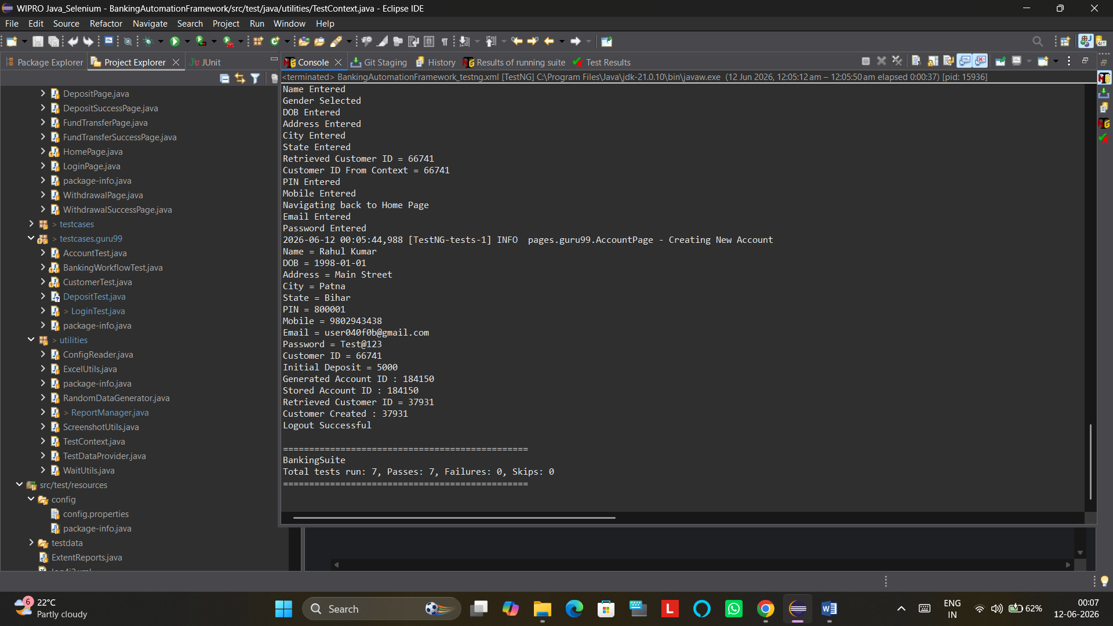
Jenkins Outputs

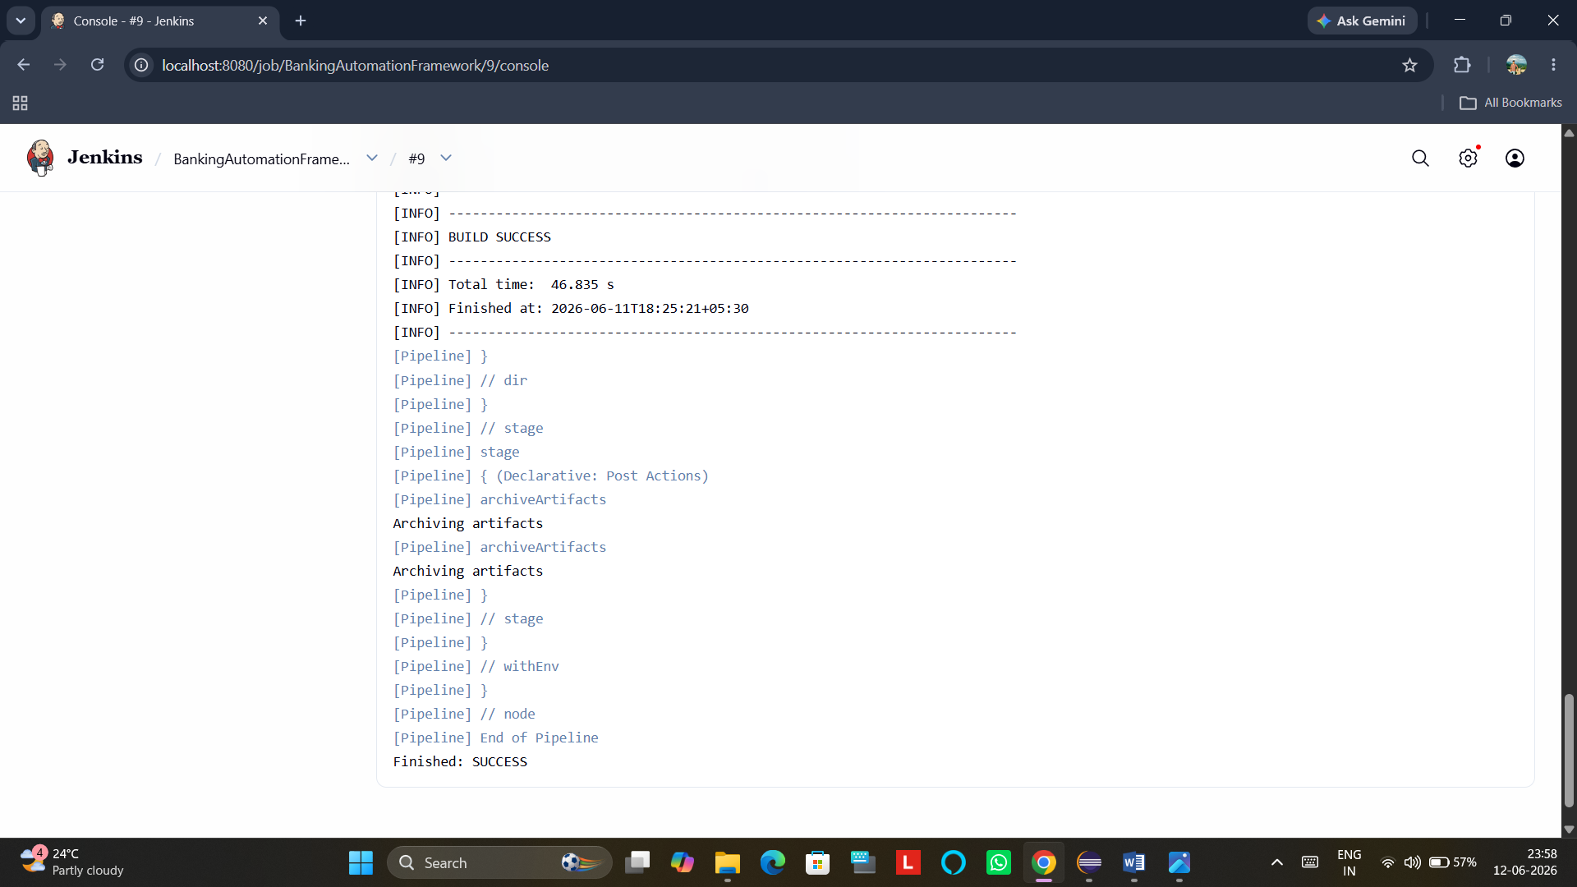

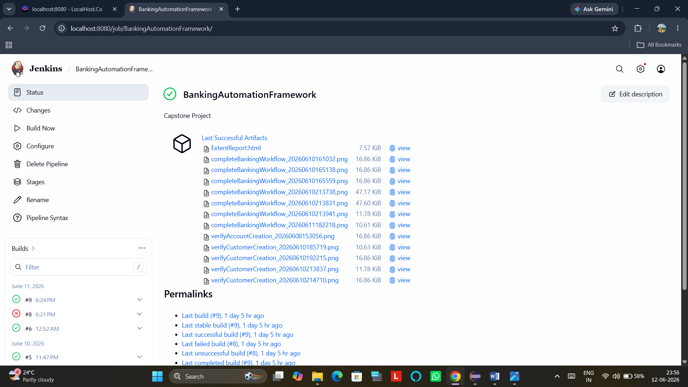

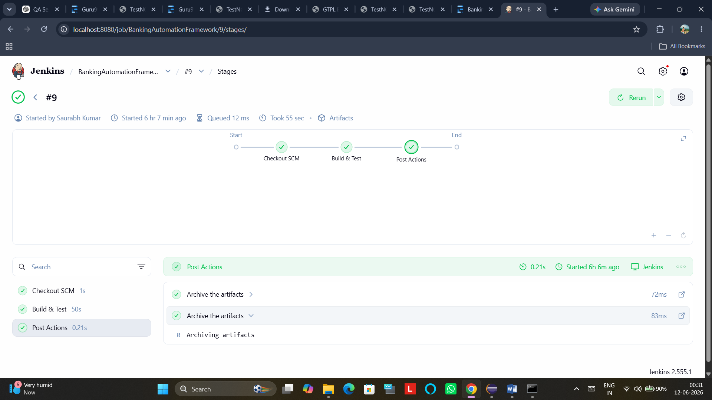

Git Build Data
Revision: abbc6a64c0d0a9cf25eebfcd35bc09acae3156b0
Repository: https://github.com/Saurabhshbm/Capstone_Project_Guru99.git
- refs/remotes/origin/master

Built Branches
- refs/remotes/origin/master: Build #9 of Revision abbc6a64c0d0a9cf25eebfcd35bc09acae3156b0 (refs/remotes/origin/master)

Docker Output:-
