Guru99 Banking Automation Framework - Test Analysis Report
GitHub URL: https://github.com/Saurabhshbm/Capstone_Project_Guru99.git

Project Information
Project Name: Guru99 Banking Automation Framework
Automation Tool: Selenium WebDriver
Programming Language: Java
Test Framework: TestNG
Build Tool: Maven
Design Pattern: Page Object Model (POM)
Reporting Tool: Extent Reports
CI/CD Tool: Jenkins
Containerization: Docker
Browser: Chrome
Environment: QA

Project Objective
To automate the functional testing of the Guru99 Banking Application using Selenium WebDriver and TestNG. The framework validates Login, Customer Management, Account Management, and End-to-End Banking Workflow.

Test Execution Summary
Total Test Cases Executed: 7
Passed: 7
Failed: 0
Skipped: 0
Pass Percentage: 100%

Module-wise Execution Status
Login Module: 3/3 Passed
Customer Module: 2/2 Passed
Account Module: 1/1 Passed
Banking Workflow Module: 1/1 Passed

Functional Test Scenarios
Login Module:
- Valid Login Verification
- Invalid Login Verification
- Empty Login Validation
Customer Module:
- Customer Creation Dataset 1
- Customer Creation Dataset 2
Account Module:
- Account Creation Verification
Banking Workflow Module:
- Complete End-to-End Banking Workflow Validation (including Deposit, Withdrawl, Log out)

Test Coverage Analysis
Functional Testing: 100%
Smoke Testing: 100%
Regression Testing: 100%
Negative Testing: 100%
UI Validation: 95%
Cross-Browser Testing: 50%
Cross Browser Status
• Chrome Browser Executed Successfully.
Edge Browser and Firefox Browser Configuration Available and Ready.
• Framework supports browser selection through configuration file.

Extent Report Analysis
The Extent Report dashboard provides a comprehensive overview of the execution results for the Guru99 Banking Automation Framework. It presents important execution details, including test start and end times, execution duration, graphical test statistics, execution timeline, and environment information. The report shows that all 7 automated test cases were executed successfully, achieving a 100% pass rate with no failed or skipped tests.
The report provides a detailed breakdown of each executed test case, covering functionalities such as Valid Login Verification, Invalid Login Validation, Empty Login Validation, Customer Creation using multiple datasets, Account Creation, and End-to-End Banking Workflow Validation (including Deposit, Withdrawal, Fund Transfer, Logout). Every test case is displayed with a Pass status along with its execution timestamp and duration, confirming the successful validation of all implemented banking functionalities.
The execution timeline visually represents the sequence and duration of each test execution, allowing easy monitoring of test performance and execution flow. The CompleteBankingWorkflow test consumed the highest execution time as it validates the entire business process from login to account creation.
Additionally, the report captures important environment details such as Project Name, Browser, Environment, Framework, CI/CD Tool, Containerization Platform, Operating System, and Java Version. These details help ensure traceability and provide a clear record of the execution environment.
Overall, the Extent Report serves as an effective reporting and monitoring tool by providing detailed execution insights, graphical test statistics, environment information, and execution timelines. The successful completion of all automated test cases demonstrates the stability, reliability, and correctness of the Guru99 Banking Automation Framework within the scope of the implemented test suite.

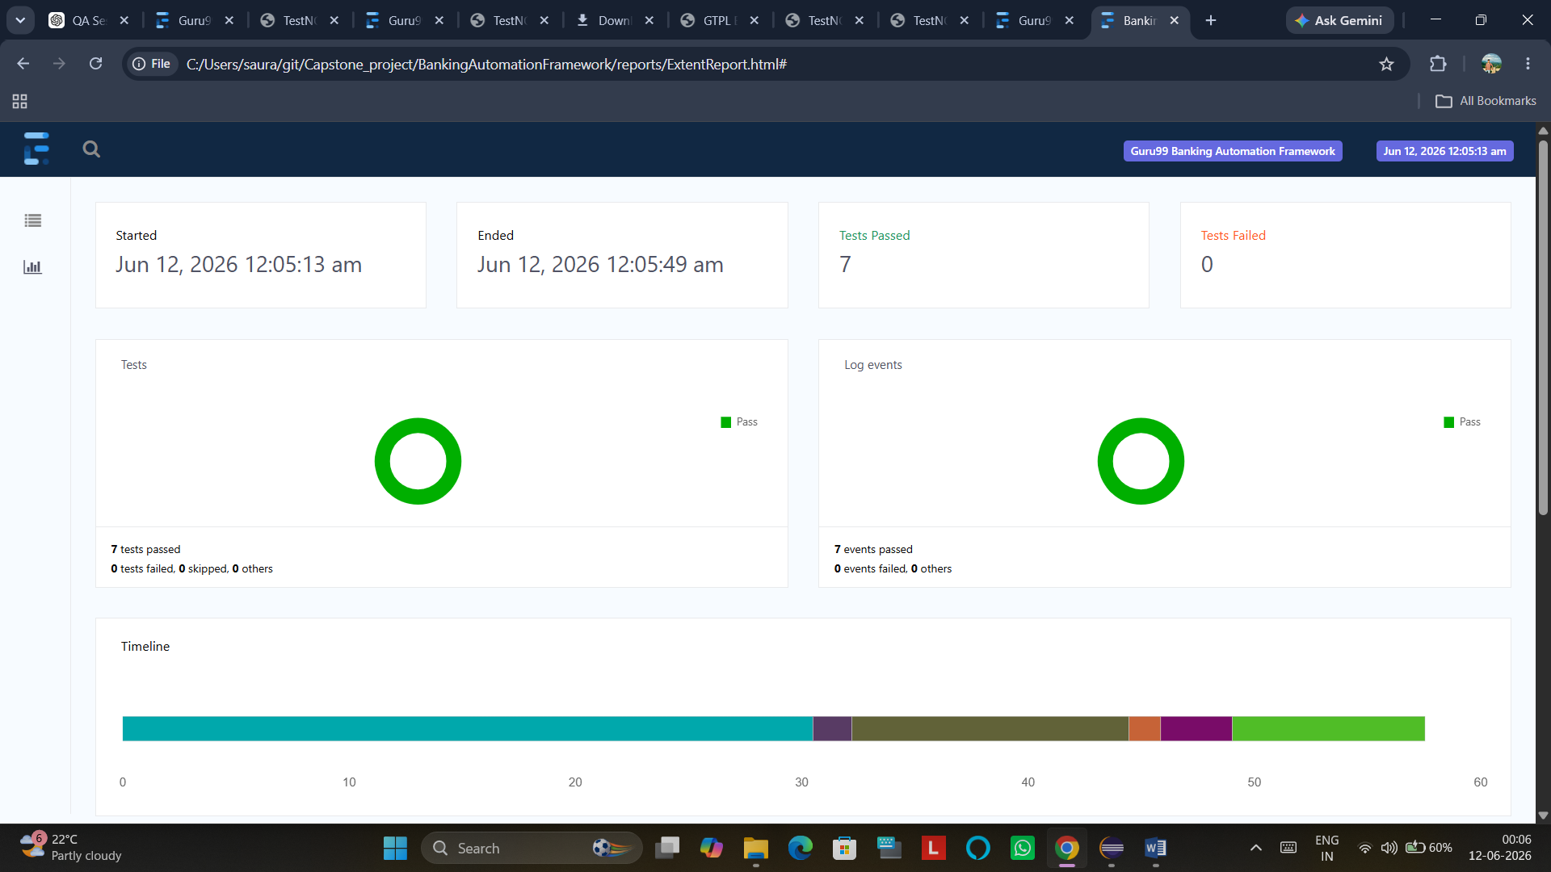
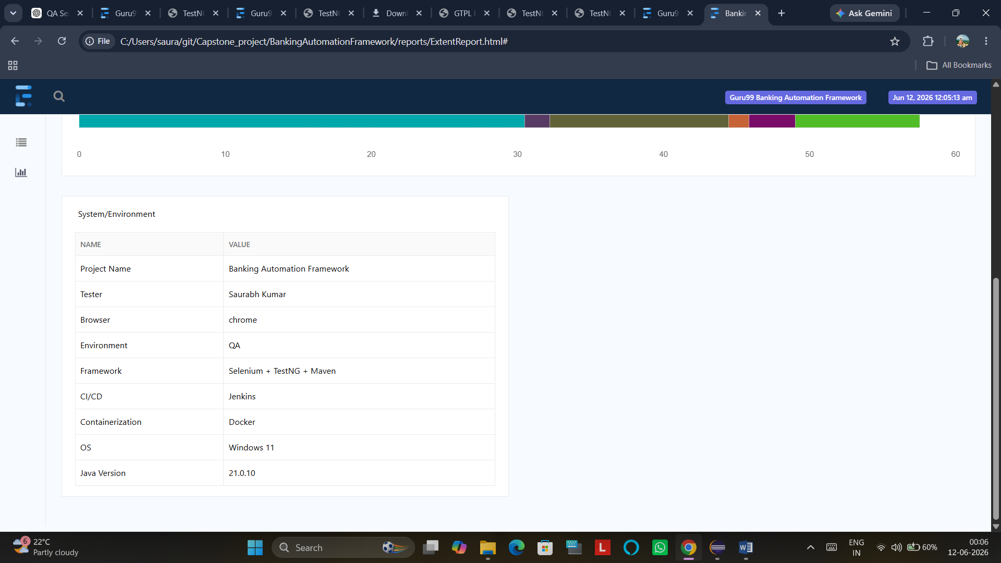
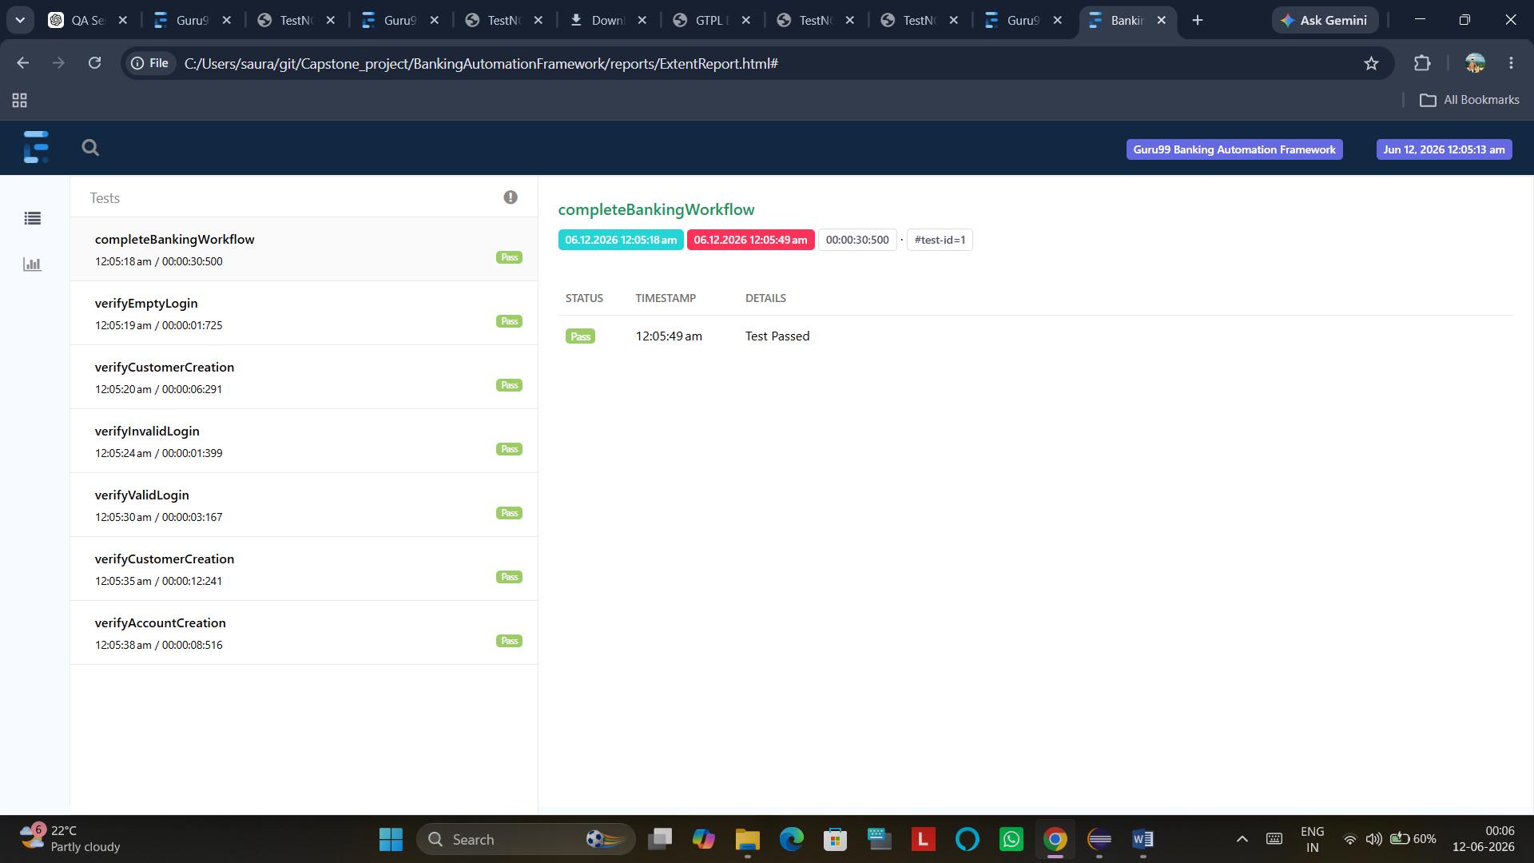

TestNG Report Anaylsis
The TestNG Report provides a comprehensive overview of the execution results for the Guru99 Banking Automation Framework. The report indicates that all 7 test methods were executed successfully, with 7 tests passing, 0 failures, 0 skipped tests, and 0 retries, demonstrating stable execution and successful validation of the implemented banking functionalities.
The executed test cases cover key application features including Valid Login Validation, Invalid Login Validation, Empty Login Validation, Customer Creation using multiple datasets, Account Creation, and Complete Banking Workflow Validation (including Deposit, Withdrawal, Fund Transfer, Logout). The use of TestNG DataProvider enabled the Customer Creation functionality to be validated with multiple sets of test data, ensuring broader test coverage and data-driven testing capability.
Each test method is displayed with a green pass status, confirming that the actual application behaviour matched the expected results during execution. The report also provides a structured view of the executed test classes and methods, making it easy to track test execution and verify individual test outcomes.
The successful execution of all automated test cases demonstrates the effectiveness of the automation framework and confirms the stability, reliability, and functional correctness of the Guru99 Banking Application within the scope of the implemented test suite. The report further validates that the Selenium WebDriver, TestNG framework, Page Object Model implementation, and supporting automation components are functioning correctly and producing consistent results.

