WEEK 3 REPORT
Advanced Data Analysis and Visualization in Logistics
Exploratory Data Analysis, Visualization and Operational Insights
Logistics Data Analyst Internship
Prepared by: Saurabh Kumar

1. Objective
This report explores the simulated logistics dataset using descriptive statistics, KPI analysis, correlation analysis, visualizations and clustering. The purpose is to identify operational patterns, cost drivers and potential bottlenecks.

2. Dataset Overview
The analytical dataset contains 1,500 simulated shipments with fields covering geography, shipping service, vehicle type, warehouse, weather, distance, shipment volume, fuel price, delivery time, scheduled delivery time, transport cost, order value and profit.

3. KPI Analysis
KPI | Simulated result
On-time delivery rate | 56.00%
Late delivery rate | 44.00%
Average delivery time | 3.56 days
Average transport cost | 1242.32
Average order value | 2332.97
Average profit | 977.08
The numerical results above are generated from the simulated dataset and are included to demonstrate the analytical process, not to represent a real logistics company's performance.

4. Visualization 1 — Delivery Time by Shipping Mode
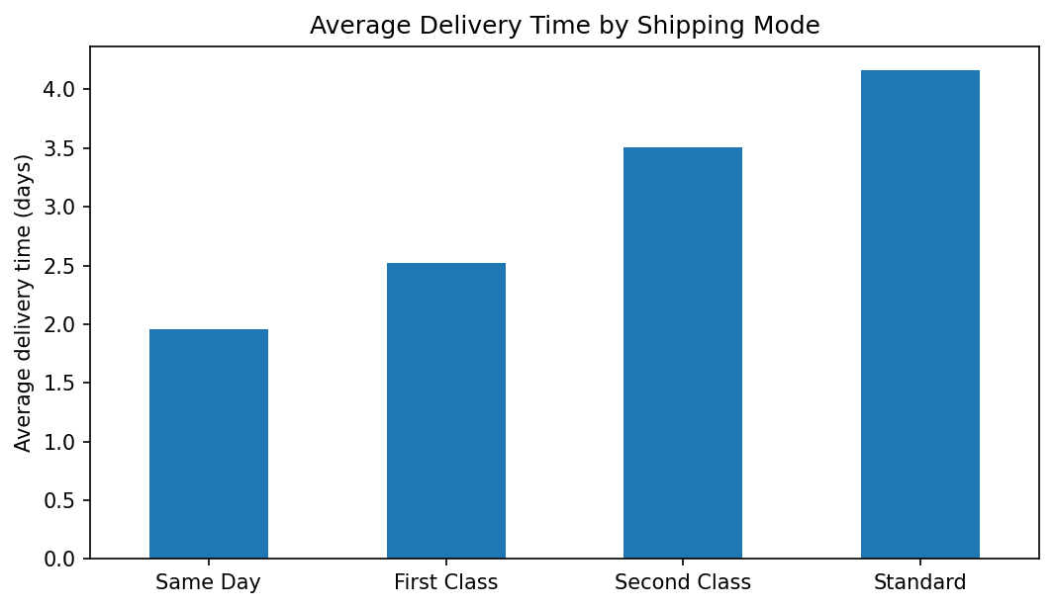
This bar chart compares average delivery duration across service levels. It helps analysts check whether observed delivery times align with service expectations and identify service categories that require deeper investigation.

5. Visualization 2 — Late Delivery Rate by Region
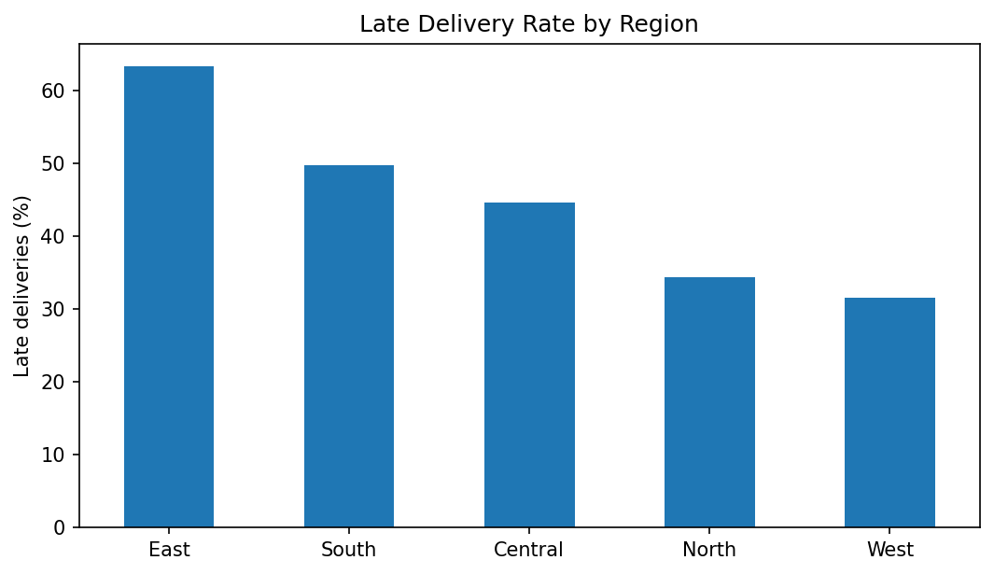
Regional comparison can highlight differences in route complexity, demand patterns, warehouse workload or operating conditions. The visualization identifies where further diagnostic analysis should be concentrated.

6. Visualization 3 — Distance and Delivery Time
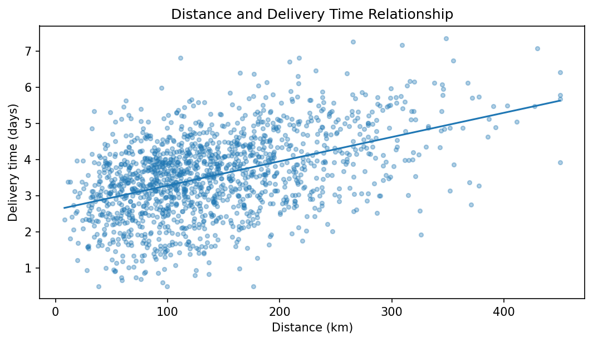
The scatter plot shows the relationship between route distance and delivery duration. The fitted trend line provides a simple visual indication of direction, while the dispersion demonstrates why additional variables are needed for accurate prediction.

7. Visualization 4 — Transport Cost Distribution
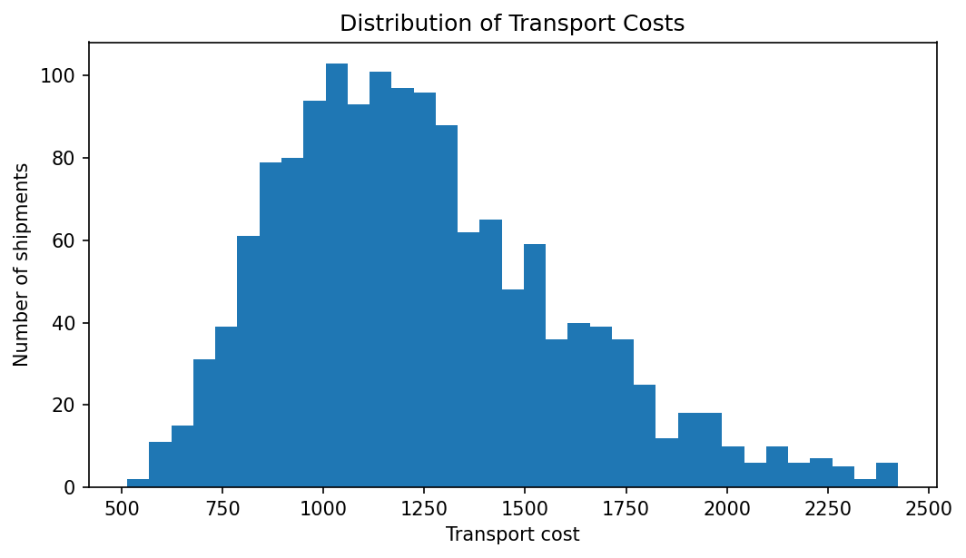
The histogram shows the distribution of modeled transport costs and can help identify the normal operating range and unusually expensive shipments.

8. Correlation Analysis
Variable | Correlation with delivery time
distance_km | 0.462
shipment_volume | 0.165
transport_cost | 0.495
order_value | 0.234
profit | 0.030
Correlation is an exploratory measure rather than proof of causation. Variables with strong relationships can be investigated further, while low pairwise correlation does not necessarily mean a variable lacks predictive value in a multivariable model.

9. Clustering Analysis
Cluster | Avg distance (km) | Avg volume | Avg cost | Avg delivery (days)
0 | 103.4 | 24.7 | 1011.9 | 3.22
1 | 127.8 | 62.9 | 1477.0 | 3.72
2 | 256.4 | 30.4 | 1655.2 | 4.34
K-means clustering groups shipments with similar operational characteristics. In a real deployment, the number of clusters should be selected using statistical diagnostics and business interpretability.

10. Python EDA Example
import matplotlib.pyplot as plt
late_rate = df.groupby("region")["late_delivery"].mean() * 100
late_rate.sort_values(ascending=False).plot(kind="bar")
plt.ylabel("Late deliveries (%)")
plt.title("Late Delivery Rate by Region")
plt.tight_layout()
plt.show()

11. Analytical Insights
- Delivery performance should be compared with the promised service level rather than evaluated only by absolute delivery time.
- Regional differences can reveal operational bottlenecks that require investigation of warehouse, route and weather variables.
- Distance is an important explanatory variable, but delivery performance depends on multiple interacting factors.
- Cost distributions can help identify high-cost shipment segments for route and vehicle review.
- Clustering can support differentiated operational policies for distinct shipment profiles.

12. Conclusion
EDA converts raw logistics records into interpretable evidence. Combining KPI summaries, distributions, relationships and segmentation provides a practical foundation for the predictive modeling and optimization work in Week 4.

Submission Description
This Week 3 report presents the advanced data analysis and visualization stage of the Logistics Data Analyst internship. The objective is to demonstrate how exploratory data analysis can convert logistics records into operational insights. A reproducible simulated dataset containing 1,500 shipment records is analyzed using Python, pandas, matplotlib and scikit-learn.
The report begins with a KPI analysis covering on-time delivery rate, late-delivery rate, average delivery time, average transportation cost, average order value and average profit. These metrics provide a structured view of service reliability, operational speed and cost performance. The report then presents multiple visualizations designed for specific analytical questions. Average delivery time is compared across shipping modes, late-delivery rates are compared across regions, the relationship between route distance and delivery time is visualized with a scatter plot, and the distribution of transportation costs is examined using a histogram.
Correlation analysis is included to explore relationships between delivery time and other numerical variables. The report also demonstrates K-means clustering to create operational shipment profiles based on distance, shipment volume and transportation cost. Each visualization and analytical technique is accompanied by an explanation of how it supports logistics interpretation. Finally, the report summarizes practical insights related to service levels, regional performance, distance, cost drivers and shipment segmentation. All numerical results are explicitly based on the simulated dataset and are intended to demonstrate analytical methodology rather than claim real-world company performance.

GitHub Project URL
https://github.com/Saurabhtbj1201/logistics-data-analyst-internship

