Maharaja Ranjit Singh College, Indore
Industrial Internship Report on
“Student Performance Management System”
Prepared by
Sauraf Kumar

Executive Summary
This report provides details of the Industrial Internship provided by upskill Campus and The IoT Academy in collaboration with Industrial Partner UniConverge Technologies Pvt Ltd (UCT).
This internship was focused on a project/problem statement provided by UCT. We had to finish the project including the report in 6 weeks’ time.
My project was the Student Performance Management System — a Python-based application designed to efficiently manage student academic records. It automates adding student details, calculating totals, averages, and assigning grades. The system generates comprehensive reports and stores data persistently in CSV format using a modular architecture with NumPy and Pandas.
This internship gave me a very good opportunity to get exposure to Industrial problems and design/implement solution for that. It was an overall great experience to have this internship.

TABLE OF CONTENTS
1 Preface 3
2 Introduction 4
2.1 About UniConverge Technologies Pvt Ltd 4
2.2 About upskill Campus 8
2.3 Objective 9
2.4 Reference 9
2.5 Glossary 10
3 Problem Statement 11
4 Existing and Proposed solution 12
5 Proposed Design/ Model 13
5.1 High Level Diagram (if applicable) 13
5.2 Low Level Diagram (if applicable) 13
5.3 Interfaces (if applicable) 13
6 Performance Test 14
6.1 Test Plan/ Test Cases 14
6.2 Test Procedure 14
6.3 Performance Outcome 14
7 My learnings 15
8 Future work scope 16

Preface
During this 6-week industrial internship, I worked on developing the Student Performance Management System — a Python-based application for efficient academic record management. The program was structured with weekly milestones covering requirements gathering, system design, implementation, testing, and documentation.
In today’s competitive job market, practical internship experience is essential for bridging the gap between academic knowledge and real-world software development. This internship provided an opportunity to apply Python programming concepts, modular architecture, and data analysis techniques in a professional setting.
My project, the Student Performance Management System, is a Python application that automates student record management — handling grade calculations using NumPy, generating reports with Pandas DataFrames, and storing data persistently in CSV format. The system follows professional modular architecture separating core logic, models, services, and utilities.
The opportunity provided by upskill Campus (USC) and UniConverge Technologies Pvt Ltd (UCT) enabled hands-on exposure to industrial software development practices, real-world problem-solving, and professional project structuring that are not typically covered in academic coursework.
The 6-week program was planned with a structured approach: Week 1 focused on understanding the problem statement and requirements; Weeks 2–3 on designing the modular architecture and implementing core modules; Weeks 4–5 on integrating services, testing, and refining features; Week 6 on documentation and final report preparation.
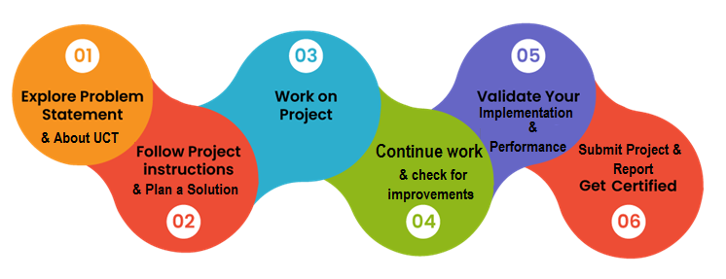
This internship significantly enhanced my understanding of Python programming, modular software design, data analysis with NumPy and Pandas, and version control with Git and GitHub. It was an enriching experience that boosted both my technical skills and professional confidence.
I would like to sincerely thank the team at UniConverge Technologies Pvt Ltd and upskill Campus for their guidance and support throughout this internship. Special thanks to my mentors and peers who helped directly and indirectly in the successful completion of this project.
To my juniors and peers: I encourage you to actively seek out internship opportunities like this one. Practical experience with real projects will accelerate your growth far beyond what classroom learning alone can offer. Embrace challenges, stay curious, and always structure your code professionally.

Introduction

About UniConverge Technologies Pvt Ltd
A company established in 2013 and working in Digital Transformation domain and providing Industrial solutions with prime focus on sustainability and RoI.
For developing its products and solutions it is leveraging various Cutting Edge Technologies e.g. Internet of Things (IoT), Cyber Security, Cloud computing (AWS, Azure), Machine Learning, Communication Technologies (4G/5G/LoRaWAN), Java Full Stack, Python, Front end etc.

- UCT IoT Platform ()
UCT Insight is an IOT platform designed for quick deployment of IOT applications on the same time providing valuable “insight” for your process/business. It has been built in Java for backend and ReactJS for Front end. It has support for MySQL and various NoSql Databases.
- It enables device connectivity via industry standard IoT protocols - MQTT, CoAP, HTTP, Modbus TCP, OPC UA
- It supports both cloud and on-premises deployments.
It has features to
• Build Your own dashboard
• Analytics and Reporting
• Alert and Notification
• Integration with third party application(Power BI, SAP, ERP)
• Rule Engine

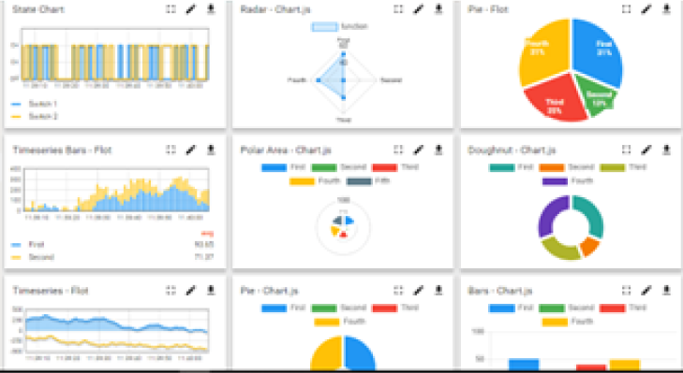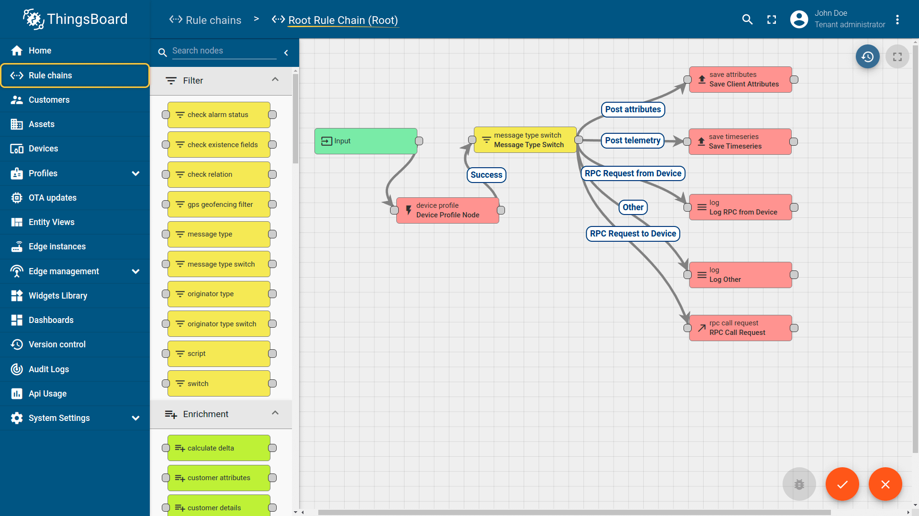

- Smart Factory Platform ()
Factory watch is a platform for smart factory needs.
It provides Users/ Factory
- with a scalable solution for their Production and asset monitoring
- OEE and predictive maintenance solution scaling up to digital twin for your assets.
- to unleased the true potential of the data that their machines are generating and helps to identify the KPIs and also improve them.
- A modular architecture that allows users to choose the service that they what to start and then can scale to more complex solutions as per their demands.
Its unique SaaS model helps users to save time, cost and money.
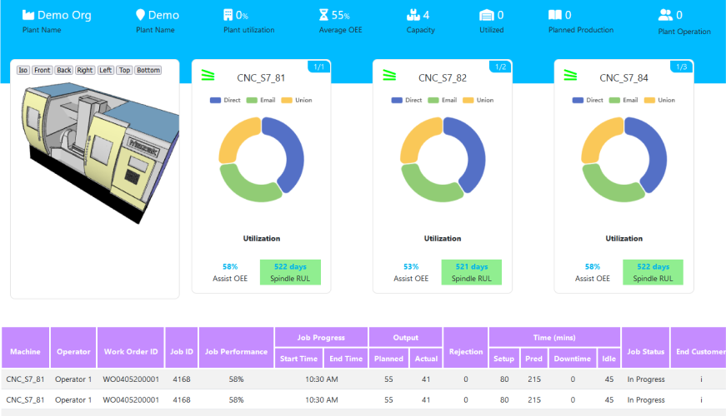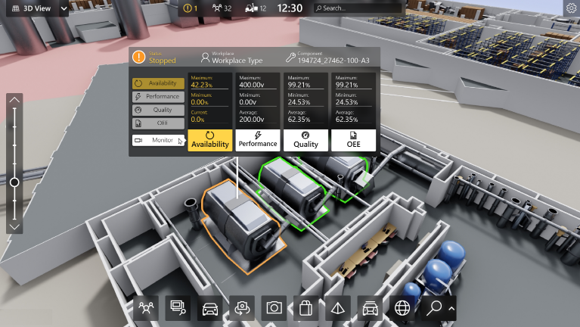

- 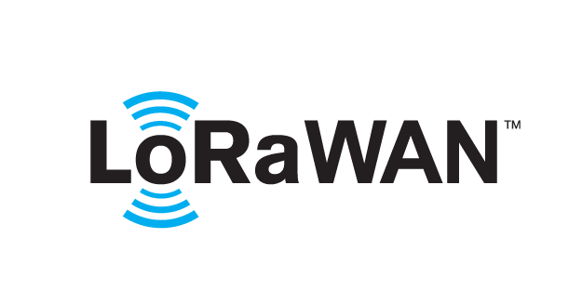 based Solution
UCT is one of the early adopters of LoRAWAN teschnology and providing solution in Agritech, Smart cities, Industrial Monitoring, Smart Street Light, Smart Water/ Gas/ Electricity metering solutions etc.
- Predictive Maintenance
UCT is providing Industrial Machine health monitoring and Predictive maintenance solution leveraging Embedded system, Industrial IoT and Machine Learning Technologies by finding Remaining useful life time of various Machines used in production process.
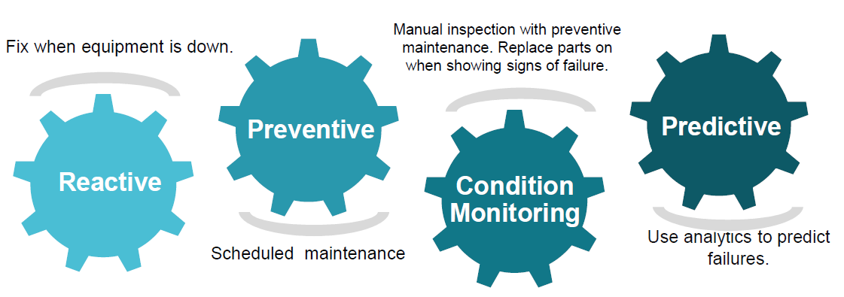

About upskill Campus (USC)
upskill Campus along with The IoT Academy and in association with Uniconverge technologies has facilitated the smooth execution of the complete internship process.
USC is a career development platform that delivers personalized executive coaching in a more affordable, scalable and measurable way.

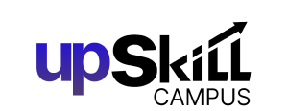


Seeing need of upskilling in self paced manner along-with additional support services e.g. Internship, projects, interaction with Industry experts, Career growth Services
https://www.upskillcampus.com/
upSkill Campus aiming to upskill 1 million learners in next 5 year

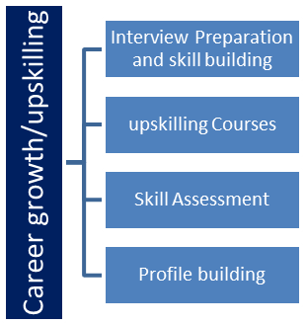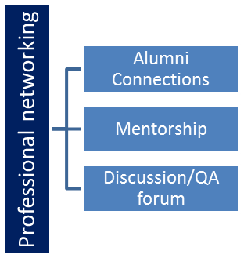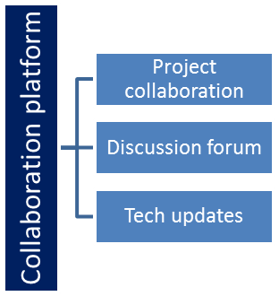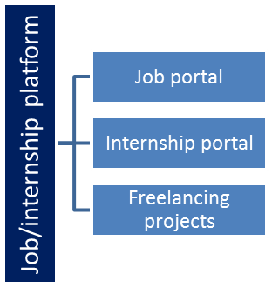

The IoT Academy
The IoT academy is EdTech Division of UCT that is running long executive certification programs in collaboration with EICT Academy, IITK, IITR and IITG in multiple domains.

Objectives of this Internship program
The objective for this internship program was to
☛ get practical experience of working in the industry.
☛ to solve real world problems.
☛ to have improved job prospects.
☛ to have Improved understanding of our field and its applications.
☛ to have Personal growth like better communication and problem solving.

Reference
[1] Python Software Foundation, “Python 3 Documentation,” https://docs.python.org/3/
[2] NumPy Developers, “NumPy Documentation,” https://numpy.org/doc/
[3] The Pandas Development Team, “pandas Documentation,” https://pandas.pydata.org/docs/

Glossary
Terms | Acronym
SPMS | Student Performance Management System
CSV | Comma-Separated Values — lightweight file format used for persistent data storage
GPA | Grade Point Average — measure of academic performance
OOP | Object-Oriented Programming — programming paradigm used in the modular design
UCT | UniConverge Technologies Pvt Ltd — Industrial partner providing the project

Problem Statement
In the assigned problem statement, educational institutions face significant challenges in manually managing student academic records. The manual process of maintaining student scores, calculating averages and grades, and generating performance reports is time-consuming and prone to human error. There was a clear need for an automated, reliable, and scalable system that could efficiently handle student data management, automate grade calculations, and generate comprehensive performance reports while storing data persistently for long-term access.
The core challenge was to design and implement a Python application that automates the entire student performance lifecycle: from data entry and validation, through grade computation using standardized thresholds (A+: 90+, A: 75–89, B: 60–74, C: below 60), to report generation and persistent CSV-based storage. The system also needed to support search functionality and identify top performers efficiently.

Existing and Proposed solution

Existing solutions such as spreadsheet-based management (Microsoft Excel, Google Sheets) require manual formula entry and are not scalable for large datasets. Commercial Learning Management Systems (LMS) like Moodle are complex, expensive, and over-engineered for small institutions. Simple database-backed tools lack user-friendly interfaces and require SQL expertise. These solutions are limited by manual effort, lack of automation, poor modularity, and absence of integrated performance analysis.
The proposed solution is a Python-based Student Performance Management System with a menu-driven interface that automates all aspects of student record management. It uses NumPy for efficient grade calculations and Pandas for generating formatted performance reports. Data is stored persistently in CSV files, making it lightweight and portable without requiring a database server.
The key value additions of this system include: (1) Professional modular architecture separating core, models, services, data, and utils layers; (2) Automated grade assignment eliminating manual calculation errors; (3) Pandas-powered report generation with CSV export capability; (4) Input validation ensuring data integrity; (5) Search and top-performer filtering for quick access to student insights.

Code submission (Github link)

Report submission (Github link) : first make placeholder, copy the link.

Proposed Design/ Model

The Student Performance Management System follows a professional modular architecture that separates concerns into distinct layers. The application starts from main.py as the entry point, which initializes the system and triggers core/app.py. The app module manages the complete workflow through a menu-driven loop, coordinating all services. Student data is modeled in models/student.py, calculations are handled by services/calculator.py using NumPy, reports are generated by services/report.py using Pandas, and search operations are handled by services/search.py. Data persistence is managed by data/storage.py through CSV file operations, while utils/ provides input validation and menu display utilities.

High Level Diagram (if applicable)

Figure 1: HIGH LEVEL DIAGRAM OF THE SYSTEM

Low Level Diagram (if applicable)

Interfaces (if applicable)
The system workflow follows a menu-driven design: Start → Display Menu → User Choice → Perform Operation → Calculate Results → Store/Display Data → Return to Menu. The grading interface uses a threshold-based algorithm: Average = (Math + Science + English) / 3; Grade A+ for 90+, A for 75–89, B for 60–74, C for below 60. The storage interface reads/writes student records as CSV rows with fields: Name, Math, Science, English, Total, Average, Grade. Input validation enforces marks within 0–100 range and non-empty name fields.

Performance Test

The performance testing of the Student Performance Management System evaluated key constraints relevant to a data management application: accuracy of grade calculations, speed of report generation, and data integrity across CSV read/write operations.
Key constraints identified for this system include: (1) Calculation accuracy — grade assignments must be 100% correct; (2) Data integrity — CSV read/write must not corrupt or lose records; (3) Input validation — marks must be within 0–100 range with no empty fields; (4) Report generation speed — Pandas DataFrame rendering should complete within acceptable time for the expected dataset size.
These constraints were addressed through: NumPy-based calculations ensuring floating-point precision for averages; exception handling (try/except) blocks in storage.py preventing CSV corruption; validator.py enforcing range checks before any record is accepted; and Pandas DataFrame operations optimized for in-memory tabular data processing.
Test results confirmed: all grade assignments matched expected outputs based on the grading scale (e.g., Sauraf with Math: 88, Science: 90, English: 85 correctly received Average: 87.67 and Grade: A); CSV persistence correctly saved and reloaded all student records across sessions; invalid inputs (marks > 100 or empty names) were properly rejected with error messages; and report generation completed successfully for test datasets.
For large-scale deployment (1000+ students), the CSV storage model may become a bottleneck in terms of read/write speed and concurrent access. The recommendation is to migrate to MongoDB as planned in future enhancements, which would provide indexing, faster queries, and better scalability without impacting the core calculation and reporting logic.
Overall, the system performed reliably within the expected constraints for the internship scope, validating its readiness for small-to-medium scale academic use.

Test Plan/ Test Cases
The test plan covered the following cases: (1) Add a student with valid marks and verify correct Total, Average, and Grade assignment; (2) Attempt to add a student with marks outside 0–100 range and verify rejection; (3) Attempt to add a student with an empty name and verify error message; (4) Save records and reload the application to verify CSV persistence; (5) Search for a student by name and verify correct record retrieval; (6) Request top performers and verify only Grade A/A+ students are listed; (7) Generate a report and verify Pandas DataFrame output is correctly formatted.

Test Procedure
Each test case was executed by running the application from the terminal and navigating the menu-driven interface. For grade calculation tests, student records were entered with known marks and the computed output was compared against manually calculated expected values. For validation tests, boundary values (0, 100, -1, 101) were entered to verify the validator.py module’s response. For persistence tests, the application was restarted and the data/storage.py module was checked to confirm previously saved records were correctly loaded. For search and filter tests, existing records were queried to verify accurate retrieval.

Performance Outcome
All test cases passed successfully. Grade calculations were 100% accurate — verified with the example record: Name: Sauraf, Math: 88, Science: 90, English: 85, Total: 263, Average: 87.67, Grade: A. Input validation correctly rejected out-of-range marks and empty fields. CSV persistence maintained full data integrity across application restarts. Search and top-performer filter operations returned accurate results. Report generation produced correctly formatted Pandas DataFrames with all student metrics. The system demonstrated reliable functionality across all planned test scenarios.

My learnings

This internship provided comprehensive learning across technical and professional dimensions. On the technical side, I gained hands-on experience with Python programming concepts including variables and data types, conditional statements, loops, functions, lists and dictionaries, file handling with CSV, exception handling, and modular package architecture. I also learned to leverage NumPy for efficient numerical computations and Pandas for data analysis and report generation. Working with Git and GitHub taught me version control best practices essential for collaborative development. Professionally, this project helped me understand how real-world software is structured, how to separate concerns across modules, and how to write maintainable, scalable code. These skills directly strengthen my career prospects in software development, data engineering, and backend application development.

Future work scope

Several enhancements are planned for future iterations of this system: (1) Develop a web version using a Flask backend and React frontend for broader accessibility and a modern user interface; (2) Integrate MongoDB to replace CSV storage, enabling improved scalability, faster queries, and better data management for large student populations; (3) Expand analytics capabilities with data visualization including charts, graphs, and performance trend analysis using Matplotlib or Plotly; (4) Add user authentication and role-based access control so administrators, teachers, and students can access the system with appropriate permissions; (5) Implement email notification features to automatically alert students and parents about performance outcomes and grade updates.

