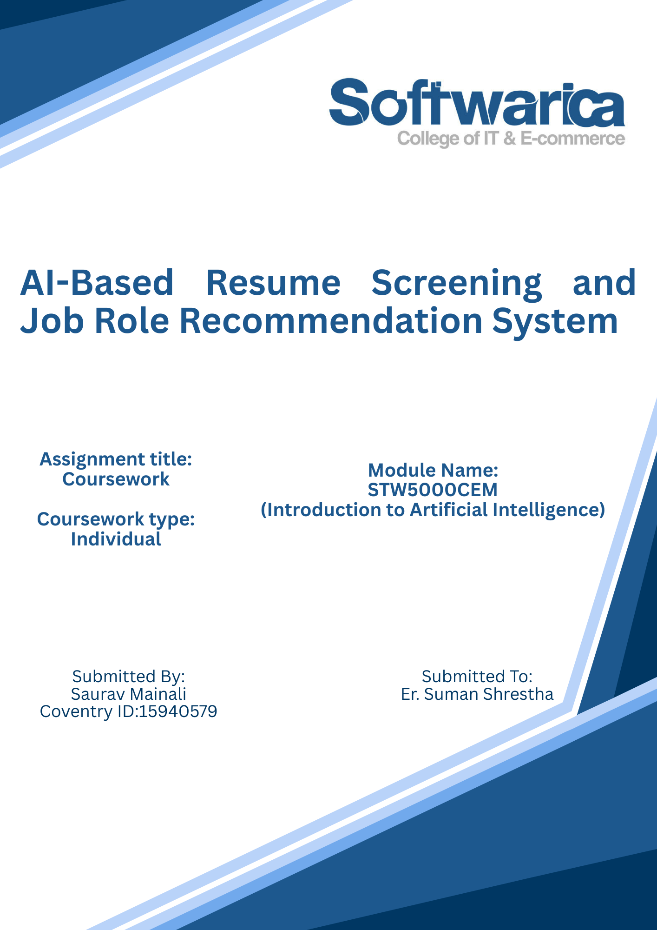

Acknowledgement

I would like to express my sincere gratitude to my module leader, Er. Suman Shrestha, for his guidance and support throughout this module. His expertise in Artificial Intelligence and practical teaching approach significantly contributed to my understanding of machine learning concepts and their real-world applications.
I also acknowledge the creators of the publicly available resume dataset and open-source Python libraries, including scikit-learn, pandas, and joblib, which enabled the practical implementation of this project. Finally, I am thankful to my peers for their collaborative discussions and academic support during the development of this coursework.

Abstract

Resume screening is a critical stage in the recruitment process, yet manual evaluation of resumes is time-consuming, inconsistent, and difficult to scale. With the increasing number of job applications received by organizations, automated solutions are necessary to enhance efficiency and decision-making accuracy. This project presents an AI-based Resume Screening and Job Role Recommendation System that integrates Natural Language Processing (NLP), machine learning classification, and rule-based skill matching techniques.
The system utilizes TF-IDF vectorization to transform resume text into numerical feature representations and applies a Logistic Regression classifier to categorize resumes into predefined job categories. In addition to classification, a weighted skill-matching mechanism compares candidate skills with predefined job role requirements to generate realistic job recommendations and identify missing competencies.
The model performance was evaluated using multi-class classification metrics including accuracy, precision, recall, F1-score, and confusion matrix analysis. The results demonstrate that the system can effectively classify resumes and provide meaningful job role suggestions. The proposed solution highlights the practical application of Artificial Intelligence in recruitment and career guidance, offering an efficient and scalable alternative to manual resume screening.

Table of Contents

Acknowledgement 2
Abstract 3
Table of Figures 5
Introduction 7
Background and Motivation 7
Problem Statement and Scope 8
Objective 9
Literature Review 10
Methodology 12
Overview 12
Data preprocessing 13
Feature Extraction using TF-IDF 15
Model Training using Logistic Regression 16
Why Logistic Regression? 17
Job Role Recommendation System 17
Model Evaluation 19
Critical Discussion 22
Strengths of the Proposed System 22
Observed Limitations 22
Comparison with Alternative Approaches 23
Real-World Applicability 23
Ethical Considerations 24
Limitations 25
Future Improvements 26
Version Control and Reproducibility 27
Conclusion 27

Table of Figures
Figure 1: Overall System Architecture of the AI-Based Resume Screening and Job 13
Figure 2: Distribution of Resume Categories in the Dataset. 14
Figure 3: Illustration of TF-IDF Vectorization Process. 15
Figure 4: Code Snippet 1 15
Figure 5: Code Snippet 2 17
Figure 6: Command-Line Interface Output for Job Role Recommendation. 19
Figure 7: Classification Performance Metrics of the Trained Model. 20
Figure 8: Confusion Matrix of Multi-Class Resume Classification. 21

Introduction

Artificial Intelligence (AI) is increasingly being used in many real-world applications, including recruitment and job recommendation systems. One of the most important steps in recruitment is resume screening, where recruiters analyze candidate resumes to determine whether they are suitable for specific job roles. However, manual resume screening is time-consuming, inefficient, and difficult to scale when there are a large number of applicants. This creates a need for automated systems that can analyze resumes and recommend suitable job roles efficiently.
This project presents an AI-based Resume Screening and Job Role Recommendation System that uses machine learning and skill matching techniques to analyze resume content. The system processes resume text, identifies important skills, and predicts suitable job categories using a trained machine learning model. In addition, the system compares the candidate’s skills with predefined job role requirements to recommend appropriate roles and identify missing skills that need improvement.
The system combines Natural Language Processing (NLP), machine learning classification, and rule-based skill matching to provide meaningful and realistic job recommendations. This helps job seekers understand which roles they are best suited for and what skills they need to develop further. The project demonstrates how artificial intelligence can be used to improve efficiency and decision-making in recruitment and career guidance.

Background and Motivation

With the rapid growth of the technology industry, companies receive a large number of job applications for every open position. Recruiters must manually review resumes to identify suitable candidates, which requires significant time and effort. This process becomes inefficient when handling hundreds or thousands of resumes.
Artificial Intelligence provides a solution by automatically analyzing resume content and identifying relevant skills and job categories. Machine learning models can learn patterns from existing resume datasets and use this knowledge to classify new resumes. In addition, skill-matching systems can compare candidate skills with job requirements to recommend suitable roles.
The motivation behind this project is to develop an intelligent system that helps users understand which job roles they are most suitable for and what skills they need to improve. This system can assist both job seekers and recruiters by providing faster and more accurate resume analysis.

Problem Statement and Scope

Manual resume screening is inefficient and may lead to errors, delays, and inconsistent decision-making. Job seekers often do not know which job roles best match their skills, and recruiters spend excessive time reviewing resumes.
The problem addressed in this project is to develop an automated system that can:
- Analyze resume text using machine learning
- Classify resumes into relevant job categories
- Recommend suitable job roles based on skills
- Identify missing skills required for specific roles
The scope of this project focuses on using machine learning and Natural Language Processing techniques to analyze resume text and provide job role recommendations. The system is designed as a command-line application that allows users to input their resume skills and receive recommendations.
This project does not include advanced features such as PDF parsing or real-time integration with job portals, but it demonstrates the core functionality of AI-based resume screening and recommendation.

Objective

The main objective of this project is to develop an AI-based Resume Screening and Job Role Recommendation System that helps users identify suitable job roles based on their skills.
The specific objectives are:
- To collect and preprocess a resume dataset for training
- To train a machine learning model to classify resumes into job categories
- To implement a skill-matching system that compares resume skills with job requirements
- To recommend suitable job roles based on resume analysis
- To identify missing skills and provide improvement suggestions
- To evaluate the model using performance metrics such as accuracy, precision, recall, and F1-score
The system aims to provide a simple, efficient, and practical solution for automated resume analysis and job role recommendation.

Literature Review

The use of Artificial Intelligence in recruitment has increased significantly in recent years due to the growing number of job applications and the need for efficient candidate screening. Traditional resume screening is performed manually by recruiters, which is time-consuming and may lead to inconsistent decision-making. To address this issue, researchers and organizations have explored machine learning and Natural Language Processing (NLP) techniques to automate resume analysis and job recommendation.
Resume screening can be considered a text classification problem, where resumes are categorized into predefined job roles based on their content. Several machine learning algorithms have been used for text classification tasks, including Naïve Bayes, Support Vector Machines (SVM), Logistic Regression, and Neural Networks. Among these, Logistic Regression has proven to be highly effective for high-dimensional textual data. It works efficiently with sparse feature representations and provides interpretable results. Compared to more complex models such as deep neural networks, Logistic Regression requires less computational power and is easier to implement, making it suitable for small to medium-sized datasets.
Before applying machine learning algorithms, textual data must be converted into numerical form. One of the most commonly used feature extraction techniques is Term Frequency–Inverse Document Frequency (TF-IDF). TF-IDF assigns weights to words based on their importance within a document relative to the entire dataset. Words that appear frequently in one resume but are rare across others receive higher weights, helping the model identify important technical skills such as programming languages and tools. TF-IDF is widely used in document classification tasks because it balances efficiency and effectiveness.
Recent advancements in NLP have introduced deep learning models such as Convolutional Neural Networks (CNNs), Recurrent Neural Networks (RNNs), and transformer-based models like BERT. These models can capture contextual meaning and semantic relationships between words. However, they require large datasets and significant computational resources. For structured resume datasets of moderate size, traditional machine learning methods combined with TF-IDF often provide reliable and efficient performance.
In addition to classification models, recommendation systems are often used to improve practical usability. While classification predicts a general category, recommendation systems can provide more personalized suggestions. Hybrid systems that combine machine learning predictions with rule-based skill matching enhance transparency and interpretability. In recruitment applications, interpretability is important because automated decisions directly impact individuals’ career opportunities.
Despite the benefits of AI-based resume screening, challenges remain. Similar job roles may share overlapping skills, leading to potential misclassification. Class imbalance can also affect model performance if certain categories have significantly more samples than others. Furthermore, automated systems must be carefully designed to minimize bias and ensure fair decision-making.
Overall, machine learning and NLP techniques provide an effective foundation for developing automated resume screening systems. By combining TF-IDF feature extraction, Logistic Regression classification, and rule-based skill matching, this project aims to implement a practical and interpretable AI-driven solution for job role recommendation.

Methodology

Overview
This project implements an AI-based Resume Screening and Job Role Recommendation System using a hybrid approach that combines machine learning with rule-based skill matching. The system follows a structured pipeline:
- Data loading and inspection of the raw resume dataset.
- Text preprocessing to remove noise (e.g., URLs, emails) and normalize technical terms, producing a cleaned dataset for learning.
- Feature extraction using TF-IDF to transform cleaned resume text into numerical vectors suitable for machine learning.
- Model training using Logistic Regression for multi-class resume category classification.
- Model evaluation using standard classification metrics and confusion matrix analysis.
- Interactive CLI interface that provides job role recommendations and improvement suggestions using weighted skill matching and machine learning confidence.
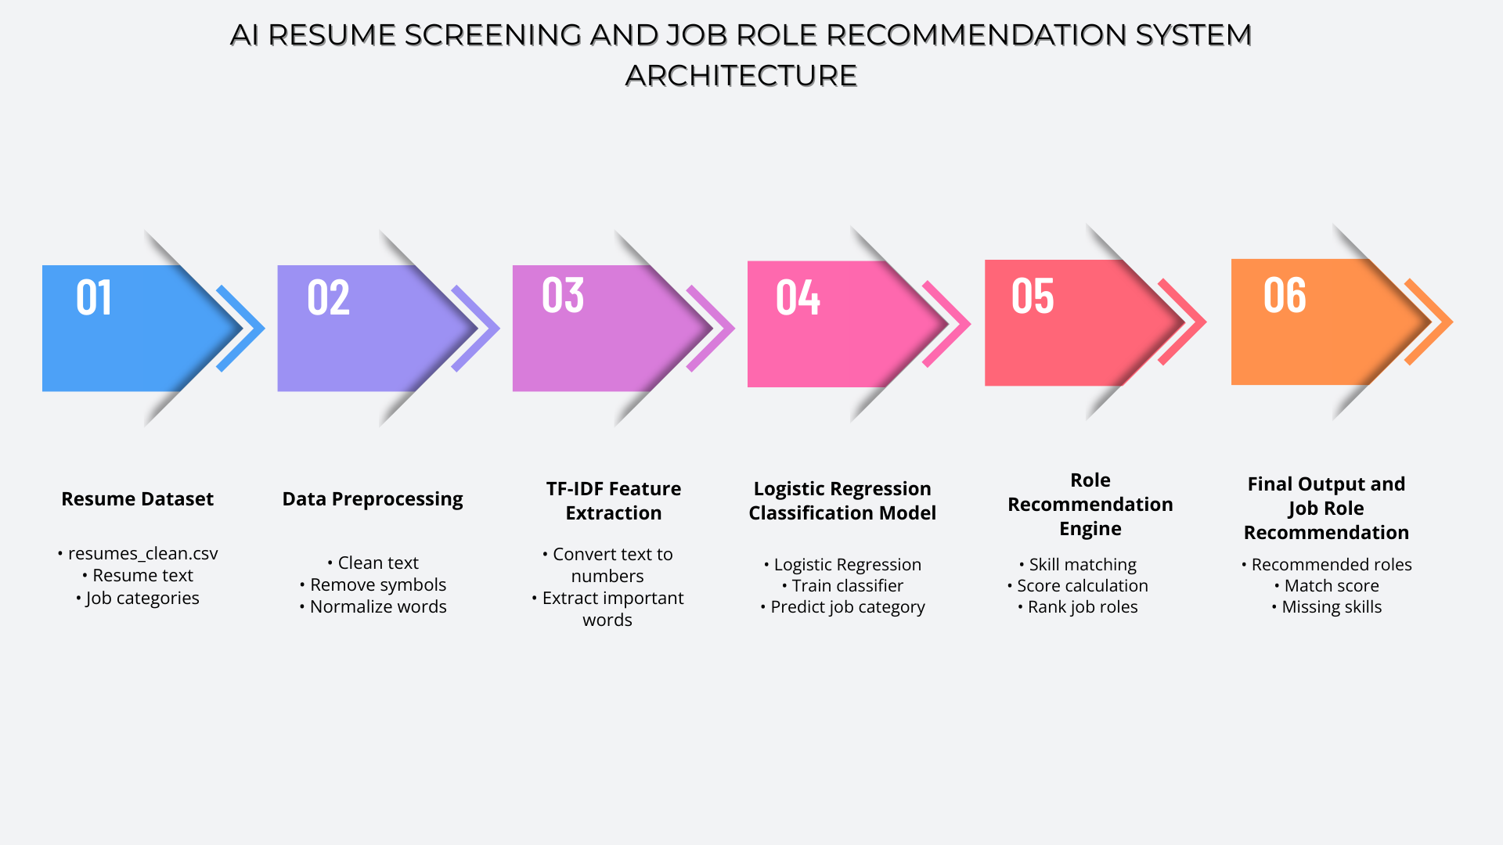
This methodology aligns with the coursework requirement to define an AI problem, prepare a dataset, implement an AI model, evaluate it with suitable metrics, and demonstrate the system through an interface.

Figure 1: Overall System Architecture of the AI-Based Resume Screening and Job

Data preprocessing

The raw resume dataset contains unstructured text with various symbols, formatting, and noise that cannot be directly used for machine learning. Therefore, data preprocessing was performed to clean and normalize the resume text. The preprocessing steps included converting all text to lowercase, removing special characters, removing URLs and unnecessary symbols, and normalizing technical terms. These steps help improve the quality of the data and ensure that the machine learning model can accurately learn patterns from the resume text. The cleaned resume text was then stored in a new file called resumes_clean.csv, which was used for model training and evaluation.

In addition to cleaning textual noise, preprocessing improves feature quality and reduces dimensional sparsity in the TF-IDF representation. Removing URLs and email addresses prevents the model from learning irrelevant patterns that do not contribute to job classification. Dropping rows with missing values ensures that incomplete samples do not introduce bias or unstable learning behavior.
Very short resumes were removed because they contain insufficient textual information for reliable classification. Including extremely short samples may introduce noise and reduce model generalization performance. By filtering low-information entries, the dataset becomes more consistent and representative of realistic resume content.
Furthermore, preserving technical tokens such as “C++”, “C#”, and “.NET” was important because these terms are highly discriminative features in technical job classification tasks. Retaining these tokens ensures that meaningful skill indicators are not lost during preprocessing.

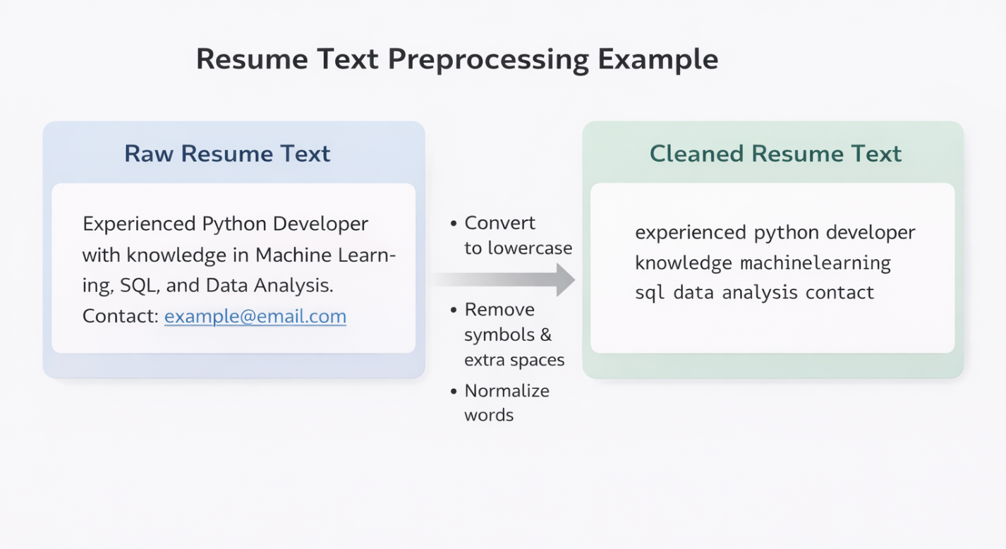
Figure 2: Distribution of Resume Categories in the Dataset.

Feature Extraction using TF-IDF

TF-IDF (Term Frequency–Inverse Document Frequency) was used to convert the cleaned resume text into numerical features. Machine learning models cannot understand text directly, so TF-IDF assigns numerical weights to words based on their importance in the resume. Words that appear frequently in a specific resume but are rare across other resumes receive higher importance scores. This helps the model identify key technical skills such as programming languages and tools. In this project, the TfidfVectorizer from the scikit-learn library was used with a maximum feature size of 5000. The resulting numerical vectors were used as input for training the Logistic Regression model.
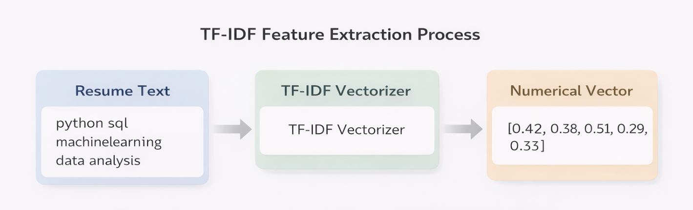
Figure 3: Illustration of TF-IDF Vectorization Process.

Figure 3 illustrates how TF-IDF converts resume text into numerical vectors. Each word is assigned a weight based on its importance, allowing the machine learning model to process and analyze resume content. This step is essential because machine learning algorithms require numerical input.
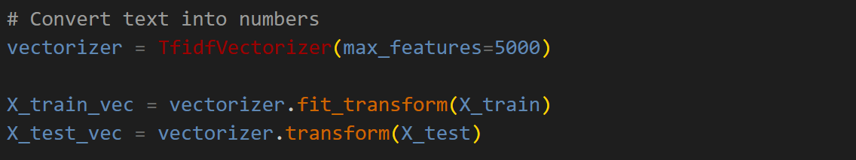
Figure 4: Code Snippet 1

Model Training using Logistic Regression

Logistic Regression was selected as the supervised machine learning algorithm to classify resumes into predefined job categories. It is widely used for multi-class classification problems and performs effectively in high-dimensional sparse feature spaces such as those produced by TF-IDF vectorization. In this project, the TF-IDF numerical representations of resume text were used as input features for the model.
The dataset was divided into training and testing sets using an 80:20 stratified split. Stratified sampling ensured that class distributions were preserved across both subsets, providing a reliable and balanced evaluation. The training set was used to learn the relationships between resume features and job categories, while the testing set was used to evaluate the model’s ability to generalize to unseen data. A fixed random_state value was applied to ensure reproducibility across multiple runs.
The Logistic Regression model was implemented using the scikit-learn library and configured with a maximum iteration limit of 1000. Increasing the iteration limit ensured proper convergence of the optimization algorithm, particularly given the high-dimensional TF-IDF feature space. The model was trained using the fit() function and later used to predict job categories through the predict() function.
By separating training and testing data, the risk of overfitting was reduced, ensuring that performance metrics reflect realistic generalization capability rather than memorization of training samples. After successful training, the model and TF-IDF vectorizer were serialized using the joblib library for reuse within the resume screening and recommendation system.

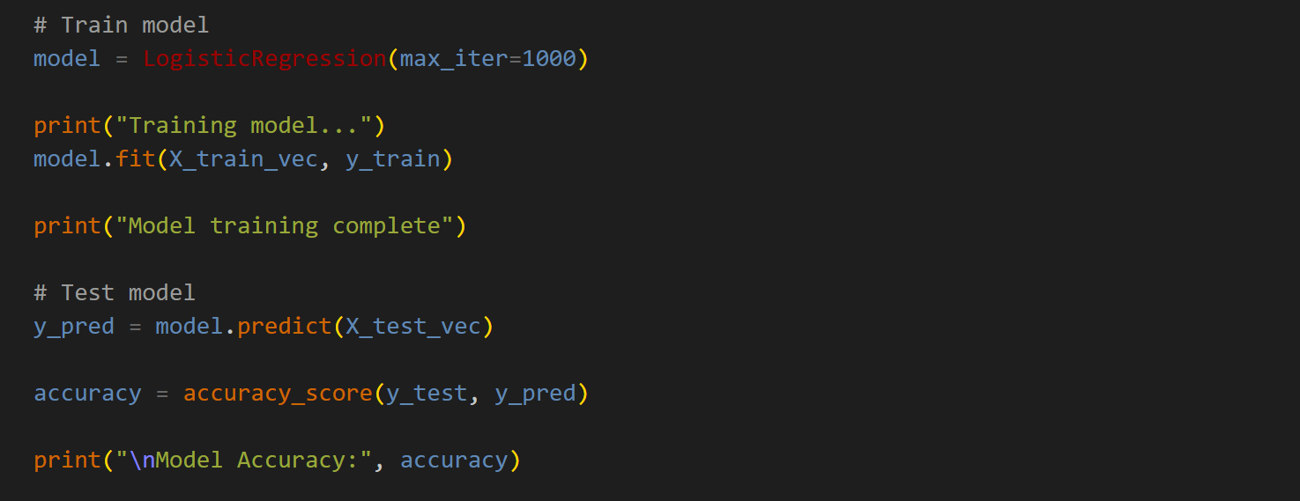
Figure 5: Code Snippet 2

Figure 5 shows the implementation of the Logistic Regression model used for training and prediction. The model learns from the TF-IDF features of the training data and predicts job categories for new resume inputs. This trained model forms the core classification component of the resume screening system.

Why Logistic Regression?

Logistic Regression was chosen because it performs well for text classification problems and provides efficient and accurate predictions. It works effectively with TF-IDF features and requires less computational power compared to more complex algorithms such as neural networks.

Job Role Recommendation System

The Job Role Recommendation System was implemented to recommend suitable job roles based on the candidate’s resume skills. While the Logistic Regression model predicts the job category, the recommendation system provides more practical and detailed suggestions by comparing the candidate’s skills with predefined job role requirements. Each job role contains a list of core skills and optional skills. The system extracts skills from the resume and compares them with the required skills for each role. Based on this comparison, the system calculates a match score and ranks job roles according to their suitability.

The recommendation system uses a weighted scoring method to calculate the suitability of each job role. Core skills are given higher importance compared to optional skills because they represent essential requirements for the job. The system calculates a score based on the number of matched core and optional skills and assigns a percentage value representing how well the resume matches the role. The system also identifies missing skills and provides suggestions to help users improve their job readiness. This approach makes the system more realistic and useful for real-world job recommendation scenarios.

The recommendation component uses a weighted scoring strategy to reflect realistic hiring requirements. For each job role, skills are divided into core skills (essential requirements) and optional skills (additional strengths). Core skills are weighted more heavily than optional skills because lacking core competencies usually makes a candidate unsuitable even if they match several optional skills. This weighted design improves interpretability by clearly showing which essential skills are missing and what improvements are most impactful.

To increase practical usefulness, the final output combines machine learning predictions with ATS-style skill matching. The Logistic Regression model provides a category “hint” based on learned patterns from the dataset, while the rule-based skill matching provides explicit, actionable feedback by comparing the user’s skills against predefined role requirements. This hybrid approach balances predictive capability with transparency, which is important in recruitment-related applications where users need to understand the reason behind recommendations.
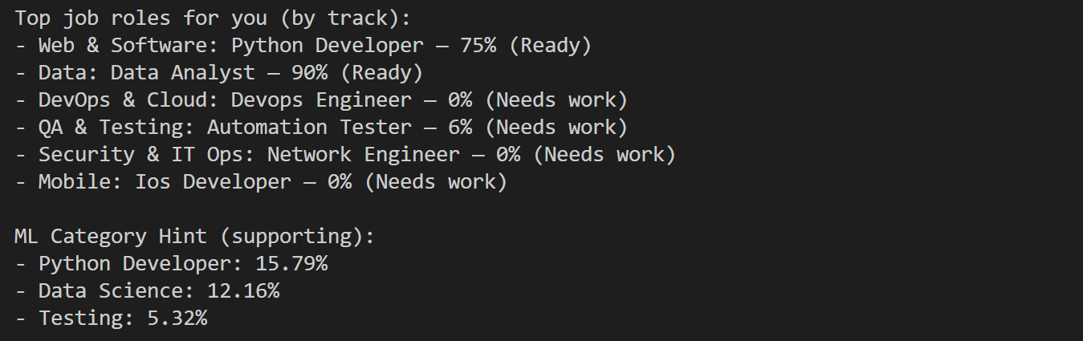
Figure 6: Command-Line Interface Output for Job Role Recommendation.

Model Evaluation
To evaluate the effectiveness of the proposed Resume Screening System, the trained Logistic Regression model was tested on a held-out test set comprising 20% of the dataset (193 resumes). The model achieved an overall accuracy of 99.48%, indicating that nearly all resumes were correctly classified into their respective job categories.
In addition to accuracy, macro and weighted evaluation metrics were computed to assess performance across multiple classes. The macro F1-score was 0.9945, while the weighted F1-score was 0.9949. The macro average treats all classes equally, whereas the weighted average accounts for class support (number of samples per class). The close similarity between macro and weighted F1-scores suggests that the model performs consistently across categories and is not heavily biased toward dominant classes.
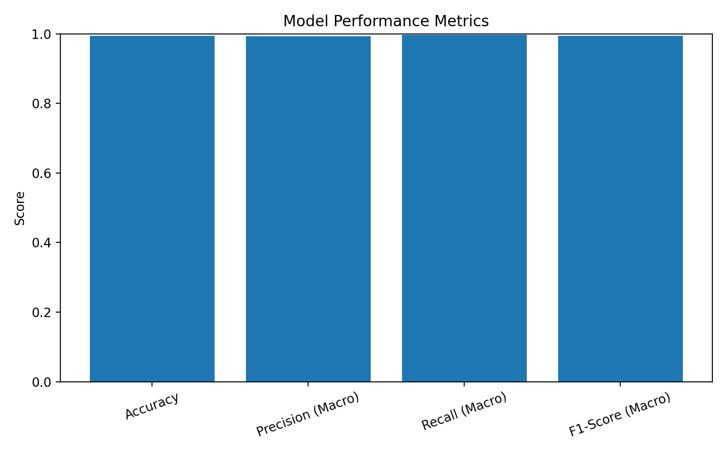
Figure 7: Classification Performance Metrics of the Trained Model.

The confusion matrix analysis revealed very few misclassifications. Most categories achieved perfect precision and recall scores. Minor classification confusion occurred in categories such as “Automation Testing” and “DevOps Engineer,” which may share overlapping technical skills such as scripting, testing frameworks, and deployment tools. This indicates that role similarity can occasionally affect model predictions.
The high classification performance can be attributed to several factors. First, resume text often contains explicit technical keywords (e.g., programming languages, tools, frameworks), which are highly discriminative features in TF-IDF representations. Second, Logistic Regression performs effectively in high-dimensional sparse feature spaces. Third, proper preprocessing and stratified sampling ensured consistent learning across categories.
Although performance is very high, it is important to note that real-world resumes may contain more diverse formatting and ambiguous skill descriptions. Therefore, while the model demonstrates strong performance on the available dataset, further testing on larger and more varied datasets would provide additional validation of robustness.
Overall, the results demonstrate that the proposed system achieves excellent classification accuracy and reliable generalization, supporting its practical applicability in automated resume screening.

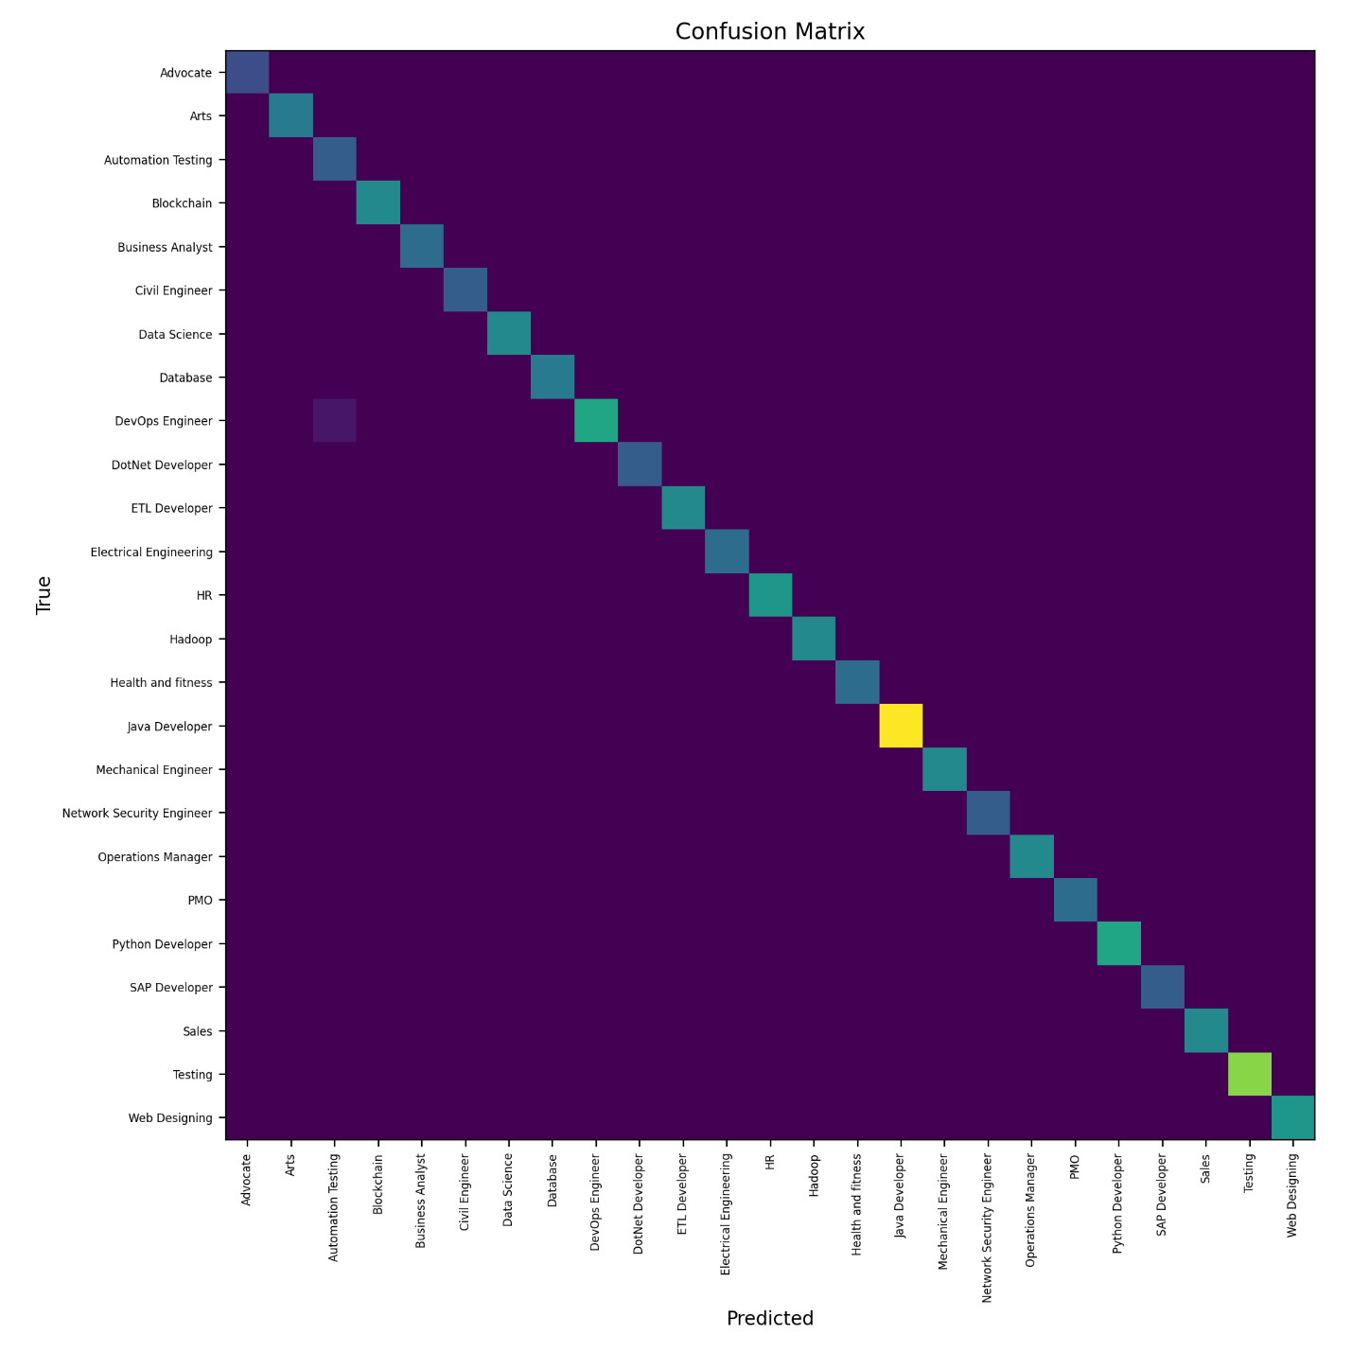
Figure 8: Confusion Matrix of Multi-Class Resume Classification.

The confusion matrix provides a visual representation of how well the model classified each job category. The diagonal values represent correct predictions, while off-diagonal values represent misclassifications. Due to the limited dataset size and the presence of multiple job categories, some misclassifications occurred between similar technical roles.

Critical Discussion

The proposed AI-based Resume Screening and Job Role Recommendation System demonstrates strong performance in multi-class classification tasks, achieving high accuracy and F1-scores across all categories. The results indicate that the combination of TF-IDF feature extraction and Logistic Regression is highly effective for structured resume datasets where job roles are distinguishable through technical keywords.

Strengths of the Proposed System
One of the primary strengths of the system is its simplicity and efficiency. Logistic Regression performs well in high-dimensional sparse feature spaces, making it well suited for TF-IDF representations. The model achieved an overall accuracy of 99.48% and macro F1-score of 0.9945, indicating strong generalization performance across categories.
Another key strength is the hybrid architecture combining machine learning classification with rule-based skill matching. While the classification model predicts the most likely job category, the skill-matching component provides interpretable feedback by identifying missing core competencies. This improves transparency and usability, which is particularly important in recruitment applications where decisions impact individuals’ career opportunities.
Additionally, stratified sampling during the train-test split ensures balanced representation of classes, improving reliability of performance metrics. The modular code structure and model serialization also support reproducibility and future scalability.

Observed Limitations

Despite strong performance, several limitations must be acknowledged.
First, the dataset consists of 962 resumes, which is moderate in size. Although the model performs well on this dataset, larger and more diverse real-world datasets may introduce additional complexity such as varied writing styles, informal language, or incomplete skill descriptions.
Second, certain job categories share overlapping skills (e.g., DevOps Engineer and Automation Testing), which may occasionally lead to minor misclassifications. This highlights a limitation of purely keyword-based TF-IDF approaches, which may struggle with nuanced contextual differences.
Third, TF-IDF treats each word independently and does not capture semantic relationships between terms. For example, synonyms or context-based meanings are not inherently modeled. More advanced techniques such as word embeddings or transformer-based architectures could potentially improve contextual understanding.
Finally, the extremely high classification accuracy may indicate that the dataset categories are strongly separable. While this benefits model performance, real-world resumes may be less structured and more ambiguous.

Comparison with Alternative Approaches

Alternative classification algorithms such as Naïve Bayes and Support Vector Machines could also be applied to this problem. Naïve Bayes is computationally efficient but relies on the assumption of feature independence, which may not always hold in resume text. Support Vector Machines can achieve strong performance but may require more computational resources and parameter tuning.
Deep learning approaches, including recurrent neural networks and transformer-based models, could potentially capture contextual meaning more effectively. However, these models require larger datasets, longer training times, and higher computational cost. For the dataset size used in this project, Logistic Regression provides an effective balance between accuracy, efficiency, and interpretability.

Real-World Applicability

The system demonstrates strong potential for practical application in recruitment support systems. Its ability to classify resumes accurately and provide actionable feedback through skill matching makes it suitable for use as an assistive tool for both recruiters and job seekers.
However, deployment in real-world environments would require additional validation, bias auditing, and integration with secure data handling mechanisms to ensure fairness and compliance with data protection regulations.

Ethical Considerations

The application of Artificial Intelligence in recruitment and resume screening introduces important ethical considerations. While automated systems can improve efficiency and consistency, they also have the potential to introduce bias or unfair decision-making if not carefully designed and evaluated.
One key concern is algorithmic bias. If the training dataset reflects historical hiring trends or imbalanced representation across certain roles, the model may learn patterns that unintentionally disadvantage particular groups or reinforce existing inequalities. Although the dataset used in this project is labeled by job category rather than demographic attributes, the possibility of indirect bias through language patterns cannot be fully eliminated.
Another ethical concern involves transparency and interpretability. In recruitment contexts, decisions directly affect individuals’ career opportunities. Therefore, it is important that automated systems provide understandable explanations rather than opaque predictions. The hybrid design of this system, which combines machine learning classification with rule-based skill matching, improves interpretability by explicitly identifying matched and missing skills.
Data privacy is also a critical consideration. Resumes often contain sensitive personal information, including contact details, employment history, and educational background. Any real-world deployment of such a system must comply with data protection regulations and ensure secure storage and processing of personal data.
Finally, automated systems should be viewed as decision-support tools rather than decision-makers. Human oversight remains essential to ensure fairness, contextual understanding, and responsible application of AI technologies.
Overall, while the proposed system demonstrates strong technical performance, ethical awareness and responsible implementation are necessary for safe and fair real-world adoption.

Limitations

Although the proposed Resume Screening and Job Role Recommendation System demonstrates strong classification performance, several limitations must be acknowledged.
First, the dataset used in this project consists of 962 resumes across multiple job categories. While this dataset is sufficient to train and evaluate a machine learning model, it may not fully represent the diversity and complexity of real-world resumes. Real recruitment datasets may contain varied formatting styles, inconsistent skill descriptions, spelling errors, and non-standard terminology, which could reduce model performance.
Second, the TF-IDF feature representation relies on word frequency and does not capture deeper semantic relationships between terms. For example, synonyms such as “software developer” and “software engineer” may not be treated as equivalent unless explicitly learned from the dataset. More advanced techniques such as word embeddings or transformer-based language models could potentially improve contextual understanding.
Third, the model assumes that resumes are clearly aligned with a single dominant job category. In practice, many candidates possess cross-disciplinary skills (e.g., data engineering and DevOps), which may lead to ambiguity in classification. Although the model provides high accuracy, it may oversimplify multi-skilled profiles by assigning them to only one primary category.
Additionally, the rule-based skill matching system depends on predefined lists of core and optional skills. While this improves interpretability, it requires manual updates to remain aligned with evolving industry requirements. Emerging technologies and tools would need to be added to maintain relevance.
Finally, the system has been implemented as a command-line interface for demonstration purposes. A real-world deployment would require integration with secure databases, scalable infrastructure, and user-friendly web interfaces to support large-scale adoption.
Despite these limitations, the system provides a strong foundation for automated resume classification and demonstrates the effective application of AI techniques in recruitment support systems.

Future Improvements

Although the proposed system demonstrates strong performance, several enhancements could further improve its robustness, scalability, and real-world applicability.
One potential improvement involves integrating more advanced Natural Language Processing techniques. Instead of relying solely on TF-IDF, future work could incorporate word embeddings such as Word2Vec or GloVe to capture semantic similarity between terms. More sophisticated transformer-based models such as BERT could also be explored to improve contextual understanding of resume content. These approaches may enhance performance on more diverse and ambiguous datasets.
Another improvement would be the implementation of cross-validation and hyperparameter tuning techniques such as Grid Search or Random Search. While the current model performs well, systematic optimization of hyperparameters (e.g., regularization strength, n-gram range, feature size) could further improve generalization and robustness.
The system could also be extended to support multi-label classification. Many real-world resumes reflect expertise across multiple domains. Allowing the model to assign multiple relevant categories would better represent candidates with interdisciplinary skill sets.
From a deployment perspective, the command-line interface could be upgraded to a web-based application with a graphical user interface. Integration with databases and cloud infrastructure would allow real-time resume screening at scale. Additionally, implementing user authentication and secure data handling mechanisms would be essential for practical deployment.
Future work could also incorporate fairness auditing mechanisms to detect potential bias across demographic groups. Monitoring model performance across different subsets of users would help ensure ethical and responsible AI implementation.
Overall, these improvements would enhance the system’s scalability, fairness, contextual understanding, and practical adoption in real-world recruitment environments.

Version Control and Reproducibility

To ensure reproducibility and organized development, the project was structured using modular Python scripts, separating functionality into data loading, preprocessing, model training, evaluation, and the command-line interface. This modular structure improves maintainability and allows independent testing of each component.
A fixed random_state parameter was used during the train-test split to ensure that dataset partitioning remains consistent across multiple runs. This guarantees that evaluation results are reproducible and not dependent on random variation. Additionally, stratified sampling was applied to preserve class distribution in both training and testing sets, ensuring reliable performance measurement.
The trained machine learning model and TF-IDF vectorizer were serialized using the joblib library and stored in a dedicated models directory. This allows the trained system to be reused without retraining, ensuring consistent predictions across executions.
All scripts were organized in a structured project directory, separating source code, datasets, trained models, and output files such as evaluation plots and logs. This directory structure supports clarity, debugging, and future expansion of the system.
For collaborative or real-world development environments, version control systems such as Git can be used to track code changes, maintain development history, and support reproducibility. Proper documentation and dependency management further enhance the reproducibility and maintainability of the project.
Overall, reproducibility practices implemented in this project ensure that the system’s results can be consistently regenerated and validated.

Conclusion
This project presented the design and implementation of an AI-based Resume Screening and Job Role Recommendation System using Natural Language Processing and machine learning techniques. The system was developed to address inefficiencies in manual resume screening by automating job category classification and providing interpretable role recommendations.
The methodology involved structured data preprocessing, TF-IDF feature extraction, and multi-class classification using Logistic Regression. The dataset consisted of 962 labeled resumes, which were split into training and testing subsets using an 80:20 stratified split to ensure balanced evaluation. The trained model achieved an accuracy of 99.48%, with macro and weighted F1-scores exceeding 0.99, demonstrating strong generalization performance across categories.
In addition to classification, the system incorporated a rule-based skill-matching mechanism to provide actionable feedback. This hybrid architecture enhanced interpretability by identifying matched and missing skills for specific job roles. The integration of machine learning predictions with weighted skill scoring improved transparency and practical usability.
While the system demonstrated excellent performance on the available dataset, limitations related to dataset size, contextual understanding, and real-world variability were acknowledged. Ethical considerations such as bias, fairness, and responsible AI usage were also discussed to highlight the importance of careful deployment in recruitment environments.
Overall, the project successfully demonstrates the practical application of Artificial Intelligence techniques in automated resume screening. The system achieves high classification accuracy, provides interpretable recommendations, and establishes a foundation for future enhancements involving advanced NLP models, scalable deployment, and fairness auditing. The results confirm that AI-driven approaches can significantly improve efficiency and consistency in recruitment support systems.

