**EXPERIMENT 1**

TITLE: DDL (Data Definition Language) commands

**Objective**: To understand the concept of designing issue related to the database with creating, populating the tables.

1.Create the tables described below:

Table name: **CLIENT_MASTER**

Description: used to store client information

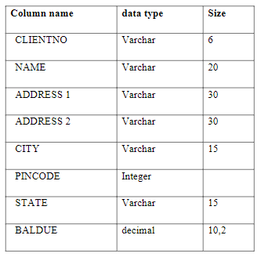

1: TABLE GIVEN IN MANUAL

Database Query:

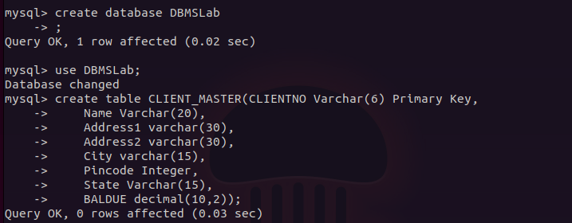

: Query Executed in MySQL

Description of Table:

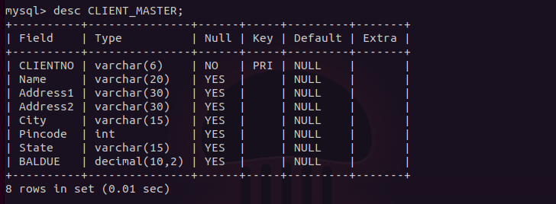

: Description of Table CLIENT_MASTER

**Table Name: PRODUCT_MASTER**

**Description:** used to store product information

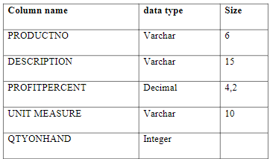

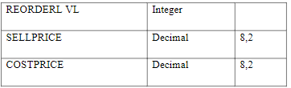

2: Table given in Lab Manual

Database Query:



2: Query Executed in MySQL

Description of Table:

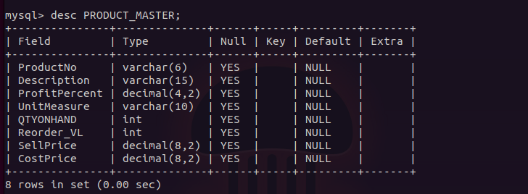

2: Description of Table PRODUCT_MASTER

**Table Name:** SALESMAN_MASTER

**Description:** Used to store salesman information working for the company.

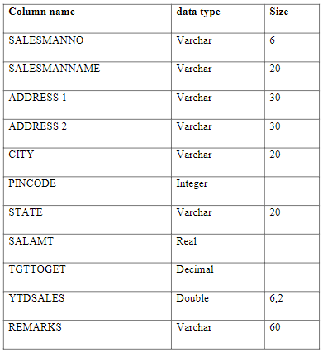

3: Table given in Lab Manual

Database Query:

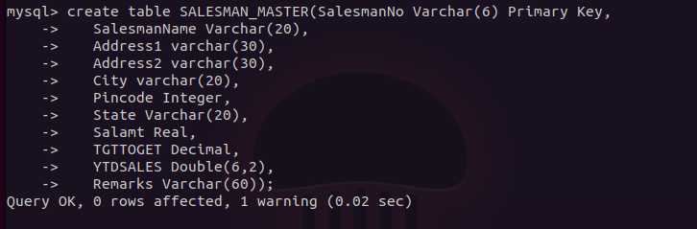

3: Query Executed in MySQL

Description of Table:

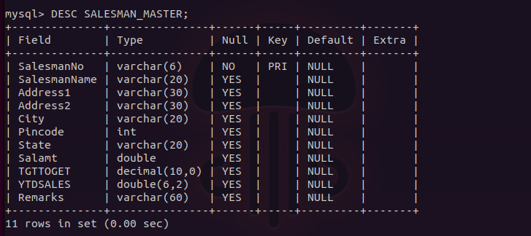

3: Description of Table SALESMAN_MASTER

2.Insert the data from Lab Manual into their respective tables:

a) Data for CLIENT_MASTER table:

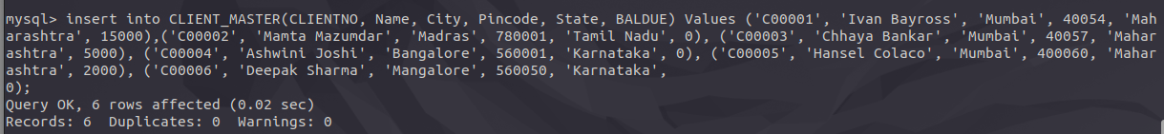

: Insertion Query of Table CLIENT_MASTER

b) Data for PRODUCT_MASTER table:

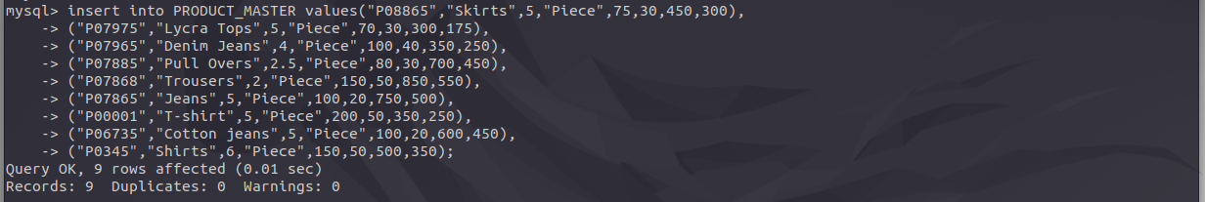

: Insertion Query of Table PRODUCT_MASTER

c) Data for SALESMAN_MASTER table:

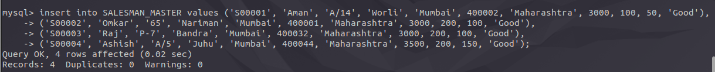

3: Insertion Query of Table SALESMAN_MASTER

Screenshot of Files after Insertion Queries

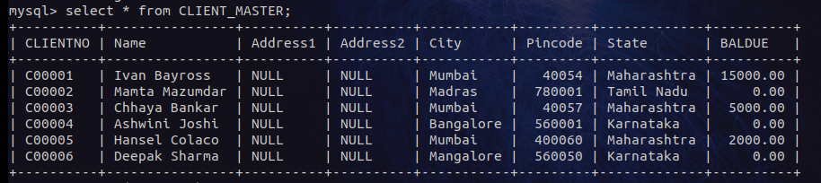

: Data in CLIENT_MASTER Table

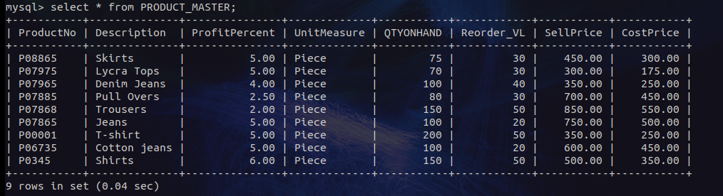

: Data in PRODUCT_MASTER Table

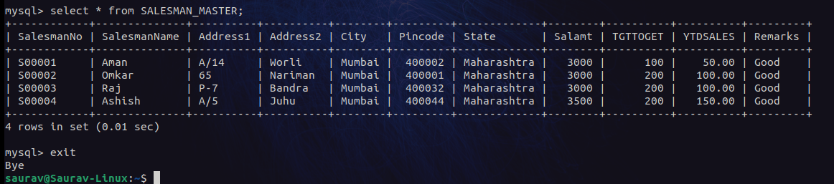

: Data in SALESMAN_MASTER Table