# **EXPERIMENT 3**

TITLE: **DDL (Data Definition Language) commands with Data Constraints**

Objective: To understand the concept of data constraints that is enforced on data being stored in the table. Focus on Primary Key and the Foreign Key

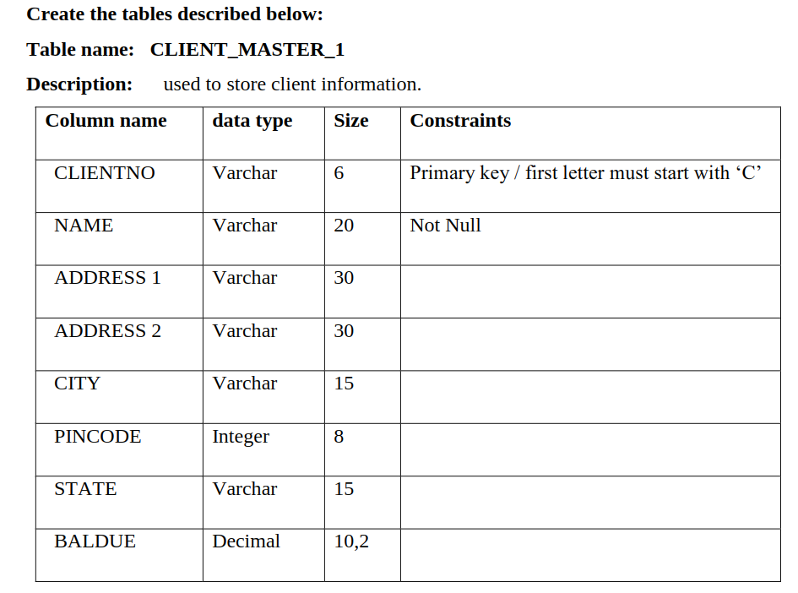

Solution:

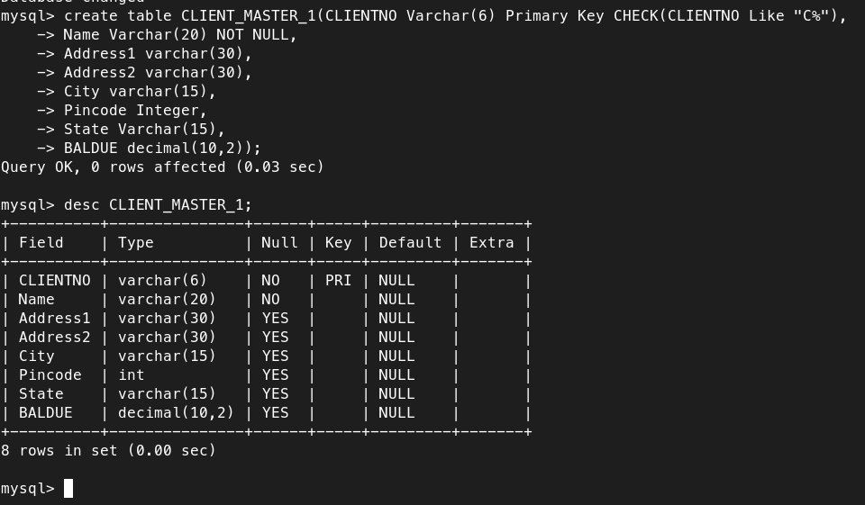

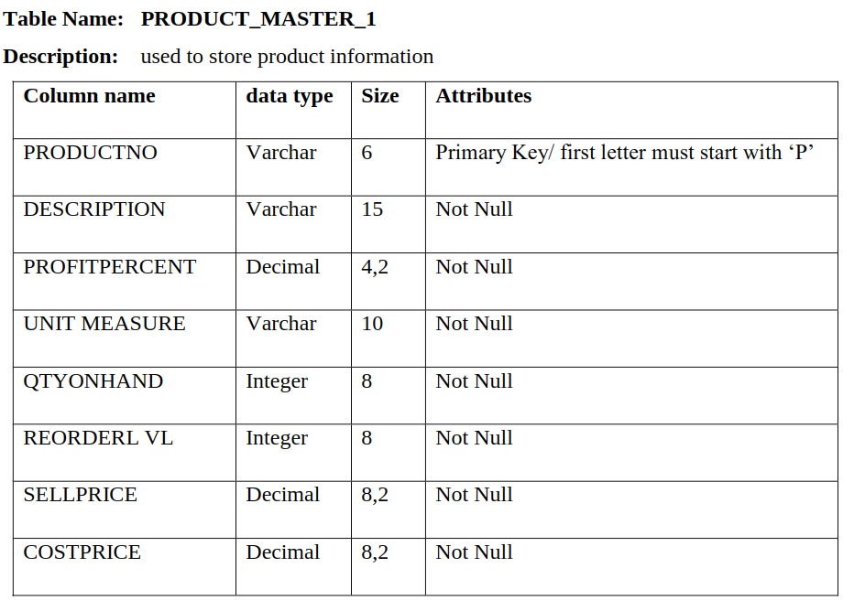

solution:

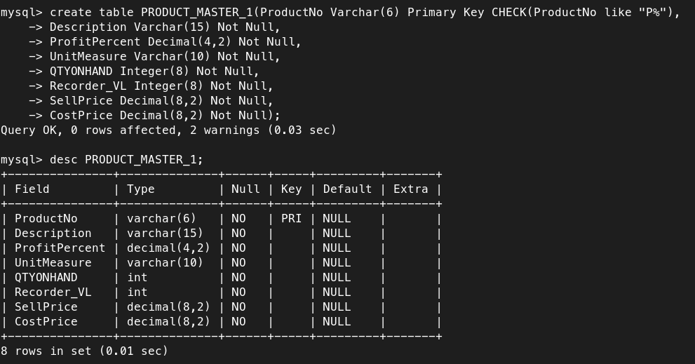

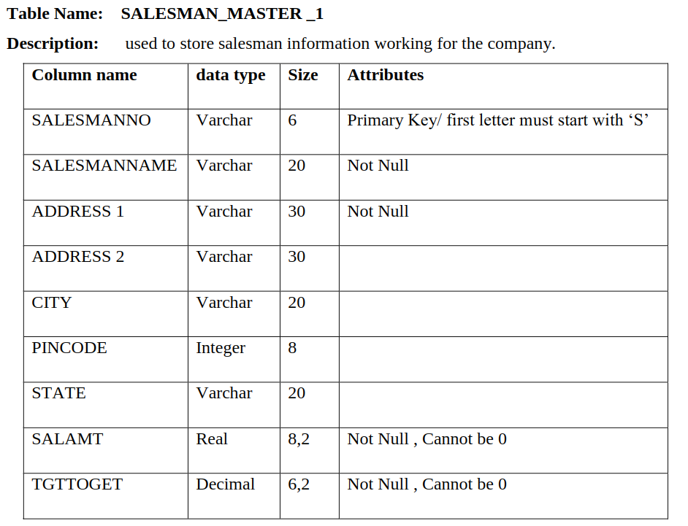

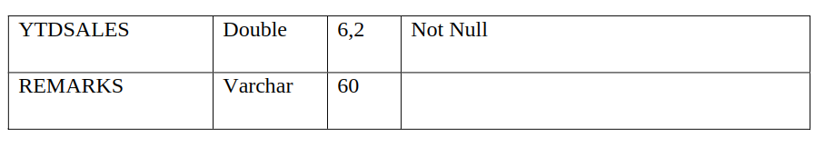

Solution:

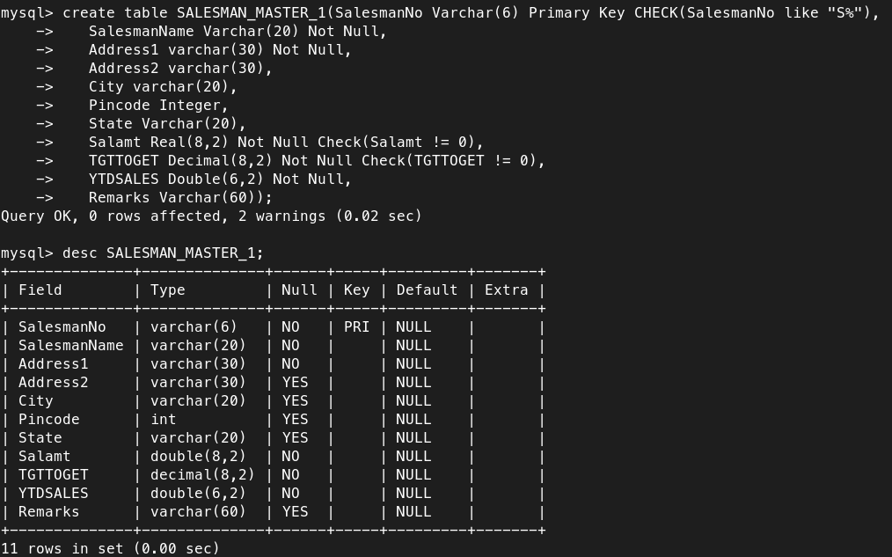

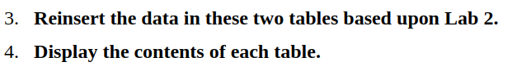3.Reinsert the data in these two tables based upon Lab 2.

4.Display the contents of each table.

