EXPERIMENT 2

TITLE: DML commands with constraints

Objective: To understand the concept of different DML commands.
Exercise on retrieving records from a table.

a. Find out the names of all the clients.

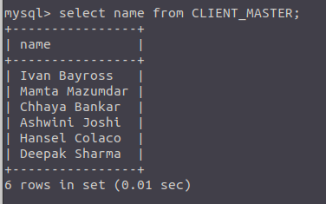
Figure 1: Output
b. Retrieve the entire contents of the Client_Master table.
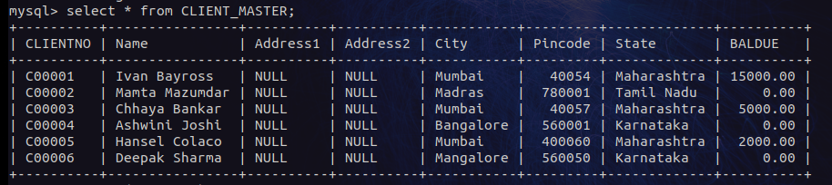Figure 2: Output

c. Retrieve the list of names, city and the state of all the clients.
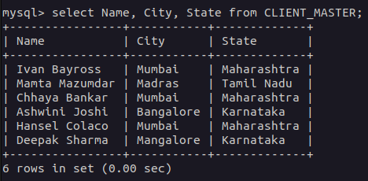
Figure 3: Output
d. List the various products available from the Product_Master table.
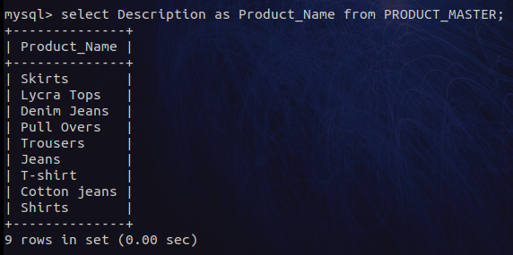
Figure 4: Output

e. List all the clients who are located in Mumbai.
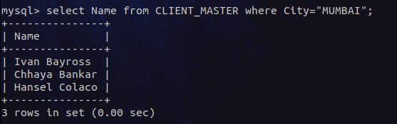
Figure 5: Output

f. Find the names of salesman who have a salary equal to Rs.3000.
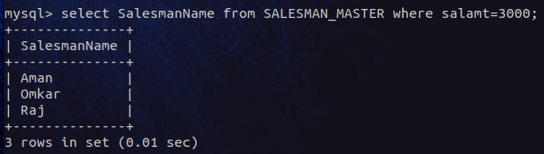
Figure 6: Output
1.Exercise on updating records in a table
a. Change the city of ClientNo ‘C00005’ to ‘Bangalore’.
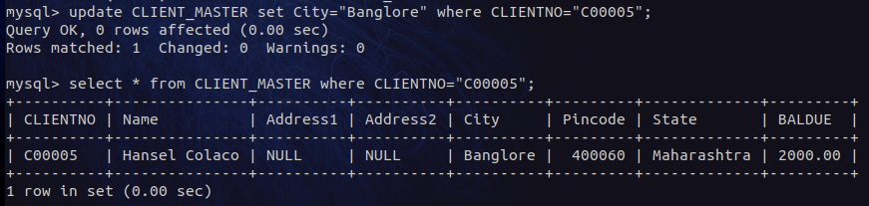Figure 7: QUERY with OUTPUT
b. Change the BalDue of ClientNo ‘C00001’ to Rs.1000.
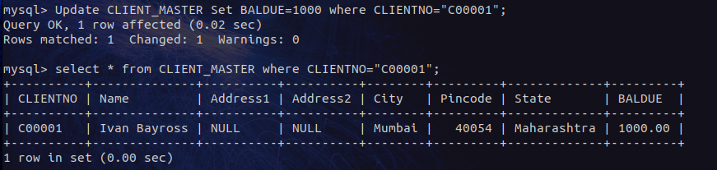Figure 8: QUERY with OUTPUT
c. Change the cost price of ‘Trousers’ to Rs. 950.00.
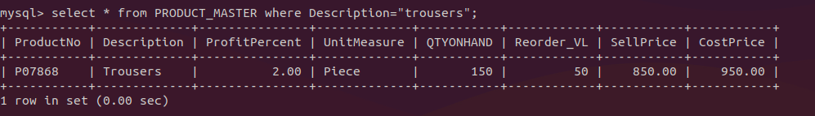Figure 9: QUERY with OUTPUT
d. Change the city of the salesman to Pune.
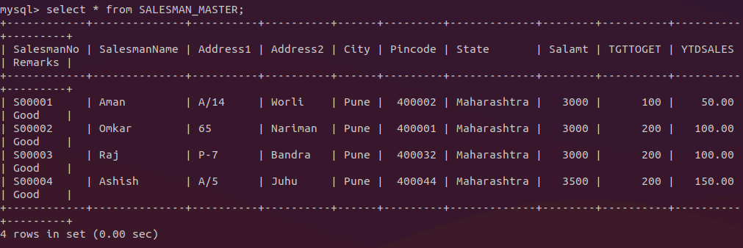Figure 10: QUERY with OUTPUT
2.Exercise on deleting records in a table
a. Delete all salesman from the Salesman_Master whose salaries are equal to Rs.3500.
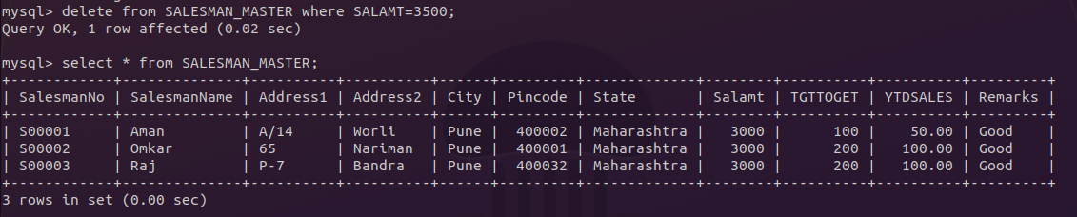Figure 11: QUERY and OUTPUT

b. Delete all products from Product_Master where the quantity on hand is equal to 100.
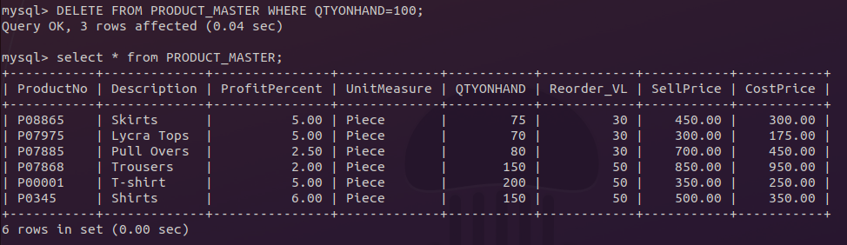Figure 12: QUERY and OUTPUT
c. Delete from Client_Master where the column state holds the value ‘Tamil Nadu’.
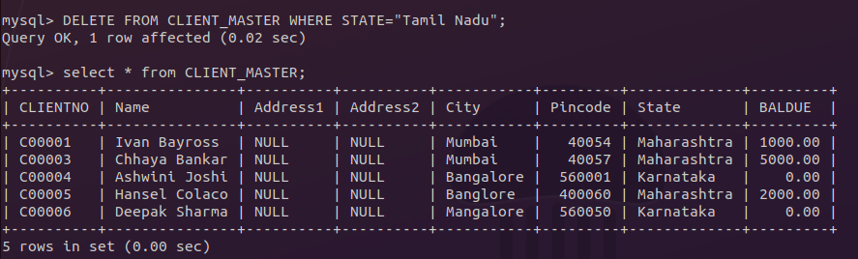Figure 13: QUERY and OUTPUT
4.Exercise on altering the table structure
a. Add a column called ‘Telephone’ of data type integer to the Client_Master table.
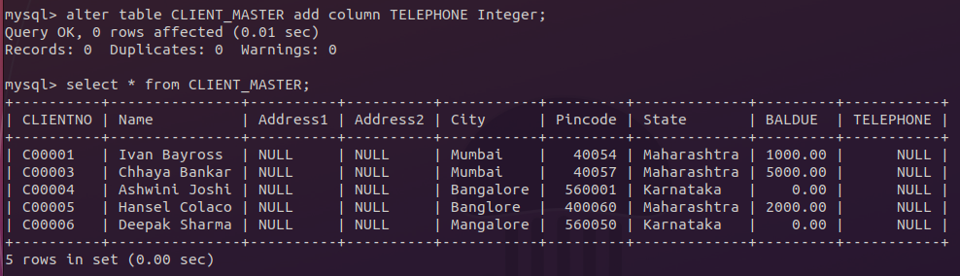Figure 14: QUERY and OUTPUT

b. Change the size off SellPrice column in Product _Master to 10, 2.
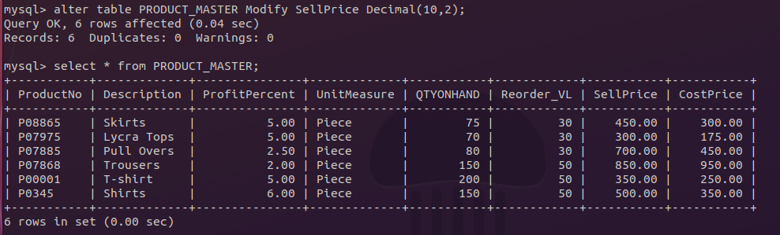Figure 15: QUERY and OUTPUT

5.Exercise on deleting the table structure along with the data
a. Destroy the table Client_Master along with its data.
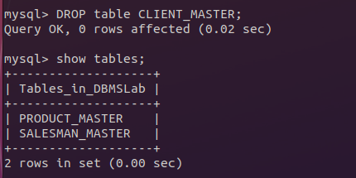
Figure 16: QUERY and OUTPUT
6.Exercise on renaming the table
a. Change the name of the Salesman_Master to sman_mast.
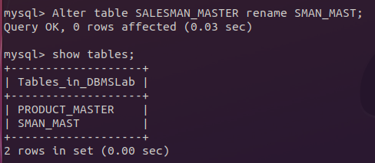
Figure 17: QUERY and OUTPUT

