DMart Product Catalogue Analysis
Pricing, Assortment & Discount Intelligence Report
DMart Management | Data Science & Analytics Team

1. Executive Summary
This report presents a focused analysis of DMart's product catalogue comprising 5,187 valid SKUs across 30 categories, 87 subcategories, and 821 brands. The analysis is deliberately concise, surfacing exactly 5 key findings, 3 critical risks, 3 strategic opportunities, and 5 recommended management actions — all visualised through a 3-tab interactive HTML decision dashboard.
The dashboard's three pages mirror this report's structure: Executive Summary (KPIs and key findings), Risks & Opportunities (risk cards, opportunity cards, supporting charts), and Recommended Actions (prioritised action plan with impact-effort matrix).

2. Problem Statement & Business Objectives
DMart offers a wide range of products across grocery, packaged food, personal care, home & kitchen, beverages, and other categories. Managing such a large product assortment requires effective pricing and assortment decisions to maintain customer value while avoiding excessive discounting and identifying gaps in product and brand coverage.
The primary objective is to transform DMart's product catalogue data into actionable insights by understanding the product and brand assortment, evaluating price and discount patterns, identifying factors associated with higher discounting, detecting pricing and data-quality risks, and providing management-oriented recommendations through an interactive decision dashboard.

3. Dataset Overview
The dataset (DMart.csv) contains 5,189 raw records and 9 columns: Name, Brand, Price (MRP), DiscountedPrice, Category, SubCategory, Quantity, Description, and BreadCrumbs. After cleaning (removing null/zero prices and fixing 2 reversed price entries), 5,187 valid records were retained.
Metric | Value
Total SKUs (after cleaning) | 5,187
Categories / Subcategories | 30 / 87
Unique Brands | 821
Average MRP | Rs 344.10 (Median: Rs 175)
MRP Range | Rs 5 to Rs 10,990
Average Discount % | 26.39%
Maximum Discount % | 98.00%
Unbranded Products | 400 (7.7% of total)
Table 1: Core Dataset Statistics

4. Project Architecture & File Structure
The project separates concerns cleanly into a backend analysis engine and a standalone frontend dashboard. Running main.py produces all JSON outputs; the dashboard reads them directly from the browser — no web server required.
File | Type | Purpose
main.py | Python | Entry point — runs the full backend analysis pipeline
requirements.txt | Config | Python dependencies: pandas, numpy
backend/analysis.py | Python | Core engine — 8 analytical phases, outputs 9 JSON files
frontend/dashboard.html | HTML/JS | Interactive 3-tab decision dashboard (Chart.js, no server)
outputs/kpis.json | JSON | 6 headline KPIs consumed by Executive Summary tab
outputs/anomalies.json | JSON | Extreme discounts, no-brand anomalies for Risk tab
outputs/opportunities.json | JSON | Assortment gaps and promotional imbalances for Opportunity tab
Table 2: File Structure
Architecture Flow: DMart.csv → main.py → backend/analysis.py (8 phases) → outputs/*.json → frontend/dashboard.html (Chart.js, 3 tabs)

5. Five Key Findings
# | Finding | Key Data Point
1 | Heavily Promotional Catalogue | Avg discount 26.39%, max 98% — DMart is a promotion-driven retailer
2 | Concentrated Category Mix | Personal Care, Packaged Food, Home & Kitchen = 63% of all SKUs
3 | 21.8% of SKUs Carry >=40% Discount | 1,132 products at deep discount — significant margin exposure
4 | Brand Coverage Gaps | 400 unbranded SKUs + 13 single-brand subcategories
5 | Price Skew Towards Value | Median Rs 175 vs mean Rs 344 — strong value-tier skew, limited premium range
Table 3: Five Key Findings

6. Dashboard — Page 1: Executive Summary
The Executive Summary tab is the first page management sees. It presents 6 KPI cards across the top row (Total Products, Total Brands, Avg MRP, Avg Discount, High-Discount SKUs, No-Brand SKUs), followed by the 5 Key Findings as individual cards, and two summary charts: Products by Category (bar) and Discount Depth Distribution (doughnut). This page gives the entire portfolio health picture in a single view.

Screenshot — Page 1: Executive Summary
[Dashboard Screenshot 1 — Executive Summary tab showing KPI cards, 5 key findings and summary charts. See outputs/screenshot_executive.png]

7. Dashboard — Page 2: Risks & Opportunities

7.1 Three Key Risks
Risk | Description | Data Evidence
Extreme Discounting Anomalies | 27 products carry discounts of 70% or more, including a 98% outlier. These likely represent data entry errors or uncontrolled clearance pricing. | 27 SKUs at >=70% discount; max 98%
Unbranded Product Data Gap | 400 SKUs (7.7%) have no brand assigned, undermining supplier accountability, catalogue searchability, and brand-level reporting. | 400 unbranded SKUs = 7.7% of catalogue
Promo Over-Reliance | Several subcategories average above 45% discount, indicating structural promo dependency. Without a discount floor policy, margin erosion becomes systemic. | 1,132 SKUs (21.8%) at >=40% discount
Table 4: Three Key Risks

7.2 Three Key Opportunities
Opportunity | Description | Scale
Expand Single-Brand Subcategories | 13 subcategories carry only one brand. Adding a second competitor brand reduces supply risk, enables price competition, and typically increases basket conversion. | 13 subcategories to expand
Target Under-Promoted Categories | Several categories average below 15.8% discount — under the 26.39% portfolio average. Selective promotions can unlock latent demand in these segments. | 4 under-promoted categories identified
Premium Segment Gap | 10 high-average-price subcategories have 2 or fewer brands. Adding premium or imported brands captures aspirational customers and lifts basket value without discounts. | 10 premium subcategories under-served
Table 5: Three Key Opportunities

7.3 Screenshot — Risks & Opportunities Page
[Dashboard Screenshot 2 — Risks & Opportunities tab showing 3 risk cards, extreme discount chart, promo overload chart, 3 opportunity cards, single-brand subcategory chart and price gap chart. See outputs/screenshot_insights.png]

8. Dashboard — Page 3: Recommended Actions
The Recommended Actions tab presents 5 numbered action cards, each with a horizon label (Immediate, Short-Term, or Strategic), a concise description with specific data references, and an Impact/Effort score. Two supporting charts are shown below: an Action Impact vs Effort bubble matrix to visualise relative priority, and a Category Avg Discount vs High-Discount SKU Share chart to contextualise the discount governance actions.
# | Action | Horizon | Impact / Effort
1 | Fix Extreme Discount Anomalies — audit 27 products at >=70% discount, implement hard 60% ceiling in catalogue system | Immediate | Impact: 5 / Effort: 1
2 | Assign Brand Data to All 400 Unbranded SKUs — establish data-entry SLA requiring brand, subcategory and MRP before any new SKU goes live | Immediate | Impact: 4 / Effort: 2
3 | Add Competing Brands to 13 Single-Brand Subcategories — target at least one additional brand per subcategory to reduce supply risk | Short-Term | Impact: 4 / Effort: 3
4 | Launch Promotions in Under-Discounted Categories — run 2-week targeted campaigns below 15.8% avg discount to stimulate trial | Short-Term | Impact: 3 / Effort: 2
5 | Introduce Tiered Discount Governance Policy — max 40% regular, 60% clearance, senior sign-off above thresholds across 5,187 SKUs | Strategic | Impact: 5 / Effort: 4
Table 6: Five Recommended Actions

8.1 Screenshot — Recommended Actions Page
[Dashboard Screenshot 3 — Recommended Actions tab showing 5 numbered action cards with horizon labels and impact/effort scores, plus the Action Impact vs Effort bubble matrix and Category Discount comparison chart. See outputs/screenshot_actions.png]

9. Conclusion
This focused analysis of DMart's 5,187-SKU catalogue surfaces 5 clear findings, 3 actionable risks, and 3 concrete opportunities — all tied to specific data-backed numbers. The interactive 3-tab dashboard gives management a crisp, decision-ready view without information overload.
The 5 recommended actions, prioritised across Immediate, Short-Term, and Strategic horizons, provide a clear roadmap: fix data anomalies now, expand brand assortment in the medium term, and formalise discount governance for long-term margin health. Together these actions address the root causes identified in the findings and unlock the three growth opportunities.

7. Screenshot — Dashboard Page 1 — Executive Summary
6 KPI cards, 5 Key Findings strip, Products-by-Category bar chart and Discount Depth Distribution doughnut chart.
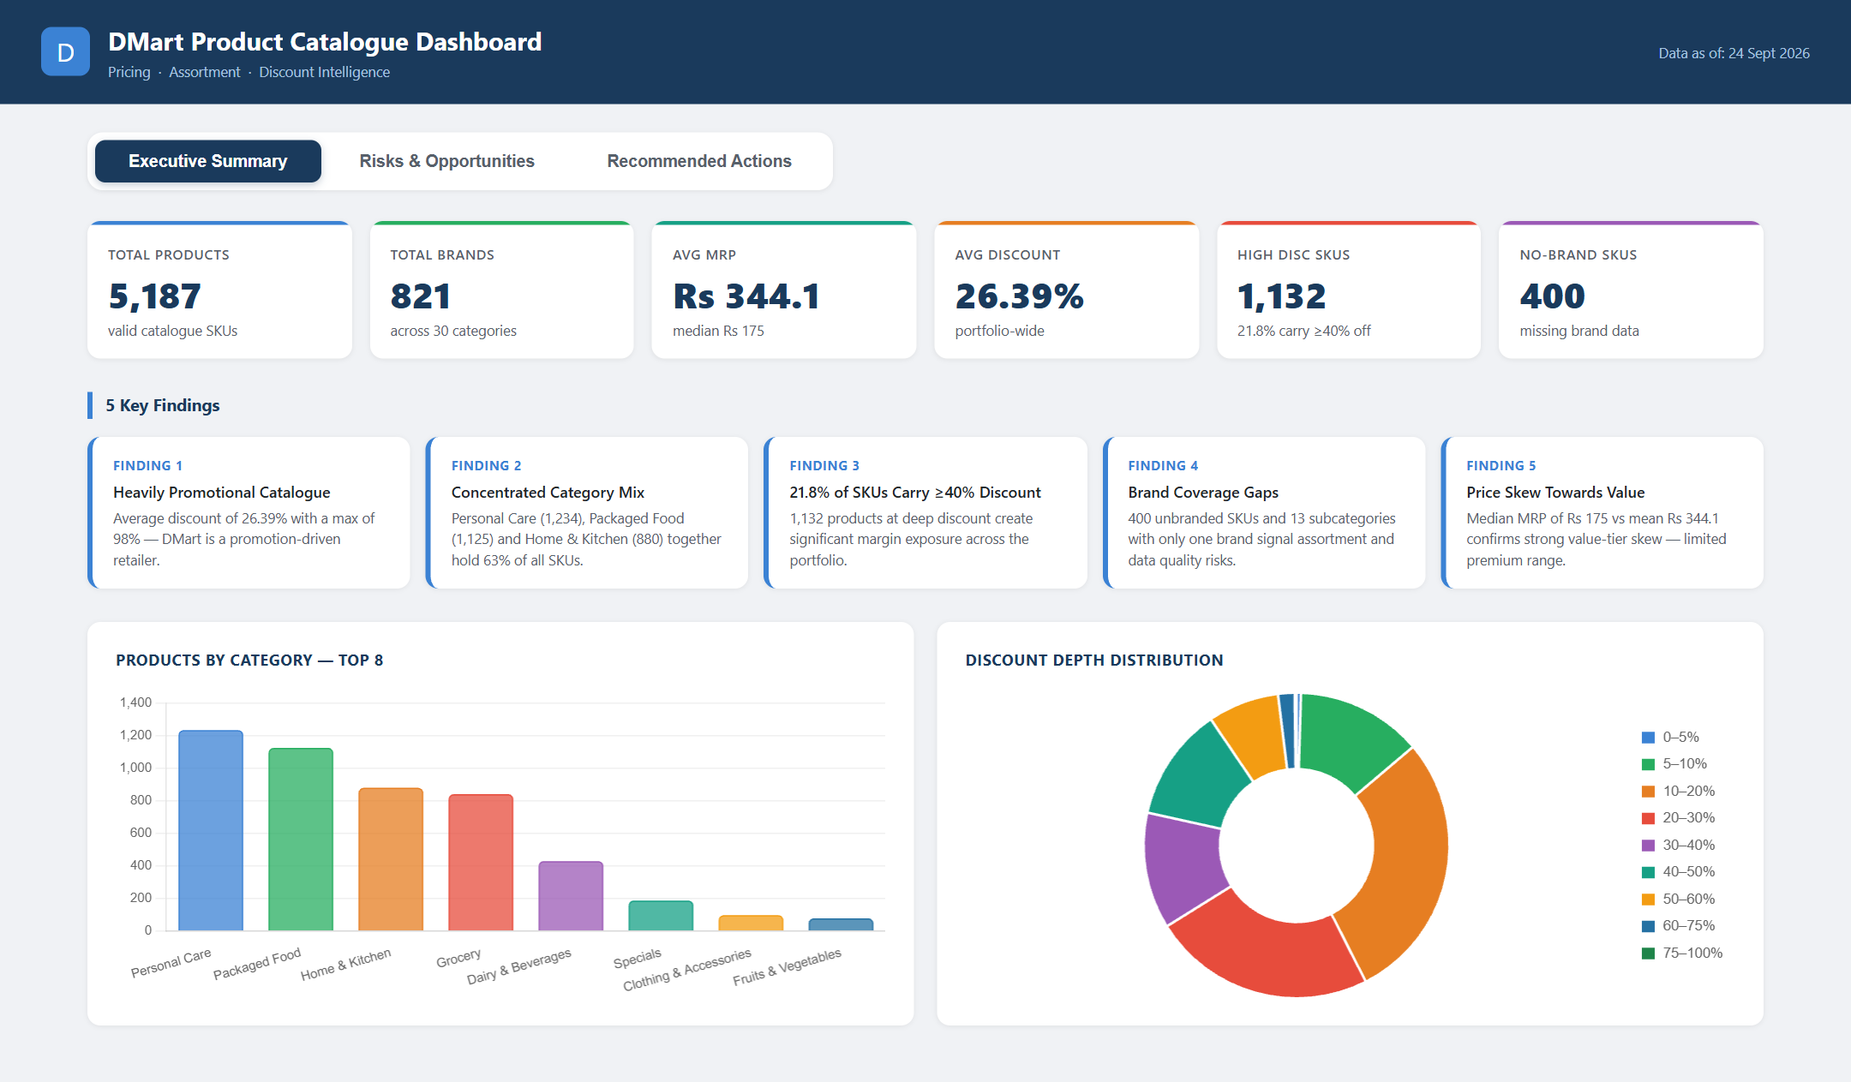
Figure 1: Dashboard Page 1 — Executive Summary

8. Screenshot — Dashboard Page 2 — Risks & Opportunities
3 Risk cards with supporting charts (extreme discount by category, top promo subcategories), 3 Opportunity cards with assortment gap and price gap charts.
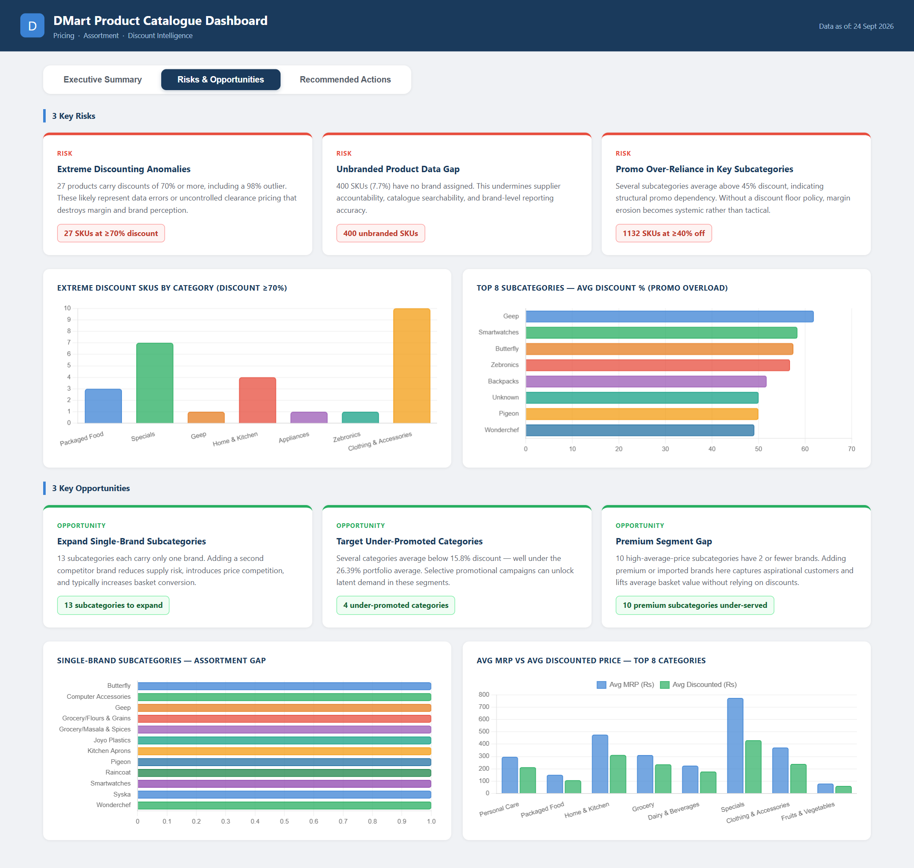
Figure 2: Dashboard Page 2 — Risks & Opportunities

9. Screenshot — Dashboard Page 3 — Recommended Actions
5 numbered action cards with horizon labels, Action Impact vs Effort bubble matrix, and Category Discount % comparison chart.
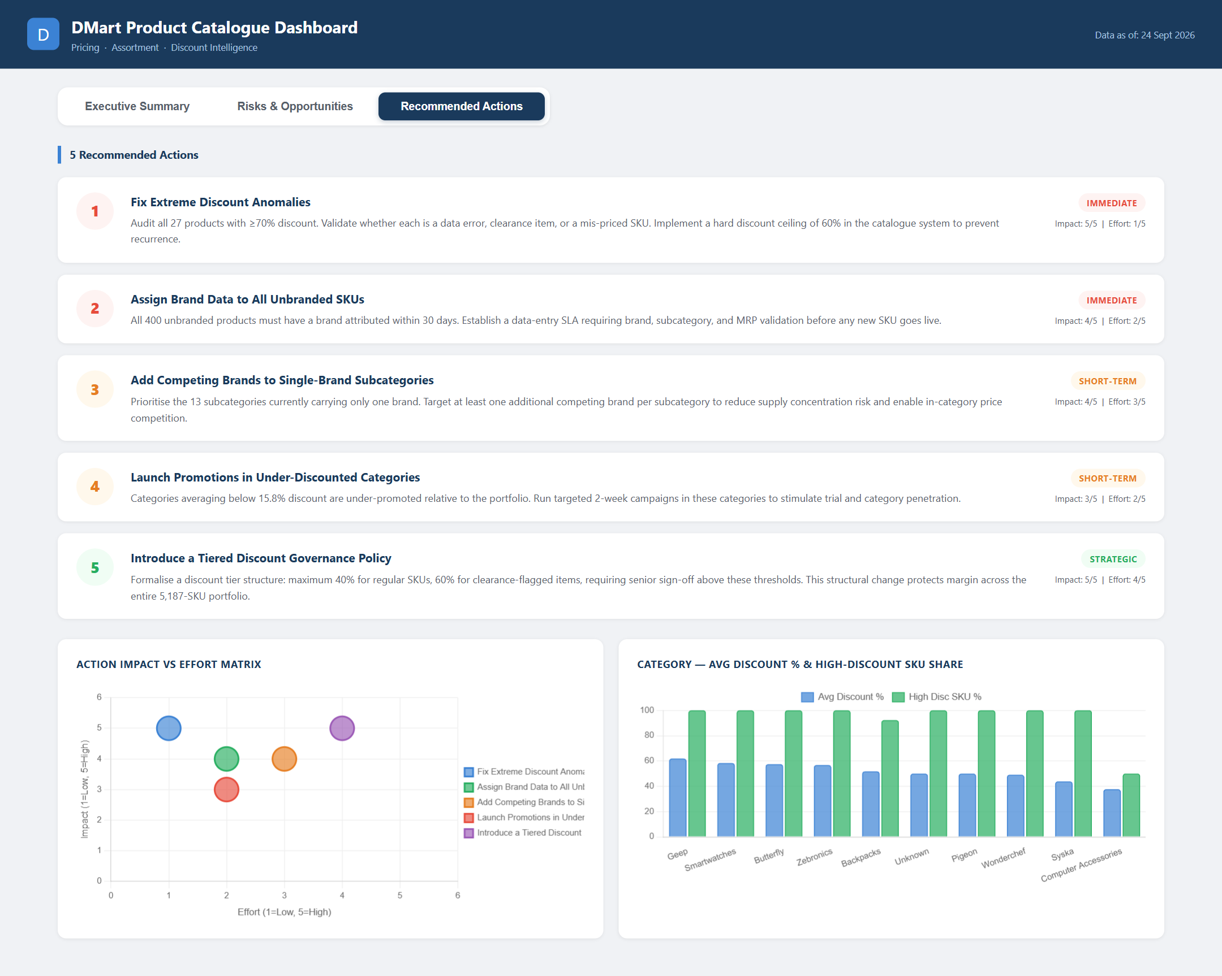
Figure 3: Dashboard Page 3 — Recommended Actions

