Technical Design Document (TDD)
Project: Online Movie Ticket Booking Platform
Company Exercise: Publicis Sapient Architecture Assignment
Author: Saurav Shekher

1. System Overview
This platform enables theatre partners (B2B) to onboard theatres and manage movie shows while allowing end customers (B2C) to browse movies, search shows by city/date, and book tickets online. The system is designed to support high concurrency for seat bookings while maintaining data consistency and availability.

2. Functional Requirements
- Users can browse movies by city, language, genre, and date.
- Users can view theatres running a specific movie along with show timings.
- Users can select seats and book movie tickets.
- Theatres can onboard themselves to the platform.
- Theatres can create, update, and delete shows.
- Theatres can allocate and update seat inventory.
- System supports bulk booking and cancellation.
- Discount rules (e.g., 50% discount on the third ticket, 20% discount for afternoon shows).
- Integration with payment gateway for ticket payments.

3. Non-Functional Requirements
- High availability: 99.99% uptime.
- Scalability to support multiple cities and countries.
- Low latency for search and booking APIs (<200 ms).
- Strong data consistency during seat booking transactions.
- Security against OWASP Top 10 threats.
- Payment security compliance (PCI-DSS).
- Observability through monitoring, logging, and alerts.

4. High Level Architecture
Clients (Web/Mobile) communicate with backend services through a Load Balancer and API Gateway. Backend services are implemented as microservices using Spring Boot. Redis is used for caching frequently accessed data such as movies and show listings. A relational database stores transactional data such as bookings and payments.

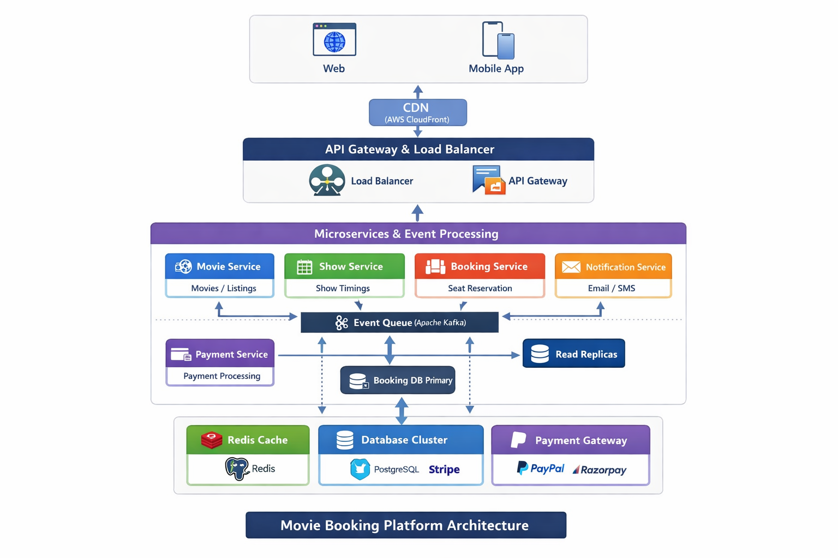
Integration with Theatre Management System (TMS)
Some theatres operate their own Theatre Management Systems (TMS) to manage show schedules, seat layouts, and ticketing operations.
To support such theatres, the platform provides an Integration API Layer. These APIs allow theatre systems to synchronize their data with the booking platform.
Typical integration APIs include:
- POST /integration/movies – Publish movie information
- POST /integration/shows – Publish show schedules
- POST /integration/seats/update – Update seat availability
Through these APIs, external theatre systems can automatically push their show and seat data into the platform.
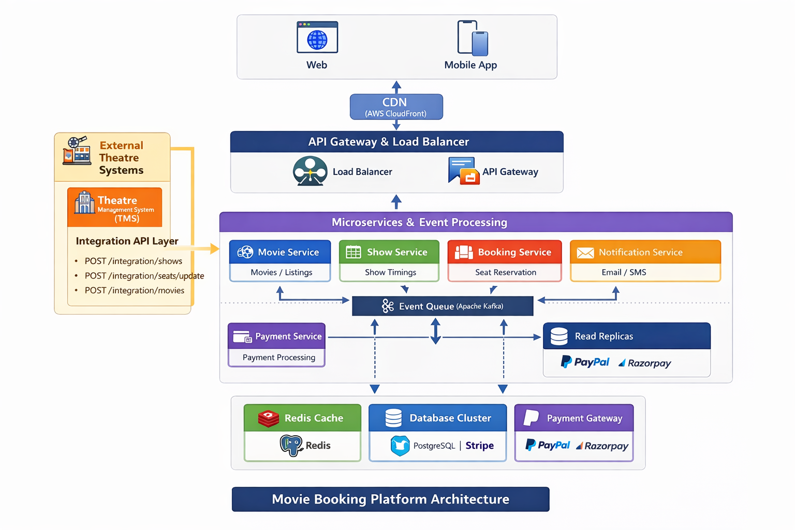

5. Core Services
- Movie Service – manages movie catalog and metadata.
- Theatre Service – manages theatre onboarding and screen details.
- Show Service – manages show timings and seat layout.
- Booking Service – handles seat reservation and booking transactions.
- Payment Service – integrates with payment gateways.
- Notification Service – sends booking confirmations via email/SMS.

6. API Contract

1. Search Movie Shows API
This API allows users to search available movie shows based on movie name, city, date, and optional show time.
Endpoint
GET /movies/shows
Parameter | Type | Required | Description
movieName | String | Yes | Name of the movie
city | String | Yes | City where the movie is playing
date | Date | Yes | Show date (YYYY-MM-DD)
showTime | Time | No | Filter shows by specific time

Success Response
HTTP Status: 200 OK
Response Body
{
"shows": [
{
"showId": 1,
"movieName": "Avengers",
"theatreName": "PVR Orion Mall",
"city": "Bangalore",
"screen": "Screen 1",
"showDate": "2026-04-01",
"showTime": "10:00:00",
"availableSeats": 120
},
{
"showId": 2,
"movieName": "Avengers",
"theatreName": "INOX Garuda Mall",
"city": "Bangalore",
"screen": "Screen 3",
"showDate": "2026-04-01",
"showTime": "13:30:00",
"availableSeats": 85
}
]
}
Error Response
{
"errorCode": "SHOW_NOT_FOUND",
"message": "No shows available for the given search criteria"
}
2. Book Movie Ticket API
This API allows users to book seats for a selected show.
Endpoint
POST /booking
Request Body
{
"showId": 1,
"userName": "Saurav",
"seats": ["A1", "A2"]
}

Field | Type | Required | Description
showId | Long | Yes | Unique identifier for the show
userName | String | Yes | Name of the user making the booking
seats | List | Yes | List of seat numbers to be booked

Success Response
HTTP Status: 201 Created
Response Body
{
"bookingId": 101,
"showId": 1,
"userName": "Saurav",
"seats": ["A1", "A2"],
"status": "CONFIRMED",
"message": "Booking successful"
}
Error Responses
{
"timestamp": "2026-04-01T10:43:17.424+00:00",
"status": 500,
"error": "Internal Server Error",
"message": "Seats already booked: [A1, A2]",
"path": "/booking"
}

Class Diagram
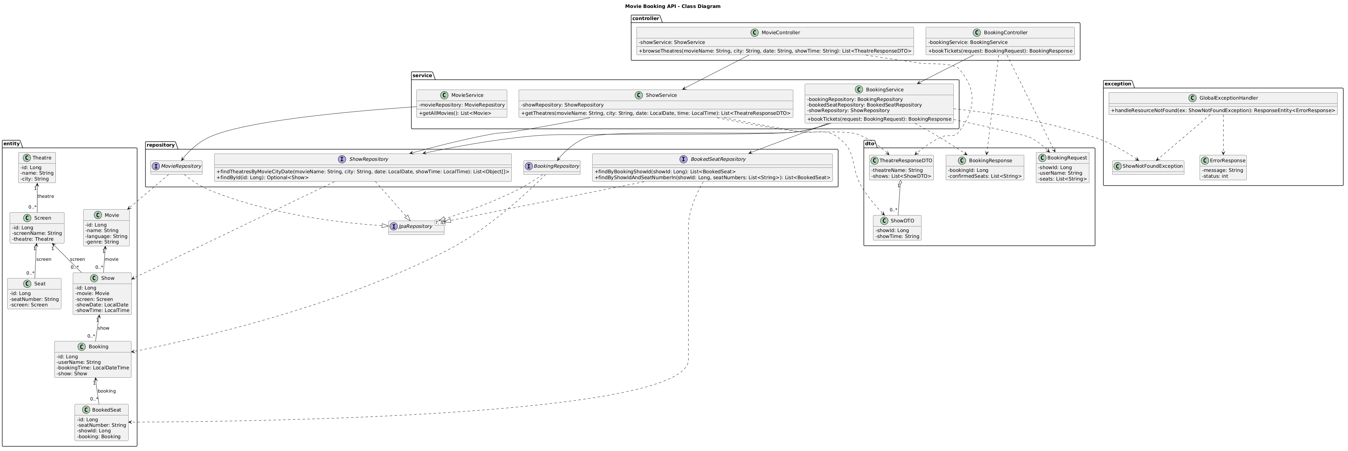
Flow Diagram
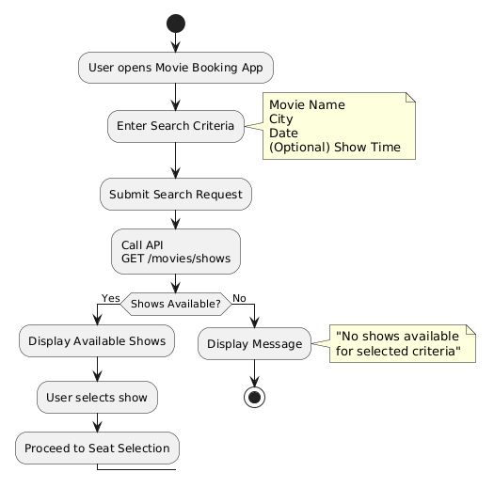

Sequence Diagram
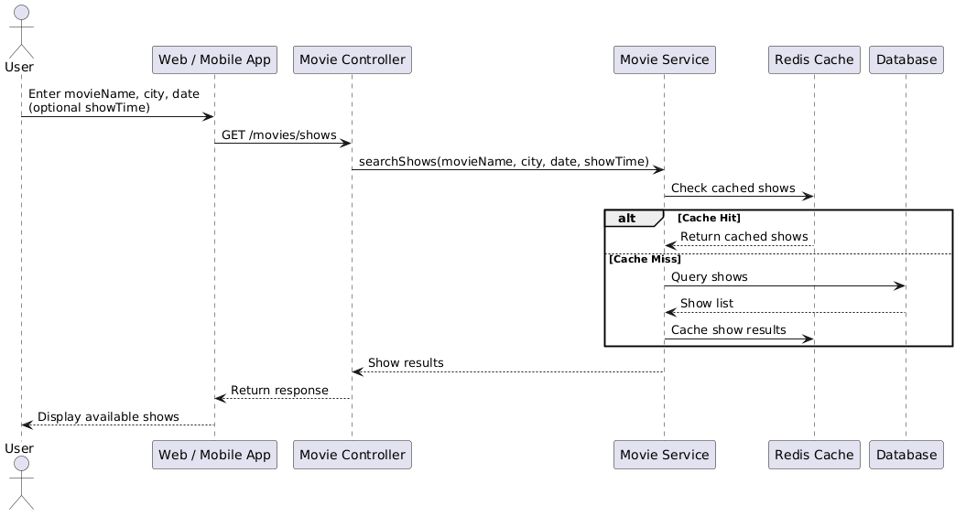

7. Database Design
Core database tables:
- User
- Movie
- Theatre
- Screen
- Show
- Seat
- Booking
- BookedSeat
- Payment
To prevent double booking, a unique constraint is applied on (show_id, seat_number). This ensures only one user can reserve a seat for a specific show.

8. Transaction Management
Seat booking is a critical transactional operation. The booking flow includes checking seat availability, creating a booking record, reserving seats, processing payment, and confirming the booking. The system uses Spring Boot @Transactional annotation to ensure atomicity. If any step fails, the entire transaction is rolled back.
Concurrency Control
Seat booking systems face high concurrency when multiple users attempt to reserve the same seat simultaneously. To prevent double booking, the system enforces a unique database constraint on (show_id, seat_number) and uses transactional locking during seat allocation. If two users attempt to reserve the same seat, only one transaction succeeds while the other fails and returns a seat already booked error.
This ensures strong consistency during booking operations.

9. Integration with Theatre Systems
The platform integrates with theatre partners using REST APIs. Existing theatres with IT systems can push show schedules and seat data via APIs or webhooks. New theatres can manage their shows through a partner portal.

10. Payment Gateway Integration
The platform integrates with payment providers such as Razorpay, Stripe, or PayPal. The payment process includes payment initiation, gateway processing, webhook confirmation, and booking confirmation.

11. Caching Strategy
Redis is used to cache frequently accessed data to improve performance and reduce database load.
Movie catalog
Theatre list per city
Show schedules
Popular search queries
Seat availability is NOT cached to ensure real-time consistency during booking.

12. Scalability Strategy
Horizontal scaling is achieved by deploying multiple application instances behind a load balancer. Database read replicas are used for scaling read-heavy workloads. Redis caching reduces database load.
- Horizontal scaling using multiple application instances
- Load balancer distributes traffic
- Auto scaling during high traffic
- Database read replicas
- Database partitioning/sharding for large datasets
- Redis caching reduces DB queries
- Asynchronous processing using messaging (Kafka/RabbitMQ)

13. Security
- Spring Security with JWT authentication.
- Role-based access control (Admin, Theatre Partner, Customer).
- Input validation using Spring validation.
- Prepared statements to prevent SQL injection.
- HTTPS communication with TLS encryption.
- API rate limiting.

Hh
DDoS Protection and Rate Limiting
- To protect the platform from abuse, bot traffic, and Distributed Denial of Service (DDoS) attacks, API rate limiting is enforced at the API Gateway layer. The gateway monitors incoming requests and applies throttling policies to prevent excessive traffic from overwhelming backend services.
- Requests that exceed the configured thresholds are either throttled or rejected with HTTP 429 (Too Many Requests) responses. This ensures fair usage of system resources and protects the platform from malicious traffic patterns.

- The following rate limiting policies are applied:
Policy | Limit
Requests per user | Maximum 10 requests per second per authenticated user
Requests per IP address | Maximum 50 requests per second per IP address
- These controls help mitigate automated attacks, prevent scraping or abuse of APIs, and ensure stable system performance during peak traffic.

14. Monitoring and Logging
The platform uses Prometheus for metrics collection and Grafana for monitoring dashboards. Logs are collected using ELK stack (Elasticsearch, Logstash, Kibana) to analyze system logs and detect failures.

15. Platform Monetization
- Convenience fee per ticket.
- Commission from theatre partners.
- Advertisements and promotions.
- Premium listings for theatres.

16. Deployment Architecture
The system is deployed on cloud infrastructure such as AWS, Azure, or GCP using Docker containers and Kubernetes orchestration. CI/CD pipelines automate build, testing, and deployment.

17. KPIs
- Booking success rate
- API response latency
- System uptime
- Payment success rate
- Daily active users

18. High Level Project Plan
- Requirement analysis and architecture design (1 week)
- Core API development (4 weeks)
- Payment integration (2 weeks)
- Testing and performance validation (2 weeks)
- Deployment and monitoring setup (1 week)

