Q) How is this step "How often is each Cell type ranked top or last?" in EDA analysis going to help?
Ans: This step is actually quite useful for understanding dominance and variability of cell types in your dataset. Let me explain it carefully in the context of cell abundance data.
Assume your data after reshaping looks like:
slide | x | y | cell_type | abundance
S1 | 10 | 20 | C1 | 0.62
S1 | 10 | 20 | C2 | 0.12
S1 | 10 | 20 | C3 | 0.05
S1 | 10 | 20 | C4 | 0.21
At each spatial location (slide, x, y) you can rank cell types by abundance.
Example ranking at that pixel:
cell_type | abundance | rank
C1 | 0.62 | 1 (top)
C4 | 0.21 | 2
C2 | 0.12 | 3
C3 | 0.05 | 4 (last)
Now repeat this ranking for every spatial location in your dataset.

Why this step is useful in EDA
1️⃣ Identifies dominant cell types
If a particular cell type is top-ranked very frequently, it means it dominates most regions.
Example:
cell_type | times ranked 1
C1 | 68%
C2 | 5%
C3 | 12%
C4 | 15%
Interpretation:
- C1 is globally dominant
- Others are secondary.
This tells you which biological populations drive the data.

2️⃣ Detects rare or weak features
If a cell type is almost always ranked last, it may be:
- extremely rare
- noisy
- poorly predicted by the model
- unnecessary for modeling
Example:
cell_type | last rank frequency
C3 | 70%
Meaning:
- C3 rarely contributes significantly.
Such features may have low predictive power.

3️⃣ Reveals spatial heterogeneity
If multiple cell types are often ranked top, the tissue is heterogeneous.
Example:
cell_type | top frequency
C1 | 35%
C2 | 30%
C3 | 20%
C4 | 15%
This indicates diverse microenvironments.

4️⃣ Detects class imbalance in features
For ML models, features that dominate can bias training.
Example:
If C1 dominates everywhere, your model might learn:
snow_depth ≈ function(C1)
and ignore other features.
EDA helps detect this early.

5️⃣ Helps feature engineering
You might create features like:
- dominant cell type
- entropy of abundance
- top 2 cell types
Example engineered feature:
dominant_cell = argmax(cell abundance)
This is commonly used in spatial biology analysis.

Why this matters for your project
Since you are working with cell abundance as features for prediction, this step helps you see:
- which cell types actually vary
- which ones are informative
- which ones are almost constant
Low-variance features are often removed before modeling.

Simple analogy
Think of it like medal rankings in Olympics.
If a country always gets gold, it dominates.
If a country always comes last, it has little impact.
Same logic applies to cell abundance ranking.

✅ In short:
This step tells you
- dominant cell populations
- rare cell types
- dataset imbalance
- useful vs weak features
which is exactly what EDA is supposed to reveal before modeling.

If you want, I can also show you a very powerful EDA technique specifically for cell abundance data called "cell dominance maps" that many spatial biology papers use. It might actually impress your professor if you include it in your analysis.

try.h5 is the Machenko normalized h5 file for the stains.
4. Model Preparation
4.1 Encoder
DeepTileEncoder
- Input size: [B, 3, 78, 78]
- Purpose: Processes the entire 78×78 tile (from spot coordinates).
- Residual blocks: Stacked ResidualBlocks (two 3×3 Conv + BN + SiLU; 1×1 Conv shortcut if needed)
- Multi-scale pooling:
  - Global: AdaptiveAvgPool2d(1×1) → [B,256]
  - Mid-scale: AdaptiveAvgPool2d(3×3) → [B,256×3×3]
- MLP (3 layers):
SubtileEncoder
- Input size: [B, 9, 3, 26, 26]
- Purpose: Captures local details from 9 subtiles.
- Residual blocks: Applied after reshaping to [B×9, 3, 26, 26]
- Multi-scale pooling (per patch):
  - Global 1×1 → [B×9,128]
  - Mid 2×2 → [B×9,128×2×2]
  - Large 3×3 → [B×9,128×3×3]
- Aggregation:
  - Reshape to [B, 9, total_dim]
  - Average over 9 → [B, total_dim]
- MLP (2 layers):
CenterSubtileEncoder
- Input size: [B, 3, 26, 26]
- Purpose: Focuses on the single central patch.
- Structure: Same as SubtileEncoder but only for the center.
- Multi-scale pooling: 1×1, 2×2, 3×3 → concatenate → Flatten
- MLP (2 layers):

4.2 Decoder
- Concatenate: [tile_dim] + [subtile_dim] + [subtile_dim] → [B, tile_dim+2×subtile_dim]
- Four-layer MLP:
- Output: Multi-task prediction vector of length output_dim, which is 35.
Loss function: Mean Squared Error (MSE)

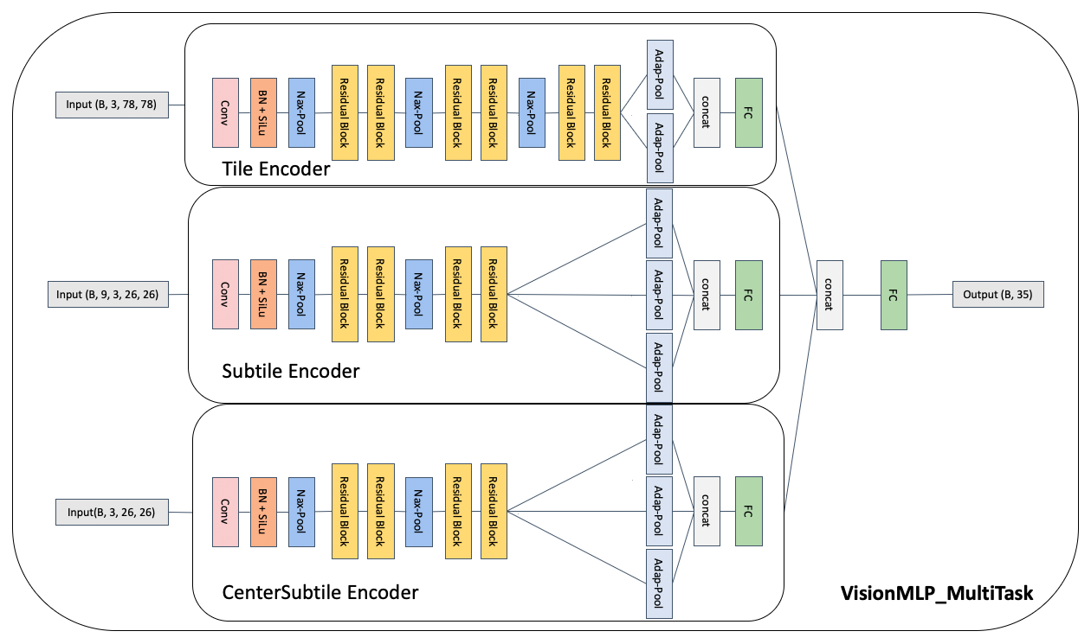

5. Training Strategy
5.1 Leave-One-Out (LOO) Cross-Validation
- Six folds → six models.
5.2 Model Stacking
- Use each of the six models to predict on all samples → produce a dataframe of shape (spots_n, 35 × 6).
- Train a small MLP on this dataframe → final output (spots_n, 35).
  - Learns to weight each fold’s prediction adaptively.

Optimization Notes
- Model structure: Residual + multi-scale design proved most stable.
- Input size: 78×78 tile + 9×26×26 subtiles + center 26×26 gave best results.
- Patch size choice: Mean spot spacing ≈ 26 px, so 3×26 covers full receptive field. That's why I use 26*3 as the global vision for input and 26 as the local vesion.
