

Submitted By:

Saurav Kumar Roy (S#2)

BDCOM0037

Hasibul Islam (S#1)

BDCOM0042

Report #1

Vlans

**Problem 1:** Communicate with 2 switch with port 1 in vlan. 1001

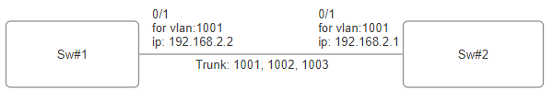

**Solution:**

**Configure for switch2:**

Setup vlans:

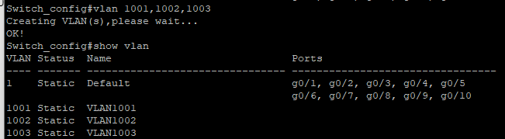

Set port 1 in trunk mode.

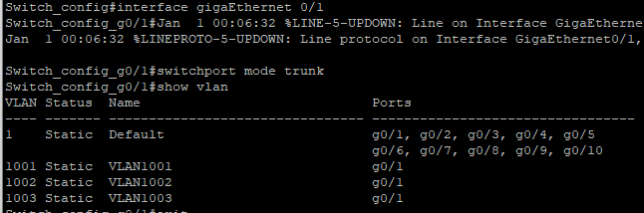

Set ip for vlan 1001:

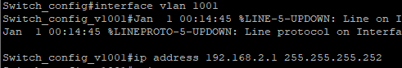

**Configure for switch 1:**

Setup vlans:

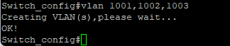

Show the vlans:

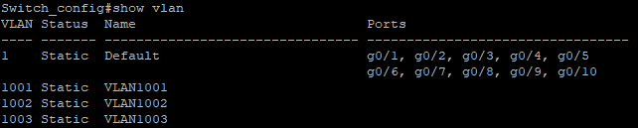

Set port 1 trunk mode:

5

6

Set ip to vlan 1 interface:

9

**Output from switch 2**:

Ping switch 1:

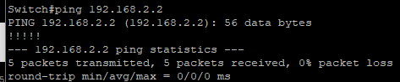

**Problem 2:** Connect pc in port 2 and communicate with vlan 1003 in access mode. Assign ip to the pc and the vlan interface.

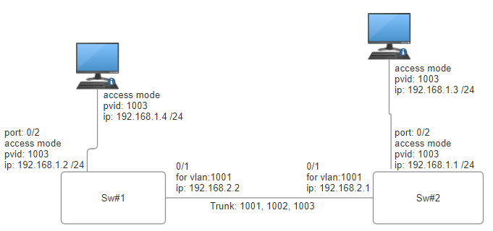

Pc #1

Pc #2

**Solution:**

**Config for switch2:**

Set ip to vlan 1003:

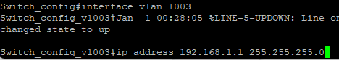

Ready port 2 for vlan 1003 in access mode.

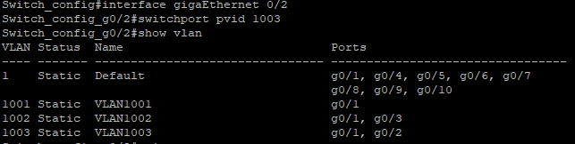

Ip was assigned to vlan 1003 and the pc. The ip was of subnet 255.255.255.0

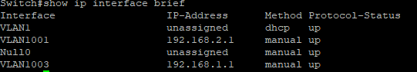

The Port 2 is set to access mode with pvid 1003

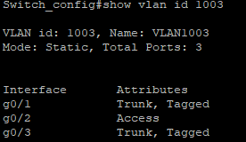

Setup PC#2:

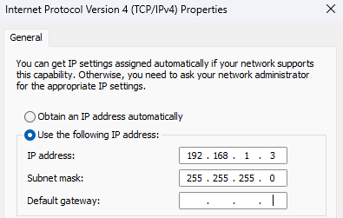

**Configuration in Switch 1:**

Set port 2 in access mode:

Set port 2 to access mode:

Screenshot 2023-11-09 001511



Set vlan interface:

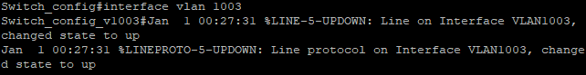

Screenshot 2023-11-09 001853

Configure pc#1:

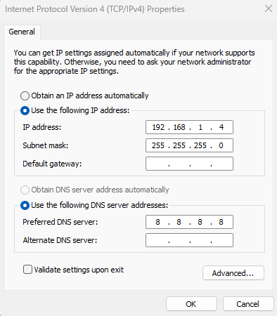

Ping pc#1:

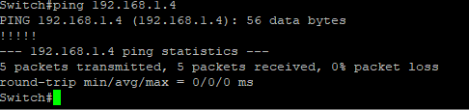

**Problem 3:** Connect pc in port 2 and communicate with vlan 1002 in trunk mode. Assign ip to the pc of subnet /30

**Solution:**

**Config for switch2:**

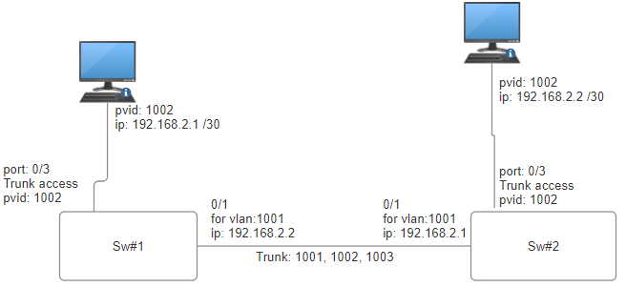

Pc #1

Pc #2

Ready prot 3 for vlan 1002:

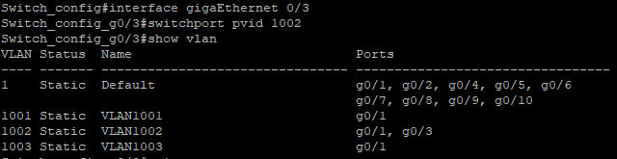

Ip was assigned to the pc#2 with subnet /30.

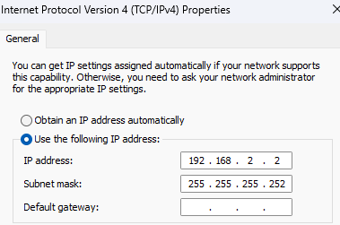

No ip was given to the switch ports. Port 3 is in trunk mode. So to send data Pvid 1002 is added.

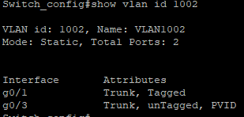

**Configuration for switch 1:**

Going to port 0/3 interface

15

Adding switch port mode to trunk mode.

16

Setting PC IP (192.168.2.1/30) for pc #1:

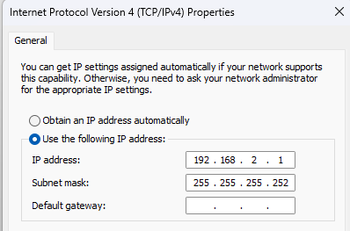

Ping PC#1 from pc#2

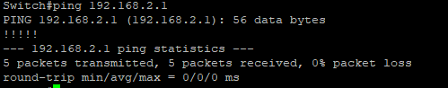

**Conclusion:**

Vlans are created to isolate groups of pc with same network. Now only the groups can communicate within them selves. This makes a large network manageable and reduces broadcasting domains.

In conclusion we can say that 2 device can communicate if the are in the same vlan.