Submitted By:

Saurav Kumar Roy (S#2)

BDCOM0037

Hasibul Islam (S#1)

BDCOM0042



Report #2

RSTP, LACP and DHCP

**Problem 1: Check Spanning tree protocol (RSTP). Make S#2 as root and port 2 as primary.**

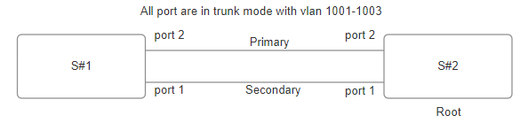

**To make S#2 as root:**

We have to set the priority value of the root to minimum:

Mode: config

Command: spanning-tree rstp priority 2

Here the priority is set to 2. Which is minimum than S#1. So it will work as Root.

Now to set port 2 to primary we need to reduce the port value.

Command:

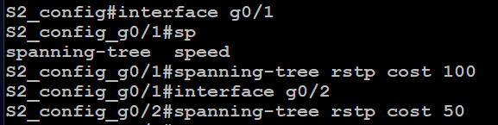

Here the cost of port 1 is set to 100 and cost of port to is set to 50.

**Similarly we need to configure the Swtich #1**

Configure port 2 with low cost and port 1 with high cost

10

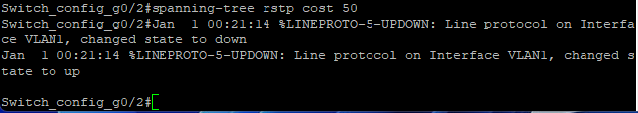

12

From switch #2 we can confirm that port 2 is now the primary port.

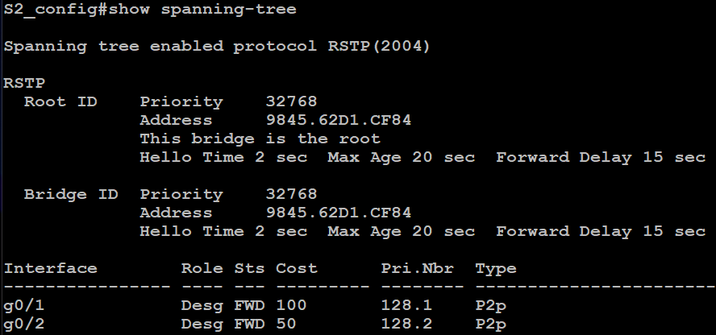

From switch#1 we can see that g0/1 port is blocked as secondary port.

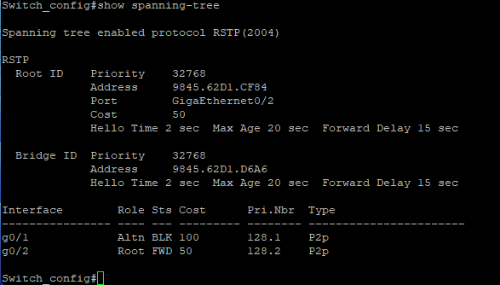

**Problem2: Aggregation of port 1 and 2.**

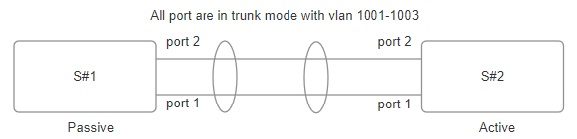

**Config in switch#2:**

Create Port aggregator:

Mode: config

Command: interface port-aggregator 8

The command creates a port-aggregator of group 8.

Aggrigator group (Trunk mode) should be same as the ports (Trunk mode) used in the mode. In this case all are in trunk mode with 3 vlans. 1001,1002 and 1003.

Add aggregator to the ports with g0/1,2 in active mode as per instruction switch 2 is in active mode.



From the config file we can confirm its in active mode which is default.

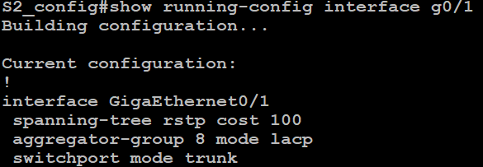

**Config in switch#1**:

The port g0/1 in switch 1 is configured to passive.

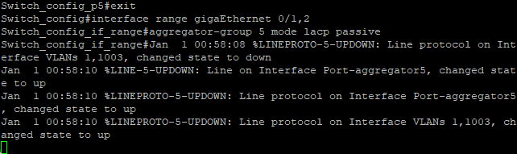

Check running config in S#1

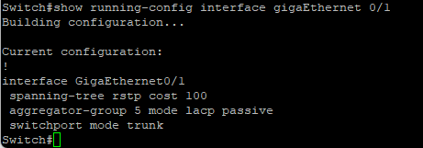

**Output from switch 2:**

Finally we can see that the 2 ports are aggregated and the bandwidth is now 2Gb (1Gb+1Gb)

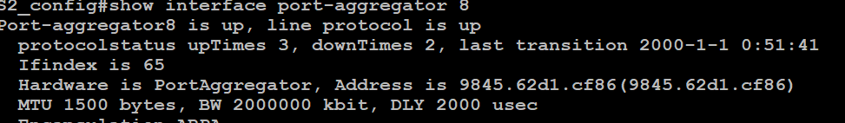

**Problem 3: Configure the Vlan 1003 interface with DHCP protocol with ip of /29 block.**

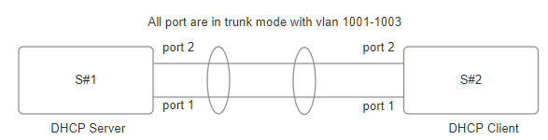

**S#1:**

DHCP Server:

Give ip for DHCP server.

Setup Server 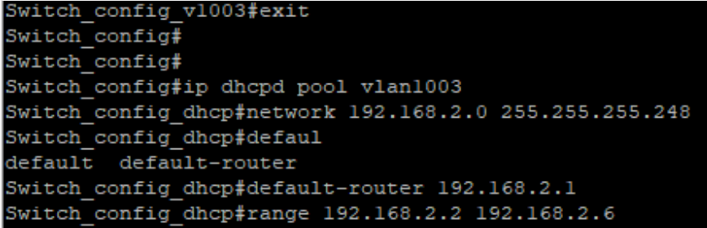

**S#2: DHCP Client**.

We need to go to the interface of the vlan.



Now assign ip with DHCP.



To check if ip is assigned in vlan 1003:

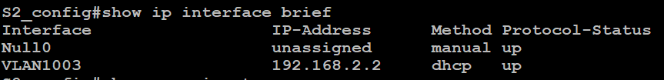

After assinging ip to switch 2 if we check switch 1 we see that it has the mac of switch 2:

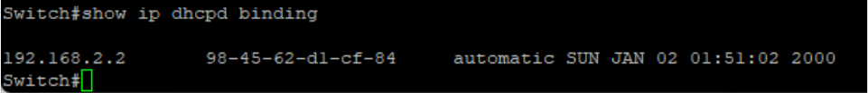

Now Switch 2 can ping switch 1:

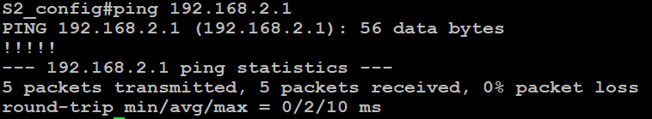

**Conclusion:**

RSTP is a spanning tree protocol which can control loop in a network by assigning a root switch and the election can also be manually modified. It can also improve redundancy.

LACP use multiple links to create a group and it can improve bandwidth. It also improves redundancy.

DHCP protocol creates a DHCP server which can give ip to all the devices connected to the network which sends DHCP request. The DHCP pool can be modified in the dhcp server. The server can provide IP, subnet, gateway and other features. It helps to remove the hassel of manually assigning ip to each device in a network.