Report #3

Routing Technology

Submitted By:

Saurav Kumar Roy (S#2)

BDCOM0037

Hasibul Islam (S#1)

BDCOM0042



**Task: Ospf (point to point, area 0), and static routing:**

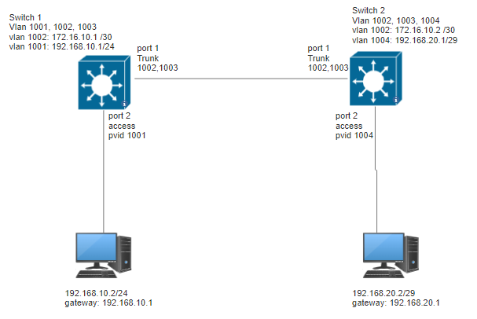

Pc#1

Pc#2

**Configuration for switch#2:**

Create Vlans:



Setup port 1:







Setup ip to the vlans:









Check the ip:

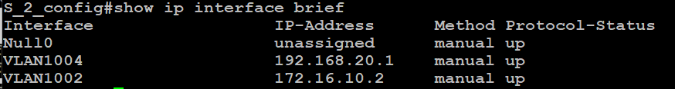

Check port 1 configuration:

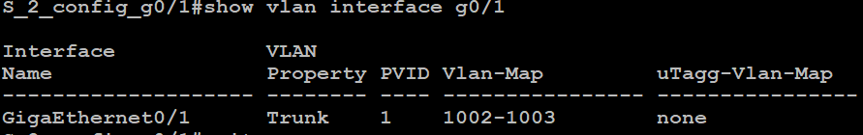

Setup port2:





Check port 2

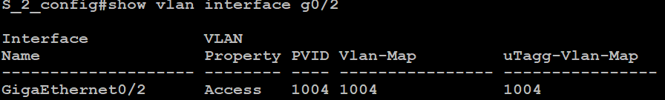

Setup pc#2:

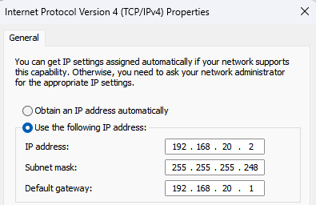

We can see that there is no device connected with static or ospf protocol:

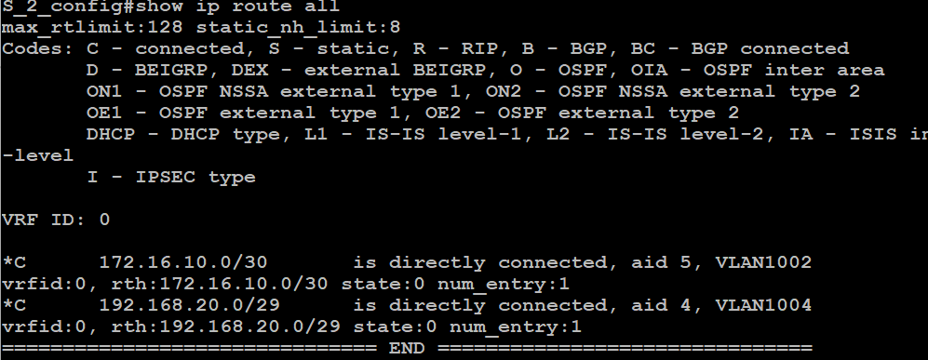

Configure Switch #1

Creating three VLAN 1001, 1002, 1003

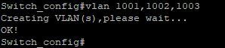

Now if we try to ping from PC-1 to PC-2, we would not get any reply

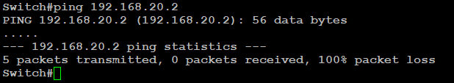

After that changing the IP manually on PC#1`

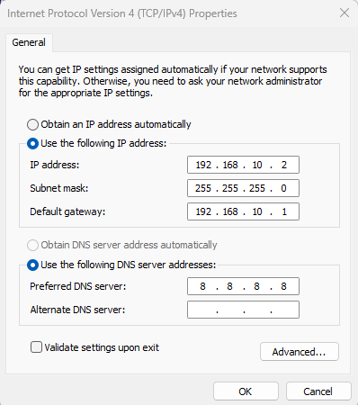

But we can not get reply from the pc#1 to pc#2.

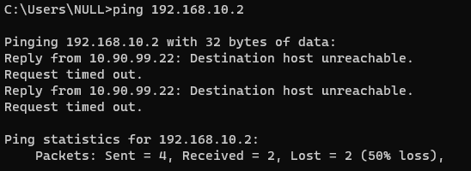

**Static Route:**

**Config for Switch#2**

setup static route:



Check if route is created or not:



**Config for Swtich#1:**

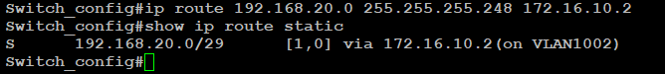

From the routing table of switch #2 we can see the connected devices:

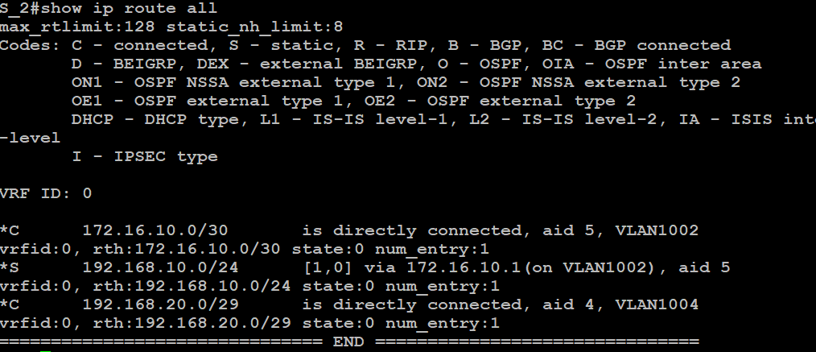

Now we can ping pc#1 from pc#2:

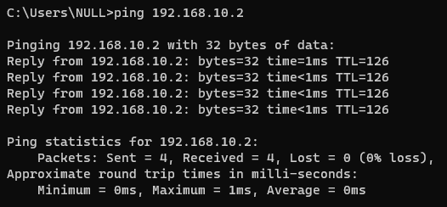

**OSPF (Network: P2P at area 0)**

**Switch #2:**

disable static in swtich:



Now we can see static is removed.

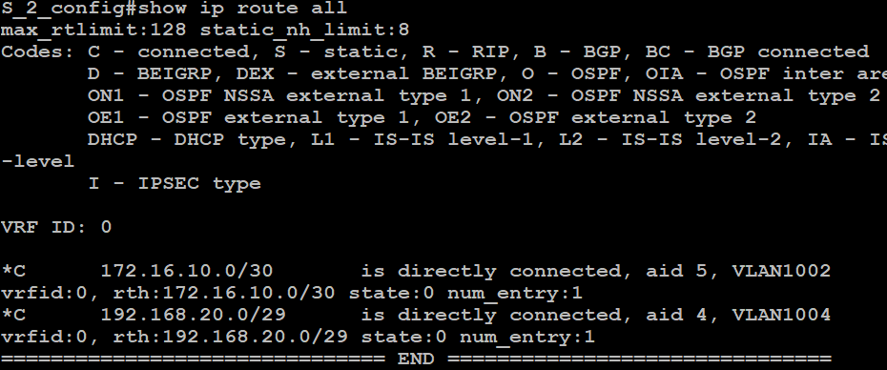

Configure ospf:

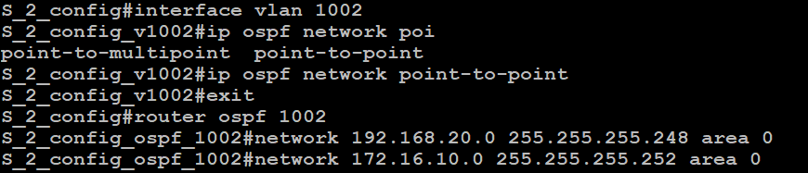



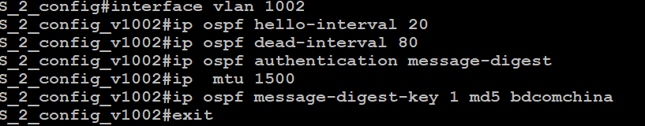

Check configuration:

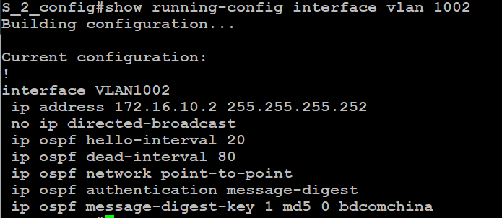

**Configuration for Switch#1**

First of all remove the static configuration and check weather the configuration removed successfully or not.

12

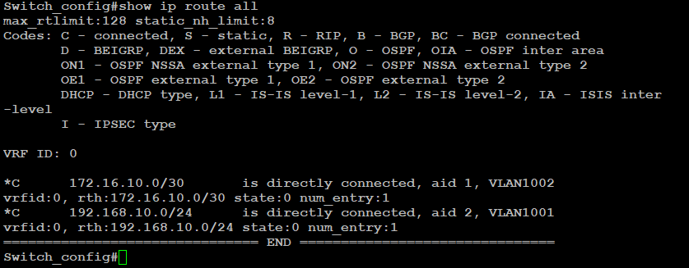

Then go to VLAN 1002 interface and set OSCP point to point connection. With additional configs:

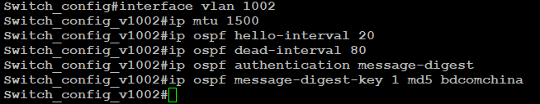

14

Then exit from the interface and set network IP and assign to Area 0

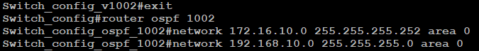

**Check outputs form switch#2**

Check ospf routing:



Ospf database:

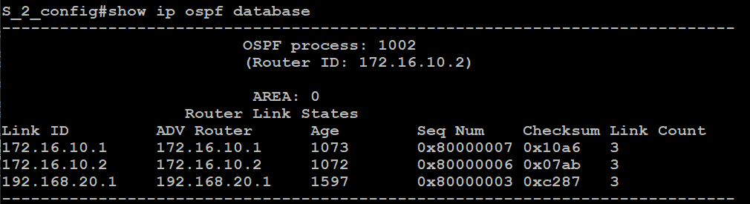

Check neighbour:

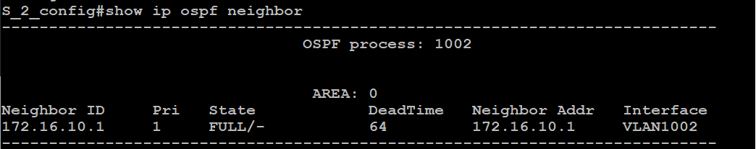

Check Connectied devices:

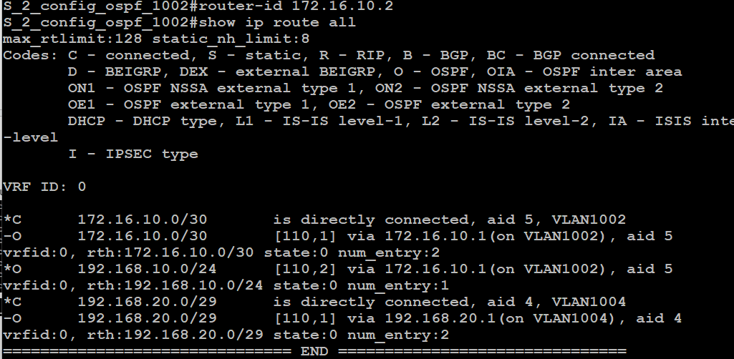

It will create the configuration as stated. Now we can check different parameters to confirm successful configuration

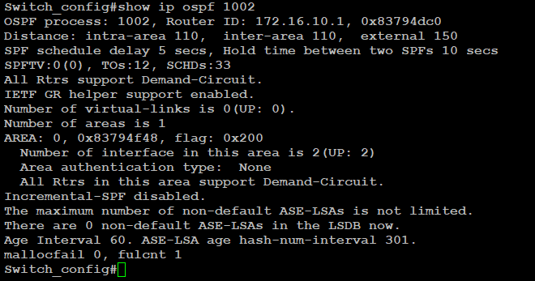

After establishing connection we can now check :get ping from pc#2 to pc#1

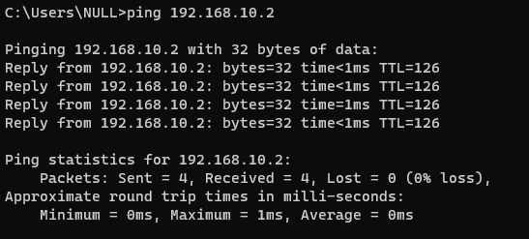

**Conclusion:**

Routing is needed for connecting 2 different networks. We use layer3 switch which support routing table to create routing. We use vlan interface for routing with the switch. At first we can see there was no routing so there was no communication with pc#1 and #2.

Then we established static routing Which creates a communication but static routing is not suitable for large network as we need to add all the gateway and entries to every swtich manually.

For that we use ospf point to point connection in a same area. It Creates a dynamic routing table for us and its lest troublesome.