|  |  |  |  |  |
| --- | --- | --- | --- | --- |
|  | INTERNATIONAL TELECOMMUNICATION UNION  **TELECOMMUNICATION** **STANDARDIZATION SECTOR**  STUDY PERIOD 2022-2024 | | **Focus Group on AI Native Networks** | |
| **AINN-I-xx** | |
| **Original: English** | |
| **Question(s):** | | N/A | Virtual, TBD 2024 | |
| **INPUT DOCUMENT** | | | | |
| **Source:** | | *CDAC MH* | | |
| **Title:** | | *Report on* *ITU WTSA Hackathon 2024 – AI/ML-driven Anomaly Detection in 5G/6G Telecommunications Networks* | | |
| **Contact:** | | Mr. Neetiraj | | E-mail: [neetiraj@cdac.in](mailto:neetiraj@cdac.in) [msaurav@cdac.in](mailto:msaurav@cdac.in) |

|  |  |
| --- | --- |
| **Abstract:** | This document contains the submission report for team name “Team_CDAC” towards ITU WTSA Hackathon 2024 for use case *“AI/ML-driven Anomaly Detection in 5G/6G Telecommunications Networks”.* |

## Use case introduction: **“**AI/ML-driven Anomaly Detection in 5G/6G Telecommunications Networks**”**

As the world transitions to 5G and prepares for 6G networks, managing telecommunications during high-demand, emergency situations becomes increasingly critical. Traditional anomaly detection mechanisms often fall short in handling the scale and complexity of modern telecoms networks, especially in emergency scenarios where network integrity is crucial. The lack of real-world datasets simulating massive emergency events further hampers effective AI/ML-driven network optimization and anomaly detection. The objective of this use case is to deploy AI/ML technologies to detect and mitigate network anomalies in real-time during mission-critical events, such as large-scale emergencies, where continuous and reliable communication is essential.

Consider the scene map below:

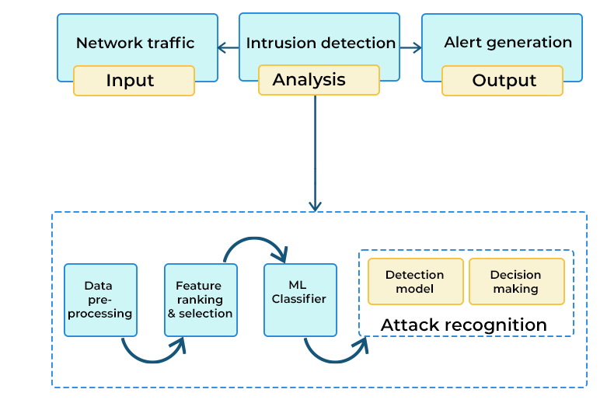

* Phase 1: **Emergency Event Occurs (Natural Disaster) -** A major earthquake hits a densely populated city. Thousands of people are using their mobile devices to make emergency calls, share information, and access vital services. The sudden spike in network traffic starts to strain the 5G/6G telecommunications infrastructure, creating the potential for network failures and communication delays. The AI/ML-based network monitoring system detects an unusual increase in network load in specific cell towers and starts tracking potential anomalies.
* Phase 2: **Initial Anomalies Detected -** As emergency responders are deployed across the city, network congestion worsens, and anomalies such as packet loss, signal degradation, and high latency are detected. The AI system categorizes these anomalies, classifying them as critical due to the ongoing emergency. The system identifies that certain critical services, such as emergency call systems, are experiencing delays. Immediate actions are recommended to prioritize network traffic for emergency responders and hospitals.
* Phase 3: **Network Traffic Rerouting -** AI algorithms optimize the network by rerouting traffic from heavily congested areas to nearby cell towers with spare capacity. Emergency calls and mission-critical communications are given priority by identifying these links in network and restricting only critical communication through them (direct communication between hospitals and citizens), while non-essential services are throttled to ensure bandwidth availability for high-priority users like first responders, ambulances, and hospitals. AI-driven traffic predictions help prevent future congestion by dynamically allocating resources based on anticipated network usage patterns.
* Phase 4: **Continuous Anomaly Monitoring and Mitigation -** As the emergency response continues, the AI/ML system constantly monitors the network for new anomalies. It detects a bottleneck in a critical area where a key cell tower is about to fail due to hardware damage caused by the earthquake. The system recommends rerouting traffic away from the affected cell tower and optimize resources of nearby towers for better connectivity for emergency services. Simultaneously, a notification is sent to field engineers for hardware intervention. This real-time response ensures minimal disruption to emergency communications.
* Phase 5: **Post-Emergency Network Recovery -** Once the immediate crisis is under control and network demand starts to stabilize, the AI system shifts its focus to recovering normal services. It reverts the network to its standard operating procedures while maintaining a high level of monitoring to ensure no further issues arise. Data collected during the event is analyzed to fine-tune the AI models for future emergency scenarios, improving the system’s predictive accuracy and response speed. The report summarizing the steps taken and how to further improve the network for future anomaly is generated.

Clause-3: PS1: pipeline design

* AI /ML Concept used is Anomaly Detection. The following pipeline design is used.

Clause-5: Relation to Standards.

Clause-6: Code submission details

The code is written for Intrusion detection evaluation dataset. We have used Random forest classifier for classifying if there has been a intrusion in the dataset on not.

Clause-7: Self-Testing results

The model is classifying with close to 100 percent accuracy.

_________________