Q1.
DES ENCRYPTION

PROGRAM CODE:

import numpy as np

#Initial permut matrix for the datas
PI = [58, 50, 42, 34, 26, 18, 10, 2,
60, 52, 44, 36, 28, 20, 12, 4,
62, 54, 46, 38, 30, 22, 14, 6,
64, 56, 48, 40, 32, 24, 16, 8,
57, 49, 41, 33, 25, 17, 9, 1,
59, 51, 43, 35, 27, 19, 11, 3,
61, 53, 45, 37, 29, 21, 13, 5,
63, 55, 47, 39, 31, 23, 15, 7]

#Initial permut made on the key
CP_1 = [57, 49, 41, 33, 25, 17, 9,
1, 58, 50, 42, 34, 26, 18,
10, 2, 59, 51, 43, 35, 27,
19, 11, 3, 60, 52, 44, 36,
63, 55, 47, 39, 31, 23, 15,
7, 62, 54, 46, 38, 30, 22,
14, 6, 61, 53, 45, 37, 29,
21, 13, 5, 28, 20, 12, 4]

#Permut applied on shifted key to get Ki+1
CP_2 = [14, 17, 11, 24, 1, 5, 3, 28,
15, 6, 21, 10, 23, 19, 12, 4,
26, 8, 16, 7, 27, 20, 13, 2,
41, 52, 31, 37, 47, 55, 30, 40,
51, 45, 33, 48, 44, 49, 39, 56,
34, 53, 46, 42, 50, 36, 29, 32]

#Expand matrix to get a 48bits matrix of datas to apply the xor with Ki
E = [32, 1, 2, 3, 4, 5,
4, 5, 6, 7, 8, 9,
8, 9, 10, 11, 12, 13,
12, 13, 14, 15, 16, 17,
16, 17, 18, 19, 20, 21,
20, 21, 22, 23, 24, 25,
24, 25, 26, 27, 28, 29,
28, 29, 30, 31, 32, 1]

#SBOX
S_BOX = [

[[14, 4, 13, 1, 2, 15, 11, 8, 3, 10, 6, 12, 5, 9, 0, 7],
[0, 15, 7, 4, 14, 2, 13, 1, 10, 6, 12, 11, 9, 5, 3, 8],
[4, 1, 14, 8, 13, 6, 2, 11, 15, 12, 9, 7, 3, 10, 5, 0],
[15, 12, 8, 2, 4, 9, 1, 7, 5, 11, 3, 14, 10, 0, 6, 13],
],

[[15, 1, 8, 14, 6, 11, 3, 4, 9, 7, 2, 13, 12, 0, 5, 10],
[3, 13, 4, 7, 15, 2, 8, 14, 12, 0, 1, 10, 6, 9, 11, 5],
[0, 14, 7, 11, 10, 4, 13, 1, 5, 8, 12, 6, 9, 3, 2, 15],
[13, 8, 10, 1, 3, 15, 4, 2, 11, 6, 7, 12, 0, 5, 14, 9],
],

[[10, 0, 9, 14, 6, 3, 15, 5, 1, 13, 12, 7, 11, 4, 2, 8],
[13, 7, 0, 9, 3, 4, 6, 10, 2, 8, 5, 14, 12, 11, 15, 1],
[13, 6, 4, 9, 8, 15, 3, 0, 11, 1, 2, 12, 5, 10, 14, 7],
[1, 10, 13, 0, 6, 9, 8, 7, 4, 15, 14, 3, 11, 5, 2, 12],
],

[[7, 13, 14, 3, 0, 6, 9, 10, 1, 2, 8, 5, 11, 12, 4, 15],
[13, 8, 11, 5, 6, 15, 0, 3, 4, 7, 2, 12, 1, 10, 14, 9],
[10, 6, 9, 0, 12, 11, 7, 13, 15, 1, 3, 14, 5, 2, 8, 4],
[3, 15, 0, 6, 10, 1, 13, 8, 9, 4, 5, 11, 12, 7, 2, 14],
],

[[2, 12, 4, 1, 7, 10, 11, 6, 8, 5, 3, 15, 13, 0, 14, 9],
[14, 11, 2, 12, 4, 7, 13, 1, 5, 0, 15, 10, 3, 9, 8, 6],
[4, 2, 1, 11, 10, 13, 7, 8, 15, 9, 12, 5, 6, 3, 0, 14],
[11, 8, 12, 7, 1, 14, 2, 13, 6, 15, 0, 9, 10, 4, 5, 3],
],

[[12, 1, 10, 15, 9, 2, 6, 8, 0, 13, 3, 4, 14, 7, 5, 11],
[10, 15, 4, 2, 7, 12, 9, 5, 6, 1, 13, 14, 0, 11, 3, 8],
[9, 14, 15, 5, 2, 8, 12, 3, 7, 0, 4, 10, 1, 13, 11, 6],
[4, 3, 2, 12, 9, 5, 15, 10, 11, 14, 1, 7, 6, 0, 8, 13],
],

[[4, 11, 2, 14, 15, 0, 8, 13, 3, 12, 9, 7, 5, 10, 6, 1],
[13, 0, 11, 7, 4, 9, 1, 10, 14, 3, 5, 12, 2, 15, 8, 6],
[1, 4, 11, 13, 12, 3, 7, 14, 10, 15, 6, 8, 0, 5, 9, 2],
[6, 11, 13, 8, 1, 4, 10, 7, 9, 5, 0, 15, 14, 2, 3, 12],
],

[[13, 2, 8, 4, 6, 15, 11, 1, 10, 9, 3, 14, 5, 0, 12, 7],
[1, 15, 13, 8, 10, 3, 7, 4, 12, 5, 6, 11, 0, 14, 9, 2],
[7, 11, 4, 1, 9, 12, 14, 2, 0, 6, 10, 13, 15, 3, 5, 8],
[2, 1, 14, 7, 4, 10, 8, 13, 15, 12, 9, 0, 3, 5, 6, 11],
]
]

#Permut made after each SBox substitution for each round
P = [16, 7, 20, 21, 29, 12, 28, 17,
1, 15, 23, 26, 5, 18, 31, 10,
2, 8, 24, 14, 32, 27, 3, 9,
19, 13, 30, 6, 22, 11, 4, 25]

#Final permut for datas after the 16 rounds
FI = [40, 8, 48, 16, 56, 24, 64, 32,
39, 7, 47, 15, 55, 23, 63, 31,
38, 6, 46, 14, 54, 22, 62, 30,
37, 5, 45, 13, 53, 21, 61, 29,
36, 4, 44, 12, 52, 20, 60, 28,
35, 3, 43, 11, 51, 19, 59, 27,
34, 2, 42, 10, 50, 18, 58, 26,
33, 1, 41, 9, 49, 17, 57, 25]

#Matrix that determine the shift for each round of keys
SHIFT = [1,1,2,2,2,2,2,2,1,2,2,2,2,2,2,1]

def convert(char):
return "{0:064b}".format(int(char, 16))

def xor(x,y):
return (int(x,2) ^ int(y,2))

def sbox(text):
new_text=""
for i in range(8):
x=int((text[0]+text[5]),2)
y=int((text[1:5]),2)
temp=S_BOX[i][x][y]
new_text+=('{0:04b}'.format(temp))
text=text[6:]
return new_text

def straight(text):
inp=[0]*32
x=0
for i in P:
inp[x]=text[i-1]
x=x+1
inp=''.join(inp)
return inp

def permu(text):
inp=[0]*64
x=0
for i in PI:
inp[x]=text[i-1]
x=x+1
inp=''.join(inp)
return inp

def final(text):
inp=[0]*64
x=0
for i in FI:
inp[x]=text[i-1]
x=x+1
inp=''.join(inp)
return inp

def expand(text1):
text=[0]*48
x=0
for i in E:
text[x]=text1[i-1]
x=x+1
text=''.join(text)
return text

def drop(key):
l_key=[0]*56
x=0
for i in CP_1:
l_key[x]=key[i-1]
x=x+1
return l_key

def compress(key):
r_key=[0]*48
x=0
for i in CP_2:
r_key[x]=key[i-1]
x=x+1
r_key=''.join(r_key)
return r_key

def shift(key):
return key[1:]+key[0]

def key_generator(key):
s_key=convert(key)
s_key=drop(s_key)
left=s_key[:len(s_key)//2]
right=s_key[len(s_key)//2:]
left=''.join(left)
right=''.join(right)
key=[0]*16
for i in range(16):
for j in range(SHIFT[i]):
left=shift(left)
right=shift(right)
temp=left+right
key[i]=compress(temp)
#temp = int(key[i], 2)
#print(hex(temp).upper())
return key

def funtion(right,key):
text=expand(right)
text=xor(text,key)
text=('{0:048b}'.format(text))
text=sbox(text)
text=straight(text)
return text

def swapper(left,right):
return right,left

def des(inputt,key):
inputt=convert(inputt)
text=permu(inputt)
print("Round\t Left\t\t Right\t\t Round Key\n")
left=text[:len(text)//2]
right=text[len(text)//2:]
left=''.join(left)
right=''.join(right)
print("Initial\t",hex(int(left, 2)).upper(),"\t",hex(int(right, 2)).upper(),"\t (Initial Permutation)\n")
for i in range(16):
out=funtion(right,key[i])
left=xor(left,out)
left=('{0:032b}'.format(left))
if(i != 15):
left,right=swapper(left,right)
print(i+1,"\t",hex(int(left, 2)).upper(),"\t",hex(int(right, 2)).upper(),"\t",hex(int(key[i], 2)).upper())
text=left+right
output=final(text)
print("\nCIPHER TEXT : ",hex(int(output, 2)).upper(),"\t (After Final Permutation)")
return output

key="AABB09182736CCDD"
key=key_generator(key)

inputt="123456ABCD132536"
ciper=des(inputt,key)

OUTPUT:
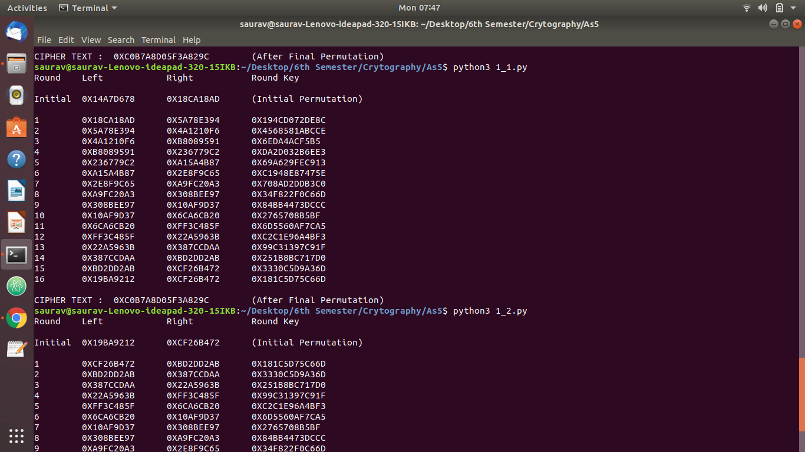

DES DENCRYPTION

PROGRAM CODE:

import numpy as np

#Initial permut matrix for the datas
PI = [58, 50, 42, 34, 26, 18, 10, 2,
60, 52, 44, 36, 28, 20, 12, 4,
62, 54, 46, 38, 30, 22, 14, 6,
64, 56, 48, 40, 32, 24, 16, 8,
57, 49, 41, 33, 25, 17, 9, 1,
59, 51, 43, 35, 27, 19, 11, 3,
61, 53, 45, 37, 29, 21, 13, 5,
63, 55, 47, 39, 31, 23, 15, 7]

#Initial permut made on the key
CP_1 = [57, 49, 41, 33, 25, 17, 9,
1, 58, 50, 42, 34, 26, 18,
10, 2, 59, 51, 43, 35, 27,
19, 11, 3, 60, 52, 44, 36,
63, 55, 47, 39, 31, 23, 15,
7, 62, 54, 46, 38, 30, 22,
14, 6, 61, 53, 45, 37, 29,
21, 13, 5, 28, 20, 12, 4]

#Permut applied on shifted key to get Ki+1
CP_2 = [14, 17, 11, 24, 1, 5, 3, 28,
15, 6, 21, 10, 23, 19, 12, 4,
26, 8, 16, 7, 27, 20, 13, 2,
41, 52, 31, 37, 47, 55, 30, 40,
51, 45, 33, 48, 44, 49, 39, 56,
34, 53, 46, 42, 50, 36, 29, 32]

#Expand matrix to get a 48bits matrix of datas to apply the xor with Ki
E = [32, 1, 2, 3, 4, 5,
4, 5, 6, 7, 8, 9,
8, 9, 10, 11, 12, 13,
12, 13, 14, 15, 16, 17,
16, 17, 18, 19, 20, 21,
20, 21, 22, 23, 24, 25,
24, 25, 26, 27, 28, 29,
28, 29, 30, 31, 32, 1]

#SBOX
S_BOX = [

[[14, 4, 13, 1, 2, 15, 11, 8, 3, 10, 6, 12, 5, 9, 0, 7],
[0, 15, 7, 4, 14, 2, 13, 1, 10, 6, 12, 11, 9, 5, 3, 8],
[4, 1, 14, 8, 13, 6, 2, 11, 15, 12, 9, 7, 3, 10, 5, 0],
[15, 12, 8, 2, 4, 9, 1, 7, 5, 11, 3, 14, 10, 0, 6, 13],
],

[[15, 1, 8, 14, 6, 11, 3, 4, 9, 7, 2, 13, 12, 0, 5, 10],
[3, 13, 4, 7, 15, 2, 8, 14, 12, 0, 1, 10, 6, 9, 11, 5],
[0, 14, 7, 11, 10, 4, 13, 1, 5, 8, 12, 6, 9, 3, 2, 15],
[13, 8, 10, 1, 3, 15, 4, 2, 11, 6, 7, 12, 0, 5, 14, 9],
],

[[10, 0, 9, 14, 6, 3, 15, 5, 1, 13, 12, 7, 11, 4, 2, 8],
[13, 7, 0, 9, 3, 4, 6, 10, 2, 8, 5, 14, 12, 11, 15, 1],
[13, 6, 4, 9, 8, 15, 3, 0, 11, 1, 2, 12, 5, 10, 14, 7],
[1, 10, 13, 0, 6, 9, 8, 7, 4, 15, 14, 3, 11, 5, 2, 12],
],

[[7, 13, 14, 3, 0, 6, 9, 10, 1, 2, 8, 5, 11, 12, 4, 15],
[13, 8, 11, 5, 6, 15, 0, 3, 4, 7, 2, 12, 1, 10, 14, 9],
[10, 6, 9, 0, 12, 11, 7, 13, 15, 1, 3, 14, 5, 2, 8, 4],
[3, 15, 0, 6, 10, 1, 13, 8, 9, 4, 5, 11, 12, 7, 2, 14],
],

[[2, 12, 4, 1, 7, 10, 11, 6, 8, 5, 3, 15, 13, 0, 14, 9],
[14, 11, 2, 12, 4, 7, 13, 1, 5, 0, 15, 10, 3, 9, 8, 6],
[4, 2, 1, 11, 10, 13, 7, 8, 15, 9, 12, 5, 6, 3, 0, 14],
[11, 8, 12, 7, 1, 14, 2, 13, 6, 15, 0, 9, 10, 4, 5, 3],
],

[[12, 1, 10, 15, 9, 2, 6, 8, 0, 13, 3, 4, 14, 7, 5, 11],
[10, 15, 4, 2, 7, 12, 9, 5, 6, 1, 13, 14, 0, 11, 3, 8],
[9, 14, 15, 5, 2, 8, 12, 3, 7, 0, 4, 10, 1, 13, 11, 6],
[4, 3, 2, 12, 9, 5, 15, 10, 11, 14, 1, 7, 6, 0, 8, 13],
],

[[4, 11, 2, 14, 15, 0, 8, 13, 3, 12, 9, 7, 5, 10, 6, 1],
[13, 0, 11, 7, 4, 9, 1, 10, 14, 3, 5, 12, 2, 15, 8, 6],
[1, 4, 11, 13, 12, 3, 7, 14, 10, 15, 6, 8, 0, 5, 9, 2],
[6, 11, 13, 8, 1, 4, 10, 7, 9, 5, 0, 15, 14, 2, 3, 12],
],

[[13, 2, 8, 4, 6, 15, 11, 1, 10, 9, 3, 14, 5, 0, 12, 7],
[1, 15, 13, 8, 10, 3, 7, 4, 12, 5, 6, 11, 0, 14, 9, 2],
[7, 11, 4, 1, 9, 12, 14, 2, 0, 6, 10, 13, 15, 3, 5, 8],
[2, 1, 14, 7, 4, 10, 8, 13, 15, 12, 9, 0, 3, 5, 6, 11],
]
]

#Permut made after each SBox substitution for each round
P = [16, 7, 20, 21, 29, 12, 28, 17,
1, 15, 23, 26, 5, 18, 31, 10,
2, 8, 24, 14, 32, 27, 3, 9,
19, 13, 30, 6, 22, 11, 4, 25]

#Final permut for datas after the 16 rounds
FI = [40, 8, 48, 16, 56, 24, 64, 32,
39, 7, 47, 15, 55, 23, 63, 31,
38, 6, 46, 14, 54, 22, 62, 30,
37, 5, 45, 13, 53, 21, 61, 29,
36, 4, 44, 12, 52, 20, 60, 28,
35, 3, 43, 11, 51, 19, 59, 27,
34, 2, 42, 10, 50, 18, 58, 26,
33, 1, 41, 9, 49, 17, 57, 25]

#Matrix that determine the shift for each round of keys
SHIFT = [1,1,2,2,2,2,2,2,1,2,2,2,2,2,2,1]

def convert(char):
return "{0:064b}".format(int(char, 16))

def xor(x,y):
return (int(x,2) ^ int(y,2))

def sbox(text):
new_text=""
for i in range(8):
x=int((text[0]+text[5]),2)
y=int((text[1:5]),2)
temp=S_BOX[i][x][y]
new_text+=('{0:04b}'.format(temp))
text=text[6:]
return new_text

def straight(text):
inp=[0]*32
x=0
for i in P:
inp[x]=text[i-1]
x=x+1
inp=''.join(inp)
return inp

def permu(text):
inp=[0]*64
x=0
for i in PI:
inp[x]=text[i-1]
x=x+1
inp=''.join(inp)
return inp

def final(text):
inp=[0]*64
x=0
for i in FI:
inp[x]=text[i-1]
x=x+1
inp=''.join(inp)
return inp

def expand(text1):
text=[0]*48
x=0
for i in E:
text[x]=text1[i-1]
x=x+1
text=''.join(text)
return text

def drop(key):
l_key=[0]*56
x=0
for i in CP_1:
l_key[x]=key[i-1]
x=x+1
return l_key

def compress(key):
r_key=[0]*48
x=0
for i in CP_2:
r_key[x]=key[i-1]
x=x+1
r_key=''.join(r_key)
return r_key

def shift(key):
return key[1:]+key[0]

def key_generator(key):
s_key=convert(key)
s_key=drop(s_key)
left=s_key[:len(s_key)//2]
right=s_key[len(s_key)//2:]
left=''.join(left)
right=''.join(right)
key=[0]*16
for i in range(16):
for j in range(SHIFT[i]):
left=shift(left)
right=shift(right)
temp=left+right
key[i]=compress(temp)
#temp = int(key[i], 2)
#print(hex(temp).upper())
return key

def funtion(right,key):
text=expand(right)
text=xor(text,key)
text=('{0:048b}'.format(text))
text=sbox(text)
text=straight(text)
return text

def swapper(left,right):
return right,left

def des(inputt,key):
inputt=convert(inputt)
text=permu(inputt)
print("Round\t Left\t\t Right\t\t Round Key\n")
left=text[:len(text)//2]
right=text[len(text)//2:]
left=''.join(left)
right=''.join(right)
print("Initial\t",hex(int(left, 2)).upper(),"\t",hex(int(right, 2)).upper(),"\t (Initial Permutation)\n")
for i in range(16):
out=funtion(right,key[15-i])
left=xor(left,out)
left=('{0:032b}'.format(left))
if(i != 15):
left,right=swapper(left,right)
print(i+1,"\t",hex(int(left, 2)).upper(),"\t",hex(int(right, 2)).upper(),"\t",hex(int(key[15-i], 2)).upper())
text=left+right
output=final(text)
print("\nPLAIN TEXT : ",hex(int(output, 2)).upper(),"\t (After Final Permutation)")
return output

key="AABB09182736CCDD"
key=key_generator(key)

inputt="C0B7A8D05F3A829C"
ciper=des(inputt,key)

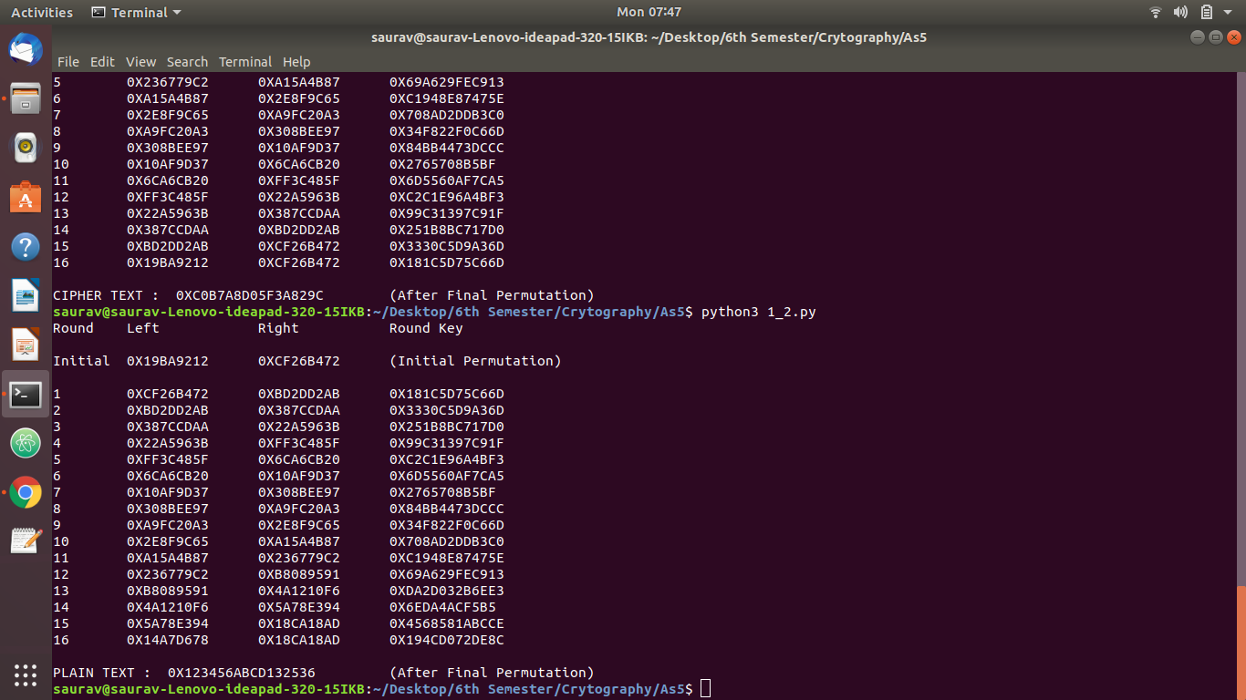
OUTPUT:
Q2.
AES
(128 bit key and message)

PROGRAM CODE:

import numpy as np
s_box = [
[0x63, 0x7C, 0x77, 0x7B, 0xF2, 0x6B, 0x6F, 0xC5, 0x30, 0x01, 0x67, 0x2B, 0xFE, 0xD7, 0xAB, 0x76],
[0xCA, 0x82, 0xC9, 0x7D, 0xFA, 0x59, 0x47, 0xF0, 0xAD, 0xD4, 0xA2, 0xAF, 0x9C, 0xA4, 0x72, 0xC0],
[0xB7, 0xFD, 0x93, 0x26, 0x36, 0x3F, 0xF7, 0xCC, 0x34, 0xA5, 0xE5, 0xF1, 0x71, 0xD8, 0x31, 0x15],
[0x04, 0xC7, 0x23, 0xC3, 0x18, 0x96, 0x05, 0x9A, 0x07, 0x12, 0x80, 0xE2, 0xEB, 0x27, 0xB2, 0x75],
[0x09, 0x83, 0x2C, 0x1A, 0x1B, 0x6E, 0x5A, 0xA0, 0x52, 0x3B, 0xD6, 0xB3, 0x29, 0xE3, 0x2F, 0x84],
[0x53, 0xD1, 0x00, 0xED, 0x20, 0xFC, 0xB1, 0x5B, 0x6A, 0xCB, 0xBE, 0x39, 0x4A, 0x4C, 0x58, 0xCF],
[0xD0, 0xEF, 0xAA, 0xFB, 0x43, 0x4D, 0x33, 0x85, 0x45, 0xF9, 0x02, 0x7F, 0x50, 0x3C, 0x9F, 0xA8],
[0x51, 0xA3, 0x40, 0x8F, 0x92, 0x9D, 0x38, 0xF5, 0xBC, 0xB6, 0xDA, 0x21, 0x10, 0xFF, 0xF3, 0xD2],
[0xCD, 0x0C, 0x13, 0xEC, 0x5F, 0x97, 0x44, 0x17, 0xC4, 0xA7, 0x7E, 0x3D, 0x64, 0x5D, 0x19, 0x73],
[0x60, 0x81, 0x4F, 0xDC, 0x22, 0x2A, 0x90, 0x88, 0x46, 0xEE, 0xB8, 0x14, 0xDE, 0x5E, 0x0B, 0xDB],
[0xE0, 0x32, 0x3A, 0x0A, 0x49, 0x06, 0x24, 0x5C, 0xC2, 0xD3, 0xAC, 0x62, 0x91, 0x95, 0xE4, 0x79],
[0xE7, 0xC8, 0x37, 0x6D, 0x8D, 0xD5, 0x4E, 0xA9, 0x6C, 0x56, 0xF4, 0xEA, 0x65, 0x7A, 0xAE, 0x08],
[0xBA, 0x78, 0x25, 0x2E, 0x1C, 0xA6, 0xB4, 0xC6, 0xE8, 0xDD, 0x74, 0x1F, 0x4B, 0xBD, 0x8B, 0x8A],
[0x70, 0x3E, 0xB5, 0x66, 0x48, 0x03, 0xF6, 0x0E, 0x61, 0x35, 0x57, 0xB9, 0x86, 0xC1, 0x1D, 0x9E],
[0xE1, 0xF8, 0x98, 0x11, 0x69, 0xD9, 0x8E, 0x94, 0x9B, 0x1E, 0x87, 0xE9, 0xCE, 0x55, 0x28, 0xDF],
[0x8C, 0xA1, 0x89, 0x0D, 0xBF, 0xE6, 0x42, 0x68, 0x41, 0x99, 0x2D, 0x0F, 0xB0, 0x54, 0xBB, 0x16],
]
r_const=["01","02","04","08","10","20","40","80","1B","36"]
constant=['2','3','1','1','1','2','3','1','1','1','2','3','3','1','1','2']
constant=np.array(constant).reshape(4,4)

def multiply(p1,p2):
p2=('{0:08b}'.format(p2))
p1=('{0:08b}'.format(p1))
mod="100011011"
result="0"
p2="0"+p2
p1= "".join(reversed(p1))
if(p1[0]=="1"):
result=p2[1:]
for i in range(1,len(p1)):
p2=p2[1:]+"0"
if(p2[0]=="1"):
p2 = int(p2,2) ^ int(mod,2)
p2=('{0:09b}'.format(p2))
if(p1[i]=="1"):
result=int(p2,2) ^ int(result,2)
result=('{0:08b}'.format(result))
return result

def xor(x,y):
state=[" "]*16
state=np.array(state).reshape(4,4)
for i in range(4):
for j in range(4):
temp=int(x[i][j],16) ^ int(y[i][j],16)
state[i][j]=('{0:02x}'.format(temp)).upper()
return state

def xor1(x,y):
state=[" "]*4
for i in range(4):
temp=int(x[i],16) ^ int(y[i],16)
state[i]=('{0:02x}'.format(temp)).upper()
return state

def sub(text):
for i in range(4):
for j in range(4):
x=int(text[i][j][0],16)
y=int(text[i][j][1],16)
temp=s_box[x][y]
text[i][j]=('{0:02x}'.format(temp)).upper()
return text

def shift(text):
i=0
for row in text:
text[i]=np.roll(row,-i)
i=i+1
return text

def mix(text):
result=["00"]*16
result=np.array(result).reshape(4,4)
for i in range(4):
for j in range(4):
for k in range(4):
temp = int(result[i][j],16) ^ int(multiply(int(constant[i][k],16),int(text[k][j],16)),2)
result[i][j]=('{0:02x}'.format(temp)).upper()
return result

def hex_gen(text):
while(len(text) < 16):
text=text+"z"
if(len(text)>16):
text=text[:16]
new_text=[]
for i in text:
temp=(ord(i))
temp=('{0:02x}'.format(temp)).upper()
new_text.append(temp)
text_array=np.array(new_text).reshape(4,4).transpose()
return text_array

def state_gen(text,i):
text=sub(text)
text=shift(text)
if(i != 9):
text=mix(text)
return text

def key_gen(key,index):
key=np.array(key).transpose()
temp=np.roll(key[3],-1)
for i in range(4):
x=int(temp[i][0],16)
y=int(temp[i][1],16)
temp1=s_box[x][y]
temp[i]=('{0:02x}'.format(temp1)).upper()
temp2=int(temp[0],16) ^ int(r_const[index],16)
temp[0]=('{0:02x}'.format(temp2)).upper()
for i in range(4):
key[i]=xor1(key[i],temp)
temp=key[i]
key=np.array(key).transpose()
return key

def aes(text,key):
key=hex_gen(key)
text=hex_gen(text)
state=xor(text,key)
print("Round 0 :")
print(state)
for i in range(10):
state=state_gen(state,i)
key=key_gen(key,i)
#print(key)
state=xor(state,key)
print("\nRound",i+1,":")
print(state)
state=np.array(state).transpose()
state=np.array(state).reshape(16)
return state

key="Thats my Kung Fu"
text="Two One Nine Two"
cipher=aes(text,key)
text=""
for i in cipher:
text+=chr(int(i,16))
print("\nCIPHER TEXT : ",cipher)

OUTPUT:
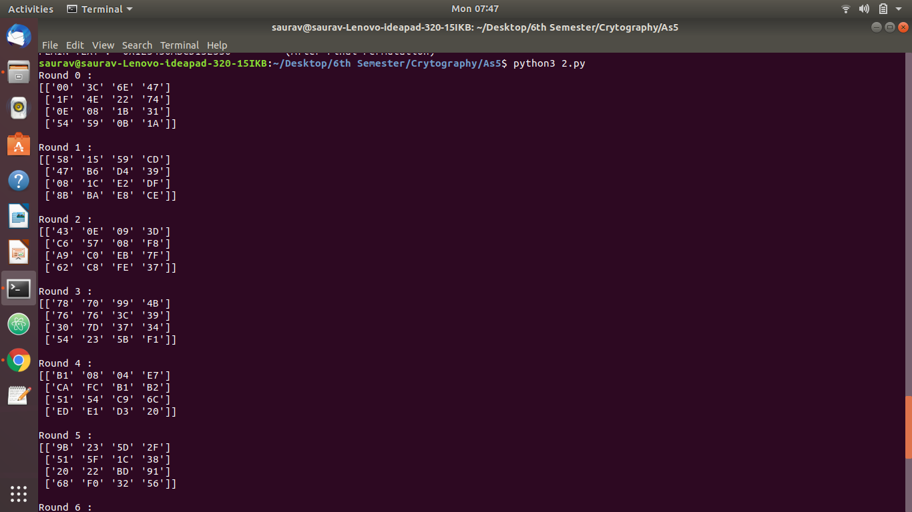
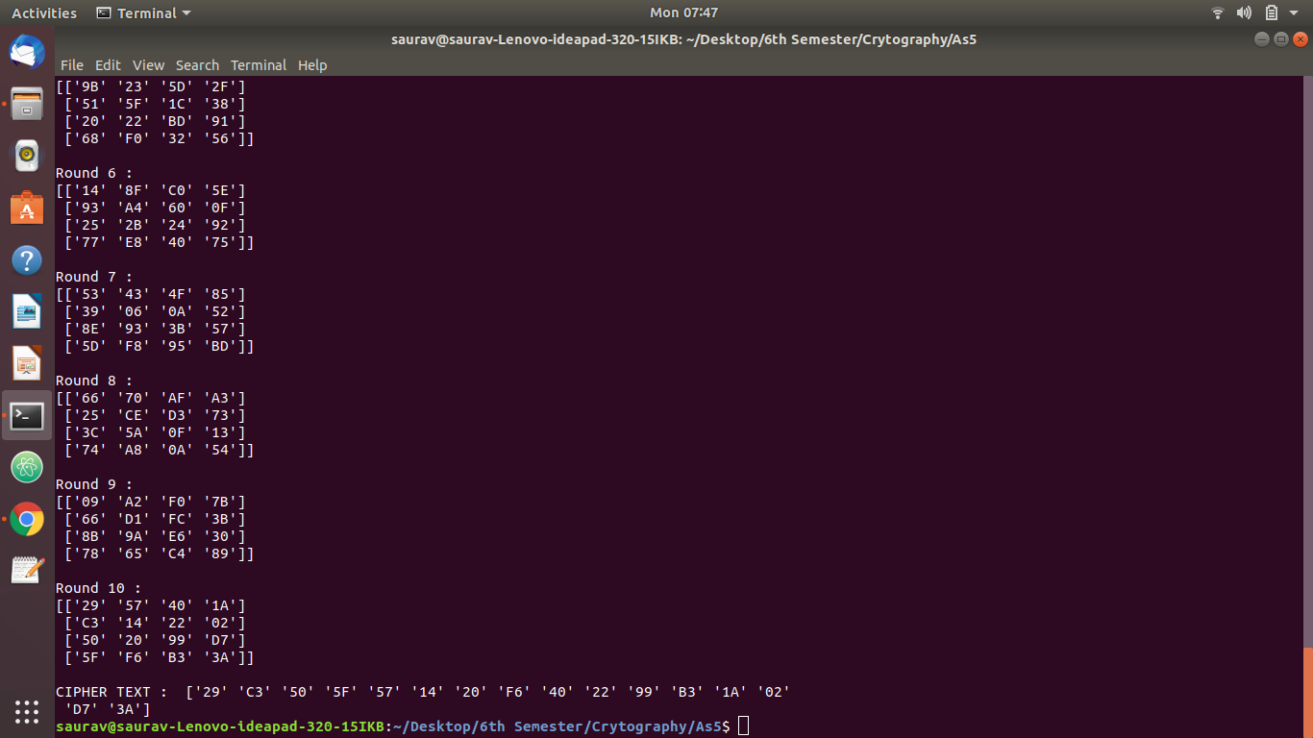
Q2.
RSA
PROGRAM CODE (Server Side):

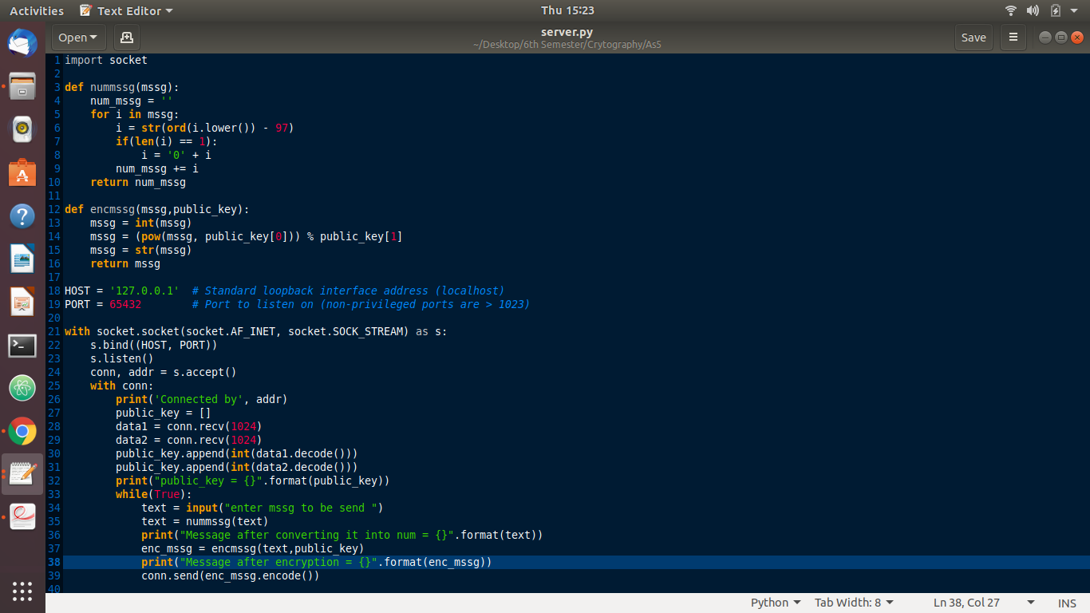

PROGRAM CODE (Client Side):
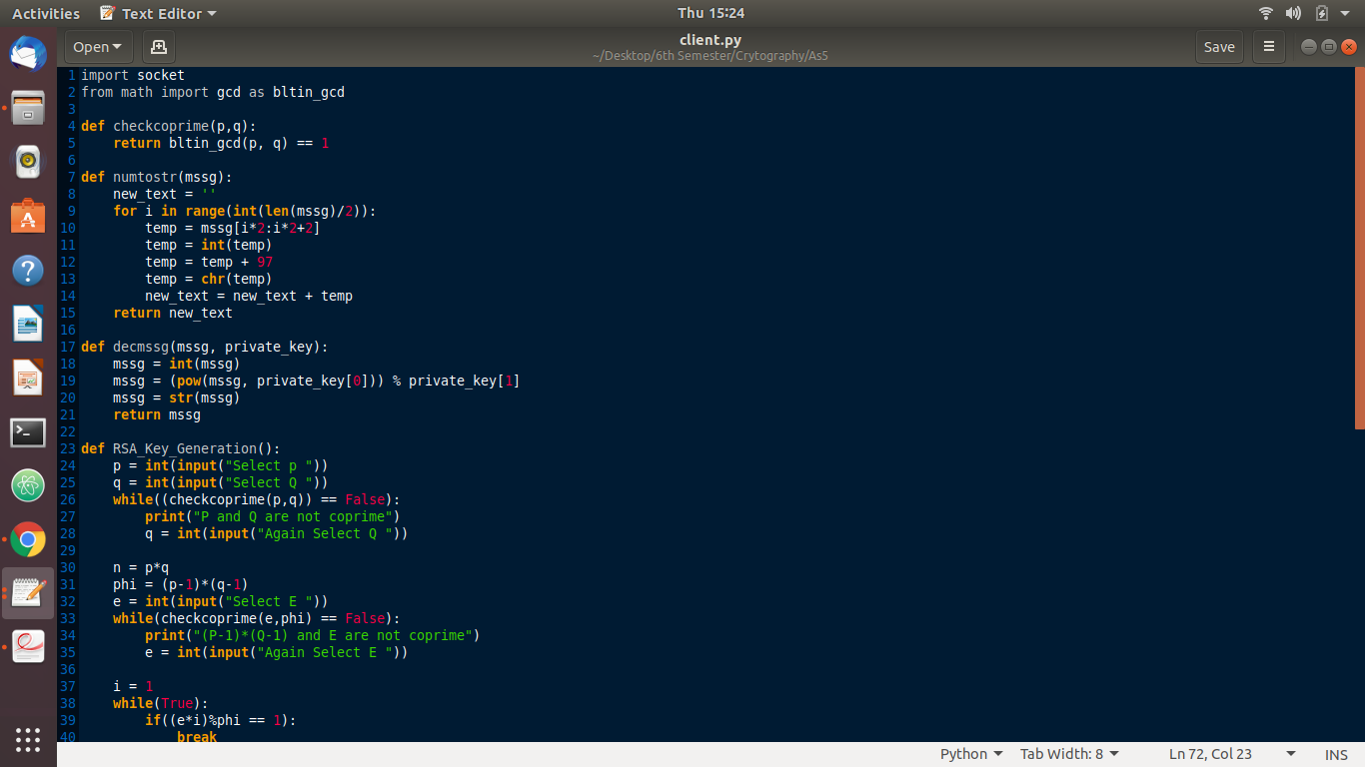

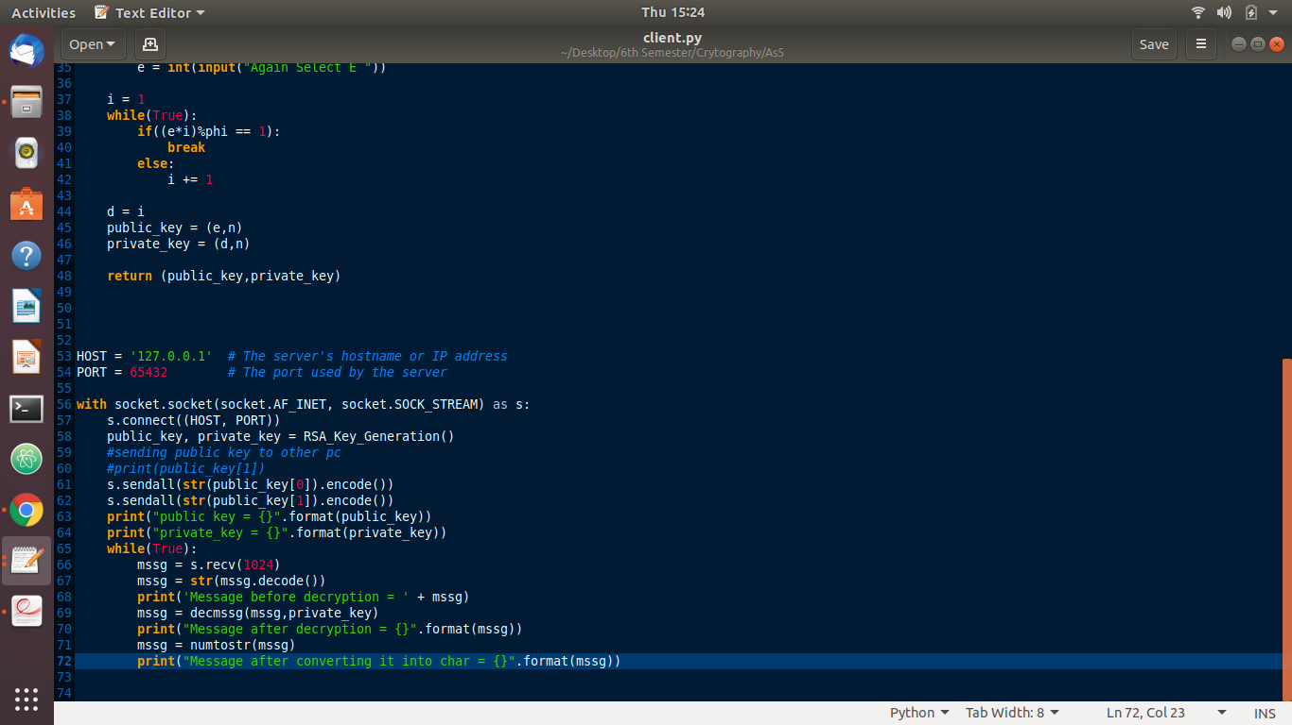

OUTPUT:

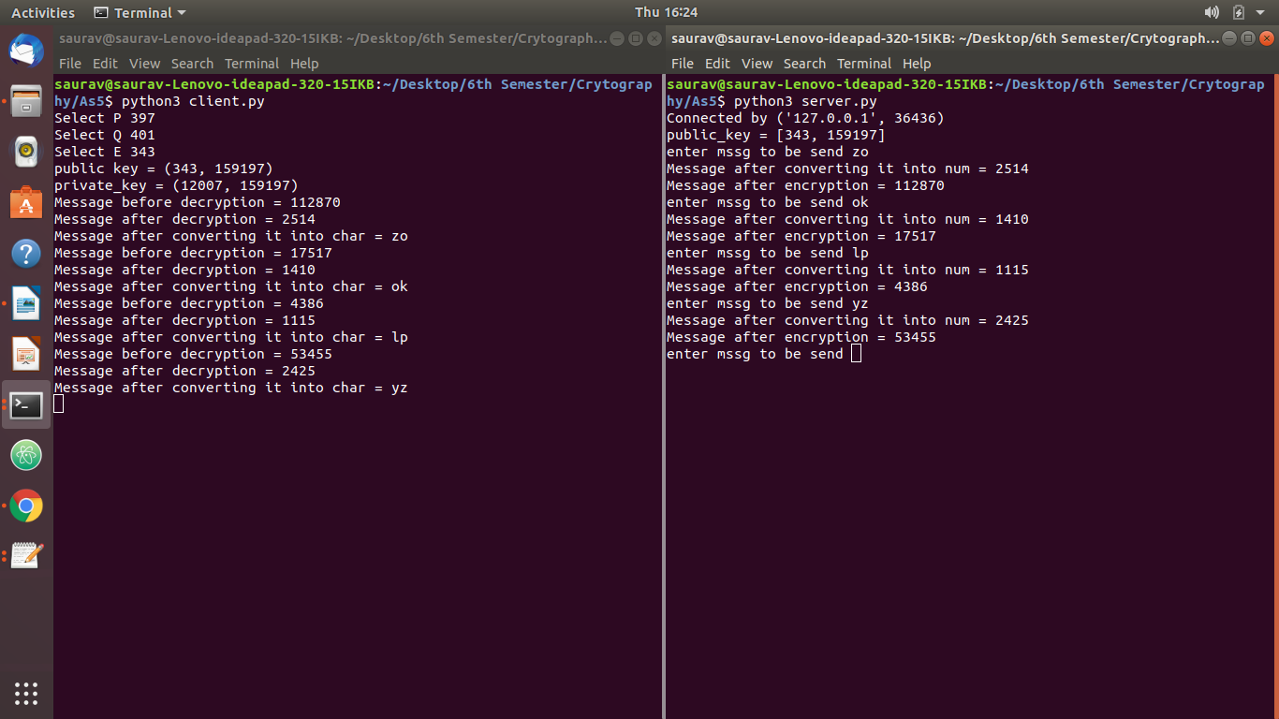

Q4.
RSA
(Digital Signature)
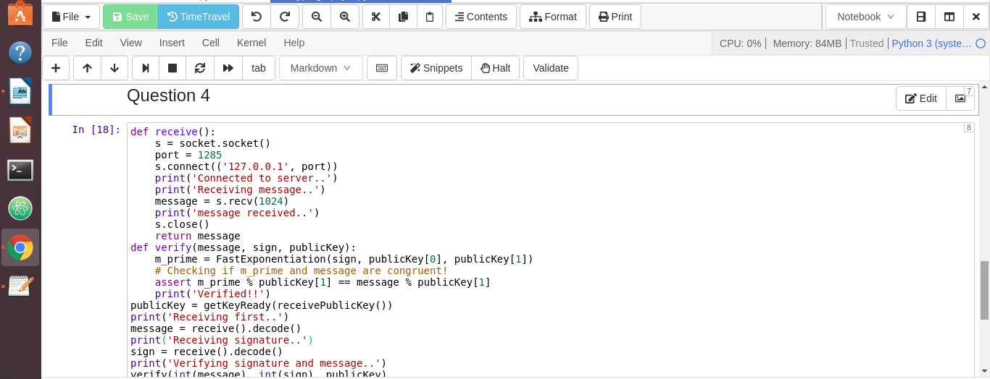
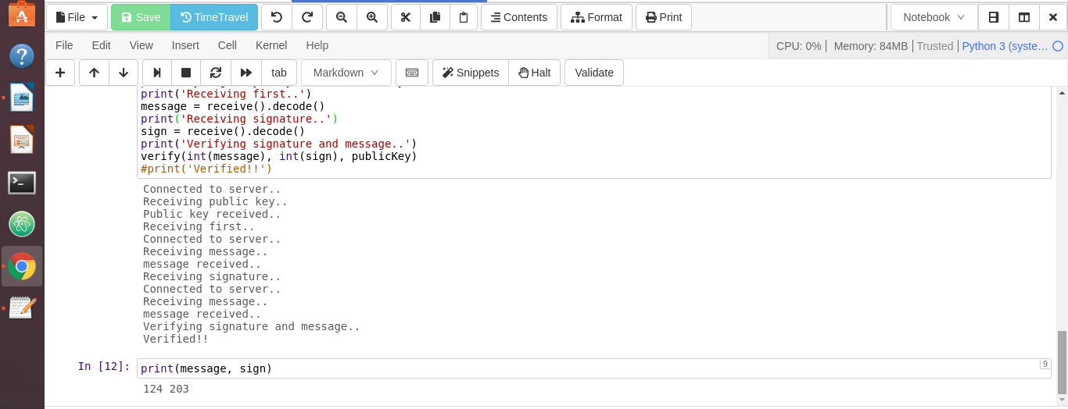
SCREENSHOT:

