# ASSIGNMENT 1

**A**

**QUICK MASK**

To edit portions of your pictures, remove unwanted objects or cut out parts of an image to place in another, first select the desired object or image portion by using any of the selection tools in Pixelmator, or a combination of selection tools.

Quick Mask is the most powerful selection tool in Pixelmator. While in Quick Mask Mode, a red overlay shows areas that have not been selected. Once out of Quick Mask Mode, the area not covered by the red overlay will appear as a selection. In Quick Mask Mode, painting with white will add to the selection and painting with black will subtract from it. This makes it easy to trace around any object.

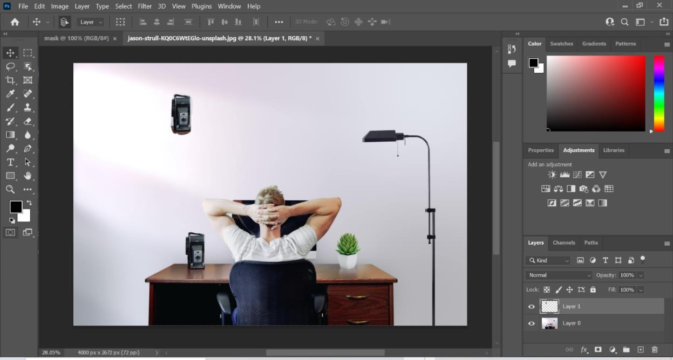

# B

# CLIPPPING MASK

A clipping mask is a group of layers to which a mask is applied. The bottommost layer, or base layer, defines the visible boundaries of the entire group. For example, suppose you have a shape in the base layer, a photograph in the layer above it, and text in the topmost layer.

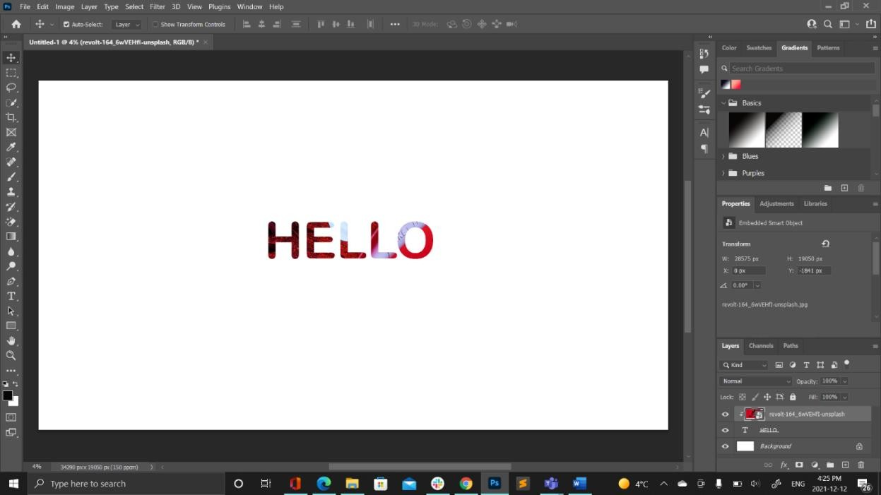

# C

# VECTOR MASK

A vector mask represents a path where the object clips out the contents of the layer. We can also use the Adobe Photoshop properties panel to refine the mask with the same options as the layer (pixel) mask. Creating an Adobe Photoshop Layer Mask.

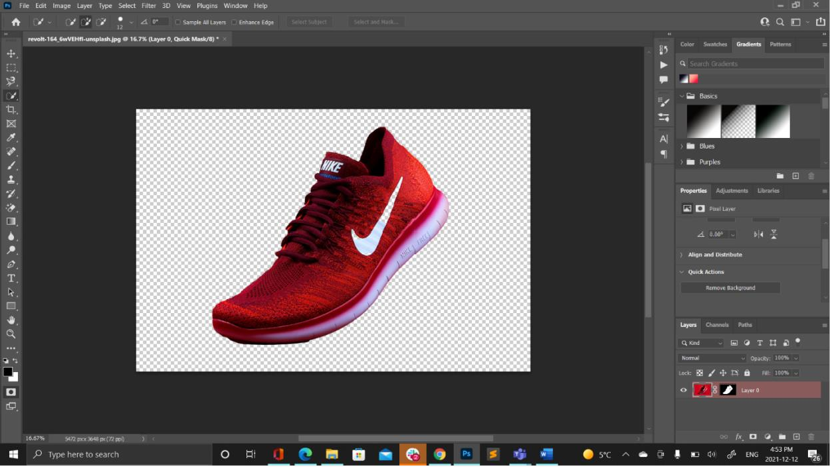

**D**

**LAYER MASK**

Layer masks are a fundamental tool in image manipulations. They allow you to selectively modify the opacity (transparency) of the layer they belong to. This differs from the use of the layer Opacity slider as a mask has the ability to selectively modify the opacity of different areas across a single layer.

