***Study of effect of temperature on Diffusion and Conductivity of Lithium ions in Li-Battery***

* **Introduction**

Solid electrolyte interphase (SEI) in Li-ion batteries performs a crucial role, that is the reason why they are most popular over alkaline, Ni-Cd and lead acid batteries.lithium-based battery performance is the electrode/electrolyte

interface, which is the key to understand battery electrochemistry, as it is where the electron and Li-ion combine and then get stored in the electrode, via intercalation, alloying, or simply as Li metal.This interface is usually further complicated by a passivation layer on the electrode. The understanding of this passivation layer on negative electrodes started from its observation on lithium metal soaked in non-aqueous electrolyte by Dey. Peled introduced the concept of solid electrolyte interphase in 1979 as an electronically insulating and ionically conducting passivation layer, formed between the electrode and electrolyte, acting as a solid electrolyte; and thus, it is named as the SEI. This model was further enriched with the inclusion of compositional information observed over two decades and summarized by Peled et al. In 1997 and by Aurbach et al. in 1999. On one hand, a dense and intact SEI can restrict the electron tunneling and thus prohibit further reduction of the electrolyte, which is vital for the chemical and electrochemical stability of a battery. On the other hand, SEI formation and growth consume active lithium and electrolyte materials, leading to capacity fading, increasing battery resistance, and poor power density. Until today, SEI is still regarded as “the most important but least understood (component) in rechargeable Li-ion batteries” which can be attributed to the complexity of the chemical and electrochemical reactions to form it and insufficient direct measurement of its physical properties.

* **Simulation Details**

In the MD method, the electrolyte is modeled by accounting for interactions at the atomic level. We have used Lennard-Jones potential models for the pair potential.The depth Ƹ and length σ parameters are listed in Table-1. Other pairs potentials which are not listed in Table-1, calculated using rule Ƹ=√(Ƹ1.Ƹ2) and σ=(σ1 + σ2)/2.

**Table-1 Lennard-Jones Pair Potential Parameters**

Pair/Atom σ(Å) Ƹ(Kcal/mol)

H .044 2.886

Li 0.051 3.15

P 0.305 4.147

F 0.072 3.60

C 0.105 3.851

O .06 3.5

Mn .0345 1.485

Topologies of single Graphene and LiPF6 molecules are created using Accelrys BIOVIA Materials Studio. Fig-1 and Fig-2 are the LiPF6 and Graphene molecule taken from Material Studio.

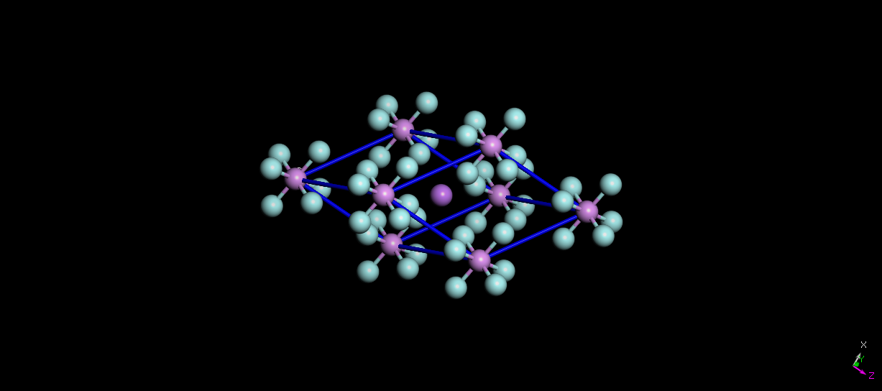

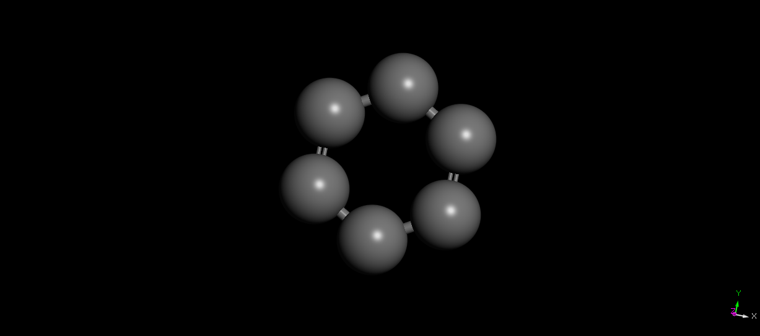

Fig:1 and 2-Topology of LiPF6 and Graphene molecule created in Material Studio

Then, these are further utilized to generate the initial configuration of the system using the Packing Optimization for Molecular Dynamics Simulations (PACKMOL). Initial volume of the cubic box 100 × 100 × 50 Å3 is taken and Graphene molecules are arranged in cylindrical manner in the center of that cube box.Total 10800 atoms are taken of Graphene and LiPF6(Fig:3). Periodic boundary conditions are applied on all three sides of the cubic simulation box.

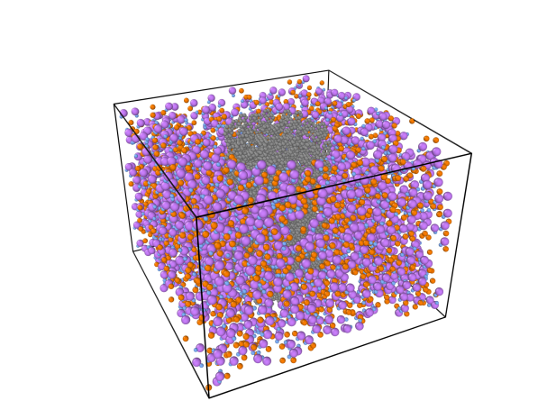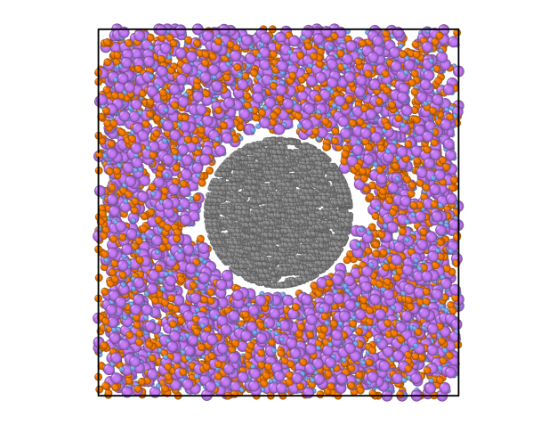

Fig:3- Images taken from OVITO representing the final configuration of LiPF6 and Graphene obtained from PACKMOL. At the center cylinder arrangement of Graphene molecules are representing Anode of the battery surrounded by the LiPF6 molecules

Geometry Optimization are done in Material Studio itself using VAMP module.

The MD simulations are performed using an open source tool LAMMPS. The system is simulated at different temperature range from Ti =300 K to Tf=350k and pressure P = 1 atm . Nose-Hoover thermostat and barostat are applied to maintain the temperature and pressure at the prescribed state. Integration time-step of .001 fs is used. Initially, the system is allowed to evolve under constant NVT conditions (up to 1ps) to relax the system from its initial configuration. Once it relaxes, the Nose-Hoover barostat is removed and the volume of the simulation box V is frozen to further carry out the simulation at NPT conditions for 10ps. We have used three different cut off lengths respectively(6, 8, 10 Å) and calculated the Diffusivity, Radial Distributions and Conductivity.

* **Results**

Dynamic properties of the electrolyte such as diffusivity and ionic conductivity gives the information about the performance of a battery. For instance, faster movement of the Li ion (Li+ ) through the solution results in higher current density of the Lithium battery. Study of the trajectories of the ions under zero electric field condition within the MD simulation helps to determine the diffusivity of the ions and ionic conductivity of the solution. We now describe the effect of salt concentration on diffusivity and conductivity.

**Diffusivity:-**The diffusivity of a particle DC represents the pace at which the particle is transported. The DC can be computed from the mean square displacement (MSD) of the particles. MSD = ⟨[r(t) − r(0)]2⟩ varies linearly with time t, and it can be related to the DC (in a three-dimensional space) using Einstein’s relation.

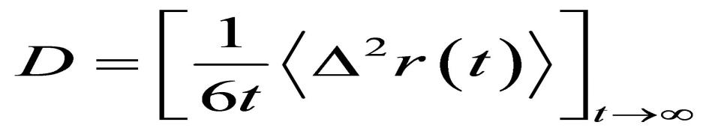

Here, r(t) denotes the position of a particle at time t. ⟨ ⟩ indicates ensemble average.

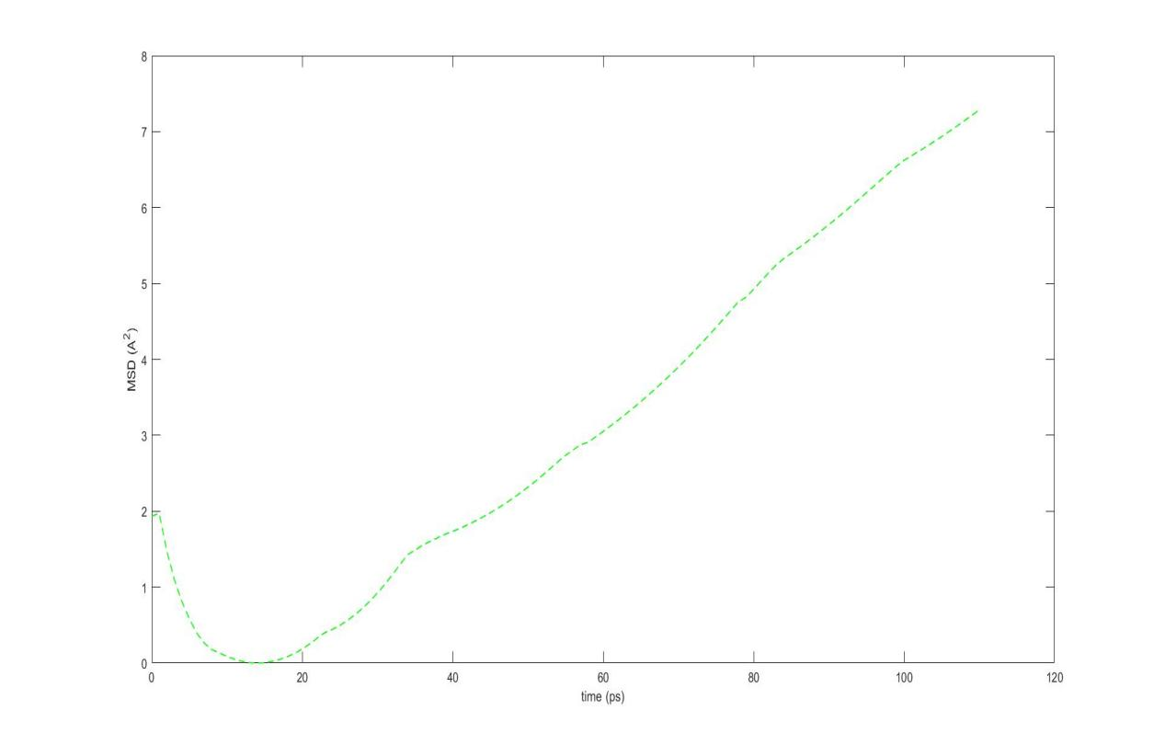

Fig: MSD vs t of Li+. In the long time limit, MSD vs t curve shows a linear

behavior. Diffusivity of an ion is obtained by calculating the slope of MSD curve.

To calculate diffusivity, we have calculated slope of the MSD curve and used the above formula in Matlab.

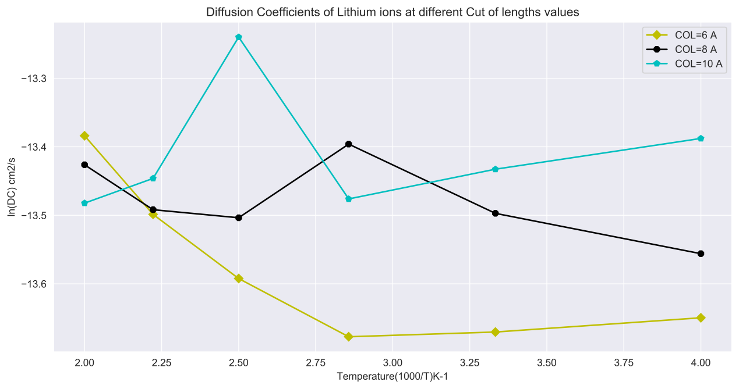

Fig: Effect of temperature at Diffusivity of Lithium ions.Diffusivity of Li+ is computed at different temperature with different cut off lengths. As expected, diffusivity of both ions drops with increase in temperature at a cut off length of 6 Å, but increases and then decrease at a cut off length equal to 8 and 10 Å.

Above fig describes the change in Diffusivity with increasing temperature. As temperature increased from 253k to 500k, diffusivity decreases continuously

at cut off length of 6 Å, reason

But we got some strange results at higher cutoff lengths(8 and 10 Å), where the diffusivity of Li ions is increasing the decreasing as the temperature is increased, reason

**Conductivity:-** Conductivity can be defined as rate at which the electrolytic solution conducts the charge influences the charge−discharge rates of a battery and in turn its applications. Hence, the charge transfer rate is an important parameter in the design of electrolytes. The estimation of the diffusivity of ion is of help to understand their mobility through the solvent. Conductivity of Li+ ions can be calculated using the Nernst-Einstein Equations.

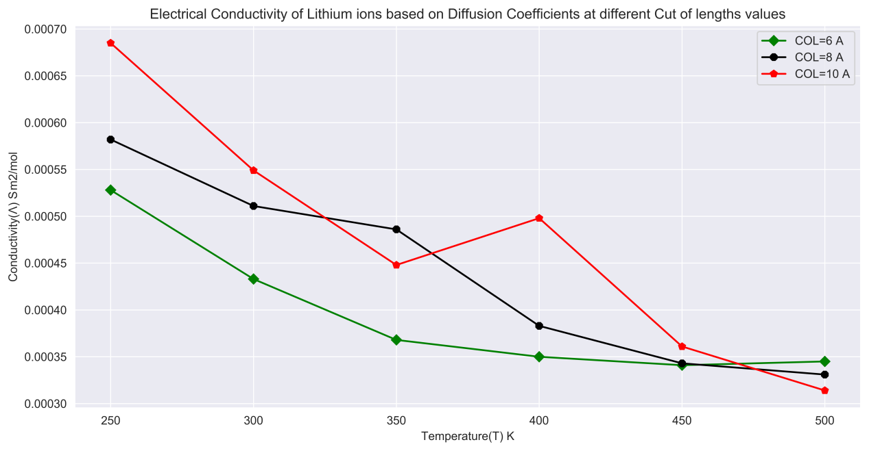

Fig: Effect of temperature on conductivity of Li+ ions. Conductivity of Li+ is computed at different temperature with different cut off lengths. As expected, Conductivity of ion drops with increase in temperature at a cut off length of 6 Å, but increases and then decrease at a cut off length equal to 8 and 10 Å.

|  |
| --- |
| Λ=zi^2Di(F2/RT) |

|  |  |  |
| --- | --- | --- |
| zi |  | charge of ion i |
| T | in K | absolute temperature |
| F | = 9.6485·104 Coulomb/mol | Faraday’s constant |
| R | = 8.31446 J/(K mol) | gas constant |
| F2/(RT) | = 3.7554·106 s·S mol-1 | proportionality constant at 25°C |
| Di | in m2/s | diffusion coefficient of ion i |
| Λ0m,iΛm,i0 | in S m2/mol (= 104 S cm2/mol) | molar limiting conductivity of ion i |

**Solvations Characterstics:-** We can determinethe solvation of ions and dissociation of salt molecules using radial distribution function (RDF) of various atoms pair. The RDF of x−y pair is defined as

g(r) = n(r)/4Пr^2drρ

where n(r) is the number of y atoms at a radial distance r from the position of x, 4πr^2dr is the volume of a shell of thickness dr at r, and ρ is the bulk number density of y atoms. Thus, RDF enables quantification of molecular configurations in a mixture of various atoms and ions like the battery electrolyte. The RDF of Li−Oc pair shows how the Li+ are solvated (i.e., surrounded by the solvent molecules). The RDF of Li−P showing how

PF6− locates radially provides insights into the dissociation of salt and formation of molecular complexes.