COMP 330/543 Lab #3: An Introduction to Spark

The purpose of this lab is to get some experience with Spark. You might use the lecture on Spark as a reference.

Task 1: Running Word Count on Spark

- First, create a new Amazon EMR cluster. Make sure you check the Spark checkbox when selecting your desired applications.

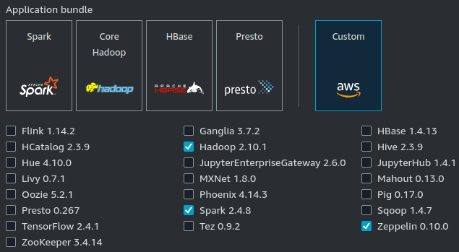

Also, as with Labs 1 and 2, remember to create your cluster in the US East Region (N. Virginia), otherwise there is a chance you might not be able to access the data needed for this lab. You can double-check you are using the right region in the upper-right corner of the AWS console.

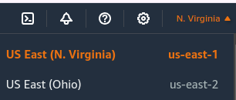

- Connect to your cluster via SSH similarly to Labs 1 & 2.
- In your cluster’s terminal, type pyspark. This will open up a Python interpreter shell that is connected to your Spark cluster.

- In the shell, copy and paste the following simple function that uses Spark to count the top 200 most frequently occurring words in a text file:

def countWords (file_name):
textfile = sc.textFile(file_name)
lines = textfile.flatMap(lambda line: line.split(" "))
counts = lines.map (lambda word: (word, 1))
aggregatedCounts = counts.reduceByKey (lambda a, b: a + b)
return aggregatedCounts.top (200, key=lambda p : p[1])

- Once the function has been defined, execute the following line:

countWords(‘s3://luisguzmannateras/text/Holmes.txt’)

Important note: Sometimes, Spart takes a few minutes to complete its booting up process. If you get a bunch of errors when attempting to run the code, chances are that Spark is not up yet. In this case, simply exit the Python interpreter (type exit() or use control-d) then try again a few minutes later.

You should get a list containing 200 (word, # occurrences) pairs as the output.

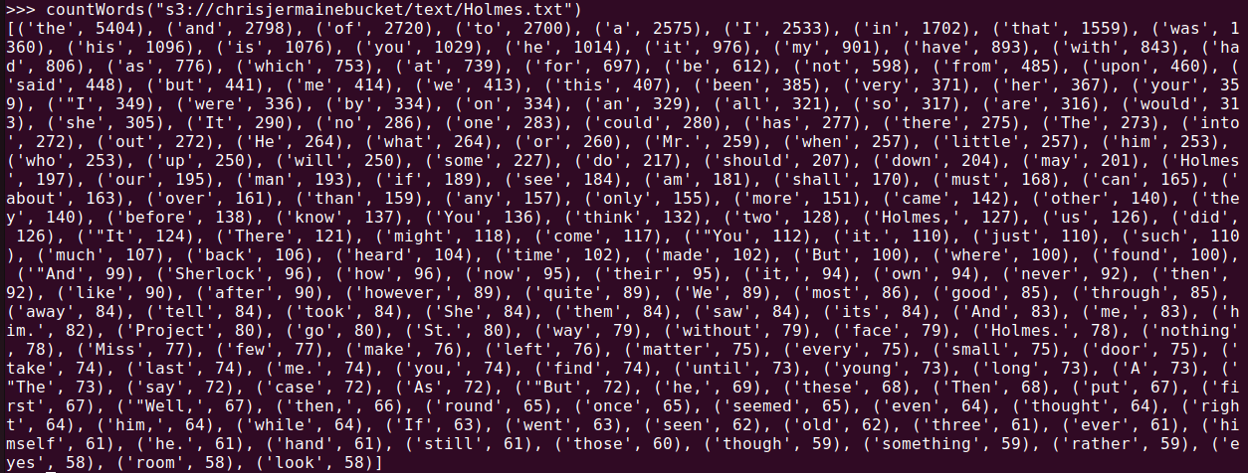

Task 2: Completing a Spark Program

For this task, we have provided you with an almost-complete code that analyzes a corpus of real text documents. Your task is to complete such code by providing a lambda function.

- First, start by looking at the dataset located here. There are 19,997 lines in this file, each corresponding to a different text “document”.

The goal is to build an RDD that works as a dictionary: The keys in the dictionary will be
the words in the corpus. The values corresponding to each key will be a number between 0 - 19,999 which we will interpret as a rank.

The words will be ranked according to their frequency in the corpus, with 0 being the most frequent, and 19,999 being the 20th-thousand-most frequent.

- You can find the Spark code here. Start by copy pasting each line of code up to (but not including) line 43 (the one with the question marks) into the Pyspark shell.

Note that, due to Spark’s lazy evaluation, nothing interesting happens until you enter the line that tries to collect the results using top (line 33) at which point Spark performs all the computations and collects the results into topWords.

At this point, topWords is a local Python variable and you can manipulate it, change it, print it just as you would any other local variable

- Replace the question marks in line 43 with an appropriate lambda that is going to attach the correct word to each number.

The lambda you provide must create a (key, value) tuple where the key is a word and the value is the rank (index) for that word.

Hint: your lambda must make use of the topWords local variable.

- Afterwards, run dictionary.top(10), copy and paste the results into Canvas to get points for the Lab.

Note: this will return the top 10 words by name (i.e., lexicographically) and not by their rank.

As usual, REMEMBER TO SHUT DOWN YOUR CLUSTER.

