**ASSESMENT DATABASE (SQL)**

~ Saurav

**Task 1 :**

SELECT O.country_name_eng, s.city_name, c.customer_name

FROM country O

LEFT JOIN city s ON O.id = s.country_id

LEFT JOIN customer c ON s.id = c.city_id

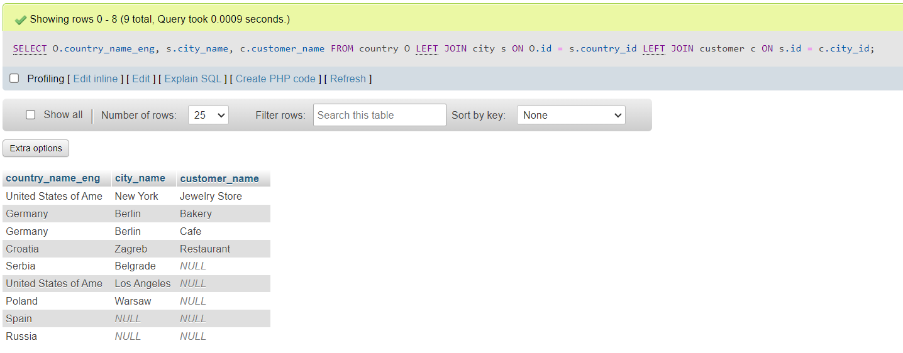

**Task 2)**

SELECT O.country_name_eng, s.city_name, c.customer_name

FROM country O

LEFT JOIN city s ON s.id = s.country_id

INNER JOIN customer c ON s.id = c.city_id

