**About Teradata Database**

Teradata Database is an information repository supported by tools and utilities that make it a complete and active relational database management system.

**Designing Teradata Database**

Teradata developers designed Teradata Database from mostly off-the-shelf hardware components. The result was an inexpensive, high-quality system that exceeded the performance of conventional relational database management systems. The hardware components of Teradata Database evolved from those of a simple parallel database computer into those of a general-purpose, massively parallel computer running the database.

The architecture supports both single-node, Symmetric Multiprocessing (SMP) systems and multinode, Massively Parallel Processing (MPP) systems in which the distributed functions communicate by means of a fast interconnect structure. The interconnect structure is the BYNET for MPP systems and the boardless BYNET for SMP systems.

**Teradata Database as a “Single Data Store”**

A design goal of Teradata Database was to provide a single data store for a variety of client architectures. This approach greatly reduces data duplication and inaccuracies that can creep into data that is maintained in multiple stores.

This approach to data storage is known as the single version of the business, and Teradata Database implements this through heterogeneous client access. Clients can access a single copy of enterprise data and Teradata Database takes care of such things as data type translation, connections, concurrency, and workload management

The following figure illustrates the idea of heterogeneous client access, where mainframe clients, network-attached workstations, and personal computers can access and manipulate the same database simultaneously. In this figure, the mainframe is attached via channel connections and other systems are attached via network connections.

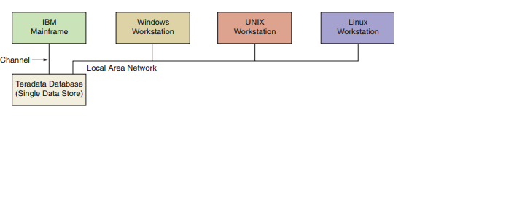

**Teradata SQL SQL**

Teradata SQL SQL is the language of relational database communication. Teradata SQL, which is broadly compatible with ANSI SQL, extends the capabilities of SQL by adding Teradata-specific extensions to the generic SQL statements. You can run transactions in either Teradata or ANSI mode and these modes can be set or changed.

**Capacity**

• Scaling from gigabytes to terabytes to petabytes of detailed data stored in billions of rows.

• Scaling to millions of millions of instructions per second (MIPS) to process data.

**Parallel processing**

Makes Teradata Database faster than other relational systems.

**Single data store**

• can be accessed by network-attached and channel-attached systems.

• supports the requirements of many diverse clients.

**Fault tolerance**

• can be accessed by network-attached and channel-attached systems.

• supports the requirements of many diverse clients

**Fault tolerance**

Automatically detects and recovers from hardware failures.

**Data integrity**

Ensures that transactions either complete or rollback to a consistent state if a fault occurs.

**Scalable**

Growth allows expansion without sacrificing performance.

**SQL**

Serves as a standard access language that permits users to control data.