**Stateful Application**

**STEP 1: PROVISION OF INFRASTRUCTURE**

* Firstly, clone the repository to your desired location (locally or on Azure Cloud Shell): [**https://mohdumairakbar@dev.azure.com/mohdumairakbar/AKSStatefullApp/_git/AKSStatefullApp**](https://mohdumairakbar@dev.azure.com/mohdumairakbar/AKSStatefullApp/_git/AKSStatefullApp)
* Then, change your present working directory to **infrastructure** directory, this directory has both power-shell file:
* azure-sql-db.ps1 (This will create SQL server and SQL Database).
* azure-kube-environment.ps1 (This will provision ACR and AKS).

**STEP 2: CI/CD of Application Using Azure DevOps**

* In the build Section, we need to update 2 things:

1. **acrurl = hclcloudnativeacr.azurecr.io**
2. **aksurl = 45b472fdbc80452e9926.eastus.aksapp.io**

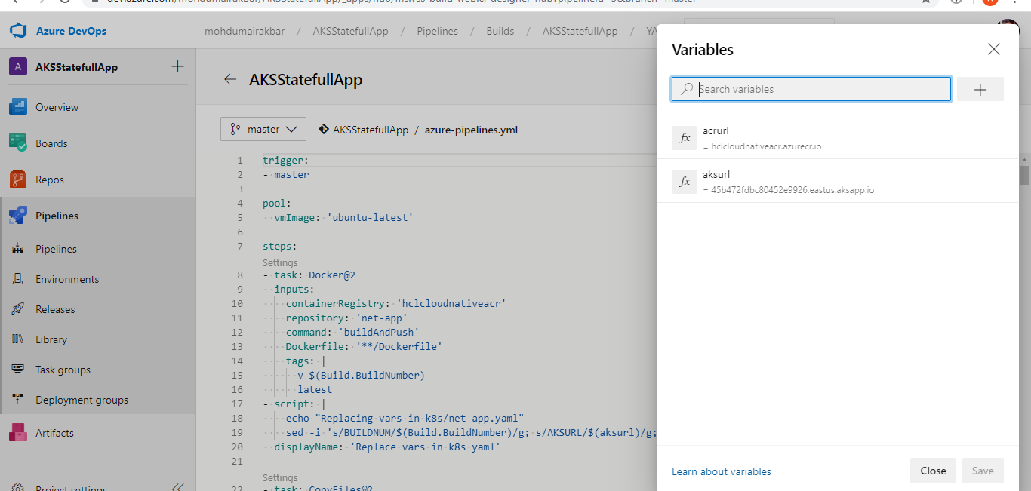

**Note: for aksurl we need to enable http routing in the network section.**

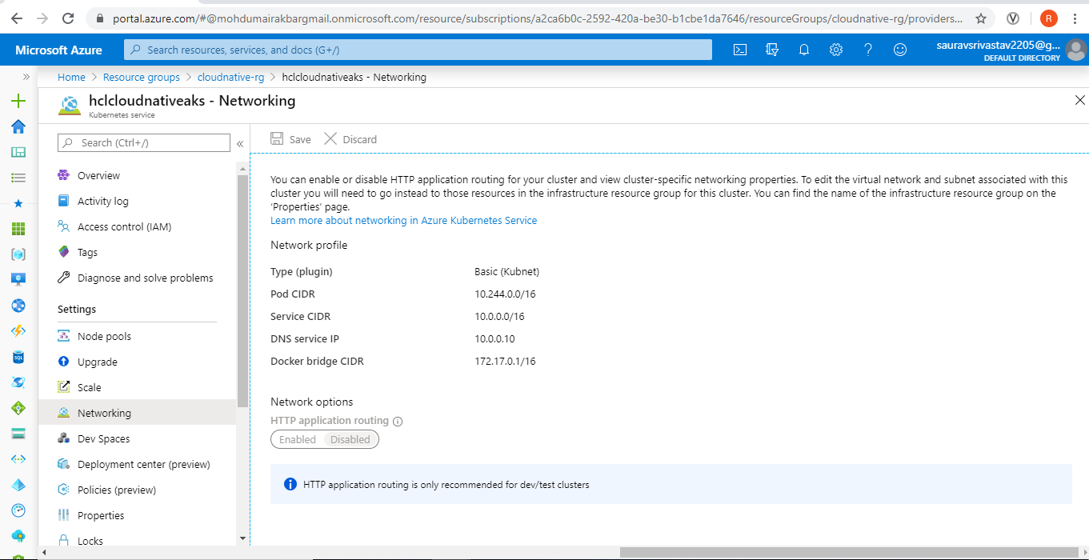

**STEP 3: Update Connection String in appsettings.json with the latest connection string created after SQL Server and database.**

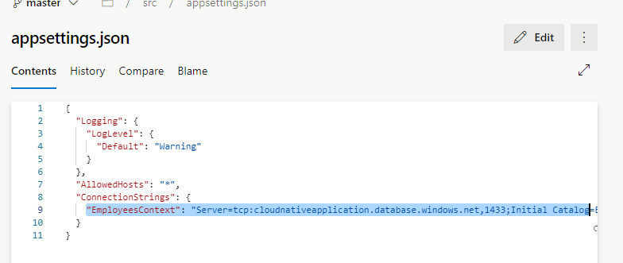

**Step4: And, we need to create Service Connection for:**

1. **GitHub**
2. **Azure Container Registry**
3. **Azure Kubernetes Service**

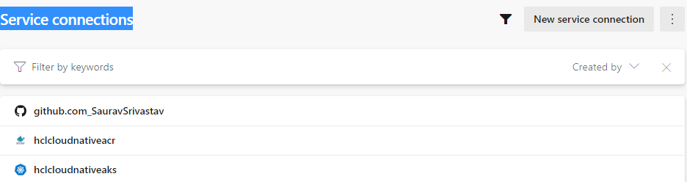

**2) Azure container Registry:**

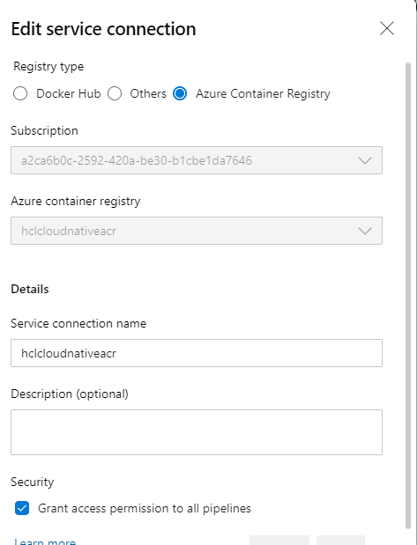

**3) Azure Kubernetes Service :** 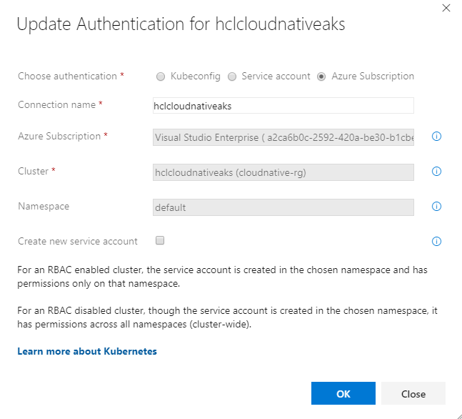

**Notes on Service Principle Connection for pulling images from ACR into AKS Cluster**

If we are getting below mentioned error (ImagePullBackOff) than we can troubleshoot our error with below mentioned points:

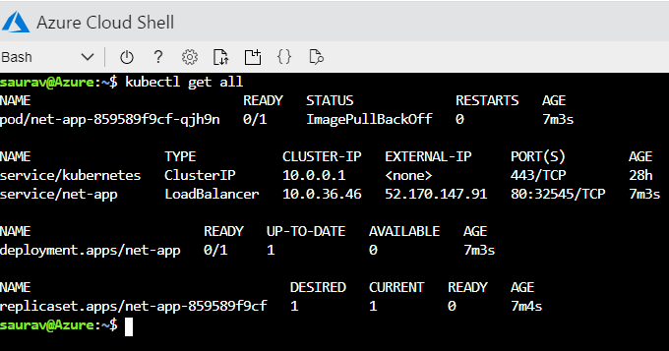

1. First go to the Portal.azure.com > Container registries > Access control (IAM) > Role Assignment

In this check whether role assignment is there or not for ACRPull role. If there is no role then create a new one and give access to the desired cluster:

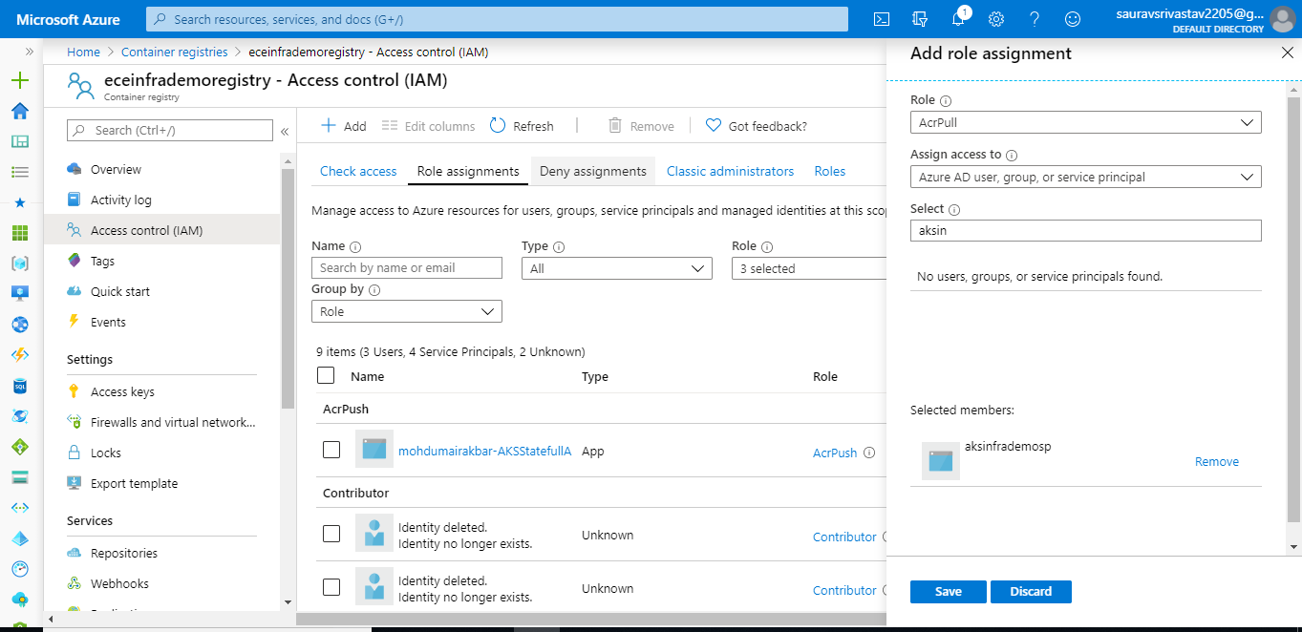

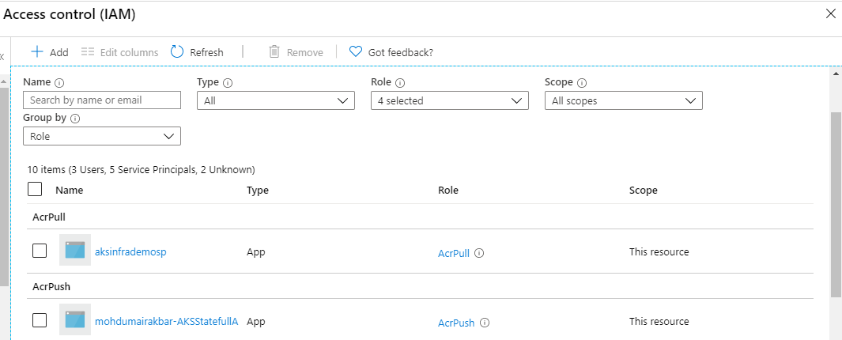

After updating check with the command: Kubectl get all and we can check whether the pod is up and running or not:

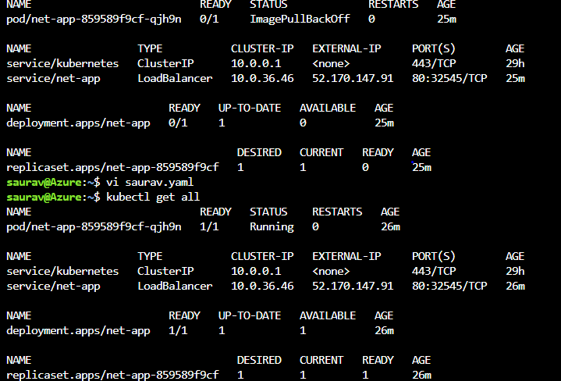

**NOTE**: And, the above-mentioned task is manually and if we required, we can achieve the same with below mentioned commands:

ACR_ID=$(az acr show --name eceinfrademoregistry --resource-group ece-infrademo-rg --query "id" --output tsv)

az aks update --name aksinfrademocluster --resource-group ece-infrademo-rg --attach-acr $ACR_ID