

*SEMINAR REPORT ON*

**FOOD DELIVERY SYSTEM FOR IT LAB**

*SUBMITTED TO*

**Department of Computer Science & Engineering**

*by*

Name: Saurav Panda Reg no: 160905256

Roll no: 37 Sem: 7 Sec: A

AND

Name: Divyansh Verma Reg no: 160905332

Roll no: 49 Sem: 7 Sec: A

Name & Signature of Evaluator 1 Name & Signature of Evaluator 2

(Oct 2019)

**TABLE OF CONTENTS**

1. **INTRODUCTION**
2. **SCREENSHOTS**
3. **CODE BEHIND**
4. **CONCLUSION**

**INTRODUCTION**

For our final project for IT Lab, 7th Semester, we were assigned to make a “Food Delivery System” using ASP.NET and C# technologies. The delivery system app was made according to features and specifications given to us by the college and we used ASP.NET concepts like query strings, master pages, themes, cookies, Application/Session states, numerous different ASP.NET data controls etc as was seen fit.

The app gives the functionality to register and login as user and admin separately, both having different features given to them and varying degrees of control over the content over the website. The user can View, Search and Comment on different food outlets and can see food outlets based on their location, rating etc.

The admin has various powers like accepting/rejecting comments made by various users, viewing reports and filtering food outlets based on different filter parameters. Admin also has the ability to register new food outlets to the site.

The backend data warehousing was handled by the SQL database. The site uses queries to perform various CRUD operations and running various queries, most of which are dynamically built. We use concepts like direct data access and disconnected data access, data binding techniques etc. were used.

**SCREENSHOTS**

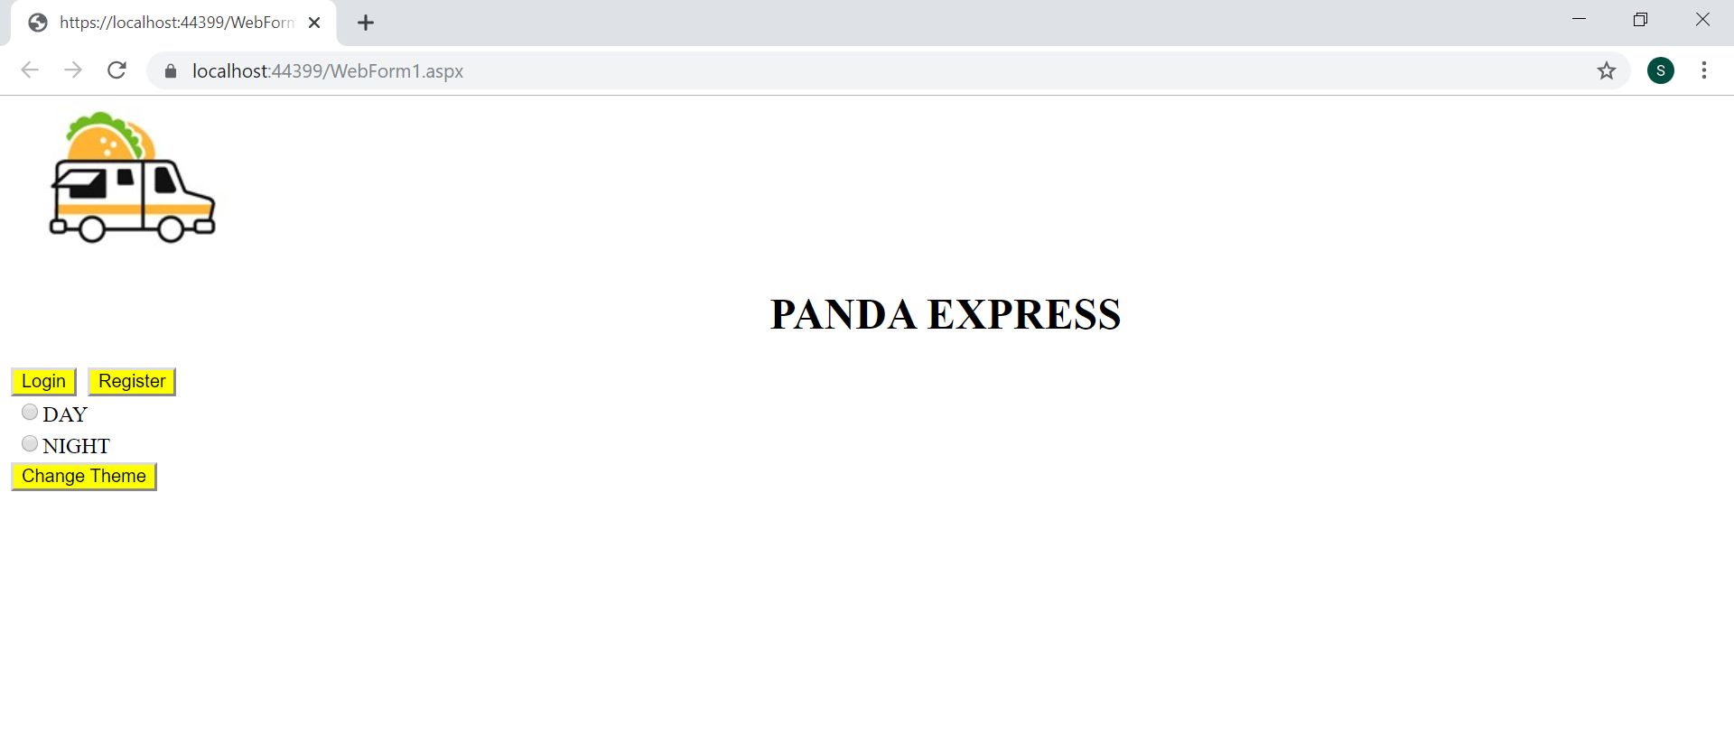

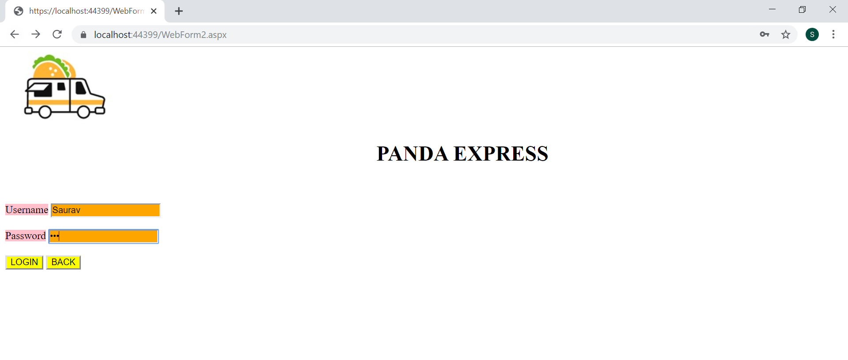

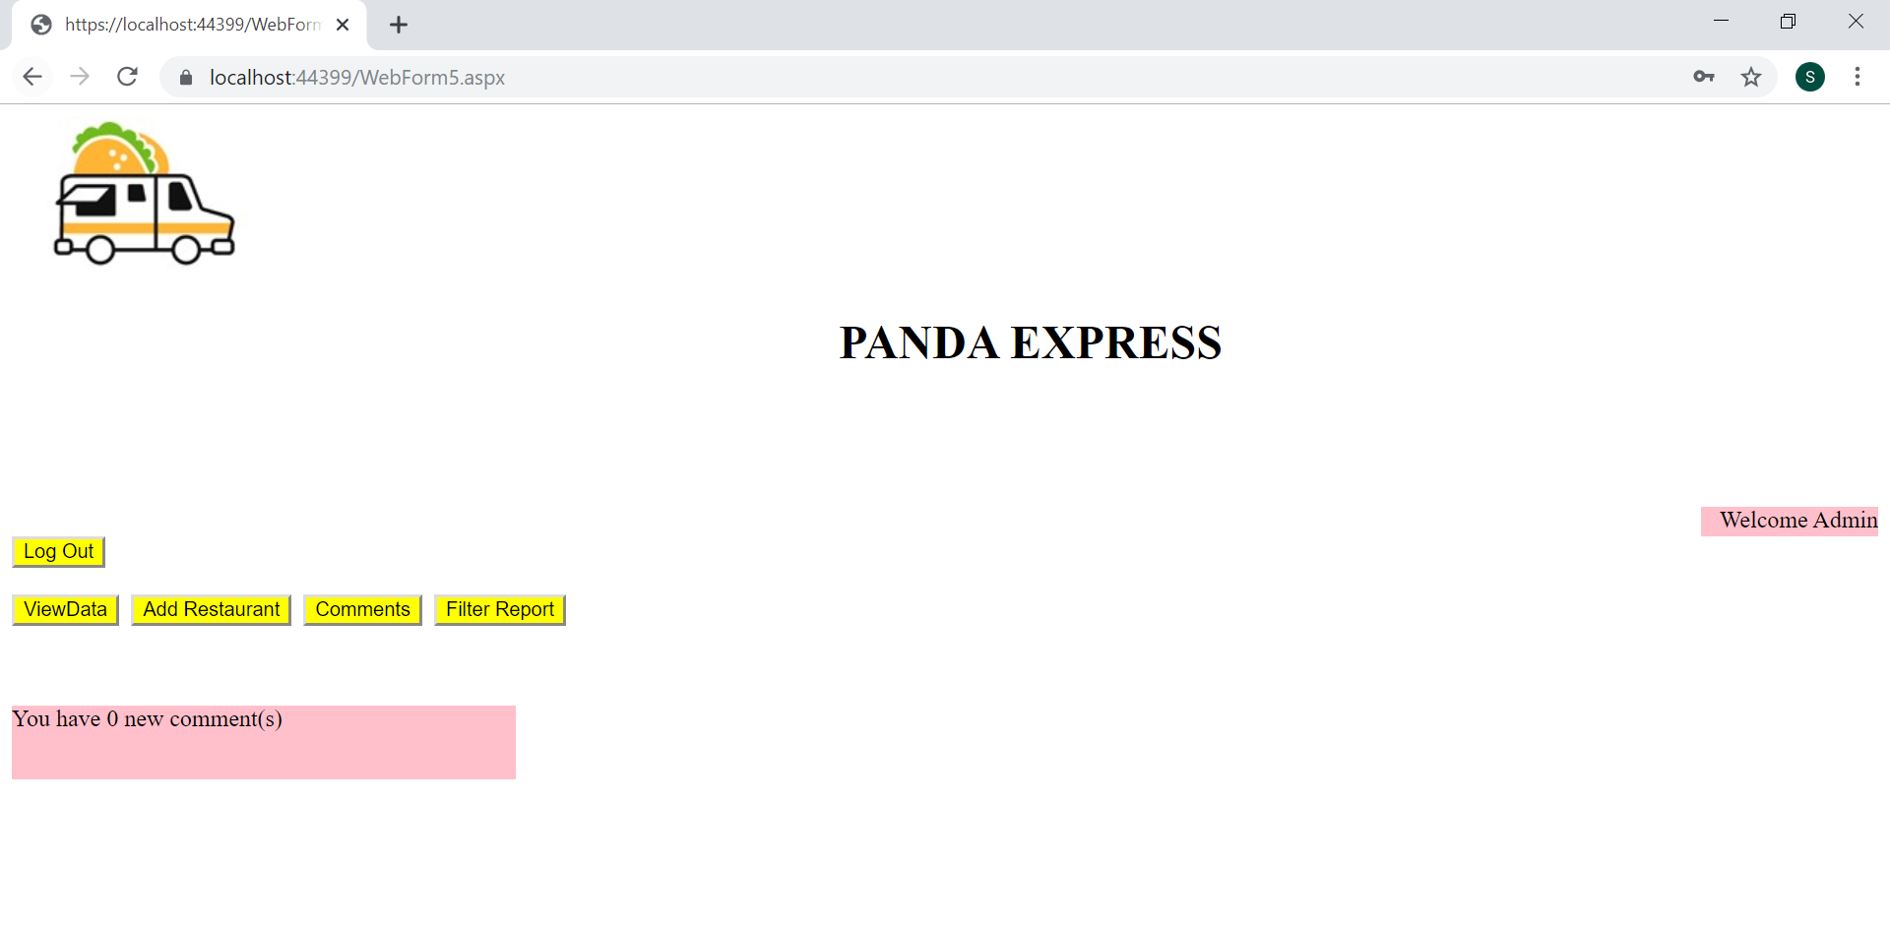

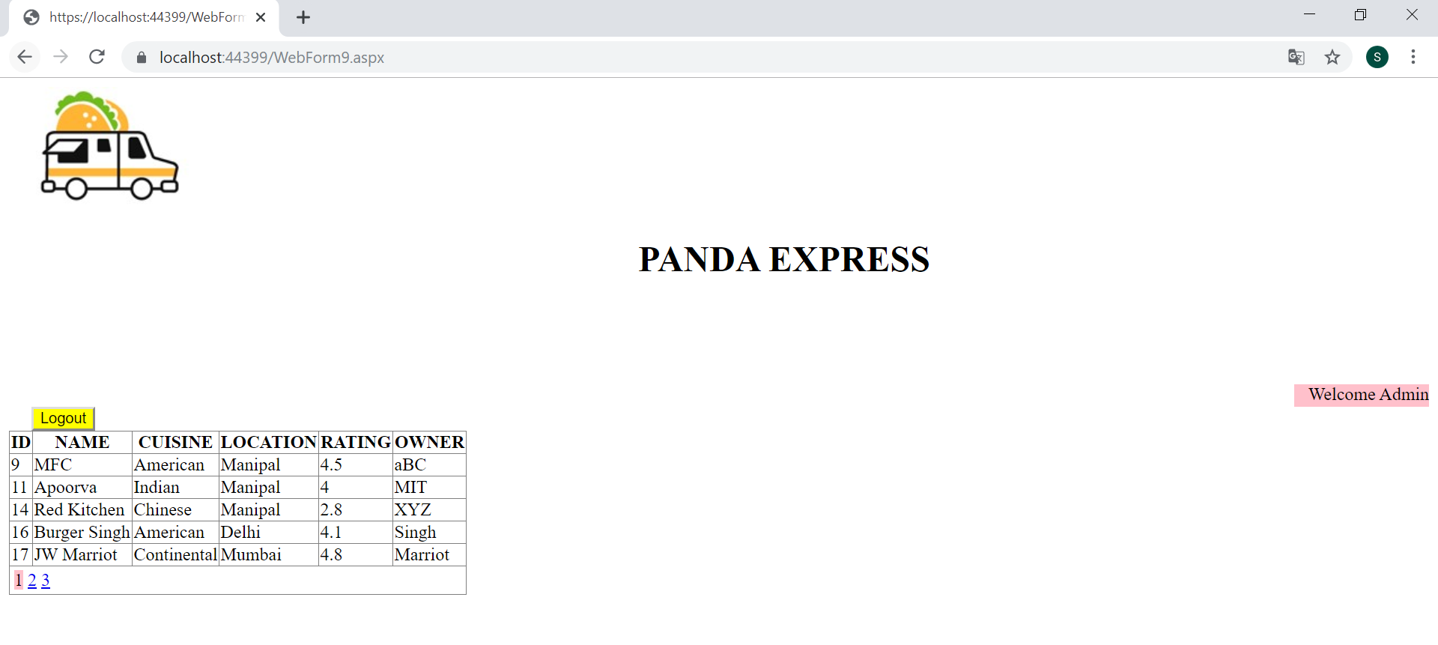

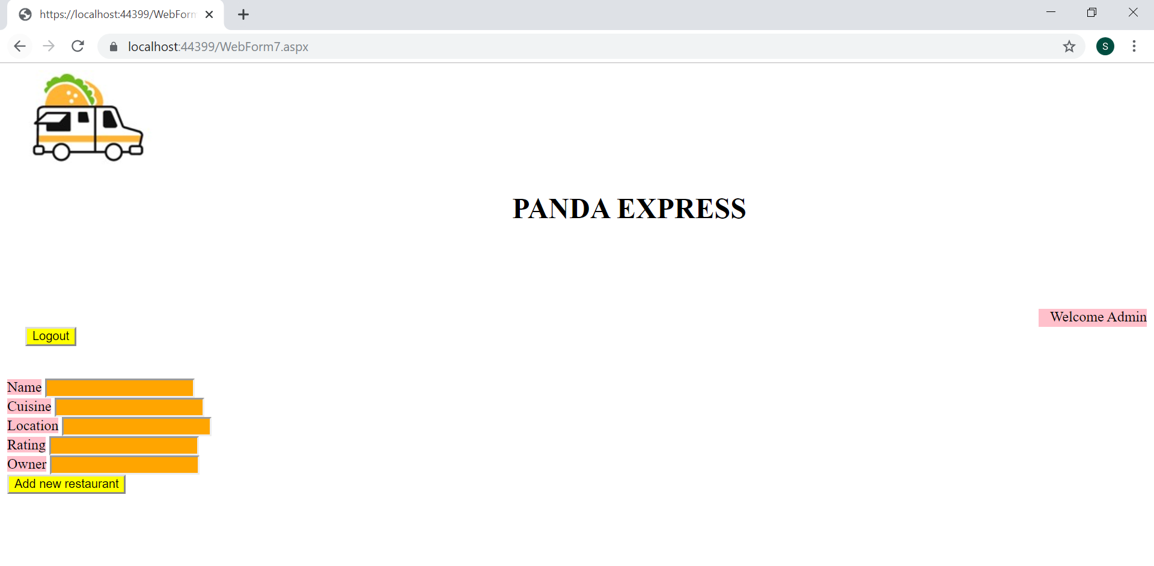

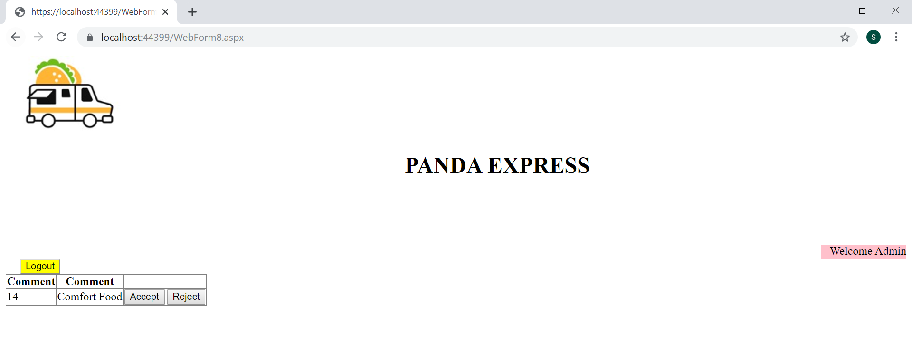

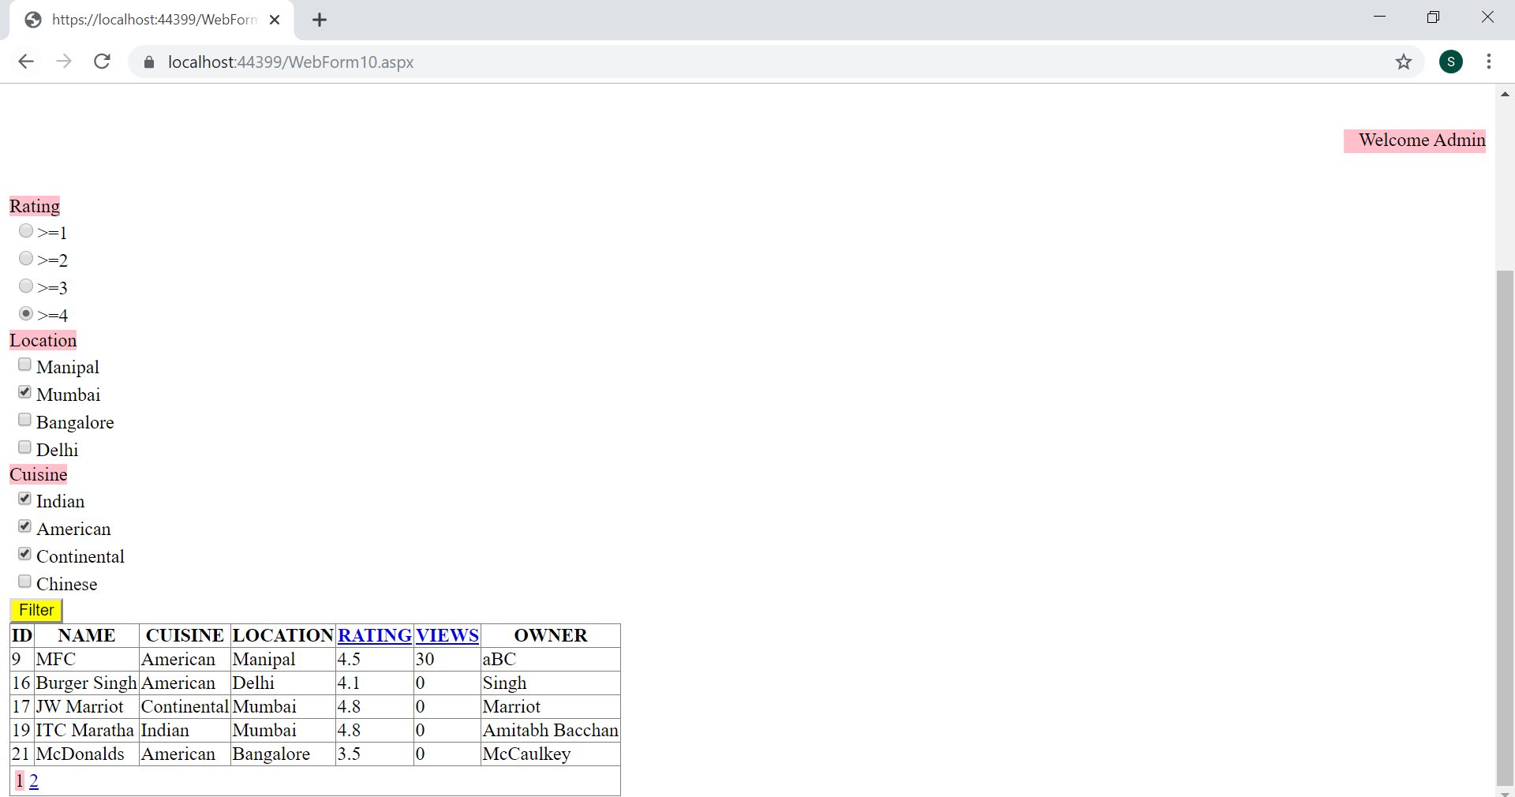

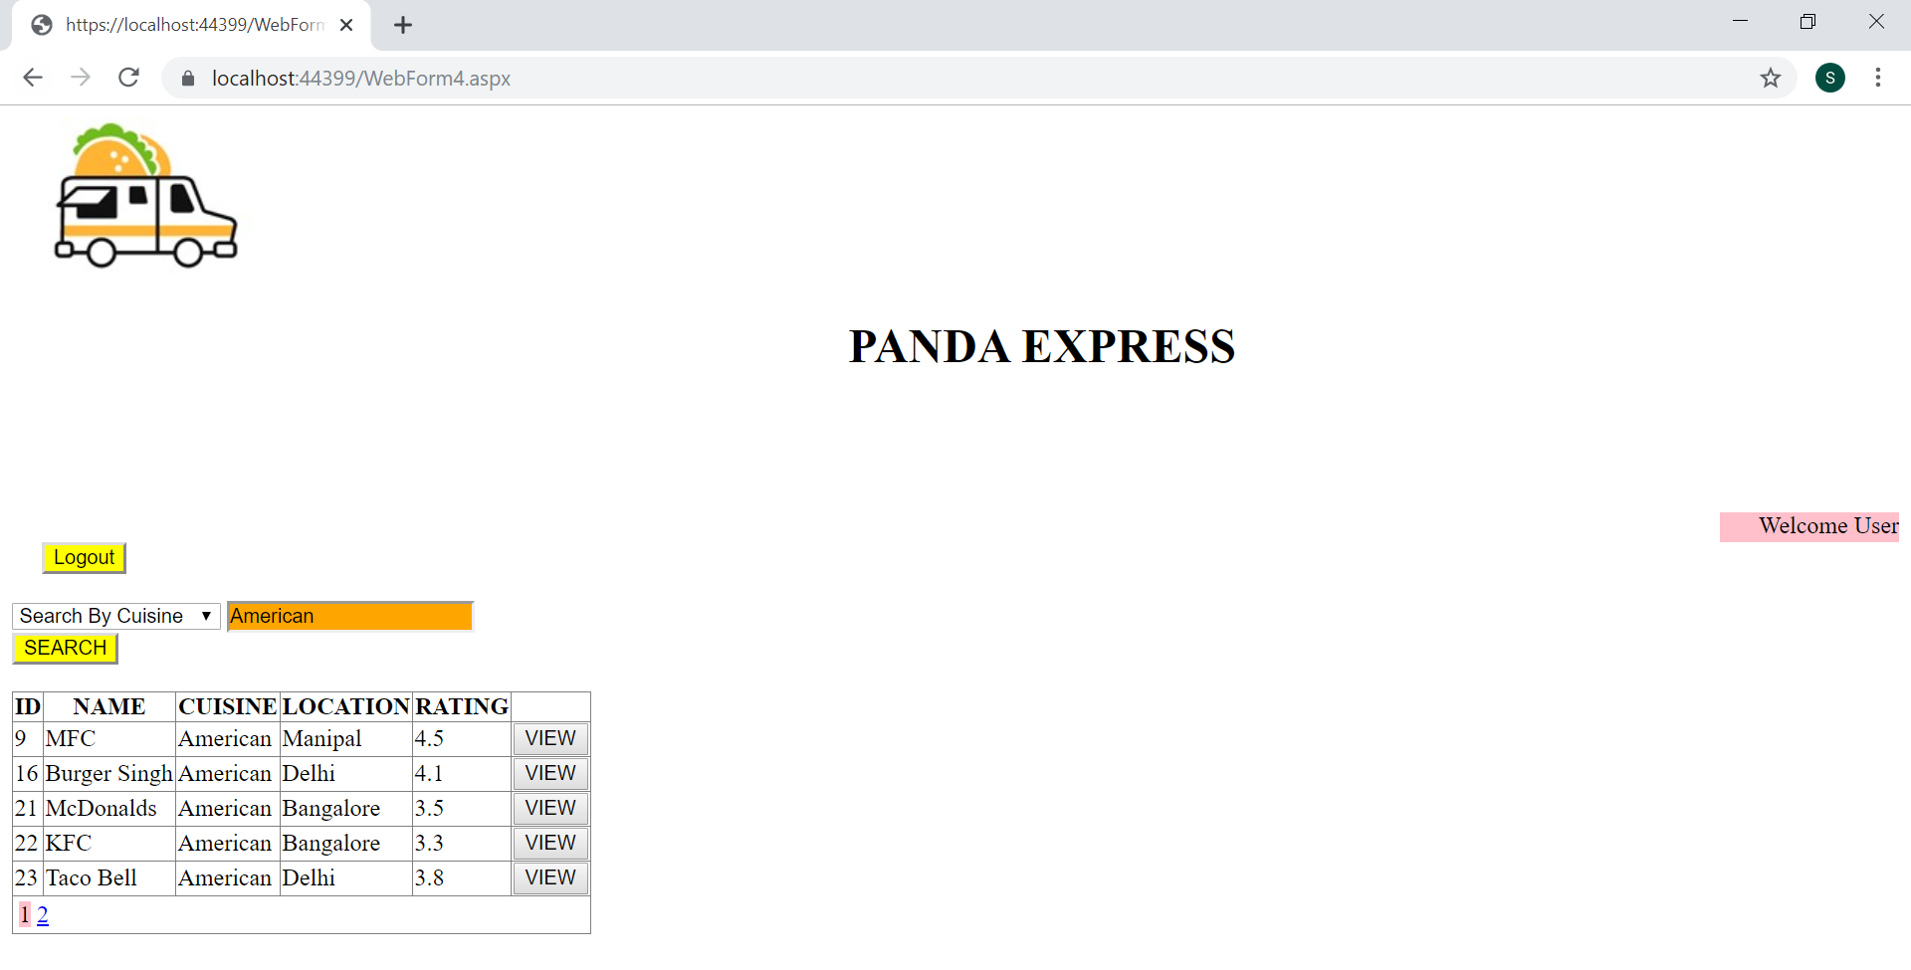

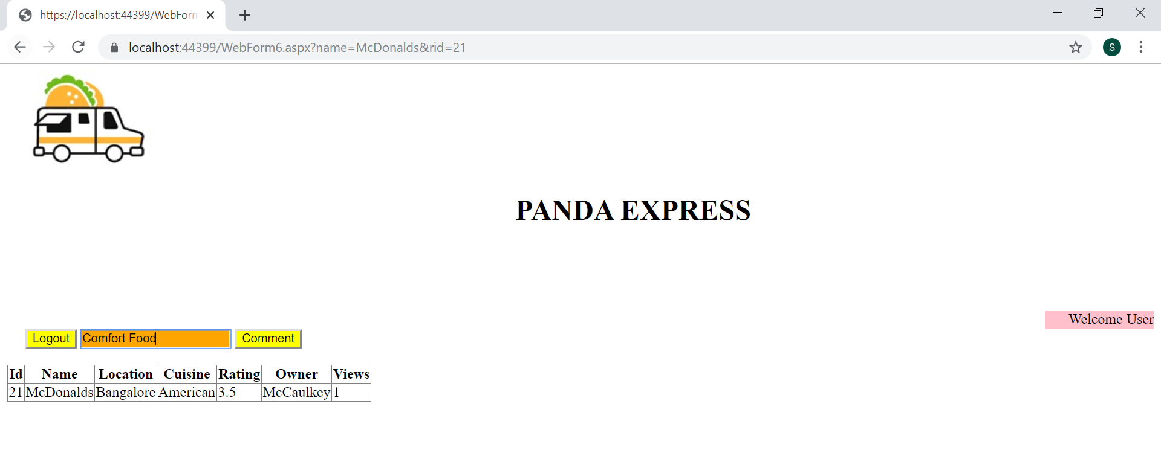

**CODE BEHIND**

**Webform1.aspx**

<%@ Page Title="" Language="C#" MasterPageFile="~/Site1.Master" AutoEventWireup="true" CodeBehind="WebForm1.aspx.cs" Inherits="PandaExpress.WebForm1" %>

<asp:Content ID="Content1" ContentPlaceHolderID="head" runat="server">

</asp:Content>

<asp:Content ID="Content2" ContentPlaceHolderID="ContentPlaceHolder1" runat="server">

<asp:Button ID="Button1" runat="server" Text="Login" OnClick="Button1_Click" />&nbsp

<asp:Button ID="Button2" runat="server" Text="Register" OnClick="Button2_Click" />

<asp:RadioButtonList ID="RadioButtonList1" runat="server"></asp:RadioButtonList>

<asp:Button ID="Button3" runat="server" Text="Button" OnClick="Button3_Click" />

<%-- <asp:Button ID="Button3" runat="server" Text="Register as Administrator" OnClick="Button3_Click" />--%>

<%--<asp:Label ID="Label1" runat="server" Text="Label"></asp:Label>--%>

</asp:Content>

**Webform1.aspx.cs**

using System;

using System.Collections.Generic;

using System.Linq;

using System.Web;

using System.Web.UI;

using System.Web.UI.WebControls;

namespace PandaExpress

{

public partial class WebForm1 : System.Web.UI.Page

{

HttpCookie cookie;

protected void Page_Load(object sender, EventArgs e)

{

if (!IsPostBack)

{

RadioButtonList1.Items.Add("DAY");

RadioButtonList1.Items.Add("NIGHT");

}

}

protected void Button1_Click(object sender, EventArgs e)

{

Response.Redirect("WebForm2.aspx");

}

protected void Page_PreInit(object sender, EventArgs e)

{

cookie = Request.Cookies["User_Themes"];

if (cookie == null)

cookie = new HttpCookie("User_Themes");

else

Page.Theme = cookie["User_Themes"];

}

protected void Button2_Click(object sender, EventArgs e)

{

Response.Redirect("WebForm3.aspx");

}

protected void Button3_Click(object sender, EventArgs e)

{

cookie["User_Themes"] = RadioButtonList1.SelectedValue;

Response.Cookies.Add(cookie);

cookie.Expires = DateTime.Now.AddYears(1);

Response.Redirect("WebForm1.aspx");

}

}

}

**Webform2.aspx**

<%@ Page Title="" Language="C#" MasterPageFile="~/Site1.Master" AutoEventWireup="true" CodeBehind="WebForm2.aspx.cs" Inherits="PandaExpress.WebForm2" %>

<asp:Content ID="Content1" ContentPlaceHolderID="head" runat="server">

</asp:Content>

<asp:Content ID="Content2" ContentPlaceHolderID="ContentPlaceHolder1" runat="server">

<br />

<br />

<asp:Label ID="Label1" runat="server" Text="Username"></asp:Label>

<asp:TextBox ID="TextBox1" runat="server"></asp:TextBox>

<asp:RequiredFieldValidator ID="RequiredFieldValidator1" ControlToValidate="TextBox1" runat="server" ForeColor="Red" ErrorMessage="*Field Required"></asp:RequiredFieldValidator>

<br />

<br />

<asp:Label ID="Label2" runat="server" Text="Password"></asp:Label>

<asp:TextBox ID="TextBox2" TextMode="Password" runat="server"></asp:TextBox>

<asp:RequiredFieldValidator ID="RequiredFieldValidator2" ControlToValidate="TextBox2" runat="server" ForeColor="Red" ErrorMessage="*Field Required"></asp:RequiredFieldValidator>

<br />

<br />

<asp:Button ID="Button1" runat="server" Text="LOGIN" OnClick="Button1_Click" />

<asp:Button ID="Back_Home" runat="server" Text="BACK" OnClick="Back_Home_Click" CausesValidation="false" />

</asp:Content>

**Webform2.aspx.cs**

using System;

using System.Collections.Generic;

using System.Data.SqlClient;

using System.Linq;

using System.Web;

using System.Web.UI;

using System.Web.UI.WebControls;

namespace PandaExpress

{

public partial class WebForm2 : System.Web.UI.Page

{

protected void Page_Load(object sender, EventArgs e)

{

}

protected void Page_PreInit(object sender, EventArgs e)

{

HttpCookie cookie = Request.Cookies["User_Themes"];

if(cookie!=null)

Page.Theme = cookie["User_Themes"];

}

protected void Button1_Click(object sender, EventArgs e)

{

string s1 = TextBox1.Text;

string s2 = TextBox2.Text;

SqlConnection con = new SqlConnection();

con.ConnectionString = @"Data Source=(localdb)\MSSQLlocalDB;Initial Catalog=abcd;Integrated Security=True";

string d = "Select Id,Username,Password,User_Type from UserDetails";

con.Open();

SqlCommand cmd = new SqlCommand(d, con);

SqlDataReader reader = cmd.ExecuteReader();

while (reader.Read())

{

if (s1 == reader["Username"].ToString() && s2 == reader["Password"].ToString())

{

Session["Uid"] = reader["Id"];

if ((bool)reader["User_Type"] == true)

{

Session["Salutation"] = "User";

Response.Redirect("WebForm4.aspx");

}

else

{

Session["Salutation"] = "Admin";

Response.Redirect("WebForm5.aspx");

}

}

}

con.Close();

}

protected void Back_Home_Click(object sender, EventArgs e)

{

Server.Transfer("WebForm1.aspx");

}

}

}

**Webform3.aspx**

<%@ Page Title="" Language="C#" MasterPageFile="~/Site1.Master" AutoEventWireup="true" CodeBehind="WebForm3.aspx.cs" Inherits="PandaExpress.WebForm3" %>

<asp:Content ID="Content1" ContentPlaceHolderID="head" runat="server">

</asp:Content>

<asp:Content ID="Content2" ContentPlaceHolderID="ContentPlaceHolder1" runat="server">

<br />

<br />

<asp:RadioButtonList ID="RadioButtonList1" runat="server"></asp:RadioButtonList>

<asp:Label ID="Label1" runat="server" Text="Username"></asp:Label>

<asp:TextBox ID="tb1" runat="server"></asp:TextBox>

<asp:RequiredFieldValidator ID="RequiredFieldValidator1" ControlToValidate="tb1" runat="server" ForeColor="Red" ErrorMessage="*Field Required"></asp:RequiredFieldValidator><br />

<asp:Label ID="Label2" runat="server" Text="Password"></asp:Label>

<asp:TextBox ID="tb2" runat="server" TextMode="Password"></asp:TextBox>

<asp:RequiredFieldValidator ID="RequiredFieldValidator2" ControlToValidate="tb2" runat="server" ForeColor="Red" ErrorMessage="*Field Required"></asp:RequiredFieldValidator><br />

<asp:Label ID="Label3" runat="server" Text="Name"></asp:Label>

<asp:TextBox ID="tb3" runat="server"></asp:TextBox>

<asp:RequiredFieldValidator ID="RequiredFieldValidator3" ControlToValidate="tb3" runat="server" ForeColor="Red" ErrorMessage="*Field Required"></asp:RequiredFieldValidator><br />

<asp:Label ID="Label4" runat="server" Text="Mobile"></asp:Label>

<asp:TextBox ID="tb4" runat="server"></asp:TextBox>

<asp:CustomValidator ID="CustomValidator1" runat="server" ForeColor="Red" ErrorMessage="*Valid Mobile Number Required" ControlToValidate="tb4" OnServerValidate="CustomValidator1_ServerValidate"></asp:CustomValidator><br />

<asp:Label ID="Label5" runat="server" Text="Email"></asp:Label>

<asp:TextBox ID="tb5" runat="server"></asp:TextBox>

<asp:RegularExpressionValidator ID="RegularExpressionValidator2" runat="server" ForeColor="Red" ErrorMessage="*Valid Email Required" ControlToValidate="tb5" ValidationExpression="^([\w\.\-]+)@([\w\-]+)((\.(\w){2,3})+)$"></asp:RegularExpressionValidator><br />

<br />

<asp:Button ID="Button1" runat="server" Text="Register" OnClick="Button1_Click" />

<asp:Button ID="Back_Home" runat="server" Text="BACK" OnClick="Back_Home_Click" CausesValidation="false" />

</asp:Content>

**Webform3.aspx.cs**

using System;

using System.Collections.Generic;

using System.Data.SqlClient;

using System.Linq;

using System.Web;

using System.Web.UI;

using System.Web.UI.WebControls;

using System.Text.RegularExpressions;

namespace PandaExpress

{

public partial class WebForm3 : System.Web.UI.Page

{

protected void Page_Load(object sender, EventArgs e)

{

if (!IsPostBack)

{

RadioButtonList1.Items.Add("Admin");

RadioButtonList1.Items.Add("User");

}

}

protected void Page_PreInit(object sender, EventArgs e)

{

HttpCookie cookie = Request.Cookies["User_Themes"];

if (cookie != null)

Page.Theme = cookie["User_Themes"];

}

protected void Button1_Click(object sender, EventArgs e)

{

SqlConnection con = new SqlConnection();

con.ConnectionString = @"Data Source=(localdb)\MSSQLlocalDB;Initial Catalog=abcd;Integrated Security=True";

SqlCommand cmd = new SqlCommand("INSERT INTO UserDetails (Username, User_Type, Password, Name, Mobile, EmailID) VALUES (@m1, @ut, @m2, @m3, @m4, @m5)", con);

cmd.Parameters.AddWithValue("@m1", tb1.Text);

cmd.Parameters.AddWithValue("@m2", tb2.Text);

cmd.Parameters.AddWithValue("@m3", tb3.Text);

cmd.Parameters.AddWithValue("@m4", tb4.Text);

cmd.Parameters.AddWithValue("@m5", tb5.Text);

cmd.Parameters.AddWithValue("@ut", RadioButtonList1.SelectedIndex);

con.Open();

int y = cmd.ExecuteNonQuery();

con.Close();

Server.Transfer("WebForm2.aspx");

}

protected void CustomValidator1_ServerValidate(object source, System.Web.UI.WebControls.ServerValidateEventArgs args)

{

string g = tb4.Text;

if (!Regex.IsMatch(g, "[0-9]{10}"))

args.IsValid = false;

}

protected void Back_Home_Click(object sender, EventArgs e)

{

Server.Transfer("WebForm1.aspx");

}

}

}

**Webform4.aspx**

<%@ Page Title="" Language="C#" MasterPageFile="~/Site1.Master" AutoEventWireup="true" CodeBehind="WebForm4.aspx.cs" Inherits="PandaExpress.WebForm4" %>

<asp:Content ID="Content1" ContentPlaceHolderID="head" runat="server">

</asp:Content>

<asp:Content ID="Content2" ContentPlaceHolderID="ContentPlaceHolder1" runat="server">

<br /><br /><br /><br />

<div style="text-align:right">

<asp:Label ID="Label1" runat="server" Text="Label" Height="20px" style="margin-left: 0px" Width="120px"></asp:Label>

</div>

&nbsp&nbsp&nbsp&nbsp

<asp:Button ID="Button2" runat="server" Text="Logout" OnClick="Button2_Click" CausesValidation="false" />

<br />

<br />

<asp:DropDownList ID="DropDownList1" runat="server"></asp:DropDownList>

<asp:TextBox ID="TextBox1" runat="server"></asp:TextBox>

<asp:RequiredFieldValidator ID="RequiredFieldValidator1" runat="server" ControlToValidate="TextBox1" ForeColor="Red" ErrorMessage="RequiredFieldValidator"></asp:RequiredFieldValidator><br />

<asp:Button ID="Button1" runat="server" Text="SEARCH" OnClick="Button1_Click" />

<br />

<br />

<asp:GridView ID="GridView1" runat="server" AutoGenerateColumns="false" AllowPaging="true" PageSize="5" DataKeyNames="Id" OnRowCommand="goto_click">

<Columns>

<asp:BoundField DataField="Id" HeaderText="ID"></asp:BoundField>

<asp:BoundField DataField="Name" HeaderText="NAME"></asp:BoundField>

<asp:BoundField DataField="Cuisine" HeaderText="CUISINE"></asp:BoundField>

<asp:BoundField DataField="Location" HeaderText="LOCATION"></asp:BoundField>

<asp:BoundField DataField="Rating" HeaderText="RATING"></asp:BoundField>

<asp:ButtonField CommandName="chalo" ButtonType="Button" Text="VIEW"/>

</Columns>

</asp:GridView>

</asp:Content>

**Webform4.aspx.cs**

using System;

using System.Collections.Generic;

using System.Data;

using System.Data.SqlClient;

using System.Linq;

using System.Web;

using System.Web.UI;

using System.Web.UI.WebControls;

namespace PandaExpress

{

public partial class WebForm4 : System.Web.UI.Page

{

protected void Page_Load(object sender, EventArgs e)

{

Label1.Text = "Welcome " + Session["Salutation"];

if (!IsPostBack)

{

DropDownList1.Items.Add("Search By Name");

DropDownList1.Items.Add("Search By Cuisine");

DropDownList1.Items.Add("Search By Rating");

DropDownList1.Items.Add("Search By Location");

}

}

protected void Page_PreInit(object sender, EventArgs e)

{

HttpCookie cookie = Request.Cookies["User_Themes"];

if (cookie != null)

Page.Theme = cookie["User_Themes"];

}

protected void goto_click(object sender, GridViewCommandEventArgs e)//

{

if (e.CommandName == "chalo")

{

int index = Convert.ToInt32(e.CommandArgument);

GridViewRow selectedRow = GridView1.Rows[index];

int rid = Convert.ToInt32(selectedRow.Cells[0].Text);

//TableCell contactName = selectedRow.Cells[1].Text;

//string chosen_restaurant =;

//Update count

string s1 = selectedRow.Cells[1].Text;

SqlConnection con = new SqlConnection();

con.ConnectionString = @"Data Source=(localdb)\MSSQLlocalDB;Initial Catalog=abcd;Integrated Security=True";

string update_view_query = "UPDATE HOTEL SET [Views] = [Views]+1 WHERE NAME = @name AND Id = @id;";

SqlCommand cmdViewUp = new SqlCommand(update_view_query, con);

cmdViewUp.Parameters.AddWithValue("@name", s1);

cmdViewUp.Parameters.AddWithValue("@id",rid);

Application.Lock();

con.Open();

cmdViewUp.ExecuteNonQuery();

con.Close();

Application.UnLock();

Response.Redirect("WebForm6.aspx?name=" + selectedRow.Cells[1].Text+"&rid="+rid);

}

}

protected void Button1_Click(object sender, EventArgs e)

{

SqlConnection con = new SqlConnection();

con.ConnectionString = @"Data Source=(localdb)\MSSQLlocalDB;Initial Catalog=abcd;Integrated Security=True";

con.Open();

string d1 = "Select * from HOTEL where name=@name";

string d2 = "Select * from HOTEL where cuisine=@cuisine";

string d3 = "Select * from HOTEL where rating=@rating";

string d4 = "Select * from HOTEL where location=@location";

string d;

//TextBox2.Text = DropDownList1.SelectedItem.Text;

SqlCommand cmd;

if (DropDownList1.SelectedItem.Text == "Search By Name")

{

d = d1;

cmd = new SqlCommand(d, con);

cmd.Parameters.AddWithValue("@name", TextBox1.Text);

}

else if (DropDownList1.SelectedItem.Text == "Search By Cuisine")

{

d = d2;

cmd = new SqlCommand(d, con);

cmd.Parameters.AddWithValue("@cuisine", TextBox1.Text);

}

else if (DropDownList1.SelectedItem.Text == "Search By Rating")

{

d = d3;

cmd = new SqlCommand(d, con);

cmd.Parameters.AddWithValue("@rating", TextBox1.Text);

}

else

{

d = d4;

cmd = new SqlCommand(d, con);

cmd.Parameters.AddWithValue("@location", TextBox1.Text);

}

DataSet ds = new DataSet();

SqlDataAdapter adapter = new SqlDataAdapter(cmd);

adapter.Fill(ds, "HOTEL");

con.Close();

d = "";

GridView1.DataSource = ds;

GridView1.DataBind();

//Server.Transfer("WebForm1.aspx");

}

protected void Button2_Click(object sender, EventArgs e)

{

Session["Salutation"] = null;

Session["Uid"] = null;

Response.Redirect("WebForm1.aspx");

}

}

}

**Webform5.aspx**

<%@ Page Title="" Language="C#" MasterPageFile="~/Site1.Master" AutoEventWireup="true" CodeBehind="WebForm5.aspx.cs" Inherits="PandaExpress.WebForm5" %>

<asp:Content ID="Content1" ContentPlaceHolderID="head" runat="server">

</asp:Content>

<asp:Content ID="Content2" ContentPlaceHolderID="ContentPlaceHolder1" runat="server">

<br /><br /><br /><br />

<div style="text-align:right">

<asp:Label ID="Label1" runat="server" Text="Label" Height="20px" style="margin-left: 0px" Width="120px"></asp:Label>

</div>

<asp:Button ID="Button5" runat="server" Text="Log Out" OnClick="Button5_Click"/><br /><br />

<asp:Button ID="Button1" runat="server" Text="ViewData" OnClick="Button1_Click1" />&nbsp

<asp:Button ID="Button2" runat="server" Text="Add Restaurant" OnClick="Button2_Click1"/>&nbsp

<asp:Button ID="Button3" runat="server" Text="Comments" OnClick="Button3_Click"/>&nbsp

<asp:Button ID="Button4" runat="server" Text="Filter Report" OnClick="Button4_Click"/><br />

<br /><br /><br />

<asp:Label ID="lbl" runat="server" Height="50px" Width="341px"/>

</asp:Content>

**Webform5.aspx.cs**

using System;

using System.Collections.Generic;

using System.Data;

using System.Data.SqlClient;

using System.Linq;

using System.Web;

using System.Web.UI;

using System.Web.UI.WebControls;

namespace PandaExpress

{

public partial class WebForm5 : System.Web.UI.Page

{

protected void Page_PreInit(object sender, EventArgs e)

{

HttpCookie cookie = Request.Cookies["User_Themes"];

if (cookie != null)

Page.Theme = cookie["User_Themes"];

}

protected void Page_Load(object sender, EventArgs e)

{

Label1.Text = "Welcome " + Session["Salutation"];

DataSet ds = new DataSet();

SqlConnection con = new SqlConnection();

con.ConnectionString = @"Data Source=(localdb)\MSSQLlocalDB;Initial Catalog=abcd;Integrated Security=True";

string query = "Select count(*) as cnt from Comments where status=0";

SqlCommand cmd = new SqlCommand(query, con);

con.Open();

SqlDataReader reader = cmd.ExecuteReader();

reader.Read();

string com_count = reader["cnt"].ToString();

if (com_count == null)

com_count = "0";

string x = "You have " + com_count + " new comment(s)";

lbl.Text = x;

}

protected void Button1_Click1(object sender, EventArgs e)

{

Response.Redirect("WebForm9.aspx");

}

protected void Button2_Click1(object sender, EventArgs e)

{

Response.Redirect("WebForm7.aspx");

}

protected void Button3_Click(object sender, EventArgs e)

{

Response.Redirect("WebForm8.aspx");

}

protected void Button4_Click(object sender, EventArgs e)

{

Response.Redirect("WebForm10.aspx");

}

protected void Button5_Click(object sender, EventArgs e)

{

Session["Salutation"] = null;

Session["Uid"] = null;

Response.Redirect("WebForm1.aspx");

}

}

}

**Webform6.aspx**

<%@ Page Title="" Language="C#" MasterPageFile="~/Site1.Master" AutoEventWireup="true" CodeBehind="WebForm6.aspx.cs" Inherits="PandaExpress.WebForm6" %>

<asp:Content ID="Content1" ContentPlaceHolderID="head" runat="server">

</asp:Content>

<asp:Content ID="Content2" ContentPlaceHolderID="ContentPlaceHolder1" runat="server">

<br /><br /><br /><br />

<div style="text-align:right">

<asp:Label ID="Label1" runat="server" Text="Label" Height="20px" style="margin-left: 0px" Width="120px"></asp:Label>

</div>

&nbsp&nbsp&nbsp&nbsp

<asp:Button ID="Button2" runat="server" Text="Logout" OnClick="Button2_Click" />

<asp:TextBox ID="TextBox1" Text="Add a public comment" runat="server"></asp:TextBox>

<asp:Button ID="Button1" runat="server" Text="Comment" OnClick="Button1_Click" /><br />

<br />

<asp:GridView ID="GridView1" runat="server"></asp:GridView>

<br/><br/><br/><br/>

<asp:GridView ID="GridView2" runat="server" AutoGenerateColumns="false">

<Columns>

<asp:BoundField DataField="Cmt_Text" HeaderText="Comments"></asp:BoundField>

<%-- <asp:BoundField DataField="Cuisine" HeaderText="CUISINE"></asp:BoundField>

<asp:BoundField DataField="Location" HeaderText="LOCATION"></asp:BoundField>

<asp:BoundField DataField="Rating" HeaderText="RATING"></asp:BoundField>

<asp:ButtonField CommandName="chalo" ButtonType="Button" Text="VIEW"/>--%>

</Columns>

</asp:GridView>

</asp:Content>

**Webform6.aspx.cs**

using System;

using System.Collections.Generic;

using System.Linq;

using System.Web;

using System.Web.UI;

using System.Web.UI.WebControls;

using System.Data.Sql;

using System.Data.SqlClient;

using System.Data;

namespace PandaExpress

{

public partial class WebForm6 : System.Web.UI.Page

{

private DataSet ds = new DataSet();

private DataSet ds1 = new DataSet();

protected void Page_Load(object sender, EventArgs e)

{

Label1.Text = "Welcome " + Session["Salutation"];

//Update count

string s1 = Request.QueryString["name"];

int s2 = Convert.ToInt32(Request.QueryString["rid"]);

SqlConnection con = new SqlConnection();

con.ConnectionString = @"Data Source=(localdb)\MSSQLlocalDB;Initial Catalog=abcd;Integrated Security=True";

string query = "Select * from HOTEL Where Name=@pp1 AND Id = @pp2";

string query2 = "Select * from Comments Where Rest_ID=@ppp1 and Status=1";

SqlCommand cmd = new SqlCommand(query, con);

cmd.Parameters.AddWithValue("@pp1", s1);

cmd.Parameters.AddWithValue("@pp2", s2);

con.Open();

SqlDataAdapter adapter = new SqlDataAdapter(cmd);

adapter.Fill(ds, "HOTEL");

GridView1.DataSource = ds;

GridView1.DataBind();

con.Close();

cmd = new SqlCommand(query2, con);

cmd.Parameters.AddWithValue("@ppp1", s2);

con.Open();

SqlDataAdapter adapter1 = new SqlDataAdapter(cmd);

adapter1.Fill(ds1, "Comments");

con.Close();

GridView2.DataSource = ds1;

GridView2.DataBind();

}

protected void Page_PreInit(object sender, EventArgs e)

{

HttpCookie cookie = Request.Cookies["User_Themes"];

if (cookie != null)

Page.Theme = cookie["User_Themes"];

}

protected void Button1_Click(object sender, EventArgs e)

{

string comment = TextBox1.Text;

int rid = Convert.ToInt32(Request.QueryString["rid"]);

int uid = Convert.ToInt32(Session["Uid"]);

SqlConnection con = new SqlConnection();

con.ConnectionString = @"Data Source=(localdb)\MSSQLlocalDB;Initial Catalog=abcd;Integrated Security=True";

string query = "INSERT INTO Comments (Cmt_Text,Commenter,Rest_Id,Status) values (@text,@comt,@rest,@status)";

SqlCommand cmd = new SqlCommand(query, con);

cmd.Parameters.AddWithValue("@text",comment);

cmd.Parameters.AddWithValue("@comt",uid);

cmd.Parameters.AddWithValue("@rest", rid);

cmd.Parameters.AddWithValue("@status",0);

con.Open();

cmd.ExecuteNonQuery();

con.Close();

}

protected void Button2_Click(object sender, EventArgs e)

{

Session["Salutation"] = null;

Session["Uid"] = null;

Response.Redirect("WebForm1.aspx");

}

}

}

**Webform7.aspx**

<%@ Page Title="" Language="C#" MasterPageFile="~/Site1.Master" AutoEventWireup="true" CodeBehind="WebForm7.aspx.cs" Inherits="PandaExpress.WebForm7" %>

<asp:Content ID="Content1" ContentPlaceHolderID="head" runat="server">

</asp:Content>

<asp:Content ID="Content2" ContentPlaceHolderID="ContentPlaceHolder1" runat="server">

<br /><br /><br /><br />

<div style="text-align:right">

<asp:Label ID="Label6" runat="server" Text="Label" Height="20px" style="margin-left: 0px" Width="120px"></asp:Label>

</div>

&nbsp&nbsp&nbsp&nbsp

<asp:Button ID="Button2" runat="server" Text="Logout" OnClick="Button2_Click" CausesValidation="false"/>

<br />

<br />

<br />

<asp:Label ID="Label1" runat="server" Text="Name"></asp:Label>

<asp:TextBox ID="tb1" runat="server"></asp:TextBox>

<asp:RequiredFieldValidator ID="RequiredFieldValidator1" runat="server" ForeColor="Red" ErrorMessage="*RequiredFieldValidator" ControlToValidate="tb1"></asp:RequiredFieldValidator><br />

<asp:Label ID="Label2" runat="server" Text="Cuisine"></asp:Label>

<asp:TextBox ID="tb2" runat="server"></asp:TextBox>

<asp:RequiredFieldValidator ID="RequiredFieldValidator2" runat="server" ForeColor="Red" ErrorMessage="*RequiredFieldValidator" ControlToValidate="tb2"></asp:RequiredFieldValidator><br />

<asp:Label ID="Label3" runat="server" Text="Location"></asp:Label>

<asp:TextBox ID="tb3" runat="server"></asp:TextBox>

<asp:RequiredFieldValidator ID="RequiredFieldValidator3" runat="server" ForeColor="Red" ErrorMessage="*RequiredFieldValidator" ControlToValidate="tb3"></asp:RequiredFieldValidator><br />

<asp:Label ID="Label4" runat="server" Text="Rating"></asp:Label>

<asp:TextBox ID="tb4" runat="server"></asp:TextBox>

<asp:RangeValidator ID="RangeValidator1" runat="server" ErrorMessage="*RangeValidator" ForeColor="Red" ControlToValidate="tb4" MinimumValue="0" MaximumValue="5"></asp:RangeValidator><br />

<asp:Label ID="Label5" runat="server" Text="Owner"></asp:Label>

<asp:TextBox ID="tb5" runat="server"></asp:TextBox>

<asp:RequiredFieldValidator ID="RequiredFieldValidator4" runat="server" ForeColor="Red" ErrorMessage="*RequiredFieldValidator" ControlToValidate="tb5"></asp:RequiredFieldValidator><br />

<asp:Button ID="Button1" runat="server" Text="Add new restaurant" OnClick="Button1_Click1" />

</asp:Content>

**Webform7.aspx.cs**

using System;

using System.Collections.Generic;

using System.Data.SqlClient;

using System.Linq;

using System.Web;

using System.Web.UI;

using System.Web.UI.WebControls;

namespace PandaExpress

{

public partial class WebForm7 : System.Web.UI.Page

{

protected void Page_Load(object sender, EventArgs e)

{

Label6.Text = "Welcome " + Session["Salutation"];

}

protected void Page_PreInit(object sender, EventArgs e)

{

HttpCookie cookie = Request.Cookies["User_Themes"];

if (cookie != null)

Page.Theme = cookie["User_Themes"];

}

protected void Button1_Click1(object sender, EventArgs e)

{

SqlConnection con = new SqlConnection();

con.ConnectionString = @"Data Source = (localdb)\MSSQLlocalDB; Initial Catalog = abcd; Integrated Security = True";

SqlCommand cmd = new SqlCommand("INSERT INTO HOTEL (Name,Cuisine,Location,Rating,Owner) VALUES (@m1, @m2, @m3, @m4, @m5)", con);

cmd.Parameters.AddWithValue("@m1", tb1.Text);

cmd.Parameters.AddWithValue("@m2", tb2.Text);

cmd.Parameters.AddWithValue("@m3", tb3.Text);

float v;

float.TryParse(tb4.Text, out v);

cmd.Parameters.AddWithValue("@m4", v);

cmd.Parameters.AddWithValue("@m5", tb5.Text);

con.Open();

int y = cmd.ExecuteNonQuery();

con.Close();

}

protected void Button2_Click(object sender, EventArgs e)

{

Session["Salutation"] = null;

Session["Uid"] = null;

Response.Redirect("WebForm1.aspx");

}

}

}

**Webform8.aspx**

<%@ Page Title="" Language="C#" MasterPageFile="~/Site1.Master" AutoEventWireup="true" CodeBehind="WebForm8.aspx.cs" Inherits="PandaExpress.WebForm8" %>

<asp:Content ID="Content1" ContentPlaceHolderID="head" runat="server">

</asp:Content>

<asp:Content ID="Content2" ContentPlaceHolderID="ContentPlaceHolder1" runat="server">

<br /><br /><br /><br />

<div style="text-align:right">

<asp:Label ID="Label1" runat="server" Text="Label" Height="20px" style="margin-left: 0px" Width="120px"></asp:Label>

</div>

&nbsp&nbsp&nbsp&nbsp

<asp:Button ID="Button2" runat="server" Text="Logout" OnClick="Button2_Click" />

<asp:GridView ID="GridView1" runat="server" AutoGenerateColumns="false" OnRowCommand="GridView1_RowCommand">

<Columns>

<asp:BoundField DataField="Id" HeaderText="Comment"/>

<asp:BoundField DataField="Cmt_Text" HeaderText="Comment"/>

<asp:ButtonField ButtonType="Button" Text="Accept" CommandName="chalo"/>

<asp:ButtonField ButtonType="Button" Text="Reject" CommandName="niklo"/>

</Columns>

</asp:GridView>

</asp:Content>

**Webform8.aspx.cs**

using System;

using System.Collections.Generic;

using System.Data;

using System.Data.SqlClient;

using System.Linq;

using System.Web;

using System.Web.UI;

using System.Web.UI.WebControls;

namespace PandaExpress

{

public partial class WebForm8 : System.Web.UI.Page

{

protected void Page_Load(object sender, EventArgs e)

{

Label1.Text = "Welcome " + Session["Salutation"];

DataSet ds = new DataSet();

SqlConnection con = new SqlConnection();

con.ConnectionString = @"Data Source=(localdb)\MSSQLlocalDB;Initial Catalog=abcd;Integrated Security=True";

string query = "Select * from Comments Where Status=0";

SqlCommand cmd = new SqlCommand(query, con);

con.Open();

SqlDataAdapter adapter = new SqlDataAdapter(cmd);

adapter.Fill(ds, "Comments");

con.Close();

GridView1.DataSource = ds;

GridView1.DataBind();

}

protected void Page_PreInit(object sender, EventArgs e)

{

HttpCookie cookie = Request.Cookies["User_Themes"];

if (cookie != null)

Page.Theme = cookie["User_Themes"];

}

protected void GridView1_RowCommand(object sender, GridViewCommandEventArgs e)

{

SqlConnection con = new SqlConnection();

con.ConnectionString = @"Data Source=(localdb)\MSSQLlocalDB;Initial Catalog=abcd;Integrated Security=True";

string sx = "Update Comments SET [Status] = 1";

string sy = "Delete FROM Comments Where ID=@abc";

if (e.CommandName == "chalo")

{

SqlCommand cmd = new SqlCommand(sx, con);

con.Open();

int x = cmd.ExecuteNonQuery();

con.Close();

Response.Redirect("WebForm8.aspx");

}

else if (e.CommandName == "niklo")

{

int index = Convert.ToInt32(e.CommandArgument);

GridViewRow selectedRow = GridView1.Rows[index];

int cid = Convert.ToInt32(selectedRow.Cells[0].Text);

SqlCommand cmd = new SqlCommand(sy, con);

cmd.Parameters.AddWithValue("@abc", cid);

con.Open();

int x = cmd.ExecuteNonQuery();

con.Close();

Response.Redirect("WebForm8.aspx");

}

}

protected void Button2_Click(object sender, EventArgs e)

{

Session["Salutation"] = null;

Session["Uid"] = null;

Response.Redirect("WebForm1.aspx");

}

}

}

**Webform9.aspx**

<%@ Page Title="" Language="C#" MasterPageFile="~/Site1.Master" AutoEventWireup="true" CodeBehind="WebForm9.aspx.cs" Inherits="PandaExpress.WebForm9" %>

<asp:Content ID="Content1" ContentPlaceHolderID="head" runat="server">

</asp:Content>

<asp:Content ID="Content2" ContentPlaceHolderID="ContentPlaceHolder1" runat="server">

<br /><br /><br /><br />

<div style="text-align:right">

<asp:Label ID="Label1" runat="server" Text="Label" Height="20px" style="margin-left: 0px" Width="120px"></asp:Label>

</div>

&nbsp&nbsp&nbsp&nbsp

<asp:Button ID="Button2" runat="server" Text="Logout" OnClick="Button2_Click" />

<asp:GridView ID="GridView1" runat="server" AutoGenerateColumns="false" AllowPaging="true" PageSize="5" DataKeyNames="Id">

<Columns>

<asp:BoundField DataField="Id" HeaderText="ID"></asp:BoundField>

<asp:BoundField DataField="Name" HeaderText="NAME"></asp:BoundField>

<asp:BoundField DataField="Cuisine" HeaderText="CUISINE"></asp:BoundField>

<asp:BoundField DataField="Location" HeaderText="LOCATION"></asp:BoundField>

<asp:BoundField DataField="Rating" HeaderText="RATING"></asp:BoundField>

<asp:BoundField DataField="Owner" HeaderText="OWNER"></asp:BoundField>

</Columns>

</asp:GridView>

</asp:Content>

**Webform9.aspx.cs**

using System;

using System.Collections.Generic;

using System.Data;

using System.Data.SqlClient;

using System.Linq;

using System.Web;

using System.Web.UI;

using System.Web.UI.WebControls;

namespace PandaExpress

{

public partial class WebForm9 : System.Web.UI.Page

{

protected void Page_Load(object sender, EventArgs e)

{

Label1.Text = "Welcome " + Session["Salutation"];

DataSet ds = new DataSet();

SqlConnection con = new SqlConnection();

con.ConnectionString = @"Data Source=(localdb)\MSSQLlocalDB;Initial Catalog=abcd;Integrated Security=True";

string query = "Select * from HOTEL";

SqlCommand cmd = new SqlCommand(query, con);

con.Open();

SqlDataAdapter adapter = new SqlDataAdapter(cmd);

adapter.Fill(ds, "HOTEL");

con.Close();

GridView1.DataSource = ds;

GridView1.DataBind();

}

protected void Page_PreInit(object sender, EventArgs e)

{

HttpCookie cookie = Request.Cookies["User_Themes"];

if (cookie != null)

Page.Theme = cookie["User_Themes"];

}

protected void Button2_Click(object sender, EventArgs e)

{

Session["Salutation"] = null;

Session["Uid"] = null;

Response.Redirect("WebForm1.aspx");

}

}

}

**Webform10.aspx**

<%@ Page Title="" Language="C#" MasterPageFile="~/Site1.Master" AutoEventWireup="true" CodeBehind="WebForm10.aspx.cs" Inherits="PandaExpress.WebForm10" %>

<asp:Content ID="Content1" ContentPlaceHolderID="head" runat="server">

</asp:Content>

<asp:Content ID="Content2" ContentPlaceHolderID="ContentPlaceHolder1" runat="server">

<br /><br /><br /><br />

<div style="text-align:right">

<asp:Label ID="Label4" runat="server" Text="Label" Height="20px" style="margin-left: 0px" Width="120px"></asp:Label>

</div>

<br /><br />

<asp:Label ID="Label1" runat="server" Text="Rating"></asp:Label>

<asp:RadioButtonList ID="RadioButtonList1" runat="server"></asp:RadioButtonList>

<asp:Label ID="Label2" runat="server" Text="Location"></asp:Label>

<asp:CheckBoxList ID="CheckBoxList1" runat="server" ></asp:CheckBoxList>

<asp:Label ID="Label3" runat="server" Text="Cuisine"></asp:Label>

<asp:CheckBoxList ID="CheckBoxList2" runat="server" ></asp:CheckBoxList>

<asp:Button ID="Button1" runat="server" Text="Filter" OnClick="Button1_Click"/>

<asp:GridView ID="GridView1" runat="server" AllowSorting="true" AllowPaging="true" PageSize="5" AutoGenerateColumns="false" OnSorting="GridView1_Sorting">

<Columns>

<asp:BoundField DataField="Id" HeaderText="ID"></asp:BoundField>

<asp:BoundField DataField="Name" HeaderText="NAME" ></asp:BoundField>

<asp:BoundField DataField="Cuisine" HeaderText="CUISINE"></asp:BoundField>

<asp:BoundField DataField="Location" HeaderText="LOCATION"></asp:BoundField>

<asp:BoundField DataField="Rating" HeaderText="RATING" SortExpression="Rating"></asp:BoundField>

<asp:BoundField DataField="Views" HeaderText="VIEWS" SortExpression="Views"></asp:BoundField>

<asp:BoundField DataField="Owner" HeaderText="OWNER"></asp:BoundField>

</Columns>

</asp:GridView>

</asp:Content>

**Webform10.aspx.cs**

using System;

using System.Collections.Generic;

using System.Data;

using System.Data.SqlClient;

using System.Linq;

using System.Web;

using System.Web.UI;

using System.Web.UI.WebControls;

using System.Configuration;

namespace PandaExpress

{

public partial class WebForm10 : System.Web.UI.Page

{

DataTable ds = new DataTable();

protected void Page_Load(object sender, EventArgs e)

{

Label4.Text = "Welcome " + Session["Salutation"];

if (!IsPostBack)

{

RadioButtonList1.Items.Add(">=1");

RadioButtonList1.Items.Add(">=2");

RadioButtonList1.Items.Add(">=3");

RadioButtonList1.Items.Add(">=4");

CheckBoxList1.Items.Add("Manipal");

CheckBoxList1.Items.Add("Mumbai");

CheckBoxList1.Items.Add("Bangalore");

CheckBoxList1.Items.Add("Delhi");

CheckBoxList2.Items.Add("Indian");

CheckBoxList2.Items.Add("American");

CheckBoxList2.Items.Add("Continental");

CheckBoxList2.Items.Add("Chinese");

}

}

private const string ASCENDING = " DESC";

private const string DESCENDING = " ASC";

protected void Button1_Click(object sender, EventArgs e)

{

string x = RadioButtonList1.SelectedValue;

List<string> v1 = CheckBoxList1.Items.Cast<ListItem>().Where(li => li.Selected).Select(li => li.Value).ToList();

List<string> v2 = CheckBoxList2.Items.Cast<ListItem>().Where(li => li.Selected).Select(li => li.Value).ToList();

//v1 = v1.Concat(v2).ToList();

string query;

if (v1.Count == 0 && v2.Count == 0 && x=="")

query = "SELECT * from HOTEL";

else

{

query = "SELECT * from HOTEL WHERE ";

if (v1.Count != 0)

{

for (int i = 0; i < v1.Count - 1; i++)

{

query += "[Location] = '" + v1[i] + "' OR ";

}

query += "[Location] = '" + v1[v1.Count - 1] + "'";

}

if (v2.Count != 0)

{

if (v1.Count != 0)

query += " AND ";

for (int i = 0; i < v2.Count - 1; i++)

{

query += "[Cuisine] = '" + v2[i] + "' OR ";

}

query += "[Cuisine] = '" + v2[v2.Count - 1] + "'";

}

if (x != "")

{

if (v1.Count() + v2.Count() != 0)

query += " AND [Rating] " + x;

else

query += " [Rating] " + x;

}

}

SqlConnection con = new SqlConnection(@"Data Source=(localdb)\MSSQLlocalDB;Initial Catalog=abcd;Integrated Security=True");

SqlCommand cmd = new SqlCommand(query, con);

SqlDataAdapter sda = new SqlDataAdapter(cmd);

sda.Fill(ds);

ViewState["pla"] = ds;

GridView1.DataSource = ds;

GridView1.DataBind();

}

public SortDirection GridViewSortDirection

{

get

{

if (ViewState["sortDirection"] == null)

ViewState["sortDirection"] = SortDirection.Ascending;

return (SortDirection)ViewState["sortDirection"];

}

set { ViewState["sortDirection"] = value; }

}

private void SortGridView(string sortExpression, string direction)

{

// You can cache the DataTable for improving performance

DataTable dt = (DataTable)ViewState["pla"];

DataView dv = new DataView(dt);

dv.Sort = sortExpression + direction;

GridView1.DataSource = dv;

GridView1.DataBind();

}

protected void Page_PreInit(object sender, EventArgs e)

{

HttpCookie cookie = Request.Cookies["User_Themes"];

if (cookie != null)

Page.Theme = cookie["User_Themes"];

}

protected void GridView1_Sorting(object sender, GridViewSortEventArgs e)

{

string sortExpression = e.SortExpression;

if (GridViewSortDirection == SortDirection.Ascending)

{

GridViewSortDirection = SortDirection.Descending;

SortGridView(sortExpression, DESCENDING);

}

else

{

GridViewSortDirection = SortDirection.Ascending;

SortGridView(sortExpression, ASCENDING);

}

}

}

}

**DAY.skin**

<%--

Default skin template. The following skins are provided as examples only.

1. Named control skin. The SkinId should be uniquely defined because

duplicate SkinId's per control type are not allowed in the same theme.

<asp:GridView runat="server" SkinId="gridviewSkin" BackColor="White" >

<AlternatingRowStyle BackColor="Blue" />

</asp:GridView>

2. Default skin. The SkinId is not defined. Only one default

control skin per control type is allowed in the same theme.

<asp:Image runat="server" ImageUrl="~/images/image1.jpg" />

--%>

<asp:Label runat ="server" BackColor="Pink"/>

<asp:TextBox runat ="server" BackColor="Orange"/>

<asp:Button runat = "server" BackColor = "Yellow"/>

**NIGHT.skin**

<%--

Default skin template. The following skins are provided as examples only.

1. Named control skin. The SkinId should be uniquely defined because

duplicate SkinId's per control type are not allowed in the same theme.

<asp:GridView runat="server" SkinId="gridviewSkin" BackColor="White" >

<AlternatingRowStyle BackColor="Blue" />

</asp:GridView>

2. Default skin. The SkinId is not defined. Only one default

control skin per control type is allowed in the same theme.

<asp:Image runat="server" ImageUrl="~/images/image1.jpg" />

--%>

<asp:Label runat ="server" BackColor="Cyan"/>

<asp:TextBox runat ="server" BackColor="Yellow"/>

<asp:Button runat = "server" BackColor = "Pink"/>

**CONCLUSION**

In conclusion, a food delivery system was created using ASP.NET and C# techniques and it allowed us to learn and strengthen our concepts in the subject. We got to learn a lot of new concepts as well. The app has implemented all of the asked functionality as asked while using all the various methods required.