**NEURAL NETWORK**

MLPClassifier(activation='relu', alpha=0.0001, batch_size='auto', beta_1=0.9,

beta_2=0.999, early_stopping=False, epsilon=1e-08,

hidden_layer_sizes=(100,), learning_rate='constant',

learning_rate_init=0.001, max_iter=200, momentum=0.9,

n_iter_no_change=10, nesterovs_momentum=True, power_t=0.5,

random_state=None, shuffle=True, solver='adam', tol=0.0001,

validation_fraction=0.1, verbose=False, warm_start=False)

Training Accuracy 0.813953488372093

Training Confusion = [[3551 815]

[ 177 789]]

precision recall f1-score support

1 0.81 0.95 0.88 3728

2 0.82 0.49 0.61 1604

micro avg 0.81 0.81 0.81 5332

macro avg 0.82 0.72 0.75 5332

weighted avg 0.81 0.81 0.80 5332

========================================================

Test Accuracy 0.7923538230884558

Test Confusion = [[879 229]

[ 48 178]]

precision recall f1-score support

1 0.79 0.95 0.86 927

2 0.79 0.44 0.56 407

micro avg 0.79 0.79 0.79 1334

macro avg 0.79 0.69 0.71 1334

weighted avg 0.79 0.79 0.77 1334

Out[303]:

['nnwt.joblib']

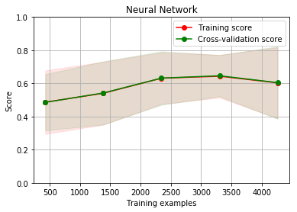

**DECISION TREE**

DecisionTreeClassifier(class_weight=None, criterion='gini', max_depth=None,

max_features=None, max_leaf_nodes=None,

min_impurity_decrease=0.0, min_impurity_split=None,

min_samples_leaf=1, min_samples_split=2,

min_weight_fraction_leaf=0.0, presort=False, random_state=None,

splitter='best')

Training Accuracy 1.0

Training Confusion = [[3728 0]

[ 0 1604]]

precision recall f1-score support

1 1.00 1.00 1.00 3728

2 1.00 1.00 1.00 1604

micro avg 1.00 1.00 1.00 5332

macro avg 1.00 1.00 1.00 5332

weighted avg 1.00 1.00 1.00 5332

========================================================

Test Accuracy 0.828335832083958

Test Confusion = [[821 123]

[106 284]]

precision recall f1-score support

1 0.87 0.89 0.88 927

2 0.73 0.70 0.71 407

micro avg 0.83 0.83 0.83 1334

macro avg 0.80 0.79 0.80 1334

weighted avg 0.83 0.83 0.83 1334

Out[301]:

['dtweight.joblib']

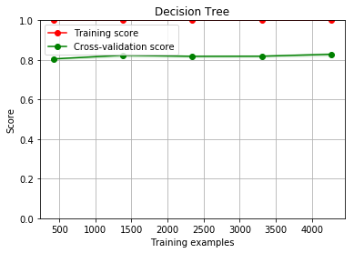

**LOGISTIC REGRESSION**

LogisticRegression(C=100000.0, class_weight=None, dual=False,

fit_intercept=True, intercept_scaling=1, max_iter=100,

multi_class='warn', n_jobs=None, penalty='l2', random_state=None,

solver='lbfgs', tol=0.0001, verbose=0, warm_start=False)

Coefficients = [[-3.40530421e-05 4.96628329e-08 -1.55627808e-05 -2.29038257e-06

-1.24448254e-07 -8.31636496e-05 -5.10218743e-06 1.29880273e-05

-1.54566506e-03 -4.91728274e-06]]

Intercept = [-7.78487654e-07]

Training Accuracy 0.840960240060015

Training Confusion = [[3508 628]

[ 220 976]]

precision recall f1-score support

1 0.85 0.94 0.89 3728

2 0.82 0.61 0.70 1604

micro avg 0.84 0.84 0.84 5332

macro avg 0.83 0.77 0.79 5332

weighted avg 0.84 0.84 0.83 5332

========================================================

Test Accuracy 0.8373313343328336

Test Confusion = [[875 165]

[ 52 242]]

precision recall f1-score support

1 0.84 0.94 0.89 927

2 0.82 0.59 0.69 407

micro avg 0.84 0.84 0.84 1334

macro avg 0.83 0.77 0.79 1334

weighted avg 0.84 0.84 0.83 1334

Out[300]:

['lrweight.joblib']

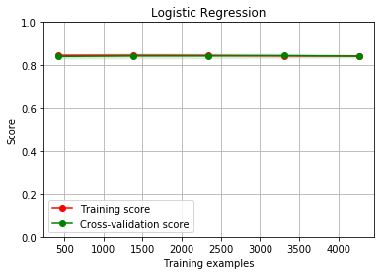

**RANDOMFORREST**

Training Accuracy 0.9692423105776444

Training Confusion = [[3690 126]

[ 38 1478]]

precision recall f1-score support

1 0.97 0.99 0.98 3728

2 0.97 0.92 0.95 1604

micro avg 0.97 0.97 0.97 5332

macro avg 0.97 0.96 0.96 5332

weighted avg 0.97 0.97 0.97 5332

========================================================

Test Accuracy 0.8650674662668666

Test Confusion = [[856 109]

[ 71 298]]

precision recall f1-score support

1 0.89 0.92 0.90 927

2 0.81 0.73 0.77 407

micro avg 0.87 0.87 0.87 1334

macro avg 0.85 0.83 0.84 1334

weighted avg 0.86 0.87 0.86 1334

Out[305]:

['rfwt.joblib']

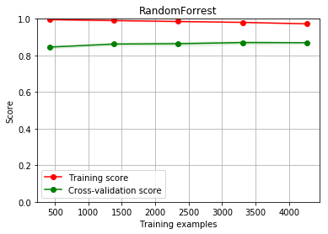

**KNN**

Training Accuracy 0.8769692423105776

Training Confusion = [[3456 384]

[ 272 1220]]

precision recall f1-score support

1 0.90 0.93 0.91 3728

2 0.82 0.76 0.79 1604

micro avg 0.88 0.88 0.88 5332

macro avg 0.86 0.84 0.85 5332

weighted avg 0.88 0.88 0.88 5332

========================================================

Test Accuracy 0.8275862068965517

Test Confusion = [[836 139]

[ 91 268]]

precision recall f1-score support

1 0.86 0.90 0.88 927

2 0.75 0.66 0.70 407

micro avg 0.83 0.83 0.83 1334

macro avg 0.80 0.78 0.79 1334

weighted avg 0.82 0.83 0.82 1334

Out[307]:

['knnwt.joblib']

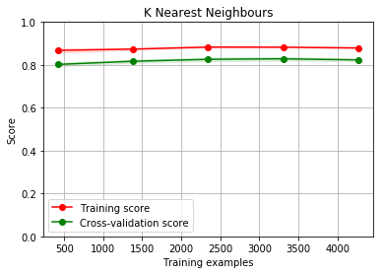

**EXTRATREE**

Training Accuracy 1.0

Training Confusion = [[3728 0]

[ 0 1604]]

precision recall f1-score support

1 1.00 1.00 1.00 3728

2 1.00 1.00 1.00 1604

micro avg 1.00 1.00 1.00 5332

macro avg 1.00 1.00 1.00 5332

weighted avg 1.00 1.00 1.00 5332

========================================================

Test Accuracy 0.868815592203898

Test Confusion = [[868 116]

[ 59 291]]

precision recall f1-score support

1 0.88 0.94 0.91 927

2 0.83 0.71 0.77 407

micro avg 0.87 0.87 0.87 1334

macro avg 0.86 0.83 0.84 1334

weighted avg 0.87 0.87 0.87 1334

Out[308]:

['extwt.joblib']

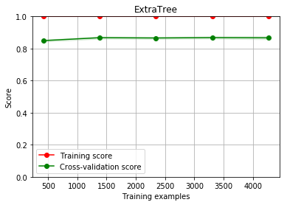

**NAIVE BAYES**

Training Accuracy 0.8257689422355589

Training Confusion = [[3533 734]

[ 195 870]]

precision recall f1-score support

1 0.83 0.95 0.88 3728

2 0.82 0.54 0.65 1604

micro avg 0.83 0.83 0.83 5332

macro avg 0.82 0.75 0.77 5332

weighted avg 0.82 0.83 0.81 5332

========================================================

Test Accuracy 0.8193403298350824

Test Confusion = [[883 197]

[ 44 210]]

precision recall f1-score support

1 0.82 0.95 0.88 927

2 0.83 0.52 0.64 407

micro avg 0.82 0.82 0.82 1334

macro avg 0.82 0.73 0.76 1334

weighted avg 0.82 0.82 0.81 1334

Out[309]:

['nbcwt.joblib']

