- Contact Book Project Report
Project Title: Contact Book Management
Course /Subject: Python Programming
Student Name: SINGH SAURAV DURGA PRASAD
Roll Number: 25BCE11074
Submitted To: M K Jayanthi
Date: 24 November 2025

- Introduction
This project presents a simple command-line contact management application written
in Python. It allows users to create, view, search, and delete contact entries conveniently, demonstrating fundamental programming concepts and basic data management in a user-friendly format.

- Problem Statement
Digital contact management tools are often overly complex for simple needs. This project addresses the problem by providing an easy-to-use CLI solution for managing contacts, ideal for beginners and situations where a lightweight tool is preferred.

- Functional Requirements
- Add new contacts with a name and phone number
- View all saved contacts
- Search contacts by name
- Delete a contact by name
- Simple, user-driven navigation via a menu

4. Non-functional Requirements
- Quick execution and response times
- Robust input validation and user feedback
- Maintainable, readable source code
- No external dependencies; pure Python standard library
- Portable and easily executable on any system with Python installed

5. System Architecture
- User Interface: Command-line menu and prompts
- Logic: Structured as individual functions for each feature
- Storage: In-memory storage using Python's data structures
- Persistence: None in the current version (session-based only)

6. Design Diagrams
Use Case Diagram
- The user can add, view, search, and delete contacts via a menu interface.
Workflow Diagram
- The user's input is directed to respective functions based on menu selection, and results are shown before returning to the menu.
Sequence Diagram
- User selects an option → Application prompts for details → User provides input → Application processes and displays results.
Class/Component Diagram
- Main module contains functions responsible for adding, viewing, searching, and deleting contacts; all interact with a shared in-memory data structure.

7. Design Decisions & Rationale
- Chose dictionary data structure for efficient retrieval and update of contacts.
- Adopted a menu-driven approach for simplicity and clarity.
- Kept the code modular by separating core functionalities into distinct functions.
- Refrained from using file/database storage to maintain project scope and focus on logic.

8.Implementation Details
- All program logic is concentrated in a single Python file.
- Navigation is handled through a menu system, looping until the user exits.
- Data is temporarily stored in a dictionary within the session.

9.Screenshots / Results
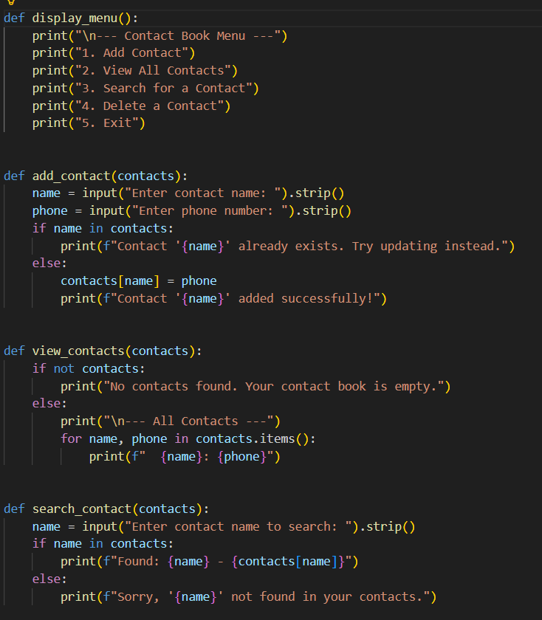

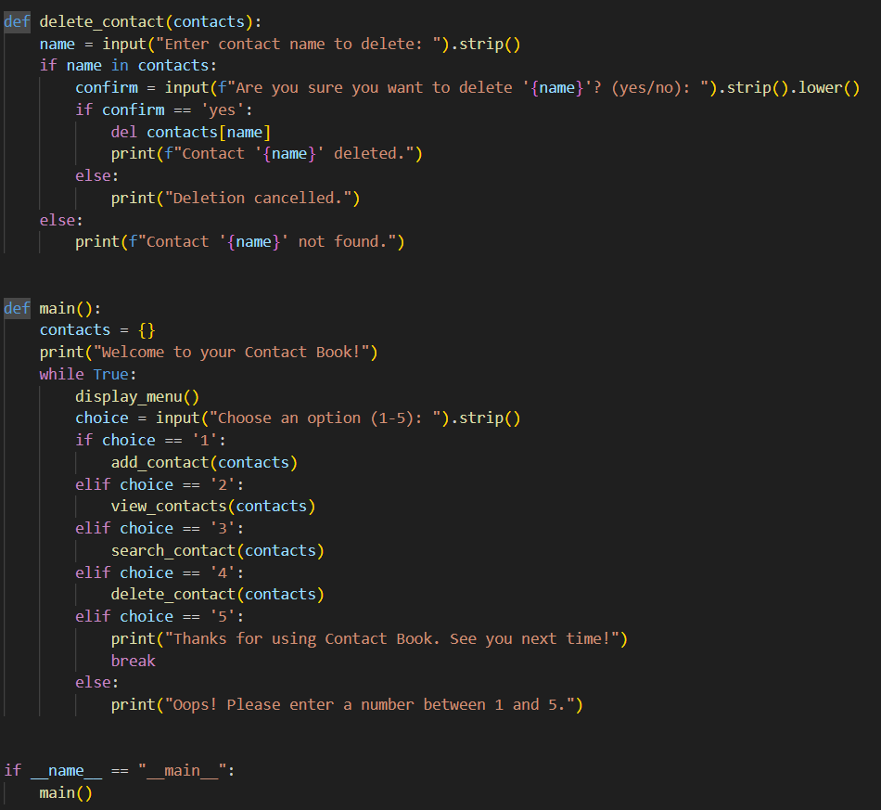

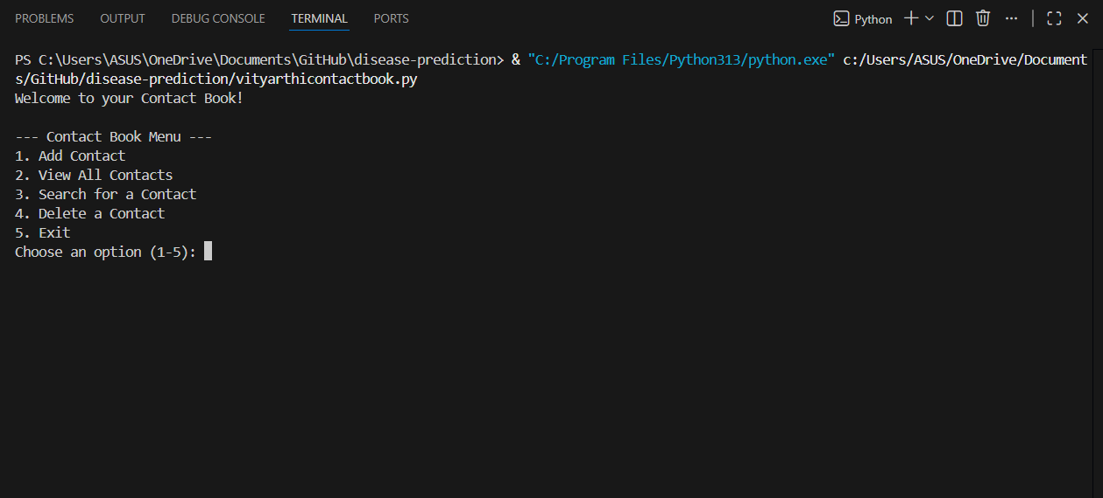

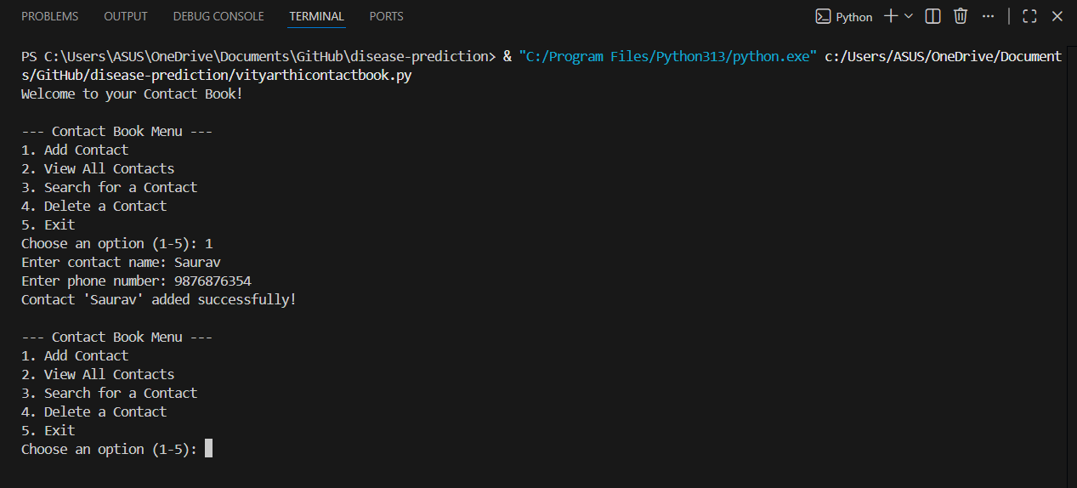

- Testing Approach
- Performed manual testing by executing all menu options and entering valid/invalid data.
- Tested edge cases such as duplicate entries, blank inputs, and deleting non-existent contacts.
________________________________________

11. Challenges Faced
- Ensuring contact uniqueness and preventing duplicate entries.
- Implementing user confirmation dialogs for deletion.
- Designing for intuitive user interaction in a command-line setting.
________________________________________
12. Learnings & Key Takeaways
- Reinforced fundamental data structures in Python.
- Gained practical experience designing modular, menu-driven CLI programs.
- Appreciated the importance of input validation and user-centric design.

13. Future Enhancements
- Add persistent storage via files (JSON/CSV) or databases.
- Enable editing/updating contacts.
- Expand contact fields (e.g., email, address).
- Introduce input validation for contact information.
- Potentially develop a graphical interface.

