i) Write a shell script that will generate and print all prime numbers within the given range.
Example:
Input=10
20
Output= 11
13
17
19

Code

echo "enter starting the range"
read s
echo "enter ending the range"
read e
echo "the prime nos are:"
for (( i = $s+1 ; $i <= $e ; i = $i + 1))
do
c=0
for (( j = 1 ; $j <= $i ; j = $j + 1))
do
if [ `expr $i % $j` -eq 0 ]
then
c=$((c+1))
fi
done
if [ $c -eq 2 ]
then
echo $i
else
continue
fi
done

OUTPUT

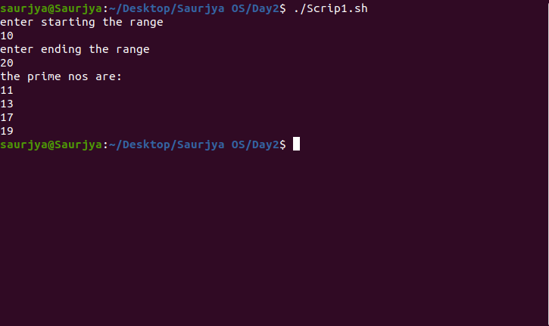
ii) Write a shell program that accepts a number and performs the basic operations [ 1. Add 2. Substract 3. Multiply 4. Division default. Wrong input ] of a calculator.
example:
Input = 3
5
1
output =8

Code

echo "Enter 1 for Addition 2 for Subtraction 3 for Multiplication 4 for Divition 5 to Quit"
read a
case "$a" in
"1") echo "Enter the Addends."
read b
read c
echo "The Result = "`echo " $b + $c " | bc`
;;
"2") echo "Enter the Subtrahends."
read b
read c
echo "The Result = "`echo " $b - $c " | bc`
;;
"3") echo "Enter the Multiplicands."
read b
read c
echo "The Result = "`echo " $b * $c " | bc`
;;
"4") echo "Enter the Divisors."
read b
read c
echo "The Result = "`echo " $b / $c " | bc`
;;
"*") echo "Quit."
exit 0
;;
esac

Output

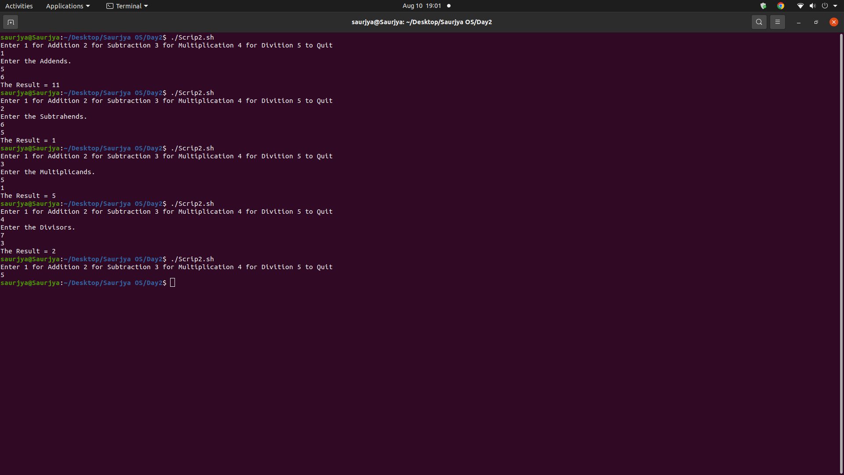
iii ) Write a shell script to evaluate the following
∑ (x) for x = 1 to N (N>1)
The input contains the upper limit N.
The output must be scaled up to 3 decimal places.
Note: Enter the input directly as shown below without using any print statement to prompt user for entering input.
Example 1
Input:
4
Output:
1.379

Code

echo "Enter the term"
read n
S=0.000
for (( i = 1 ; $i <= $n ; i = $i + 1))
do
l=`echo "scale=3;l($i)/l(10)" | bc -l`
S=`echo "scale=3;$S + $l" | bc -l`
done
echo "Result="$S

Output

