5.1 Create an unnamed pipe to communicate between parent/child proceses. Accept a string (user input ) in child process and pass the string to parent process which will reverse that and send it back to child process and the child process will print it out.

Code:
#include <stdio.h>
#include <sys/types.h>
#include <string.h>
#include <unistd.h>
int main()
{
char S[32],S1[32],Rev[32],Rev2[32] ;
int fd[2],w ,r,p,c ,i = 0, j,size;
p = pipe(fd);
c = fork();
if(c == 0)
{
printf("I am Child Process\n");
printf("Please Enter a String withing 32 Characters : \n");
fgets(S,32,stdin);
w = write(fd[1],S,sizeof(S));
sleep(10);
r = read(fd[0],Rev2,sizeof(S));
printf("Reverse String = %s",Rev2);
}
else
{
printf("I am Parent Process\n");
r = read(fd[0],S1,sizeof(S1));
printf("Input String = %s",S1);
j = strlen(S1)-1;
size = j;
printf("%d",j);
sleep(5);
while ( i <= size)
Rev[i++] = S1[j--];
Rev[i]='\0';
w = write(fd[1],Rev,sizeof(S1));
}
return 0;
}
OUTPUT:
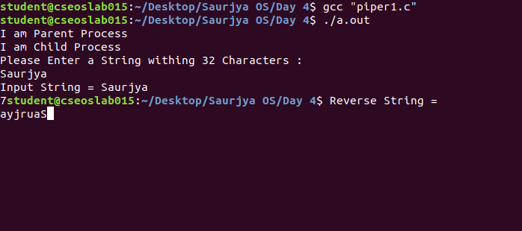
5.2 Create an unnamed pipe to communicate between parent process and child process. Use the pipe to send 2 integers x & y (user input) from child process to its parent process. Calculate x^y in parent process & send it to child process. Print the result in child process.

CODE:
#include <stdio.h>
#include <sys/types.h>
#include <string.h>
#include <unistd.h>
int main()
{
int fd[2],w ,r,p,c , arr[3] , arr2[3], temp , t1 , t2;
p = pipe(fd);
c = fork();
if(c == 0)
{
printf("I am Child Process\n");
printf("Please Enter an Integer : \n");
scanf("%d",&arr[0]);
printf("Please Enter an Integer : \n");
scanf("%d",&arr[1]);
w = write(fd[1],arr,sizeof(arr));
sleep(3);
r = read(fd[0],arr,sizeof(arr));
printf("Printing from Child \n Power of %d raised to the power of %d is %d",arr[0],arr[1],arr[2]);
}
else
{
printf("I am Parent Process\n");
r = read(fd[0],arr2,sizeof(arr2));
t1 = arr2[0];
t2 = arr2[1];
temp = arr2[0];
for(int i = 1 ; i < arr2[1]; i++)
temp = temp * arr2[0];
arr2[2] = temp;
w = write(fd[1],arr2,sizeof(arr2));
}
return 0;
}

OUTPUT:
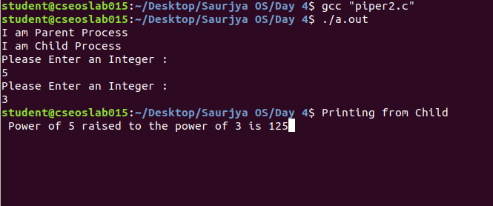
5.3 Use a named pipe (FIFO) to send an array of integers from a process P1 to another process P2. The process P2, after receiving the array, will sort the array & send back to P1. P1 will print the sorted array.

CODE:
P1.c
#include <stdio.h>
#include <string.h>
#include <fcntl.h>
#include <sys/stat.h>
#include <sys/types.h>
#include <unistd.h>
int main()
{
int fd , size = 5 , r ,w;
char * myfifo = "/tmp/myfifo58";
mkfifo(myfifo, 0666);
int arr[5]={5,3,6,9,8};
int arr1[5]={0,0,0,0,0};
fd = open(myfifo, O_WRONLY);
printf("Unsorted Array = ");
for (int i = 0; i < size ; ++i)
printf("%d ",arr[i]);
for (int i = 0; i < 5; ++i)
{
printf("\nTrying to Send Data for %d secs ",i+1);
sleep(1);
w = write(fd, arr, sizeof(arr));
}
if(w != -1)
printf("\nMessage Sent");
close(fd);
fd = open(myfifo, O_RDONLY);
for (int i = 0; i < 7; ++i)
{
r = read(fd, arr1, sizeof(arr1));
printf("\nTrying to Receive Data for %d secs ",i+1);
sleep(1);

}
if(r != -1)
printf("\nMessage Received and Sorted");
printf("\nSorted Array = ");
for (int i = 0; i < size ; ++i)
printf("%d ",arr1[i]);
printf("\n");
close(fd);
return 0;
}

P2.c

#include <stdio.h>
#include <string.h>
#include <fcntl.h>
#include <sys/stat.h>
#include <sys/types.h>
#include <unistd.h>
int main()
{
int fd1 , size =5 , r , w;
char * myfifo = "/tmp/myfifo58";
mkfifo(myfifo, 0666);
int array[5]={0,0,0,0,0};
fd1 = open(myfifo,O_RDONLY);
for (int i = 0; i < 5; ++i)
{
printf("\nTrying to Receive Data for %d secs ",i+1);
sleep(1);
r = read(fd1, array, sizeof(array));
}
close(fd1);
for (int step = 0; step < size - 1; ++step) {
for (int i = 0; i < size - step - 1; ++i) {
if (array[i] > array[i + 1]) {
int temp = array[i];
array[i] = array[i + 1];
array[i + 1] = temp;
}
}
}
if(r != -1)
printf("\nMessage Received and Sorted");
fd1 = open(myfifo,O_WRONLY);
for (int i = 0; i < 5; ++i)
{
printf("\nTrying to Send back the Sorted Data for %d secs ",i+1);
sleep(1);
w = write(fd1, array, sizeof(array));
}
if(w != -1)
printf("\nMessage Sent\n");
close(fd1);
return 0;
}

OUTPUT:

