AI Finance Platform - Full Architecture Documentation

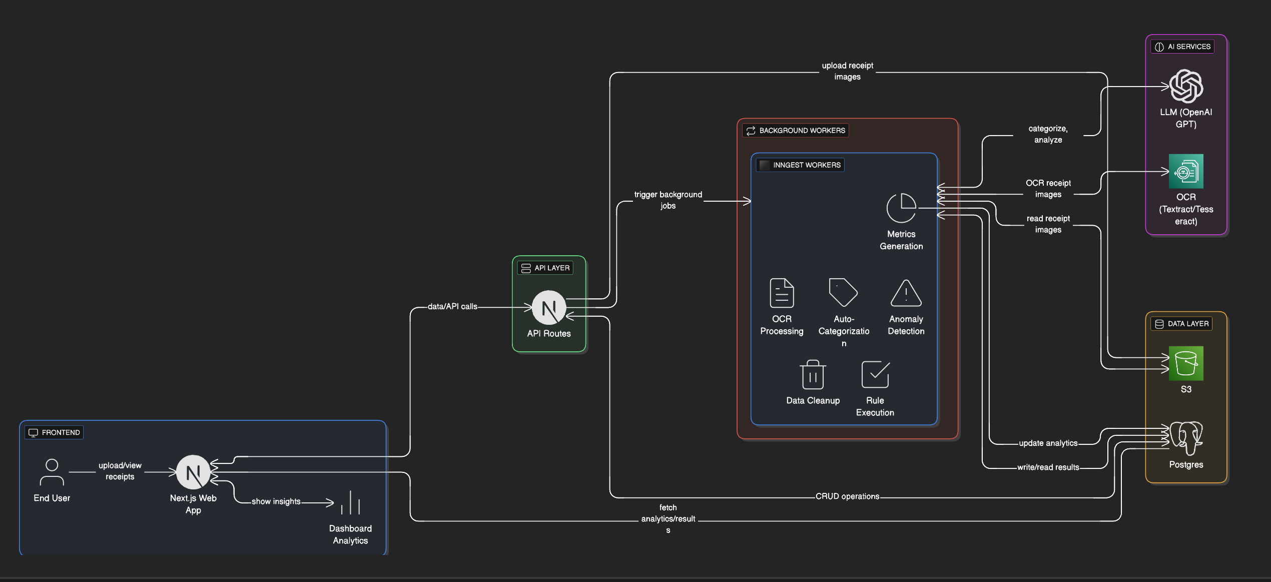

. Database ER Diagram

