FREEDOM INTERNATIONAL SCHOOL # 33, Sector IV, HSR Layout, Bengaluru, Karnataka 560102

SCHOOL CODE: 45175

AFFILIATION NUMBER:830183

PHYSICS PROJECT ON DETECTION OF EARTH’S MAGNETIC FIELD USING A TANGENT GALVANOMETER SUBMITTED BY Soham Raydhaudhuri Class XII A Under the guidance of Ms. BULTI SAHA PGT- Physics

Vice Principal Ms. Clara David Principal Ms. Sneha Rai Freedom International School Bangalore Freedom International School Bangalore

FREEDOM INTERNATIONAL SCHOOL # 33, Sector IV, HSR Layout, Bengaluru, Karnataka 560102

SCHOOL CODE: 45175

AFFILIATION NUMBER:830183

CERTIFICATE

This is to certify that the Physics Project Report entitled Detection of Earth’s Magnetic Field Using a Tangent Galvanometer was carried out by Soham Raychaudhuri of Class XII A, Roll No. 30 , a student of FREEDOM INTERNATIONAL SCHOOL in partial fulfilment of the Physics Practical Examinations prescribed by the CBSE during the Academic Year 2022-23. I certify that this project has been done by him/her with his/her own effort under the guidance of the teacher. Signature of the Teacher in Charge Ms. Bulti Saha

Name of the Examiners

1. _______________________

2. _______________________ __________________________ __________________________

Signature of the Principal

Ms. Sneha Rai

Signature with date

**ACKNOWLEDGEMENT**

I would like to express my special thanks and gratitude to my teacher and project guide Ms. Bulti Saha who gave me this wonderful opportunity to work on this interesting project, which required a lot of research and was an excellent learning experience.

My sincere thanks goes to Ms. Sneha Rai, our Principal, for her coordination in extending every possible support for the completion of this project. I also extend my sincere thanks to our lab assistant, Ms. Aruna P for her assistance during the project work. I also thank my parents for their constant motivation and support. Last but not least, I would like to thank all those who had helped me directly or indirectly towards the completion of this

project.

**An Introduction to Tangent Galvanometers**

The tangent galvanometer is an instrument used to measure small electric currents. It consists of a coil of insulated copper wire wound around a circular, non-magnetic frame and works based on the tangent law of magnetism. When a current is passed through a circular coil, a magnetic field is produced passing perpendicular to the plane of the coil. On arranging the tangent galvanometer along the horizontal component of the Earth’s magnetic field, two mutually perpendicular components can be said to be acting on the galvanometer simultaneously.

If $θ$ is the deflection of the needle, according to tangent law…

*B = Bhtan $θ$*

Let I be the current passing through a coil of radius a, turned n times. The magnetic field produced is…

$$B=\left(unI\right)/2a$$

On equating the two, we get…

*2aBh/un = I/tan $θ$*

Taking K (reduction factor) as I/tan $θ$, we get…

*Bh = unK/2a - 1*

Thus, we can find the strength of the magnetic field of the Earth at any point if the required constants are known.

**Experiment**

**Materials required**:

1. Tangent galvanometer
2. Spirit level
3. Rheostat
4. Power supply
5. Switch
6. Ammeter
7. Graduated compass

**Theory:**

The horizontal component of Earth’s magnetic field is the projection of Earth’s magnetic field on its surface. If no external magnetic field is present, the compass will align with this component. When the horizontal component of Earth’s magnetic field and the external magnetic force (induced by current) are in equilibrium…

B = Bhtan $θ$

**Procedure**:

1. Place the tangent galvanometer away from ferrous metals to prevent external magnetic fields from interfering with the results
2. Connect the tangent galvanometer to the ammeter and power supply as shown to generate an electric current and hence a magnetic field
3. Rotate the tangent galvanometer to read 0-0 at the ends of the aluminium pointer
4. Adjust the rheostat for deflections between 10 and 60 degrees
5. Use formula 1 by taking the necessary measurements and tabulate the results

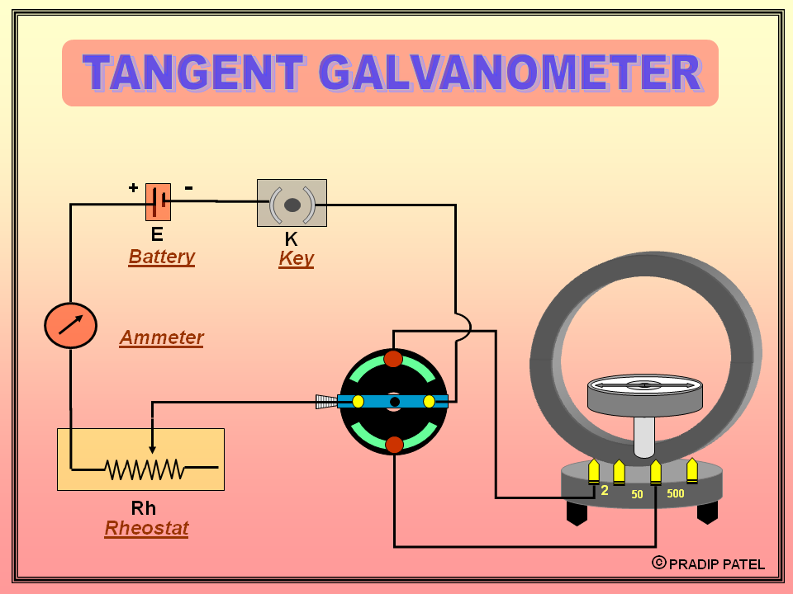

**Results:**

Magnitude of Earth’s gravitational field has been successfully calculated

**References:**

1. [www.slideshare.net](http://www.slideshare.net)
2. [www.mccc.edu](http://www.mccc.edu)
3. [www.niser.ac.in](http://www.niser.ac.in)
4. [www.unacademy.com](http://www.unacademy.com)
5. [www.amrita.edu](http://www.amrita.edu)