System Monitor Tool

A tool that displays real-time information about system processes, memory usage, and CPU load ? similar to the 'top' command.
Code
// sysmon.cpp
// Build: g++ -std=c++17 sysmon.cpp -o sysmon -lncurses
// Run: ./sysmon [interval_seconds]

#include <bits/stdc++.h>
#include <ncurses.h>
#include <signal.h>
using namespace std;
namespace fs = filesystem;

struct ProcSnapshot {
int pid;
string name;
unsigned long total_time = 0; // utime+stime (jiffies)
long rss_kb = 0;
double cpu_percent = 0.0;
double mem_mb = 0.0;
};

unsigned long get_total_jiffies() {
ifstream f("/proc/stat");
string line;
getline(f, line);
// line: cpu 3357 0 4313 1362393 ...
stringstream ss(line);
string cpu; unsigned long v, sum=0;
ss >> cpu;
while (ss >> v) sum += v;
return sum;
}

vector<int> list_pids() {
vector<int> pids;
for (auto &e : fs::directory_iterator("/proc")) {
string name = e.path().filename();
if (!name.empty() && all_of(name.begin(), name.end(), ::isdigit))
pids.push_back(stoi(name));
}
return pids;
}

bool read_proc_times(int pid, unsigned long &totaltime, long &rss_kb, string &name) {
string statp = "/proc/" + to_string(pid) + "/stat";
ifstream sf(statp);
if (!sf) return false;
string content; getline(sf, content);
size_t rp = content.rfind(')');
if (rp == string::npos) return false;
name = content.substr(content.find(' ')+1, rp - content.find(' ') - 1);
string after = content.substr(rp+2);
vector<string> toks; string t; stringstream s(after);
while (s >> t) toks.push_back(t);
if (toks.size() < 13) return false;
unsigned long utime = stoul(toks[11]);
unsigned long stime = stoul(toks[12]);
totaltime = utime + stime;

// rss from /proc/[pid]/status
rss_kb = 0;
ifstream pf("/proc/" + to_string(pid) + "/status");
string line;
while (pf && getline(pf,line)) {
if (line.rfind("VmRSS:",0) == 0) {
string key; long val; string unit;
stringstream ss(line); ss >> key >> val >> unit;
rss_kb = val;
break;
}
}
return true;
}

int main(int argc, char** argv) {
int interval = 2;
if (argc >= 2) interval = stoi(argv[1]);
bool sort_by_cpu = true;

initscr();
cbreak();
noecho();
nodelay(stdscr, TRUE); // non-blocking getch
keypad(stdscr, TRUE);

// We'll keep previous snapshots in maps
unordered_map<int, unsigned long> prev_proc_time;
unsigned long prev_total_jiffies = get_total_jiffies();

while (true) {
unsigned long cur_total_jiffies = get_total_jiffies();

vector<ProcSnapshot> procs;

for (int pid : list_pids()) {
unsigned long ttime;
long rss;
string name;
if (!read_proc_times(pid, ttime, rss, name)) continue;
ProcSnapshot ps;
ps.pid = pid; ps.name = name; ps.total_time = ttime; ps.rss_kb = rss; ps.mem_mb = rss/1024.0;
auto it = prev_proc_time.find(pid);
unsigned long proc_prev = (it!=prev_proc_time.end()) ? it->second : 0;
unsigned long proc_delta = (ttime >= proc_prev) ? (ttime - proc_prev) : 0;
unsigned long total_delta = (cur_total_jiffies >= prev_total_jiffies) ? (cur_total_jiffies - prev_total_jiffies) : 1;
ps.cpu_percent = 100.0 * (double)proc_delta / (double)total_delta;
procs.push_back(ps);
// update temp map later
}

// update previous maps
prev_proc_time.clear();
for (auto &p : procs) prev_proc_time[p.pid] = p.total_time;
prev_total_jiffies = cur_total_jiffies;

if (sort_by_cpu) {
sort(procs.begin(), procs.end(), [](auto &a, auto &b){ return a.cpu_percent > b.cpu_percent; });
} else {
sort(procs.begin(), procs.end(), [](auto &a, auto &b){ return a.mem_mb > b.mem_mb; });
}

// Render
erase();
mvprintw(0,0,"SysMon (Day 5) - refresh every %d s - sort by %s - press 's' to toggle sort, 'k' to kill PID, 'q' to quit", interval, sort_by_cpu ? "CPU" : "MEM");
mvprintw(1,0,"%-6s %-20s %-8s %-8s", "PID", "NAME", "CPU%", "MEM(MB)");
int row = 2;
int show = 0;
for (auto &p : procs) {
if (show++ >= 25) break;
mvprintw(row++, 0, "%-6d %-20s %7.2f %-8.1f", p.pid, p.name.c_str(), p.cpu_percent, p.mem_mb);
}
refresh();

// handle keys
int ch;
bool killedSomething = false;
for (int t=0; t<interval*10; ++t) { // poll every 100ms to be responsive to keypress
ch = getch();
if (ch == 'q') {
endwin();
return 0;
} else if (ch == 's') {
sort_by_cpu = !sort_by_cpu;
break; // break to refresh immediately
} else if (ch == 'k') {
// prompt user for PID
echo();
nodelay(stdscr, FALSE);
mvprintw(row+1, 0, "Enter PID to kill (SIGTERM): ");
char buf[32];
getnstr(buf, 31);
int pid = atoi(buf);
int res = kill(pid, SIGTERM);
if (res == 0) mvprintw(row+2,0,"SIGTERM sent to %d", pid);
else mvprintw(row+2,0,"Failed to kill %d: %s", pid, strerror(errno));
noecho();
nodelay(stdscr, TRUE);
killedSomething = true;
break;
} else if (ch == ERR) {
// no input
}
napms(100); // 100 ms
}
if (killedSomething) {
// immediate refresh in next loop iteration
continue;
}
}

endwin();
return 0;
}

Output
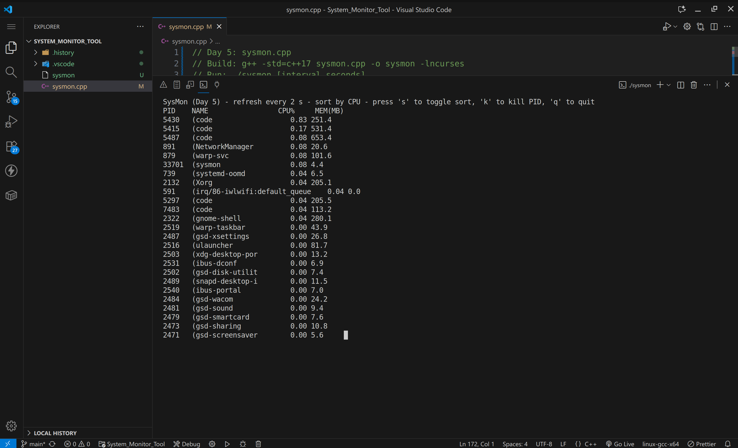
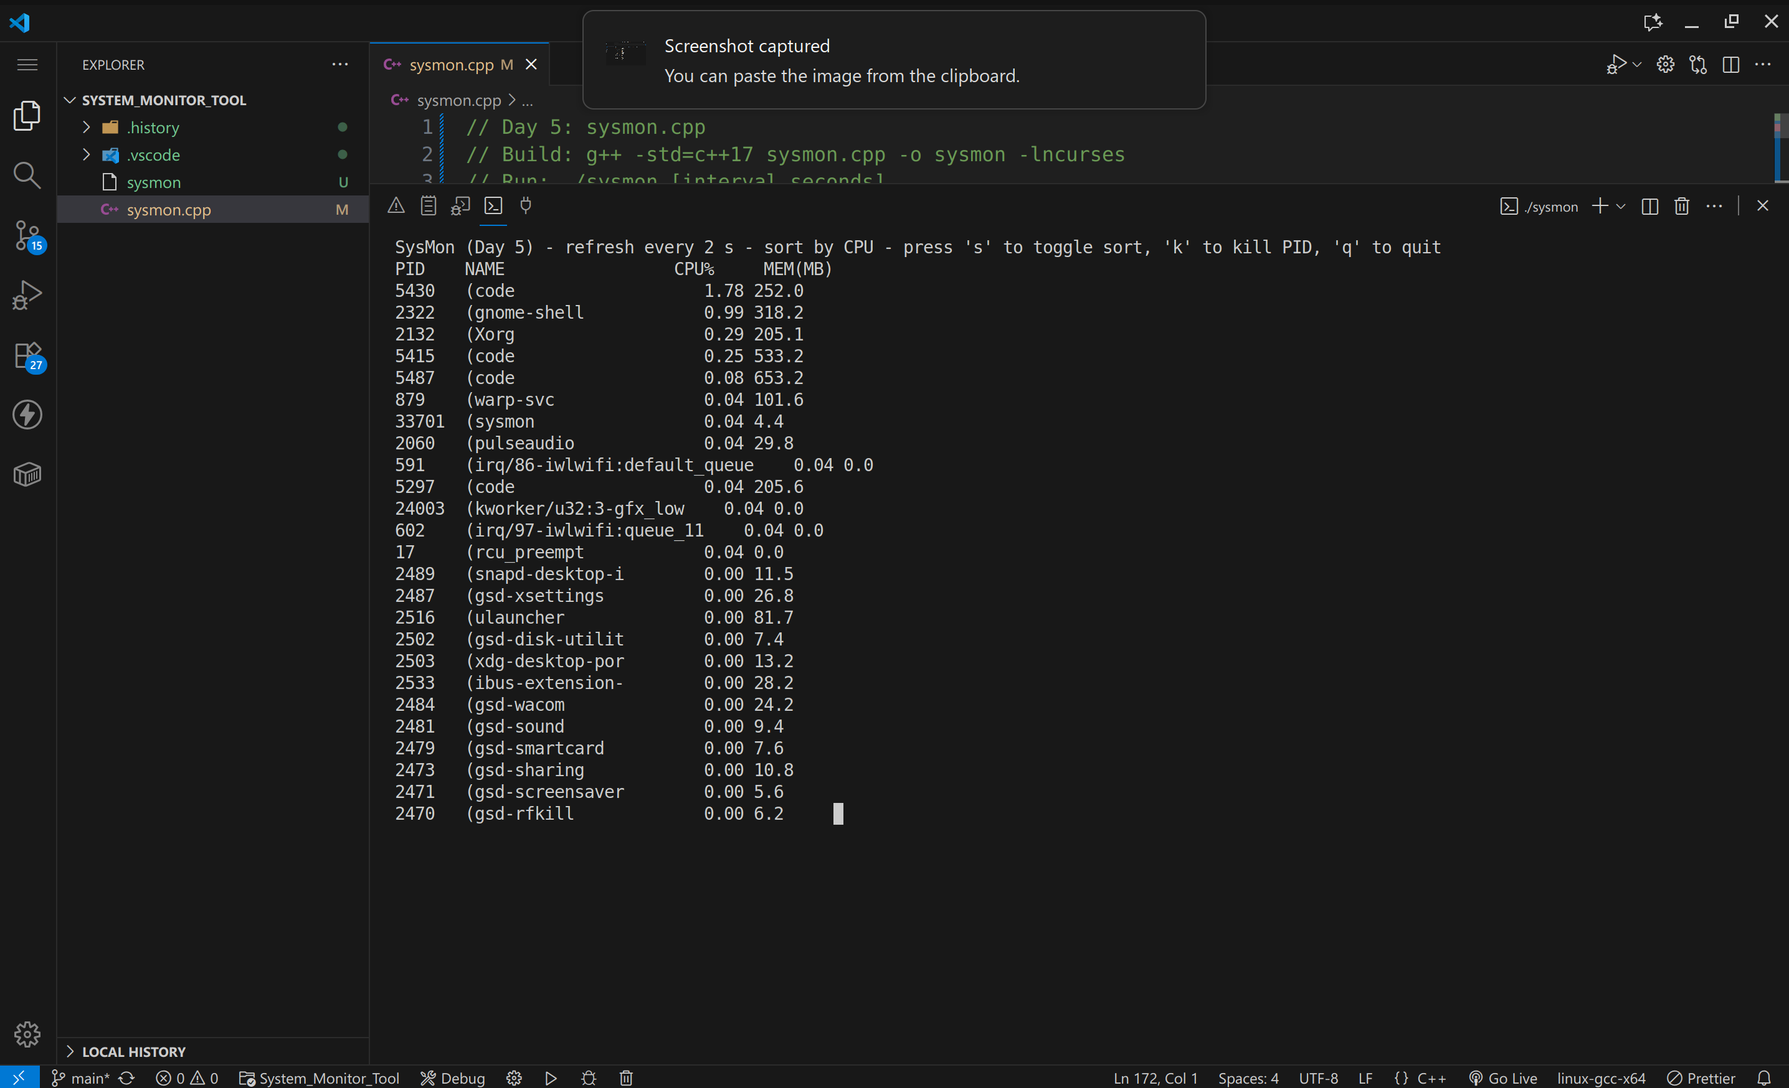
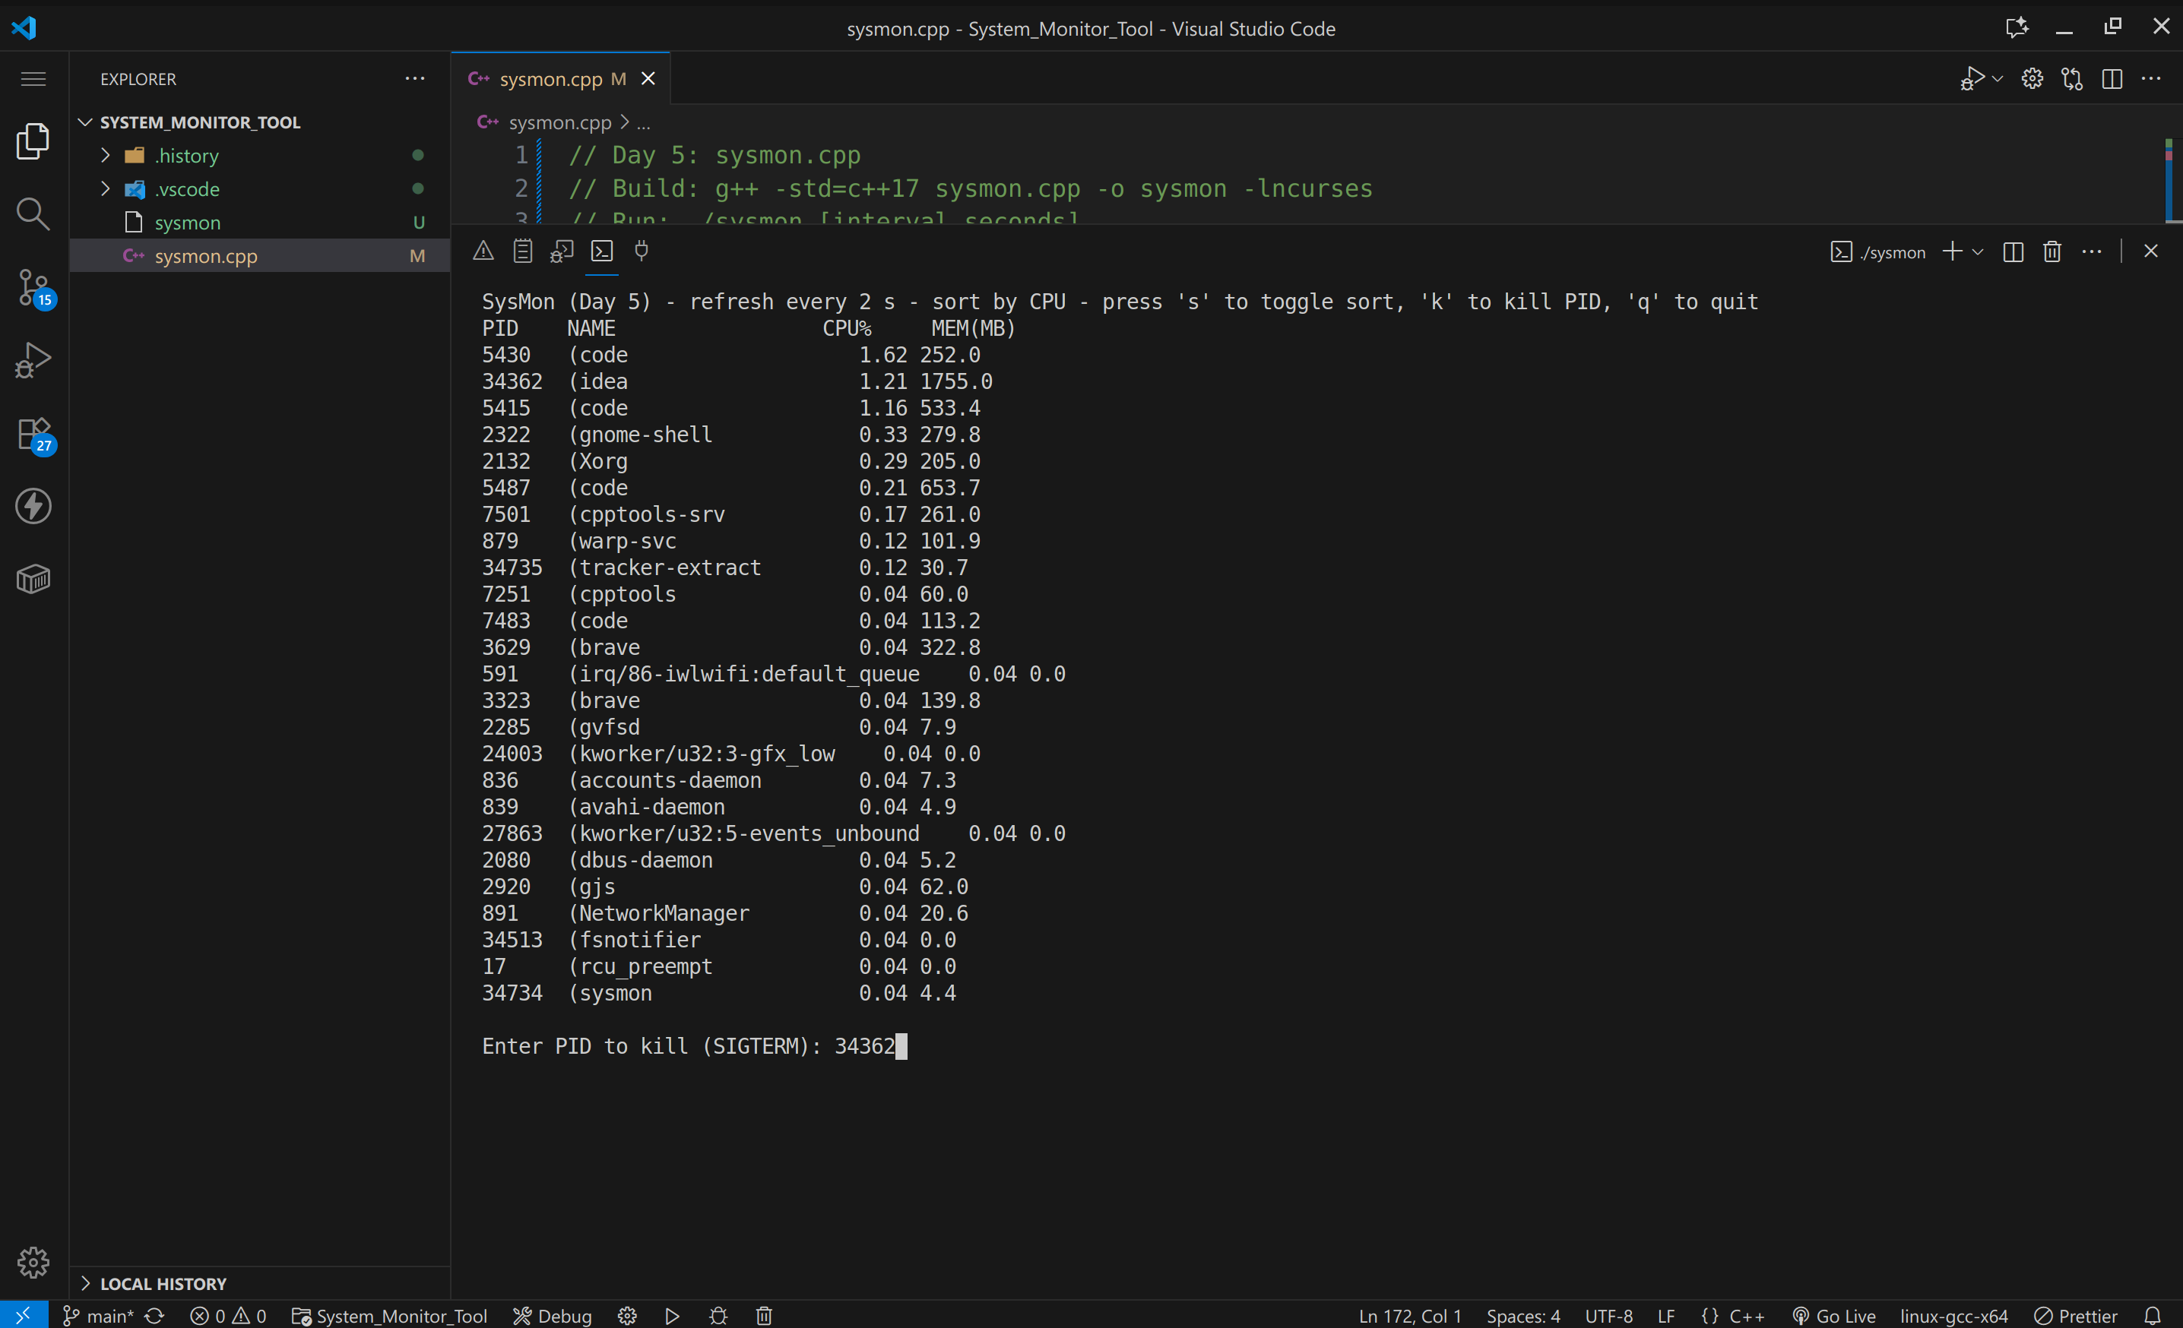
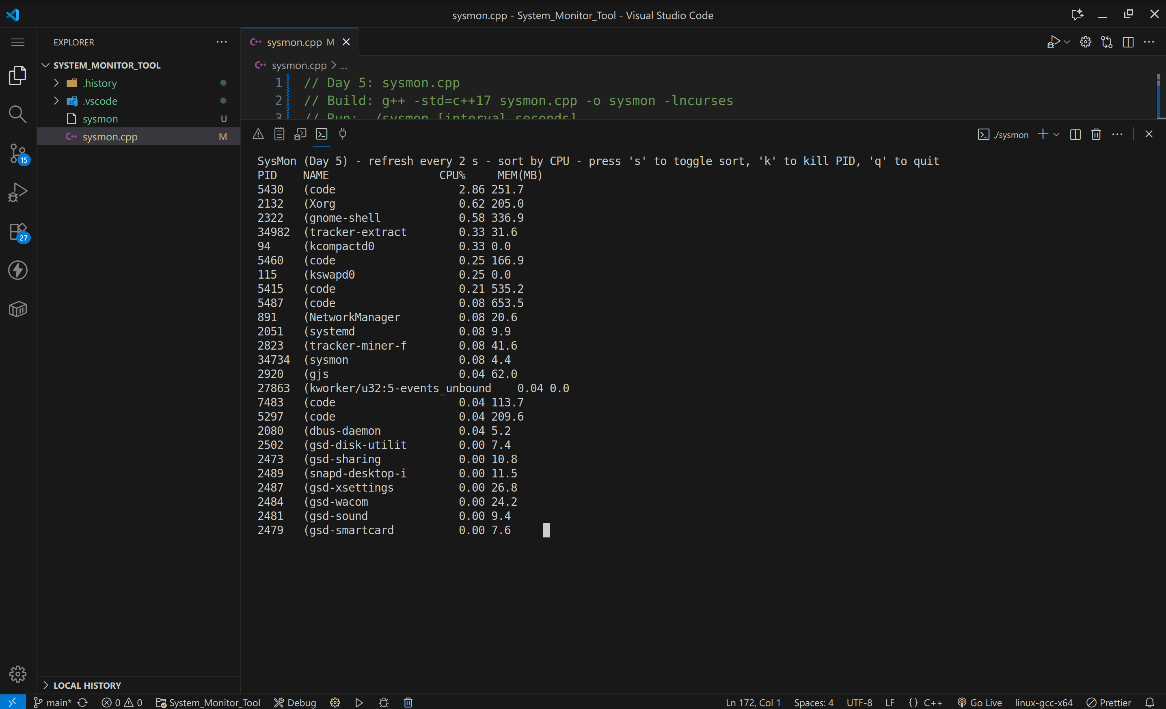

GitHub
Repo URL: https://github.com/SauvikPrasad/Wipro_System_Moniter_Tool

Sauvik Prasad
Regd. No. : 2241016507
Wipro COE Embedded Batch 13

