Make sure that the correct database files are in the correct folders or the PROGRAM WILL NOT WORK.

If they get lost or corrupted, you can download them from here:

This is the correct file structure:

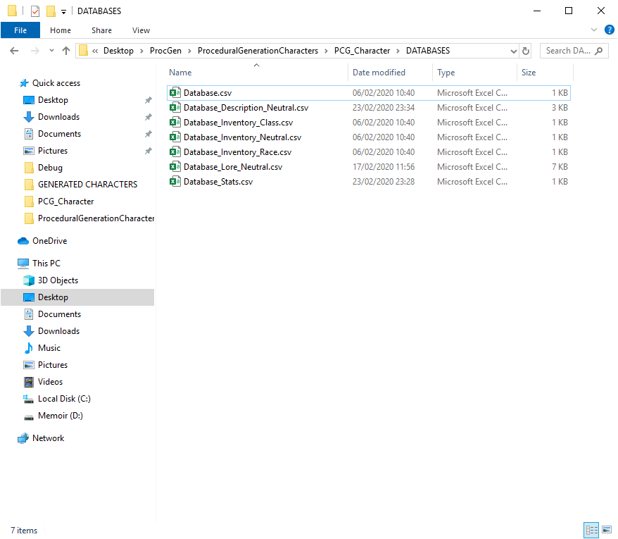

By opening the files, you can see the correct way of filling in information.

The information can be altered to your needs but **FOLLOWING THE SAME STRUCTURE.**

**Classes, Races, Stats and Inventory items, Lore and Characteristics can be added and removed freely.**

**ALL DATABASES, MUST HAVE AN “END” TO SIGNIFY THE END OF THE COLUMNS ALONG WITH A “-“**

**EXAMPLE:**

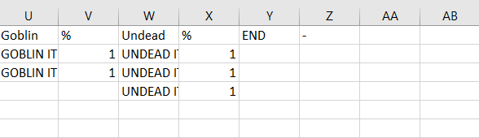

**FAILURE TO DO SO WILL RESULT IN THE PROGRAM NOT WORKING CORRECTLY OR AT ALL.**

Run the program and follow the onscreen commands to generate your characters, choose any number between 1 and 1000 and type it down then press enter.

Then print them in any filter you want by typing the appropriate number.

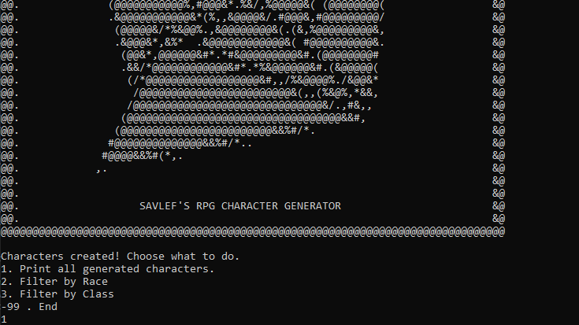

Once you type the selection and press enter to confirm it. It will look like this

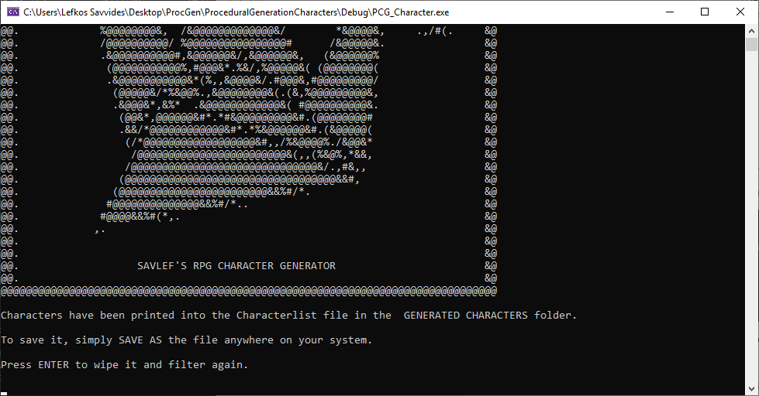

The generated characters can be found in the file: Characterlist.csv in the GENERATED CHARACTERS folder.

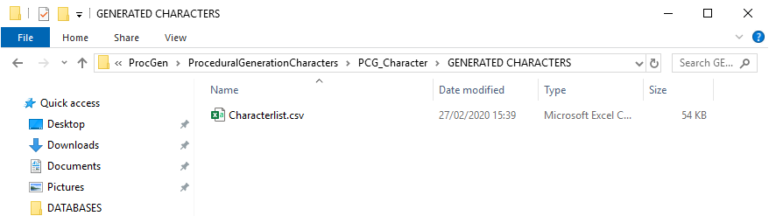

**As soon as you press ENTER again the file will be wiped. To save your character list just save the file as something else while you have it open.**   
Alternatively, you can just copy-paste the characters you like or even all of them into another spreadsheet folder.

If you choose to view the generated characters again or with any other filter, just make the appropriate selection again and the file should display the same information as long as the program is running.

When you are done saving/ looking at your characters simply close the program.

Copyright Notice:

All mentions of copyrighted names and objects in this are purely for testing and showcase purposes, and they belong to their respective owners.   
  
The developer does not claim any ownership over any data that this application uses or anything this application creates using the given data.

This is a modular tool meant to be used to create content by the end user.

The end user is responsible for any damages caused by misuse of this tool and the developer does not take responsibility for any damages, liabilities or copyright infringement that may occur from the use or misuse of this tool.

The end user is free to use anything they create with this tool for non-profit so long as they mention the original creator of this tool.   
  
For commercial use, please get in touch first.

This tool has been designed and developed by Lefkos Savvides.

Twitter handle: @SavLef

Website: https://Savvides.design