

**User manual**

**v1.2**

Contents

Introduction 5

The Basics 5

What does Machete do? 5

How does Machete work? 5

How do I login to Machete? 5

What does Machete not do? 5

terminology 6

The Machete Interface 6

navigation 6

Required fields 8

Discard Changes warning 8

Pages of machete 9

User Accounts 9

Bilingual Support 10

Work flow 10

Home 11

Employers 12

searching for an employer 12

editing an existing employer 13

creating a new employer 13

deleting an employer (Managers Only) 14

Creating a new order 14

Work order buttons 15

Work Order fields 16

Searching for and editing an existing work order 17

Moving a Work Order to a different employer 17

Deleting work orders 18

Creating a new work assignment 18

Work assignment fields 18

Work assignment buttons 19

Assigning a worker directly to an assignment (orphaned assignment) 21

Work ORDERS 22

Work order summary 22

Summary functionality 22

Summary buttons 23

Work order details 23

Details functionality 24

Work order STATUS & color 24

DISPATCH 25

Dispatch buttons 25

Lottery List 26

Sign-in list 26

Lottery 26

Assign 26

Remove 26

Requested (Active) 26

Skilled (Active) 27

Open (Active) 27

Assigned (Active) 28

Assigned (Completed) 28

All 29

persons 30

Searching for a person 30

Creating a new person 31

Editing an existing person 31

Deleting a person 32

workers 33

Searching for a worker 33

Creating a worker 33

Editing a worker 34

Status 34

of a Worker 34

Deleting a worker 35

Events 36

Creating a new Event 36

Editing an Event 37

Deleting an Event 38

worker signin 39

Machete users 40

Creating a new user account 40

Assigning or changing roles on user accounts 40

# Introduction

## The Basics

### What does Machete do?

Machete is a web application that manages a day labor referral service. Machete tracks work orders for employers looking for short term, casual labor. It also provides a means for matching laborers with specific skills to requests made by employers for skilled labor.

Machete performs the following tasks:

1. Stores basic contact information for all persons associated with the Machete system
2. Stores biographical and membership information on its members
3. Records member sign-in using a identification number through either a bar code scanner or the keyboard
4. Captures employer, work order, and work assignment details into a relational database
5. Provides a fast, flexible method of dispatching workers to work orders based on English level, skill level, and employer requests

### How does Machete work?

Machete is a web application, meaning that it web server connected to a datbase. The web server interacts with a web client (FireFox, Chrome, Internet Explorer, Safari) to provide the application functionality. The web client/server framework provides a great deal of flexibility, but also comes with it’s own quirks and restraints.

### How do I login to Machete?

Because Machete is a web application, it can be setup on any Microsoft Web Server (IIS). To access Machete, use a compliant web browser and use it to go to the Machete web server:

The default is: <http://machete/>

You will need a login and password to sign in to Machete. You can register for an account by clicking in the Logon link in the upper right hand corner of the Machete page. A manager or dispatcher will need to give your account permission to use Machete.

### What does Machete not do?

Reports. Machete captures data, display data, and prints select data through the web client’s print functionality.

Reports on the data that Machete collects are available through any SQL-compliant tool.

A set of SQL Server Reporting Services (SSRS) reports are provided, but SSRS is a separate component, not available with the free verson of SQL Server.

**Casa Latina Note:** Microsoft Reporting & Analysis Service will be used to provide report access. Reports can be found at <http://machete/reports/>

### terminology

Within Machete there are some terms that have a specific meaning.

* Persons: A person record contains basic information on persons in Machete.
* Workers: A worker record is a companion to the person record and is linked to the person record.
* Employers: An employer record is a person or business that calls to hire a worker.
* Work Orders: A work order record is a request by an employer for one or more workers.
  + Pending Orders: A pending order is a new order, or an incomplete order, or an order not yet marked active.
  + Active Orders: An active order is an order that has at least one work assignment and has been marked *active*.
  + Complete Orders: A complete order has had all of it’s assignments filled with workers and marked as complete.
  + Cancelled Orders: Orders cancelled by the employer
  + Expired Orders: Orders that could not be fulfilled (either because no worker was available, or no worker with the specific skill required could be found in time for the job).
* Work Assignment: A work assignment is part of a work order. One assignment is created for each worker needed.
* Dispatch: Dispatch is the process of assigning a worker who has signed-in for the day to an active work assignment.
* Worker Sign-in: A sign-in occurs when a worker signs in to Machete. A sign-in is required for the worker to appear in the Machete Dispatch page.
* Skills: Every work assignment requires the selection of the skills necessary to complete the work. Some skills are general skills, such as digging, that any worker can fulfill. Other skills are specialty skills, which limit which workers are eligible to be assigned to the work assignment.

## The Machete Interface

### navigation

The diagram below identifies common components of the machete interface.



Menu Links

Every Machete page has a row of gray boxes, the Menu Links, that contain HTML links. These links go to different Machete pages, providing access to various areas of the application.

The links cause the browser to load a new HTML page. The links divide the major areas of Machete functionality. Clicking on the link for the page you are already viewing will cause the page to be re-loaded.

Tabs

Machete uses tabs to divide different areas of functinality. When records are opened, a new tab is opened to display the information. Moving away from a tab will cause a new tab to be re-loaded. If you return to the previous tab, it will also be re-loaded. The tabs are re-loaded intentionally to make sure information is current.

List tab

The List Tab is the default tab for most Machete pages. The list tab shows a list of a given page’s records and provides search and sorting features against the records.

Once a record is found that needs to be edited or printed, double-click on the record row in the list tab. A record tab will open to the right, with identifying information in the tab’s text box.

The lists are implemented with an open source add-on called datatables and can be found at www.datatables.net.

Search box

The search box automatically searches the list of records for text as it’s being entered. There is a 400 ms second delay on searching, to reduce load on the Machete database. Most fields displayed in a list will be searched, with the exception of ‘Updated by’ fields. These fields are seldom searched and increase search load for all searches, so they are excluded.

Create tab

The Create Tab is available for almost all pages. The create tab provides a blank record for entering new information. The save button must be used to save the new record to the database.

It is important to note that for most Machete operations, there are a series of records that must be created, in succession, in order to complete a task. In such situations, creating a record will open up a new set of tabs. This new set of tabs will have a List tab and a Create Tab that function in the same manner as their parent.

RECORD TAB

When a record is created using the Create tab and saved, a new tab will be opened. Record tabs can also be opened by double clicking on a record row in a List tab.

Record tabs allow a user to edit or delete a record. The delete functionality should be used carefully, because it may also delete related records. There is no undelete functionality; deletions are permanent.

Table entries per page

This option controls how many rows are displayed in a table at a given time. The default number is set relatively low because it reduces processing load and time on the server.

Pagination

The pagination arrows move through pages of table data. Each click will make a call to the database to fetch a new set of records to display in the table.

Language

The language links tell Machete which language to display for the pages. Currently Spanish and English are the languages available for Machete.

### Required fields

Some fields are required in order to save a record. If a user attempts to save the record without filling out a required field, the field is highlighted in red and an error message is displayed.

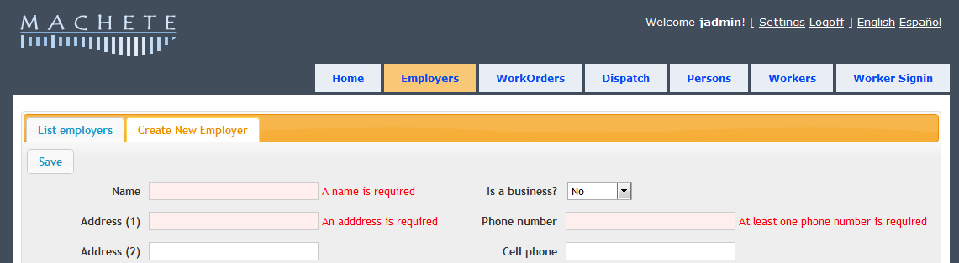

Required fields exist to ensure that all necessary information for processing an order or managing a worker is collected.

### Discard Changes warning

All pages in Machete detect when changes are made to a record and warn you if you attempt to leave a page without saving the record.

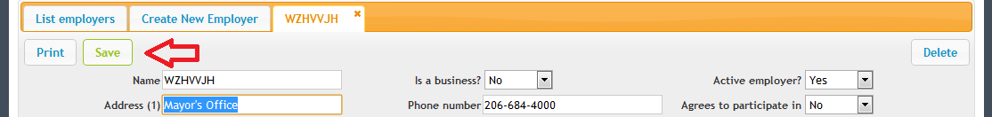

When a change is detected, the Save button changes color from blue to green, indicating a Save is necessary. If the user attempts to leave the page, a dialog box asks the user to verify if the really intended to leave without saving the changes.

## Pages of machete

The pages of Machete correspond to the major functions that it performs. However, the organization may not be intuitive based on the names alone.

Employers

The employers page provides access for searching, creating, editing, and deleting employer records. It is also the page that provides access for creating work orders and work assignments. The work order and work assignment creation is embedded in the employer page because such actions are always employer-specific.

Work Orders

The work order page provides summary and management functionality for work orders. It does not provide creation functionality—see employers.

DiSPATCH

The dispatch page brings together the list of workers signed in to Machete for the day and the list of work assignments that need to be filled. The page provides several methods of filtering the lists to find workers with skills necessary for an assignment. It also provides an interface for recording lottery selections using a bar code scanner.

PERSONS

The persons page provides access for searching, creating, editing, and deleting person records. It also provides access for creating worker records. This functionality is located in the person page (and not the workers page) because a person record must be created first. A worker record is created afterward.

WORKERS

The workers page provides access for searching, editing, and deleting worker records. The worker page allows users to search by worker membership number.

WORKER SIGN-IN

The worker sign-in page records daily registration of workers. The page can be used with a bar-code scanner, or the membership number of the worker can be entered using the keyboard.

## User Accounts

To access Machete, a user must create a user account AND be granted privileges to access the system by an Administrator.

The user creation process prompts the user to give their real first and last name. Using a real first and last name is important because this name is also part of the logging system. The name of the user is logged whenever he or she makes a change to a record.

When a user is not logged in, [Logon] is displayed in the upper right hand corner of every page. If the user does not have an account, a Register link is available from the logon page.

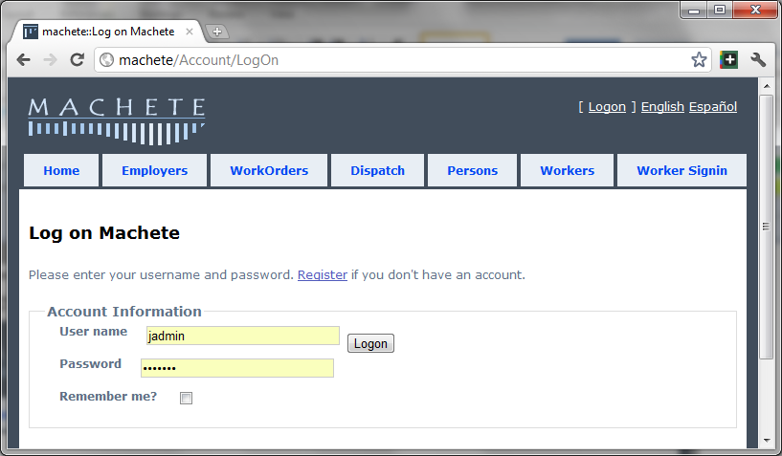

## Bilingual Support

Machete has the capability to support muliple display languages. As of Summer 2011, it supports English and Spanish. More languages can be added.

The links to switch between English and Spanish are in the upper right hand corner of every page. A user can switch between English and Spanish anywhere in the application.

## Work flow

The diagram below illustrates the basic work flow of creating orders in Machete. Creating a work order involves an employer record, a work order record, and at least one work assignment record. At the end of the process, the users signifies that the order is complete by activating the order.

Active orders are visible in the Dispatch page and are able to be assigned workers.



The following pages will discuss the pages of Machete that provide this functionality.

# Home

The home page offers a landing page of Machete news when a user logs in to their account. The home page contains a number of tabs that provides general information on Machete.

Machete News

The Machete news tab is the default tab and contains information about the latest updates to Machete. This information is static HTML and is updated by editing the /Views/Home/Index.cshtml file in the IIS Machete directory.

Issue Tracker

The issue tracker tab is a simple tab that contains an external link to an open source issue tracker page. Internet access is required to access this link.

documentation

The documentation tab contains this manual and other information regarding machete.

reports

The reports tab contains links to an external reporting solution. By default, these links assume a Reporting Services installation at <http://machete/reports>. Any change will require updating the links on this page.

About

The about tab contains basic information about Machete; the technology used and the origin of the name.

# Employers

The employers page is the primary page for managing employers. In addition to creating, editing, and deleting employer records, the employer page is the only page that allows for the creation of work orders.

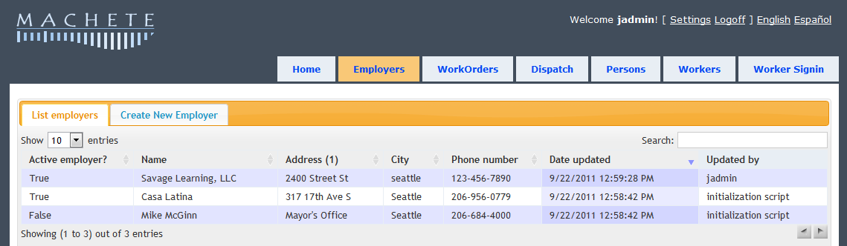

The reason that work order creation is on the employer page is that all work orders must be associated with an employer record at the time of creation. There are no employer-less work orders in Machete. Therefore, an employer record must first be selected, and the employer page provides the means do select an employer.

## searching for an employer

The employer page shows the List employers tab when it is first loaded. It is a good idea to search for an existing employer before creating a new employer. Duplicating an employer record reduces the ability to report how many employers are new vs. returning employers, distorting customer satisfaction analysis.

The search box on the List tab searches all of the employers in Machete, as you type. You do not need to type the entire name or phone number; Machete will search based on the text you provide.

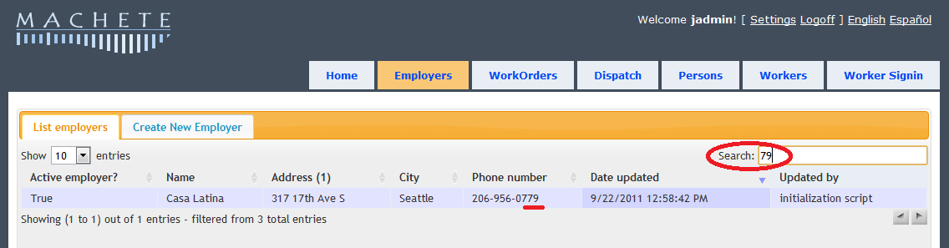

Machete searches:

* using the entire string that you type in; it does not detect words and search for them individually
* the name field
* the address field
* the city field
* the phone number field

## editing an existing employer

To edit an existing employer record, first use the List tab on the employer page to search and find the record to edit. Double-click on the employer row in the List tab to open the record tab and edit it.

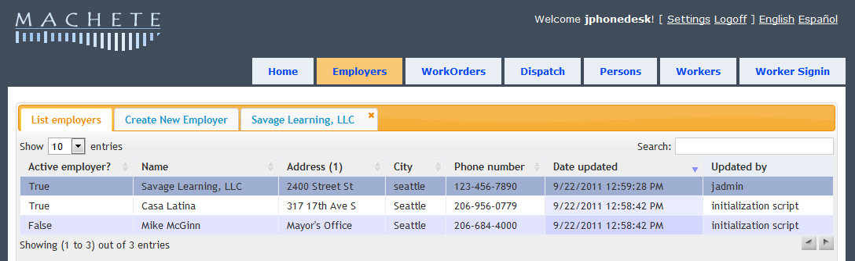

Double-clicking on the employer record row will open a record tab. This provides access to update information on the employer and to create or edit work orders for that employer.

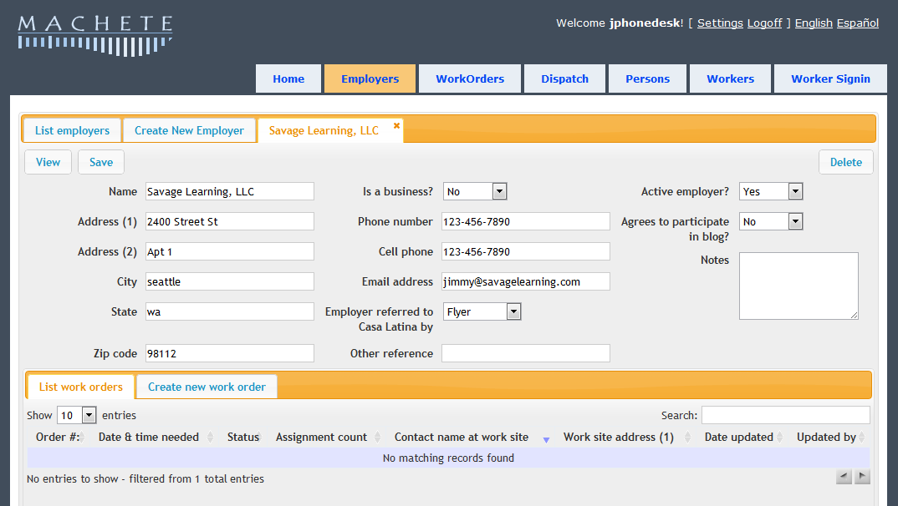

Be sure to click the Save button in order to save any changes made to the record.

## creating a new employer

To create a new employer record, use the Create New Employer tab on the employer page. The tab will provide a blank employer record. Fill out the information and click the Save button.

**Note:** Some fields are required, and cannot be left blank. If you attempt to save a record without providing information for a required field, the field will be highlighted in red. You record is not saved until you put some value in the required field and click the Save button again. If the employer will not provide the information, put “not available” or “N/A” in the field.

Once you save the employer record, a record tab for the new record will open, showing the information you just entered. The record tab will also give access to the work order information for the employer.

## deleting an employer (Managers Only)

To delete an employer record, open the Record tab for the employer you want to delete. On the right hand side, if you have permission to delete records, a button to delete the record will be visible.

**Note:** Deleting an employer record will also delete all work orders and all assignments for that employer. Any survey information associate with those work orders will also be deleted. Deleting employers is only necessary if you’re removing a duplicate employer and have moved existing work orders to a different employer.

Click the delete button to delete the employer record. A dialog box will appear asking to confirm the delete. If you confirm, the employer record and all its work orders and work assignments will be deleted. Use carefully!

## Creating a new order

To create a new work order, you must first search for and open a record tab for an existing employer record, or create a new employer record. Creating a new employer will open the record tab when you save the new employer record. At the bottom of the employer record tab, there will be tabs for the work order records.

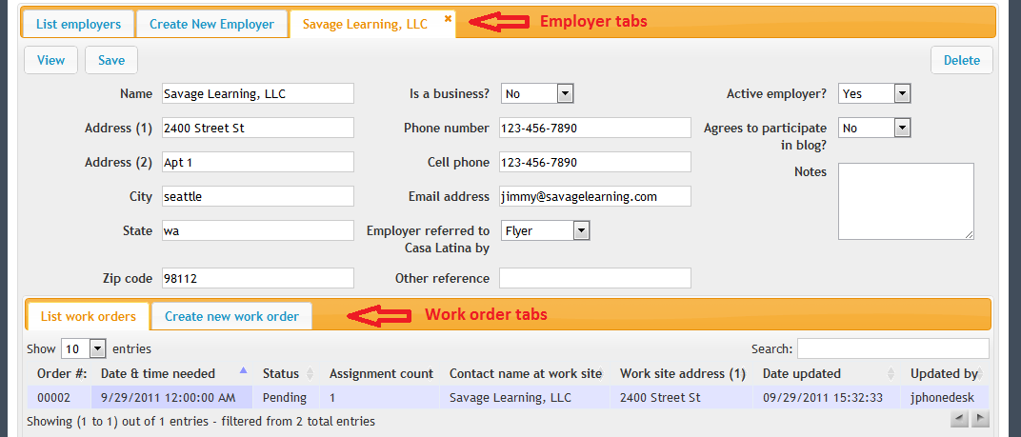

By default, the employer record tab opens the list tab for work orders belong to the employer. This list tab works the same way as the other list tabs: double-click on a work order record to open it. Use the create new work order tab to create a new work order for the employer.

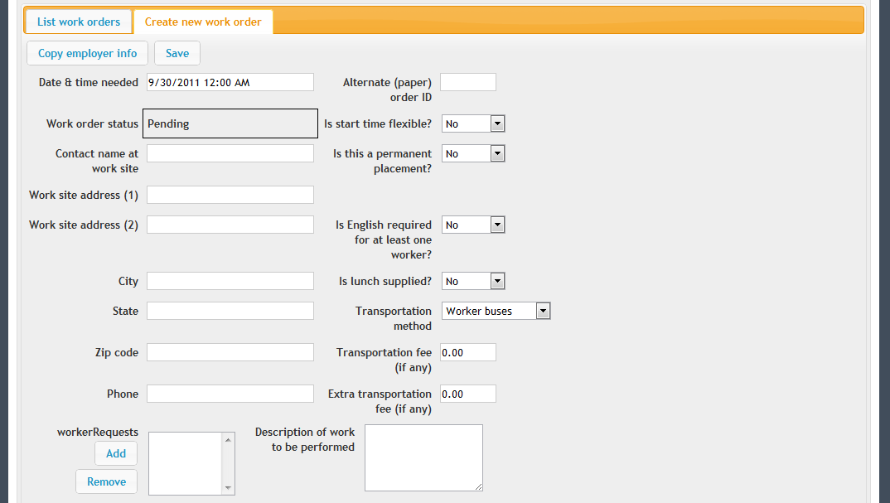

Fill in the fields and click the ‘save’button to save the new work order. The work order is not saved until you use the save button. When you save an order, the Work Assignment tabs will appear.

**Note**: At least one work assignment must be created. Once an assignment is created, the ‘activate work order’ button will be visible at the bottom of the screen. Users must activate orders for them to be visible on the dispatch page.

### **Work order buttons**

The following functionality is provided through buttons on the work order tab. Some buttons, such as printing, are only visible when editing a work order. To print an order create it, then save it, then open the record and print button will be available.

* Print order: The print order button on the work orders opens a separate browser tab to print the order. The page content is formatted for printing. On the new page, there are two buttons, ‘print work order’ and ‘print google maps’. The second print work order button opens the browser dialog box. The print google button opens another browser window to maps.google.com.

The multiple browser pages and print buttons are a quirk of printing from browers. The first button goes to a page with some fields hidden for printing. The second button intiates the brower’s print functionality.

* Print Google map: The print google map button takes the address from the work order, the work site address, and sends it to Google maps to create a map to get the work site. The button assumes that the starting address is Casa Latina's address. If the users wants a different map, they can use the google maps webpage to change the starting address and re-draw the map.
* Copy employer info: This button copies some information from the employer record. Once the information is copied, it can be changed as needed. This button is only available when first creating a record.
* Save: The save button saves the record and returns to the list tab.
* Delete: The delete button will delete the work order and any work assignments created in it. This button is only available to managers. **Note:** A Work Order can only be changed or deleted by a Manager after the Date & Time needed has passed.

### **Work Order fields**

While some work order fields are self-explanatory, others require explanation.

* Alternate order ID: Machete has automatically gives a unique ID to each order. However, other numbering systems may exist (such as paper ordering systems), so Machete allows the user to enter an alternate ID for the order. If an ID number is entered, that ID is used for searching and printing. If an ID is not entered, the internal number will be used.
* Permanent placement: Machete will track both temporary and permanent work placement. Permanent job placement can be identified by setting this value to ‘yes’; otherwise, leave it as ‘no’.
* English required: Machete has both a required English level for each work assignment and a general English required field. The field on the work order is general; when set to ‘yes’, it reveals an additional text box to record employer requests regarding language skill requirements. The use of this field is optional and does not affect any other parts of the Machete system.
* Worker Requests: The worker requests buttons allow the user to find and record when an employer requests a specific user. The ‘add’ button creates a modal dialog box that allows the user to search through existing workers, by name or membership ID number. The table within the dialog box works the same way as other tables in Machete: search using the search box and select a record by double-clicking on the record row.

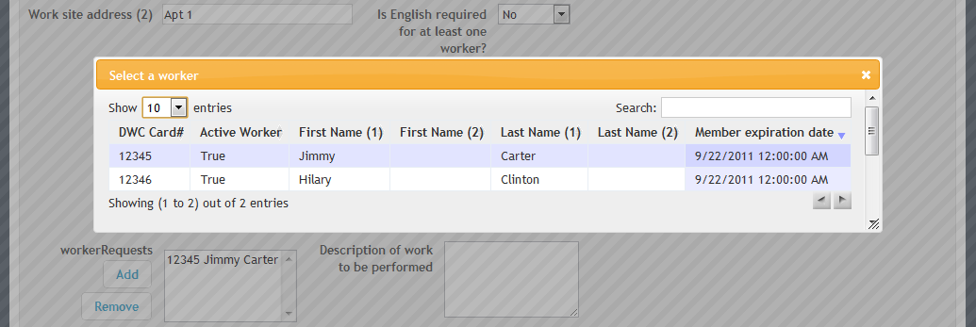

The requests are used in the dispatch process. Workers specifically requested by an employer are visible on the dispatch page using the ‘Requested’ filter. Using the worker requests feature is important because it rewards workers for hard work. The request is tracked by Machete and will be used in reporting and customer satisfaction analysis.

* Work order status: The status of a work order is important for processing work orders. While users of Machete cannot edit the status directly, managers are able to set the status of an order. Order status will be documented in the Work Orders section of the documentation, below.

## Searching for and editing an existing work order

There are two ways to access (and edit) an existing work order. The first method is through the employer page and the second is through the work order page. The employer page organizes work orders by employer; if you’re looking for a work order for a specific employer, use the employer page.

If you’re looking for a work order based on work order ID, date of work, or address, or phone number, use the work order page. The work order page allows the user to search these fields for all work orders, and allows you to open the record directly from the table. Double-click on a record to open it.

## Moving a Work Order to a different employer

Sometimes duplicate Employer records are created. You may forget to search for the Employer before creating the record, or the Employer’s name or phone number may be incorrect, causing a the record not to be found when you search for it. To clean up the duplicate Employer, a Manager needs to move all the Work Orders from the duplicate Employer to the true Employer record and then delete the duplicate Employer. To move a Work Order:

* Open the duplicate Employer record
* Open a Work Order from the duplicate record
* Click on the Change Employer button

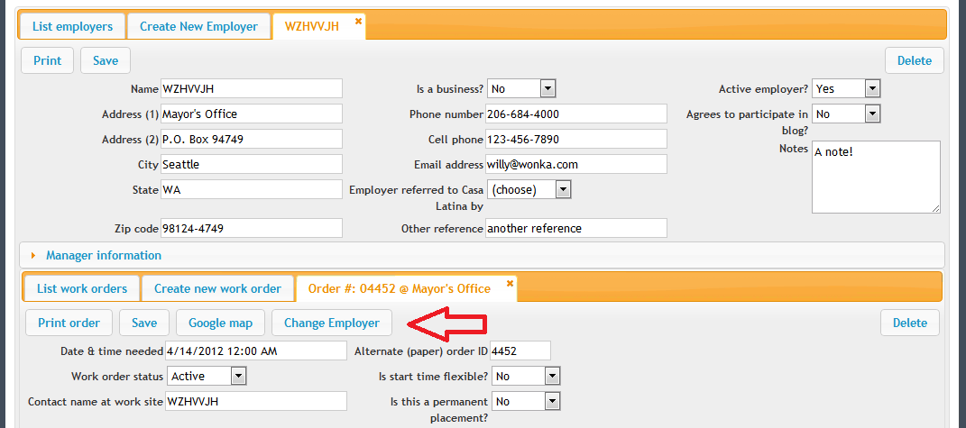

* Find the true Employer record in the list
* Double click on true Employer record
* Verify that you want to move the Work Order and click the Move button

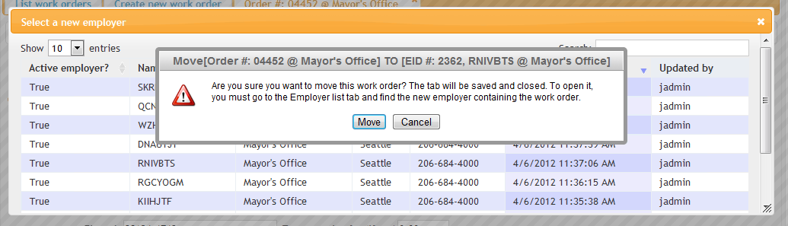

* The move happens immediately and the List tab for the open Employer record is refreshed

## Deleting work orders

To delete a work order, open the work order record from either the employer or the work order page. Click the delete button on the right side of the work order record. A dialog box will confirm if the users really intends to delete the record.

Deleting a work order record will delete the work order, all associated work assignments, and all survey data associated with the work order. Deleting work orders should only be done to remove duplicate entries.

## Creating a new work assignment

After saving a new work order, the user is automatically presented with the create new work assignment tab. This behavior is different from other tabs; after creating an employer or a person record, the user is shown the list tab for subsequent records. This difference in behavior stream-lines the order entry because a new work order requires at least one work assignment to be complete and eligible for activation.

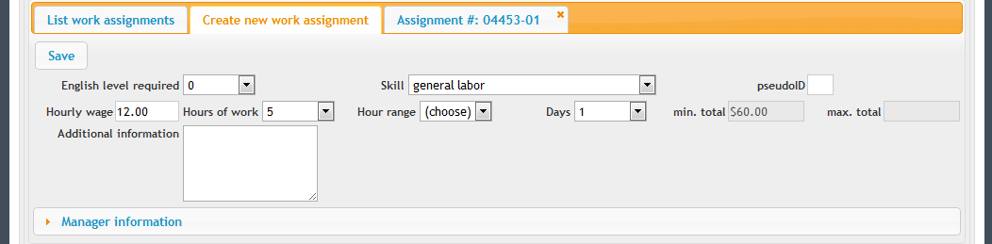

### Work assignment fields

The fields of the create new work assignment tab are as follows:

* English level: The English level is used to filter worker eligibility in the dispatch page. When filtering for eligibility based on a worker’s specific skills, assignments will be visible only if the it’s English level is equal or lesser than the worker’s skill level.
* Skill: The skill field identifies the type of work to be performed and the necessary skill required to complete the work. The skill selected will pre-populate other fields, such as the hourly wage and hours of work. Some skills are general skills, available to any worker. Other skills, such as Chambita skills, will lock the wage, hours, and days of work.

Specialty skills require a worker with a specific skill set; selecting a specialty skill will affect which workers are eligible in the dispatch page.

* pseudoID: The pseudo ID is a display field and shows a counter used to distinguish between different assignments in a work order. It is not editable.
* Hours of work and Hour Range: The Hours of work field is the minimum hours of work required, or the total hours required. The Hour range field is the maximum, if the Employer is unsure.
* Additional information: This field allows the user to enter specific requests from the employer for this position. The field is different for every assignment in the work order, allowing for additional information specific to the assignment. Users should use the ‘description’ field on the work order record for information general to the entire work order (warnings, directions to access the premises, etc.)

### Work assignment buttons

When creating a new assignment, the only button available is the save button. Once the assignment is saved, the new assignment record tab is opened, and additional buttons are available.

* Duplicate assignment: Because many assignments are the same on a work order, the duplicate assignment button allows the user to quickly duplicate the assignment in the open assignment record tab. This button will sake the current assignment, copy it and save the new record, and open the newly created assignment as well.
* Delete: Deletes the assignment and any associated survey data for the assignment.

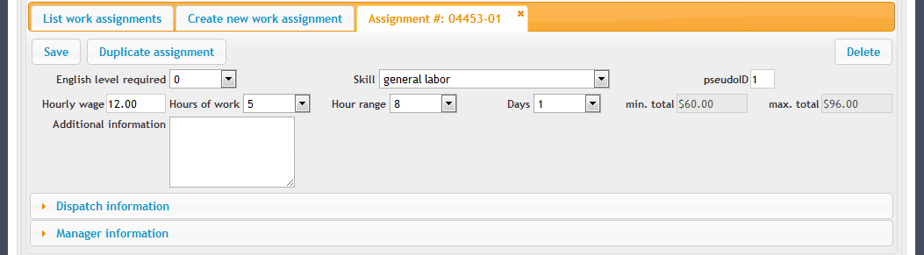

* Activate order: Once a work assignment is saved, the list work assignment tabs is shown and an ‘activate order’button appears. The button is not visible until at least one assignment is created, because a work order is not complete until there is at least assignment.

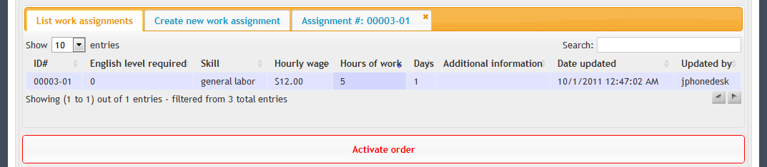

Clicking the activate order button will change the status of the order to active. It will also open the print page for the order. The user still has to print from the web browser to print the page.

## Assigning a worker directly to an assignment (orphaned assignment)

Sometimes it is necessary to assign a worker to an assignment without using the dispatch process. Machete allows the user to assign a worker to a work assignment from inside the Employers page, when editing the information of the work assignment.

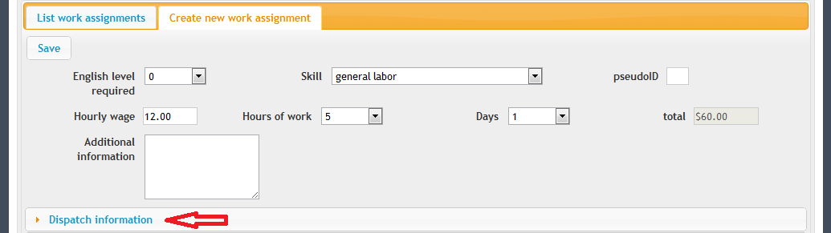

The dispatch information bar is only visible to users who are managers or administrators in Machete. Clicking on the Dispatch Information bar will reveal the the buttons that allow the user to add a worker directly to the assignment.



Clicking on the Change button will reveal the worker dialog to select a worker.

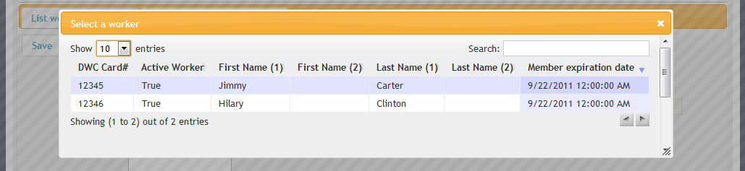

Note that using this method to change an assignment that was made through the dispatch page will also disconnect the worker sign-in record from the work assignment.

# Work ORDERS

The work orders page allows the user to manage work orders, change their status, print work orders in bulk, and review the status of all work orders by day.

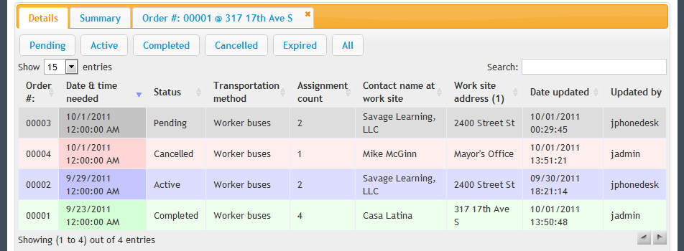

There are two tabs on the work order page, the details tab and the summary tab.

## Work order summary

The work orders summary tab shows a grid of information. Each row represents a single day and the columns divide the work orders and assignments by their status.

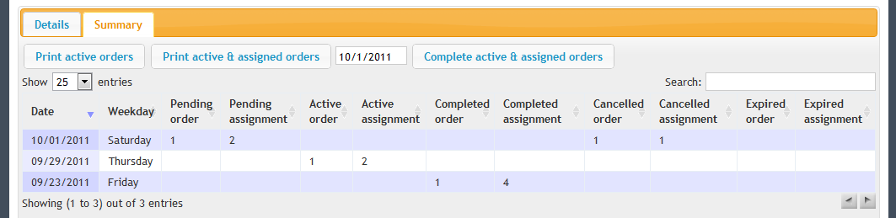

The image above shows the work orders summary tab. There are 12 columns. The first 2 show date information. The remaining 10 columns show orders and assignments based on their status. The summary tab shows both the order count and the assignment count because they can be different; this display gives dispatchers an instant count of how many workers are needed and how many orders need to be dispatched.

### Summary functionality

The summary tab simplifies printing and completing orders in a group. The following diagram illustrates the intended use of functionality on the summary tab.



**Note:** By double-clicking on a row in the summary page, the work order details page is activated and automatically filtered for the day corresponding to the row selected.

### Summary buttons

The following functionality is provided through buttons on the work order summary tab:

* Print active orders: This button prints all active orders for a single day. The day is selected through a calendar dialog, which is accessed by clicking on the date field on the same row as the button. The date field is automatically populated with the current date.
* Print active & assigned orders: This button prints all active and assigned orders for a single day. The day is selected through a calendar dialog; the current date is the default for the date.
* Complete active & assigned orders: This button sets the status to complete for all orders that are active and assigned for a single day. The day is selected through from the date field on the same row.

The intended use is that orders will be assigned workers through the dispatch page. Orders will then be printed from the work order summary page, and completed from the work order summary page.

## Work order details

The work order details tab provides access to all work orders and allows the user to search or filter the work orders to find specific work orders. Users can also open a work order record and edit it from the details tab.

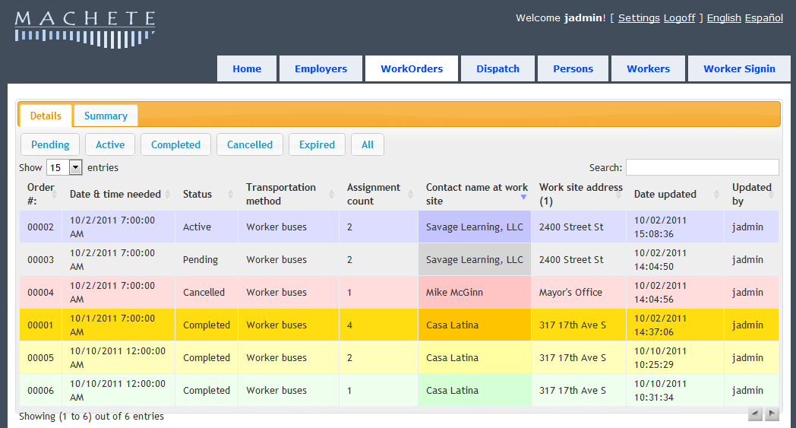

### Details functionality

The details tab behaves like other list tabs. It provides searching and sorting functionality. The following fields are searched when text is entered into the search box:

* Order #
* Date & time needed
* Contact name
* Work site address
* Updated by

The date updated field is not search because including it in the search algorithm will reduce performance and it is unlikely that this will be used. Additionally, the work orders cannot be searched by status, but they can be filtered by status using the status buttons on the details tab.

Double-clicking on a work order record row will open the record tab for that work order. Users can modify or delete the work order, or modify the work assignments associated with the work order.

### Work order STATUS & color

The rows of the work order details tab are color-coded, corresponding to the work order’s status. The status of an order is important in Machete because the status determines whether the order is included or excluded in reporting, and also whether the order is visible in certain displays. For example, pending orders are not visible in the Dispatch page.

* Grey – pending: orders that are not ready to be dispatched, are ‘on-hold’, or for some other reason should not be seen in the dispatch screen. When on-line orders are available, they will enter the system as pending and must be reviewed and manually set to active.
* Blue – active: orders that are ready to be dispatched. Active orders are visible in the dispatch screen.
* Green – completed: orders that have workers assigned to **all** of the order’s assignments and have been marked as completed.
* Red – cancelled: orders that have been cancelled by the employer.
* Yellow – completed & orphaned: orders that are completed, but one or more assignment is orphaned. An orphaned assignment has a worker assigned, but there is no corresponding worker sign-in record associated with the assignment.
* Orange – completed & unassigned: orders that are completed, but one or more assignment does not have a worker assigned to it.

Completed orders, orphaned & unassigned

Completed & Orphaned orders are undesireable, but sometimes unavoidable. An orphaned assignment is when a worker is assigned to a work assignment by editing the work assigment directly, instead of using the dispatch page. An orphaned assignment is undesirable because the sign-in record is not connected with the dispatch. However, if a worker is dispatched to more than one job per day, the subsequent dispatches can only be recorded as orphaned records. Machete cannot associate multiple assignments with a single worker sign-in record.

Completed & Unassigned orders are bad and should be avoided. Setting an order’s status to complete will include it in reports, but leaving an assignment without a worker means there is no record of which worker was dispatched. Any survey information will be useless, because there will be no worker associated with it. Additionally, the assignment will be absent from the worker’s job history.

# DISPATCH

The dispatch page brings together the worker sign-ins and the work orders for a given day. The page shows two tables, one for sign-ins and one for assignments. The page shows assignments, not work orders, because the assignments represent a worker needed (an order can have multiple assignments).

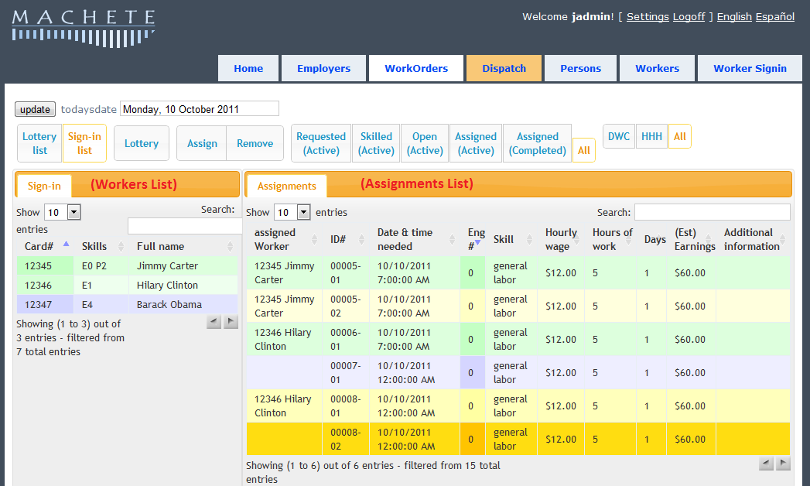

The dispatch allows for assignment of workers to work assignments by day. Additionally, Sunday assignments are visible when viewing information for Saturday.

## Dispatch buttons

The dispatch page has buttons that affect the records displayed.

* Lottery List: Filters the worker list by lottery status
* Sign-in list: Shows all sign-in records for the day
* Lottery: Opens the lottery dialog to record lottery results
* Assign: Assigns a worker to a work assignment
* Remove: Removes a work from a work assignment
* Requested (Active): Shows active assignments that have a work request associated wit the work order
* Skilled (Active): Shows active assignments that require a specialty skill
* Open (Active): Shows all active assignments that are not assigned with a worker
* Assigned (Active): Shows all active assignments that are assigned with a worker
* DWC: Show sign-ins and assignments for DWC workers
* HHH: Show sign-ins and assignments for HHH workers
* All: Shows all assignments (removes all filters from the button group)

### Lottery List

The Lottery list button filters the workers list. It shows only workers who were registered using the lottery dialog.

### Sign-in list

The Sign-in list button filters the workers list. It shows only workers who signed-in using the worker sign-in page.

### Lottery

The Lottery button opens the lottery dialog. This dialog is used to record the daily lottery drawing for work assignments. The lottery order is stored as a timestamp on the worker sign-in record.

### Assign

The Assign button assigns a worker to a work assignment. To use the Assign button, you need to select an unassigned worker from the workers list and an unassigned work assignment from the assignments list.

If the user attempts to assign a worker to a work assignment that is already filled, an error occurs and the assign action is canceled. Similarly, if the user attempts to assign a worker to a work assignment and the worker is already assigned, an error occurs.

### Remove

The Remove button removes an assignment between an worker and a work assignment. To use the Remove button, you only need to select the worker or the work assignment. The Remove button only needs one side of the connection to find it and remove it.

### Requested (Active)

The Requested (Active) button filters both the worker list and the assignment list. In the worker list, it shows only workers who have been requested in a work order for the day. In the assignment list, it shows only active work assignments that have a work request associated with the work order.

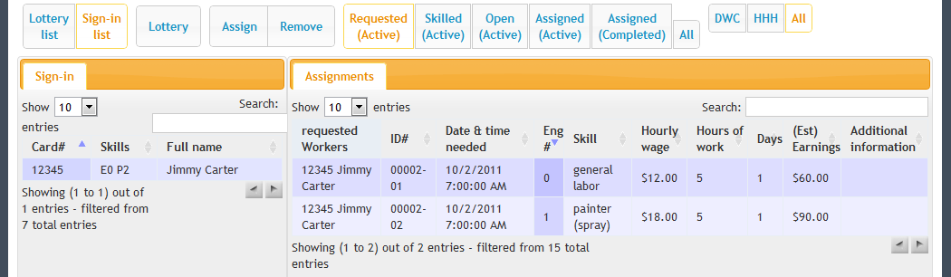

When the button is clicked, the requested workers column is revealed. If multiple workers are requested for the work order, each worker will be listed with every work assignment in that work order because in most cases the worker will be able to fill either assignment in the order.

### Skilled (Active)

The Skilled (Active) button filters the worker list and the assignment list. In the worker list, it shows only workers who have specialty skills in their worker record. In the assignment list, it shows only active work assignments that require the worker to have a special skill.

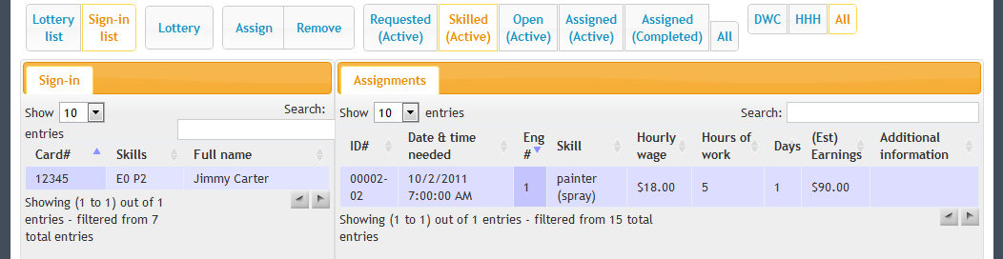

The specialty skills do not prevent an unskilled worker from being assigned to a skilled assignment. A user can assign an unskilled worker, or a worker with a skill other than the skill required to an assignment, through the other filters. The skilled filter facilitates assigning available skilled workers to assignments, but leaves ultimate control with the user.

### Open (Active)

The Open (Active) button filters the worker list and the assignment list. In the worker list, it shows only workers that are not assigned to a work assignment.

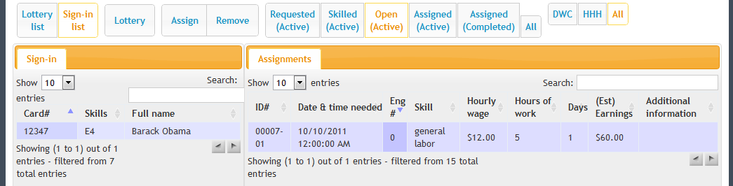

In the assignments list, it only shows work assignments that are active and unassigned.

### Assigned (Active)

The Assigned (Active) button filters the assignments list and hides the workers list. The worker list is hidden to make room for the additional columns in the assignments list table.

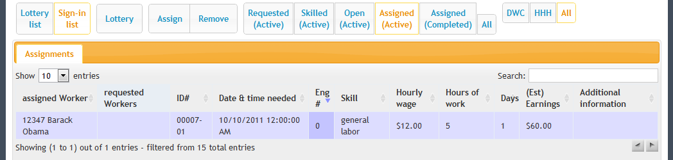

The additional columns are the assigned worker, and requested worker column.

### Assigned (Completed)

The Assigned (Completed) button filters the assignments list and hides the workers list. The workers list is hideen to make room for additional columns in the assignments list table.

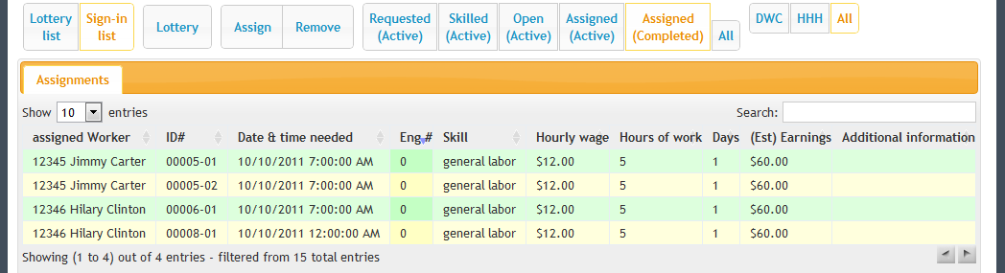

The green row indicates that the assignment is part of a work order that is marked as complete, a worker is assigned to the work assigment, and the work assignment is associated with a worker sign-in record.

The yellow row indicates that the assignment is part of a work order that is marked as complete, a worker is assigned to the work assignment, but the work assignment is *not associated*  with a worker sign-in record.

### All

The All button clears all status, requested, skilled, open, and assigned filters from both tables.

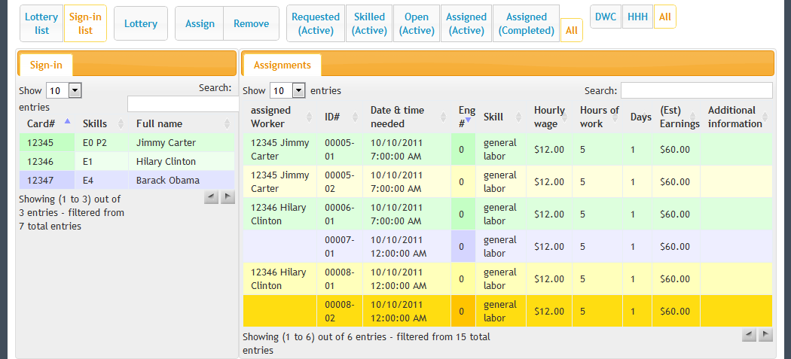

The orange row indicates that the assignment is part of a work order that is marked as complete, but no worker is assigned to the work assignment. This should be avoided. See the *Completed Orders, Orphaned & Unassigned* section for a discussion of the problems caused by completed & unassigned work assignments.

# persons

The Persons page is the primary page for managing person records. A person record must exist for each worker in Machete, and must be created first, before the worker record can be created. The person record serves a modular function within Machete—it provides one record for each individual that might exist in different areas of Machete.

**Note:** At this time, employers and Machete users are not associated with Person records. For employers, the association can be added later when the need arises. For users, the long-term goal is to use Windows Domain Controller to manage user accounts.

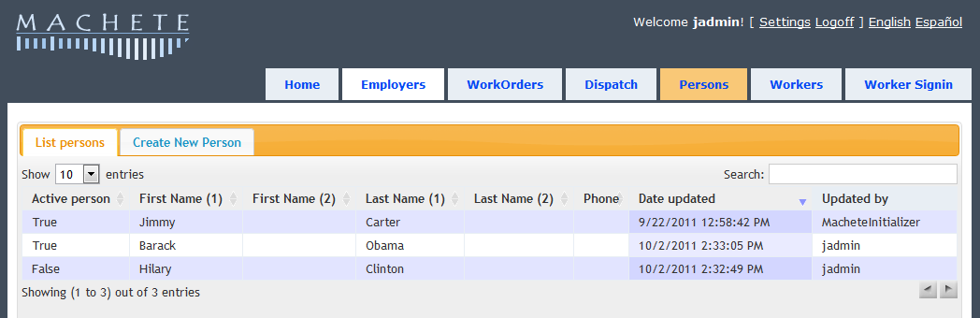

## Searching for a person

The perons page shows the List persons tab when it is first loaded. It is a good idea to search for a person before creating a new one. Duplicating person records reduces the ability to report on persons and workers, and can create confusion later.

The search box on the List tab searches all person records in Machete, as you type. You do not need to type the entire name or phone number; Machete will search based on the text you provide.

## Creating a new person

To create a new person record, use the Create New Person tab on the Persons page. The tab will provide a blank person record. Fill out the information and click the Save button.

**Note:** Some fields are required, and cannot be left blank. If you attempt to save a record without providing information for a required field, the field will be highlighted in red. You record is not saved until you put some value in the required field and click the Save button again.

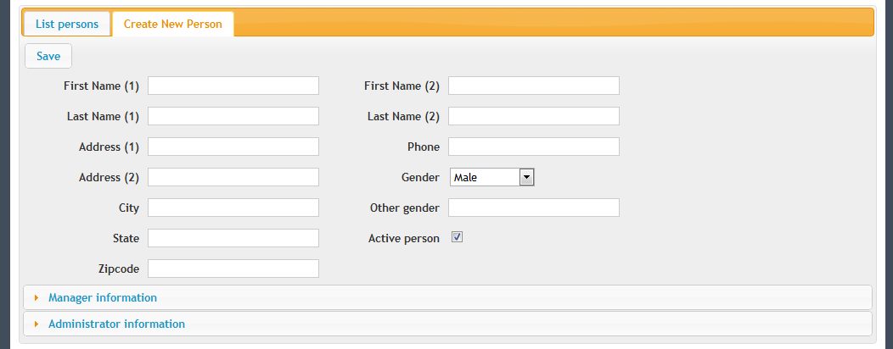

When you save the person record, the Person List tab is selected. The new person record will be accessible by searching for the person using their name or phone number.

## Editing an existing person

To edit an existing person record, first use the List tab on the persons page to search and find the record. Double-click on the person row in the List tab to open the record tab and edit the record.

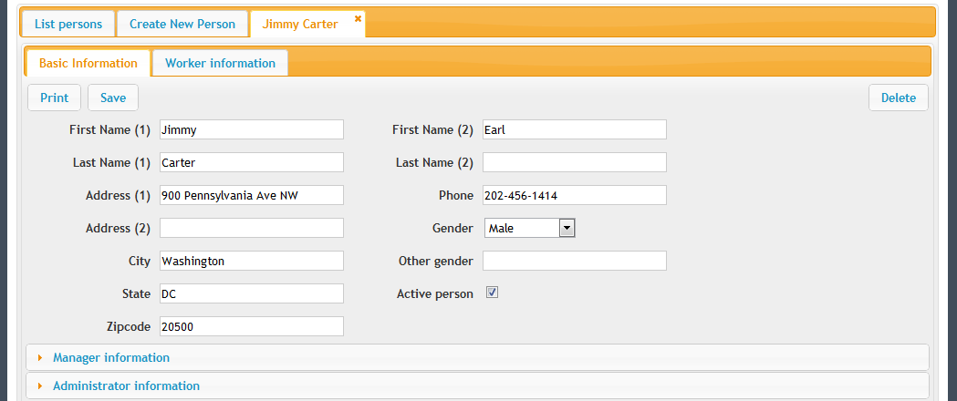

## Deleting a person

To delete a person record, open the Record tab for the person you want to delete. On the right hand side, if you have permission to delete records, a button to delete the record will be visible.

**Note:** Deleting a person record will also delete their worker record. All links in the worker sign-in table, the work assignment table, and any other tables will be broken because they will point to a non-existant record. Deleting a person record is only necessary if you’re removing a duplicate record.

Click the delete button to delete the person record. A dialog box will appear asking to confirm the delete. If you confirm, the person record and any associated records (e.g. worker record) will be deleted. Use carefully!

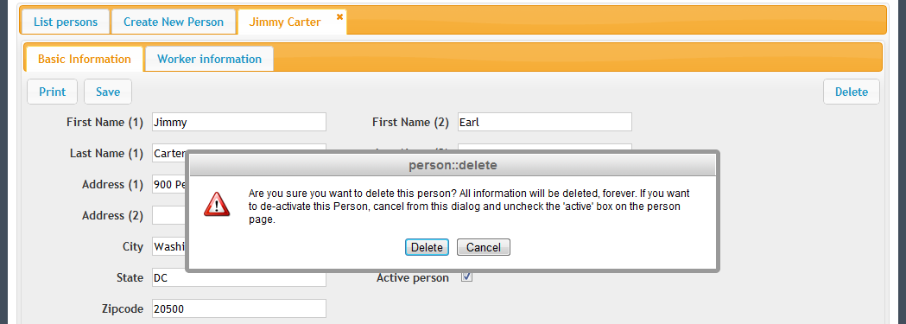

If you want to de-activate the person, so they do not appear in reports, edit the person record and remove the check from the Active person check box.

# workers

The Workers page is an alternative page for searching and editing of worker records. Worker records are also accessible from the person page. The Workers page provides additional fields for searching worker records, specific to the worker record.

## Searching for a worker

The worker page shows the List workers tab when it is first loaded. The search box on the List tab searches all worker records in Machete, as you type. You do not need to type entire name or membership number; Machete will search based on the text you provide.

It is important to note that the search functionality is intended only to facilitate finding worker records in order to update them.

## Creating a worker

In order to create a worker record, a person record must already exist for the individual. A worker record is essentially an add-on to the person record (they share the same unique ID inside Machete). Therefore, the create worker functionality is a part of the Person record, to simplify correlating the two records.

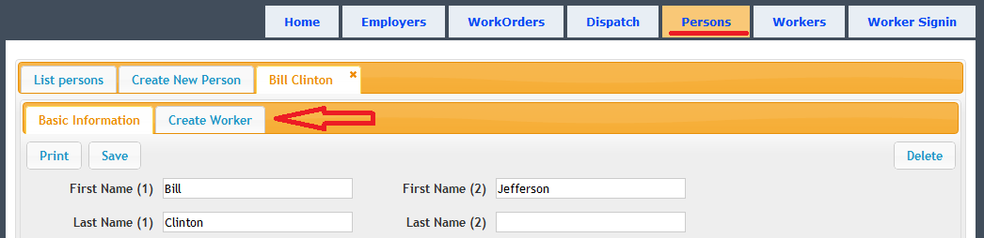

Create (or edit) a person record. When the person record is open, there are two additional tabs. The first tab shows basic information (stored in the person record). The second tab will either allow the user to create a worker record (if it does not exist), or edit the worker record if it does exist.

## Editing a worker

To edit an existing worker record, first use the List tab on the workers page to search and find the record. Double-click on the worker row in the List tab to open the record tab and edit the record. Click save to save the changes to the record.

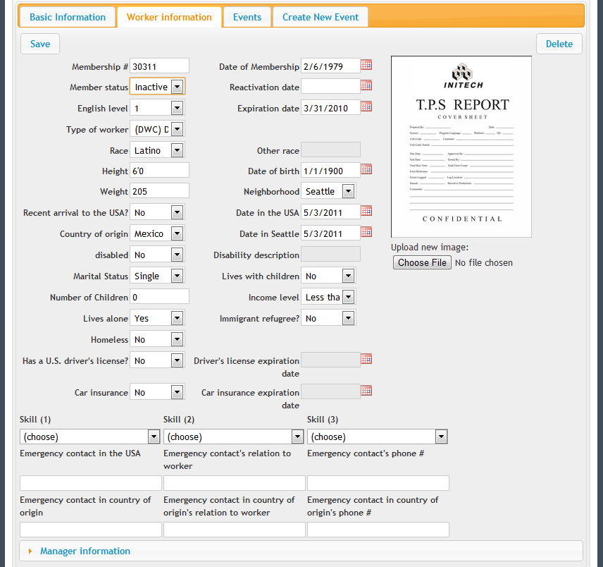

Information about the worker record:

* The worker record is modeled after the intake form used to collect information necessary for United Way and City of Seattle reporting requirements.
* Most of the drop-down boxes are controlled by a table in the Machete database called ‘Lookups’.
* Additional entries to a drop-down can be added without modifying the Machete program—new rows with the proper information need only be added to the Lookups table.
* Clicking on the calendar icons will open a calendar dialog to assist in finding the date. You can also type directly into the field.

## Status of a Worker

The Member Status of a worker controls a number of features within Machete, such as whether a Sign-in registration will be record, of if the Worker is eligible for work assignment. The status determines how the record is displayed in worker look-ups, or if the record is even available.

The status is controlled by the Member Status drop-down box on the Worker Information tab. To change a worker’s status, open the Person record from the Person page. Next, click on the Worker Information tab.

There are five possible statuses for a worker.

* **Active:** A normal worker within Machete. There are no restrictions on this worker. Active workers blue are in the List Worker Dialogs.
* **Expired:** A worker who has not renewed their membership is automatically changed to Expired once the Expiration date passes. Currently there are no restrictions on expired workers, but they are displayed in yellow in the List Worker Dialogs.
* **Inactive**: A worker who no longer seeks work should be set to inactive. They are displayed in yellow on the List Worker Dialogs. If a reactivation date is set, the worker will be set to active once the Reactivation date passes.
* **Sanctioned**: A sanctioned worker is not able to receive work through Machete. If they Sign-in, the attempt is recorded, but a notice is displayed that the worker should not be permitted to participate in work for that day. Sanctioned workers are not recorded for Activity registrations, such as classes. Sanctioned workers are displayed in red on the List Worker Dialogs. If a reactivation date is set, the worker will be set to active once the Reactivation date passes.
* **Expelled**: An expelled worker is disabled within the Machete system. If they Sign-in, the attempt is record, but a notice is displayed that the worker is expelled. Expelled workers are not recorded for Activity registrations. Expelled workers are displayed in red on the List Worker Dialogs.

## Deleting a worker

To delete a worker record, edit the Worker record tab for the worker you want to delete. On the right hand side, if you have permission to delete the worker record, a button to delete the record will be visible.

**Note**: Deleting a worker record will break all links within Machete in the worker sign-in table and the work assignment table. Deleting a worker record is only necessary if you’re removing a duplicate record.

Click the delete button to delete the person record. A dialog box will appear asking to confirm the delete. If you confirm, the person record and any associated records (e.g. worker record) will be deleted. Use carefully

# Events

For each Person record in Machete, it is possible to store information about various events related to that person. This information is organized in the form of Event records, which are accessed from the Person page.

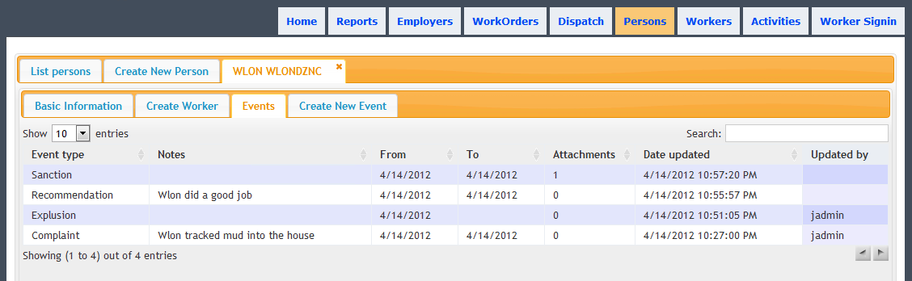

Events form part of the Person record in Machete, and can be included in any reporting tool that uses Machete data. Each event can have multiple attachments stored with it, such as scans of recommendation or sanction letters. The attachments are visible when editing an event record.

## Creating a new Event

To create an Event, first open the Person record to access the Create New Event tab.

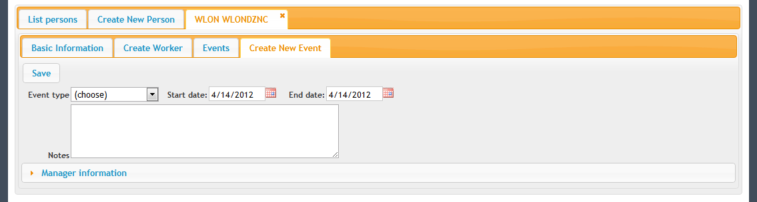

Select an Event type for this event. Event types are defined within the Machete database and can be modified by the Administrator using Microsoft SQL Server Management Studio.

The State date is the date of the event, or starting date if the event is for a duration of time. By default, both dates are set to the current day. They can be modified by clicking on the calendar next to their input field.

Once the Event is saved, the new Event’s tab will open, where attachments can be added.

## Editing an Event

To edit an existing Event record, first use the Events tab on the Person record to find the event you want. Double-click the Event row to open the record.

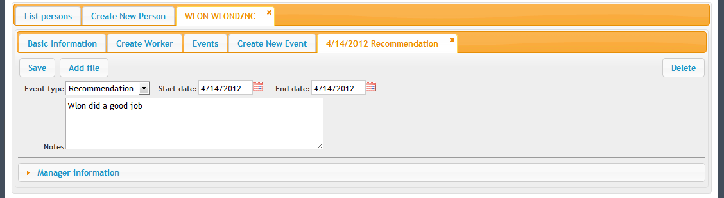

Click the Add attachment button.

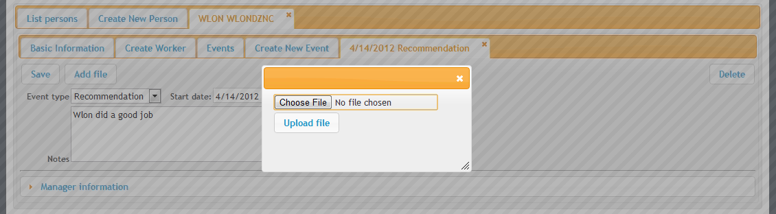

Click the choose file button. This will open your web browser’s Open File dialog. Choose the file you want. Click the button necessary to open the file for your browser.

Next, click the upload file button on the web page to send the file to Machete. If the file is an image that the browser can display, a preview image will be available next to the file information. If not, an icon will be displayed.

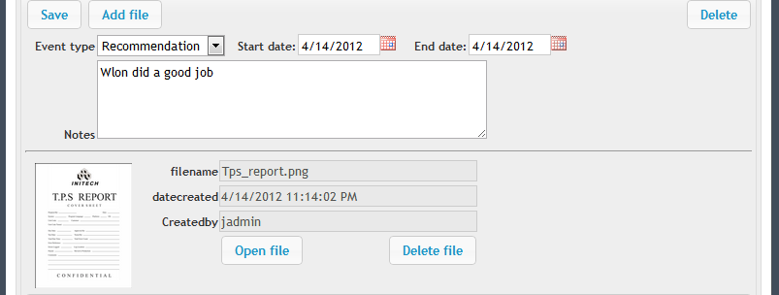

Double-clicking on the file opens it if it is an image, otherwise prompts to save the file. The open file button can be used to save either images or files from Machete to your computer.

**Note:** Attachments should be used for important items related to the Person record. The attachment will reside in the database and retrieving it will be more difficult than if the file was stored on a laptop or computer.

## Deleting an Event

To delete an Event record, edit the Person record, then double-click on the Event from the Events tab to open the Event. If you have permission to delete the Event, a button to delete it will be visible.

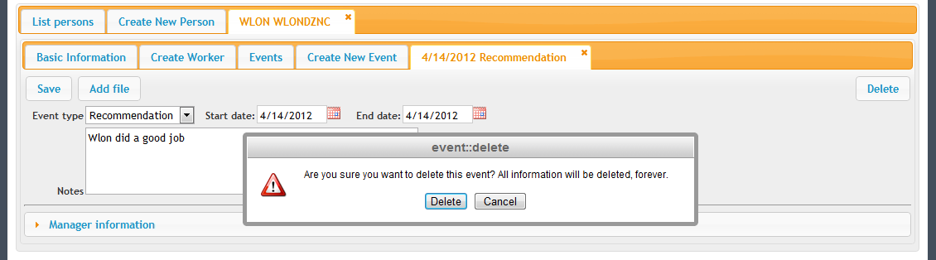

Click the delete button to delete the Event. A dialog box will appear asking to confirm the delete. If you confirm, the Event and all its attached files will also be deleted.

# Activities

The Activities page records when a member participates in any activity that needs to be tracked for reporting or analysis purposes. An Activity record is created to represent each activity occurrence, such as a language class, and assembly, or a conference. Once the Activity record is created, an interface for registering members based on their membership number is available.

## Searching for an Activity

The Activity page shows the List Activities tab when it first loads. The search box on the List tab searches all Activity records in Machete, as you type. The search will search the name, type, teacher, start time, and end time.

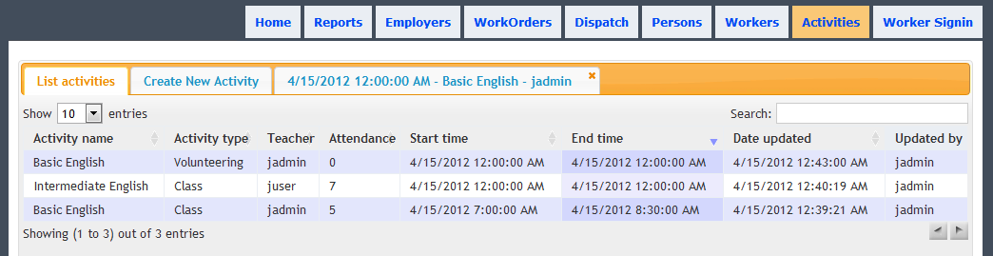

You do not need to type in the entire phrase you are looking for; Machete will search based on the text you provide.

## Creating a New Activity

To create a new Activity record, use the Create New Activity tab on the Activities page. The tab will provide a blank Activity record. Fill out the information and click the save button. Some fields are required and cannot be left blank.

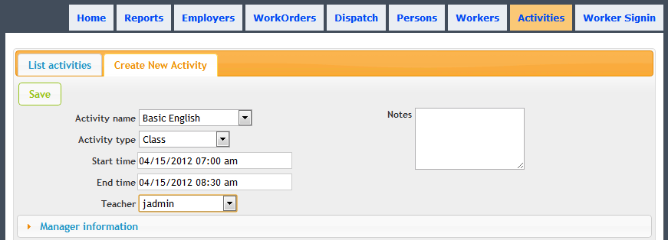

Every class, assembly, or other event will need a separate Activity record. For regularly occurring classes, the Name and Type may be the same, but the date will change. It is important that this information be entered correctly and reviewed for accuracy because it is the basis for reporting the number of hours a member has participated in classes or other activities.

## Recording attendance for the Activity

Once a new Activity record is created, it is opened in a new tab. The tab has the date & time, activity name, and the activity leader’s (teacher’s) name in the tab description. The information regarding the Activity record can be modified from this tab.

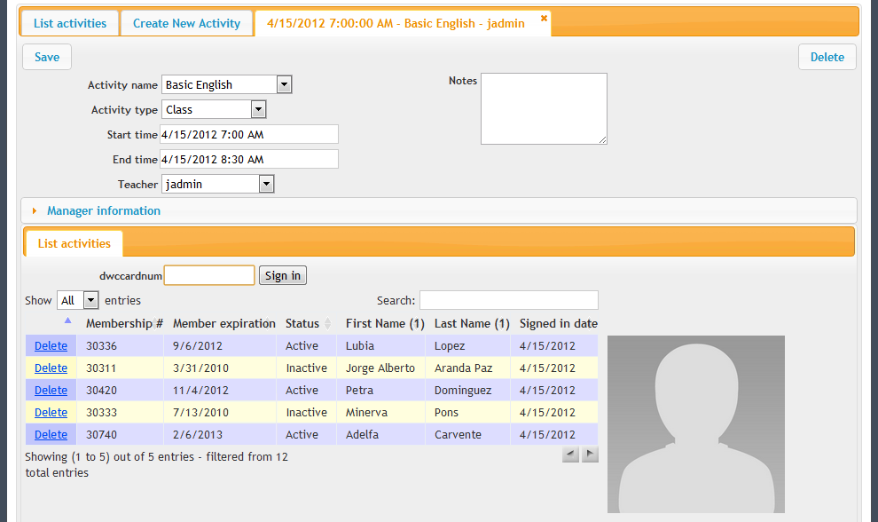

Additionally, a Sign-in tab for the Activity is displayed before the Activity record. The focus is moved to the membership number field automatically. The page is now ready to accept registrations from a barcode scanner or the keyboard. Either swipe the membership card through the scanner, or type the membership number and press enter. As members are registered, they will be listed in the Sign-in tab.

If a sanctioned or expelled member attempts to register, a notice is displayed that the member is sanctioned or expelled. Their attendance is not recorded into the system. The notice instructs that the card should be returned to the member.

If a member is registered incorrectly, their registration can be deleted with the Delete link next to their member ID number.

**Note:** Machete records the registration as soon as the card is swiped or as soon as the number is typed and the enter key is pressed. You do not need to hit the Save button record the registrations. You only need to use the Save button if you change details associated with the Activity record definition.

## Deleting an Activity

To delete an Activity record, find the record in the List tab and double-click on it. This opens Activity record tab. On the right hand side, if you have permission to delete records, a button to delete the record will be visible.

**Note:** Deleting an Activity record will also delete **ALL** registrations associated with the record. Deleting an Activity record is only necessary if you’re removing a duplicate record for the same day.

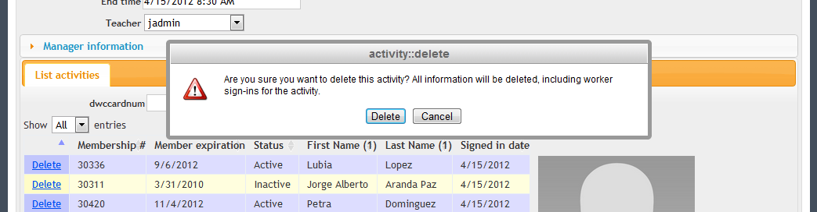

Click the delete button to delete the Activity record. A dialog box will appear asking to confirm the delete. If you confirm, the Activity record and any associated records (e.g. registrations) will be deleted. Use carefully!

# worker signin

The worker sign-in page records when a worker registers for the day. The page loads with the cursor set to the membership text box and assumes that either a barcode scanner or a keyboard will enter in a card number. Either method can be used inter-changeably:

* Using a USB barcode scanner, scan the card. The scanner will enter the ID number and hit enter.
* Using the keyboard, type the ID number and hit enter.

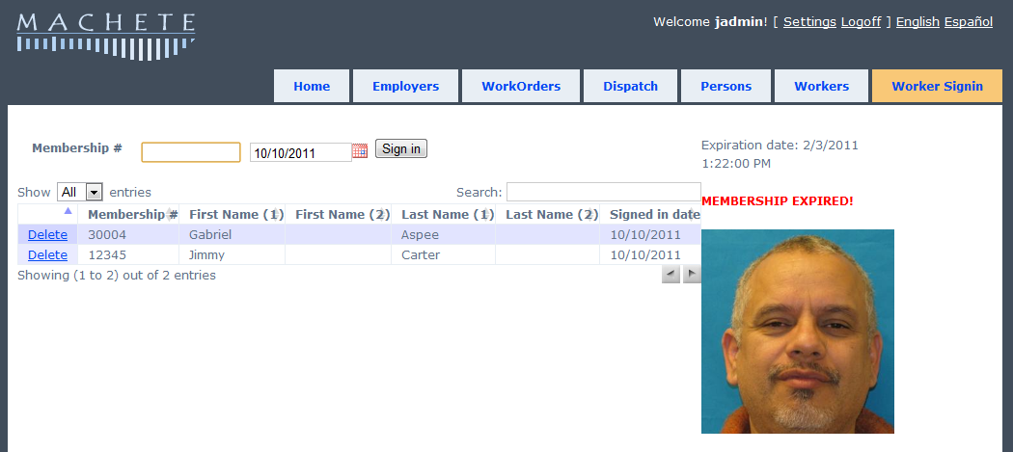

Other important information regarding the worker sign-in page

* Clicking the ‘Sign in’ button does the same thing as hitting the enter key. It attempts to register the ID number entered
* The page will record IDs even if there is no corresponding worker record
* If an ID number is entered multiple times, it is only registered once
* If the worker is expired, ‘MEMBERSHIP EXPIRED’ will display in red letters above the picture
* If there is no picture associated with the account, there will be a blank space instead of the picture
* You can sort each column by clicking on the column header
* You can search the table using the search box
* If you change the date, it will default back to the current date for the next entry
* You can print the page using the web brower’s print functionality

# Machete users

## Creating a new user account

Each user of Machete should have their own account. This account identifies who creates an order and who might update an order afterward.

To be able to take orders, a manager must authorize your account.

1. Go to [**http://machete/account/register**](http://machete/account/register)

[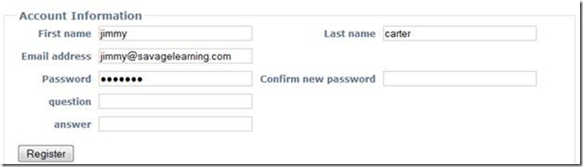](http://download.codeplex.com/Project/Download/FileDownload.aspx?ProjectName=machete&DownloadId=270270)

2. Fill in the information requested and click Register

The information is used to construct your login username. Your first name and your last name become your user name, which you will provide to login to the system. Your names will be separated by a period, “.” For example, Hilary Clinton’s username when she logs in to machete will be: hilary.clinton

The other information is for future features:

* The **email address** will be used to send instructions to reset a password, if you forget it. This is not implemented in the 1.0 release.
* The **question field** is a security question that you can use to reset your password. This is not implemented in the1.0 release.
* The **answer field** is the answer to the security question. This is not implemented in the 1.0 release.

3. Request a manager to assign your account the “Phonedesk” role

Once your account is created, a manager will need to assign you the role of phonedesk to be able to take orders.

## Assigning or changing roles on user accounts

Before a volunteer can use Machete to take orders, the volunteer must create an account and a manager must assign the following roles to the account:

* user
* phonedesk

To assign roles, the manager goes to <http://machete/account>

The page shows a list of user accounts. Click on Edit to change the role settings.

[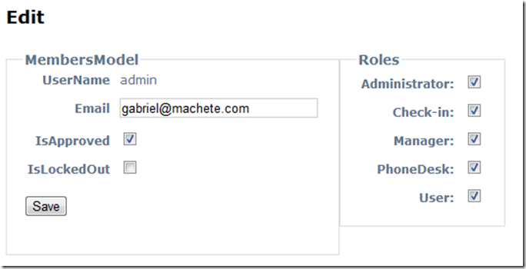](http://download.codeplex.com/Project/Download/FileDownload.aspx?ProjectName=machete&DownloadId=270413)

* Click on the check boxes next to PhoneDesk and User. The User role allows an account to see information.
* Click Save. The user will now be able to see and change Employer, WorkOrder, and Assignment records.