**MODULE: 1 (SDLC)**

**Q. What is software? What is software engineering?**

Ans. Software is a set of programs (sequence of instructions) that allows the users to perform a well-defined function or some specified tasks.

Software Engineering: Software engineering is defined as a process of analyzing user requirements and then designing, building, and testing software applications which will satisfy those requirements.

**Q. Explain types of software.**

Ans. There are mainly three types of software.

1. **System software** – It sits between hardware and application software. Ex. Operating system.

2. **Utility Software -** Utility software is part of the system software and performs specific tasks to keep the computer running. Utility software is always running in the background. Ex. Anti-virus software, disk clean-up, etc.

3. **Application Software -** Anything that is not an operating system, or a utility is an application or app. So, a word processor, spreadsheet, web browser, and graphics software are all examples of application software, and they can do many specific tasks.

**Q. What is SDLC? Explain each phase of SDLC.**

Ans. SDLC stands for Software Development Life Cycle. It is a framework that defines activities that are performed during the software development process   
  
**Phases:**

**1. Requirement:** In this phase, all the requirements are collected from the customer/client. All the details are discussed with the customer/client in detail.

**2. Design:**

* It gives the architecture of software products.
* It describes how each feature in the product should work and every component.

**3. Implementation:**

* This is the longest phase.
* This phase consists of Front end + Middleware + Back-end.
* In front-end: Development of coding is done even SEO settings are done.
* In Middleware: They connect both the front end and back end.
* In the back end: A database is created.

**4. Testing:** Testing is carried out to verify the entire system. The aim of the tester is to find out the gaps and defects within the system and to check whether the system is running according to the requirement of the customer/client.

**5. Deployment:** After successful testing, the product is delivered/deployed to the client, and even clients are trained on how to use the product.

**6. Maintenance:** Once the product has been delivered to the client a task of maintenance starts as when the client will come up with an error the issue should be fixed from time to time.

**Q. What is DFD? Create a DFD diagram on Flipkart.**

Ans. DFD stands for Data flow diagram. It is used to display the graphical representation of the

System/programs. The flow of data of a system or a process is represented by DFD.

Types of DFD:

a) 0 - Level DFD

b) 1 - Level DFD

c) 2 – Level DFD

**Q. What is Flowchart? Create a Flowchart of the addition of two numbers.**

Ans. A flowchart is a diagram that shows an overview of a program. Flowcharts normally use standard symbols to represent the different types of instructions. These symbols are used to construct the flowchart and show the step-by-step solution to the problem. Flowcharts are sometimes known as flow diagrams.

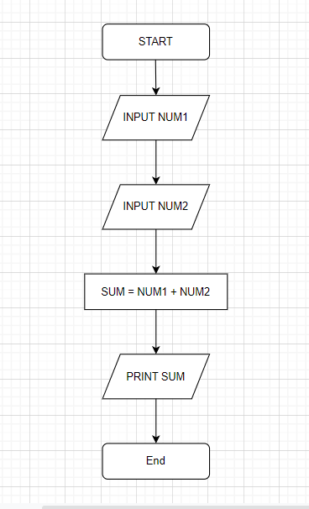

**Q. What is a Use case Diagram? Create a use-case diagram on the bill payment on Paytm.**

Ans. A use case diagram is used to represent the dynamic behavior of a system. It encapsulates the system's functionality by incorporating use cases, actors, and their relationships. It models the tasks, services, and functions required by a system/subsystem of an application.