This document provides a comprehensive breakdown of the data flow within your End-to-End Data Engineering Project. It outlines the specific steps your data follows, from its initial extraction from an on-premise source to its final presentation in an interactive dashboard.

**Project Goals:**

* Securely transfer data from an on-premise source (e.g., local SQL Server) to the Microsoft Azure cloud platform.
* Clean and transform the data as needed for in-depth analysis.
* Make the data readily accessible for data analysts and business intelligence tools.
* Leverage the scalability and cost-effectiveness advantages of Azure for data management.

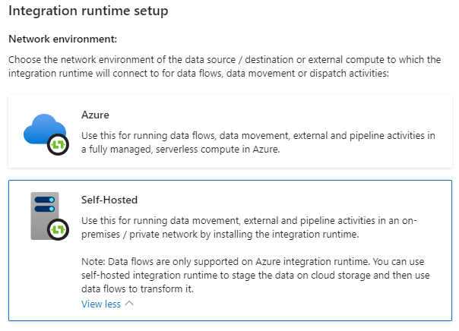

**Data Flow Overview:**

The project follows a well-defined, five-stage data flow, ensuring each step plays a crucial role in preparing the data for analysis:

1. **Data Extraction:** The data embarks on its journey by being securely extracted from your on-premise source using Azure Data Factory (ADF). This secure connection leverages a self-hosted integration runtime (SHIR) installed within your on-premise network.
2. **Data Transfer:** The extracted data is securely transferred to Azure Data Storage, a secure cloud repository, using ADF copy activities.
3. **Data Transformation (Optional):** Depending on your data's specific needs, Azure Databricks can be utilized for data cleaning, transformation, and enrichment tasks.
4. **Data Loading:** The transformed data (or the raw data if no transformation is needed) is loaded into a designated area within Azure Synapse Analytics for further analysis.
5. **Data Consumption:** Finally, business intelligence tools like Power BI can access the prepared data and turn it into informative dashboards with charts and graphs.

**Detailed Breakdown:**

Each stage of the data flow is explained in more detail below, with references to your project code for specific configurations.

1. **Data Extraction:**
   * **Source:** The exact on-premise data source (e.g., database name and tables involved) is identified.
   * **Credentials:** The authentication method used to access the data source is described.
   * **Extraction Method:** The specific method used to extract data using ADF copy activities (refer to project code for details) is explained. Common extraction methods include using a JDBC driver for relational databases or a custom script for more complex scenarios.
   * **Data Format:** The format of the data after extraction (e.g., CSV, JSON) is mentioned.

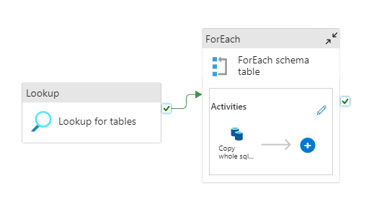

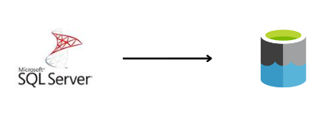

1. **Data Transfer:**
   * **Destination:** The specific Azure Data Storage container where the data lands is specified (reference project code for container name).
   * **Transfer Method:** The method used to move the data to Azure using ADF copy activities (refer to project code for details) is described. ADF copy activities provide a reliable and efficient mechanism for data movement between on-premise and cloud storage.

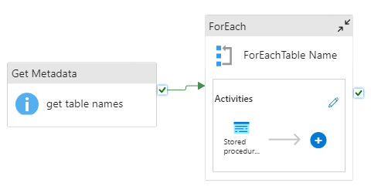



1. **Data Transformation:**
   * This step is included if your data needs cleaning, transformation, or enrichment.
   * Specific steps used to address data quality issues (e.g., handling missing values) and any data formatting changes (e.g., converting data types) implemented in your project using Azure Databricks notebooks are explained. Databricks notebooks offer a versatile platform for data manipulation using programming languages like Spark SQL and Python.
   * If applicable, details on how the data is enriched with additional information from external sources are mentioned.

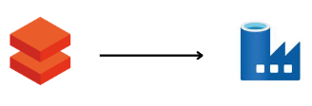

1. **Data Loading:**
   * **Target Storage:** The final destination of the data in Azure Synapse Analytics (workspace and table name) is specified (reference project code for details).
   * **Loading Method:** The way the data is loaded using ADF copy activities (refer to project code for details) is described. ADF provides efficient data loading capabilities into Azure Synapse Analytics, a data warehouse service optimized for large-scale analytics.

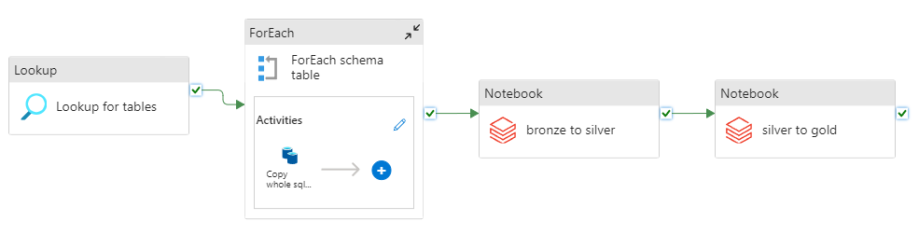



1. **Data Consumption:**
   * **Business Intelligence Tool:** A user-friendly tool like Power BI is used to connect to the data source in Azure Synapse Analytics.
   * **Dashboard Creation:** Power BI is used to create interactive dashboards with charts, graphs, and maps that bring your data to life, enabling users to explore the data from multiple angles and gain valuable insights.

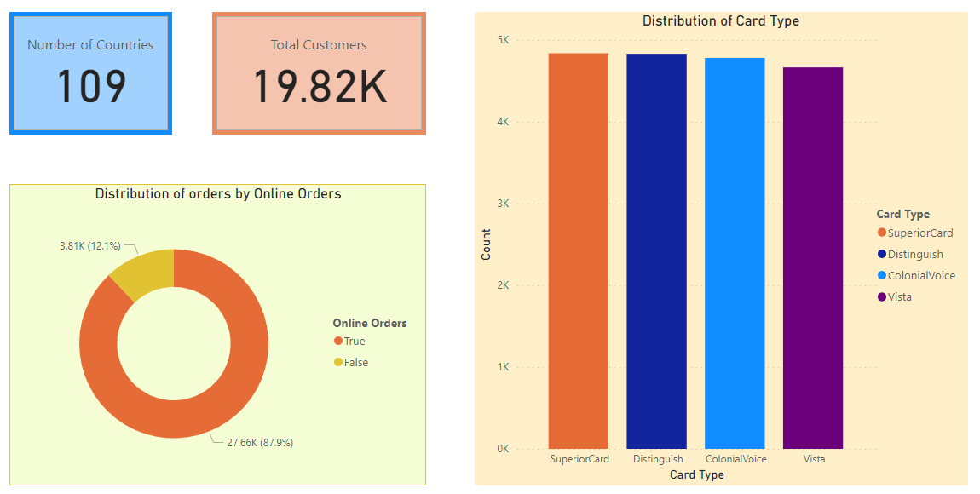

This comprehensive data flow ensures your data is securely transferred, prepared, and readily available for analysis, empowering you to make data-driven decisions.