**Introduction**

This document details the data flow for the Tokyo Olympics 2021 data exploration project. It outlines the steps involved in acquiring, preprocessing, analyzing, and visualizing the Olympic dataset, incorporating insights from the provided references:

* <https://medium.com/@sanjaybhargavk007/understanding-the-olympics-a-data-driven-dive-into-athletes-countries-and-medals-using-chatgpt-aa3fcc2aef68> by Brijesh Patel
* <https://medium.com/@sanjaybhargavk007/understanding-the-olympics-a-data-driven-dive-into-athletes-countries-and-medals-using-chatgpt-aa3fcc2aef68> by Hamnaanwar

**Data Acquisition**

**Image 1: Data Acquisition Diagram**

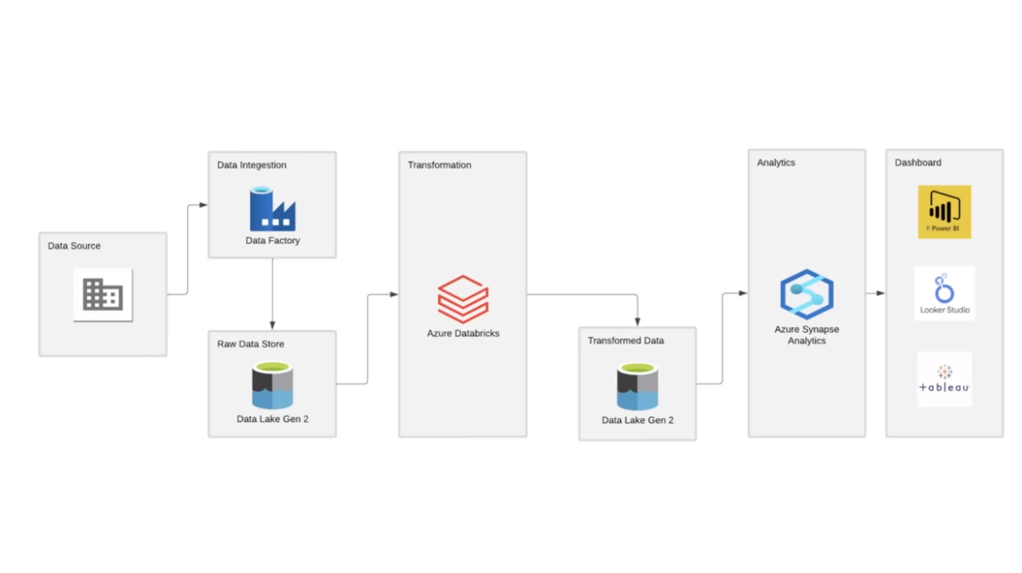

1. **Source:** The data will be retrieved from the public repository on GitHub: <https://github.com/kaoutharElbakouri/2021-Olympics-in-Tokyo-Data>. This dataset encompasses a wealth of information about athletes, events, medals, and historical contexts.
2. **Method:** Azure Data Factory (ADF) will be used to orchestrate the data acquisition process. The specific tools or scripts within ADF will depend on your chosen implementation:
   * **Web Activity:** Downloads data directly from the GitHub repository URL.
   * **Data Lake Storage connector:** Downloads data if it's stored in Azure Data Lake Storage.
3. **Considerations:**
   * **Authentication:** If the repository requires access credentials, configure ADF to securely authenticate with GitHub.
   * **Error handling:** Implement error handling mechanisms in ADF to handle potential download failures (e.g., network issues, repository unavailability). Consider retry logic and notification mechanisms for errors.

**Data Preprocessing**

**Image 2: Data Preprocessing Diagram**

1. **Tools:** The data preprocessing stage might utilize tools within ADF or a separate environment like Azure Databricks (if needed for complex transformations):
   * **ADF:** Offers basic data cleaning and transformation capabilities (e.g., data type conversion, filtering, joining).
   * **Databricks:** Provides more advanced capabilities for complex data manipulation tasks (e.g., handling missing values with statistical methods, feature engineering).
2. **Tasks:** This stage may involve:
   * **Cleaning:** Identifying and handling missing values, inconsistencies, or data quality issues:
     + Missing values: Analyze patterns in missingness and employ appropriate techniques (e.g., deletion, imputation with mean/median/mode, predictive modeling).
     + Inconsistencies: Address data formatting inconsistencies (e.g., date formats, units).
     + Quality issues: Detect and correct errors (e.g., typos, outliers).
   * **Transformation:** Converting data formats, creating new derived attributes, or performing aggregations:
     + **Format conversion:** Change data types (e.g., string to date, integer to numeric).
     + **Derived attributes:** Create new features based on existing data (e.g., calculating age from birth date, grouping sports by category).
     + **Aggregations:** Summarize data (e.g., total medals per country, average height of athletes in a sport).
   * **Validation:** Ensuring data integrity and consistency after transformations:
     + Verify that transformations produced the expected results.
     + Check for any new inconsistencies or errors introduced during processing.
3. **Considerations:**
   * Document the specific cleaning and transformation steps applied.
   * Consider using version control for tracking changes to the data preprocessing logic (e.g., Git for scripts, notebooks). This enables reverting to previous versions if needed.

**Data Exploration**

1. **Techniques:** This stage involves exploring the preprocessed data to understand its structure, identify patterns, and formulate research questions. Techniques may include:
   * **Descriptive statistics:** Calculate measures like central tendency (mean, median) and dispersion (standard deviation) to understand data distribution and identify potential outliers.
   * **Data visualization:** Create compelling visualizations (histograms, box plots, scatter plots) to explore relationships between variables and visually identify trends and patterns.

**Data Analysis**

1. **Research Questions:** Based on the data exploration findings, formulate specific research questions to guide the analysis. Here are some examples, inspired by the references and potentially expandable based on your data:
   * **Athlete Performance:**
     + How does athlete performance vary across different countries and sports?
     + Are there any correlations between athlete age, training methods, and performance?
     + Is there a gender disparity in participation and medal distribution across sports?
   * **National Trends:**
     + How do medal counts vary across countries?
     + Are there any historical trends in performance across Olympic editions (if data permits)?
     + What factors potentially influence a nation's success in the Olympics (e.g., GDP, population)?
   * **Competition Analysis:**
     + Which sports have the highest number of participants?
     + Are there any trends in sports participation over time?
     + How is the distribution of medals across sports?

**Image 3: Data Analysis Diagram**

download

photo_prints

1. **Methods:** Based on the research questions, employ appropriate data analysis techniques:
   * **Statistical Analysis:**
     + Calculate relevant statistics (e.g., correlation coefficients, regression models) to understand relationships between variables.
     + Analyze variance (ANOVA) to compare performance across groups.
   * **Machine Learning (Optional):** If the project scope allows, explore using machine learning models to predict performance or identify factors influencing success (requires expertise in machine learning).
   * **Data Visualization:** Create compelling visualizations (charts, graphs, heatmaps) in Power BI or other chosen tools to effectively communicate insights and trends within the data. Consider:
     + Bar charts and line charts for trends over time or comparing countries.
     + Scatter plots to explore correlations between variables (e.g., athlete age and performance).
     + Heatmaps to visualize complex relationships across multiple dimensions (e.g., country, sport, medal count).

**Data Visualization**

1. **Effective Communication:** Use data visualization to effectively communicate insights and findings from the analysis to a broader audience.
2. **Clarity and Accuracy:** Ensure visualizations are clear, accurate, and well-labeled.
3. **Interactive Exploration:** Consider using interactive features in Power BI to allow users to explore the data further.

**Documentation and Reporting**

1. **Document:** Document the entire data flow process, including data acquisition, preprocessing, analysis, and visualization steps.
2. **Findings and Insights:** Clearly present the key findings and insights extracted from the analysis.
3. **Limitations:** Acknowledge any limitations of the data or analysis methodologies.

**Conclusion**

This detailed data flow process outlines the steps involved in exploring the Tokyo Olympics 2021 dataset. By following these steps and leveraging the insights from the provided references, you can gain valuable insights into athlete performance, national trends, and competition analysis. The analysis can be further extended by incorporating historical Olympic data (if available) or delving deeper into specific aspects based on your research questions.

**Additional Considerations**

* **Security:** If the data source requires authentication, ensure secure access through Azure Active Directory or other appropriate mechanisms.
* **Scalability:** Consider the scalability of the data flow pipeline if you anticipate working with larger datasets in the future. Azure Data Factory offers capabilities to handle increasing data volumes.
* **Version Control:** Implement version control for your data preprocessing scripts and analysis notebooks to track changes and revert to previous versions if needed (e.g., Git for scripts, notebooks).

