Assignment 5 – Isosurfaces

# Interface design

1. I implemented the marching cubes algorithm to construct the isosurfaces.
2. The default of isovalue is set to average of the range.
3. The user can use mouse to rotate and/or zoom the model.
4. The visualization controls are located at the bottom left corner of the screen.
5. User can also enable/disable wireframe and lighting from respective check boxes.
6. User can also use the slider to change the isovalue. Once the desired isovalue is set, the user must click the update button to refresh the visualization.
7. Similar to A05P01, there is still a color map legend on the right indicating the chosen isovalue. The color of the model changes according to the isovalue.
8. Similar to the example provided for marching cubes by you, I draw the bounding box to indicate the bounds of the dataset.

# Additional features

1. I kept the legend on the right and didn’t draw the isosurface with a single color. Instead, I drew it as a varying color depending on isovalue.
2. I added a single light source. Inspired by one of the open frameworks light source examples I realized, light would be a very useful tool to visualize the surface of many tiny triangular faces next to each other. Lighting specifically brings out the contours of the overall surface. And also enables us to notice the subtle angular inclination a particular face makes with its neighbors because each one of them reflect light differently.
3. I also added an optional wireframe for the user. It enables us to differentiate many triangular faces in the absence of light.

# Extending feature set

1. As an extension to what I’ve already built, I would like to render multiple isosurfaces simultaneously with varying opacity. I already have a color map & a legend for isovalues. I would create a handful, say 5/6 isosurfaces with a particular opacity and visualize them simultaneously. For example, in case of tooth dataset, this would enable user to look at many internal surfaces of the tooth simultaneously.
2. As a second feature, I would like to add an option for user to slice the isosurface which is another way of viewing the internals.

# Isosurface vs Slice

I personally found both of them very useful to view the internals of a 3D model.

1. I found isosurface more useful that slice because slice only gives you a 2D image where as isosurfaces are 3D.
2. But it was quite easy (more like natural) to visualize sliced images and find abnormality or understand the internal structure because we have been doing this since school with all the transverse/lateral views of plants and animals in biology.
3. But isosuface has the potential to scale by showing multiple isovalues simultaneously whereas slice image doesn’t.

# Findings

1. I had tried looking at the tooth dataset through a slice image earlier. I could barely find a structure resembling tooth on any of axis. (also probably because of a lot noise in the dataset). However, it was very easy and smooth in case of isosurface.
2. Same observation with hydrogen dataset as well.
3. With small isovalues, I could see the connection between the two bulbs (probably atoms forming hydrogen molecule) in the hydrogen dataset. Also a ring around the intersection which doesnt’t touch the atoms (maybe an energy field).

# Implementation

1. I used the edge table and the triangle vertices table from the following link that was posted on piazza. <http://paulbourke.net/geometry/polygonise/>
2. I also followed cube’s vertex and edge labeling notation from the same link.
3. Once the vertices that form the trinagular faces for each march of the cube is identified, I calculated the normal of each face and added into to mesh along the vertices.
4. For interpolation, I used a standard linear interpolation technique.

# Screenshots

Hydrogen with light and wireframe enabled

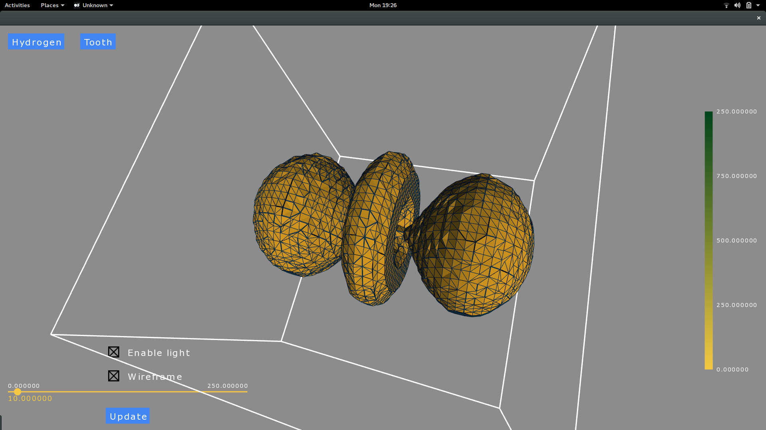

Hydrogen with light disabled

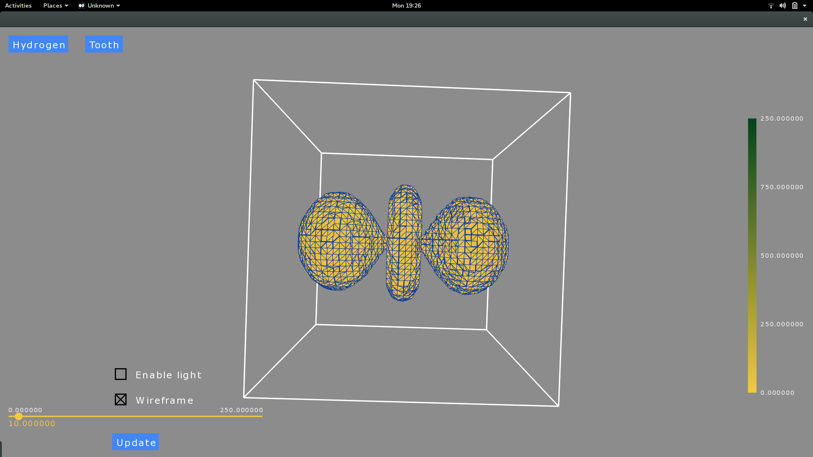

tooth with light and wireframe disabled

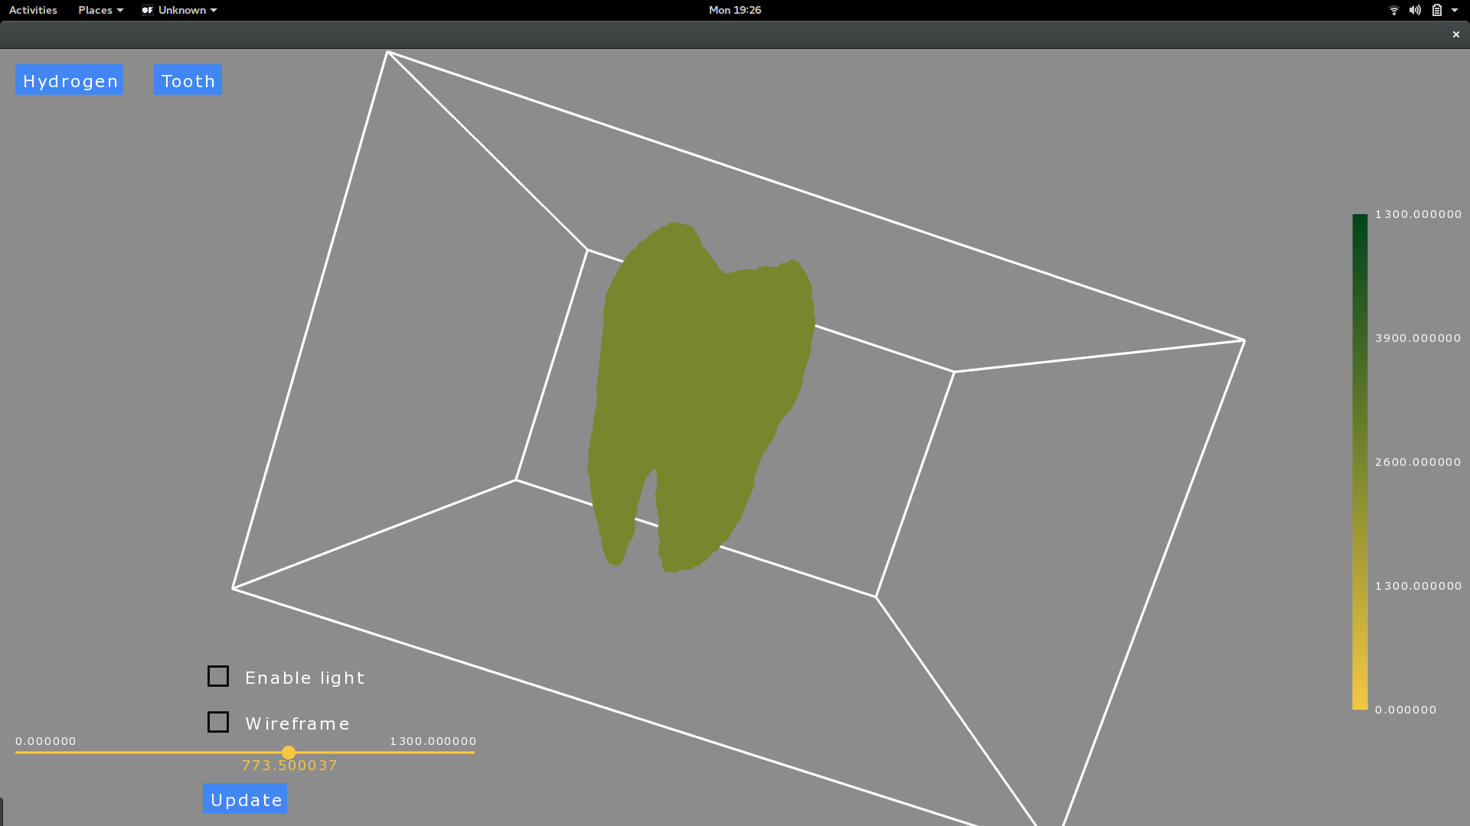

tooth with wireframe and light enabled

