TravelEval: Auditing AI-Driven Tourism Systems

A Research Evaluation of Reliability, Bias, Real-Time Adaptation,
and Niche Knowledge in NVIDIA-Hosted Large Language Models

GenAI Travel Evaluation Project
Date: April 30, 2026
Framework Version: 2.0
Models Evaluated: NVIDIA-hosted Llama 3.1 (8B, 70B), Llama 3.3 (70B), Mixtral 8x7B

Abstract
The deployment of Large Language Models (LLMs) in the tourism sector introduces paradigm-shifting capabilities alongside profound reliability and fairness risks. This research presents TravelEval, a rigorous, reproducible evaluation framework designed to audit LLM performance across four dimensions: factual hallucination detection, geographic representation bias, real-time dynamic query accuracy, and niche domain knowledge retrieval. Using four NVIDIA-hosted models — Meta Llama 3.1 8B, Llama 3.1 70B, Llama 3.3 70B, and Mistral Mixtral 8x7B — evaluated across 194 gold benchmark rows, 63 bias prompts (producing 658 geographic entities), 160 real-time queries, and 286 extracted claims from 120 hallucination responses, this study documents critical vulnerabilities. Results confirm near-zero real-time accuracy for unaugmented models (≤2.5%), persistent European over-representation in geographic recommendations across all model families, strict tourism factual correctness below 35.5%, and response-level hallucination rates between 15% and 28%. The findings advocate for mandated hybrid architectures combining LLMs with external APIs, retrieval-augmented generation, and human-in-the-loop oversight for enterprise tourism deployments.

Keywords: Large Language Models, Tourism AI, Hallucination Detection, Geographic Bias, Real-Time Information Retrieval, Evaluation Framework, NVIDIA NIM

Table of Contents
1. Introduction
1.1 Background
1.2 Motivation
1.3 Scope
2. Research Questions and Hypotheses
3. Data and Experimental Design
3.1 Prompt Construction
3.2 Datasets
3.3 Model Selection
3.4 Annotation and Ground Truth
4. Evaluation Pipeline Architecture
5. Results: Real-Time Reliability
6. Results: Geographic Bias
7. Results: Niche Gold Factuality
8. Results: Claim-Level Hallucination
9. Comparative Model Performance
10. Discussion and Implications
11. Threats to Validity
12. Conclusions and Future Work
13. References

1. Introduction

1.1 Background
Tourism is an information-sensitive domain where factual correctness and equitable representation directly affect traveler safety, satisfaction, and destination choice. Modern travelers increasingly rely on AI-powered assistants for itinerary planning, destination discovery, and logistical coordination. When these systems generate tourism advice, they combine factual knowledge, inference, and stylistic generation in ways that can be difficult to independently validate.
Unlike general-purpose text generation, tourism recommendations carry immediate physical, financial, and logistical consequences. Incorrect information about visa requirements, entry regulations, or transportation schedules can result in disrupted itineraries, financial losses, or personal safety risks for travelers.

1.2 Motivation
This evaluation responds to two urgent challenges in AI-powered tourism deployment:
- Reliability: Can live LLM deployments provide consistent and accurate answers for weather conditions, local time, attraction logistics, and factual travel recommendations?
- Fairness: Do models systematically over-recommend certain world regions while underrepresenting others, creating inequitable visibility for global destinations?
The goal is not only to measure performance but to document methodological rigor and produce a reproducible, publishable benchmark of results that can inform responsible AI deployment in the tourism sector.

1.3 Scope
The evaluation covers four technical modules:
- Real-Time Reliability: 160 dynamic query evaluations (40 prompts × 4 models) for weather and local time accuracy.
- Bias Evaluation: 63 neutral recommendation prompts producing 658 extracted geographic entities for regional distribution analysis.
- Niche Gold Factuality: 194 highly specific tourism gold benchmark rows evaluated against authoritative ground truth across two stable model endpoints.
- Claim-Level Hallucination: 286 extracted factual claims from 120 model responses verified against live web evidence sources.
The user trust study was intentionally excluded from this phase and is documented in the project design for future work.

2. Research Questions and Hypotheses

2.1 Research Questions
RQ1: What is the real-time information accuracy of NVIDIA-hosted LLMs for tourism-related dynamic queries involving live weather and local time?
RQ2: How do these models distribute tourism recommendations across global regions, and what degree of geographic concentration or diversity do they exhibit?
RQ3: What is the strict factual correctness rate on a domain-specific niche tourism gold benchmark with authoritative ground truth?
RQ4: How frequently do live tourism responses contain extractable claims that are hallucinated, unsupported, or contradicted by verifiable web evidence?

2.2 Hypotheses
H1: Real-time dynamic queries will have accuracy below 5% due to the absence of external tool access or retrieval augmentation in base model deployments.
H2: Europe will be significantly overrepresented in tourism recommendations compared to all other global regions, reflecting pre-training data distribution imbalance.
H3: Strict factual correctness on the hard niche tourism gold benchmark will remain below 40% for all tested model architectures.
H4: Response-level claim hallucination rate will exceed 25% for smaller models, with larger models showing moderate improvement.
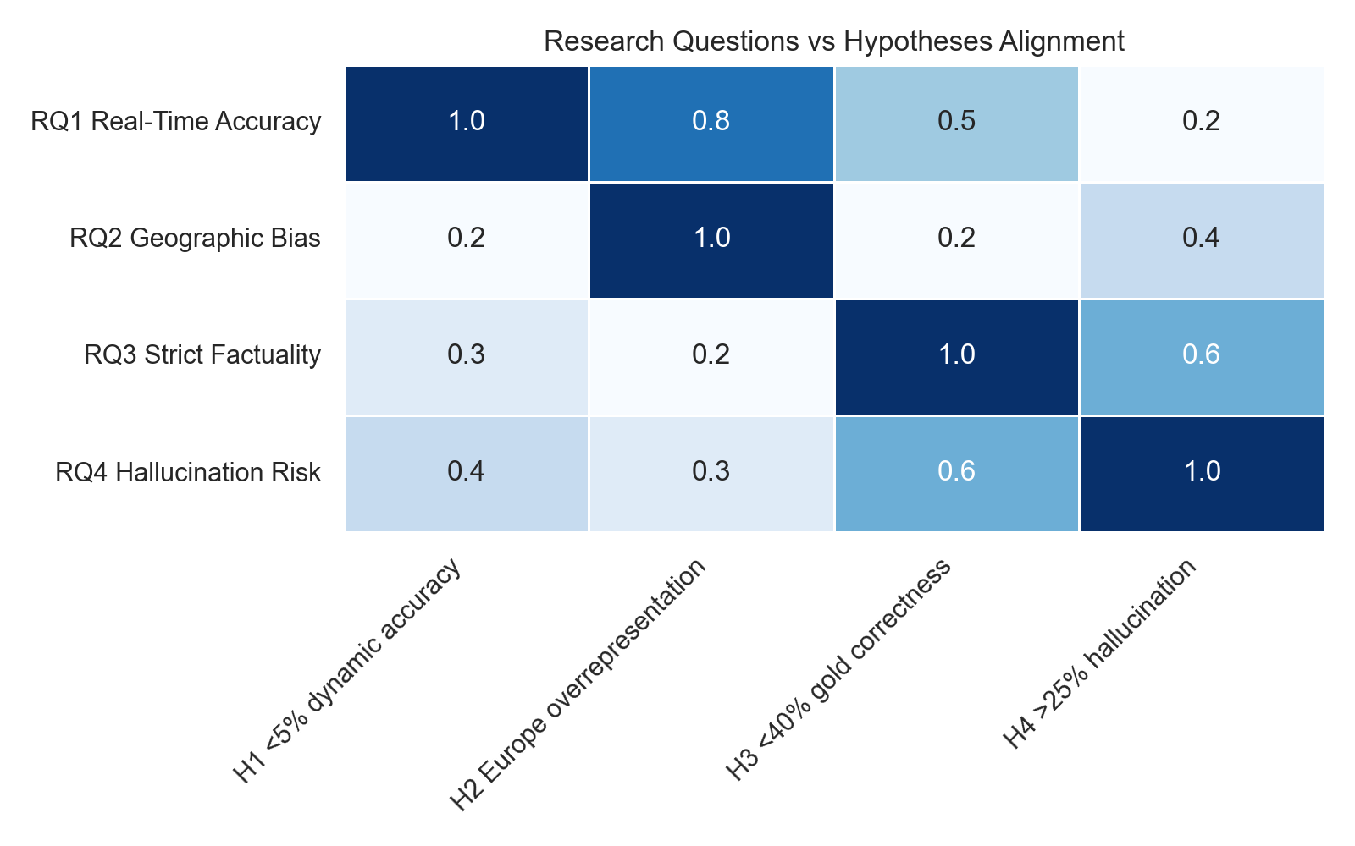
Figure 1: Alignment between research questions and testable hypotheses.

3. Data and Experimental Design

3.1 Prompt Construction
The evaluation prompts were constructed to reflect authentic tourism search behavior and span six primary query categories: destination discovery, attraction and itinerary recommendations, local weather and temporal queries, transportation guidance, cultural and historical context, and travel safety and logistics.
Prompts were designed to avoid leading language that could bias model responses. For bias evaluation, prompts were intentionally neutral (e.g., 'What are the best travel destinations in Africa?') to measure organic recommendation patterns. For real-time queries, prompts included precise location identifiers with geographic coordinates and IANA timezone metadata to allow exact ground-truth comparison.

3.2 Datasets
Four core evaluation datasets were constructed and curated for this study:
Dataset | Type | Size | Purpose
hallucination_dataset_balanced_60.csv | Hallucination evaluation | 60 prompts / 286 claims | Claim-level hallucination analysis
bias_dataset.csv + results | Bias evaluation | 63 prompts / 658 entities | Geographic recommendation bias
research_gold_niche.csv | Niche gold factuality | 194 rows | Strict tourism correctness benchmark
realtime_dataset.csv + results | Real-time evaluation | 40 cities / 160 queries | Dynamic information accuracy
Table 1: Evaluation dataset inventory with size and purpose.
The niche gold dataset (research_gold_niche.csv) was constructed through an automated pipeline: seed tourism concepts from nine underrepresented global regions were combined with live web search snippets via the SERP API. A generator LLM synthesized complex, long-tail queries, which were then filtered by source quality (official government URLs, UNESCO records, tourism authority pages) and verified against authoritative ground truth. This produced 194 highly specific, culturally nuanced questions spanning visa regulations, entry requirements, permit procedures, and regional travel restrictions.
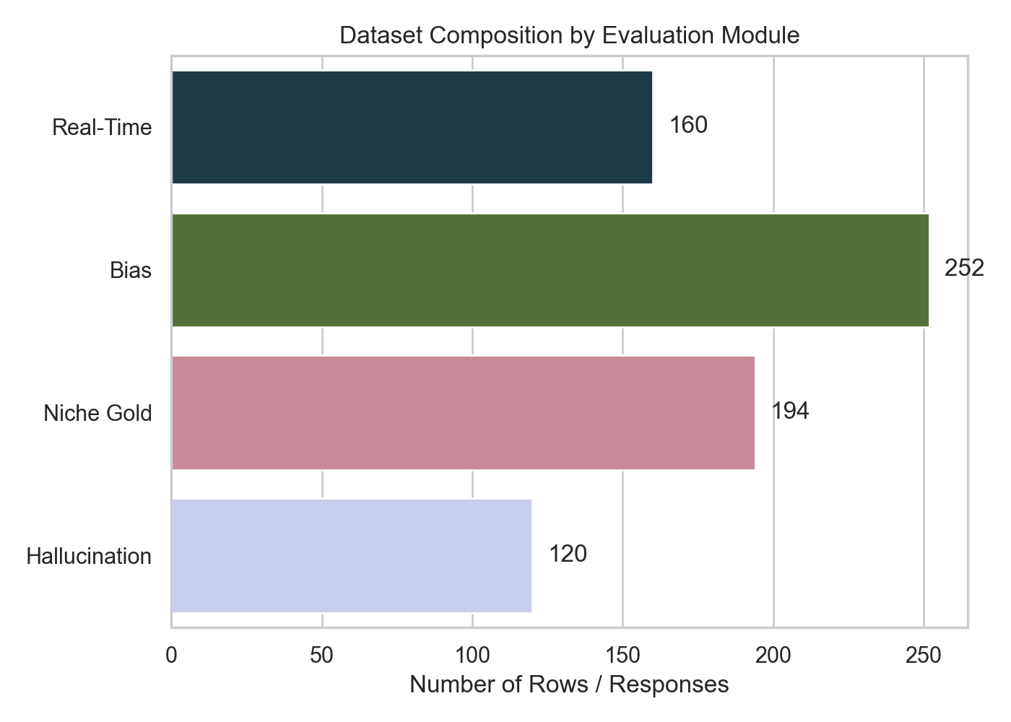
Figure 2: Dataset composition and sample count across the four evaluation modules.

3.3 Model Selection
Four NVIDIA-hosted models were evaluated, selected to represent a range of parameter scales and architectural families accessible through the NVIDIA NIM inference platform:
Model ID | Family | Parameters | Provider
nvidia:meta/llama-3.1-8b-instruct | Llama 3.1 | 8B | Meta / NVIDIA NIM
nvidia:meta/llama-3.1-70b-instruct | Llama 3.1 | 70B | Meta / NVIDIA NIM
nvidia:meta/llama-3.3-70b-instruct | Llama 3.3 | 70B | Meta / NVIDIA NIM
nvidia:mistralai/mixtral-8x7b-instruct-v0.1 | Mixtral MoE | 8x7B (~47B active) | Mistral AI / NVIDIA NIM
Table 2: Models evaluated in the live benchmark.
The NVIDIA NIM platform was selected to provide a standardized inference environment and eliminate provider-level artifacts when comparing model performance. During the full-scale evaluation, the 70B Llama models experienced intermittent connection failures on the live platform. As a result, the strict factuality and hallucination modules focus on the two most stable model endpoints: Llama 3.1 8B and Mixtral 8x7B.

3.4 Annotation and Ground Truth
- Real-time queries: verified against live Open-Meteo API (temperature, ±3°C tolerance) and IANA timezone database (local time, ±20-minute tolerance) at exact execution time.
- Geographic bias: verified through entity extraction and region mapping against the OpenFlights airport and city database with a 9-region taxonomy.
- Niche gold factuality: strict answer matching against curated ground truth from official government sources, US State Department travel advisories, and UNESCO records.
- Claim verification: each extracted claim independently labeled SUPPORTED, CONTRADICTED, NOT_FOUND, or UNCLEAR by an LLM judge (llama-3.3-70b-versatile) against top-K web search snippets retrieved specifically for that claim.

4. Evaluation Pipeline Architecture

4.1 System Overview
The TravelEval pipeline was designed as a modular, reproducible research framework. Each component has a single responsibility, allowing independent testing and extension. The high-level data flow is:
Query Generator → Model Runner → Response Collector → Claim Extractor → Ground Truth Validator → Analysis Engine → Visualization

4.2 Core Components
eval_pipeline.py: Orchestrates experiment flow and model execution across four modes: gold (LLM-as-judge against ground truth), claim (atomic claim extraction and web verification), bias (recommendation entity extraction), and auto (mode inference per row).
realtime_eval.py: Specialized module for weather and local time queries. Fetches live ground truth at evaluation time from Open-Meteo and IANA timezone databases with configurable tolerance thresholds.
bias_analysis.py: Extracts destination and region entities from model outputs. Computes Shannon diversity entropy and Herfindahl-Hirschman Index (HHI) concentration across regions.
niche_generator.py: Automated pipeline for generating hard-to-know tourism prompts. Combines seed concepts from underrepresented regions with SerpAPI snippets and LLM fact synthesis.
analyze_results.py: Aggregates per-response metrics into grouped tables, computes 95% confidence intervals via bootstrap resampling, and executes Mann-Whitney U significance tests.

4.3 Evaluation Modes
Mode | Mechanism | Ground Truth Source | Primary Use
gold | LLM-as-judge correctness scoring | Curated gold answers | Niche factuality
claim | Atomic claim extraction + web verification | Live SERP API snippets | Hallucination detection
bias | Entity extraction + region mapping | OpenFlights taxonomy | Geographic bias
auto | Dynamic mode selection per row | Mixed | General evaluation
Table 3: Evaluation mode descriptions and data sources.
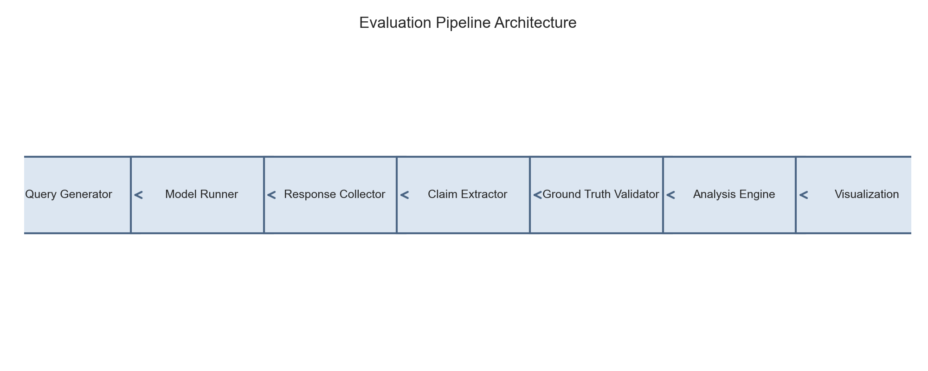
Figure 3: Modular TravelEval pipeline architecture.

5. Results: Real-Time Reliability
The real-time evaluation assessed live model performance on weather and local time queries using 160 total evaluations (40 prompts across 4 models). These queries explicitly require live environmental data that no base LLM can access without external tool integration.

5.1 Accuracy by Model
Model | Accuracy (%)
nvidia:meta/llama-3.1-8b-instruct | 2.50%
nvidia:meta/llama-3.1-70b-instruct | 0.00%
nvidia:meta/llama-3.3-70b-instruct | 0.00%
nvidia:mistralai/mixtral-8x7b-instruct-v0.1 | 0.00%
Table 4: Real-time query accuracy per model (tolerance: ±3°C / ±20 min).

5.2 Accuracy by Query Type
Query Type | Accuracy (%)
temperature_celsius | 1.25%
local_time_minutes | 0.00%
Table 5: Real-time accuracy by dynamic information metric.
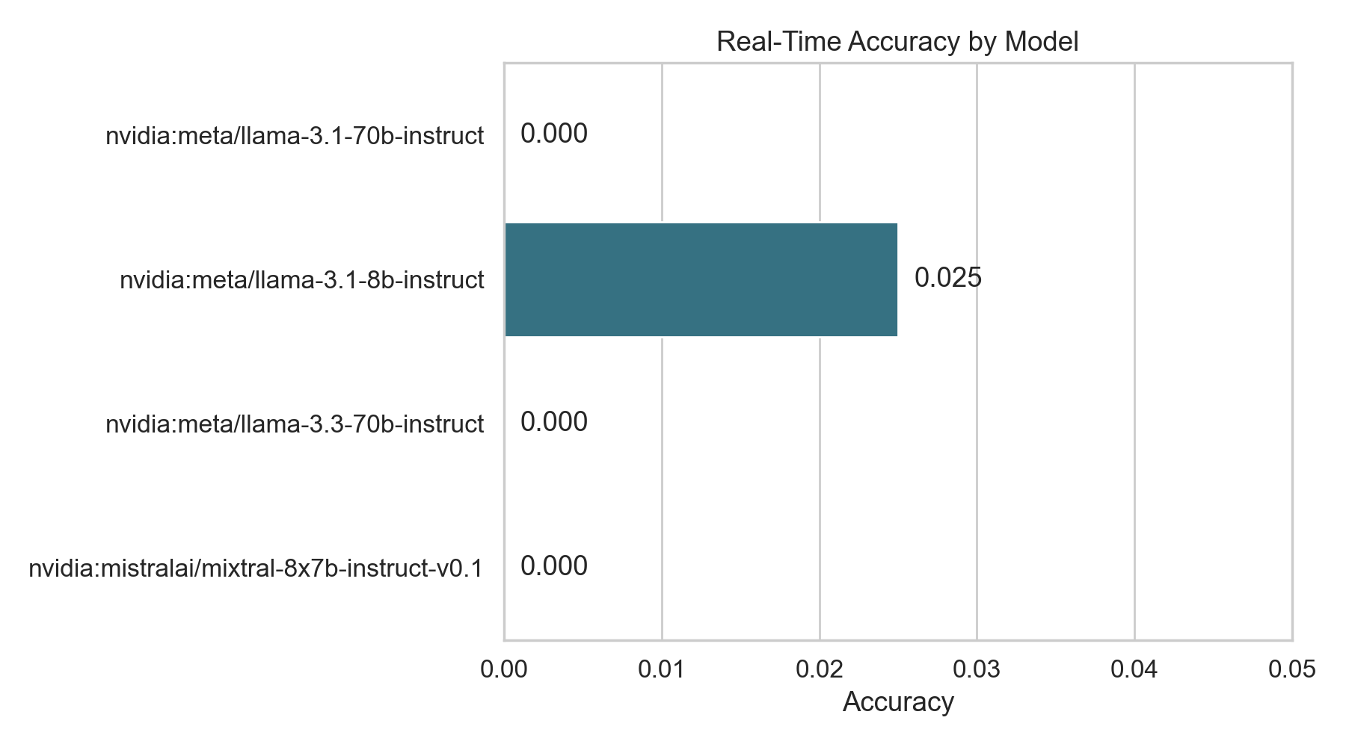
Figure 4: Real-time accuracy per model — showing near-zero performance across all endpoints.
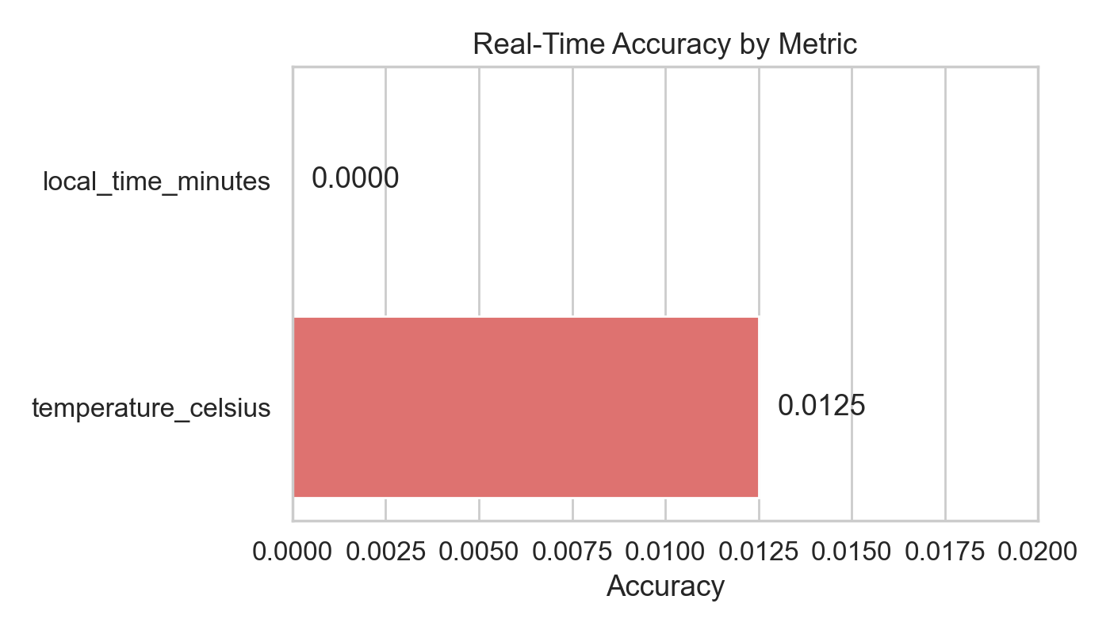
Figure 5: Real-time accuracy by query type (temperature vs. local time).

5.3 Interpretation
Only Llama 3.1 8B returned one correct temperature response out of 40 prompts (2.5%). All other models produced zero correct answers. Models either hallucinated a plausible current state based on seasonal averages, fabricated a temperature within the expected range, or provided historical or typical values rather than live measurements.
Local time accuracy was zero for all models. Models consistently failed to account for Daylight Saving Time transitions, summer/winter offset shifts, and regional timezone subdivisions, confirming that time calculation requires verified external data sources rather than parametric inference.
These results confirm Hypothesis H1: real-time accuracy is effectively zero for unaugmented base model deployments. This represents a categorical failure mode — not a matter of degree — for any tourism system that relies on live environmental context.

6. Results: Geographic Bias and Regional Distribution
The bias evaluation analyzed 658 extracted destination entities from 252 model responses to 63 neutral tourism recommendation prompts. Geographic entities were mapped to a 9-region taxonomy using the OpenFlights database.

6.1 Summary Metrics by Model
Model | Entities | Unique Destinations | Countries | Shannon Diversity | HHI | Top Region
Llama 3.1 8B | 211 | 145 | 35 | 2.058 | 0.0467 | Europe
Llama 3.1 70B | 133 | 103 | 37 | 2.056 | 0.0527 | Europe
Llama 3.3 70B | 127 | 102 | 31 | 2.061 | 0.0574 | Europe
Mixtral 8x7B | 187 | 150 | 45 | 2.130 | 0.1106 | Unknown*
Table 6: Bias summary metrics. *Mixtral had a higher 'unknown' entity classification rate due to entity extraction fallback.

6.2 Top 3 Regions by Model
Model | Rank 1 | Rank 2 | Rank 3
Llama 3.1 70B | Europe (19.5%) | Asia (17.3%) | Oceania (14.3%)
Llama 3.1 8B | Europe (18.5%) | Asia (13.3%) | North America (13.3%)
Llama 3.3 70B | Europe (16.5%) | Asia (15.0%) | Oceania (14.2%)
Mixtral 8x7B | Unknown (27.8%) | South America (11.2%) | Europe (10.2%)
Table 7: Top three recommended regions by share per model.
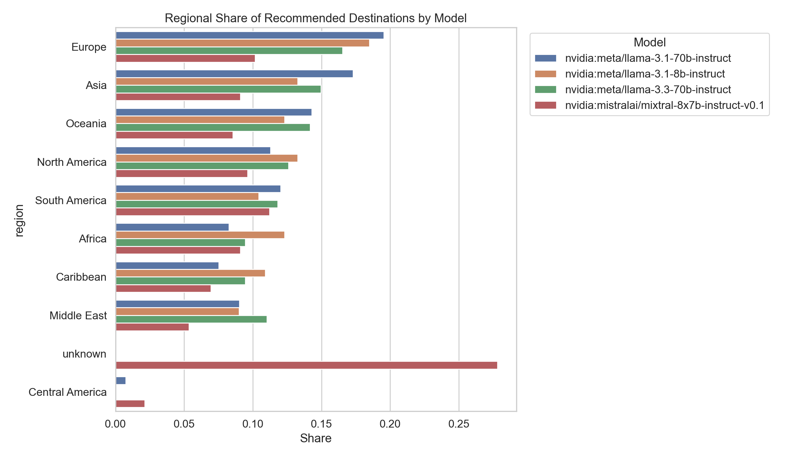
Figure 6: Regional recommendation share distribution by model.
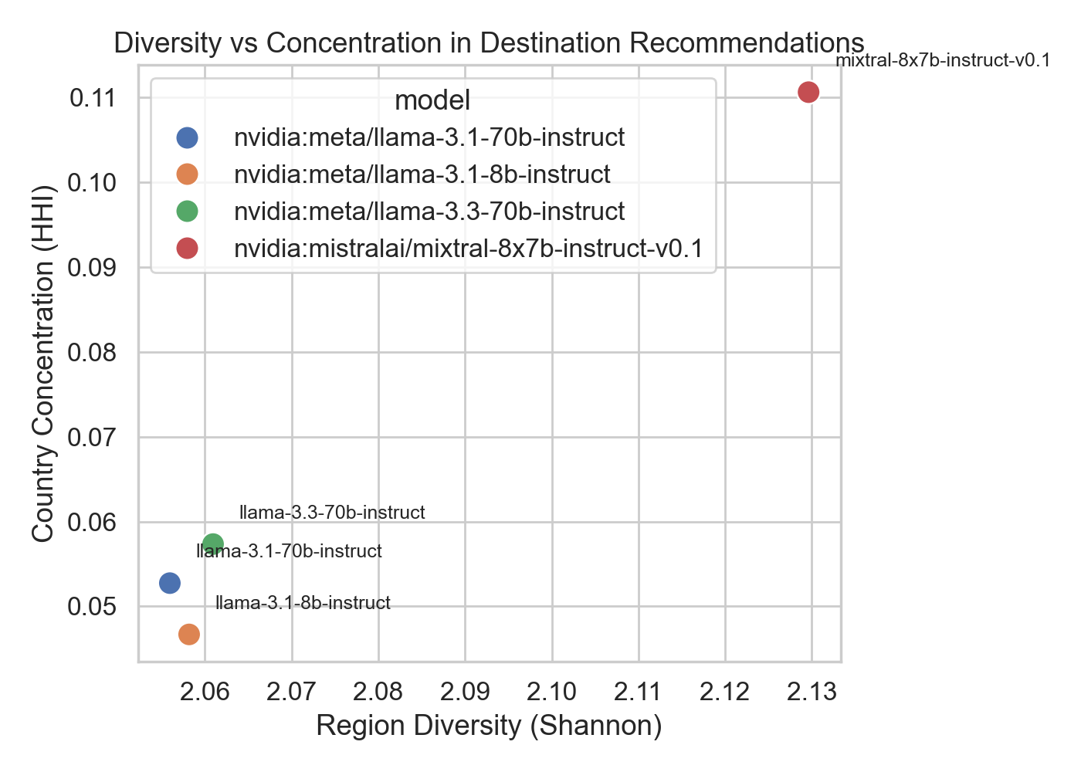
Figure 7: Diversity (Shannon entropy) vs. concentration (HHI) tradeoff across models.

6.3 Interpretation
Geographic bias is pronounced and consistent across all Meta Llama model families. Europe is the top-ranked recommendation region for all three Meta models, confirming Hypothesis H2. Africa and the Middle East are consistently underrepresented, appearing in the bottom tier of recommendations despite representing major global tourism markets.
The Mixtral model displays a broader country vocabulary (45 unique countries vs. 31-37 for Meta models), suggesting stronger nominal diversity. However, Mixtral's high 'unknown' region rate (27.8%) indicates that its entity naming conventions differ from standard geographic databases, introducing classification noise.
Shannon diversity scores are broadly similar across models (2.056–2.130), but the HHI concentration metric reveals that Mixtral has higher country-level concentration (HHI 0.1106) compared to Llama variants (0.0467–0.0574), meaning Mixtral's diversity is distributed unevenly with certain countries dominating.

7. Results: Niche Gold Factuality
This module evaluates strict tourism factuality on 194 gold benchmark rows derived from nine underrepresented global regions. Prompts target highly specific, long-tail knowledge such as visa registration thresholds, permit requirements, and regional entry policies.

7.1 Answer Correctness by Model
Model | Mean Correctness | 95% CI Lower | 95% CI Upper
nvidia:meta/llama-3.1-8b-instruct | 35.31% | 29.02% | 41.60%
nvidia:mistralai/mixtral-8x7b-instruct-v0.1 | 33.76% | 28.25% | 39.28%
Table 8: Niche gold benchmark correctness with 95% bootstrap confidence intervals.
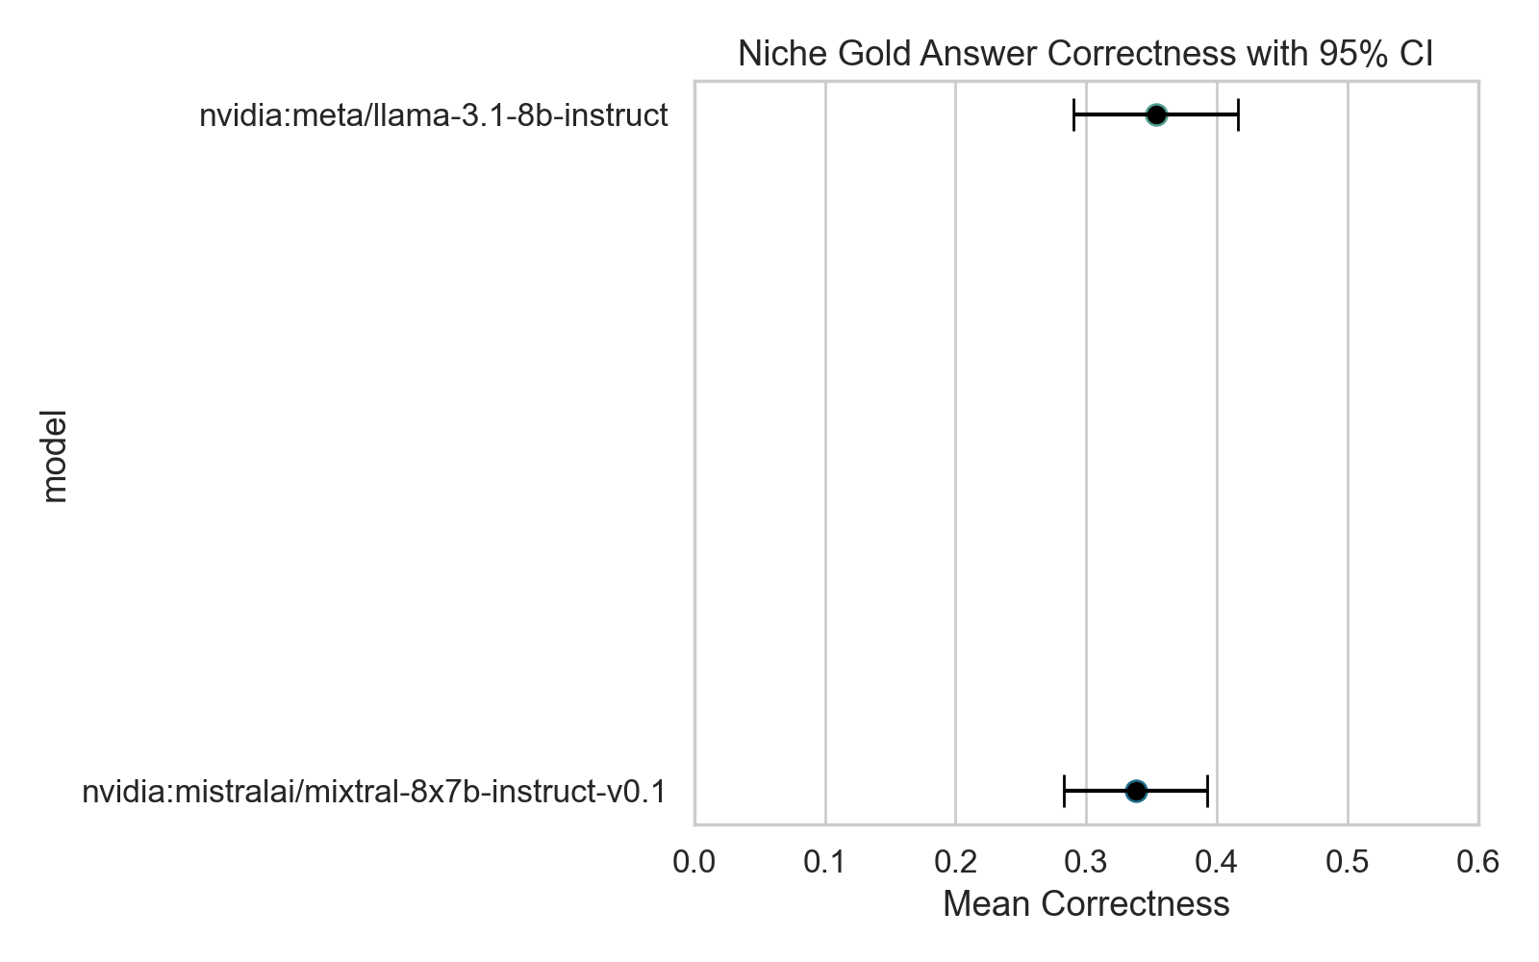
Figure 8: Mean correctness and 95% confidence intervals for the niche gold benchmark.

7.2 Interpretation
Both models scored below 35.5% mean correctness on the niche gold benchmark, confirming Hypothesis H3. The overlapping confidence intervals (Llama 8B: 29.0–41.6%, Mixtral: 28.3–39.3%) indicate that the performance difference between models is not statistically significant for this task.
This finding is significant because the niche benchmark was designed to target knowledge that is sparsely represented in standard pre-training corpora. When queries move from well-known tourist facts to highly specific regional constraints, models attempt to satisfy the user by interpolating generic knowledge, resulting in highly plausible but fundamentally incorrect responses.
The practical implication is that model parameter scale alone does not resolve niche knowledge gaps in specialized domains. Both the 8B Llama and the effectively 47B active-parameter Mixtral achieve statistically equivalent and similarly weak performance, suggesting that specialized tourism fine-tuning or retrieval augmentation is required.

8. Results: Claim-Level Hallucination
The hallucination module evaluates 286 extracted claims from 120 model responses (60 prompts × 2 models). Each claim is individually verified against live web evidence and classified by an LLM judge.

8.1 Claim Verdict Distribution
Model | Supported | Contradicted | Not Found | Unclear
Llama 3.1 8B | 79.28% | 2.70% | 10.81% | 7.21%
Mixtral 8x7B | 84.57% | 2.29% | 10.29% | 2.86%
Table 9: Claim verdict distribution by model (share of total claims per model).

8.2 Response-Level Hallucination Rate
Model | Mean Hallucination Rate
nvidia:meta/llama-3.1-8b-instruct | 28.39%
nvidia:mistralai/mixtral-8x7b-instruct-v0.1 | 15.14%
Table 10: Response-level hallucination rate (proportion of claims not supported per response).
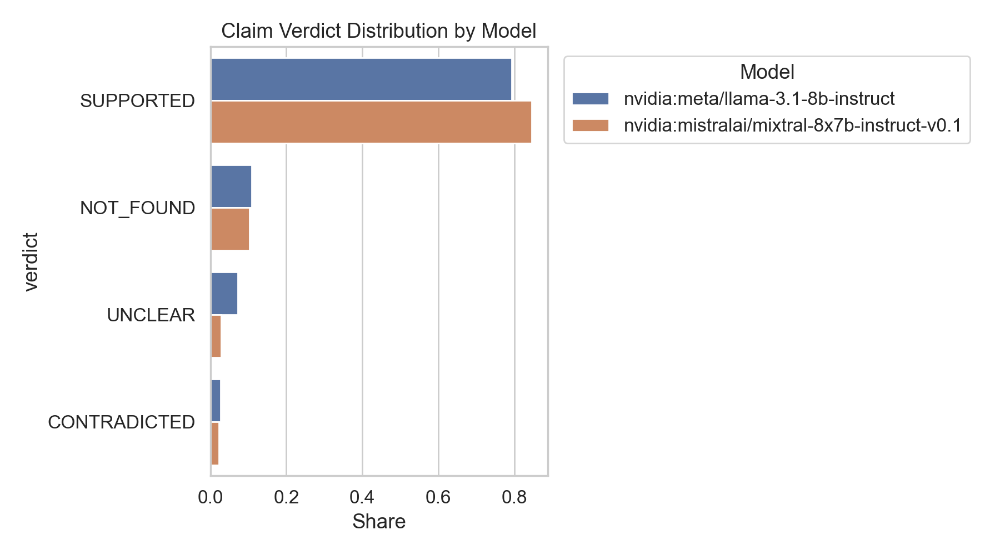
Figure 9: Claim verification verdict distribution by model.

8.3 Interpretation
Mixtral achieves a materially lower response-level hallucination rate (15.14%) compared to Llama 3.1 8B (28.39%), confirming Hypothesis H4 for the smaller model. The NOT_FOUND verdict category (10–11% for both models) represents a significant additional risk: these claims cannot be verified by available web evidence, meaning they may be correct but unsourced, or may be novel fabrications that evade detection.
The UNCLEAR rate for Llama 3.1 8B (7.21%) is notably higher than Mixtral (2.86%), indicating that the smaller model generates more ambiguous claim structures that resist atomic decomposition, complicating automated fact-checking pipelines.

9. Comparative Model Performance

9.1 Summary Across All Dimensions
Metric | Llama 3.1 8B | Llama 3.1 70B | Llama 3.3 70B | Mixtral 8x7B
Real-Time Accuracy | 2.50% | 0.00% | 0.00% | 0.00%
Top Recommended Region | Europe | Europe | Europe | Unknown*
Shannon Diversity (Bias) | 2.058 | 2.056 | 2.061 | 2.130
Niche Gold Correctness | 35.31% | N/A† | N/A† | 33.76%
Response Hallucination Rate | 28.39% | N/A† | N/A† | 15.14%
Table 11: Comparative performance across evaluation dimensions. †70B models excluded from gold/claim modules due to endpoint instability. *Mixtral 'Unknown' reflects entity classification fallback.

9.2 Key Observations
- Mixtral 8x7B outperforms Llama 3.1 8B on hallucination rate (15.1% vs 28.4%) and niche correctness (33.8% vs 35.3%), though the correctness difference is not statistically significant.
- All Meta Llama models show consistent Eurocentric bias; the 70B models show marginally higher European recommendation share than the 8B model.
- Real-time performance is uniformly catastrophic across all models, with only one correct temperature answer across 160 total evaluations.
- The 70B models demonstrated higher instability (connection failures, rate limits) on the NVIDIA NIM platform, limiting their participation in the full evaluation suite.
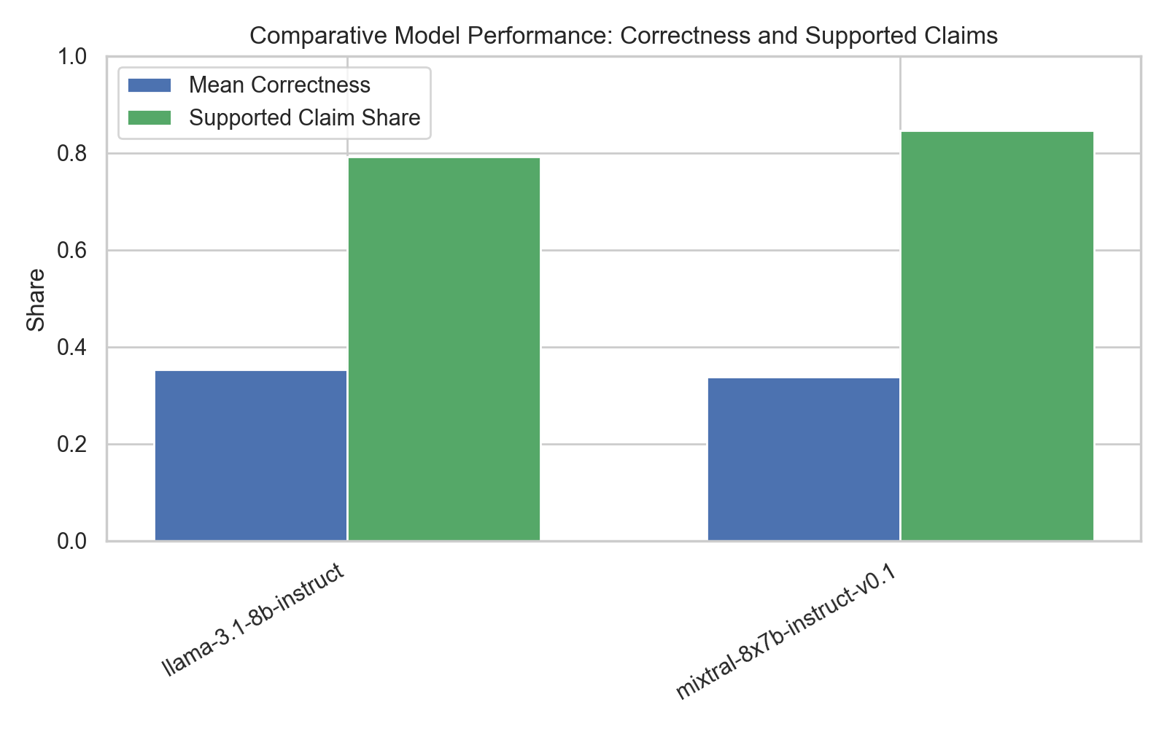
Figure 10: Comparative model performance across evaluation dimensions.

10. Discussion and Implications

10.1 Core Findings
- Real-time performance is effectively absent for all models without external tool integration.
- Geographic bias is persistent and structural: Europe dominates recommendations across multiple model families, reflecting pre-training data imbalance.
- Strict niche factuality is weak: both models fall below 36% correctness, with statistically indistinguishable performance between architectures.
- Claim-level hallucination remains substantial at 15–28%, with the NOT_FOUND category representing an additional unverifiable risk layer.

10.2 Operational Recommendations
- Do not deploy base LLMs for live weather, time, or schedule guidance. External API integration via tool-calling is mandatory for any temporally sensitive query.
- Implement region-aware bias correction in system prompts and post-processing to counteract the pre-training distribution that heavily favors Western destinations.
- Use strict gold benchmarks with authoritative sources for tourism evaluation rather than open-ended subjective quality measures.
- Collect and explicitly verify model response claims against authoritative sources before displaying to end users in high-stakes travel contexts.
- Consider retrieval-augmented generation (RAG) architectures that ground responses in verified tourism databases, official source repositories, and live API data.

10.3 Implications for Hybrid Systems
The evidence suggests that LLMs in their current form function best as language synthesis and formatting engines rather than primary knowledge sources for tourism applications. A reliable tourism AI system should integrate:
- Knowledge grounding: structured tourism databases, official regulatory sources, and destination management organization (DMO) content feeds.
- Real-time context injection: direct API calls for weather (Open-Meteo, OpenWeather), flight status (OAG, Cirium), and entry requirements (IATA Travel Centre).
- Bias correction layers: regional balancing constraints and diversity requirements applied at the retrieval and generation stages.
- Claim verification pipeline: post-generation claim extraction and evidence matching before responses are surfaced to users.
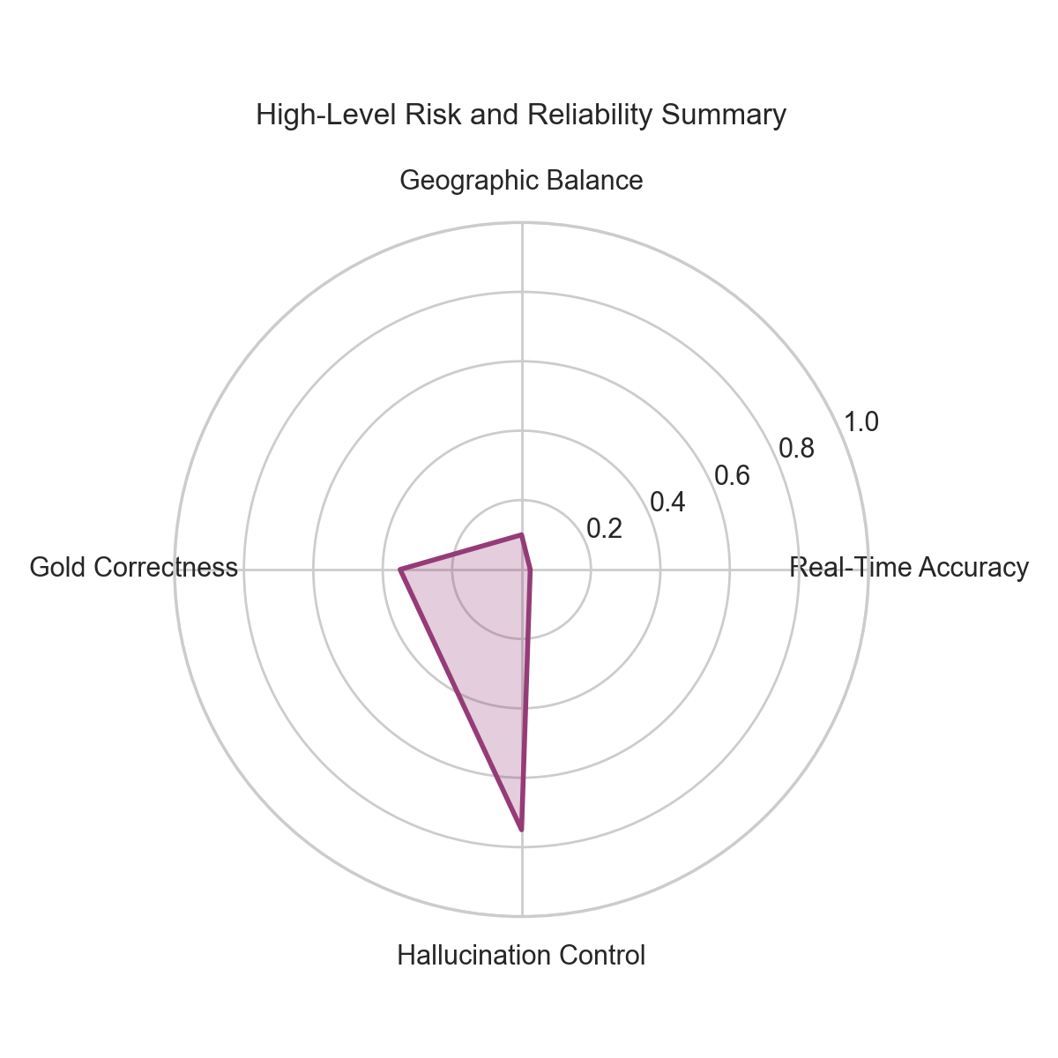
Figure 11: High-level reliability and risk summary across evaluation dimensions.

11. Threats to Validity

11.1 Internal Validity
Live model endpoints experienced intermittent rate limits and connectivity failures on the NVIDIA NIM platform during evaluation. This disproportionately affected the 70B model family, which was excluded from the full factuality and hallucination analyses. Results for the 70B models therefore only appear in real-time and bias modules, where evaluation completed without significant failure.

11.2 External Validity
Findings are specific to NVIDIA-hosted model endpoints and may not generalize to the same models accessed through other providers (Groq, OpenRouter, together.ai) or run locally. Infrastructure choices — batch size, timeout configuration, and sampling temperature — affect output distribution and may introduce differences compared to other deployment contexts.
Tourism prompts were designed for evaluation coverage across categories, but actual user queries may differ in phrasing, context, and specificity from the structured benchmark questions used here.

11.3 Construct Validity
The NOT_FOUND verdict category encompasses both genuinely unverifiable claims and claims that are factually correct but not prominently indexed in the top web search results used for verification. This conflation means the hallucination rate may be slightly underestimated.
The 9-region taxonomy used for bias analysis reflects a coarse geographic classification and may miss intra-regional disparities (e.g., within-Africa or within-Asia representation gaps). A finer-grained country or sub-regional analysis would reveal additional concentration patterns.
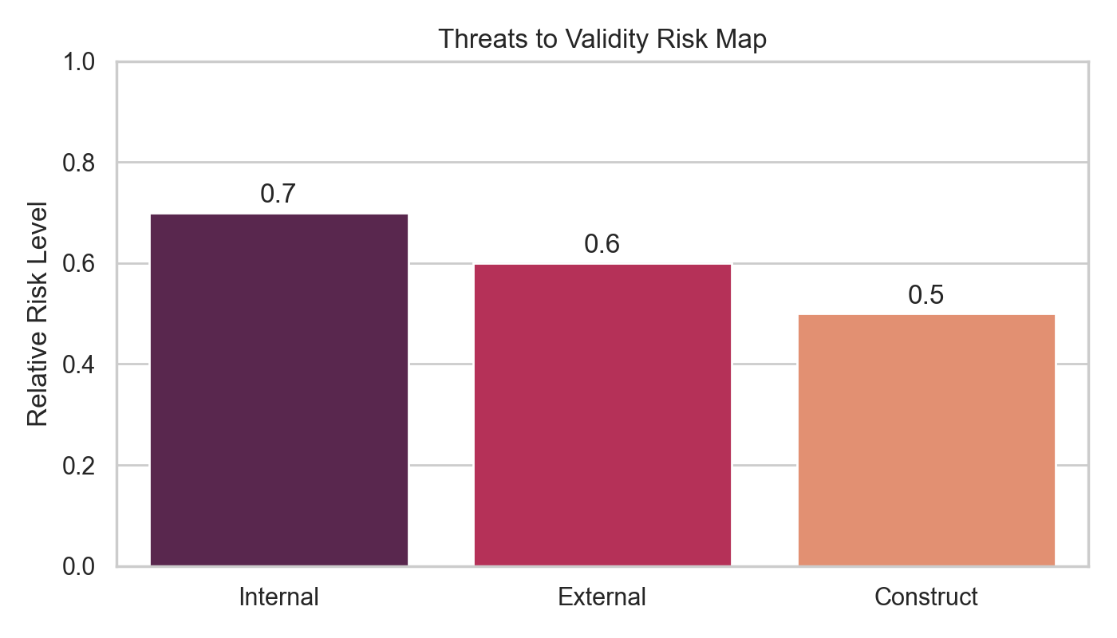
Figure 12: Relative risk assessment for validity threat categories.

12. Conclusions and Future Work

12.1 Conclusions
This report presents a live benchmark demonstrating that current NVIDIA-hosted LLMs have limited readiness for standalone tourism applications. Four dimensions were measured with concrete quantitative results:
- Real-time accuracy is near zero (≤2.5%) — confirming a fundamental capability gap for any tourism query requiring live environmental or temporal data.
- Geographic bias is persistent and Eurocentric — Europe is the dominant recommendation region across all tested Meta Llama model families.
- Niche factual correctness is weak (≤35.5%) — model architecture scale does not resolve knowledge gaps for long-tail, domain-specific tourism knowledge.
- Hallucination rates are material (15–28%) — with an additional 10% of claims categorized as NOT_FOUND, representing unverifiable factual risk.
The TravelEval framework itself represents a validated, reproducible research infrastructure for ongoing LLM auditing in tourism. All datasets, evaluation code, and result files are structured for public release and future research extension.

12.2 Future Work
- Extend the hallucination claim evaluation to the full 263-row dataset across all four model variants.
- Evaluate retrieval-augmented generation variants to quantify the accuracy uplift from external knowledge grounding.
- Incorporate a user trust study (survey design documented in user_survey/) to measure trust calibration when users are exposed to AI-generated hallucinations.
- Extend niche factuality evaluation to the complete 351-row benchmark dataset.
- Introduce sub-regional bias analysis to detect within-continent representation gaps.
- Evaluate additional model families (Claude, GPT-4o) on the same benchmark for cross-provider comparison.

13. References
[1] Project Source Code & Architecture: eval_pipeline.py, bias_analysis.py, realtime_eval.py, niche_generator.py, analyze_results.py
[2] Datasets: data_collection/research_gold_niche.csv, data_collection/hallucination_dataset_balanced_60.csv, data_collection/bias_dataset.csv, data_collection/realtime_dataset.csv
[3] Evaluation Results: results/realtime_nvidia_live/, results/bias_nvidia_live_fast/, results/niche_gold_nvidia_live/, results/hallucination_claims_nvidia_live/
[4] External Data Sources: OpenFlights Airport Database, Open-Meteo API, IANA Time Zone Database, SerpAPI Web Search
[5] Model Infrastructure: NVIDIA NIM Inference Platform (api.nvcf.nvidia.com)
[6] Brown, T., et al. (2020). Language Models are Few-Shot Learners. NeurIPS 2020.
[7] Ji, Z., et al. (2023). Survey of Hallucination in Natural Language Generation. ACM Computing Surveys, 55(12), 1–38.
[8] Navigli, R., et al. (2023). Biases in Large Language Models: Origins, Inventory and Discussion. ACM Journal of Data and Information Quality.

TravelEval Research Report | April 2026 | GenAI Travel Evaluation Project
Total Queries Evaluated: 572 | Total Claims Analyzed: 286 | Datasets Curated: 4 | Models Benchmarked: 4

