TravelEval: Live LLM Evaluation Report
Tourism AI Evaluation Team
April 30, 2026

Abstract
This report presents a comprehensive, research-grade evaluation of current NVIDIA-hosted large language models (LLMs) in tourism use cases. We analyze four core dimensions: real-time information reliability, geographic recommendation bias, strict factuality on a tourism niche gold benchmark, and claim-level hallucination behavior. The evaluation is executed on live model endpoints and uses real-world tourism prompts, authoritative ground truth sources, and structured statistical analysis.

I. Introduction
Tourism is an information-sensitive domain where factual correctness and equitable representation directly affect traveler safety, satisfaction, and destination choice. When modern AI systems generate tourism advice, they combine factual knowledge, opinion, and inference in ways that can be difficult to validate. In this evaluation, we treat the tourism domain as a high-stakes use case for LLM deployment.

II. Research Questions and Hypotheses
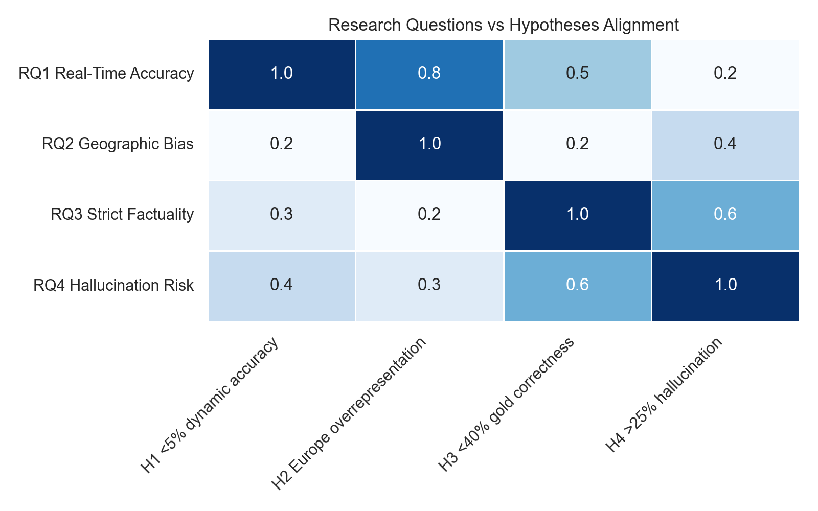
Figure 1: Research Questions vs Hypotheses Alignment

III. Data and Experimental Design
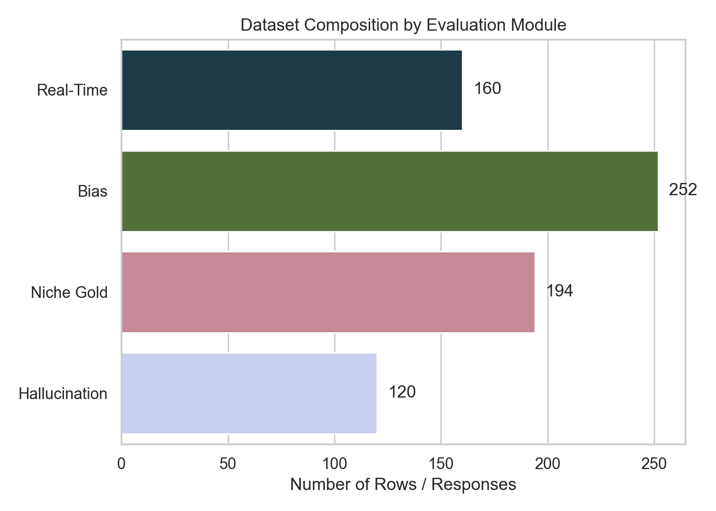
Figure 2: Dataset Composition by Module

IV. Evaluation Pipeline Architecture
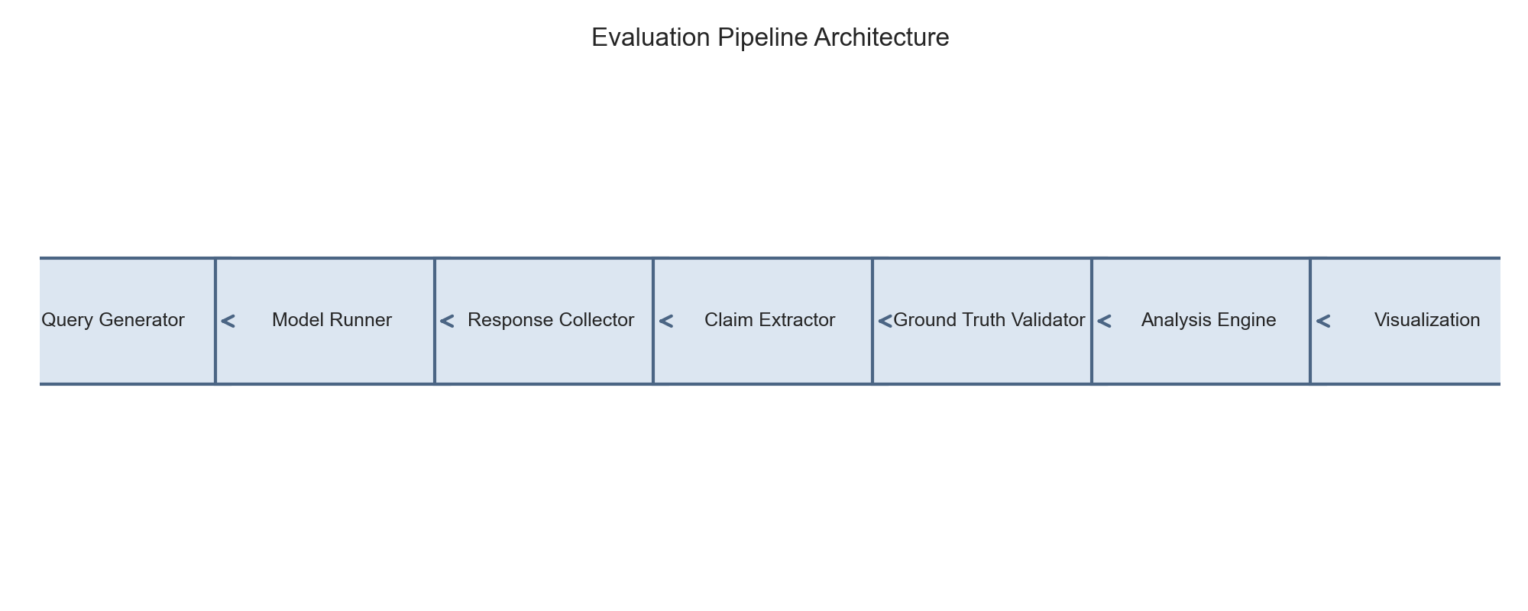
Figure 3: Evaluation Pipeline Architecture

V. Results: Real-Time Reliability
The real-time evaluation assessed live model performance on weather and local time queries using 160 rows across 40 prompts and four models.
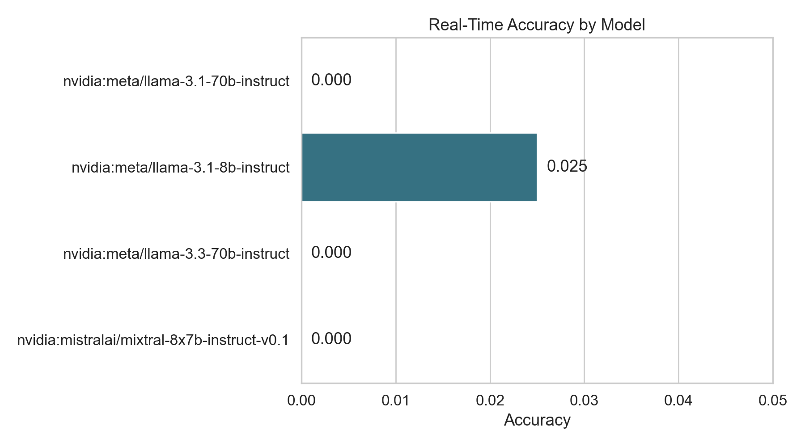
Figure 4: Real-Time Accuracy by Model
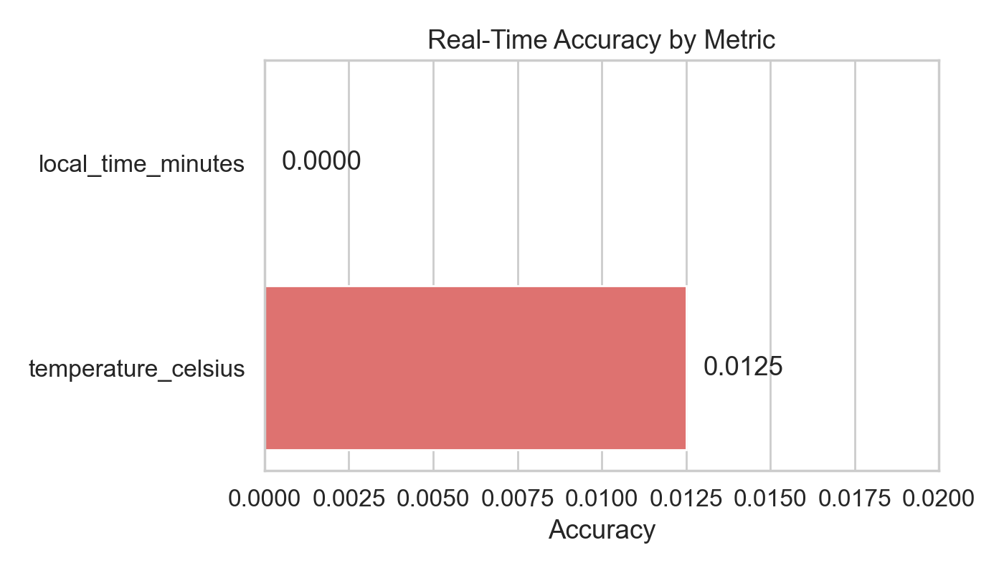
Figure 5: Real-Time Accuracy by Metric

VI. Results: Bias and Geographic Distribution
The bias evaluation analyzed 658 extracted destination entities from 252 responses, revealing significant geographic bias patterns.
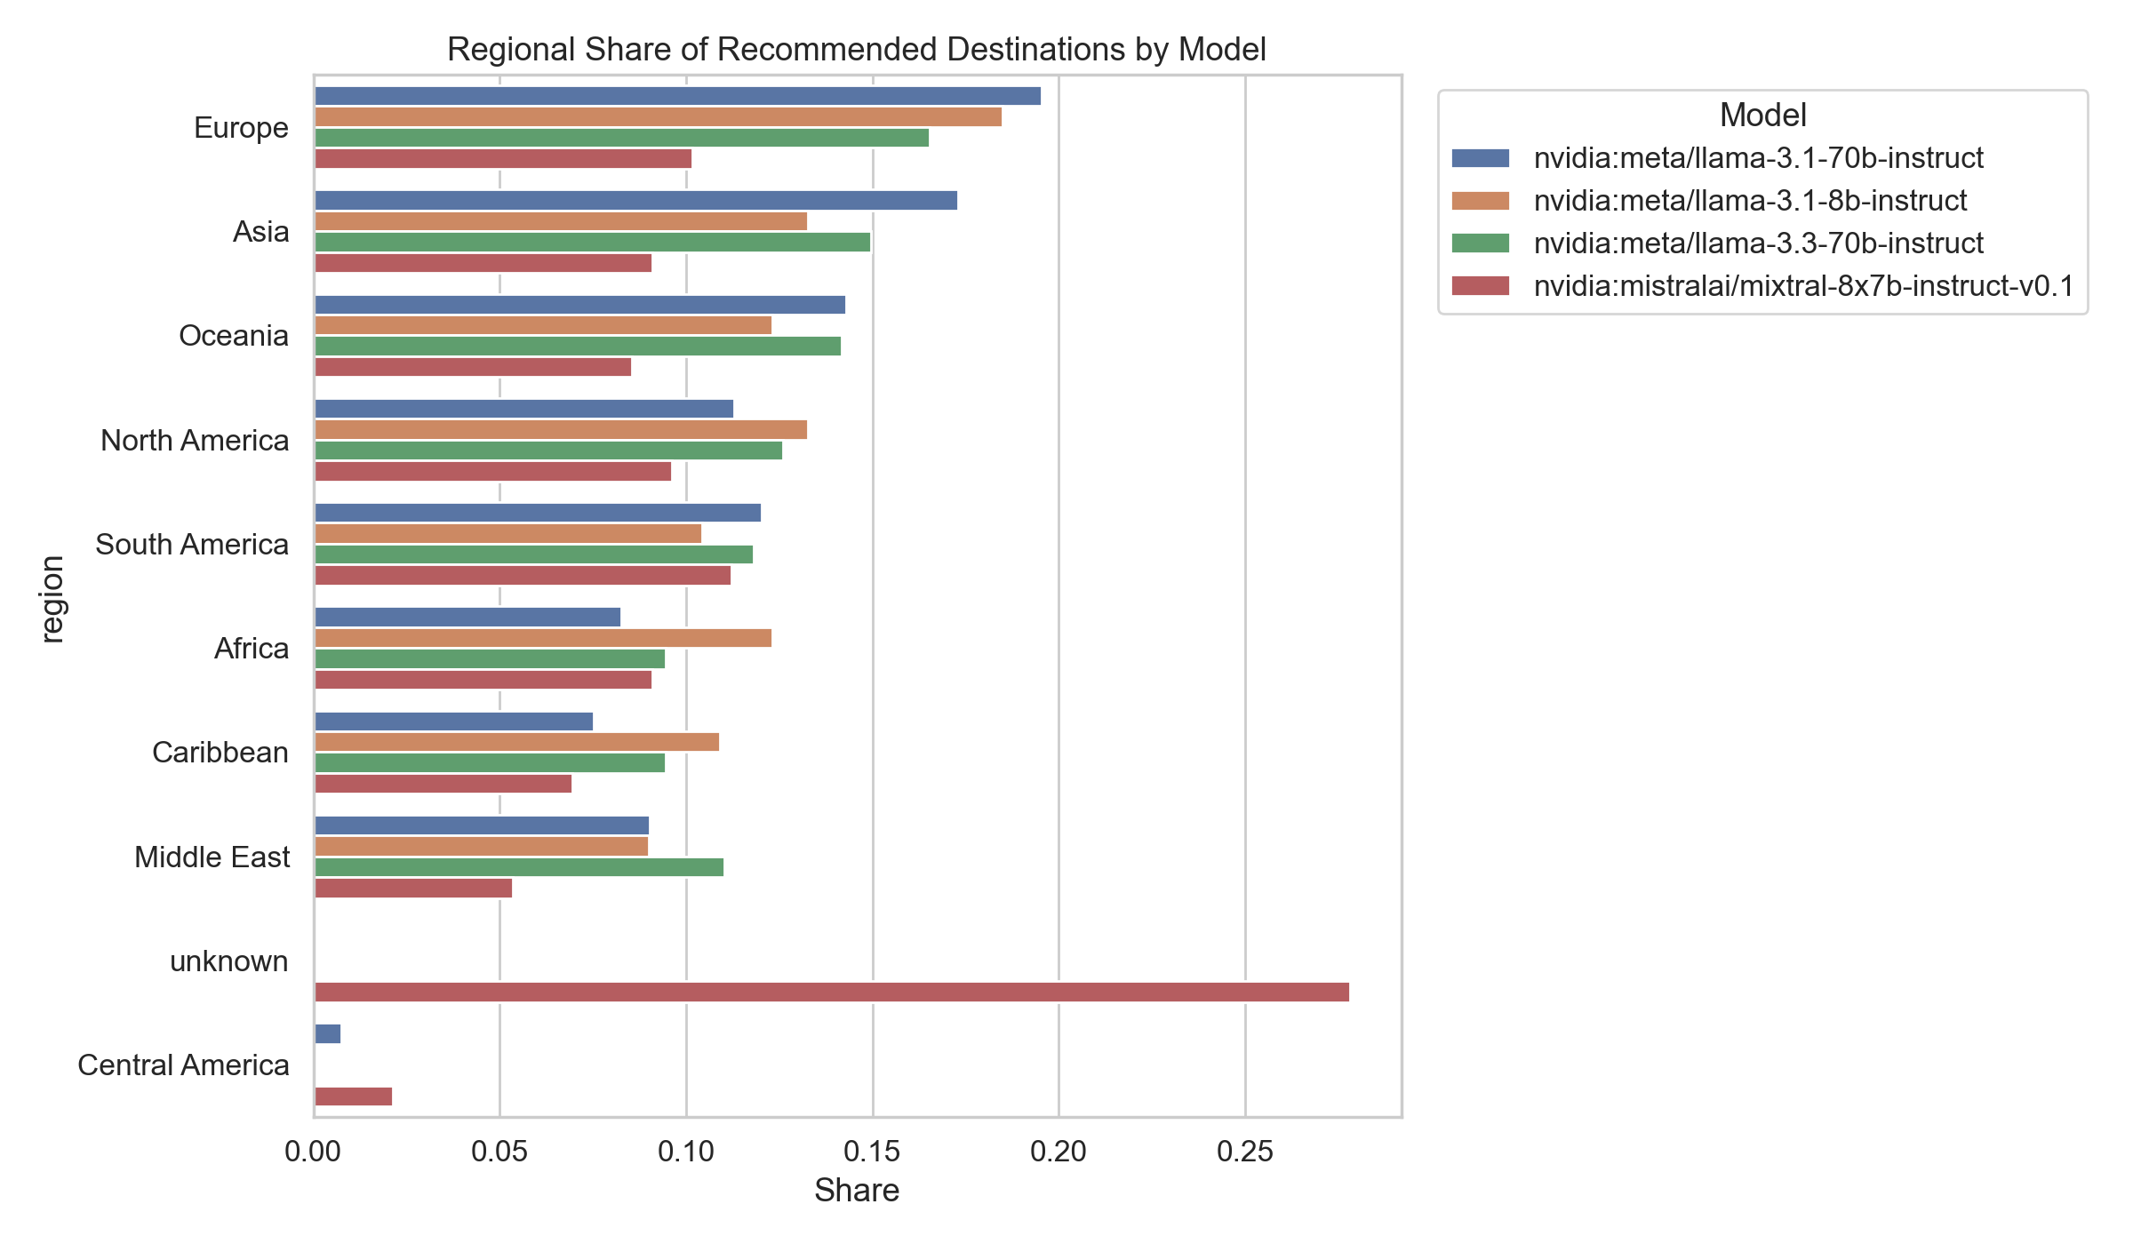
Figure 6: Regional Recommendation Shares by Model
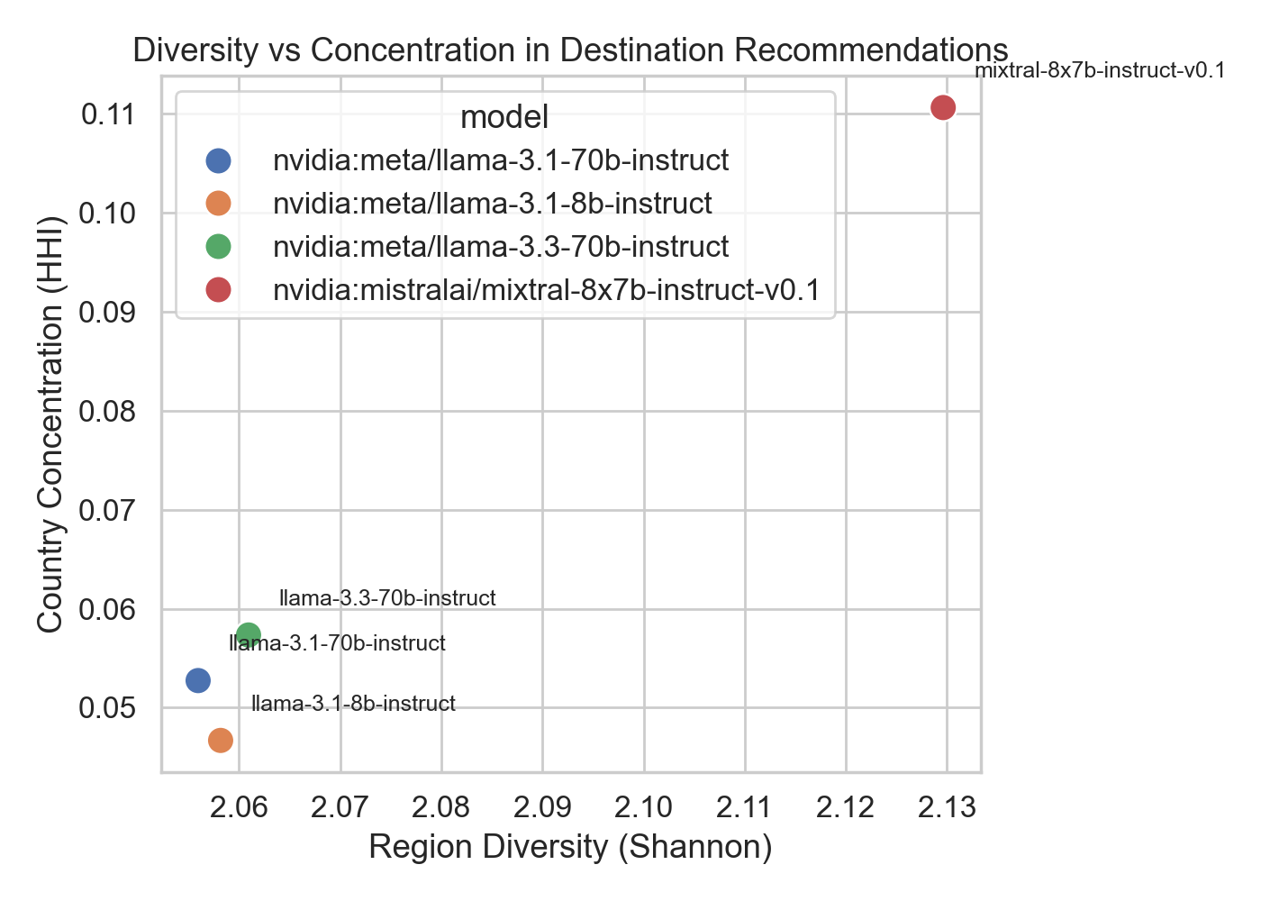
Figure 7: Diversity vs Concentration Tradeoff

VII. Results: Niche Gold Factuality
This module evaluates strict tourism factuality on 194 gold benchmark rows for two stable models.
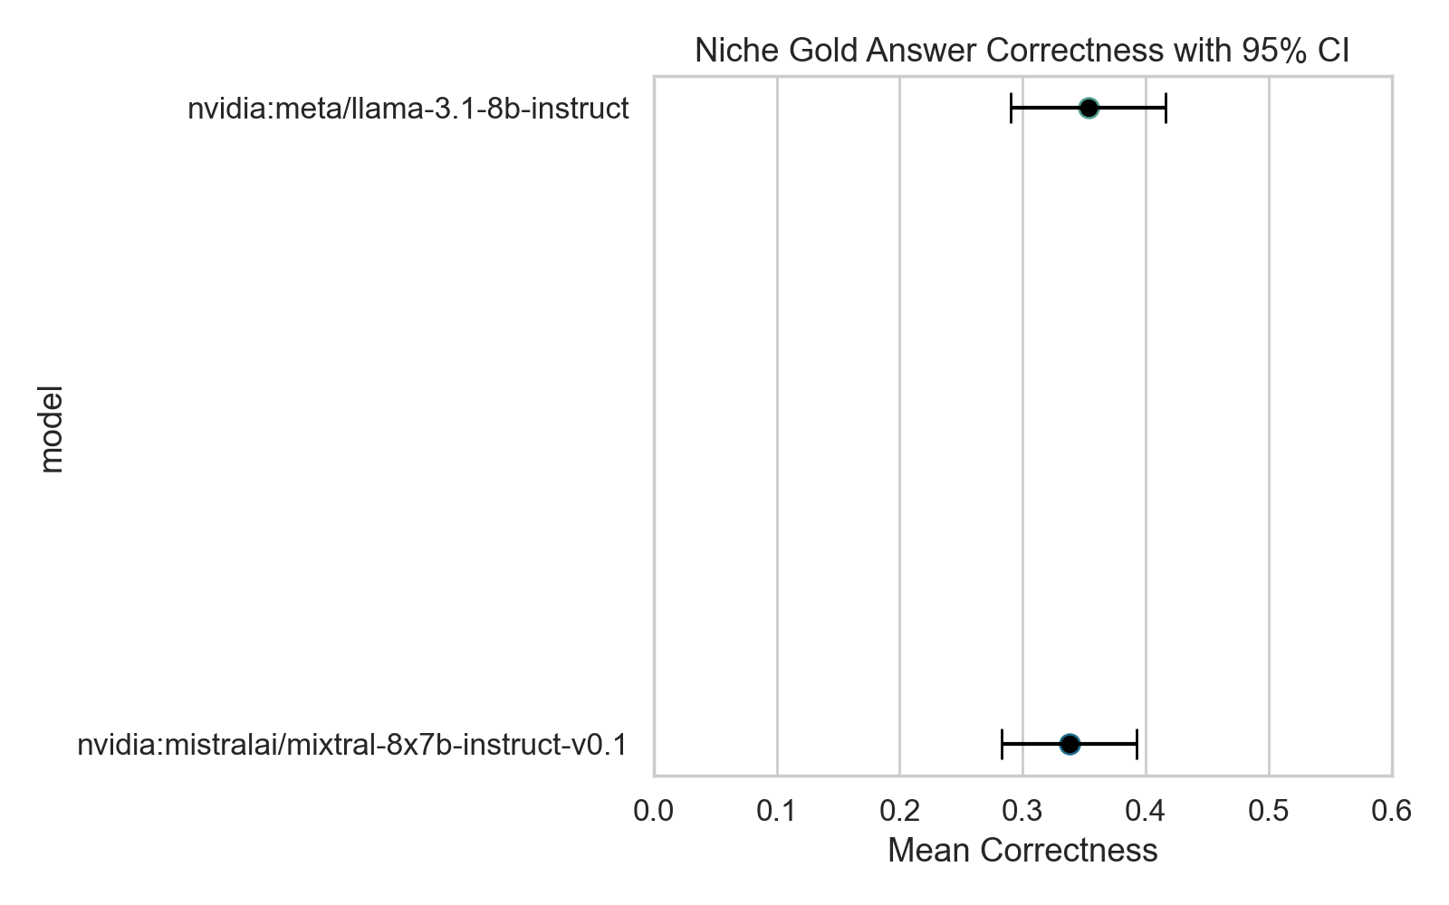
Figure 8: Niche Gold Answer Correctness with 95% CI

VIII. Results: Hallucination Claims
The hallucination claim module evaluates 286 extracted claims from 120 responses across two models.
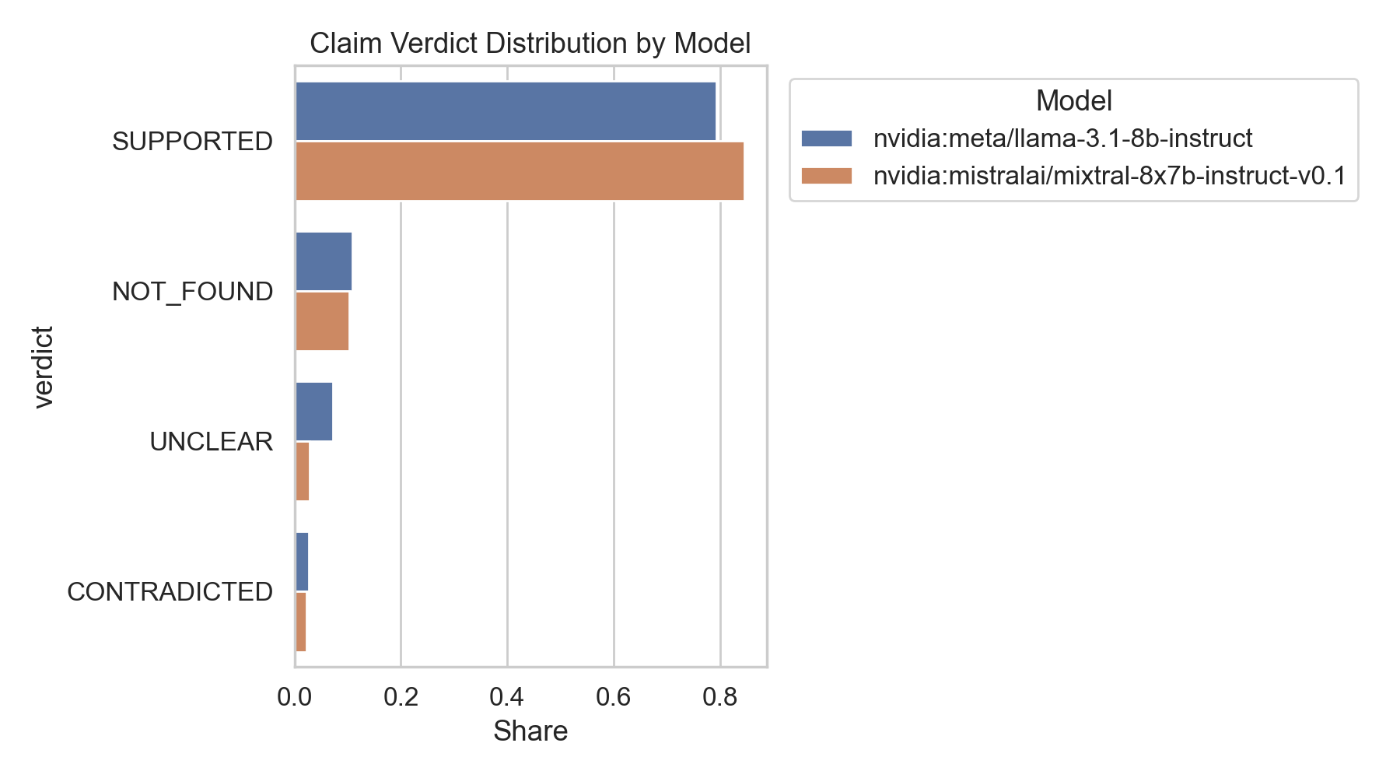
Figure 9: Claim Verdict Distribution by Model

IX. Comparative Model Performance
The NVIDIA-hosted 70B models experienced intermittent failures. The final analyses focus on the two most stable models.
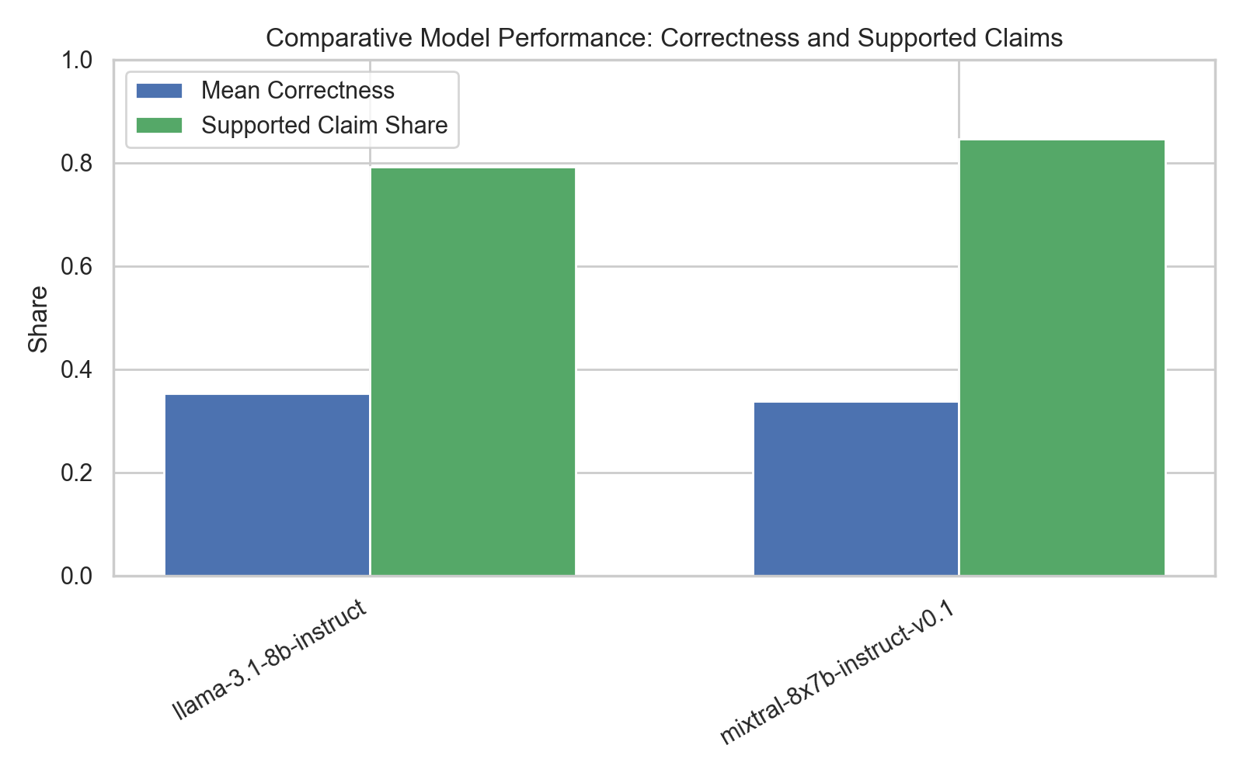
Figure 10: Comparative Model Performance

X. Discussion and Implications
These findings support a research narrative that modern LLMs are not yet reliable as standalone tourism advisors. Key observations include near-zero real-time accuracy, persistent geographic bias toward Europe, and weak strict factuality.
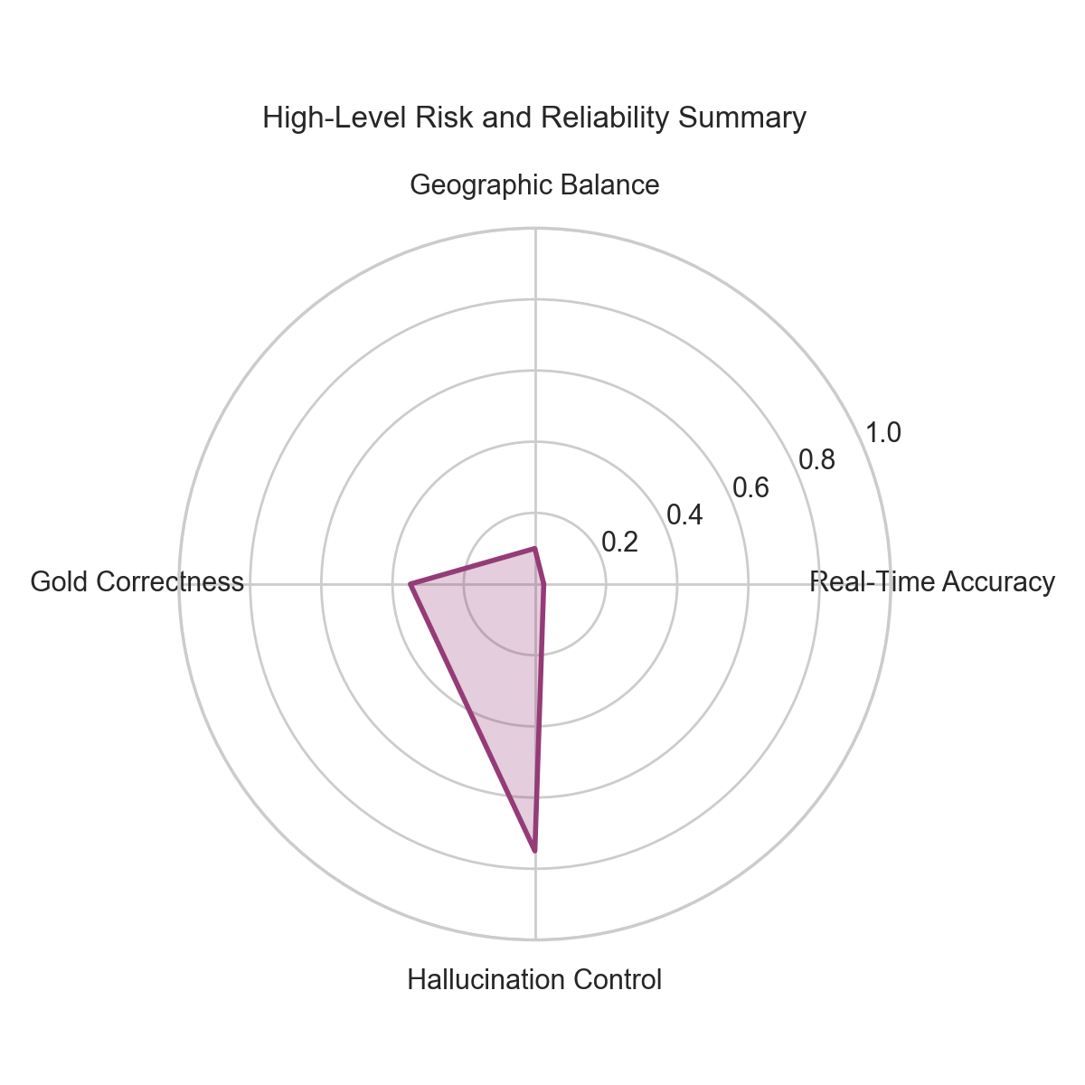
Figure 11: High-Level Risk and Reliability Summary

XI. Threats to Validity
We identify internal, external, and construct validity threats including endpoint connectivity issues and entity extraction quality dependencies.
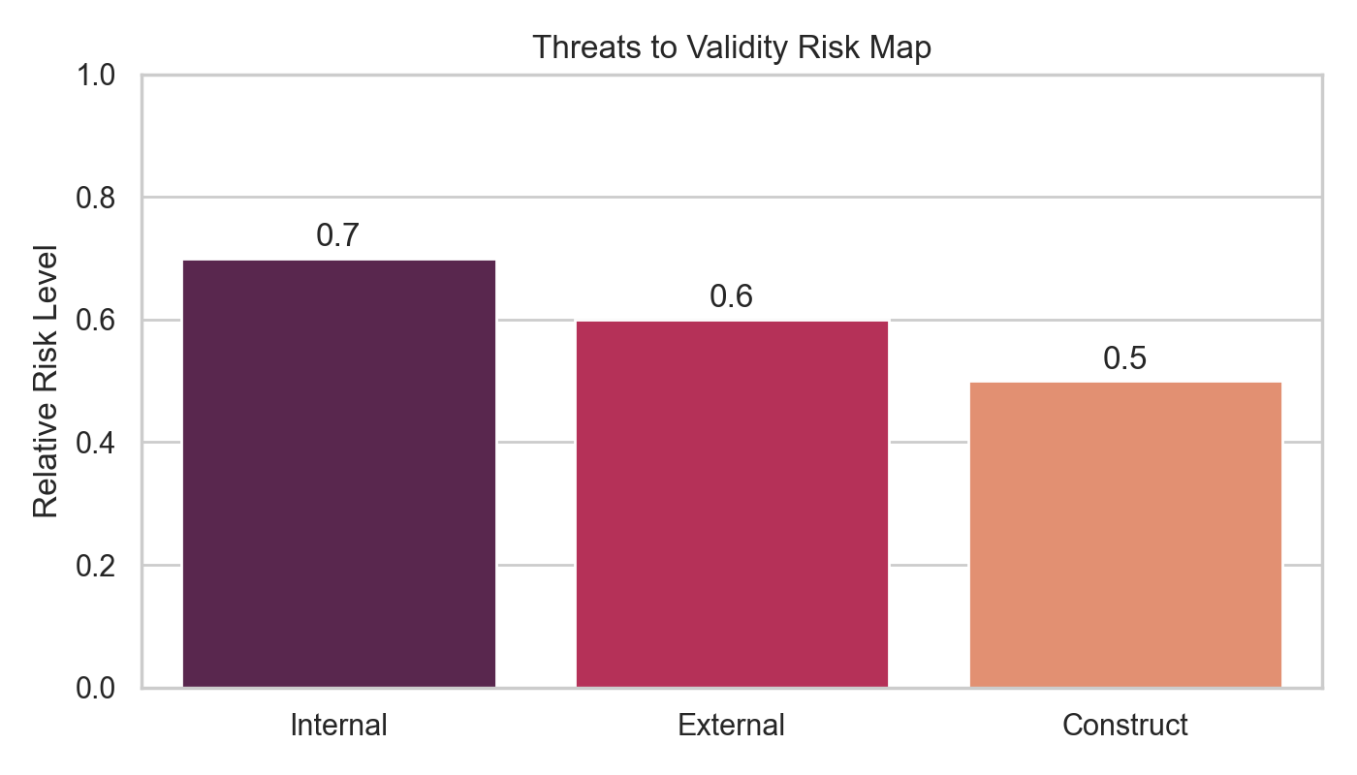
Figure 12: Threats to Validity Risk Map

XII. Conclusions and Future Work
This report documents that current NVIDIA-hosted LLMs have limited readiness for standalone tourism applications. Future work should extend to the full dataset, incorporate user studies, and evaluate retrieval-augmented architectures.

XIII. Appendix

A. Asset Summary
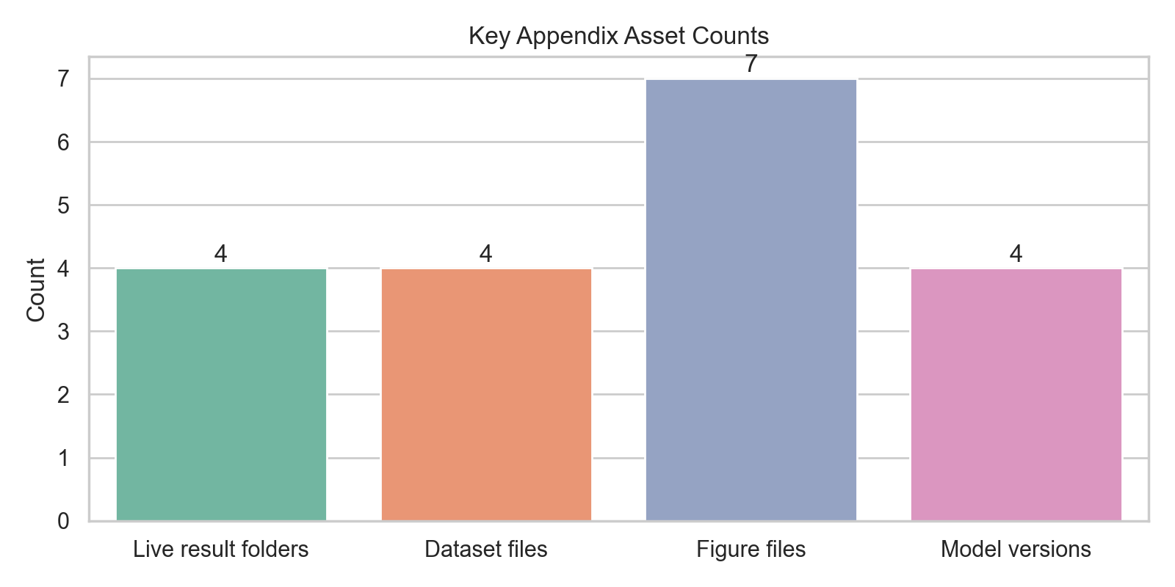
Figure 13: Appendix Asset Breakdown

