Direct Current Subtransmission Backbone for AI Factories:: A Position Paper with Source-Backed Architecture Modeling and OpenDSS Validation
Author Name(s) Here

Abstract
AI factories are becoming power-delivery-limited before they become compute-limited. The conventional response has been to improve the last portion of the power path, especially by introducing higher-voltage facility buses such as 800 VDC. That direction is necessary, but it is incomplete if alternating current still penetrates the campus deeply enough to recreate repeated conversion, distributed power-quality ownership, and reactive-power coordination across multiple pods or facility front ends. This paper takes the position that the next architectural step is to move the main AC/DC boundary upstream to the campus subtransmission interface and to treat the downstream campus as a DC-native system. To support that position, this paper combines a source-backed comparative architecture model with an OpenDSS quasi-static AC-boundary validation. Three scenarios are compared at a 100 MW delivered IT reference campus: Scenario 1, a traditional AC-centric path; Scenario 2, an NVIDIA-style 69 kV AC to 800 VDC perimeter-conversion path; and Scenario 3, a proposed 69 kV-class medium-voltage direct-current (MVDC) backbone feeding isolated DC pods and an 800 VDC facility bus. In the current source-backed model, the full-load end-to-end efficiencies are 87.55%, 91.96%, and 95.09%, respectively. The associated annual electrical-loss values are 124.54 GWh, 76.55 GWh, and 45.26 GWh. The dynamic-load analysis further shows that AI-factory power architecture should be evaluated under time-varying load envelopes, not only annual energy accounting. Most importantly, only Scenario 3 changes the campus architecture itself by establishing an MVDC backbone instead of simply improving the facility boundary. The OpenDSS layer independently confirms that pushing the AC boundary upstream reduces modeled AC-side feeder current, feeder loss, and point-of-common-coupling (PCC) voltage swing. The paper does not claim that the present model closes all deployment questions. Protection, grounding, harmonic compliance, and converter-control dynamics still require deeper study. The position advanced here is narrower and stronger: once AI factories are recognized as large, converter-rich, dynamic loads, a DC subtransmission backbone becomes the more coherent system architecture for scaling them.

Introduction
AI data centers are entering a regime in which electrical infrastructure increasingly determines scalability. Public demand forecasts already place data centers among the fastest-growing large loads on the grid, while recent AI-factory designs concentrate that demand into highly power-dense campuses [1, 2, 3]. At the same time, public and utility-facing studies now show that AI-training facilities behave as dynamic electrical loads rather than purely static loads [4, 5, 6]. These shifts mean that power architecture can no longer be framed as a rack-level efficiency detail alone.
The conventional campus path remains largely AC-centric. Power enters through AC subtransmission, continues through AC primary distribution, and then encounters a cascade of transformation and conversion stages before it reaches the GPU voltage-regulation stages. Even when modern facility designs adopt 800 VDC internally, AC often remains present up to the facility or pod boundary [7]. That approach improves the last segment of the power path, but it leaves the campus-level architecture partially unresolved.
This paper advances a position: the correct next move is to establish a DC subtransmission backbone. In that architecture, a common subtransmission AC/DC front end is placed at the campus entry. Downstream of that point, the campus backbone is DC-native, isolation is provided by isolated DC pods or DC transformers, and the facility side remains consistent with the emerging 800 VDC direction. The argument is not that every implementation detail has been solved. The argument is that this architecture is the right reference point for solving the remaining details.

Position
The central claim is that AI-factory power architecture should stop at neither the low-voltage bus nor the pod front end. If the load is increasingly DC-native and the dominant controllable resources such as batteries and photovoltaics are also DC-native, then extending AC deeply into the campus creates avoidable architectural friction.
This position rests on four propositions.
First, repeated high-power conversion stages create a multiplicative efficiency penalty. Optimizing only one stage cannot recover the architectural losses introduced by keeping several large stages in series [8, 9, 10].
Second, AI factories are dynamic loads. Public studies now describe periodic and grid-relevant power fluctuations in large AI-training sites, while utility measurements show that data-center-rich regions can exhibit nontrivial oscillatory behavior linked to power-electronic loads [4, 5, 6]. A campus architecture must therefore be judged by its dynamic interaction with the grid as well as by its steady-state efficiency.
Third, power-quality ownership becomes easier to define when the AC side is centralized. If the campus has one common AC/DC front end, then harmonics and power-factor behavior are concentrated at the grid interface rather than recreated at many downstream AC front ends.
Fourth, a DC backbone is a more natural integration domain for batteries, photovoltaics, and local energy buffers. That does not eliminate the need for sophisticated controls, but it removes unnecessary AC/DC/AC detours from the resource path.

Scenarios Under Comparison
This paper compares three scenarios derived from the supporting model files in the project workspace.
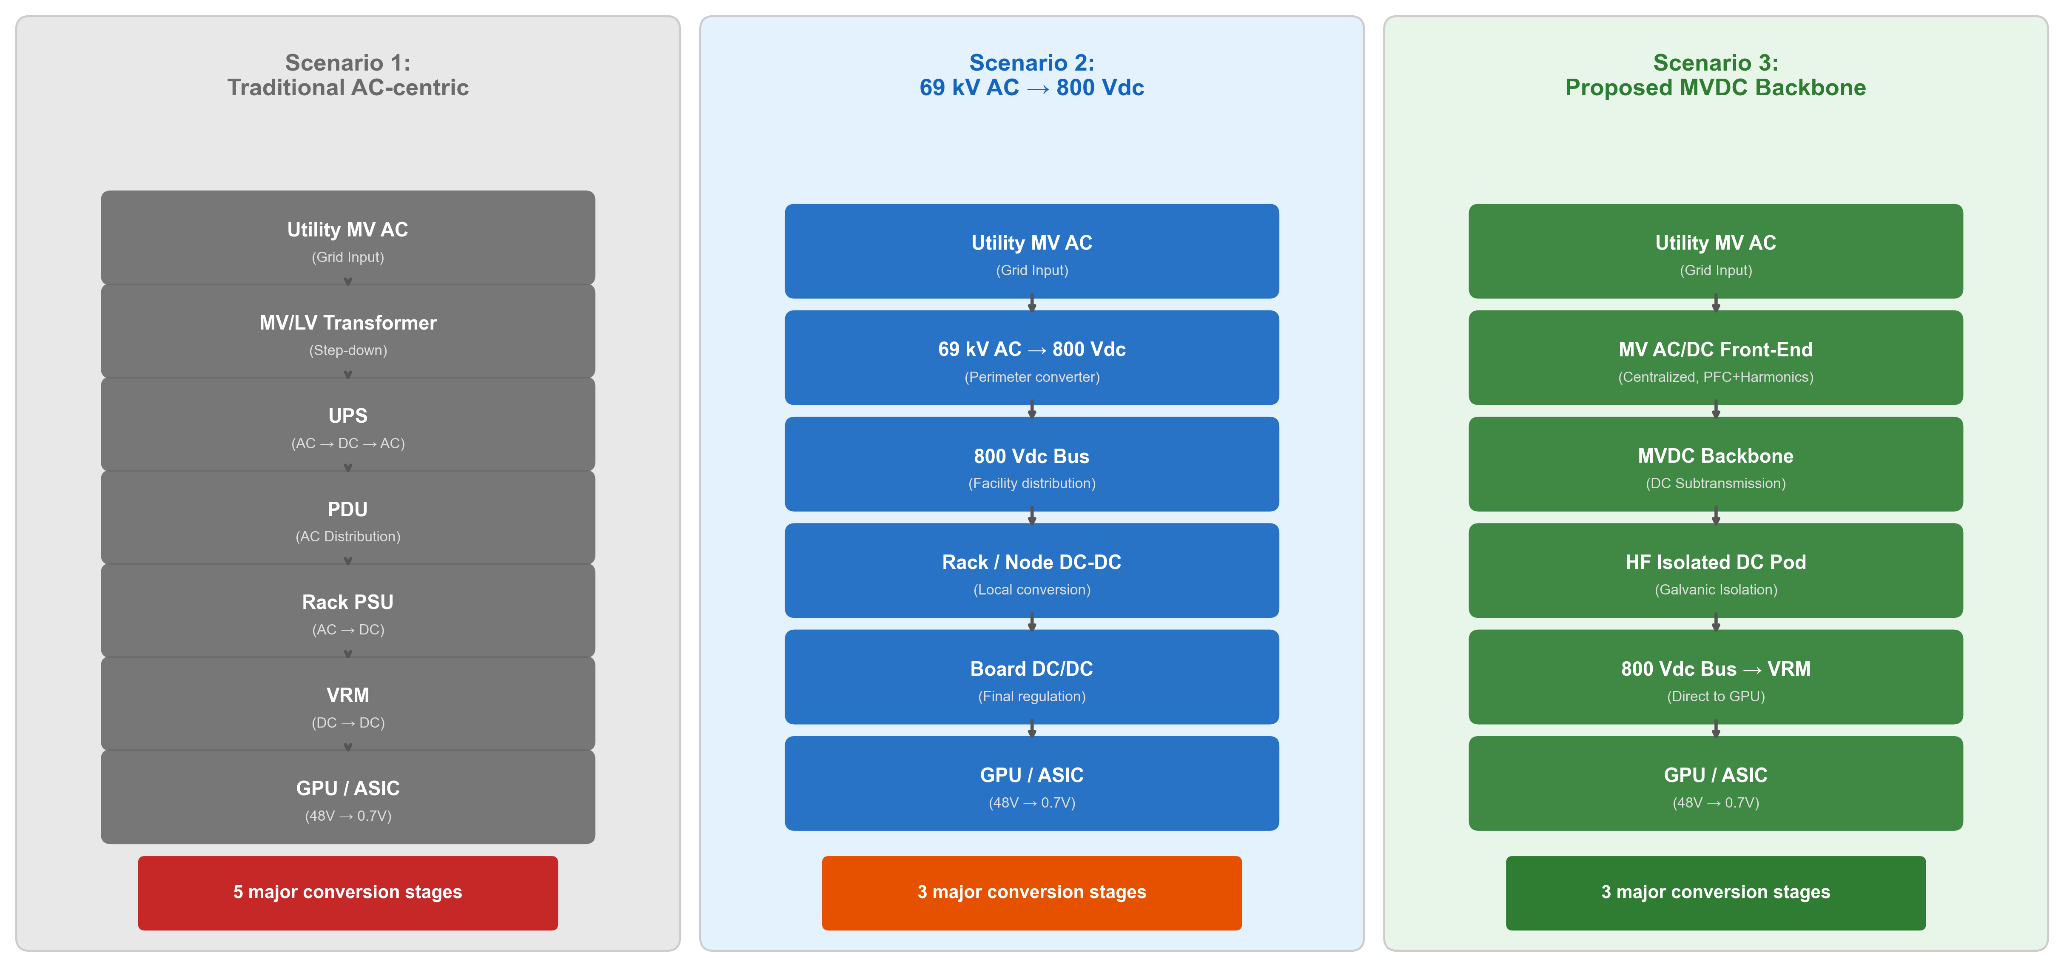
Three scenarios used throughout this paper. Scenario 3 moves the main AC/DC boundary upstream and keeps the campus DC-native downstream of the centralized front end.

Scenario 1: Traditional AC-centric baseline
The baseline keeps AC as the dominant campus-distribution domain. The representative path is a 69 kV AC campus feeder, medium-voltage to low-voltage transformation, facility UPS, low-voltage AC distribution, a PDU or transformer stage, server AC/DC conversion, and board-level DC/DC regulation.

Scenario 2: NVIDIA-style 69 kV AC to 800 VDC perimeter conversion
Scenario 2 is intended to reflect the direction of an 800 VDC facility while preserving AC upstream of the facility boundary. In the current scenario, a 69 kV AC campus feeder supplies a direct 69 kV AC to 800 VDC perimeter-conversion stage, followed by an 800 VDC facility bus, rack or node DC/DC conversion, and board-level DC/DC conversion. The 800 VDC downstream structure is source-backed; the 69 kV campus-side voltage is a local scenario assumption requested for this study [7]. Scenario 2 is therefore an important advanced comparator, but it still stops short of an MVDC backbone.

Scenario 3: Proposed MVDC backbone
Scenario 3 centralizes the AC/DC boundary at the campus entry. A centralized 69 kV-class AC/DC front end feeds an MVDC backbone, which then supplies isolated DC pods or DC transformers and finally the 800 VDC facility bus. Rack or node DC/DC conversion remains local to the IT load. This is the main architectural contribution of the paper. The key system-level change is not merely the use of better converters; it is the relocation of the main AC/DC boundary and the explicit introduction of the MVDC backbone as the campus organizing layer.

Modeling Framework

Source-backed architecture model
The first model layer is an architecture comparison model implemented in Python. It evaluates each path from the delivered IT load back to the upstream source by traversing a sequence of stages and conductors. The path efficiency is computed by combining stage efficiencies with conductor losses:
η_path = P_IT / P_source
Partial-load converter efficiencies are represented with source-backed or explicitly labeled proxy curves. The present assumptions are stored in a source-tagged JSON file so that each major input can be traced to a public source, a local scenario assumption, or a documented proxy.

Dynamic-load layer
The analytical model also includes dynamic AI-load cases. Two frequency anchors are used. The first is a 1.0 Hz reference point within the 0.1--5 Hz band that PNNL identifies as relevant for positive-sequence dynamic studies [4]. The second is a measured 14.8 Hz case drawn from a real data-center oscillation study in Dominion Energy territory [6]. Amplitude values are sensitivity cases rather than universal measured constants. For each case, the model estimates the raw PCC power swing and the native buffer power and energy that would be required at the architecture's natural support point.

OpenDSS validation layer
The second model layer uses OpenDSS as an AC-side quasi-static validation tool [11]. This layer is intentionally narrow. It does not attempt to model the internal MVDC backbone or the 800 VDC plant in electromagnetic-transient detail. Instead, it models the upstream AC source, the AC feeder or substation-side AC stub, and the equivalent downstream demand seen at that AC boundary.
For Scenarios 1 and 2, the first modeled 69 kV AC feeder is preserved in OpenDSS. For Scenario 3, the long AC feeder inside the campus is replaced by a short centralized-front-end AC stub because the AC/DC conversion is assumed to occur at the campus entry. This is a surrogate representation of the scenario boundary shift, not a claim of an already-standardized utility model.
The OpenDSS study is executed as a sequence of quasi-static snapshots over two cycles with 64 samples per cycle. At each time step, the downstream demand is updated from the analytical model and the resulting source power, feeder current, feeder loss, and PCC voltage are recorded.

Source basis and limitations
The strongest public anchors in this study come from the IEA, EIA, PNNL, official NVIDIA materials, Open Compute Project data, Schneider Electric specifications, and peer-reviewed literature on DC power conversion and data-center dynamics [1, 12, 3, 7, 4, 13, 14, 10, 6]. Some key quantities remain proxy-based, especially the exact partial-load curves for the centralized medium-voltage rectifier and the isolated DC pod stage. Those proxies are labeled accordingly in the model artifacts.

Results

Steady-state architecture results
Figure fig:efficiency shows the cumulative-efficiency thesis graphically, while Table tab:steady gives the current quantitative results for the 100 MW reference campus.
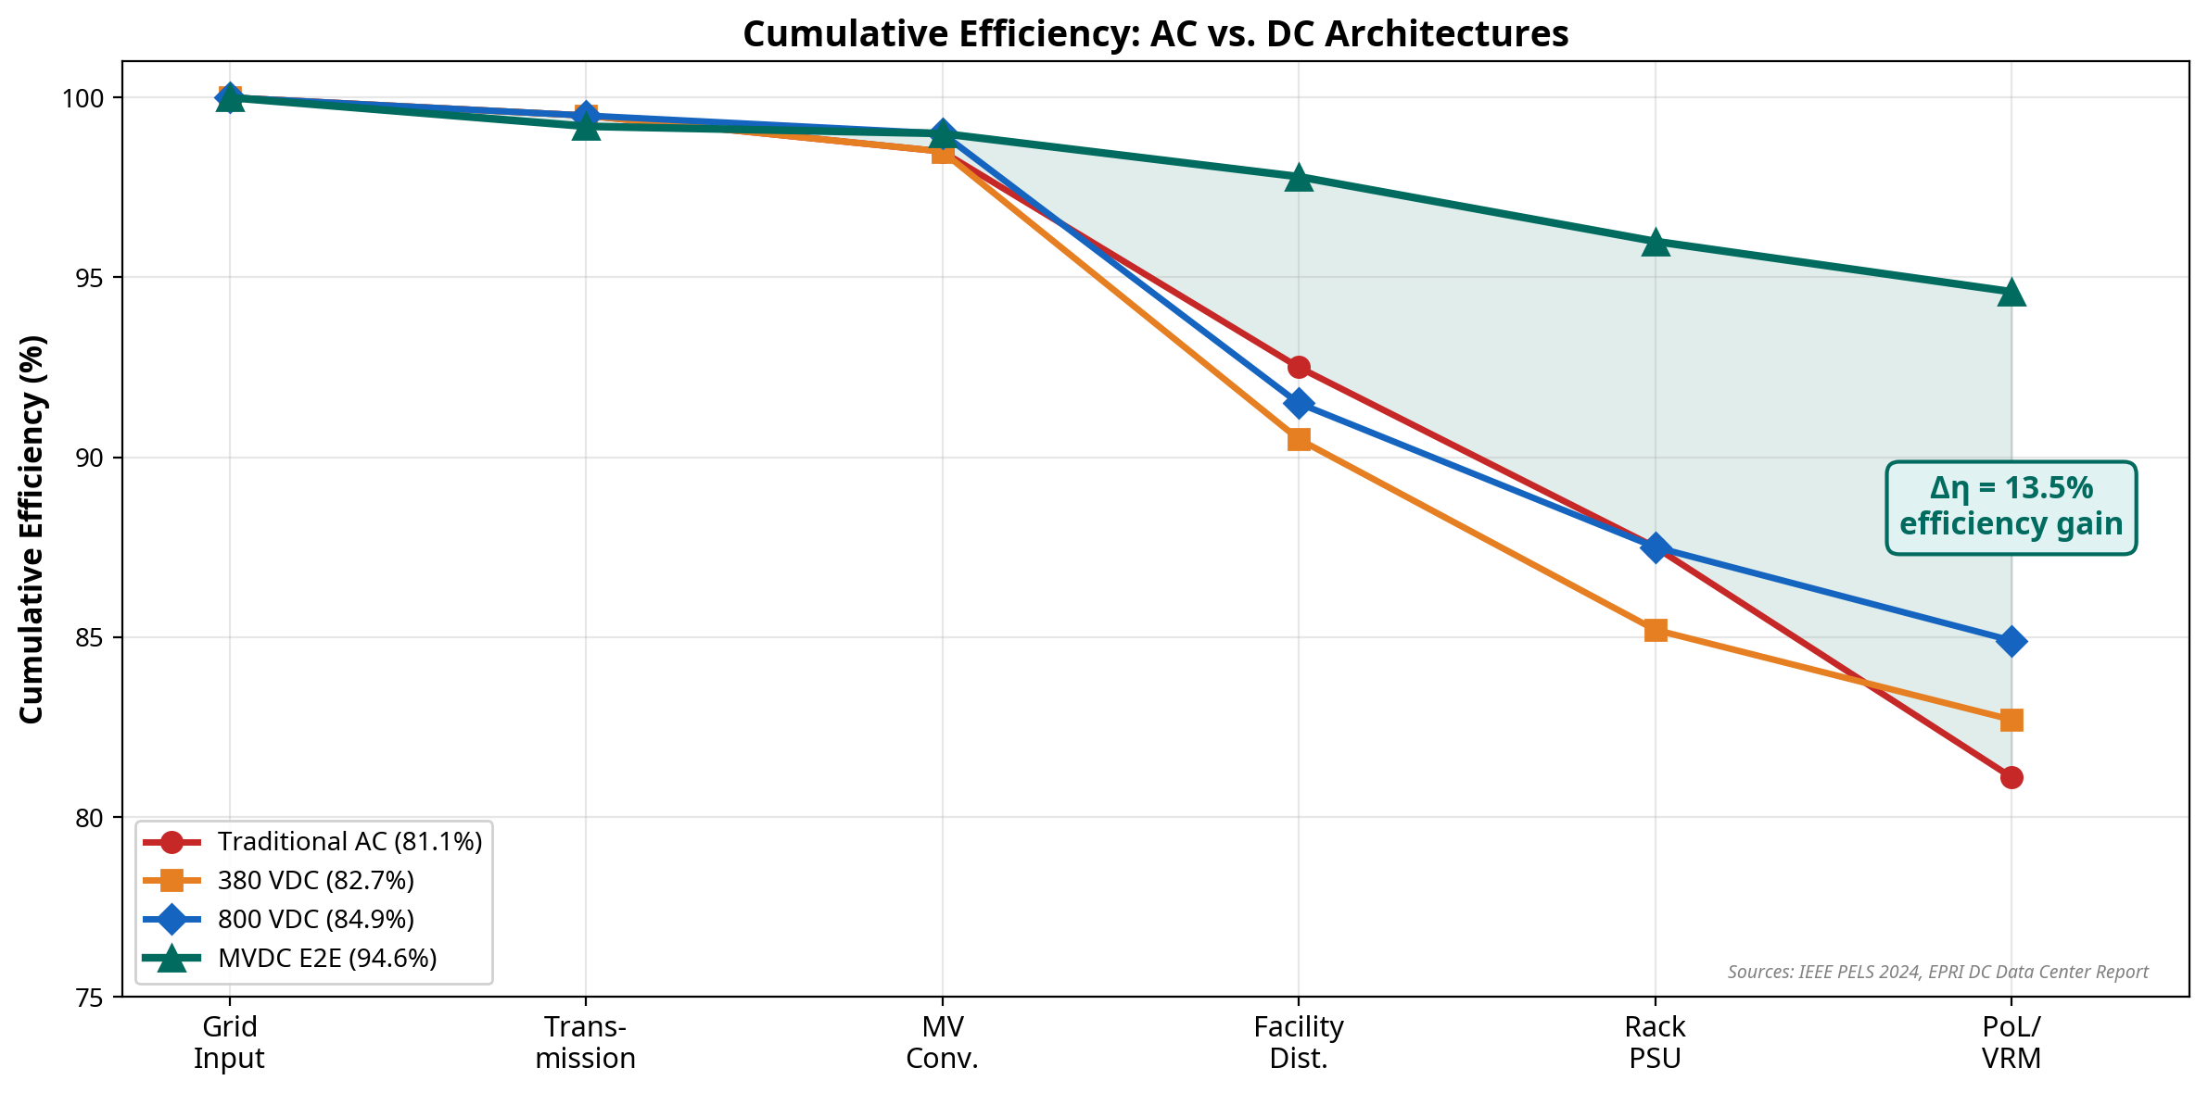
Cumulative-efficiency comparison for the three evaluated scenarios. The values shown are taken from the current source-backed model outputs.
Steady-state comparison at 100 MW delivered IT load
Scenario | Full-load eff. | Input MW | Loss GWh/yr | Loss cost (\$M/yr)
Scenario 1: Traditional AC-centric | 87.55% | 114.22 | 124.54 | 11.57
Scenario 2: 69 kV AC to 800 VDC perimeter conversion | 91.96% | 108.74 | 76.55 | 7.11
Scenario 3: Proposed MVDC backbone | 95.09% | 105.17 | 45.26 | 4.20

The steady-state result is materially traceable and architecturally significant. Scenario 3 is the important result, not only because it is numerically best, but because it is the only scenario that establishes the MVDC backbone. Relative to Scenario 1, Scenario 3 improves full-load efficiency by 7.54 percentage points and reduces annual electrical losses by 79.28 GWh in the present scenario. Relative to Scenario 2, Scenario 3 still improves full-load efficiency by 3.13 percentage points and reduces annual electrical losses by 31.29 GWh. That margin matters because it shows that the backbone itself adds value beyond the already-advanced 800 VDC perimeter-conversion concept.

Dynamic-load results
The need for a dynamic model is motivated by the public evidence that AI-training facilities can exhibit periodic power swings and grid-relevant interactions. Figure fig:gpu summarizes the dynamic-load motivation, and Table tab:dynamic presents selected dynamic results from the analytical model.
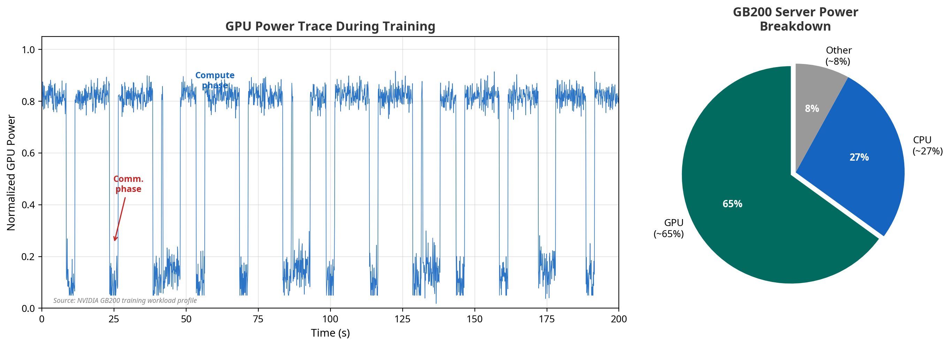
Motivation figure emphasizing the dynamic power profile of AI training and the dominance of GPU power in advanced AI systems.
Selected analytical dynamic-load results
Scenario | Case | Raw PCC peak (MW) | Native buffer (MW) | Native buffer (kWh)
Scenario 1: Traditional AC-centric | 1.0 Hz, 15% IT amplitude | 17.19 | 15.83 | 0.70
Scenario 2: 69 kV AC to 800 VDC perimeter conversion | 1.0 Hz, 15% IT amplitude | 16.38 | 15.67 | 0.69
Scenario 3: Proposed MVDC backbone | 1.0 Hz, 15% IT amplitude | 15.82 | 15.41 | 0.68
Scenario 1: Traditional AC-centric | 14.8 Hz, 10% IT amplitude | 11.45 | 10.55 | 0.03
Scenario 2: 69 kV AC to 800 VDC perimeter conversion | 14.8 Hz, 10% IT amplitude | 10.91 | 10.45 | 0.03
Scenario 3: Proposed MVDC backbone | 14.8 Hz, 10% IT amplitude | 10.53 | 10.27 | 0.03

Two points are important. First, the scenario ranking remains favorable to Scenario 3 when the load is treated dynamically rather than only statically. Second, the margin between scenarios is smaller in the dynamic power-swing metric than in the annual energy metric, which is exactly why dynamic modeling is required. A paper that only reported annual losses would miss an essential part of the AI-factory problem. The correct interpretation is therefore not that Scenario 3 only saves energy; it is that the MVDC backbone remains the strongest scenario even after the comparison is widened beyond steady-state efficiency.

OpenDSS AC-boundary validation
The OpenDSS results add an independent feeder-side perspective. Table tab:opendssbase reports the 100 MW base-case AC-boundary results, and Table tab:opendssstress reports selected dynamic stress results.
OpenDSS base-case AC-boundary validation
Scenario | Source MW | PCC min pu | Feeder loss (MW) | Peak current (A)
Scenario 1: Traditional AC-centric | 114.39 | 0.9707 | 0.194 | 1004
Scenario 2: 69 kV AC to 800 VDC perimeter conversion | 108.87 | 0.9722 | 0.175 | 955
Scenario 3: Proposed MVDC backbone | 105.16 | 0.9750 | 0.004 | 921

OpenDSS dynamic stress results at the AC boundary
Scenario | Case | Source peak (MW) | Max PCC swing | Peak feeder loss (MW)
Scenario 1: Traditional AC-centric | 1.0 Hz, 15% IT amplitude | 17.25 | 0.50% | 0.259
Scenario 2: 69 kV AC to 800 VDC perimeter conversion | 1.0 Hz, 15% IT amplitude | 16.45 | 0.47% | 0.234
Scenario 3: Proposed MVDC backbone | 1.0 Hz, 15% IT amplitude | 15.84 | 0.42% | 0.005
Scenario 1: Traditional AC-centric | 14.8 Hz, 10% IT amplitude | 11.49 | 0.33% | 0.236
Scenario 2: 69 kV AC to 800 VDC perimeter conversion | 14.8 Hz, 10% IT amplitude | 10.96 | 0.31% | 0.213
Scenario 3: Proposed MVDC backbone | 14.8 Hz, 10% IT amplitude | 10.54 | 0.28% | 0.005

These results materially strengthen the architectural case for Scenario 3. The comparison model alone shows that Scenario 3 has the lowest end-to-end loss. The OpenDSS layer adds that the same scenario also yields the lightest modeled AC-side burden at the campus boundary. In the present scenario, the AC-boundary feeder loss in Scenario 3 is approximately two orders of magnitude lower than in Scenarios 1 and 2 because the long campus-interior AC feeder is eliminated from the scenario definition. That does not prove a site-specific interconnection study result. It does show that the backbone architecture has a direct and favorable implication at the AC boundary.

Discussion
The results support three main conclusions: lower end-to-end loss, cleaner power-quality ownership, and simpler integration of DC-native resources. The evidence for each conclusion has a different strength, and that distinction matters.
The loss-reduction conclusion is supported most directly. The steady-state model shows a clear ranking across Scenario 1, Scenario 2, and Scenario 3, and that ranking remains meaningful even when Scenario 2 is included as a strong advanced comparator rather than only the traditional baseline. More importantly, the ranking shows that the MVDC backbone is not a cosmetic extension of the 800 VDC story. It is the architectural step that captures additional system-level value.
The power-quality conclusion is supported indirectly but credibly. The architecture comparison reduces the number of AC-side interaction points from four in the traditional case to one in the two advanced cases. The OpenDSS study does not compute harmonic spectra, so it does not replace a full IEEE 519 study. It does, however, show that the grid-facing AC boundary becomes cleaner and easier to define when the AC/DC conversion is centralized. This is an architectural precondition for stronger power-quality management even before a detailed harmonic study is performed.
The DC-native-integration conclusion is also supported directionally. The dynamic model's native-buffer calculations show that the natural support point of the MVDC architecture sits inside the DC domain rather than behind repeated AC boundaries. That does not yet quantify the best battery placement or control law. It does show that the architecture aligns the buffering problem with the same electrical domain as the load.
The present model is strong enough to defend three statements:
- Moving from Scenario 2 to Scenario 3, not only from Scenario 1 to Scenario 3, improves end-to-end electrical-path efficiency in the present source-backed scenario.
- AI-factory architecture should be evaluated under dynamic-load conditions, not only annual energy accounting.
- An AC-boundary OpenDSS validation shows lower feeder current, lower feeder loss, and lower PCC voltage swing when the campus-interior AC path is removed.
The paper should not yet claim that the present model proves exact harmonic compliance, exact converter-control stability margins, or deployable MVDC protection settings. Those are the right next topics, but they are not required for a strong position paper.

Research Priorities
The present results establish a defensible architecture-level case for an MVDC backbone, but several research questions remain open before the concept can be treated as deployment-ready. The most important next steps are the following.
- Protection and grounding: Develop equipment-specific fault-clearing, grounding, insulation-coordination, and sectionalization concepts for the MVDC backbone.
- Converter characterization: Replace proxy efficiency curves with vendor-qualified or experimentally measured curves for the centralized rectifier and isolated DC pod stages.
- PCC studies: Extend the present AC-boundary model into a site-specific interconnection study using utility Thevenin equivalents, harmonic limits, and short-circuit data.
- Dynamic controls: Move from the present quasi-static and analytical dynamic layers to converter-aware EMT studies with explicit control models for the centralized front end, isolated DC pod, and supporting buffers.
- Buffer placement: Determine the preferred placement and control role of subsecond energy buffers across the GPU, rack, pod, and backbone levels.
Among these topics, the highest-value next modeling step is an EMT-grade validation of the centralized front end, isolated DC pod, and buffer controls under weak-grid and disturbance scenarios. That step would materially strengthen the case that the architecture remains favorable not only in steady-state comparisons, but also under converter-driven transient conditions that matter for large AI-factory interconnections.

Conclusion
This paper argues that the next logical move after the 800 VDC facility bus is a DC subtransmission backbone. The position is motivated by three facts that now occur together: AI factories are becoming very large loads, they are increasingly dynamic loads, and the dominant controllable resources around them are already DC-native.
The current source-backed model supports that position. At the 100 MW reference campus, Scenario 3, the proposed MVDC backbone, achieves the best full-load efficiency and the lowest annual electrical losses among the three evaluated scenarios. The dynamic-load layer further shows that the architecture question does not disappear when AI loads are treated as time-varying. The OpenDSS validation adds a second, independent result: pushing the AC boundary upstream reduces the modeled AC-side feeder burden at the campus boundary.
The result is not a claim that every deployment question is finished. It is a claim that the right reference architecture has become visible. For AI factories, the higher-value move is no longer only a better facility front end. It is a campus architecture that treats the DC nature of the load as a first-order design principle.

Reproducibility Note
The quantitative results in this manuscript are generated from the project files dc\_backbone\_model.py, scientific\_assumptions\_v1.json, and source\_backed\_model\_report.json. The OpenDSS validation can be reproduced with:
python3 dc_backbone_model.py --run-opendss \
--save-json source_backed_model_report.json \
--write-memo MODEL_RESULTS_MEMO.md

References
[1] International Energy Agency, "Energy and AI." 2025. https://www.iea.org/reports/energy-and-ai/energy-demand-from-ai
[2] Lawrence Berkeley National Laboratory, "Berkeley Lab Report Evaluates Increase in Electricity Demand from Data Centers." 2025. https://newscenter.lbl.gov/2025/01/15/berkeley-lab-report-evaluates-increase-in-electricity-demand-from-data-centers/
[3] NVIDIA Corporation, "NVIDIA DGX SuperPOD GB200 Reference Architecture." 2025. https://docs.nvidia.com/dgx-superpod/reference-architecture-scalable-infrastructure-gb200/latest/dgx-superpod-architecture.html
[4] Pacific Northwest National Laboratory, "Electromagnetic Transient Modeling of Large Data Centers for Grid-Level Studies." Pacific Northwest National Laboratory, 2026. https://www.energy.gov/sites/default/files/2026-01/Data_Center_EMT_Models.pdf
[5] E. Choukse, B. Warrier, S. Heath, L. Belmont, A. Zhao, H. A. Khan, and others, "Power Stabilization for AI Training Datacenters." arXiv preprint arXiv:2508.14318, 2025. https://arxiv.org/abs/2508.14318
[6] C. Mishra, L. Vanfretti, J. Delaree Jr., T. J. Purcell, and K. D. Jones, "Understanding the inception of 14.7 Hz oscillations emerging from a data center." Sustainable Energy, Grids and Networks, vol. 43, pp. 101735, 2025. doi: 10.1016/j.segan.2025.101735.
[7] NVIDIA Corporation, "NVIDIA 800 V DC Architecture Will Power the Next Generation of AI Factories." 2025. https://developer.nvidia.com/blog/nvidia-800-v-hvdc-architecture-will-power-the-next-generation-of-ai-factories/
[8] A. Pratt, P. Kumar, and T. V. Aldridge, "Evaluation of 400V DC distribution in telco and data centers to improve energy efficiency." In Proc. 29th International Telecommunications Energy Conference (INTELEC), pp. 32-39, 2007. doi: 10.1109/INTLEC.2007.4448733.
[9] B. R. Shrestha, U. Tamrakar, T. M. Hansen, B. P. Bhattarai, S. James, and R. Tonkoski, "Efficiency and Reliability Analyses of AC and 380 V DC Distribution in Data Centers." IEEE Access, vol. 6, pp. 63305-63315, 2018. doi: 10.1109/ACCESS.2018.2877354.
[10] D. Rothmund, T. Guillod, D. Bortis, and J. W. Kolar, "99% Efficient 10 kV SiC-Based 7 kV/400 V DC Transformer for Future Data Centers." IEEE Journal of Emerging and Selected Topics in Power Electronics, vol. 7, no. 2, pp. 753-767, 2019. doi: 10.1109/JESTPE.2018.2886139.
[11] Electric Power Research Institute, "OpenDSS Overview." 2026. https://opendss.epri.com/OpenDSSOverview.html
[12] U.S. Energy Information Administration, "Electricity Monthly Update with Data for January 2026." 2026. https://www.eia.gov/electricity/monthly/update/end-use.php
[13] Open Compute Project, "Delta 18kW 1OU Open Rack v3 Power Shelf." 2026. https://www.opencompute.org/products/431/delta-18kw-1ou-open-rack-v3-power-shelf
[14] Schneider Electric, "Galaxy VX Technical Specifications." 2025. https://www.productinfo.schneider-electric.com/galaxyvx_iec/5ac76feb46e0fb00011d4e36/990-5850E%20400%20V%20Technical%20Specifications/English/990-5850N_EN.pdf

