1. Look at Exhibit 11b, why might comparing share price appreciation across firms be a bad way to measure CEO performance.

: Share price appreciation can be a bad way to measure CEO Performance because the share price is heavily dependent on the cycle of the industry. We can easily see that all the companies in the exhibit similar trends (ups & downs) in stock prices. This indicates that the CEO's individual competency in managing the company is not too relevant to the stock price growth.

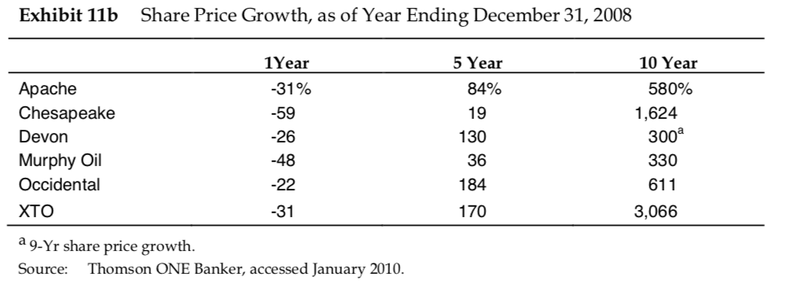

1. Look at Exhibit 11a, do you think that EPS growth is a good or bad metric in comparing CEO performance across firms (include a YES or NO in your response).

: Yes, EPS growth is a fairly good metric in comparing CEO performance. When evaluating the performance of management, the sales and net income should be core items to be factored. If we observe the numbers in the exhibit below, the EPS growth is fairly well aligning with sales and net income trends. Although it is not perfect, we can still say that EPS growth is a good enough metric.

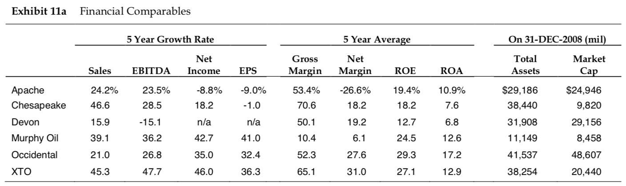

1. The compensation committee elected to keep the compensation decision more subjective than objective. If you were asked by the committee to pick objective measurements of CEO performance, which metrics would you pick for Chesapeake.

: If I were to choose metrics to measure CEO performance, I would choose margin and net income numbers. The margin shows how efficiently the CEO managed the operating cost. As the sales price of oil and gas is heavily dependent on the market, cost saving is the best metric for CEO’s competency. Also, net income shows how the CEO structured the capital distribution. Net income is what is left for the shareholder, after paying off interest on debt. Solid capital structure that maximizes the share for the equity holder is another important metric to measure CEO’s performance.

1. Do you believe a Founder Well Participation Program (FWPP) is in the best interest of shareholders? (include a YES or NO in your response)

: No / In the perspective of shareholders, FWPP is not an optimal compensation program. The CEO possibly wants to utilize FWPP to maximize his/her profit by investing not only with the CEO’s own equity but also with leveraged loans. These loans could come from private equity or other institutions. Eventually, the CEO could have debt risk, which he/she would not want to disclose to the shareholders, and also drive Chesapeake to pursue the short-term profit to make up his/her own loan related to FWPP. Moreover, if the CEO leveraged funds from industry-related companies or financial institutions, it could lead to a conflict of interest, jeopardizing shareholder value.

1. In 2008 Aubrey McClendon negotiated the sale of significant assets by the firm which resulted in a significant gain on the sale of the assets (see Exhibit 6). Also in 2008, most of Aubrey McClendon’s shares in the firm were sold, due to margin calls. What do you think would have been an appropriate way for the compensation committee to compensate Aubrey McClendon for the effect these asset sales had on the firm?

Proposal:

1. The compensation committee should give Aubrey McClendon less compensation.

2. The compensation package should comprise more company shares than cash.

Reason:

1. Since Aubrey McClendon is liquidating the firm, it is the committee's obligation to return more profit to the shareholder than distribute cash to the management team. Also, the gain of the sold asset is based on the original cost, so the intrinsic value of those assets may be significantly higher than the sell price. The company may be actually losing money.

2. Aubrey McClendon has sold many of his shares, due to the margin call. To align his financial interests with the company, the committee should give Aubrey McClendon more shares than cash.

1. Make a case for whether you believe the compensation committee’s overall proposal for Aubrey McClendon was in shareholders’ best interest (include a YES or NO, in your response).

: No, first, according to table D, 2008 CEO Compensation U.S.-based Companiesthe greatest paid, McClendon getting over $100 million in overall compensation. However, McClendon got this compensation regardless of a substantial drop in the business’s stock rate. The shareholders’ interests were harmed in this way.

Second, the board member Frederick Whittemore also served on Chesapeake’s compensation committee which helped determine how much the CEO should be paid to run Chesapeake. In that capacity, he helped determine how - and how much - McClendon would be paid. There were joint endeavors, which were unfair for shareholders.