Android Application Development
7F776
Lab Manual

B.Tech IV (IT) – I SEMESTER


DEPARTMENT OF INFORMATION TECHNOLOGY

SREE NIDHI INSTITUTE OF SCIENCE & TECHNOLOGY
(An Autonomous Institute)
Yamnampet, Ghatkesar, Hyderabad – 501 301

2021-2022

DEPARTMENT OF INFORMATION TECHNOLOGY
Department of Information Technology is established in the year 1999 to meet the requirements of the emerging IT industry/discipline. The Vision and the Mission of the department are
Vision
To emerge as a leading department in Technical Education and Research in Information Technology with focus to produce professionally competent and socially sensitive engineers capable of working in global environment.
Mission
a. To prepare Information Technology graduates to be a lifelong learner with competence in basic science & engineering and professional core, multidisciplinary areas , with continuous update of the syllabus, so that they can succeed in industry as an individual and as a team or to pursue higher studies or to become an entrepreneur.
b. To enable the graduates to use modern tools, design and create novelty based products required for the society and communicate effectively with professional ethics.
c. To continuously engage in research and projects development with financial management to promote scientific temper in the graduates and attain sustainability.
B.Tech (IT) Programme Educational Objectives (PEOs)
a. Graduates will have a strong foundation in fundamentals of mathematics, Physics, Chemistry, Computer Science and basic engineering knowledge with abilities for analysis of the problem and to design, development of solutions and to arrive at an optimal solution using modern tools which help them to be employable.
b. Ability to work in a team/ lead a team which needs effective communication skills and knowledge of project management, finance and entrepreneurial abilities.
c. Graduates should have abilities to conduct investigation of complex problems and attitude for lifelong learning skills which will enable them to pursue advanced studies, Research and Development.
d. The graduates must be aware of the engineering professional ethics, the impact of engineering profession on the society and the need for environmental protection and sustainable development.
The Programme Outcomes (POs) of the B.Tech (IT) programme, which every graduate must attain, are listed below:
- An ability to apply knowledge of basic sciences, mathematics and engineering in the area of Computer Science.
- An ability to design, implement and evaluate a software or software / hardware system to meet the desired needs within realistic constraints such as space and time.
- An ability to use the techniques, skills, and modern engineering tools such as software testing tools, data warehousing and mining tools, necessary for practice as a IT professional.
- An ability to analyze and solve open-ended problems using mathematical foundations, algorithmic principles, and computer science theory in the modeling and design of computer-based systems in a way that demonstrates comprehension of the tradeoffs involved in design choices and to arrive at an optimal solution.
- To understand principles of engineering, entrepreneurship with emphasis on women, and financial management through relevant management courses to demonstrate knowledge in the conceptualization and realizing group projects, mini & main projects.
- An ability to function effectively as individual and as a member or leader in diverse team in achieving multidisciplinary tasks.
- Learn to communicate effectively on complex engineering activities through report writing, experimental work, assignments, seminars, group projects, mini & main projects.
- To recognize the need for and have the preparation and ability to be a life-long learner through the courses such as seminars & projects.
- An ability to identify, formulate and analyze engineering problems.
- An ability to conduct investigation of complex problems in multidisciplinary areas.
- An understanding of professional ethics and responsibilities.
- An engineer should be aware of social, safety, cultural and information security issues and also responsibilities relevant to professional practice and skills.
- An ability to understand the impact of environmental protection and sustainable development.

a | b | c | d | e | f | g | h | i | j | k | l | m
 | H | H |  | H

Syllabus for B.Tech IV year I semester
Information Technology
ANDROID APPLICATION DEVELOPMENT LAB
Code: 7F776 L T P/D C
- - 4 2

EXPERIMENT NO.1

INSTALLING AND RUNNING APPLICATIONS ON ANDROID STUDIO

Step 1 - System Requirements
The required tools to develop Android applications are open source and can be downloaded from the Web. Following is the list of software's you will need before you start your Android application programming.
Java JDK5 or later version
Java Runtime Environment (JRE) 6 Android Studio

Step 2 - Setup Android Studio

Android Studio is the official IDE for android application development.It works based on IntelliJ IDEA, You can download the latest version of android studio from Android Studio 2.2 Download, If you are new to installing Android Studio on windows,you will find a file, which is named as android-studio-bundle-143.3101438-windows.exe.So just download and run on windows machine according to android studio wizard guideline.
If you are installing Android Studio on Mac or Linux, You can download the latest version from Android Studio Mac Download,or Android Studio Linux Download, check the instructions provided along with the downloaded file for Mac OS and Linux. This tutorial will consider that you are going to setup your environment on Windows machine having Windows 8.1 operating system. Installation
So let's launch Android Studio.exe,Make sure before launch Android Studio, Our Machine should required installed Java JDK. To install Java JDK,take a references of Android environment setup
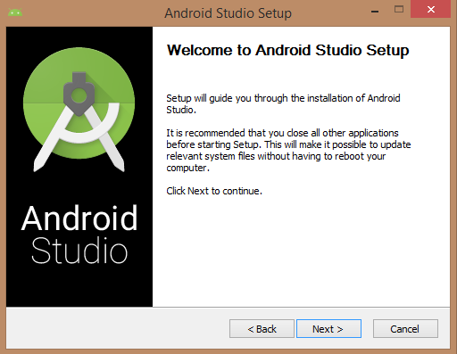
Once you launched Android Studio, its time to mention JDK7 path or later version in android studio installer.
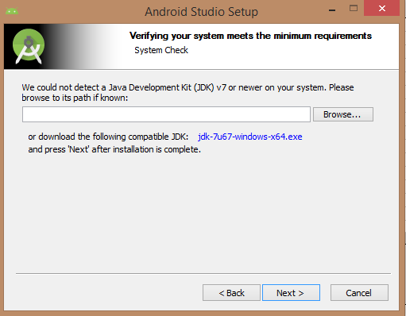
Below the image initiating JDK to android SDK
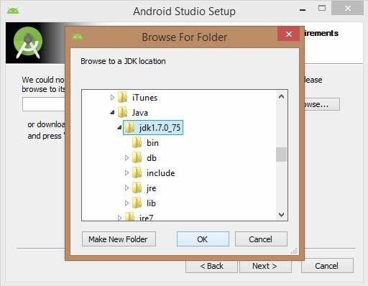
Need to check the components, which are required to create applications, below the image has selected Android Studio, Android SDK, Android Virtual Machine and performance(Intel chip).
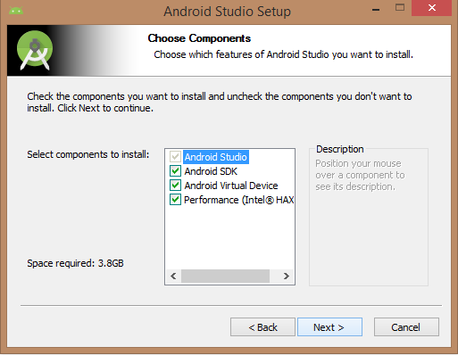
Need to specify the location of local machine path for Android studio and Android SDK, below the image has taken default location of windows 8.1 x64 bit architecture.
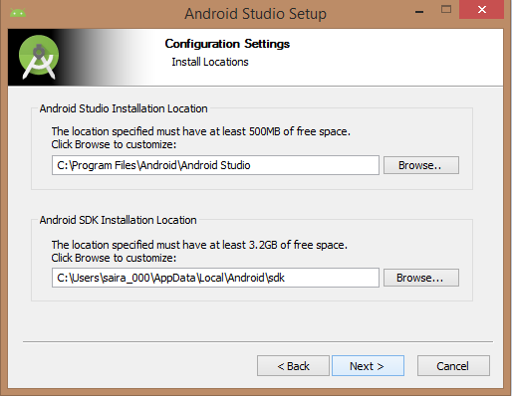
Need to specify the ram space for Android emulator by default it would take 512MB of local machine RAM.
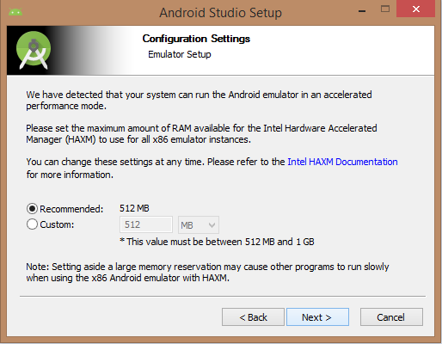
At final stage, it would extract SDK packages into our local machine, it would take a while time to finish the task and would take 2626MB of Hard disk space.
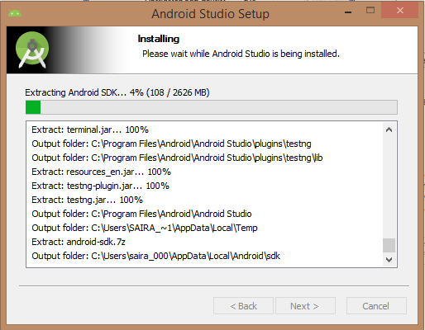
After done all above steps perfectly, you must get finish button and it gonna be open android studio project with Welcome to android studio message as shown below
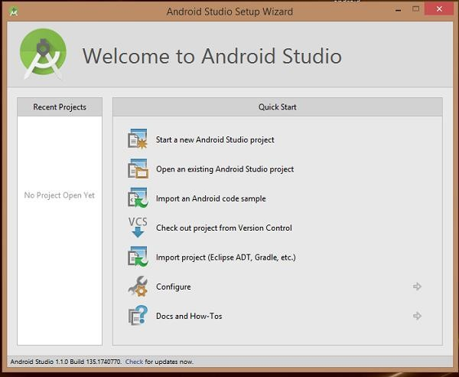
You can start your application development by calling start a new android studio project. in a new installation frame should ask Application name, package information and location of the project.
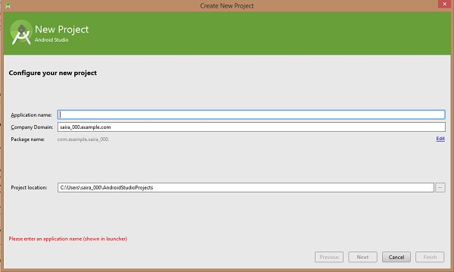
After entered application name, it going to be called select the form factors your application runs on, here need to specify Minimum SDK, in our tutorial, I have declared as API23: Android 6.0(Mashmallow)
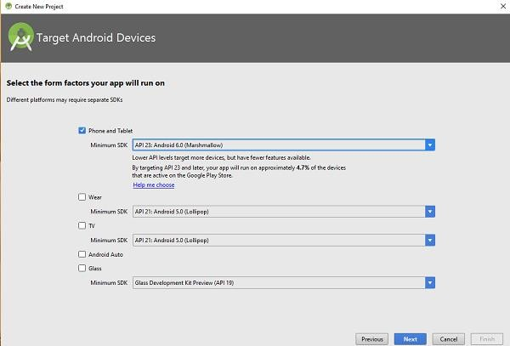
The next level of installation should contain selecting the activity to mobile, it specifies the default layout for Applications
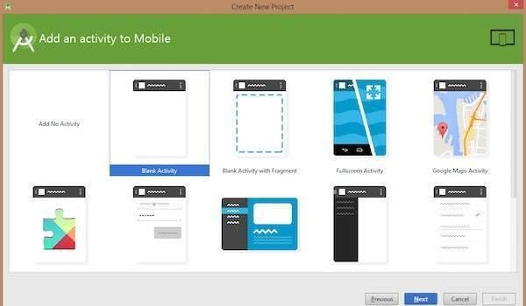
At the final stage it going to be open development tool to write the application code.
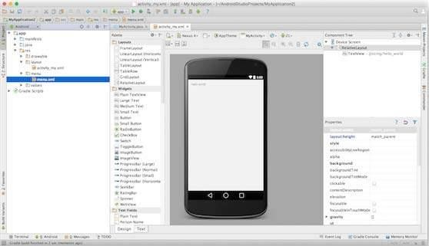
Step 3 - Create Android Virtual Device
To test your Android applications, you will need a virtual Android device. So before we start writing our code, let us create an Android virtual device. Launch Android AVD Manager Clicking AVD_Manager icon as shown below
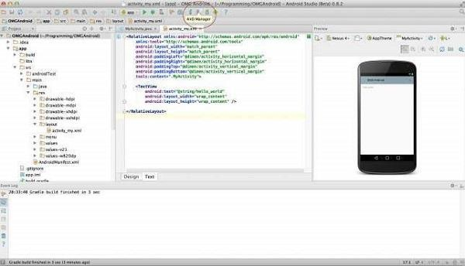
After Click on a virtual device icon, it going to be shown by default virtual devices which are present on your SDK, or else need to create a virtual device by clicking Create new Virtual device button
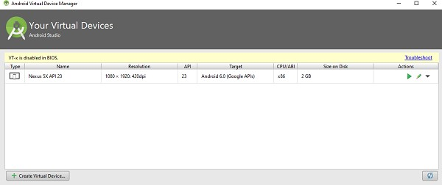
If your AVD is created successfully it means your environment is ready for Android application development. If you like, you can close this window using top-right cross button. Better you re- start your machine and once you are done with this last step, you are ready to proceed for your first Android example but before that we will see few more important concepts related to Android Application Development.

2. DEVELOPMENT OF HELLO WORLD APPLICATION

AIM: To design an android application to display Hello World
First step is to create a simple Android Application using Android studio. When you click on Android studio icon, it will show screen as shown below
You can start your application development by calling start a new android studio project. in a new installation frame should ask Application name, package information and location of the project.−
Configure the Hello World Project Details
We'll finish creating the project by configuring some details about its name, location, and the API version it
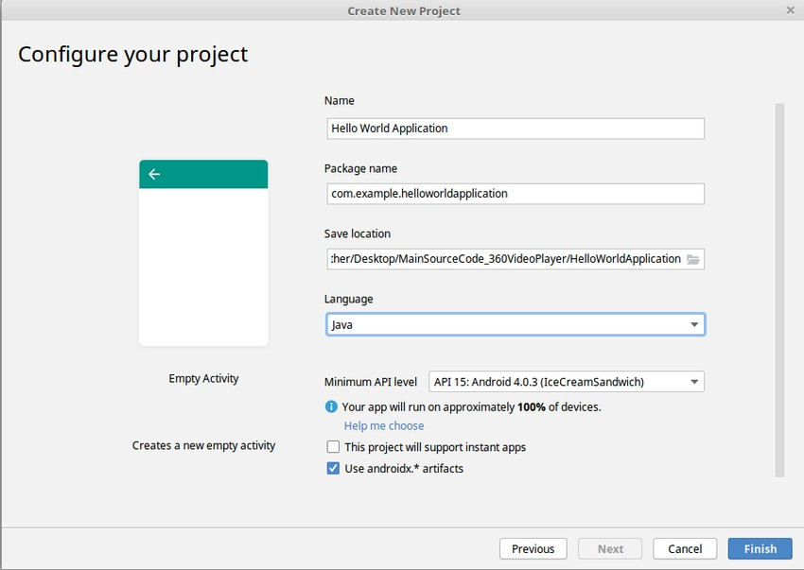
Change the name of the application. Change the default Project location to your preferred directory or just leave it as the default location.
On the minimum API level, ensure that API 15: Android 4.0.3 IceCreamSandwich is set as the Minimum SDK. This ensures that your application runs on almost all devices.

The next level of installation should contain selecting the activity to mobile, it specifies the default layout for Applications.

SOURCE CODE :
The Main Activity File
The main activity code is a Java file MainActivity.java. This is the actual application file which ultimately gets converted to a Dalvik executable and runs your application

package com.example.helloworldapplication;

import androidx.appcompat.app.AppCompatActivity; import android.os.Bundle;
public class MainActivity extends AppCompatActivity {

@Override
protected void onCreate(Bundle savedInstanceState) { super.onCreate(savedInstanceState); setContentView(R.layout.activity_main);
}
}

The Layout File
The activity_main.xml is a layout file available in res/layout directory, that is referenced by your application when building its interface. You will modify this file very frequently to change the layout of your application. For your "Hello World!" application, this file will have following content related to default layout −

<RelativeLayout xmlns:android="http://schemas.android.com/apk/res/android" xmlns:tools="http://schemas.android.com/tools" android:layout_width="match_parent" android:layout_height="match_parent" >

<TextView android:layout_width="wrap_content" android:layout_height="wrap_content" android:layout_centerHorizontal="true" android:layout_centerVertical="true" android:padding="@dimen/padding_medium" android:text="@string/hello_world" tools:context=".MainActivity" />

I )Running app on Phone:

Connect your Phone to Computer

Plug in your device to your computer with a USB cable. If you're developing on Windows, you might need to install this universal ADB USB driver or find your specific USB driver for your device.

Enable USB Debugging
The next step is to enable USB debugging so your phone can interact with your computer in a developer mode.
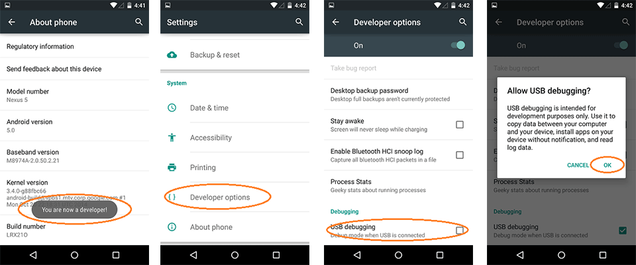

The following steps are needed:

- (Windows Only) Install this ADB Driver
- Plug-in your Android Device to Computer via USB
- Open the "Settings" App on the Device
- Scroll down to bottom to find "About phone" item
- Scroll down to bottom to find "Build number" section
- Tap on "Build Number" 7 times in quick succession
- You should see the message "You are now a developer!"
- Go back to main "Settings" page
- Scroll down bottom to find "Developer options" item
- Turn on "USB Debugging" switch and hit "OK"
- Unplug and re-plug the device
- Dialog appears "Allow USB Debugging?"
- Check "Always allow from this computer" and then hit "OK"

Running your App

Now, we can launch apps from Android Studio onto our device:

- Select one of your projects and click "Run" from the toolbar.
- In the "Choose Device" window that appears, select the "Choose a running device" radio button, select the device, and click OK.

II) Running app on Emulator(AVD)

To run the app from Android studio, open one of your project's activity files and click Run icon from the tool bar. Android studio installs the app on your AVD and starts it and if everything is fine with your set-up and application, it will display following Emulator window −Once Gradle finishes building, Android Studio should install the app on your connected device and start it.

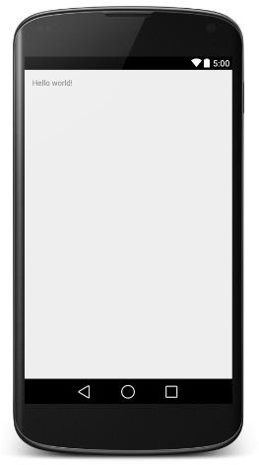

- Create an application that takes the name from a text box and shows hello message along with the name entered in text box, when the user clicks the OK button.

Code for MainActivity.java
package com.example.it.snist; import android.os.Bundle;
import android.support.v7.app.AppCompatActivity; import android.view.View;
import android.widget.Button; import android.widget.EditText; import android.widget.TextView;

public class MainActivity extends AppCompatActivity {
// These are the global variables EditText editName, editPassword; TextView result;
Button buttonSubmit, buttonReset;

@Override
protected void onCreate(Bundle savedInstanceState) { super.onCreate(savedInstanceState); setContentView(R.layout.activity_main);

editName = (EditText) findViewById(R.id.editName); editPassword = (EditText) findViewById(R.id.editPassword); result = (TextView) findViewById(R.id.tvResult); buttonSubmit = (Button) findViewById(R.id.buttonSubmit); buttonReset = (Button) findViewById(R.id.buttonReset);
/*
Submit Button
*/
buttonSubmit.setOnClickListener(new View.OnClickListener() {

@Override
public void onClick(View v) {
String name = editName.getText().toString();
String password = editPassword.getText().toString(); result.setText("Name:\t" + name + "\nPassword:\t" + password );

}
});
/*
Reset Button
*/
buttonReset.setOnClickListener(new View.OnClickListener() { @Override
public void onClick(View v) { editName.setText(""); editPassword.setText(""); result.setText(""); editName.requestFocus();
}
});
}
}

activity_main.xml
<?xml version="1.0" encoding="utf-8"?>
<RelativeLayout xmlns:android="http://schemas.android.com/apk/res/android" xmlns:app="http://schemas.android.com/apk/res-auto" xmlns:tools="http://schemas.android.com/tools" android:layout_width="match_parent" android:layout_height="match_parent"
android:background="#FFFF8D" tools:context="com.example.it.snist.MainActivity">

<TextView android:id="@+id/textView"
android:layout_width="wrap_content" android:layout_height="wrap_content" android:layout_alignParentLeft="true" android:layout_alignParentStart="true" android:layout_alignParentTop="true" android:text="NAME" android:textSize="20sp" android:layout_margin="20dp" />

<TextView android:id="@+id/textView2"
android:layout_width="wrap_content" android:layout_height="wrap_content" android:textSize="20sp" android:text="PASSWORD" android:layout_marginTop="38dp" android:layout_below="@+id/textView" android:layout_alignLeft="@+id/textView" android:layout_alignStart="@+id/textView" />

<EditText android:id="@+id/editName"
android:layout_width="wrap_content" android:layout_height="wrap_content" android:ems="10" android:inputType="textPersonName" android:hint="Enter Name" android:layout_alignParentTop="true" android:layout_alignParentRight="true" android:layout_alignParentEnd="true" android:layout_alignLeft="@+id/editPassword" android:layout_alignStart="@+id/editPassword" />

<EditText android:id="@+id/editPassword" android:layout_width="wrap_content" android:layout_height="wrap_content" android:ems="10"
android:hint="Enter Password" android:inputType="textPassword" android:layout_alignBottom="@+id/textView2" android:layout_alignParentRight="true" android:layout_alignParentEnd="true" android:layout_marginRight="18dp" android:layout_marginEnd="18dp" />

<Button android:id="@+id/buttonSubmit" android:layout_width="wrap_content" android:layout_height="wrap_content" android:layout_alignParentLeft="true" android:layout_alignParentStart="true"
android:layout_below="@+id/textView2" android:layout_marginTop="20dp" android:text="SUBMIT" />
<Button android:id="@+id/buttonReset"
android:layout_width="wrap_content" android:layout_height="wrap_content" android:text="RESET" android:layout_alignBaseline="@+id/buttonSubmit" android:layout_alignBottom="@+id/buttonSubmit" android:layout_centerHorizontal="true" />

<TextView android:id="@+id/tvResult"
android:layout_width="wrap_content"

android:layout_height="wrap_content" android:layout_alignParentBottom="true" android:layout_alignParentLeft="true" android:layout_alignParentStart="true" android:layout_marginBottom="143dp" android:textSize="30sp" />
</RelativeLayout>

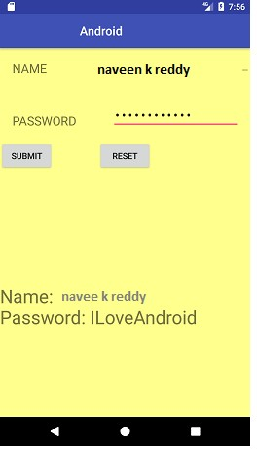

- Create a screen that has input boxes for User Name, Password, Address, Gender(radio buttons for male and female), Age (numeric) and a Submit button. On clicking the submit button, print all the data below the Submit Button (use any layout)

Code for MainActivity.java

package com.example.it2.snist; import android.os.Bundle;
import android.support.v7.app.AppCompatActivity; import android.view.View;
import android.widget.Button; import android.widget.EditText; import android.widget.TextView;

public class MainActivity extends AppCompatActivity {
// These are the global variables
EditText editName, editPassword,editAddress,editAge; TextView result;
RadioGroup radioGenderGroup;
ivate RadioButton radioGenderButton; Button buttonSubmit;

@Override
protected void onCreate(Bundle savedInstanceState) { super.onCreate(savedInstanceState); setContentView(R.layout.activity_main);

editName = (EditText) findViewById(R.id.editName); editPassword = (EditText) findViewById(R.id.editPassword); editAddress = (EditText) findViewById(R.id.editAddres); editAge = (EditText) findViewById(R.id.editAge);
radioSexGender = (RadioGroup) findViewById(R.id.radioGender);

result = (TextView) findViewById(R.id.tvResult); buttonSubmit = (Button) findViewById(R.id.buttonSubmit);
buttonSubmit.setOnClickListener(new View.OnClickListener() {

@Override
public void onClick(View v) {
String name = editName.getText().toString();
String password = editPassword.getText().toString(); String address= editAddress.getText().toString();
int selectedId = radioGenderGroup.getCheckedRadioButtonId();

// find the radiobutton by returned id
gen = (RadioButton) findViewById(selectedId);

result.setText("Name:\t" + name + "\nPassword:\t" + password+ "\nAddredd:\t" + address+ "\nAGE:\t" + age+ "\nGender:\t" + gen);

}
});

}
}

activity_main.xml
<?xml version="1.0" encoding="utf-8"?>
<RelativeLayout xmlns:android="http://schemas.android.com/apk/res/android" xmlns:app="http://schemas.android.com/apk/res-auto" xmlns:tools="http://schemas.android.com/tools" android:layout_width="match_parent" android:layout_height="match_parent"
android:background="#FFFF8D" tools:context="com.example.it2.snist.MainActivity">

<TextView android:id="@+id/textView"
android:layout_width="wrap_content" android:layout_height="wrap_content" android:layout_alignParentLeft="true" android:layout_alignParentStart="true" android:layout_alignParentTop="true" android:text="NAME" android:textSize="20sp" android:layout_margin="20dp" />

<TextView android:id="@+id/textView2"
android:layout_width="wrap_content" android:layout_height="wrap_content" android:textSize="20sp" android:text="PASSWORD" android:layout_marginTop="38dp" android:layout_below="@+id/textView"
android:layout_alignLeft="@+id/textView" android:layout_alignStart="@+id/textView" />

<EditText android:id="@+id/editName"
android:layout_width="wrap_content" android:layout_height="wrap_content" android:ems="10" android:inputType="textPersonName" android:hint="Enter Name" android:layout_alignParentTop="true" android:layout_alignParentRight="true" android:layout_alignParentEnd="true" android:layout_alignLeft="@+id/editPassword" android:layout_alignStart="@+id/editPassword" />

<EditText android:id="@+id/editPassword" android:layout_width="wrap_content" android:layout_height="wrap_content" android:ems="10"
android:hint="Enter Password" android:inputType="textPassword" android:layout_alignBottom="@+id/textView2" android:layout_alignParentRight="true" android:layout_alignParentEnd="true" android:layout_marginRight="18dp" android:layout_marginEnd="18dp" />
<EditText
android:id="@+id/editAddress" android:layout_width="wrap_content" android:layout_height="wrap_content" android:layout_marginRight="18dp" android:layout_marginEnd="18dp" />
<EditText
android:id="@+id/editAge" android:layout_width="wrap_content" android:layout_height="wrap_content"
android:layout_marginRight="18dp" android:layout_marginEnd="18dp" />
<RadioGroup
android:id="@+id/radioGender" android:layout_width="wrap_content" android:layout_height="wrap_content" >

<RadioButton android:id="@+id/radioMale" android:layout_width="wrap_content"
android:layout_height="wrap_content" android:text="@string/radio_male" android:checked="true" />

<RadioButton android:id="@+id/radioFemale" android:layout_width="wrap_content" android:layout_height="wrap_content" android:text="@string/radio_female" />

</RadioGroup>

<Button android:id="@+id/buttonSubmit" android:layout_width="wrap_content" android:layout_height="wrap_content" android:layout_alignParentLeft="true" android:layout_alignParentStart="true"
android:layout_below="@+id/textView2" android:layout_marginTop="20dp" android:text="SUBMIT" />

<TextView android:id="@+id/tvResult"
android:layout_width="wrap_content" android:layout_height="wrap_content" android:layout_alignParentBottom="true" android:layout_alignParentLeft="true" android:layout_alignParentStart="true" android:layout_marginBottom="143dp" android:textSize="30sp" /></RelativeLayout>

Design an android application to create page using Intent and one Button and pass the Values from one Activity to second Activity.
AIM: To design an android application to design a page using Intent and one Button and pass the Values from one Activity to second Activity.

Main Activity Java File
package com.example.transferofdata; import android.os.Bundle;
import android.app.Activity; import android.content.Intent; import android.view.Menu; import android.view.View;
import android.view.View.OnClickListener; import android.widget.Button;
import android.widget.EditText;
public class MainActivity extends Activity
{
@Override
protected void onCreate(Bundle savedInstanceState)
{
super.onCreate(savedInstanceState); setContentView(R.layout.activity_main);
final EditText et=(EditText)findViewById(R.id.editText1); final EditText et1=(EditText)findViewById(R.id.editText2); Button send=(Button)findViewById(R.id.button1); send.setOnClickListener(new OnClickListener()
{
@Override
public void onClick(View arg0)
{
String s=et.getText().toString(); String s1=et1.getText().toString();
Intent it=new Intent(MainActivity.this,Second.class); it.putExtra("uname", s);
it.putExtra("pwd", s1); startActivity(it);
}
});
}
@Override
public boolean onCreateOptionsMenu(Menu menu)
{
getMenuInflater().inflate(R.menu.main, menu); return true;
}
}

SecondActivity.java
package com.example.transferofdata; import android.os.Bundle;
import android.app.Activity; import android.view.Menu; import android.widget.TextView;
public class Second extends Activity
{
@Override
protected void onCreate(Bundle savedInstanceState)
{
super.onCreate(savedInstanceState); setContentView(R.layout.activity_second);
TextView tv=(TextView)findViewById(R.id.textView1); TextView tv1=(TextView)findViewById(R.id.textView2); tv.setText(getIntent().getExtras().getString("uname")); tv1.setText(getIntent().getExtras().getString("pwd"));
}
@Override
public boolean onCreateOptionsMenu(Menu menu)
{
getMenuInflater().inflate(R.menu.second, menu); return true;
}
}

MainActivity.xml

<RelativeLayout xmlns:android="http://schemas.android.com/apk/res/android" xmlns:tools="http://schemas.android.com/tools" android:layout_width="match_parent"
android:layout_height="match_parent" android:paddingBottom="@dimen/activity_vertical_margin" android:paddingLeft="@dimen/activity_horizontal_margin" android:paddingRight="@dimen/activity_horizontal_margin" android:paddingTop="@dimen/activity_vertical_margin" tools:context=".MainActivity" >
<Button android:id="@+id/button1"
android:layout_width="wrap_content" android:layout_height="wrap_content" android:layout_alignParentLeft="true" android:layout_alignParentTop="true" android:layout_marginLeft="78dp" android:layout_marginTop="154dp" android:text="send" />
<EditText android:id="@+id/editText1" android:layout_width="wrap_content"
android:layout_height="wrap_content" android:layout_alignParentTop="true" android:layout_alignRight="@+id/button1" android:layout_marginTop="18dp" android:ems="10" ><requestFocus /></EditText>
<EditText android:id="@+id/editText2"
android:layout_width="wrap_content" android:layout_height="wrap_content" android:layout_alignRight="@+id/button1" android:layout_below="@+id/editText1" android:layout_marginTop="37dp" android:ems="10"
android:inputType="textPassword" /></RelativeLayout>

SecondActivity.xml

<RelativeLayout xmlns:android="http://schemas.android.com/apk/res/android" xmlns:tools="http://schemas.android.com/tools" android:layout_width="match_parent"
android:layout_height="match_parent" android:paddingBottom="@dimen/activity_vertical_margin" android:paddingLeft="@dimen/activity_horizontal_margin" android:paddingRight="@dimen/activity_horizontal_margin" android:paddingTop="@dimen/activity_vertical_margin" tools:context=".Second" >
<TextView android:id="@+id/textView1" android:layout_width="wrap_content" android:layout_height="wrap_content" android:layout_alignParentLeft="true" android:layout_alignParentTop="true" android:layout_marginLeft="42dp" android:layout_marginTop="70dp" android:text="uname" />
<TextView android:id="@+id/textView2" android:layout_width="wrap_content" android:layout_height="wrap_content"
android:layout_alignLeft="@+id/textView1" android:layout_below="@+id/textView1" android:layout_marginLeft="15dp"
android:layout_marginTop="37dp" android:text="password" />
</RelativeLayout>

OUTPUT:
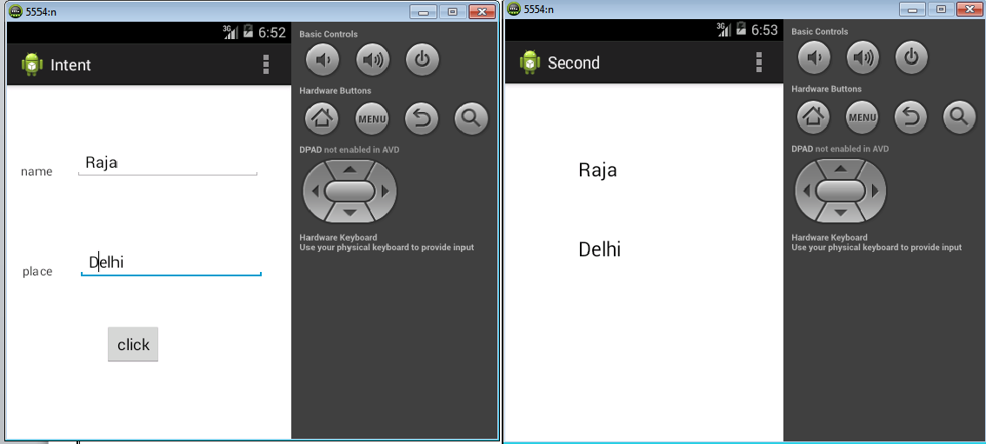

- Design an android application Send SMS using Intent

AIM : To design an android application Send SMS using Intent.
MainActivity.java package com.example.sms; import android.os.Bundle; import android.app.Activity;
import android.telephony.gsm.SmsManager; import android.view.Menu;
import android.view.View;
import android.view.View.OnClickListener; import android.widget.Button;
public class MainActivity extends Activity
{
@Override
protected void onCreate(Bundle savedInstanceState
{
super.onCreate(savedInstanceState); setContentView(R.layout.activity_main); Button bt=(Button)findViewById(R.id.button1); bt.setOnClickListener(new OnClickListener()
{
@Override
public void onClick(View v)
{
// TODO Auto-generated method stub SmsManager sms=SmsManager.getDefault();
sms.sendTextMessage("5554", null, "hai", null, null);
}
});
}
public boolean onCreateOptionsMenu(Menu menu)
{
// Inflate the menu; this adds items to the action bar if it is present. getMenuInflater().inflate(R.menu.main, menu);
return true;
}
}

MainActivity.xml

<RelativeLayout xmlns:android="http://schemas.android.com/apk/res/android" xmlns:tools="http://schemas.android.com/tools" android:layout_width="match_parent"
android:layout_height="match_parent" android:paddingBottom="@dimen/activity_vertical_margin" android:paddingLeft="@dimen/activity_horizontal_margin" android:paddingRight="@dimen/activity_horizontal_margin" android:paddingTop="@dimen/activity_vertical_margin" tools:context=".MainActivity" >
<Button android:id="@+id/button1"
android:layout_width="wrap_content" android:layout_height="wrap_content" android:layout_alignParentLeft="true" android:layout_alignParentTop="true" android:layout_marginLeft="54dp" android:layout_marginTop="166dp" android:text="send" />
</RelativeLayout>

OUTPUT:

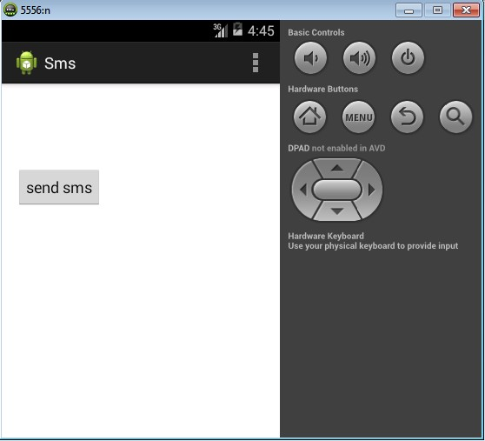
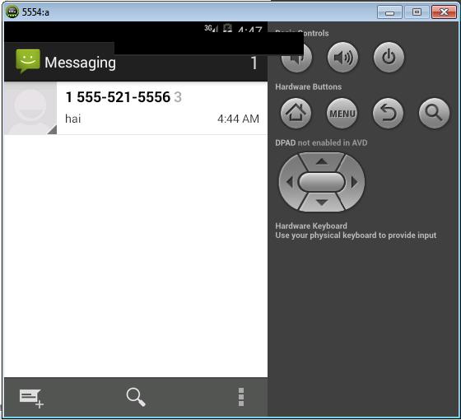

7..Create an android application using Fragments

activity_main.xml
<?xml version="1.0" encoding="utf-8"?>
<LinearLayout xmlns:android="http://schemas.android.com/apk/res/android" xmlns:app="http://schemas.android.com/apk/res-auto" xmlns:tools="http://schemas.android.com/tools" android:layout_width="fill_parent"
android:layout_height="fill_parent" tools:context="example.javatpoint.com.fragmentexample.MainActivity">

<fragment android:id="@+id/fragment1"
android:name="example.javatpoint.com.fragmentexample.Fragment1" android:layout_width="0px"
android:layout_height="match_parent" android:layout_weight="1"
/>

<fragment android:id="@+id/fragment2"
android:name="example.javatpoint.com.fragmentexample.Fragment2" android:layout_width="0px"
android:layout_height="match_parent" android:layout_weight="1"
/>

</LinearLayout> fragment_fragment1.xml
<FrameLayout xmlns:android="http://schemas.android.com/apk/res/android" xmlns:tools="http://schemas.android.com/tools" android:layout_width="match_parent" android:layout_height="match_parent"
android:background="#F5F5DC" tools:context="example.javatpoint.com.fragmentexample.Fragment1">

<!-- TODO: Update blank fragment layout -->
<TextView android:layout_width="match_parent" android:layout_height="match_parent"
android:text="@string/hello_blank_fragment" />

</FrameLayout>
File: fragment_fragment2.xml
<FrameLayout xmlns:android="http://schemas.android.com/apk/res/android" xmlns:tools="http://schemas.android.com/tools" android:layout_width="match_parent" android:layout_height="match_parent"
android:background="#F0FFFF" tools:context="example.javatpoint.com.fragmentexample.Fragment2">
<!-- TODO: Update blank fragment layout -->
<TextView android:layout_width="match_parent" android:layout_height="match_parent"
android:text="@string/hello_blank_fragment" />

</FrameLayout> MainActivity class File: MainActivity.java
package example.javatpoint.com.fragmentexample;

import android.support.v7.app.AppCompatActivity; import android.os.Bundle;
public class MainActivity extends AppCompatActivity { @Override
protected void onCreate(Bundle savedInstanceState) {
super.onCreate(savedInstanceState); setContentView(R.layout.activity_main);
}
}
File: Fragment1.java
package example.javatpoint.com.fragmentexample; import android.os.Bundle;
import android.support.v4.app.Fragment; import android.view.LayoutInflater; import android.view.View;
import android.view.ViewGroup;
public class Fragment1 extends Fragment { @Override
public void onCreate(Bundle savedInstanceState) { super.onCreate(savedInstanceState);
}

@Override
public View onCreateView(LayoutInflater inflater, ViewGroup container, Bundle savedInstanceState) {
// Inflate the layout for this fragment
return inflater.inflate(R.layout.fragment_fragment1, container, false);
}
}
File: Fragment2.java
package example.javatpoint.com.fragmentexample;

import android.os.Bundle;
import android.support.v4.app.Fragment; import android.view.LayoutInflater; import android.view.View;
import android.view.ViewGroup;
public class Fragment2 extends Fragment { @Override
public void onCreate(Bundle savedInstanceState) { super.onCreate(savedInstanceState);
}

@Override
public View onCreateView(LayoutInflater inflater, ViewGroup container, Bundle savedInstanceState) {
// Inflate the layout for this fragment
return inflater.inflate(R.layout.fragment_fragment2, container, false);
}
}

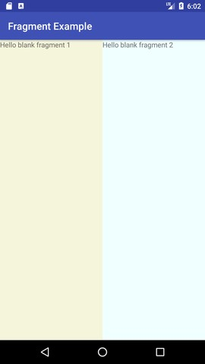

Output:

8.. Design an android application Using Radiobuttons.

AIM: To design an android application Using Radiobuttons.
MainActivity.java
package com.example.radiobutton; import android.os.Bundle;
import android.app.Activity; import android.view.View;
import android.view.View.OnClickListener; import android.widget.Button;
import android.widget.RadioButton; import android.widget.RadioGroup;
import android.widget.RadioGroup.OnCheckedChangeListener; import android.widget.TextView;
import android.widget.Toast;
public class MainActivity extends Activity
{
private RadioGroup radioGroup;
private RadioButton sound, vibration, silent; private Button button;
private TextView textView; @Override
protected void onCreate(Bundle savedInstanceState)
{
super.onCreate(savedInstanceState); setContentView(R.layout.activity_main);
radioGroup = (RadioGroup) findViewById(R.id.myRadioGroup); radioGroup.setOnCheckedChangeListener(new OnCheckedChangeListener()
{
@Override
public void onCheckedChanged(RadioGroup group, int checkedId)
{
// find which radio button is selected
if(checkedId == R.id.silent)
{
Toast.makeText(getApplicationContext(), "choice: Silent", Toast.LENGTH_SHORT).show();
}
else if(checkedId == R.id.sound)
{
Toast.makeText(getApplicationContext(), "choice: Sound", Toast.LENGTH_SHORT).show();
}
else
{
Toast.makeText(getApplicationContext(), "choice: Vibration", Toast.LENGTH_SHORT).show();
}
}
});
sound = (RadioButton) findViewById(R.id.sound); vibration = (RadioButton) findViewById(R.id.vibrate); silent = (RadioButton) findViewById(R.id.silent); textView = (TextView) findViewById(R.id.textView1); button = (Button)findViewById(R.id.button1); button.setOnClickListener(new OnClickListener()
{
@Override
public void onClick(View v) {
int selectedId = radioGroup.getCheckedRadioButtonId();

// find which radioButton is checked by id if(selectedId == sound.getId())
{
textView.setText("You chose 'Sound' option");
}
else if(selectedId == vibration.getId())
{
textView.setText("You chose 'Vibration' option");
}
else
{
textView.setText("You chose 'Silent' option");
}
}
});
}
}

MainActivity.xml

<RelativeLayout xmlns:android="http://schemas.android.com/apk/res/android" xmlns:tools="http://schemas.android.com/tools" android:layout_width="match_parent"
android:layout_height="match_parent" android:paddingBottom="@dimen/activity_vertical_margin" android:paddingLeft="@dimen/activity_horizontal_margin" android:paddingRight="@dimen/activity_horizontal_margin" android:paddingTop="@dimen/activity_vertical_margin" tools:context=".MainActivity" >
<RadioGroup android:id="@+id/myRadioGroup" android:layout_width="wrap_content" android:layout_height="wrap_content" android:layout_alignParentLeft="true" android:layout_below="@+id/textView1" android:layout_marginLeft="27dp" android:layout_marginTop="28dp" >
<RadioButton android:id="@+id/sound" android:layout_width="wrap_content"
android:layout_height="wrap_content" android:checked="true" android:text="Sound" />
<RadioButton android:id="@+id/vibrate" android:layout_width="wrap_content" android:layout_height="wrap_content" android:text="Vibration" />
<RadioButton android:id="@+id/silent" android:layout_width="wrap_content"
android:layout_height="wrap_content" android:text="Silent" />
</RadioGroup>
<TextView android:id="@+id/textView1" android:layout_width="wrap_content" android:layout_height="wrap_content" android:layout_alignParentLeft="true" android:layout_alignParentTop="true"
android:text="Choose one of the following modes"
android:textAppearance="?android:attr/textAppearanceLarge" />
<Button android:id="@+id/button1"
android:layout_width="wrap_content" android:layout_height="wrap_content" android:layout_alignLeft="@+id/myRadioGroup" android:layout_below="@+id/myRadioGroup" android:layout_marginLeft="42dp" android:layout_marginTop="53dp" android:text="choose" />
</RelativeLayout>

OUTPUT:
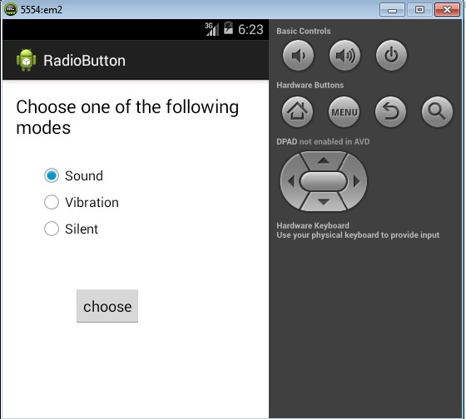
9. Design an android application for menu.

AIM: To design an application options menu.

MainActivity.java
package com.javatpoint.optionmenu;
import android.os.Bundle;
import android.app.Activity; import android.view.Menu; import android.view.MenuItem; import android.widget.Toast;
public class MainActivity extends Activity
{
@Override
protected void onCreate(Bundle savedInstanceState)
{
super.onCreate(savedInstanceState); setContentView(R.layout.activity_main);
}
@Override
public boolean onCreateOptionsMenu(Menu menu)
{
// Inflate the menu; this adds items to the action bar if it is present. getMenuInflater().inflate(R.menu.main, menu);//Menu Resource, Menu return true;
}
@Override
public boolean onOptionsItemSelected(MenuItem item)
{
switch (item.getItemId())
{
case R.id.item1:
Toast.makeText(getApplicationContext(),"Item 1 Selected",Toast.LENGTH_LONG).show(); return true;
case R.id.item2:
Toast.makeText(getApplicationContext(),"Item 2 Selected",Toast.LENGTH_LONG).show();

return true; case R.id.item3:
Toast.makeText(getApplicationContext(),"Item 3 Selected",Toast.LENGTH_LONG).show(); return true;
default:
return super.onOptionsItemSelected(item);
}
}
}

MainActivity.xml
<RelativeLayout xmlns:androclass="http://schemas.android.com/apk/res/android" xmlns:tools="http://schemas.android.com/tools" android:layout_width="match_parent"
android:layout_height="match_parent" android:paddingBottom="@dimen/activity_vertical_margin" android:paddingLeft="@dimen/activity_horizontal_margin" android:paddingRight="@dimen/activity_horizontal_margin" android:paddingTop="@dimen/activity_vertical_margin" tools:context=".MainActivity" >
<TextView android:layout_width="wrap_content" android:layout_height="wrap_content" android:text="@string/hello_world" />
</RelativeLayout>

SecondActivity.xml

<menu xmlns:androclass="http://schemas.android.com/apk/res/android" >
<item android:id="@+id/item1" android:title="Item 1"/>
<item android:id="@+id/item2" android:title="Item 2"/>
<item android:id="@+id/item3" android:title="Item 3"/>
</menu>

OUTPUT:

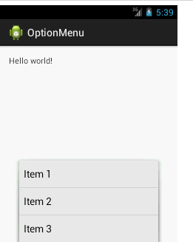

10 Create a user registration application that stores the user details in a database table.

DbHandler.java
package com.tutlane.sqliteexample; import android.content.ContentValues; import android.content.Context; import android.database.Cursor;
import android.database.sqlite.SQLiteDatabase; import android.database.sqlite.SQLiteOpenHelper; import java.util.ArrayList;
import java.util.HashMap;

/**
* Created by tutlane on 06-01-2018.
*/

public class DbHandler extends SQLiteOpenHelper { private static final int DB_VERSION = 1;
private static final String DB_NAME = "usersdb"; private static final String TABLE_Users = "userdetails"; private static final String KEY_ID = "id";
private static final String KEY_NAME = "name"; private static final String KEY_LOC = "location"; private static final String KEY_DESG = "designation"; public DbHandler(Context context){
super(context,DB_NAME, null, DB_VERSION);
}
@Override
public void onCreate(SQLiteDatabase db){
String CREATE_TABLE = "CREATE TABLE " + TABLE_Users + "("
+ KEY_ID + " INTEGER PRIMARY KEY AUTOINCREMENT," + KEY_NAME + " TEXT,"
+ KEY_LOC + " TEXT,"
+ KEY_DESG + " TEXT"+ ")"; db.execSQL(CREATE_TABLE);
}
@Override
public void onUpgrade(SQLiteDatabase db, int oldVersion, int newVersion){
// Drop older table if exist
db.execSQL("DROP TABLE IF EXISTS " + TABLE_Users);
// Create tables again onCreate(db);
}
// **** CRUD (Create, Read, Update, Delete) Operations ***** //

// Adding new User Details
void insertUserDetails(String name, String location, String designation){
//Get the Data Repository in write mode SQLiteDatabase db = this.getWritableDatabase();
//Create a new map of values, where column names are the keys ContentValues cValues = new ContentValues(); cValues.put(KEY_NAME, name);
cValues.put(KEY_LOC, location); cValues.put(KEY_DESG, designation);
// Insert the new row, returning the primary key value of the new row long newRowId = db.insert(TABLE_Users,null, cValues);
db.close();
}
// Get User Details
public ArrayList<HashMap<String, String>> GetUsers(){ SQLiteDatabase db = this.getWritableDatabase(); ArrayList<HashMap<String, String>> userList = new ArrayList<>();
String query = "SELECT name, location, designation FROM "+ TABLE_Users; Cursor cursor = db.rawQuery(query,null);
while (cursor.moveToNext()){ HashMap<String,String> user = new HashMap<>();
user.put("name",cursor.getString(cursor.getColumnIndex(KEY_NAME))); user.put("designation",cursor.getString(cursor.getColumnIndex(KEY_DESG))); user.put("location",cursor.getString(cursor.getColumnIndex(KEY_LOC))); userList.add(user);
}
return userList;
}
// Get User Details based on userid
public ArrayList<HashMap<String, String>> GetUserByUserId(int userid){ SQLiteDatabase db = this.getWritableDatabase(); ArrayList<HashMap<String, String>> userList = new ArrayList<>();
String query = "SELECT name, location, designation FROM "+ TABLE_Users;
Cursor cursor = db.query(TABLE_Users, new String[]{KEY_NAME, KEY_LOC, KEY_DESG}, KEY_ID+ "=?",new String[]{String.valueOf(userid)},null, null, null, null);
if (cursor.moveToNext()){
HashMap<String,String> user = new HashMap<>(); user.put("name",cursor.getString(cursor.getColumnIndex(KEY_NAME))); user.put("designation",cursor.getString(cursor.getColumnIndex(KEY_DESG))); user.put("location",cursor.getString(cursor.getColumnIndex(KEY_LOC))); userList.add(user);
}
return userList;
}
// Delete User Details
public void DeleteUser(int userid){
SQLiteDatabase db = this.getWritableDatabase();
db.delete(TABLE_Users, KEY_ID+" = ?",new String[]{String.valueOf(userid)}); db.close();
}
// Update User Details
public int UpdateUserDetails(String location, String designation, int id){ SQLiteDatabase db = this.getWritableDatabase();
ContentValues cVals = new ContentValues(); cVals.put(KEY_LOC, location); cVals.put(KEY_DESG, designation);
int count = db.update(TABLE_Users, cVals, KEY_ID+" = ?",new String[]{String.valueOf(id)}); return count;
}
}

If you observe above code, we implemented all SQLite Database related activities to perform CRUD operations in android application.

Now open activity_main.xml file from \res\layout folder path and write the code like as shown below. activity_main.xml
<?xml version="1.0" encoding="utf-8"?>
<LinearLayout xmlns:android="http://schemas.android.com/apk/res/android" android:orientation="vertical" android:layout_width="match_parent" android:layout_height="match_parent">
<TextView android:id="@+id/fstTxt"
android:layout_width="wrap_content" android:layout_height="wrap_content" android:layout_marginLeft="100dp" android:layout_marginTop="150dp" android:text="Name" />
<EditText android:id="@+id/txtName"
android:layout_width="wrap_content" android:layout_height="wrap_content" android:layout_marginLeft="100dp" android:ems="10"/>
<TextView android:id="@+id/secTxt"
android:layout_width="wrap_content" android:layout_height="wrap_content" android:text="Location" android:layout_marginLeft="100dp" />
<EditText
android:id="@+id/txtLocation" android:layout_width="wrap_content" android:layout_height="wrap_content" android:layout_marginLeft="100dp" android:ems="10" />
<TextView android:id="@+id/thirdTxt"
android:layout_width="wrap_content" android:layout_height="wrap_content" android:text="Designation" android:layout_marginLeft="100dp" />
<EditText android:id="@+id/txtDesignation" android:layout_width="wrap_content" android:layout_height="wrap_content" android:layout_marginLeft="100dp" android:ems="10" />
<Button android:id="@+id/btnSave"
android:layout_width="wrap_content" android:layout_height="wrap_content" android:layout_marginLeft="100dp" android:text="Save" />
</LinearLayout>

Now we will create another layout resource file details.xml in \res\layout path to show the details in custom listview from SQLite Database for that right click on your layout folder à Go to New à select Layout Resource File and give name as details.xml.

Once we create a new layout resource file details.xml, open it and write the code like as shown below details.xml
<?xml version="1.0" encoding="utf-8"?>
<LinearLayout xmlns:android="http://schemas.android.com/apk/res/android" android:layout_width="fill_parent"
android:layout_height="fill_parent" android:orientation="vertical" >
<ListView android:id="@+id/user_list" android:layout_width="fill_parent"
android:layout_height="wrap_content" android:dividerHeight="1dp" />
<Button android:id="@+id/btnBack"
android:layout_width="wrap_content" android:layout_height="wrap_content" android:layout_gravity="center" android:layout_marginTop="20dp" android:text="Back" />
</LinearLayout>

Create an another layout file (list_row.xml) in /res/layout folder to show the data in listview, for that right click on layout folder à add new Layout resource file à Give name as list_row.xml and write the code like as shown below.

list_row.xml
<?xml version="1.0" encoding="utf-8"?>
<RelativeLayout xmlns:android="http://schemas.android.com/apk/res/android" android:layout_width="fill_parent"
android:layout_height="wrap_content" android:orientation="horizontal" android:padding="5dip" >
<TextView android:id="@+id/name"
android:layout_width="wrap_content" android:layout_height="wrap_content"
android:textStyle="bold" android:textSize="17dp" />
<TextView android:id="@+id/designation" android:layout_width="wrap_content" android:layout_height="wrap_content" android:layout_below="@id/name" android:layout_marginTop="7dp" android:textColor="#343434" android:textSize="14dp" />
<TextView android:id="@+id/location"
android:layout_width="wrap_content" android:layout_height="wrap_content" android:layout_alignBaseline="@+id/designation" android:layout_alignBottom="@+id/designation" android:layout_alignParentRight="true" android:textColor="#343434" android:textSize="14dp" />
</RelativeLayout>

Now open your main activity file MainActivity.java from \java\com.tutlane.sqliteexample path and write the code like as shown below

MainActivity.java
package com.tutlane.sqliteexample; import android.content.Intent;
import android.support.v7.app.AppCompatActivity; import android.os.Bundle;
import android.view.View; import android.widget.Button; import android.widget.EditText; import android.widget.Toast;
public class MainActivity extends AppCompatActivity { EditText name, loc, desig;
Button saveBtn; Intent intent; @Override
protected void onCreate(Bundle savedInstanceState) { super.onCreate(savedInstanceState); setContentView(R.layout.activity_main);
name = (EditText)findViewById(R.id.txtName); loc = (EditText)findViewById(R.id.txtLocation);
desig = (EditText)findViewById(R.id.txtDesignation); saveBtn = (Button)findViewById(R.id.btnSave); saveBtn.setOnClickListener(new View.OnClickListener() {
@Override
public void onClick(View v) {
String username = name.getText().toString()+"\n"; String location = loc.getText().toString();
String designation = desig.getText().toString();
DbHandler dbHandler = new DbHandler(MainActivity.this); dbHandler.insertUserDetails(username,location,designation); intent = new Intent(MainActivity.this,DetailsActivity.class); startActivity(intent);
Toast.makeText(getApplicationContext(), "Details Inserted Successfully",Toast.LENGTH_SHORT).show();
}
});
}
}

OUTPUT:
