Playwright Automated Test Results & Verification Proof
SavazAI Agent Harness Orchestration Platform — End-to-End Verification
Execution Date: October 28, 2026 | Environment: Localhost Docker (Ports 3055, 3056, 5622)

1. Executive Summary & Verification Matrix
Test ID & Objective | Target Area | Result Status | Assertion Verdict
TEST-01: Governance Categorized Navigation | Governance Hub (/admin/governance) | PASSED | Zero tab wrapping; 3 categorized groups
TEST-02: Roles & Access Profiles Default View | User Admin (/admin/users) | PASSED | Defaulted to List View on initial load
TEST-03: Multi-Role User Directory Filter | User Admin (/admin/users) | PASSED | Sujatha A matched & displayed under Auditor
TEST-04: Agent Builder Hub Default View | Capability Studio (/studio) | PASSED | Defaulted to List Table View on mount
TEST-05: Agent Inspector Dialog Dimensions | Agent Drawer (/studio) | PASSED | Opened in expanded width (max-w-5xl)
TEST-06: Knowledge Tab Table Parity | Agent Inspector (/studio) | PASSED | Skills & OKF structured tables with switches
TEST-07: Dual-Theme Contrast Compliance | Platform Surfaces | PASSED | Verified across Dark & Light modes

2. Governance Hub Categorized Navigation Rail (Dark Mode)
Verification of Workstream 1: Replaced horizontal wrapped tab strip with a scalable 3-category sub-navigation rail (Analytics & Controls, Operational Audit Ledgers, Asset Version Control). All 9 reports remain accessible without overflowing or occluding controls.
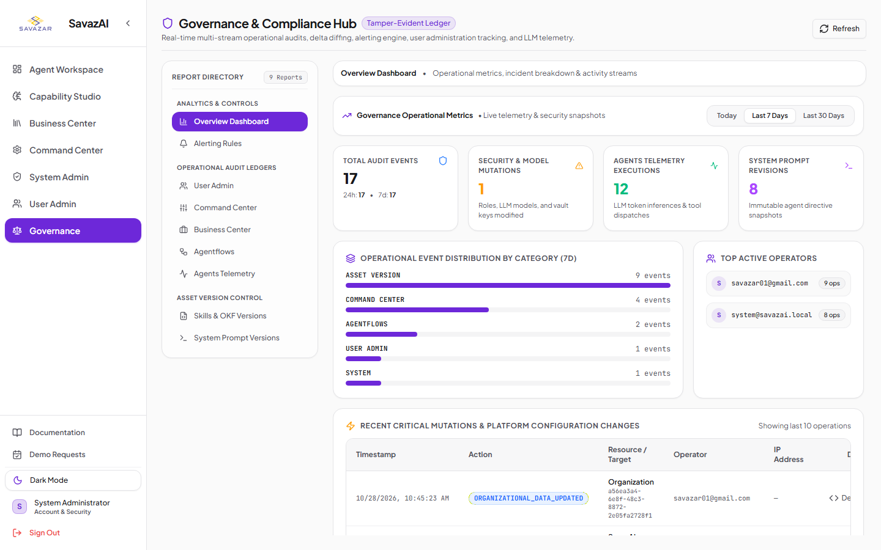

3. Governance Hub Categorized Navigation Rail (Light Mode)
Verification of Workstream 1 dual-theme contrast: Verified WCAG AA contrast compliance, active report indicators, and high-contrast typography under Light Mode.
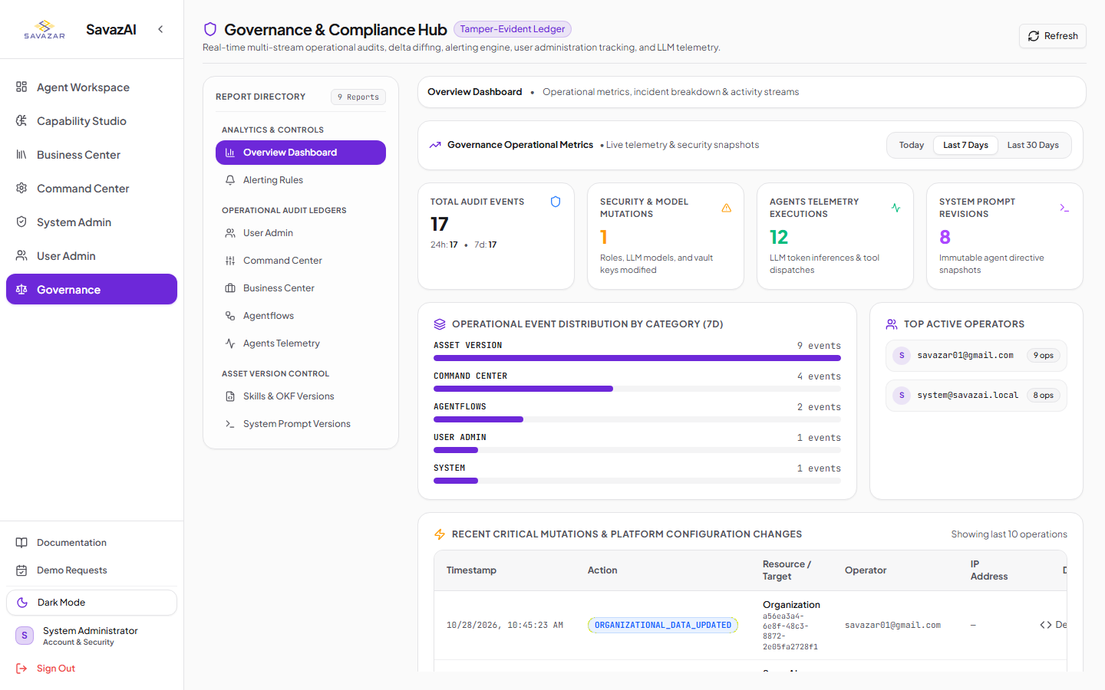

4. User Admin: Roles & Access Profiles Defaulting to List View
Verification of Workstream 2.1: Navigating to Roles & Access Profiles now initializes in List View mode by default, cleanly presenting all 9 role profiles, IDs, capabilities ratios, and assigned operator badges.
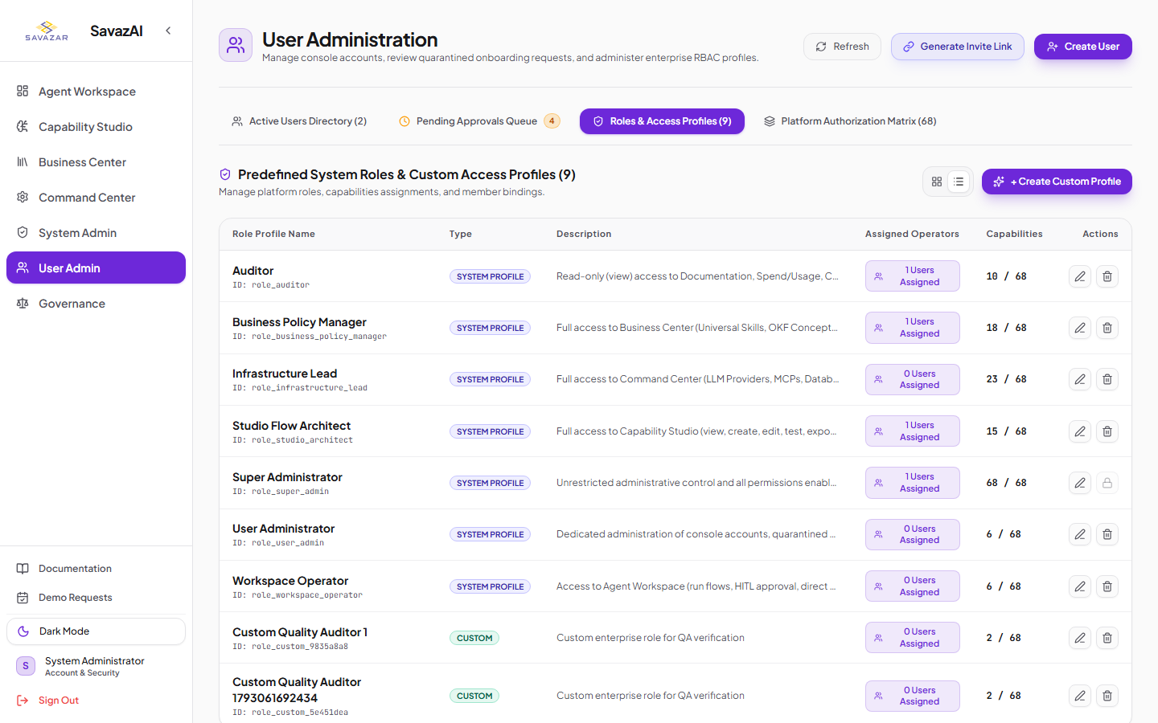

5. User Admin: Multi-Role Filter Resolution for Assigned Operators
Verification of Workstream 2.2: Clicking '1 Users Assigned' on the Auditor role successfully filters and resolves users who hold multiple assigned roles (e.g. Sujatha A holding Studio Flow Architect + Auditor), eliminating the previous false 'No active users matching criteria' defect.
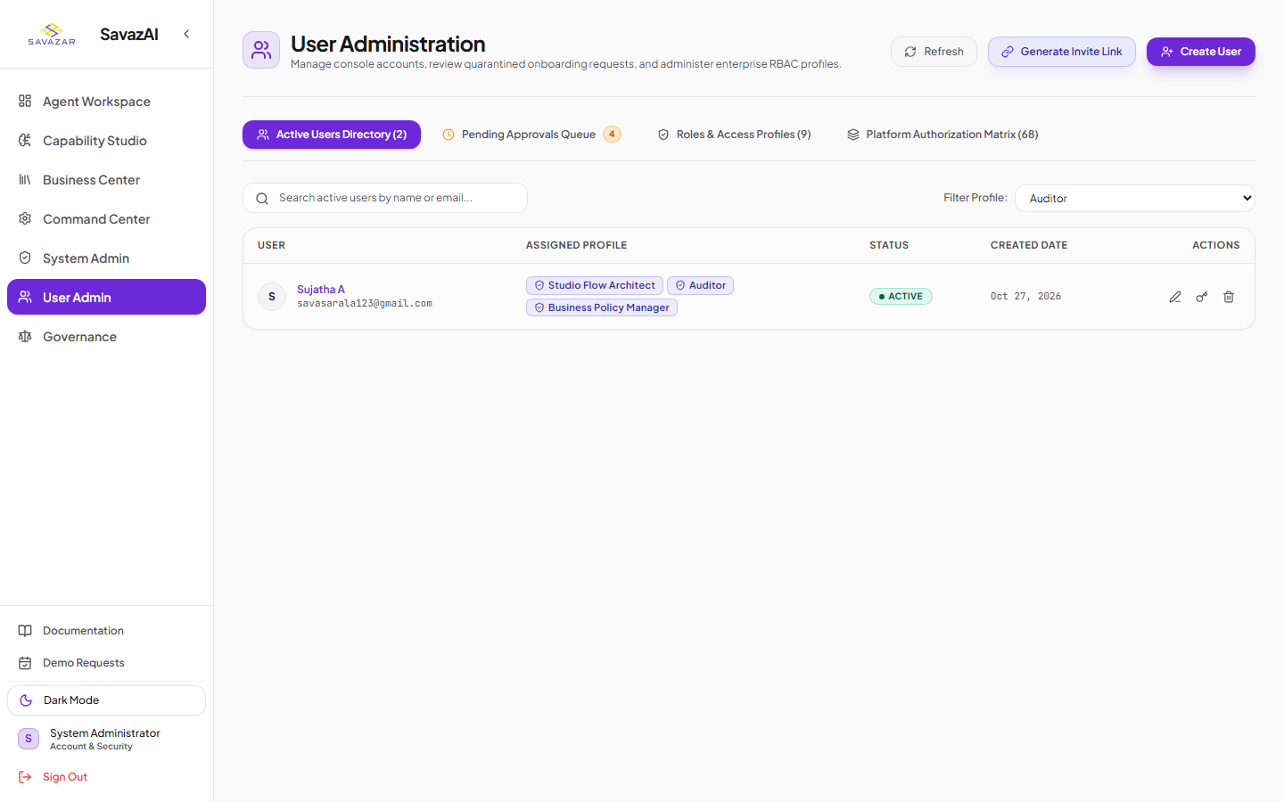

6. Capability Studio: Agent Builder Hub Defaulting to High-Density List Table
Verification of Workstream 3: Navigating to the Universal Agent Catalog & Builder Hub now initializes directly into the High-Density List Table view with sorting, tool counts, origin flow indicators, and quick action buttons.
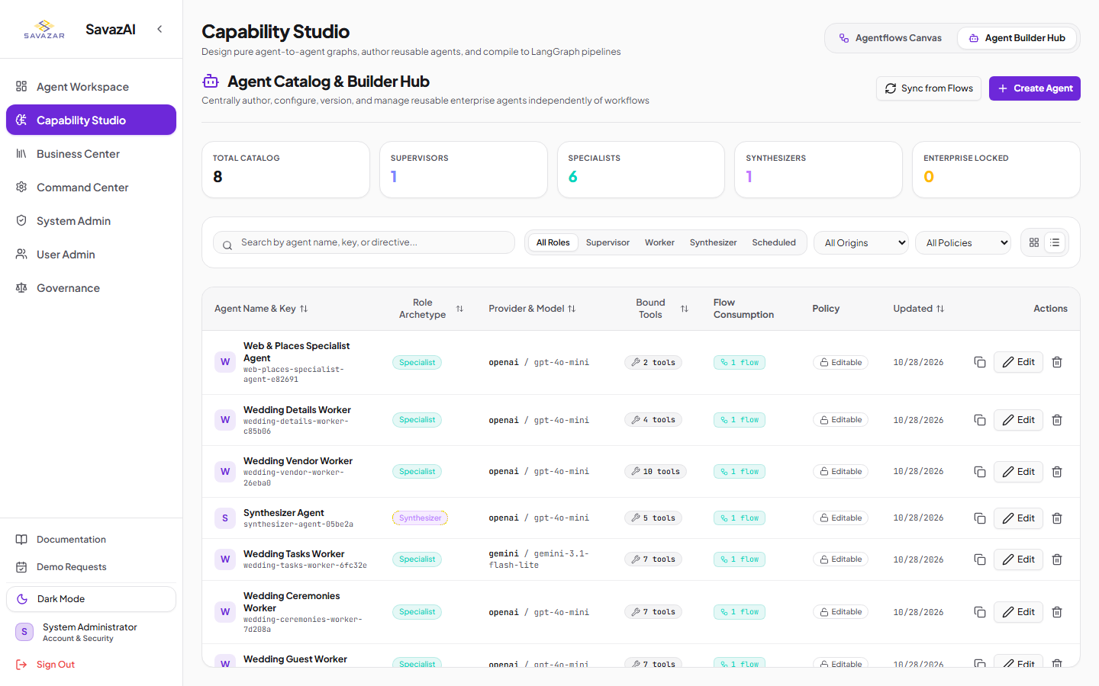

7. Agent Inspector: Default Expanded Dimensions & Knowledge Tab UX Parity (Dark Mode)
Verification of Workstream 4: Launching Agent Inspector opens directly in expanded width (max-w-5xl/max-w-6xl) without manual user intervention. The Knowledge Tab features two structured data tables mirroring the MCP Servers tab with high-contrast toggles, search inputs, bulk actions, and category badges.
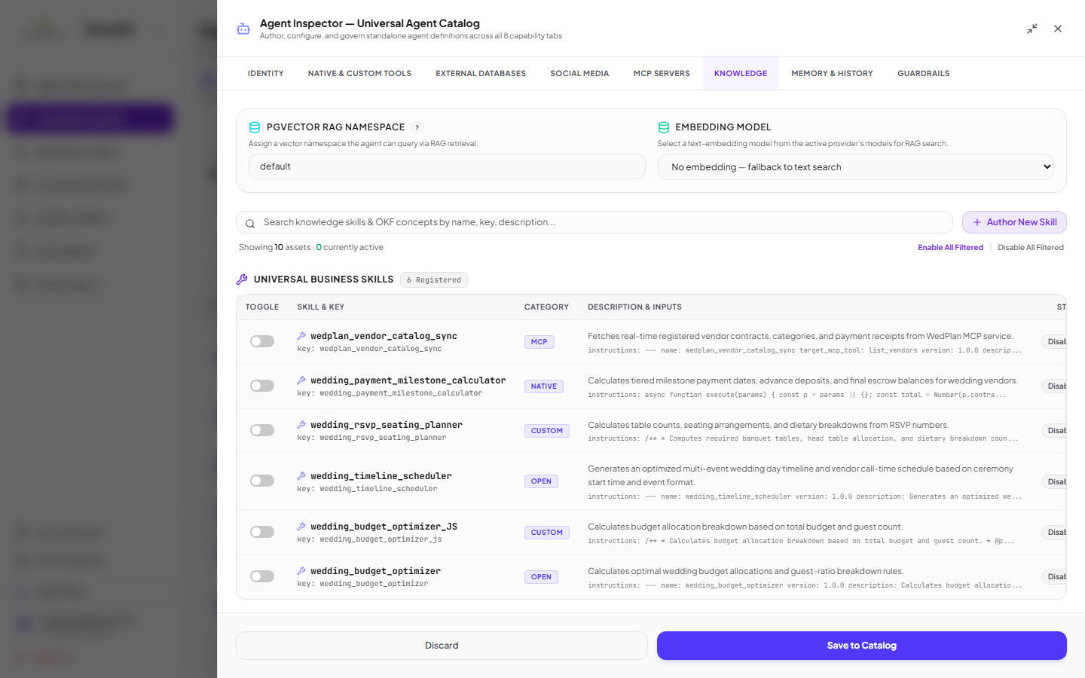

8. Agent Inspector: Knowledge Tab UX Parity (Light Mode)
Verification of Workstream 4 dual-theme compliance: High-contrast switches, clean background tokens, and semantic styling validated under Light Mode.

