5. Write a program using Arduino to control LED

1. One or more ON/OFF
2. Blinking

b. Blinking

**Block Diagram**

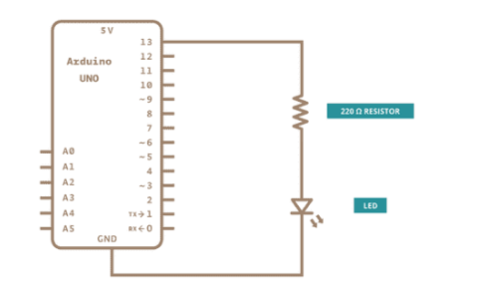

**Code:**

The Arduino Uno board has D13 as the LED_BUILTIN value.

// the setup function runs once when you press reset or power the board

void setup()

{

// initialize digital pin LED_BUILTIN as an output.

pinMode(LED_BUILTIN, OUTPUT);

}

// the loop function runs over and over again forever

void loop() {

digitalWrite(LED_BUILTIN, HIGH);

// turn the LED on (HIGH is the voltage level)

delay(1000); // wait for a second

digitalWrite(LED_BUILTIN, LOW);

// turn the LED off by making the voltage LOW

delay(1000); // wait for a second

}