**📰 SmartFoodie Founders Featured in StartupValley Magazine**

**🚀 Innovating Healthy Eating Through Technology**

We’re proud to share that SmartFoodie’s co-founders, **Theo Guo** and **Xiaoting Song**, have been featured in Germany’s renowned startup publication, **StartupValley**. In the interview, they talk about their mission to revolutionize the way we access hot, nutritious meals—powered by **Steam Cuisine**, our intelligent food solution.

**📰 About StartupValley**

**StartupValley Magazine** is one of Germany’s leading platforms for innovation and entrepreneurship. It showcases bold ideas and breakthrough technologies across sectors like foodtech, mobility, digital business, and sustainability, reaching founders, investors, and tech enthusiasts alike.

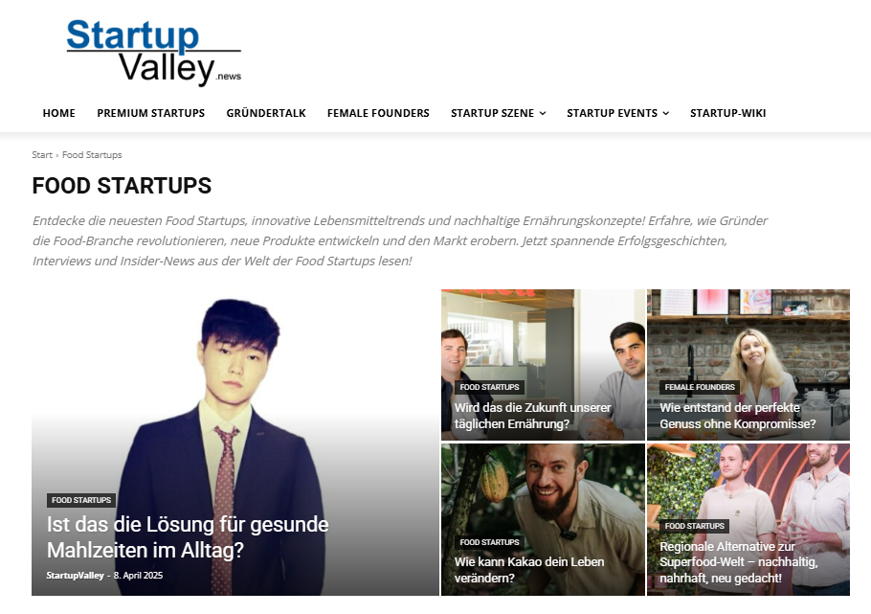

In the article, Theo and Xiaoting shared the origin of SmartFoodie: a desire to offer healthier and more convenient food options to people living busy urban lives. Their flagship system, **Steam Cuisine**, combines intelligent heating, food preservation, and automated vending into one compact unit—making it as easy to grab a hot, nourishing meal as it is to buy a coffee.

Both founders graduated from Germany’s top engineering universities—Theo from **RWTH Aachen** and Xiaoting from **TUM**—and together they’ve combined their passion for technology and love of food into a practical, scalable solution. SmartFoodie is also deeply committed to reducing food waste and encouraging more balanced eating habits. Their long-term goal? To bring that “just-right warm meal” to every metro station, office building, and university corner.



**📖 Read the full article:**

👉 <https://startupvalley.news/de/smartfoodie/>

**🧡 One Small Step, One Warm Bowl**

This feature isn’t just media recognition — it’s a reflection of our team’s values: warmth, accessibility, and purpose-driven innovation. If you’ve ever been curious about the faces behind SmartFoodie, this is your chance to meet them.

We’re building something meaningful — one bowl at a time.

**#SmartFoodie #StartupValley #FoundersFeature #SteamCuisine #Foodtech #SustainableInnovation #HealthyEating #StartupGermany**