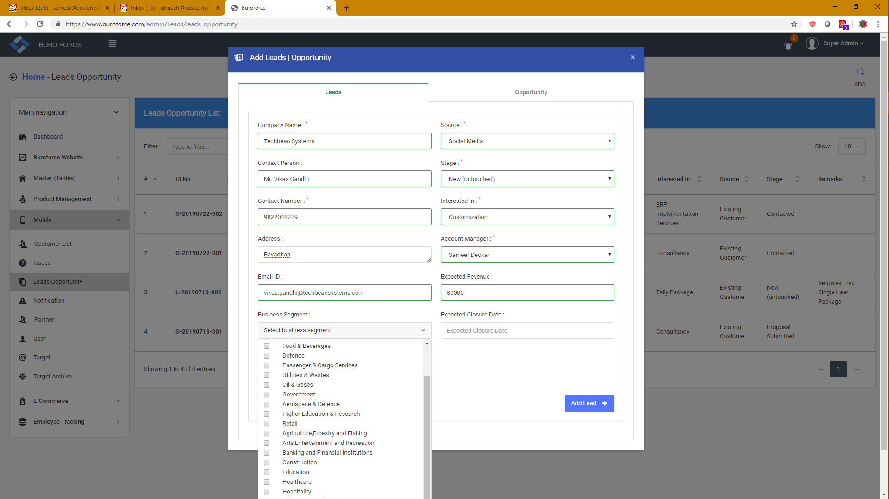

While adding lead, segment table is not visible totally. Few details are being hid at the bottom. Need proper presentation.

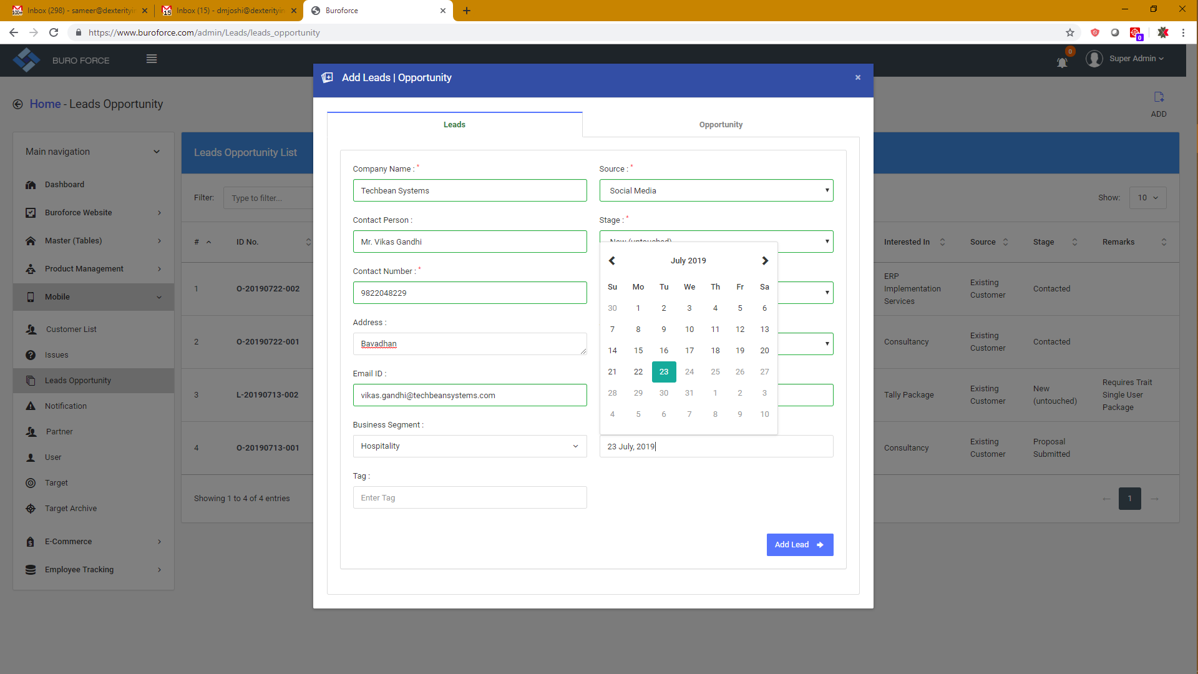

Expected Closure Date is not allowing entering future date. Lock should be removed.

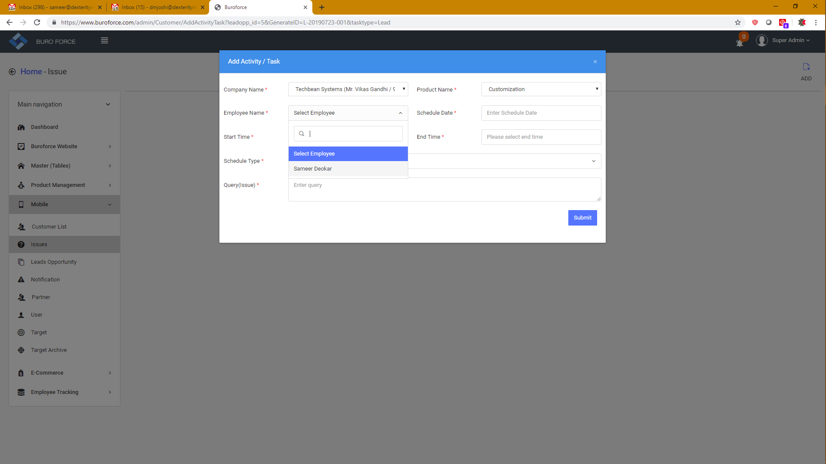

While adding activity against particular lead, it again asks me the employee Name. Though it gives only one value, it should be set by default the earlier set employee name.

**Lead Edit record option is not working.**

**Share Lead/Opportunity is not working - Pending**

**Lead/opportunity transfer feature is not working.. First I was the owne of that lead. I transferred it to Ramesh. But still it was reflecting in my account. It was not showing in Ramesh’s account.**

**Ont he other hand, while adding next activity, it takes the new employee name.**

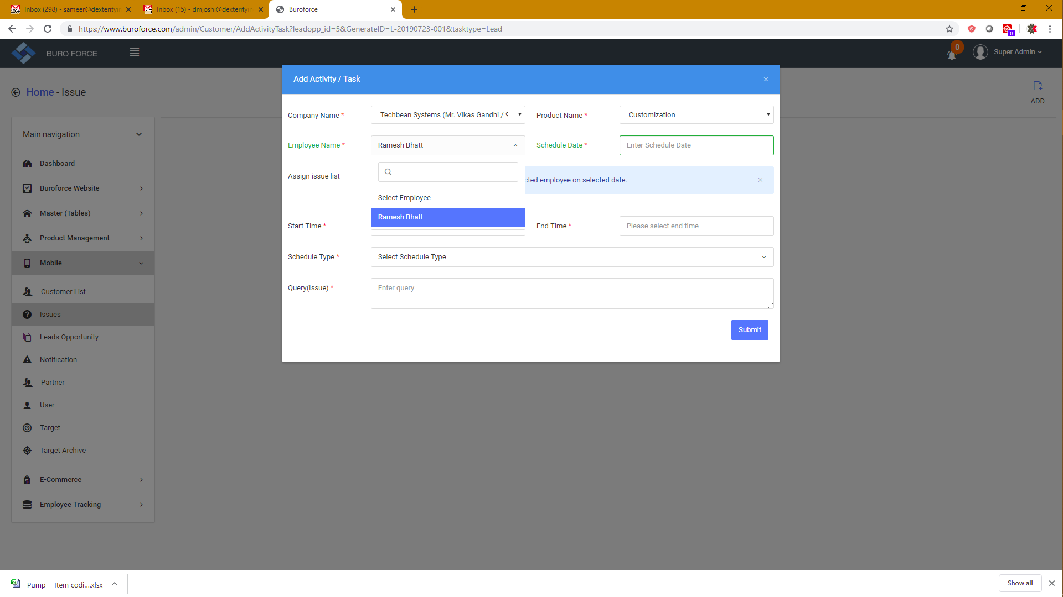

**Overlapping of the tab names is there... Check below 2 images.**

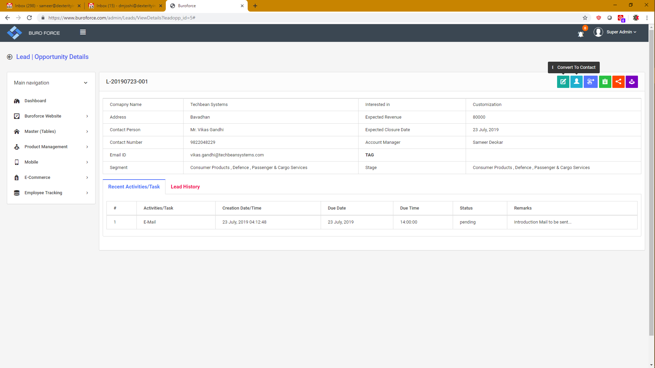

**Cursor is on Convert to Contact. But it mixes the title with Edit Lead... Need to be set properly.**

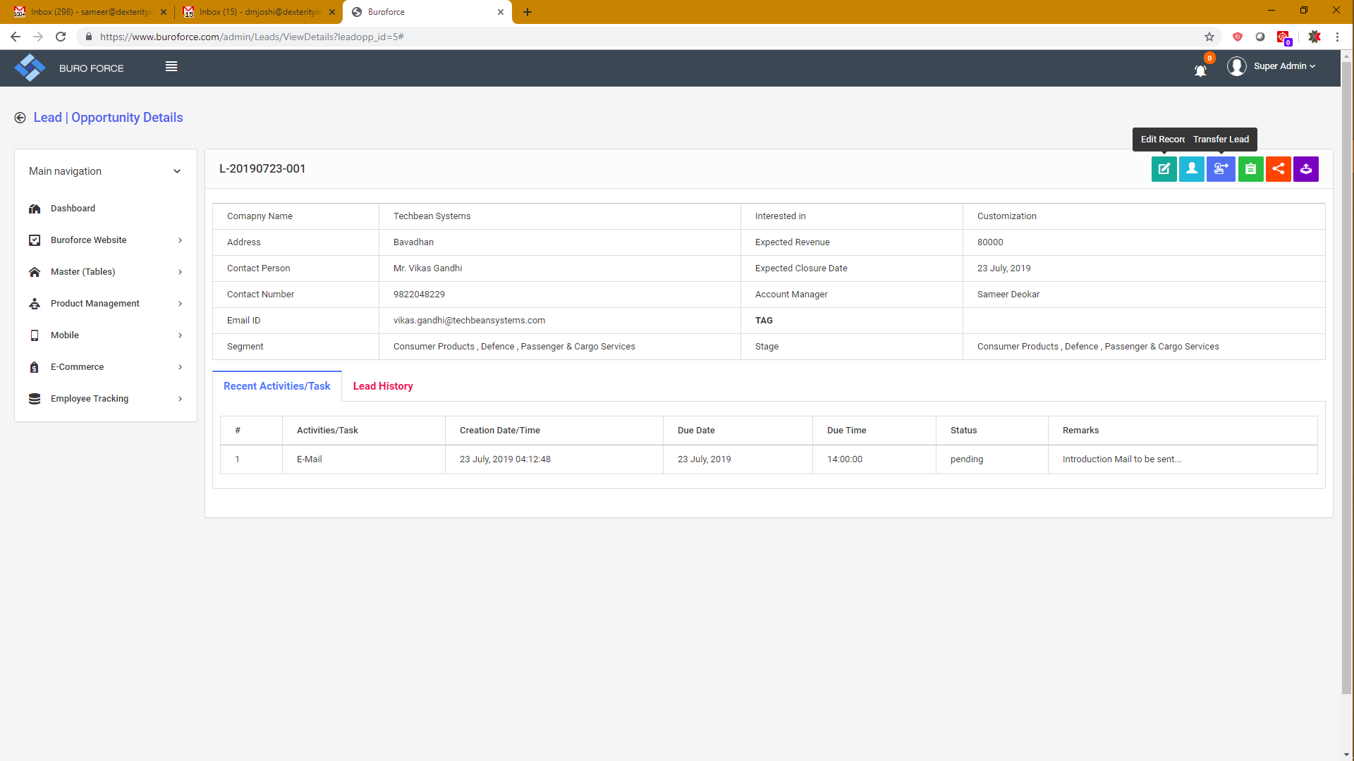

**Cursor is on Convert to Contact. But it mixes the title with Edit Lead... Need to be set properly.**

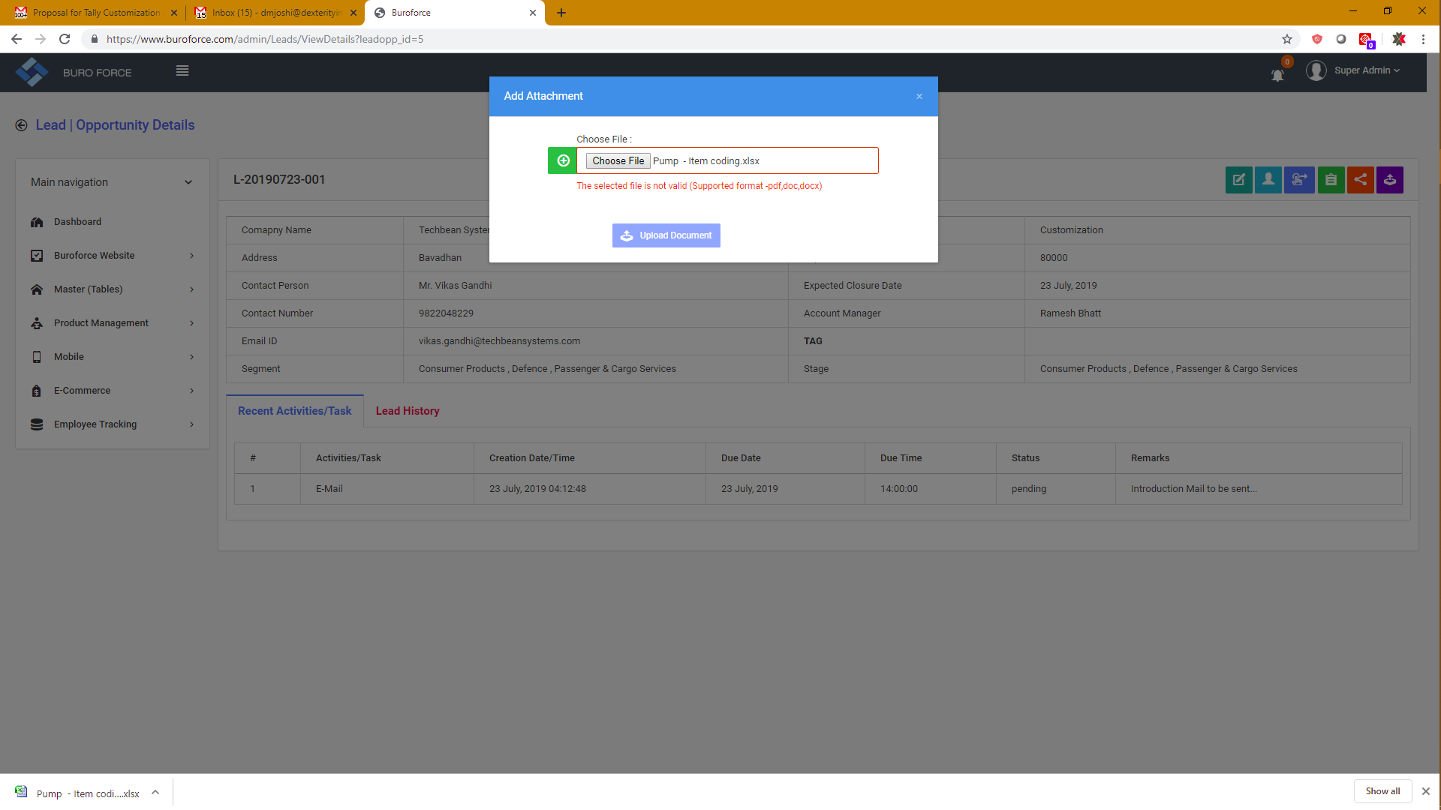

Excel file is not supportive.. rather all types of formats like excel, pdf, word, jpg, bmp etc.. should be acceptable OR valid format.

After submitting the documents, it gives successful message. But where to see attached documents? No provision to check the attached formats... In below screen shot, it is suggested to add one tab to see the attached documents...

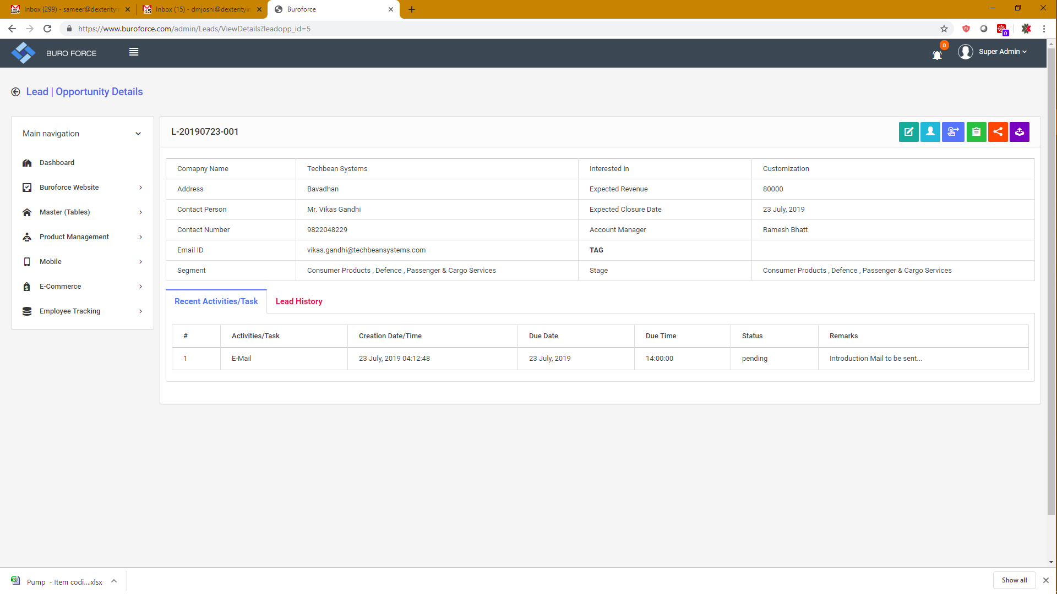

**One suggestion from customer..**

Need to have columns of completed date and time in below screen which we are finding valid.. Rather we can combine the Due date and Due Time columns and can add Completed Date & Time column... Ileaf Team suggestion is accepted here...

**Also column of owner/Employee of the lead/opportunity should be added for that particular activity.**

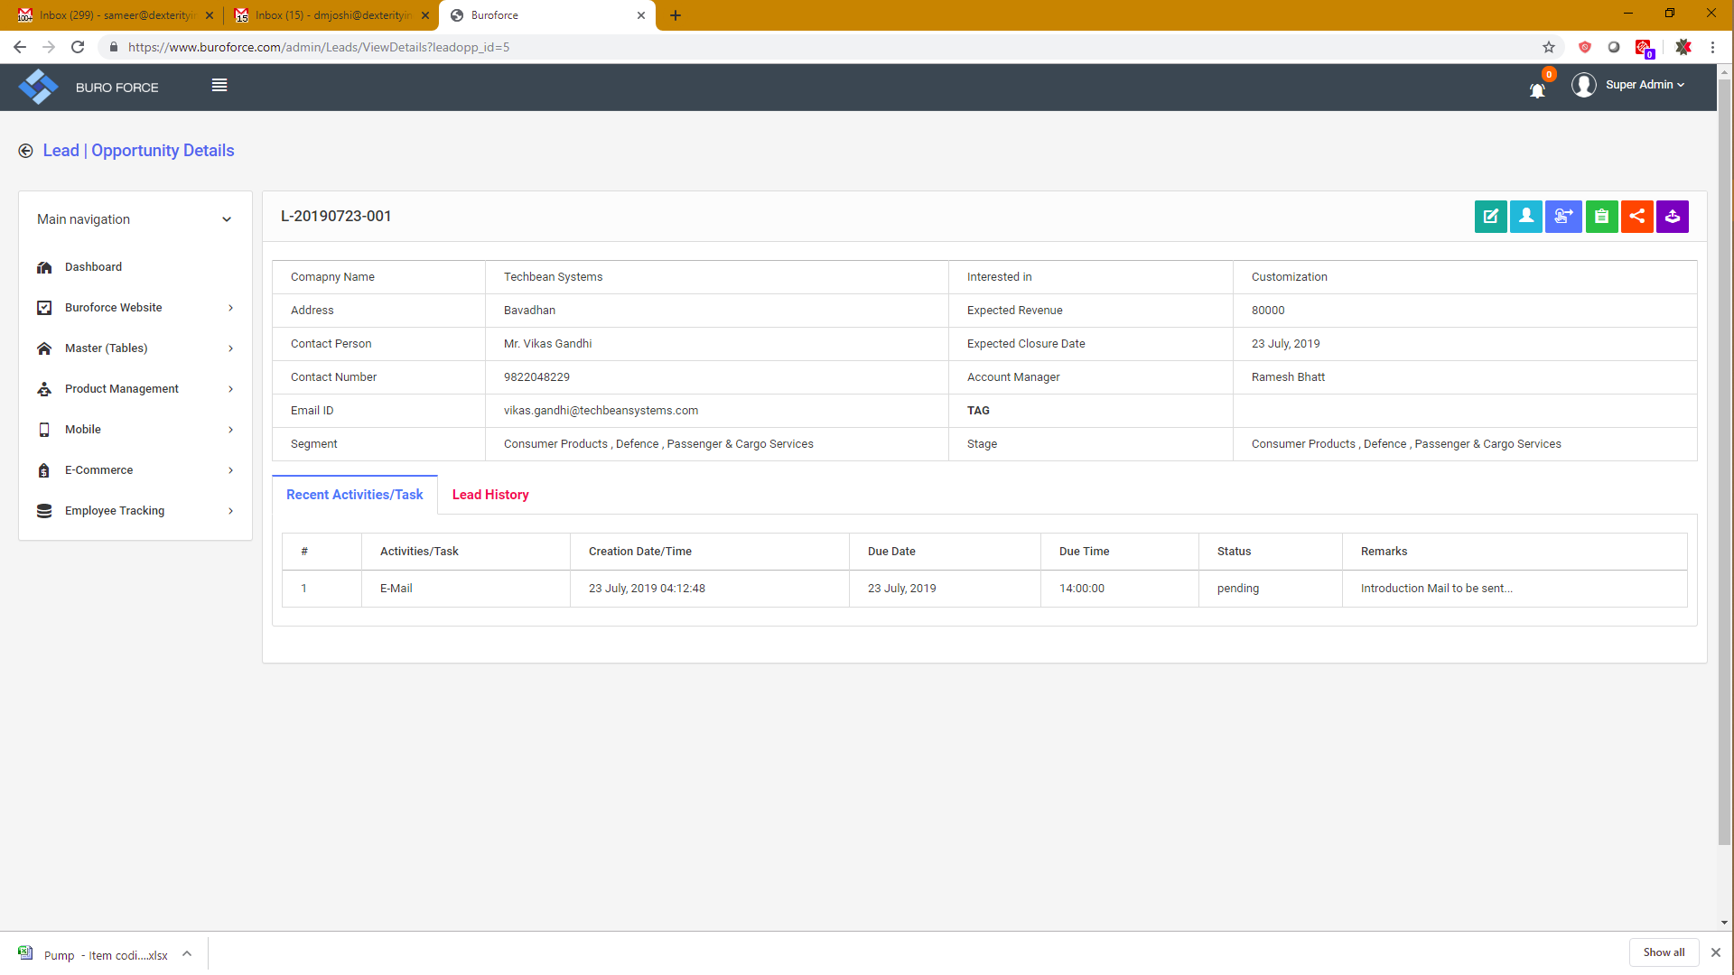

Font of the front screen is expected to be little bit larger as per discussion had with Kedar. Please do the needful. If required, I can discuss with him over call. This will have clear clarity.