Running molecular simulations with Q-Chem & iQmol

There are two major packages developed for quantum mechanical modeling of multi-atomic systems: Q-Chem and Gaussian. You can use either one for homework. In the following, we will focus on the use of Q-Chem.

The easiest way to set up and run Q-Chem simulations is via the graphical user interface, iQmol. You can download it from http://iqmol.org/ and install it on your PC. We will use it to build our molecule, create the Job file for Q-Chem to perform quantum mechanical calculations, and view the results. While the iQmol can submit the computational task to the Purdue server running Q-Chem and retrieve the results, this feature is not stable and often fails. Instead, we will transfer Job files to the server, run QChem from the Linux command line, and then copy the results back to your PC to be viewed by the iQmol.

For this homework, you do not need to know all available features of Q-Chem, but an interested person can check the Q-Chem manuals:
Q-Chem: https://www.q-chem.com/
The Q-Chem manual contains relevant keywords and a theoretical description of each implemented model: https://manual.q-chem.com/pdf/qchem_manual_5.0.pdf

Build your molecule using iQmol

When you first start iQmol, it opens in the Build mode ():
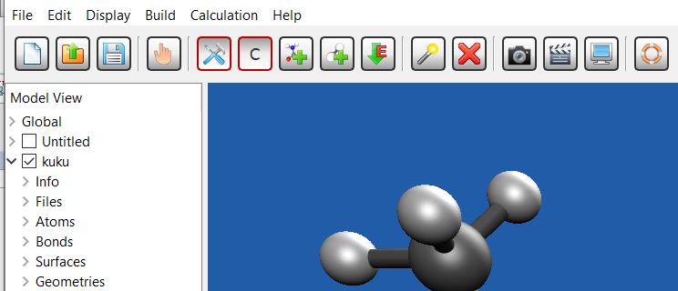
Clicking the left mouse button anywhere within the workspace will place a carbon atom at the cursor location. You can add another atom bound to the first by clicking on the first atom and then dragging a bond to the other atom's location and then releasing the mouse button. For a double-bond – add a bond by pushing the right mouse button down on the first atom, dragging the bond to the other atom, and releasing the button.
You can select different atoms from the top menu. You do not need to add hydrogen atoms explicitly to your molecule – instead, iQmol can add all missing hydrogens to the molecule automatically ( button). Since the bond lengths that you draw are most surely off when you build a molecule in such a way, you should use the Minimize Energy button () to run a rough (classical) geometry optimization procedure. Note that quantum mechanical optimization is more precise, but takes significantly more time and is executed as a task on an external server by Q-Chem.
You can switch to ‘hand mode () to move your molecule on screen (left mouse button) or rotate it (right mouse button). There are more options in iQmol, but they are self-explanatory.

Loading a molecule from an xyz file.
Alternatively, you can load a molecule from an XYZ file (or save it).

Create the Job file for Q-Chem simulations

Once the molecule is created or loaded into iQmol, go to Calculation>Q-Chem Setup.
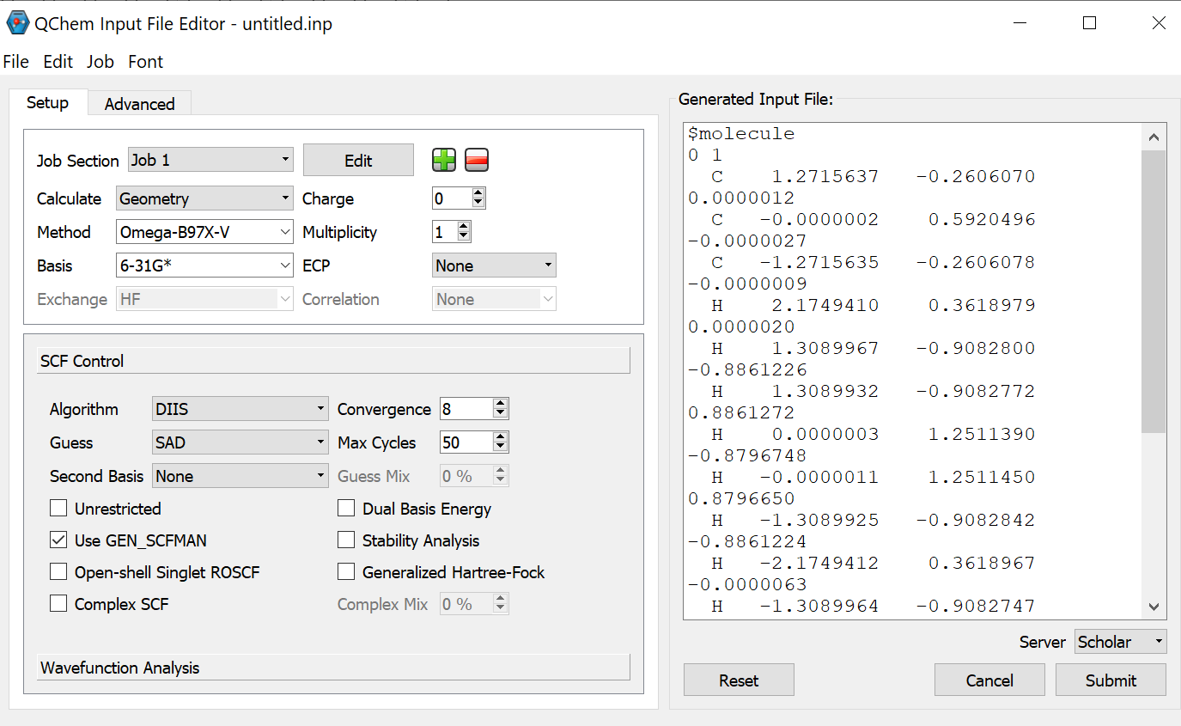
In this example, the job is set to minimize the geometry of a molecule using a specified method and basis. Convergence is set to 8 orders of magnitude (default), but for our purposes, 7 may be sufficient and will be significantly faster.

If your molecule is small, you can submit the Job to the default Q-Chem server. The calculations on this server are limited to ~10 minutes of processor time. You can use that option to first play with simple molecules (like ethane). You can check the job status using CalculationJob Monitor menu. When calculations finish, you will be offered to download the results into a directory of your choosing, and these will then be automatically loaded into the iQmol for viewing.

Alternatively, for more complex molecules, you will have to create an input file for calculations:
- Create a new directory for the input file, like mymolecule.
- Within this directory, create a new text file with *.inp extension, such as mymolecule.inp, and copy the contents of the right window (Generated Input File) into this text file. In Windows, for example, you can use Notepad for that.
- Transfer that file to the server

To use the output of the QChem calculations (such as Geometry Optimization), highlight the last structure in the Geometries dropdown submenu and then set up the task.

Transfer a Job file for Q-Chem calculations to the server

Currently, QChem is installed on the Purdue Scholar server:
scholar.rcac.purdue.edu
The easiest way to access your home directory on this server is via the gateway using a browser (like Chrome). Type the following in the browser’s address bar:
gateway.scholar.rcac.purdue.edu

You will be asked for your Purdue login name, password, and to confirm your login connection on your phone. Once there, you can view your files (home directory) and download/upload them; there is also a terminal window available (use Terminal button):

- To view, edit, and copy files from/to your PC, go to:
Select FilesHome Directory
You will see all the directories and files and a menu:
- One-time action: create a .profile file in your Home directory:
- first, check if it exists: check the “Show Dotfiles” checkbox. This will show the otherwise hidden system files (ones starting with a dot)
- If it exists, view it:
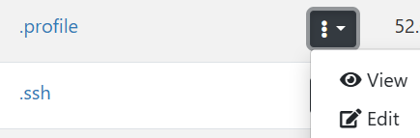
For easy access to the QChem program, add the following line to it (Edit it):
export PATH="/depot/lslipche-class/apps/bin:$PATH"
- If the .profile does not exist, create it using the +New File button and add the line above to it
- You only need to do it once
- Transfer the Job directory mymolecule (or whatever you named it, it must contain a *.inp file!) to the server using the Upload button.
- Once the QChem calculations are finished, use the Download button to download the directory back to the PC for viewing in iQmol

Run Q-Chem calculation
In the gateway window, use the Open Terminal button. You are now in the realm of Linux and will be using Linux command lines. Initially, you will be in your home directory. You can always switch back to the home directory using the cd command (change directory):
cd ~\
You can list the files in the current directory using commands:
ls lists all files except dotfiles
ls –a lists all files, including hidden dotfiles
ls *.inp lists only files matching the given mask (all inp files in this case)

To run calculations:
- switch to the directory with your inp job file, for example:
cd mymolecule
- Start QChem calculations (job) with your inp file:
qchem62 mymolecule.inp
The following options are available when you start the program:

qchem62 -w hours:minutes:seconds -ccp NPROC yourfile.inp
-ccp 4 Number of processors to be used (default = 1, max=64).
A larger number will speed up calculations, but it may push you back in the queue
-w 4:00:00 (wall) time limit for calculations, default is 4 hours, maximum is 4 hours (maybe?)
If the job does not fit into 4 hours, use longer times with an additional switch:
-q long –w 24:00:00

To check the calculation status
- To check if your job is running, use the command
squeue shows all jobs on scholar
squeue –u your_user_name shows only this user’s jobs
- Once your job is not listed, the program has finished.
- You can briefly check if there are output files in this directory using the ls command; there must be files mymolecule.inp.out and mymolecule.inp.fchk.
- View the mymolecule.inp.out file, the last lines must read:
*************************************************************
* *
* Thank you very much for using Q-Chem. Have a nice day. *
* *
*************************************************************
- If not, the QChem did not finish calculations for some reason, check other files in this directory for error description (if any)

Copy output files back to your PC
- Switch back to the Scholar file dashboard in the browser. Use Download in the drop-down menu next to your job directory
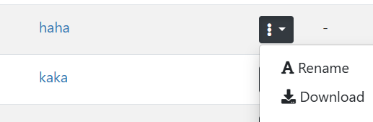
- Save all output files to a new directory

View the results of the calculation in iQmol

Open the directory with output files in iQmol using FileOpen Dir command. In the following example, the kuku directory was loaded:
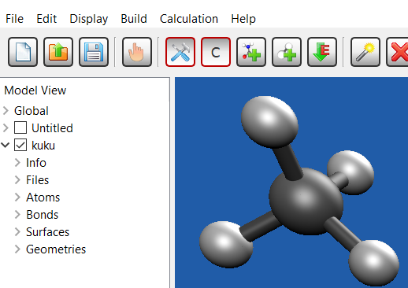

The Geometries section shows the structures in the course of QM structure optimization (if that was the task). The Surfaces menu can plot HOMO and/or LUMO orbitals if they were calculated (or more orbitals, depending on the particular job task).

See more in the Homework assignment.

