|  |  |  |  |
| --- | --- | --- | --- |
| **Fr. Conceicao Rodrigues College of Engineering**  **Department of Computer Engineering** | | | |
| **Student’s Roll No** | **9603** | **Students Name** | **Zane Falcao** |
| **Date of Performance** | **/02/2023** | **SE Computer – Div** | **A** |

**Aim:** Study Multiprocessing and Process Synchronization

## Lab Outcome:

**CSL 403.3:** Understand and apply the concepts of synchronization and deadlocks

## Pre-requirement: Python Programming. Problem Statements:

1. **WAP to demonstrate how to use lock mechanism to achieve process synchronization.**

## WAP to demonstrate the use of Queue mechanism to achieve process synchronization in Producer – Consumer Problem.

**The outputs should reflect behaviour of processes with and without process synchronization in both techniques.**

|  |  |  |  |
| --- | --- | --- | --- |
| **On time Submission (2)** | **Knowledge of Topic (4)** | **Implementation**  **and Demonstration (4)** | **Total (10)** |
|  |  |  |  |
| **Signature of Faculty** |  | **Date of Submission** |  |

# Q1) A) Without Lock Mechanism

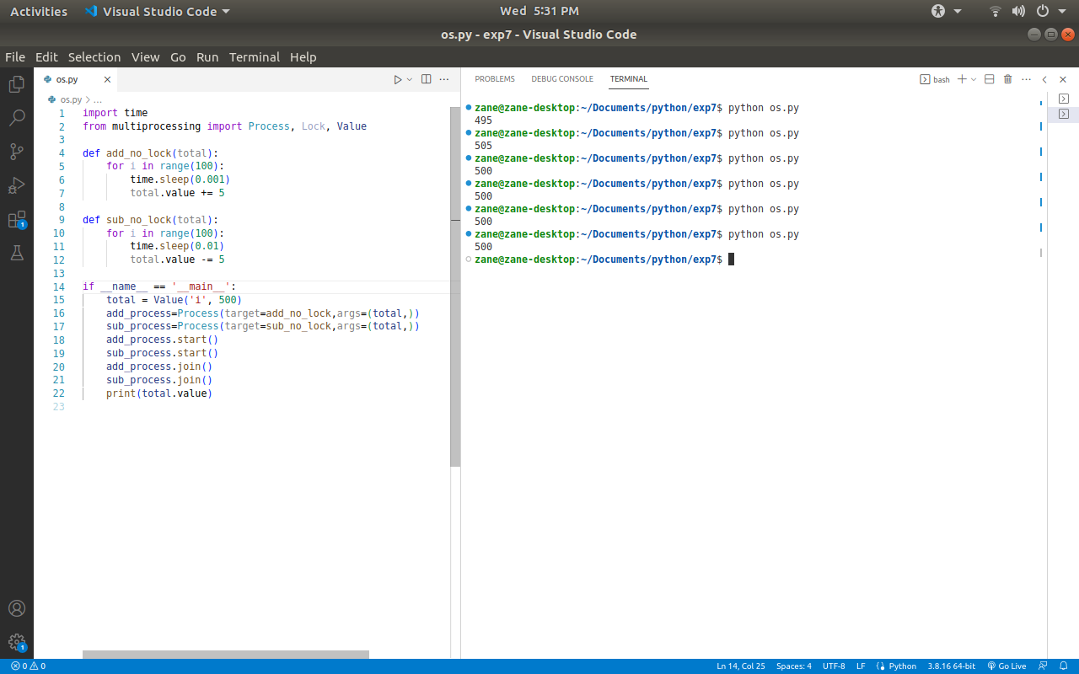

# With Lock Mechanism

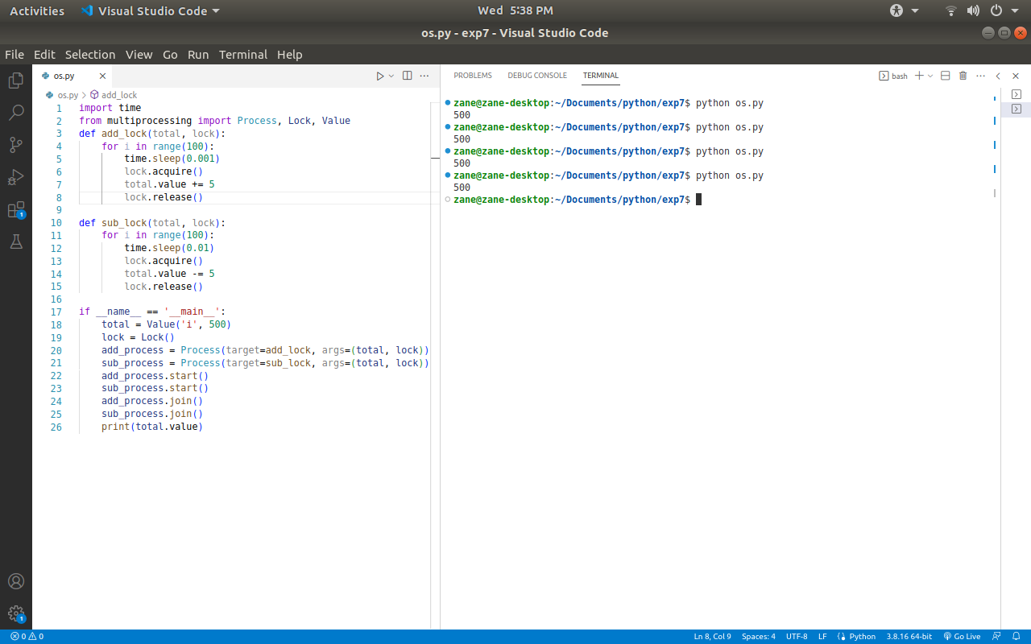

# Q2) A) Queue Mechanism Without Process Synchronization

# Screenshot from 2023-04-12 17-43-04

# B) Queue Process With Process Synchronization

## Screenshot from 2023-04-12 17-53-15